ASSEMBLY AWARE TEXT EDITOR

1. ABSTRACT
The Assembly Aware Text Editor is a specialized Integrated Development Environment (IDE) designed for 8086 Assembly language programming. Unlike conventional editors, it provides real-time syntax and semantic analysis while the user types, allowing immediate detection of errors such as invalid instructions, incorrect operands, and addressing mode issues.
The system enhances code readability through syntax highlighting and reduces debugging time by identifying errors early. It also supports optional integration with EMU8086 for assembling and executing programs. This project aims to improve learning efficiency for students and beginners in low-level programming.

2. OBJECTIVES

· Design a real-time Assembly code editor
· Implement syntax and semantic error detection
· Provide 8086-specific instruction validation
· Develop a user-friendly interface using Python (Tkinter)
· Integrate with EMU8086 for execution
· Enhance learning experience for beginners

3. SCOPE

Included:
- 8086 Assembly language support
- Real-time syntax highlighting
- Error detection and validation
- Automatic saving mechanism
- EMU8086 integration

Limitations:
- Supports only 8086 architecture
- Limited macro and advanced instruction support
- No optimization or compiler-level analysis
4. USERS

1. Students (Primary Users)
- Engineering students learning Assembly Language
- Use the editor to write, test, and debug programs
- Benefit from syntax highlighting and error detection
- Helps understand registers, memory addressing, and instruction flow
- Reduces confusion compared to plain text editors

2. Beginners in Low-Level Programming
- New learners with no prior assembly experience
- Use features like:
  - Instruction reference
  - Error panel
  - Memory validation
- Helps avoid common mistakes (syntax errors, invalid addresses)
- Acts as a guided learning tool

3. Embedded Systems Learners
- Students working on microcontrollers and hardware-level programming
- Use the editor to simulate and validate assembly code
- Helps understand:
  - Memory mapping
  - Register usage
  - Instruction execution flow

5. SOFTWARE INTEGRATION

The Virtual CPU Scheduler Simulator integrates the following software components and environments:

Category | Details
EMU8086 Emulator | Core runtime environment for executing x86 assembly code. Provides a virtual 8086 CPU, memory model, register panel, and I/O simulation. All assembly modules are assembled and run within this environment.
x86 Assembly Language | The primary programming language used for all simulation logic — scheduling algorithms, data storage, calculations, I/O, and display. Uses the 8086 instruction set (MOV, CMP, JMP, LOOP, INT, etc.).
BIOS Interrupts (INT 10h) | Used for low-level screen control — setting cursor position, clearing screen regions, and applying text color attributes for enhanced visual output.
Windows OS | Host operating system required to run the EMU8086 emulator. The simulator is platform-dependent on Windows due to EMU8086 compatibility.

6. HARDWARE ENVIRONMENT

Category | Details
Laptop | Processor : Intel i5-12500H  Storage : 512 GigaBytes  Ram : 16 GB DDR5  Graphics : RTX 3050

7. BLOCK DIAGRAM WITH DESCRIPTION

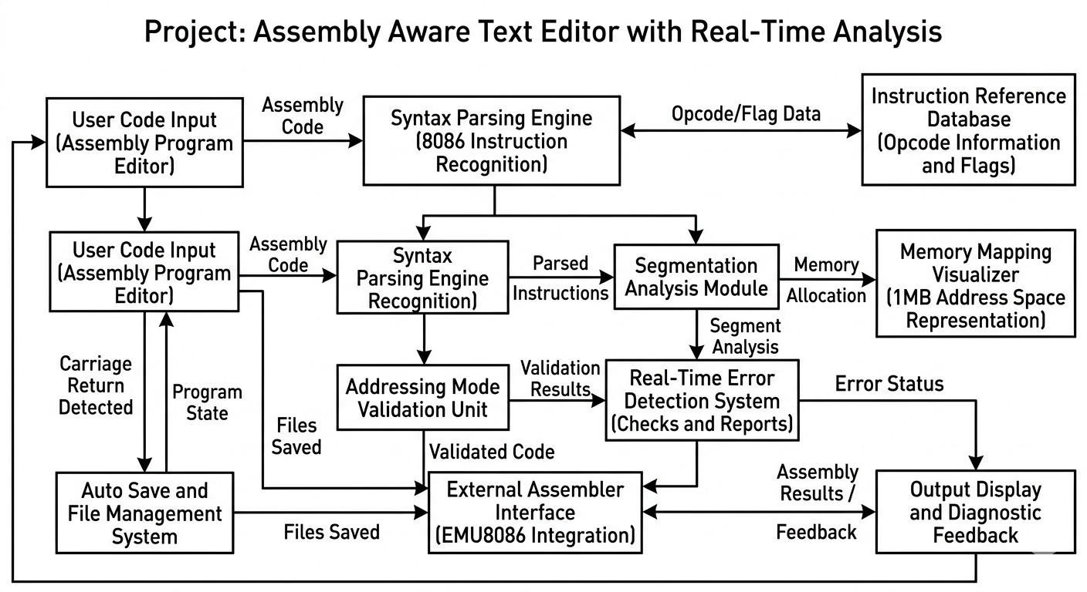
Block Diagram Description

User UI (Editor Window)
This is where the user writes and interacts with code. The process here is capturing keystrokes, edits, and commands, then immediately forwarding them to the controller. It acts as a real-time input/output surface, reflecting processed results like highlights and errors.

editor_app.py (Main Controller)
This is the brain that coordinates everything. The process involves receiving user input, routing it to appropriate modules (logic, visualization, execution), and synchronizing outputs back to the UI. It ensures all components work together without conflict.

Input Logic
This block handles correctness and structure of code. The process is continuous analysis of user input—checking syntax, validating addresses, and enforcing rules before execution or display updates.
- syntax_highlighter.py
The process scans code in real-time, identifies tokens (keywords, variables), and applies visual styles instantly. It improves readability without altering logic.
- linter.py
The process analyzes code for errors, warnings, and bad practices. It flags issues early, preventing faulty execution.
- addr_validator.py
The process validates memory addresses or references, ensuring they are valid and safe before execution. This prevents runtime faults.

Visualization Components
This block improves how information is presented. The process converts raw analysis into visual feedback for the user.
- line_numbers.py
The process dynamically tracks and updates line indices as code changes, maintaining alignment with the editor.
- error_panel.py
The process collects errors from the linter and displays them in a structured format, allowing quick debugging.

Background Tasks
This runs silently without interrupting the user. The process is periodic execution of supportive tasks.
- autosave.py
The process continuously monitors changes and saves the file at intervals, preventing data loss without user action.

emu_bridge.py (Execution Layer)
This is the bridge between editor and execution engine. The process translates validated code into a format suitable for execution and sends it to the ASM engine, then retrieves results back.

ASM Engine / Files (.ASM modules)
This is where actual execution happens. The process involves assembling and running low-level instructions, then returning output or errors back through the bridge to the UI.

8. MODULE DIAGRAM WITH DESCRIPTION

The module diagram below presents a structured view of all ten software modules that constitute the Virtual CPU Scheduler Simulator, along with their individual responsibilities and interactions.

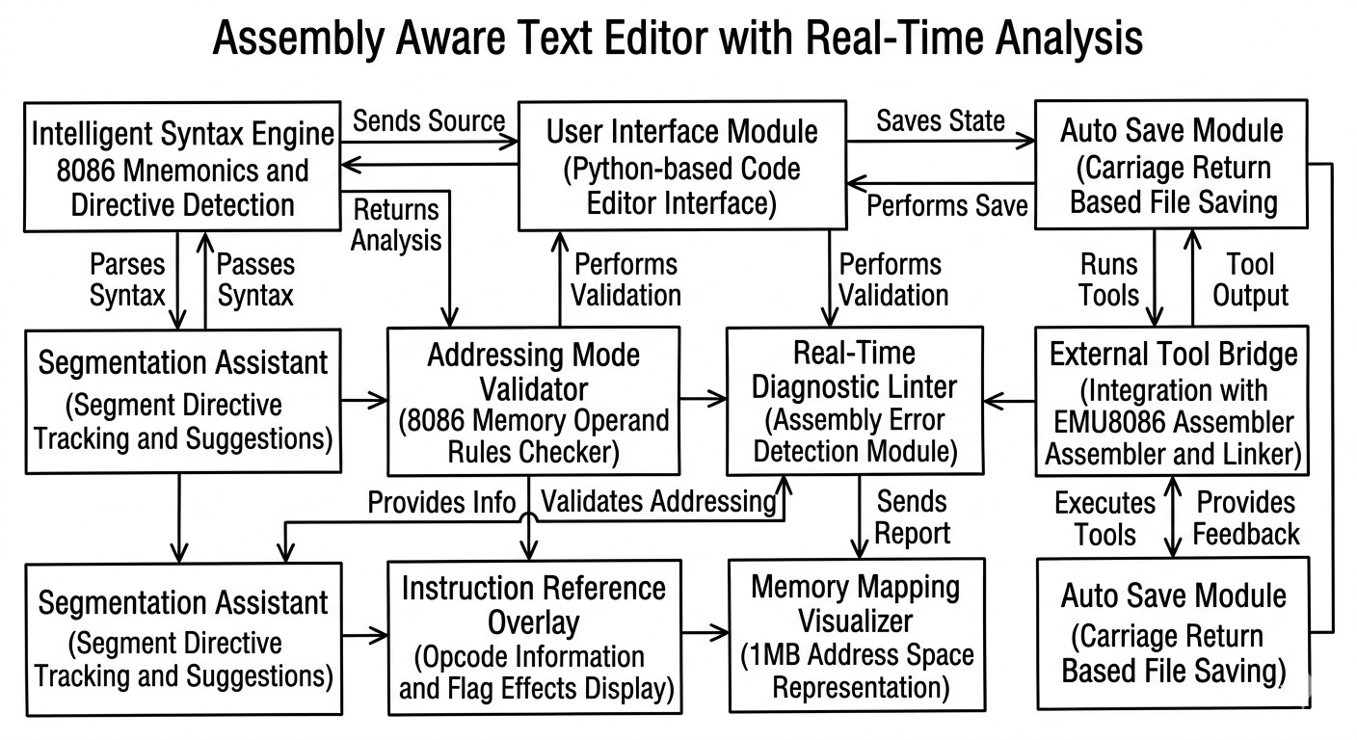
Module Descriptions
main.py (Application Entry Point)
This module initializes the entire system, loads configurations, and starts the main execution flow. It acts as the starting controller that ensures all components are properly triggered.
core_app.py (Main Version)
This is the central controller that manages workflow and data flow between all modules. It coordinates communication between Python modules and invokes ASM functions where required.
autoave.py (Online Guided Save)
This module continuously monitors user progress and automatically saves results to prevent data loss. It ensures recovery support and maintains session continuity.
interaction_ref.py (Frame Tester)
Handles user interactions and acts as a bridge between the user interface and backend logic. It sends inputs to the core system and processes feedback responses.
emu_bridge.py (EMU8086 Bridge)
This module connects the application with the EMU8086 emulator to run assembly code. It manages execution, transfers inputs, and retrieves results for further processing.
error_panel.py (Error Panel)
Responsible for detecting, displaying, and logging errors generated during execution. It also suggests possible fixes to help users debug efficiently.
live_numbers.py (Live Numbers)
Performs real-time calculations and updates dynamic data during execution. It enhances visualization by reflecting changes instantly in the system.
links.py (ASM Index)
Maintains a structured list of all assembly modules and their functionalities. It provides quick navigation and access to different ASM components.
syntax_highlighter.py (Code Highlighter)
Improves code readability by highlighting assembly syntax and structure. It also supports themes and helps users better understand code formatting.
Data Handling & Config (JSON, TXT, Directories)
Manages all configurations, file paths, and stored data required by the system. It ensures smooth loading of test cases and maintains user-specific settings.
addr_validator.py (Memory Address Check)
Validates memory addresses used in assembly programs to prevent runtime errors. It checks for alignment and range correctness before execution.
asm_keywords.py (Mnemonics, Registers, Directives)
Stores all assembly-related keywords and definitions required for parsing and validation. It supports both syntax checking and code understanding within the system.

9. SOURCE CODE
MODULE 1 - Syntax Highlighter :
.MODEL SMALL
.CODE
ORG 100h
MAIN_LOOP:
MOV DX, OFFSET MSG_PROMPT
CALL PRINT_STR
MOV AH, 0Ah
MOV DX, OFFSET INPUT_BUF
INT 21h
MOV DX, OFFSET CRLF
CALL PRINT_STR
MOV SI, OFFSET INPUT_BUF + 1
XOR CH, CH
MOV CL, [SI]
INC SI
MOV DI, OFFSET WORD_BUF
MOV [WORD_LEN], CL
JCXZ MAIN_LOOP
TOUPPER_LOOP:
MOV AL, [SI]
CMP AL, 61h
JB STORE_C
CMP AL, 7Ah
JA STORE_C
SUB AL, 20h

STORE_C:
MOV [DI], AL
INC SI
INC DI
LOOP TOUPPER_LOOP
MOV BYTE PTR [DI], 0
MOV SI, OFFSET WORD_BUF
MOV DI, OFFSET KW_EXIT
CALL STR_CMP
JZ END_PROGRAM
CALL CLASSIFY_WORD
JMP MAIN_LOOP
END_PROGRAM:
MOV DX, OFFSET MSG_BYE
CALL PRINT_STR
MOV AH, 4Ch
INT 21h
CLASSIFY_WORD PROC
MOV SI, OFFSET MNEMONIC_TABLE
CALL SEARCH_TABLE
JZ IS_MNE
MOV SI, OFFSET REGISTER_TABLE
CALL SEARCH_TABLE
JZ IS_REG
MOV SI, OFFSET DIRECTIVE_TABLE
CALL SEARCH_TABLE
JZ IS_DIR
MOV DX, OFFSET MSG_UNKNOWN
CALL PRINT_STR
MOV DX, OFFSET WORD_BUF
CALL PRINT_STR
MOV DX, OFFSET TAIL_UNK
CALL PRINT_STR
RET
IS_MNE:
MOV DX, OFFSET MSG_MNEMONIC
CALL PRINT_STR
MOV DX, OFFSET WORD_BUF
CALL PRINT_STR
MOV DX, OFFSET TAIL_MNE
CALL PRINT_STR
RET
IS_REG:
MOV DX, OFFSET MSG_REGISTER
CALL PRINT_STR
MOV DX, OFFSET WORD_BUF
CALL PRINT_STR
MOV DX, OFFSET TAIL_REG
CALL PRINT_STR
RET
IS_DIR:
MOV DX, OFFSET MSG_DIRECTIVE
CALL PRINT_STR
MOV DX, OFFSET WORD_BUF
CALL PRINT_STR
MOV DX, OFFSET TAIL_DIR
CALL PRINT_STR
RET
CLASSIFY_WORD ENDP
SEARCH_TABLE PROC
NXT:
MOV AL, [SI]
CMP AL, 0FFh
JE NOT_FND
XOR CH, CH
MOV CL, AL
CMP CL, [WORD_LEN]
JNE SKIP
INC SI
MOV DI, OFFSET WORD_BUF
PUSH CX
PUSH SI
CMP_CH:
MOV AL, [SI]
CMP AL, [DI]
JNE MISM
INC SI
INC DI
LOOP CMP_CH
POP SI
POP CX
XOR AX, AX
RET
MISM:
POP SI
POP CX
DEC SI
SKIP:
XOR CH, CH
MOV CL, [SI]
INC CX
ADD SI, CX
JMP NXT
NOT_FND:
OR AX, 1
RET
SEARCH_TABLE ENDP
STR_CMP PROC
SL:
MOV AL, [SI]
MOV BL, [DI]
CMP AL, BL
JNE SN
CMP AL, 0
JE SE
INC SI
INC DI
JMP SL
SE:
XOR AX, AX
RET
SN:
OR AX, 1
RET
STR_CMP ENDP
PRINT_STR PROC
MOV AH, 09h
INT 21h
RET
PRINT_STR ENDP
INPUT_BUF DB 20, 0, 21 DUP(0)
WORD_BUF DB 21 DUP(0)
WORD_LEN DB 0
KW_EXIT DB 'EXIT', 0
MSG_PROMPT DB 0Dh,0Ah,' Input : ','$'
CRLF DB 0Dh,0Ah,'$'
MSG_MNEMONIC DB ' Result : [MNEMONIC] --> ','$'
MSG_REGISTER DB ' Result : [REGISTER] --> ','$'
MSG_DIRECTIVE DB ' Result : [DIRECTIVE] --> ','$'
MSG_UNKNOWN DB ' Result : [UNKNOWN] --> ','$'

TAIL_MNE DB ' is a valid 8086 instruction opcode.',0Dh,0Ah,'$'
TAIL_REG DB ' is a valid 8086 register name.',0Dh,0Ah,'$'
TAIL_DIR DB ' is a valid assembler directive.',0Dh,0Ah,'$'
TAIL_UNK DB ' is NOT a recognised 8086 keyword.',0Dh,0Ah,'$'
MSG_BYE DB 0Dh,0Ah,' Process_Finished',0Dh,0Ah,'$'
MNEMONIC_TABLE:
DB 3,'MOV', 4,'PUSH',3,'POP', 3,'ADD',3,'SUB',3,'MUL',3,'DIV'
DB 4,'IDIV',4,'IMUL',3,'AND',2,'OR', 3,'XOR',3,'NOT',3,'NEG'
DB 3,'CMP',4,'TEST',3,'JMP',2,'JE', 3,'JNE',2,'JZ', 3,'JNZ'
DB 2,'JA', 3,'JAE',2,'JB', 3,'JBE',2,'JG', 3,'JGE',2,'JL',3,'JLE'
DB 2,'JS', 3,'JNS',2,'JO', 3,'JNO',4,'JCXZ',4,'CALL',3,'RET'
DB 4,'RETF',4,'LOOP',5,'LOOPE',5,'LOOPZ',6,'LOOPNE',6,'LOOPNZ'
DB 3,'NOP',3,'HLT',3,'INT',4,'INTO',4,'IRET',2,'IN',3,'OUT'
DB 3,'LEA',3,'LDS',3,'LES',4,'XCHG',4,'XLAT',3,'CBW',3,'CWD'
DB 3,'SHL',3,'SHR',3,'SAL',3,'SAR',3,'ROL',3,'ROR',3,'RCL',3,'RCR'
DB 4,'MOVS',5,'MOVSB',5,'MOVSW',4,'CMPS',5,'CMPSB',5,'CMPSW'
DB 4,'SCAS',5,'SCASB',5,'SCASW',4,'LODS',5,'LODSB',5,'LODSW'
DB 4,'STOS',5,'STOSB',5,'STOSW',3,'REP',4,'REPE',4,'REPZ'
DB 5,'REPNE',5,'REPNZ',3,'STC',3,'CLC',3,'CMC',3,'STD',3,'CLD'
DB 3,'STI',3,'CLI',5,'PUSHF',4,'POPF',3,'AAA',3,'AAD',3,'AAM'
DB 3,'AAS',3,'DAA',3,'DAS',5,'BOUND'
DB 0FFh
REGISTER_TABLE:
DB 2,'AX',2,'BX',2,'CX',2,'DX',2,'AH',2,'AL',2,'BH',2,'BL'
DB 2,'CH',2,'CL',2,'DH',2,'DL',2,'SP',2,'BP',2,'SI',2,'DI'
DB 2,'IP',2,'CS',2,'DS',2,'SS',2,'ES'
DB 0FFh
DIRECTIVE_TABLE:
DB 7,'SEGMENT',4,'ENDS',4,'PROC',4,'ENDP',2,'DB',2,'DW',2,'DD'
DB 3,'EQU',6,'ASSUME',3,'END',5,'MODEL',5,'SMALL',5,'LARGE'
DB 6,'MEDIUM',4,'CODE',4,'DATA',5,'STACK',4,'NEAR',3,'FAR'
DB 3,'ORG',6,'OFFSET',3,'PTR',4,'BYTE',4,'WORD',5,'DWORD'
DB 5,'LABEL'
DB 0FFh
END MAIN_LOOP
Module 2 : Address Validator
.MODEL SMALL
.CODE
ORG 100h
START:
LOOP_TOP:
MOV DX, OFFSET MSG_PROMPT
CALL PRINT_STR
MOV AH, 0Ah
MOV DX, OFFSET INPUT_BUF
INT 21h
MOV DX, OFFSET CRLF
CALL PRINT_STR
MOV SI, OFFSET INPUT_BUF+1
XOR CH, CH
MOV CL, [SI]
INC SI
MOV DI, OFFSET EXPR_BUF
JCXZ LOOP_TOP
UP_LOOP:
MOV AL, [SI]
CMP AL, 'a'
JB UC_OK
CMP AL, 'z'
JA UC_OK
SUB AL, 32
UC_OK:
MOV [DI], AL
INC SI
INC DI
LOOP UP_LOOP ; Repeat for all characters
MOV BYTE PTR [DI], 0 ; Null-terminate EXPR_BUF
MOV SI, OFFSET EXPR_BUF
MOV DI, OFFSET KW_EXIT
CALL STR_CMP ; Compare EXPR_BUF with "EXIT"
JZ QUIT

CALL VALIDATE_ADDR
JMP LOOP_TOP
QUIT:
MOV DX, OFFSET MSG_BYE
CALL PRINT_STR
MOV AH, 4Ch
INT 21h
VALIDATE_ADDR PROC
MOV SI, OFFSET EXPR_BUF
MOV AL, [SI]
CMP AL, '['
JNE NOT_MEM ; Must start with '[' to be a memory reference
MOV DI, SI
FIND_CLOSE:
MOV AL, [DI]
CMP AL, 0
JE NO_CLOSE ; Reached end of string without finding ']'
CMP AL, ']'
JE HAS_CLOSE ; Found closing bracket
INC DI
JMP FIND_CLOSE
NOT_MEM:
MOV DX, OFFSET MSG_INVALID ; Not a memory expression
CALL PRINT_STR
RET
NO_CLOSE:
MOV DX, OFFSET MSG_INVALID ; Missing closing ']'
CALL PRINT_STR
RET
HAS_CLOSE:
; -- Extract content between '[' and ']' into INNER_BUF --
MOV SI, OFFSET EXPR_BUF
INC SI ; Skip opening '['
MOV DI, OFFSET INNER_BUF
COPY_INNER:
MOV AL, [SI]
CMP AL, ']'
JE INNER_DONE ; Stop at closing ']'
MOV [DI], AL
INC SI
INC DI
JMP COPY_INNER
INNER_DONE:
MOV BYTE PTR [DI], 0 ; Null-terminate INNER_BUF
MOV SI, OFFSET INNER_BUF ; SI now points to inner content
MOV DI, OFFSET REG_BX
CALL CHECK_PREFIX ; Check for "BX"
JZ BASE_OK
MOV DI, OFFSET REG_BP
CALL CHECK_PREFIX ; Check for "BP"
JZ BASE_OK
MOV DI, OFFSET REG_SI
CALL CHECK_PREFIX ; Check for "SI"
JZ BASE_OK
MOV DI, OFFSET REG_DI
CALL CHECK_PREFIX ; Check for "DI"
JZ BASE_OK
MOV AL, [SI]
CMP AL, '0'
JB INVALID_BASE
CMP AL, '9'
JA INVALID_BASE
MOV DX, OFFSET MSG_DIRECT
CALL PRINT_STR
RET
INVALID_BASE:
MOV DX, OFFSET MSG_INVALID
CALL PRINT_STR
RET
BASE_OK:
MOV DX, OFFSET MSG_DIRECT
CALL PRINT_STR
RET
VALIDATE_ADDR ENDP
CHECK_PREFIX PROC
PUSH SI
PUSH DI
CP_LOOP:
MOV AL, [DI]
CMP AL, 0
JE CP_MATCH ; Reached end of DI string ? full prefix matched
MOV BL, [SI]
CMP AL, BL
JNE CP_MISS ; Mismatch found
INC SI
INC DI
JMP CP_LOOP
CP_MATCH:
POP DI
POP SI
XOR AX, AX ; AX=0 ? ZF=1 (match)
RET
CP_MISS:
POP DI
POP SI
OR AX, 1 ; AX?0 ? ZF=0 (no match)
RET
CHECK_PREFIX ENDP
STR_CMP PROC
SL: MOV AL, [SI]
MOV BL, [DI]
CMP AL, BL
JNE SN
CMP AL, 0
JE SE
INC SI
INC DI
JMP SL
SE:
XOR AX, AX
RET
SN:
OR AX, 1
RET
STR_CMP ENDP
PRINT_STR PROC
MOV AH, 09h
INT 21h
RET
PRINT_STR ENDP
INPUT_BUF DB 30, 0, 31 DUP(0)
EXPR_BUF DB 32 DUP(0)
INNER_BUF DB 32 DUP(0)
KW_EXIT DB 'EXIT', 0
REG_BX DB 'BX', 0
REG_BP DB 'BP', 0
REG_SI DB 'SI', 0
REG_DI DB 'DI', 0
CRLF DB 0Dh, 0Ah, '$'
MSG_PROMPT DB 0Dh,0Ah,' Enter : ','$'
MSG_DIRECT DB ' Result: VALID.',0Dh,0Ah,'$'
MSG_INVALID DB ' Result: INVALID',0Dh,0Ah,'$'
MSG_BYE DB 0Dh,0Ah,'Completed !!',0Dh,0Ah,'$'
END START

Module 3 : ASM_LINTER
ORG 100h
START:
MAIN:
MOV DX, OFFSET MSG_PROMPT
CALL PRINT_STR
MOV AH, 0Ah
MOV DX, OFFSET INPUT_BUF
INT 21h
MOV DX, OFFSET CRLF
CALL PRINT_STR
MOV SI, OFFSET INPUT_BUF+1
XOR CH, CH
MOV CL, [SI]
INC SI
MOV DI, OFFSET LINE_BUF
JCXZ MAIN
UC_LOOP:
MOV AL, [SI]
CMP AL, 61h
JB UC_OK2
CMP AL, 7Ah
JA UC_OK2
SUB AL, 20h
UC_OK2:
MOV [DI], AL
INC SI
INC DI
LOOP UC_LOOP
MOV BYTE PTR [DI], 0
MOV SI, OFFSET LINE_BUF
MOV DI, OFFSET KW_EXIT
CALL STR_CMP
JZ QUIT
CALL LINT_LINE
JMP MAIN
QUIT:
MOV DX, OFFSET MSG_BYE
CALL PRINT_STR
MOV AH, 4Ch
INT 21h
LINT_LINE PROC
MOV SI, OFFSET LINE_BUF
MOV DI, OFFSET PAT_MOV_CS
CALL CHECK_PREFIX
JZ ERR_MOV_CS
MOV SI, OFFSET LINE_BUF
MOV DI, OFFSET PAT_MOV_AX_AL
CALL CHECK_PREFIX
JZ ERR_SIZE_MISM
MOV SI, OFFSET LINE_BUF
CALL COUNT_BRACKETS
CMP AL, 2
JGE ERR_DOUBLE_MEM
MOV SI, OFFSET LINE_BUF
MOV DI, OFFSET PAT_PUSH_ONLY
CALL STR_CMP
JZ ERR_PUSH_NO_OP
MOV DX, OFFSET MSG_OK
CALL PRINT_STR
RET
ERR_MOV_CS:
MOV DX, OFFSET MSG_ERR_CS
CALL PRINT_STR
RET
ERR_SIZE_MISM:
MOV DX, OFFSET MSG_ERR_SZ
CALL PRINT_STR
RET
ERR_DOUBLE_MEM:
MOV DX, OFFSET MSG_ERR_MEM
CALL PRINT_STR
RET
ERR_PUSH_NO_OP:
MOV DX, OFFSET MSG_ERR_PUSH
CALL PRINT_STR
RET
LINT_LINE ENDP
COUNT_BRACKETS PROC
XOR AL, AL
CB_L:
MOV BL, [SI]
CMP BL, 0
JE CB_DONE
CMP BL, '['
JNE CB_NEXT
INC AL
CB_NEXT:
INC SI
JMP CB_L
CB_DONE:
RET
COUNT_BRACKETS ENDP
CHECK_PREFIX PROC
PUSH SI
PUSH DI
CPX:
MOV AL, [DI]
CMP AL, 0
JE CPX_OK
MOV BL, [SI]
CMP AL, BL
JNE CPX_NO
INC SI
INC DI
JMP CPX
CPX_OK:
POP DI
POP SI
XOR AX,AX
RET
CPX_NO:
POP DI
POP SI
OR AX,1
RET
CHECK_PREFIX ENDP
STR_CMP PROC
SC:
MOV AL,[SI]
MOV BL,[DI]
CMP AL,BL
JNE SCN
CMP AL,0
JE SCY
INC SI
INC DI
JMP SC
SCY:
XOR AX,AX
RET
SCN:
OR AX,1
RET
STR_CMP ENDP
PRINT_STR PROC
MOV AH,09h
INT 21h
RET
PRINT_STR ENDP
INPUT_BUF DB 40, 0, 41 DUP(0)
LINE_BUF DB 42 DUP(0)
KW_EXIT DB 'EXIT', 0
PAT_MOV_CS DB 'MOV CS', 0
PAT_MOV_AX_AL DB 'MOV AX, AL', 0
PAT_PUSH_ONLY DB 'PUSH', 0
CRLF DB 0Dh,0Ah,'$'
MSG_PROMPT DB 0Dh,0Ah,' Instruction: ','$'
MSG_OK DB ' Result: OK - no error .',0Dh,0Ah,'$'
MSG_ERR_CS DB ' ERROR : CS cannot be a destination register.',0Dh,0Ah,'$'
MSG_ERR_SZ DB ' ERROR : Size mismatch - 16-bit dst, 8-bit src.',0Dh,0Ah,'$'
MSG_ERR_MEM DB ' ERROR : MOV cannot have two memory operands.',0Dh,0Ah,'$'
MSG_ERR_PUSH DB ' ERROR : PUSH requires an operand.',0Dh,0Ah,'$'
MSG_BYE DB 0Dh,0Ah,' Finished!',0Dh,0Ah,'$'
END START

10. OUTPUT
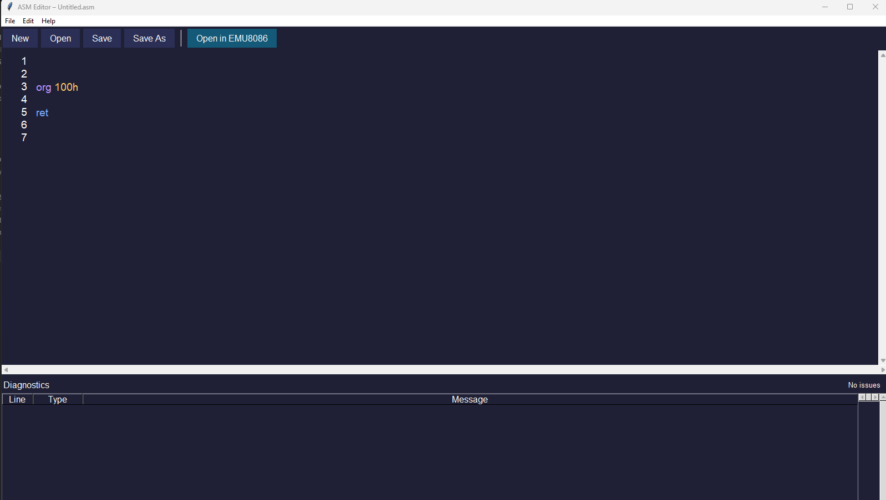

- BUGS AND RECTIFICATION
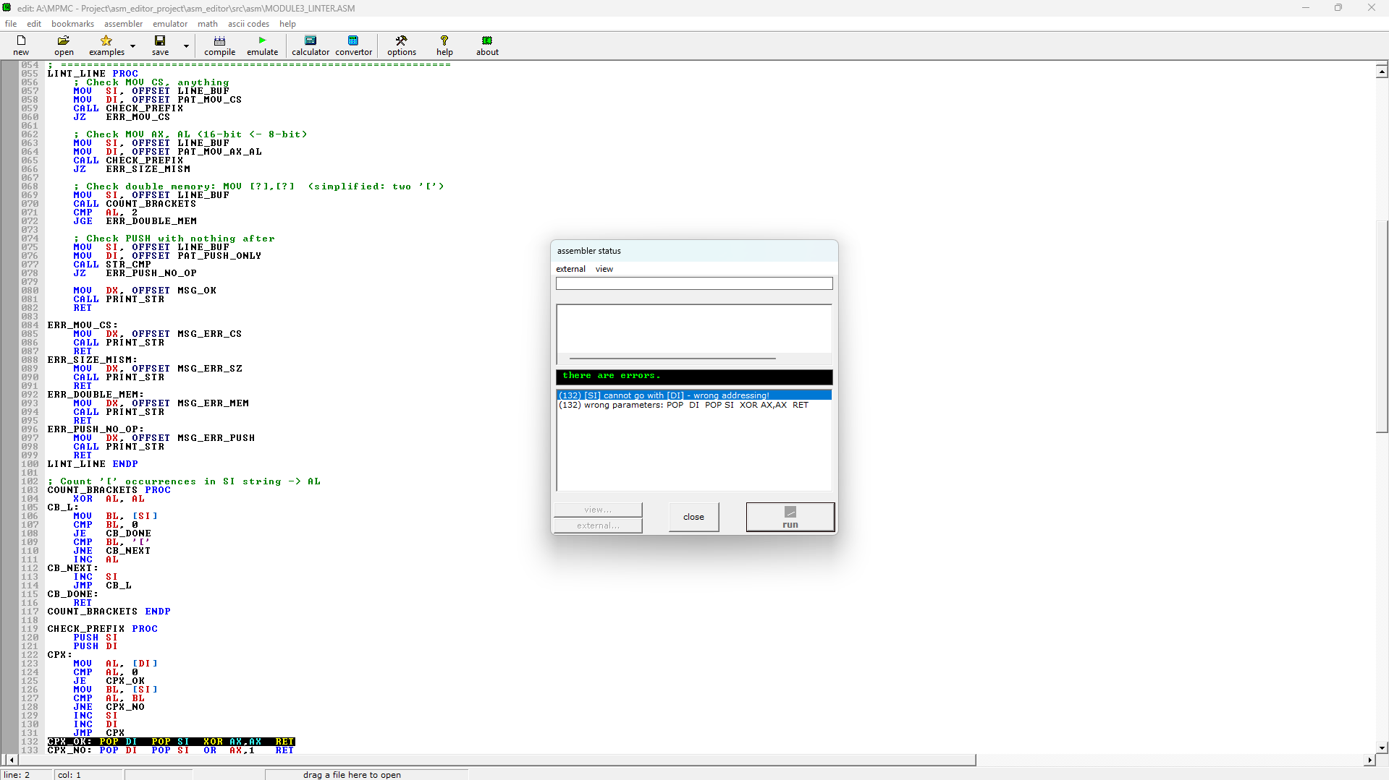
Multi Line Instruction :
Multiple instructions were entered within one line, leading to wrong parsing, thus causing an address mismatch problem for the MOV command. This happened due to the requirement that only one instruction was supposed to be on each line .
: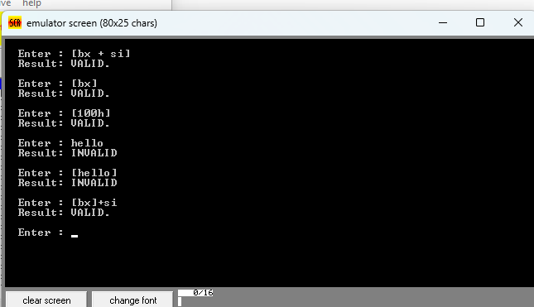
Addressing mode module :
As shown in the screenshot, the validation module for addressing mode works properly when valid data is entered and no errors are produced by the program. This was initially proven to check whether the module functions accordingly.

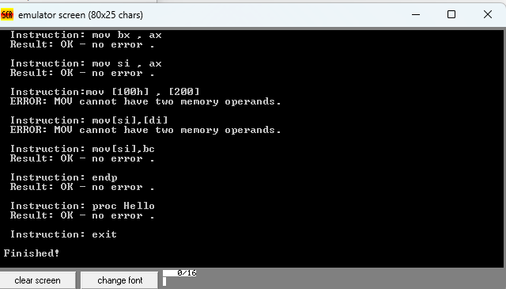
Invalid usage of the address :
The screen-shot provided is of an instance where there was an improper use of registers (SI and AX) within an addressing environment. The issue here is that the system could not identify the incorrectness in this regard. The revised screen-shot depicts a scenario where there is proper validation. 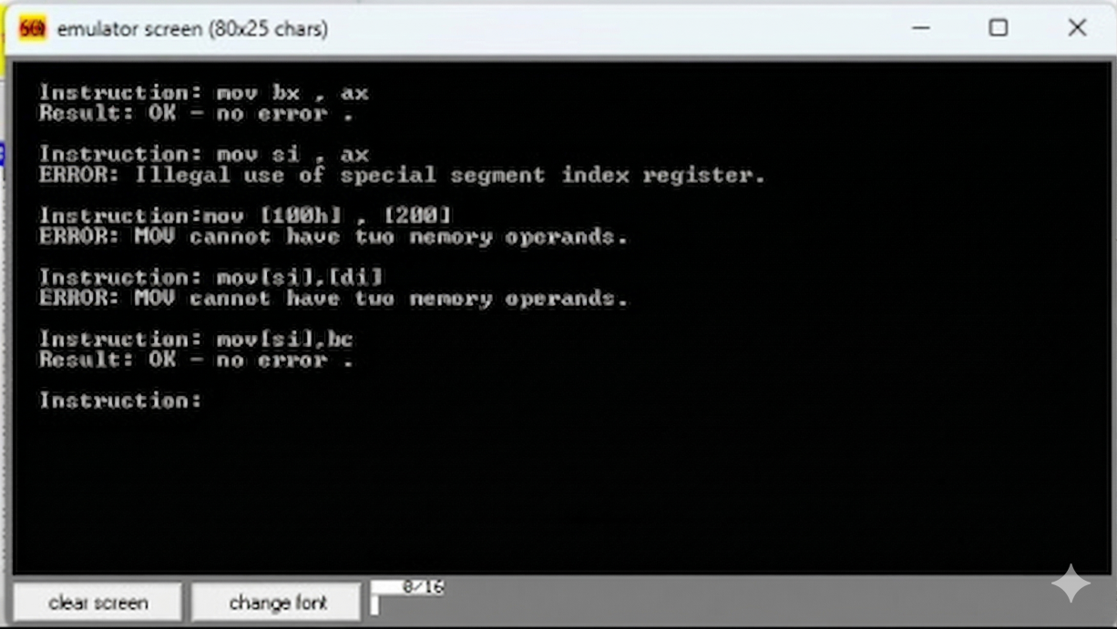
Invalid usage of the address
The snapshot represents the same erroneous data entry scenario after applying certain conditional checks. All such errors which earlier went unnoticed are now caught and reported through the program. The corrected snapshot is evidence that the condition has been applied effectively
.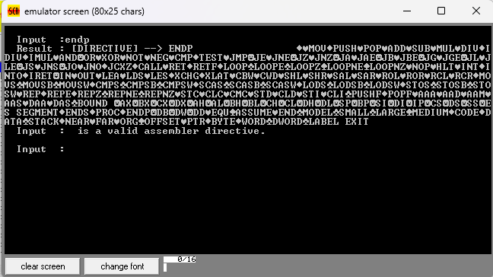
Printing the whole Table :
From the image above, it is clear that when a mnemonic or directive was typed, the program would wrongly display the entire list rather than just the corresponding item. This was because there was no proper way out of the loop. However, in the corrected screenshot below, only the matched instruction will be displayed.
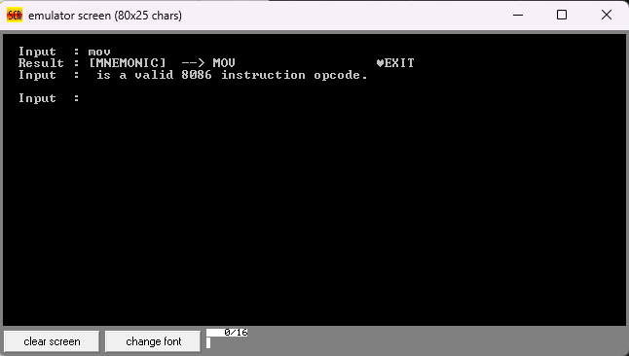
Printing the Mnemonics :
The screenshot shows the revised behavior that prints out only the discovered mnemonic rather than listing several outputs. This was done through the inclusion of a jump instruction that stops the iteration process on the table once there is a hit
.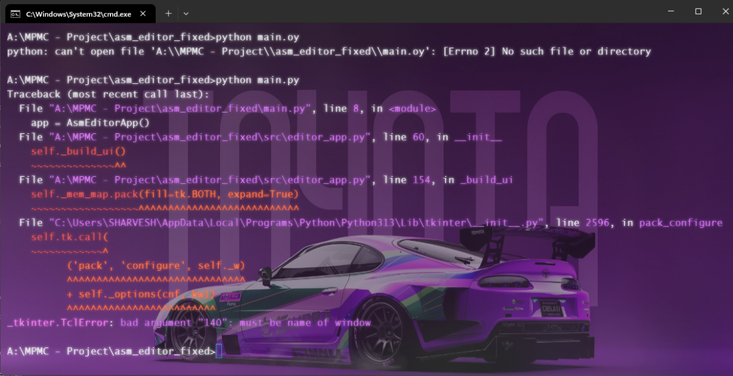
Invalid parameter in Tkinter:
The screenshot below shows the error that occurred because of the use of a Tkinter function without having established proper linking of the module with an improper keyword parameter.
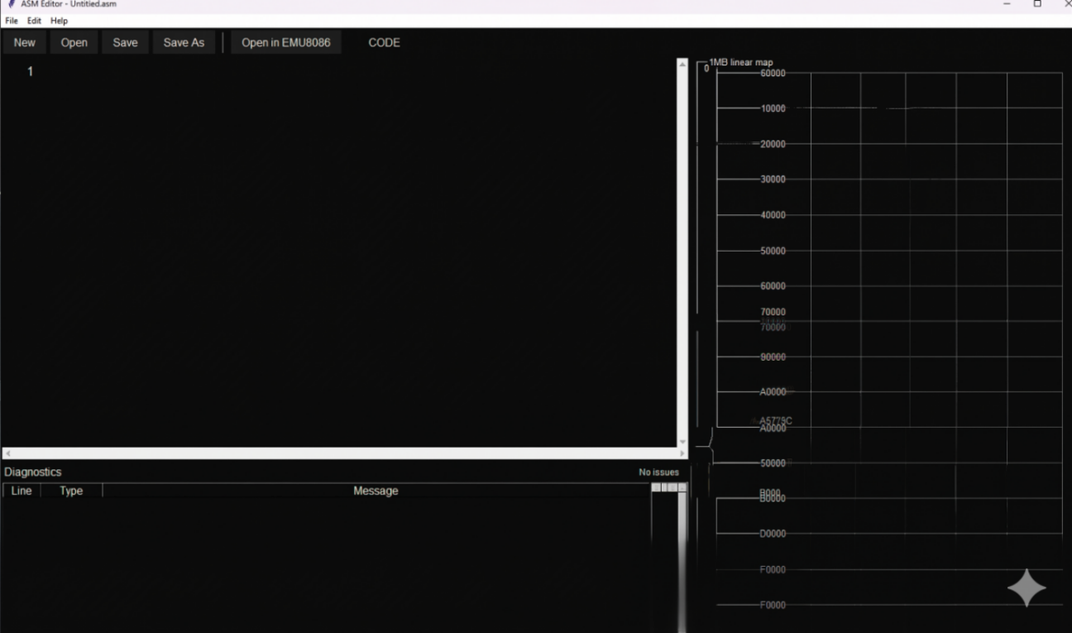
Vertical Alignment Displacement Error :
This glitch causes memory addresses on the 1 MB linear map to move and overlap, creating duplicated hex values such as 70000. There is no consistent vertical spacing because sometimes the rows will be cramped together while at other times the text will look ghosted or have corrupt characters such as A9?20C. This appears to be an internal user interface drawing problem because of the way that the gridlines are messed up.

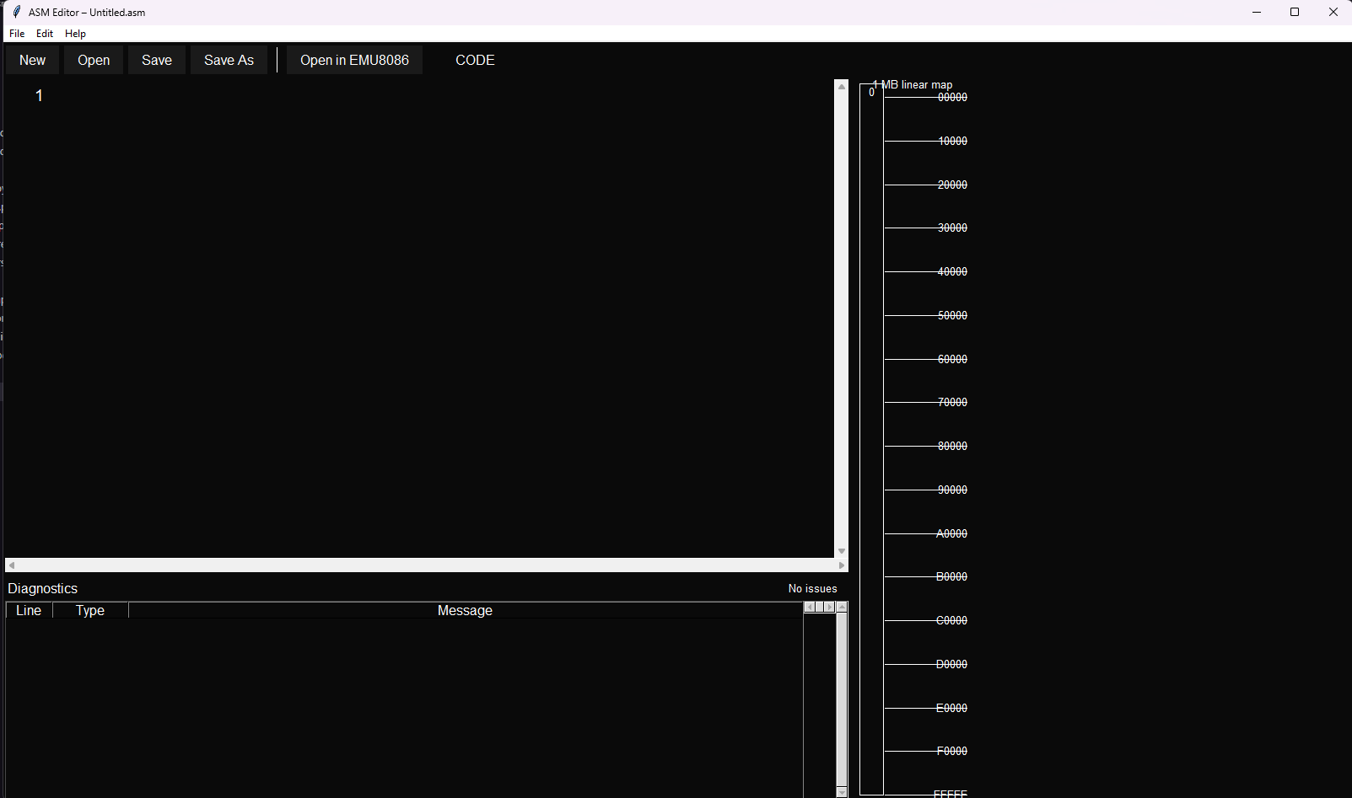
Skeleton view of the Final output :
The screenshot demonstrates the first GUI design implemented by using Tkinter that did not have any styling applied to it and had some memory problems. The memory problem was causing instability in the design and functionality of the GUI.
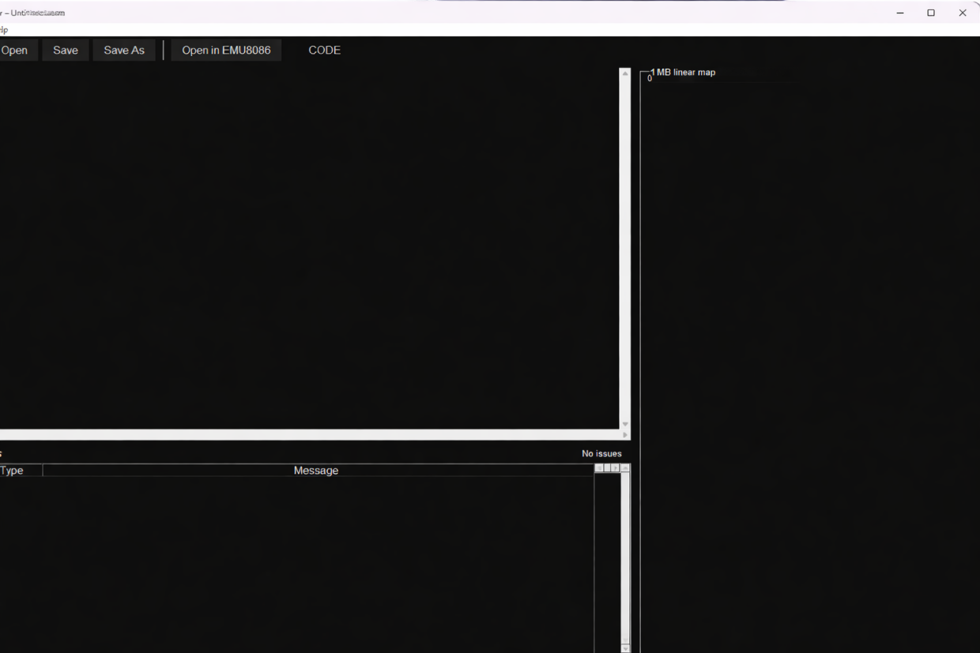
Memory Map Panel Not Rendering (UI Component Failure)
However, when trying to delete the memory map panel, the right side does not display correctly.
The space where the panel should be is blank with some leftovers of UI elements, hinting at a problem with rendering.Other than that, the program operates fine, showing that the problem lies solely with the memory map panel.
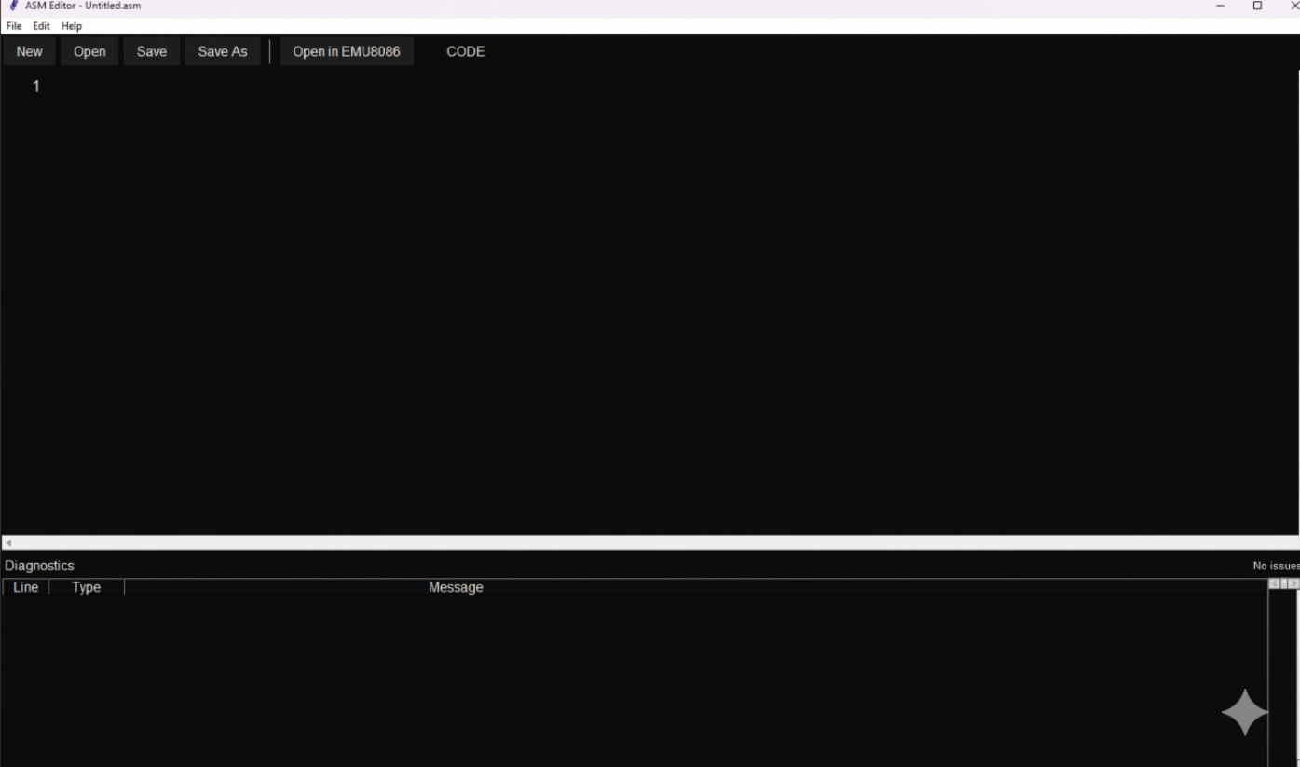
ASM Editor Interface Cleanup
The picture shows the x86 Assembly Editor with its user interface simplified, highlighting only the development space. This has been achieved by eliminating the memory map, which makes the programming interface more concentrated on coding and debugging.
12.CONCLUSION
The Assembly Aware Text Editor with Real-Time Analysis meets its objective of creating an intuitive and efficient IDE for the 8086 Assembly language code. The implementation of real-time analysis of syntax and semantics errors, dynamic syntax highlighting, auto-saved files, and context-based verification of commands and addresses makes the system very helpful in solving typical problems experienced by students and novices. The inclusion of a connection to the EMU8086 assembler greatly adds to the applicability of the system through its capability to assemble and run code in one click.
This project has helped in bridging the gap between theory and practice by introducing an easy way of learning programming on low-level languages. Although some issues like multi-line parsing and setting up Tkinter were faced, the end result is a stable system that provides valuable knowledge about Assembly programming. Possible improvements could be in the introduction of other architectures and debugger capabilities. This research will go a long way in computer science education by offering learners an easy-to-use environment for Assembly programming.

