Software Engineering Lab 3
Component Modelling & Architectural Pattern Selection – Smart Parking Space Rental & License Validator
SHARVESH K
PES1UG24AM260
Software Engineering

1. Architecture Selection and Justification
Selected architecture: Microservices Architecture. The parking system is divided into focused services for identity, reservation, license validation, billing, notifications, and reporting. This is appropriate because the system combines real-time gate operations with booking, payment, and operational monitoring, which have different performance and failure characteristics.
Scalability: reservation requests and gate-validation requests can be scaled independently during peak arrival periods. Reliability: a notification failure should not prevent a valid vehicle from exiting after payment. Security: payment data and plate-related data can be isolated behind controlled service boundaries, using TLS in transit, encryption at rest, and tokenized payment processing. Maintainability: each service has a clear responsibility and can be tested without changing the entire application.

2. Component Diagram
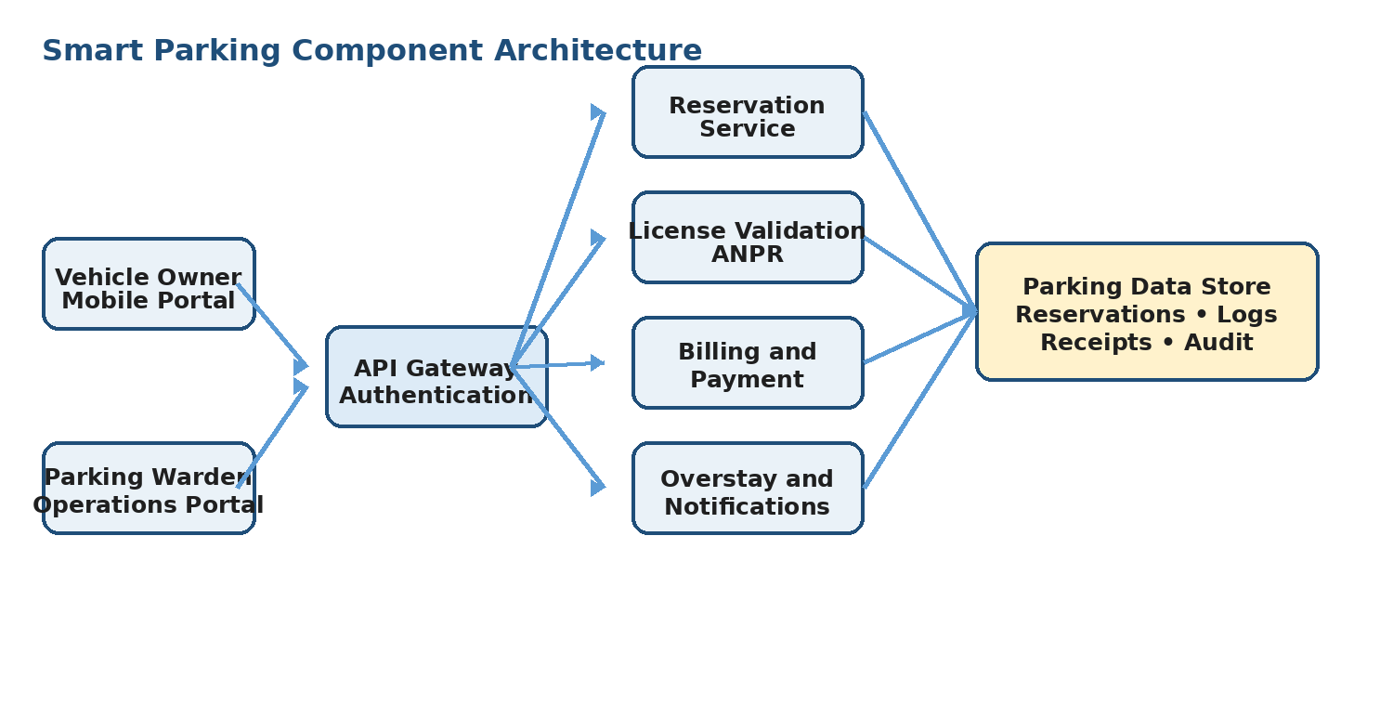
Figure 1. Component architecture for the Smart Parking Space Rental & License Validator

3. Components and Responsibilities
Component | Responsibility
API Gateway and Authentication | Authenticates vehicle owners and wardens, routes requests, and applies access control.
Reservation Service | Searches bays, creates conflict-free reservations, manages grace periods and extensions.
License Validation Service | Receives ANPR output, verifies the plate against an active reservation, and records gate events.
Billing and Payment Service | Calculates tiered parking fees, applies overstay charges, requests payment authorization, and creates receipts.
Overstay and Notification Service | Compares elapsed time with the reserved window and sends complete alerts to the warden.
Parking Data Store | Stores users, bays, reservations, entry/exit logs, billing records, receipts, and audit events.

4. Main Interfaces
Interface | Connected components | Purpose
SearchBays | Reservation Service → Parking Data Store | Returns bays available for a zone and time window.
CreateReservation | Portal → Reservation Service | Creates a reservation and holds the bay during the grace period.
ValidatePlate | Gate Camera/ANPR → License Validation Service | Checks plate confidence, active reservation, and gate eligibility.
RecordGateEvent | License Validation Service → Parking Data Store | Stores timestamped entry or exit event without retaining raw images beyond validation.
ComputeFee | License Validation Service → Billing Service | Sends entry/exit information for tiered fee computation.
PaymentAndReceipt | Portal/Gate → Billing Service | Authorizes payment and returns a digital receipt.
OverstayAlert | Overstay Service → Warden Portal | Sends bay number, plate, and overstay duration.

5. Primary System Flow
1. The owner searches for an available bay and submits a reservation request.
2. The Reservation Service checks time-window conflicts and holds the bay for the configured grace period.
3. At entry, the ANPR adapter sends the detected plate to the License Validation Service.
4. The service matches the plate to the active reservation and records the entry timestamp.
5. At exit, the service records the exit timestamp and sends elapsed duration to Billing and Payment.
6. Billing applies the progressive rate table, adds an overstay penalty if necessary, and requests payment.
7. After successful payment, the bay is released, a receipt is generated, and the gate is opened.
8. The Overstay and Notification Service alerts the warden when a reserved or paid duration is exceeded.

6. Security and Performance Considerations
Concern | Design response
License plate data | Use encrypted transport, restrict access by role, retain only the normalized plate and required audit data after validation.
Payment data | Use a payment gateway or tokenized payment method; do not store plaintext card data.
Gate response | Target license-plate reservation verification below 300 ms at P95.
Availability | Design reservation and billing services for 99.9% availability with health checks and retry-safe requests.
Concurrency | Use transactional reservation creation or distributed locking to prevent double-booking.
Failure handling | If notifications fail, preserve the overstay event for retry; do not lose the billing or gate audit record.

7. Conclusion
The component model separates user interaction, reservation logic, ANPR-based validation, billing, overstay monitoring, and persistence. Microservices are selected because these responsibilities can scale and fail independently while retaining clear interfaces. The architecture directly supports the Lab 1 acceptance criteria for fast validation, conflict-free reservations, accurate billing, overstay alerts, security, and availability.

