SHARVESH K
PES1UG24AM260

SE Lab 1: Smart Parking Space Rental & License Validator

1. Requirements Table
ID | Type | Description | Priority | Acceptance Criteria | Rationale
FR-001 | Functional | Record vehicle entry time by scanning the license plate at the gate camera (ANPR) and create a timestamped entry log linked to the active reservation, without retaining raw camera images beyond validation. | High | Plate correctly read on ≥ 95% of attempts; entry timestamp logged within 1 second; no unlinked or duplicate entry records. | Accurate entry logging is the foundation for billing, occupancy tracking and overstay detection.
FR-002 | Functional | Allow a vehicle owner to search available bays by zone and time window and reserve a bay in real time, holding it for a configurable grace period before release. | High | Reservation confirmed within 2 seconds; a held bay is never offered to a second user during the grace window; no double-booking under concurrent requests. | Real-time, conflict-free reservation is what makes the bay guarantee usable and trustworthy.
FR-003 | Functional | Compute the total billing amount at exit using a progressive (tiered) hourly rate table applied to the elapsed parking duration. | High | Correct tier applied for all boundary and mid-tier durations tested; computed fee accurate to the nearest currency unit; no rounding drift across tiers. | Billing accuracy directly affects revenue integrity and user trust in the system.
FR-004 | Functional | Detect vehicles remaining beyond their reserved or paid duration and flag the overstay to the parking warden with bay number, plate and overstay duration. | Medium | Overstay flagged within 60 seconds of threshold breach; warden receives in-app notification with complete details; no false flags for extended/renewed reservations. | Timely overstay detection enables enforcement action and frees bays faster for other users.
FR-005 | Functional | Let the vehicle owner extend an active reservation or view past reservation history and digital payment receipts from the app. | Medium | Extension succeeds only if the bay has no conflicting booking; receipt is available immediately after payment; full history retrievable for at least 12 months. | Self-service extension and receipts reduce support overhead and improve the user experience.
NFR-001 | Non-Functional (Performance & Security) | The gate camera license plate lookup API shall verify parking reservation validity in under 300 ms, and all plate images and payment data shall be encrypted in transit (TLS 1.2+) and at rest (AES-256). | Critical | Benchmark tests confirm sub-300 ms latency at P95 under simulated peak load; security audit confirms encrypted storage and transmission with no plaintext payment data. | Fast, secure validation keeps gate throughput smooth and protects sensitive user and payment data.
NFR-002 | Non-Functional (Reliability & Scalability) | The system shall maintain 99.9% uptime for reservation and billing services and support at least 500 concurrent gate transactions across a city zone without degraded response time. | High | Uptime monitoring confirms 99.9% availability over a rolling 30-day window; load tests confirm P95 API response under 1000 ms at 500 concurrent transactions. | Gate access and billing cannot tolerate downtime; continuous availability is essential at city scale.

2. UML Use-Case Diagram
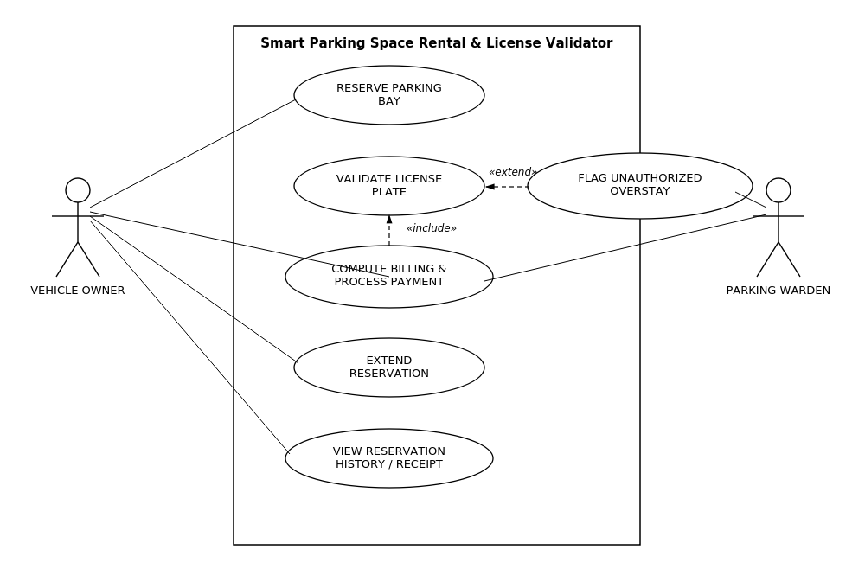
Actors: Vehicle Owner (primary), Parking Warden (secondary).
Use cases: Reserve Parking Bay, Validate License Plate, Compute Billing & Process Payment, Flag Unauthorized Overstay, Extend Reservation, View Reservation History / Receipt.
Relationships: «include» – Compute Billing & Process Payment includes Validate License Plate. «extend» – Flag Unauthorized Overstay extends Validate License Plate.

3. Main Success Scenario
Use Case Name: Compute Billing & Process Payment (Vehicle Exit)
Primary Actor: Vehicle Owner
Secondary Actor: Parking Warden (overstay and dispute logs)
Preconditions
Vehicle has an active reservation with a recorded entry timestamp; the gate camera and billing service are operational; the vehicle owner has a valid payment method on file.
Main Success Scenario
1. Vehicle approaches the exit gate and the owner triggers the exit request.
2. System captures the vehicle's license plate via the gate camera (Validate License Plate).
3. System matches the scanned plate against the active reservation record.
4. System retrieves the entry timestamp and computes the elapsed parking duration.
5. System applies the tiered hourly rate table to the elapsed duration and calculates the total fee.
6. System checks whether the elapsed duration exceeds the reserved window.
7. If the vehicle is within the reserved window, the system proceeds directly to payment.
8. System charges the fee to the owner's saved payment method and generates a digital receipt.
9. System releases the reserved bay and marks it available in real time.
10. System opens the exit gate and logs the completed transaction.
11. Owner receives an in-app confirmation with the receipt and updated reservation history.
12. System archives the transaction for audit and reporting purposes.
Postconditions
The billing transaction is recorded with amount, timestamps and payment status; the bay is marked available; the receipt is stored in reservation history; data is ready for overstay reporting (FR-004).
Alternate Flow: Overstay Detected
Trigger: Elapsed duration exceeds the reserved window at step 6.
1. System computes the additional overstay duration and applies the corresponding overstay rate/penalty tier.
2. System flags the transaction and notifies the parking warden with bay number, plate and overstay duration (Flag Unauthorized Overstay, «extend»).
3. Owner is charged the combined base fee plus overstay penalty before the gate opens.
4. Flow resumes at step 8 (charge payment) with the updated total.

