D.K.T.E. Society’s Textile and Engineering Institute, Ichalkaranji
(An Autonomous Institute, Affiliated to Shivaji University, Kolhapur)
Accredited with ‘A+’ Grade by NAAC

Department of Computer Science and Engineering
(Artificial Intelligence and Machine Learning) 2026-2027.
THE COMMUNITY ENGAGEMENT PROJECT REPORT ON
“Restrooms and Drinking Water under Lens”
Under the guidance of: Prof. Rekha Kamble
Developed By:
1. Sanchit Sachin Magdum 25UAM133
2. Sharvil Sudhakar Chavan 25UAM085
3. Jayant Uttam Magdum 25UAM135
4. Nihal Surendra Ambi 25UET106
Academic Year: 2026–2027

CERTIFICATE
This is to certify that,
1. Sanchit Sachin Magdum 25UAM133
2. Sharvil Sudhakar Chavan 25UAM085
3. Jayant Uttam Magdum 25UAM135
4. Nihal Surendra Ambi 25UET106
Have successfully completed the project work, entitled
“Restrooms and Drinking Water under Lens”
In partial fulfilment for the award of degree of Bachelor of Technology in Computer Science and
Engineering (Artificial Intelligence and Machine Learning). This is a record of their work carried
out during academic year 2026-27.
Date: ______________________________
Place: Ichalkaranji
Prof. Rekha Kamble Prof. Dr. S.K. Shirgave
[Project Guide] [Head of Department]

DECLARATION
We the undersigned students of S.Y.C.S.E.(AIML) declare that the Community Engagement Project work report entitled “Restrooms and Drinking Water under Lens” written and submitted under the guidance of Prof. Rekha Kamble is our original work. The study and observations reported here are based on our field visit and project work. The material assimilated in this report is not reproduced from any readymade report.
1. Sanchit Sachin Magdum 25UAM133
2. Sharvil Sudhakar Chavan 25UAM085
3. Jayant Uttam Magdum 25UAM135
4. Nihal Surendra Ambi 25UET106
Date: ______________________________
Place: Ichalkaranji

INDEX
CONTENTS | PAGE
1. Introduction | 5
2. Problem Statement | 6
3. Problem Description | 7
4. Facilities Requirement Related to Problems | 8
5. Field Visit | 9
6. Technical Solutions | 13
7. Conclusion | 15
8. References | 16
Appendix A – Project Overview | 17
Appendix B – Observation Checklist | 18
9. Letter | 19

1. INTRODUCTION
Clean public restrooms and safe drinking water are basic community facilities that directly affect convenience, dignity, hygiene, and public health. Public locations such as bus stands, markets, railway stations, parks, and government offices serve large numbers of people every day, but the availability and condition of these facilities can vary. The project “Restrooms and Drinking Water under Lens” focuses on understanding this practical civic problem and identifying a technology-based way to improve monitoring and maintenance.
The project team selected public restrooms and drinking-water facilities as the focus of its Community Engagement Programme. The study was connected to a field visit to Ichalkaranji Bus Stand, where the team examined the existing facilities, their cleanliness, maintenance, accessibility, and general condition, and interacted with concerned personnel. The visit was carried out with permission from the responsible transport authority.
The project repository proposes a citizen-facing application or web platform through which users can discover nearby restrooms and drinking-water points, rate facilities, report problems, and view status information. A corresponding dashboard for civic or municipal authorities can centralize complaints, highlight high-priority locations, and help track resolution. Data analysis, and machine learning where appropriate, can further identify recurring patterns and locations that need attention.
This project combines community observation with a practical digital solution. It also provides the student team with experience in field interaction, documentation, problem analysis, system thinking, teamwork, and civic responsibility.

2. PROBLEM STATEMENT
Access to clean drinking water and hygienic restroom facilities in public spaces remains inconsistent and can be poorly monitored. Citizens may encounter facilities that are unhygienic, non-functional, difficult to locate, or not adequately accessible. The project repository highlights that women, elderly people, and persons with disabilities can be especially affected when such basic facilities are unavailable or poorly maintained.
A further difficulty is the absence of a structured, localized system through which users can report facility problems and authorities can receive, prioritize, and track them. Without timely and organized information, maintenance needs may remain unresolved for longer periods and authorities may lack a clear view of problem locations.
The major problem areas identified for this study are:
• Inconsistent availability and discoverability of public restrooms and drinking-water points.
• Cleanliness, hygiene, maintenance, and functionality concerns in public facilities.
• Accessibility concerns for women, elderly citizens, and persons with disabilities.
• Limited mechanisms for citizens to report, rate, and track facility-related problems.
• Lack of centralized, real-time, localized information for civic authorities.
• Delayed prioritization of recurring or high-impact maintenance issues.
Therefore, there is a need for a community-oriented and technology-driven system that connects citizen observations with actionable maintenance information for civic authorities.

3. PROBLEM DESCRIPTION
3.1 Availability and Discoverability
Citizens need a reliable way to know where public restrooms and drinking-water points are located and whether they are currently usable. A facility that exists physically but is difficult to find or whose status is unknown may not effectively serve the public.
3.2 Hygiene and Cleanliness
Public restrooms require regular cleaning, waste management, handwashing arrangements, ventilation, lighting, and routine inspection. Visible signs of poor maintenance can reduce usability and create concerns about sanitation.
3.3 Drinking-Water Accessibility
Water points should be easy to locate and convenient to use. Users need a clear indication of where water is available and a way to report issues such as non-functioning taps, leakage, unclean surroundings, or lack of access.
3.4 Maintenance and Monitoring
Maintenance staff and civic authorities need structured information about where problems occur, what type of problem has been reported, how frequently it occurs, and whether the issue has been resolved. The repository specifically proposes a centralized dashboard for this purpose.
3.5 Accessibility and Inclusion
Facilities should consider the needs of women, elderly people, and persons with disabilities. Accessibility-related information can be included in the proposed platform so citizens can choose facilities that better match their needs.
3.6 Citizen Feedback Gap
The project identifies the need for users to report problems, rate facilities, and track status. A feedback mechanism can convert individual observations into a maintainable record for the responsible authority.
The problem is therefore not only about building physical infrastructure. It also involves visibility, feedback, maintenance coordination, prioritization, and accountability.

4. FACILITIES REQUIREMENT RELATED TO PROBLEMS
To conduct the Community Engagement Programme and support the proposed solution, the following human, field, and technical resources are required.
Human Resources
• Project Guide and student team members
• Parivahan Mahamandal / MSRTC officials or concerned personnel
• Passengers, visitors, and local users who can provide feedback on facility access and use
Field Study Materials
• Smartphones for documentation and location capture
• Notebook and structured observation checklist
• Camera / mobile camera for field documentation
• Basic stationery for recording observations
• Permission / visiting letter for access to the premises
Technical Resources for the Proposed System
• Citizen-facing mobile or web application
• Centralized database for facilities, reports, ratings, and status updates
• Map / location services for nearby amenity discovery
• Authority dashboard for complaints, priorities, and resolution tracking
• Notification service for alerts and status changes
• Data-analysis layer, with ML only where sufficient data and scope justify it
Operational Requirements
• Clear responsibility for maintenance actions
• Regular inspection and status updating
• Defined complaint categories and priority levels
• A mechanism for closing resolved complaints and retaining a maintenance history

5. FIELD VISIT
As part of the Community Engagement Programme, our team visited Ichalkaranji Bus Stand on 17-09-2026. The visit was conducted under the jurisdiction of Maharashtra State Road Transport Corporation (MSRTC) / Parivahan Mahamandal, with permission from the concerned authorities.
Purpose of the Visit
• Study the availability and general condition of public restroom facilities.
• Study the availability and usability of drinking-water facilities.
• Observe cleanliness, hygiene, maintenance, accessibility, and regular upkeep.
• Understand the practices followed for maintenance of the public facilities.
• Interact with concerned personnel and understand operational issues.
• Document observations and identify areas where improvement or digital monitoring could help.
The visit letter prepared for the project records these objectives and states that the purpose was to understand availability, cleanliness, maintenance, accessibility, and overall condition of public facilities, with particular focus on restrooms and drinking-water facilities.
Study Process
1. Reach the bus stand with the required permission.
2. Observe the restroom and drinking-water areas from a user and facility-management perspective.
3. Record the condition, accessibility, maintenance indicators, and visible support arrangements.
4. Interact with concerned personnel to understand maintenance and upkeep practices.
5. Identify gaps that can be addressed through better reporting, monitoring, and prioritization.
6. Convert the observations into functional requirements for the proposed digital system.

FIELD VISIT – OBSERVATION AREAS
The field study focused on observable and documentable parameters rather than assigning unsupported numerical scores. The following areas were considered during the visit.
Study Parameter | What the team examined | Evidence / Record
Availability | Presence and ease of locating restrooms / water points | Observation notes
Cleanliness | Visible cleanliness of floor, fixtures, surroundings, and waste disposal | Observation notes / photos
Hygiene | Handwashing provisions, sanitation-related indicators, general upkeep | Observation notes
Water facility | Presence, accessibility, visible usability and condition of drinking-water arrangements | Observation notes / photos
Maintenance | Evidence of routine cleaning, repairs, and upkeep processes | Interaction + observation
Accessibility | Ease of access for different categories of users | Observation notes
Signage | Clarity of signs and information about facility location/use | Observation notes
Feedback / reporting | Existing mechanism for reporting issues and tracking action | Interaction / notes

FIELD VISIT – INTERACTION AND KEY FINDINGS
During the visit, the team interacted with concerned personnel to understand how public facilities are maintained and how cleanliness, hygiene, and regular upkeep are handled. The visit also provided an opportunity to consider the user perspective of passengers and the practical difficulties that may arise when a facility is unavailable or requires maintenance.
Key Study Findings
• A public-facility management problem needs both physical maintenance and a reliable information flow between users and responsible authorities.
• Citizens need a simple way to identify the nearest usable facility and report a problem without a complicated process.
• Authorities benefit from structured complaint records containing location, facility type, issue category, priority, and status.
• Maintenance history and repeated complaints can help identify locations that need more frequent inspection.
• Accessibility information is important so that the system does not treat all facilities as equally suitable for every user.
• A digital system should complement, not replace, physical inspection and routine maintenance practices.
Community Engagement Learning
The field visit gave the student team practical exposure to community-oriented infrastructure. It helped the team connect a real-world public-service issue with requirements for a digital platform. The activity also developed communication, observation, documentation, teamwork, and problem-identification skills.
Limit of the Study
This report does not assign numerical hygiene scores or make city-wide claims from a single field visit. The findings are used to define the problem, identify information requirements, and propose a technology-driven monitoring and feedback system.

FIELD VISIT – PHOTOGRAPHS OF THE FIELD VISIT
Photographs captured during the Community Engagement Programme field visit at Ichalkaranji Central Bus Stand on 17-09-2026 are shown below.
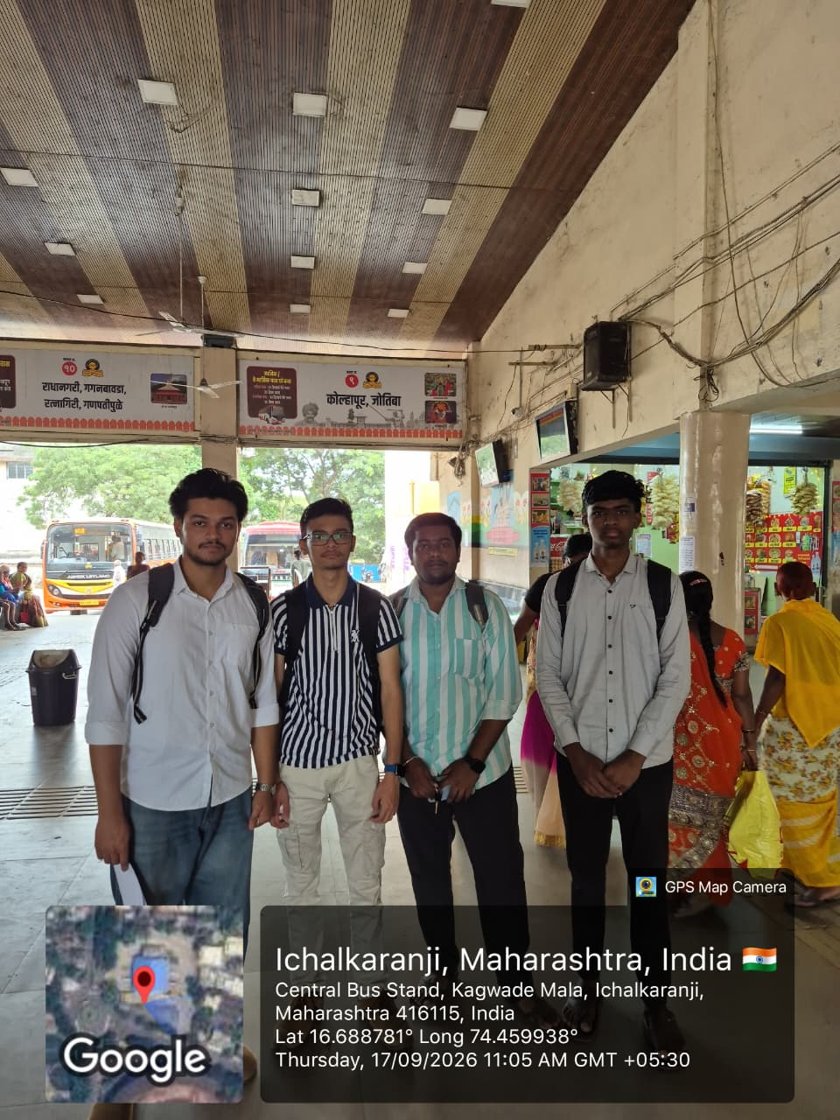  Team photograph during the field visit | 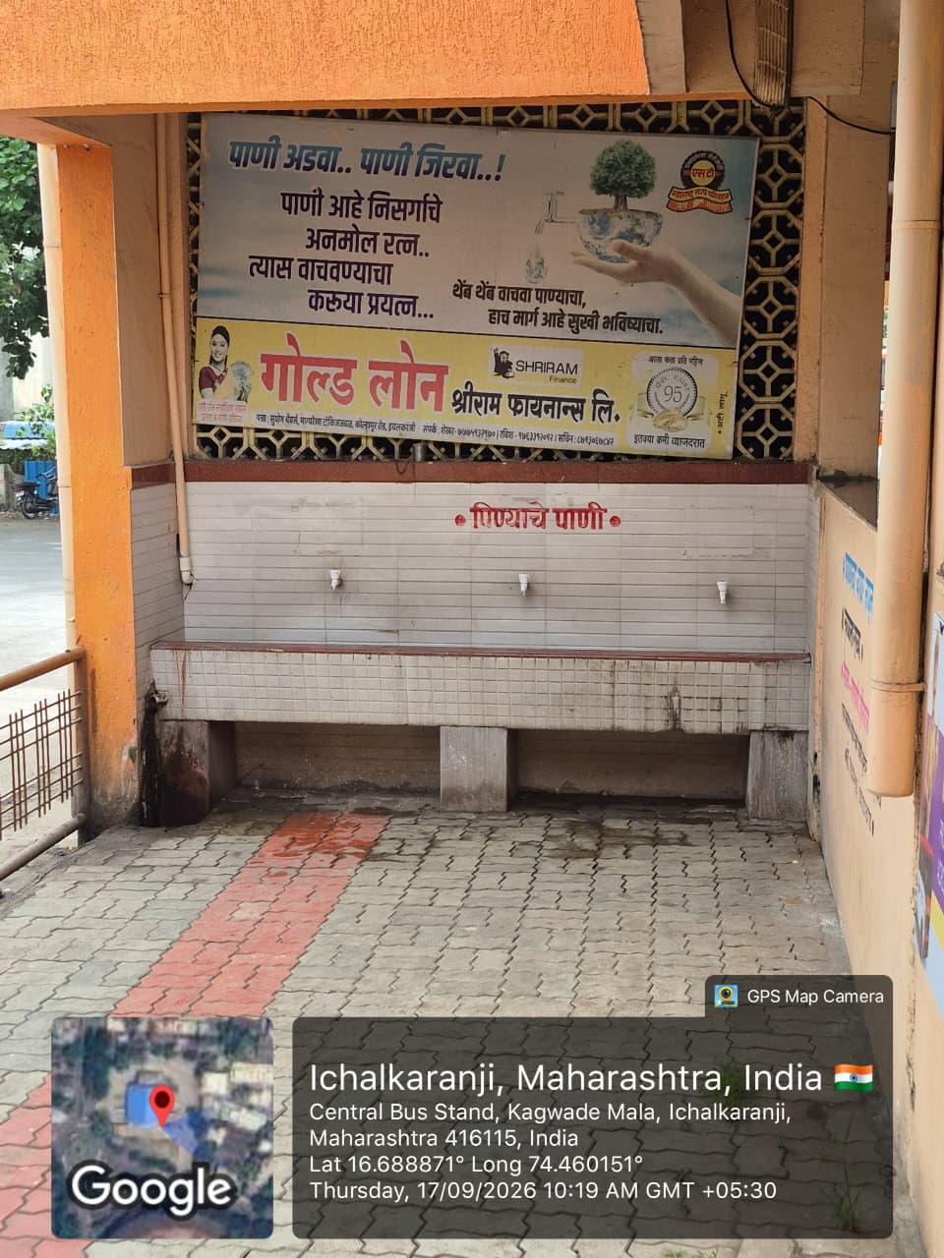  Public drinking-water facility at Ichalkaranji Central Bus Stand

6. TECHNICAL SOLUTIONS
Based on the problem statement, project objectives, and field-visit study, the following technology-driven solutions are proposed.
6.1 Citizen Mobile / Web Application
• Show nearby public restrooms and drinking-water points using location services.
• Display facility type, basic status, accessibility information, and user ratings where available.
• Allow citizens to submit issue reports with category, description, location, and optional photograph.
• Allow users to rate cleanliness / usability without exposing unnecessary personal information.
6.2 Authority Dashboard
• Show complaints on a centralized interface with filters for location, facility type, issue, date, and priority.
• Provide an issue lifecycle such as Reported → Assigned → In Progress → Resolved → Closed.
• Allow staff to record action taken and update the facility status.
• Highlight repeated or high-priority complaints so inspection can be scheduled.
6.3 Smart Notifications and Prioritization
• Generate alerts when a new high-priority issue is reported.
• Use complaint frequency, user impact, facility type, and time since last resolution as possible prioritization inputs.
• Notify users when a reported issue changes status, where such communication is appropriate.

TECHNICAL SOLUTIONS – SYSTEM FLOW AND DATA ANALYSIS
Proposed System Flow
Citizen | Mobile / Web App | Report / Rating | Central Database
Authority Dashboard | Priority / Alert | Maintenance Action | Status Update
6.4 Data and Analytics Layer
• Store facility master data: location, type, accessibility, operating status, and maintenance information.
• Store complaint data: date, location, category, description, priority, assigned authority, and resolution status.
• Generate summaries such as frequently reported locations, recurring issue types, and complaint trends over time.
• Where the project scope and dataset are sufficient, ML can be explored for complaint prioritization or recurring-issue detection.
6.5 Expected Benefits
• Faster identification of maintenance needs.
• Better visibility of facility status for citizens and authorities.
• Data-backed prioritization of inspections and repairs.
• Greater citizen participation through structured feedback.
• A record of maintenance actions that can support accountability and planning.

7. CONCLUSION
The “Restrooms and Drinking Water under Lens” Community Engagement Project provided the team with an opportunity to study an everyday public-service issue through direct field engagement. The visit to Ichalkaranji Bus Stand on 17-09-2026, conducted with the permission of the concerned Parivahan Mahamandal / MSRTC authorities, helped the team understand the practical importance of public restrooms and drinking-water facilities.
The study focused on availability, cleanliness, hygiene, maintenance, accessibility, and the way problems are identified and communicated. The project repository further defines the need for citizen reporting, facility ratings, nearby-amenity discovery, a centralized authority dashboard, status tracking, automated alerts, and data analysis.
The proposed system is intended to connect citizens and responsible authorities through a structured information flow. Instead of relying only on individual complaints or isolated inspections, it can maintain a common record of facility locations, issues, priorities, actions, and status updates. This can support more organized maintenance while also providing useful visibility to the public.
The project also strengthened the students’ skills in field observation, communication, documentation, problem analysis, teamwork, and converting community needs into technical requirements. The report deliberately avoids unsupported numerical claims and treats the proposed application, dashboard, and ML components as a solution design that can be developed and evaluated in later phases.

8. REFERENCES
1. Project GitHub Repository: “Restrooms and Drinking Water under Lens.” Team members, problem statement, objectives, and proposed solution. https://github.com/SharvilChavan-10/Restrooms-and-Drinking-Water-under-Lens
2. Community Engagement Programme Visiting Letter, Ichalkaranji Bus Stand, dated 17-09-2026; issued for study of public restrooms and drinking-water facilities under Parivahan Mahamandal / MSRTC jurisdiction.
3. D.K.T.E. Society’s Textile and Engineering Institute, Community Engagement Project report format supplied as reference template.
4. Project Guide guidance and field-study observations recorded by the student team during the visit.
Source note
The project-specific facts in this report are drawn primarily from the supplied GitHub repository and the project visiting letter. The technical solution is presented as a proposed system design, not as a claim that all features have already been implemented.

APPENDIX A – PROJECT OVERVIEW
Project Title
Restrooms and Drinking Water under Lens
Team Members
• 1. Sanchit Sachin Magdum (25UAM133)
• 2. Sharvil Sudhakar Chavan (25UAM085)
• 3. Jayant Uttam Magdum 25UAM135
• 4. Nihal Surendra Ambi 25UET106
Project Goal
To study the availability, accessibility, hygiene, and maintenance of public restrooms and drinking-water facilities and propose a platform that enables citizen reporting, facility ratings, nearby amenity discovery, and authority-side monitoring.
Core Objectives from the Repository
• Assess availability, accessibility, and hygiene condition.
• Provide citizen reporting, rating, and nearby-facility discovery.
• Create a centralized dashboard for civic authorities.
• Use data analysis and ML where in scope to identify patterns and priority areas.
• Improve response time and civic accountability.
• Raise citizen awareness and participation in sanitation infrastructure.
Repository
https://github.com/SharvilChavan-10/Restrooms-and-Drinking-Water-under-Lens
9. LETTER
VISITING LETTER

