# SHARVIL BARHANPURE

23070521136

# Subquery Tasks

1. Find the highest-spending customer in 2024.

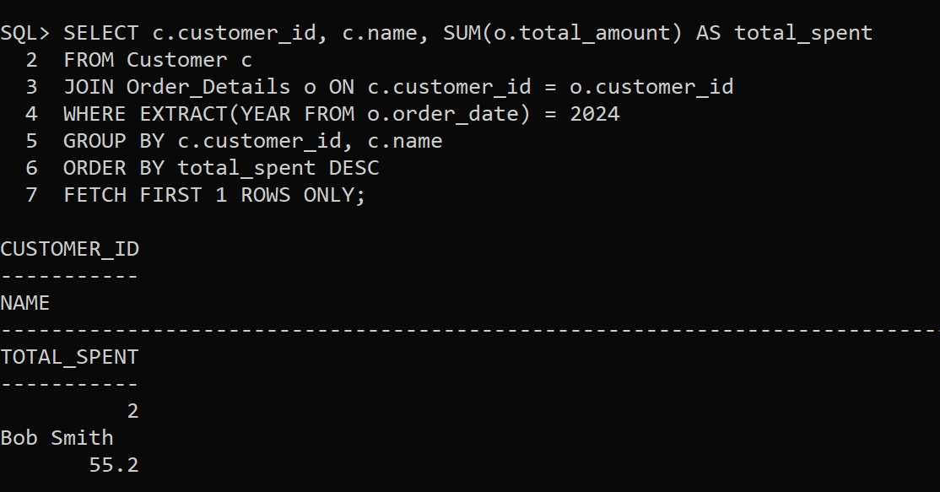

1. Retrieve the most ordered product based on quantity.

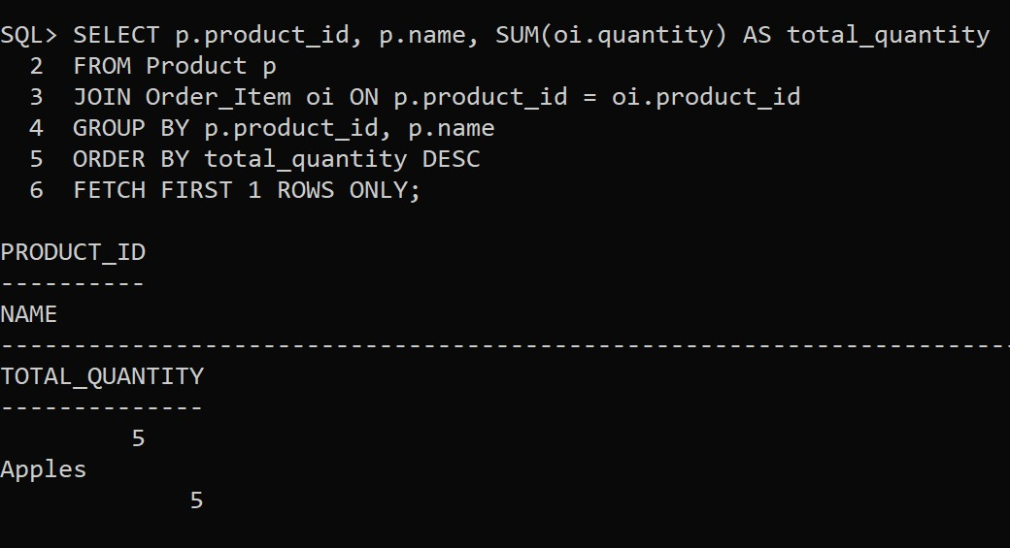

1. Find employees who earn more than the lowest-paid manager.

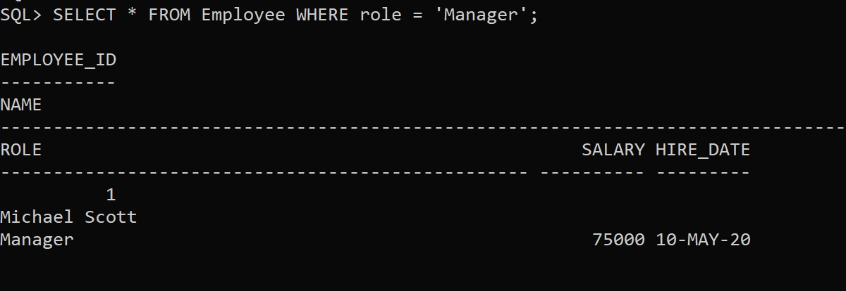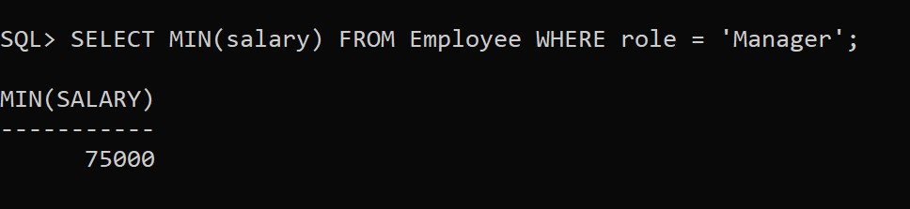

1. Retrieve customers who placed orders only in 2023 but not in 2024.

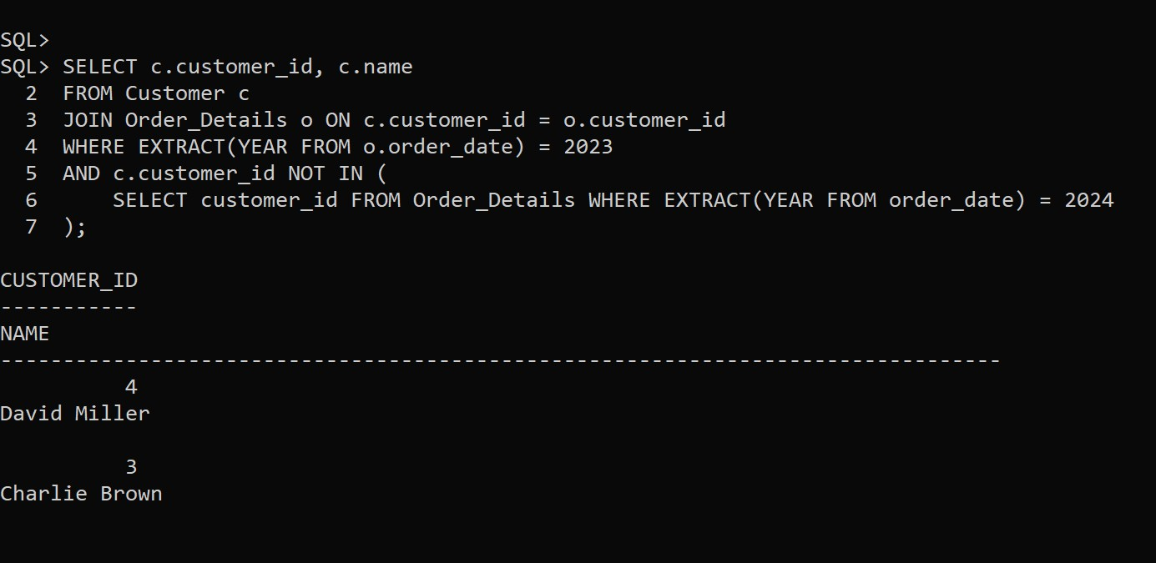

1. Find the total revenue generated in February 2024.

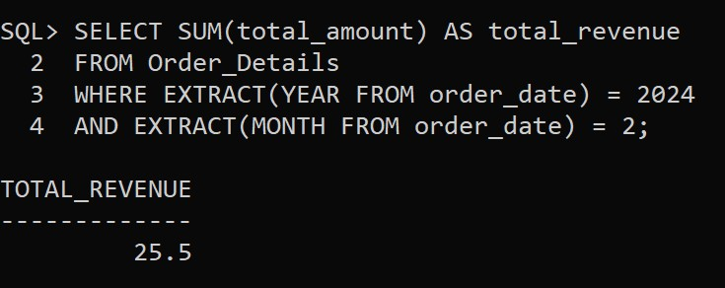

# Joins Tasks

1. Find the top 3 customers with the highest total spending.

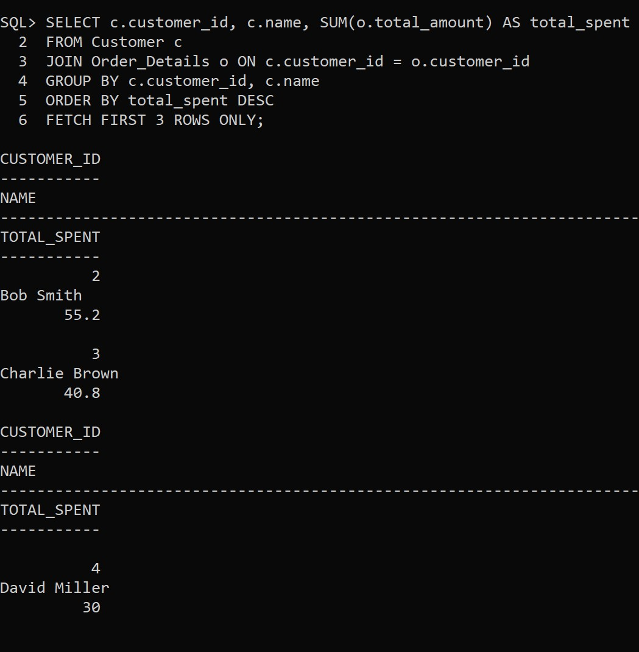

1. Retrieve employee names along with the total revenue generated from their assigned orders.

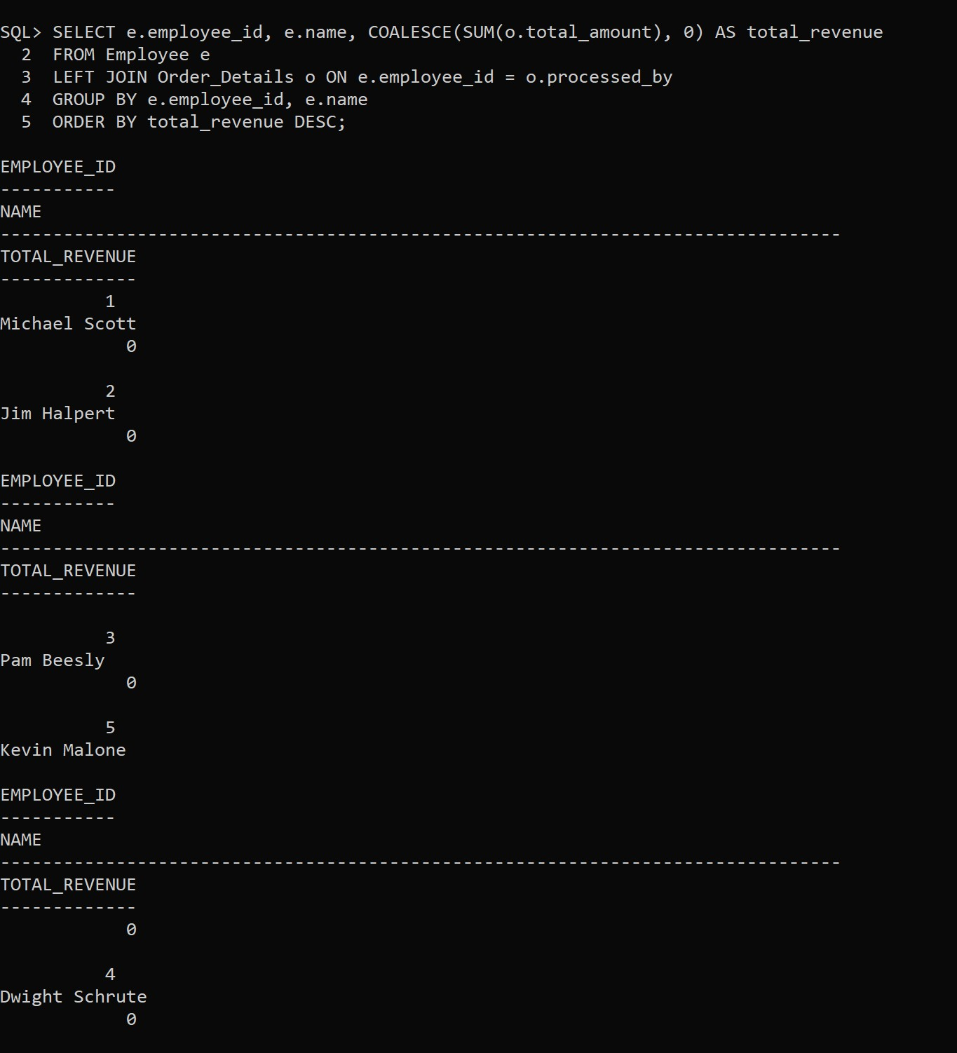

1. Show the most ordered product category and its total quantity sold. 4. Retrieve employees who earn more than their colleagues using a SELF JOIN. 5. Find employees who work under the same manager using a SELF JOIN.

