**Name: Sharvil Barhanpure**

**PRN: 23070521136**

**Sec: B(B2)**

**Practical 3:**

**Part 5:**

**Conversion Function in SQL**

In SQL **data type conversion** is important for effective **database management** and accurate query results. Data type conversion ensures that data from different sources or columns can be correctly interpreted and manipulated, especially when dealing with different formats like **numbers**, text, **dates**, and other data types.

**Types of Data Type Conversion in SQL**

There are two main types of data type conversion in SQL.

● **Implicit Data Type Conversion:** This is done automatically by the database management system (**DBMS**) when SQL operations involve columns of different data types. For instance, a **string** value might automatically be converted into a **numeric type** if required by a mathematical operation.

● **Explicit Data Type Conversion:** This is done by the user, who specifies the conversion. This is necessary when SQL cannot automatically convert between data types, or when more control over the conversion is needed.

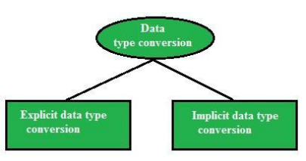

**1. Overview of Conversion Functions**

|  |  |  |  |
| --- | --- | --- | --- |
| **Function** | **Oracle**  **(SQL*Plus)** | **MySQL** | **Description** |
| TO_CHAR() | Yes | ❌ No | Converts a date/number to a string |
| TO_DATE() | Yes | ❌ No | Converts a string to a date |
| TO_NUMBER() | Yes | ❌ No | Converts a string to a number |
| CAST() | Yes | Yes | Converts from one data type to another |
| CONVERT() | ❌ No | Yes | Converts string from one character set to another |
| FORMAT() | ❌ No | Yes | Formats numbers with decimal places |
| STR_TO_DATE () | ❌ No | Yes | Converts a string to a date |
| DATE_FORMAT () | ❌ No | Yes | Formats a date as a string |
| TIME_FORMAT () | ❌ No | Yes | Formats time values |

|  |  |  |  |
| --- | --- | --- | --- |
| UNIX_TIMEST AMP() | ❌ No | Yes | Converts a date to Unix  timestamp |
| FROM_UNIXTI ME() | ❌ No | Yes | Converts Unix timestamp to a date |

**2. Conversion Functions in SQL*Plus (Oracle) /skip if you want to use mysql platform**

Oracle provides TO_CHAR(), TO_DATE(), TO_NUMBER(), and CAST() for conversion.

**2.1 TO_CHAR() – Convert Date/Number to String**

**Use Case:** Format **date & time** into a human-readable string.

SELECT TO_CHAR(SYSDATE, 'YYYY-MM-DD HH24:MI:SS') AS formatted_date FROM dual; 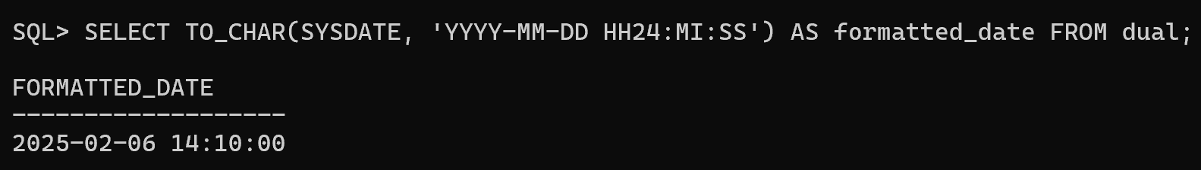

**Output Example:**

formatted_date

-------------------

2025-01-29 14:35:50

**Format Number as Currency:**

SELECT TO_CHAR(12345.67, 'L99,999.99') AS formatted_currency FROM dual;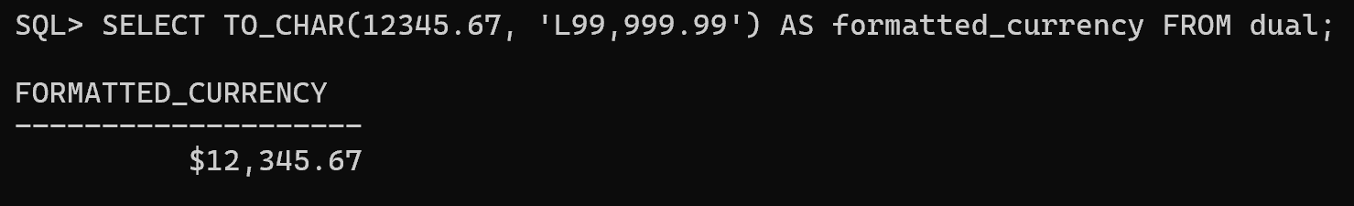

**Output Example:**

formatted_currency

------------------

$12,345.67

**2.2 TO_DATE() – Convert String to Date**

**Use Case:** Convert a **string** into a **date format**.

SELECT TO_DATE('2025-01-29', 'YYYY-MM-DD') AS converted_date FROM dual; 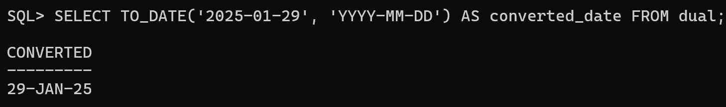

**Output Example:**

converted_date

---------------

29-JAN-25

**Using Different Date Formats:**

SELECT TO_DATE('29-01-2025', 'DD-MM-YYYY') FROM dual; 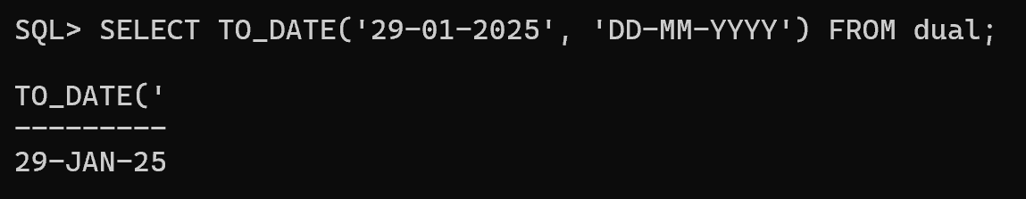Sample output

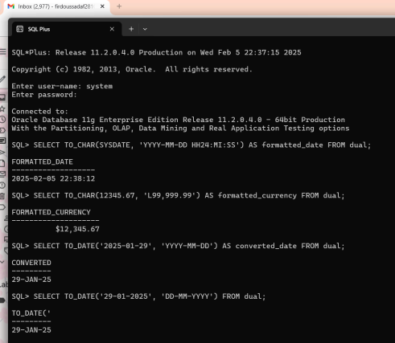**2.3 TO_NUMBER() – Convert String to Number**

**Use Case:** Convert a **string** containing numbers into a **numeric type**.

SELECT TO_NUMBER('12345.67') AS number_value FROM dual;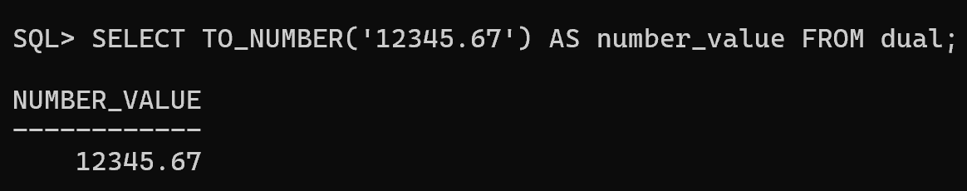 **Output Example:**

number_value

------------

12345.67

**2.4 CAST() – Convert Data Types**

**Use Case:** Convert a number to a string or vice versa.

SELECT CAST(123.45 AS VARCHAR2(10)) AS string_value FROM dual; 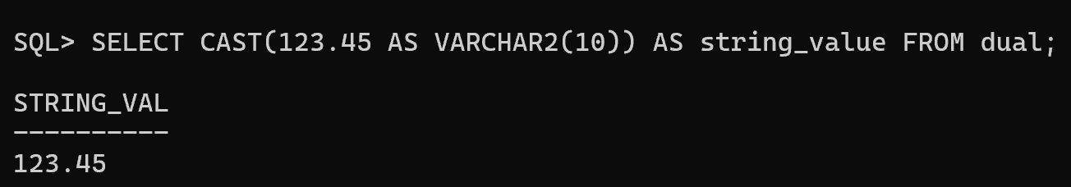

**Output Example:**

string_value

------------

123.45

**Convert String to Date:**

SELECT CAST(TO_DATE('2025-01-29', 'YYYY-MM-DD') AS DATE) FROM dual; 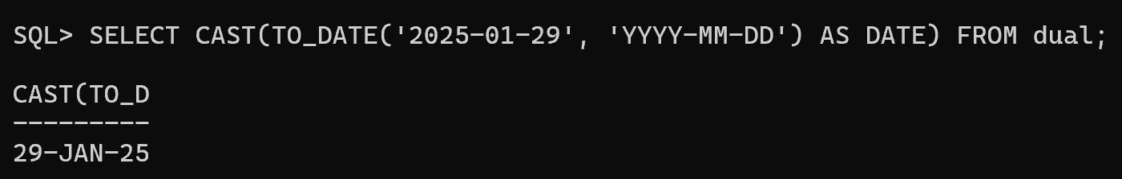

**3. Conversion Functions in MySQL //SKIP IF DONE WITH ORACLE SQLPLUS**

MySQL provides CAST(), CONVERT(), STR_TO_DATE(), DATE_FORMAT(), etc.

**3.1 CAST() – Convert Data Types**

**Use Case:** Convert an integer to a **string**.

SELECT CAST(12345 AS CHAR) AS string_value;

**Output Example:**

diff

string_value

------------

12345

**Convert a String to an Integer:**

SELECT CAST('12345' AS SIGNED) AS number_value;

**3.2 CONVERT() – Convert Between Character Sets**

**Use Case:** Change **character encoding**.

SELECT CONVERT('Héllo' USING utf8mb4) AS utf8_text; **Convert a Number to String:**

SELECT CONVERT(12345, CHAR) AS string_value;

**3.3 FORMAT() – Format Number with Commas**

**Use Case:** Display **large numbers with commas**.

SELECT FORMAT(1234567.89, 2) AS formatted_number;

**Output Example:**

diff

formatted_number

----------------

1,234,567.89

**3.4 STR_TO_DATE() – Convert String to Date**

**Use Case:** Convert **string into date format**.

SELECT STR_TO_DATE('29-01-2025', '%d-%m-%Y') AS converted_date;

**Output Example:**

diff

converted_date

---------------

2025-01-29

**3.5 DATE_FORMAT() – Format a Date as a String Use Case:** Display **formatted dates**.

SELECT DATE_FORMAT(NOW(), '%W, %M %d, %Y') AS formatted_date;

**Output Example:**

diff

formatted_date

-----------------------

Tuesday, January 29, 2025

**3.6 TIME_FORMAT() – Format Time**

**Use Case:** Convert **24-hour time** into **12-hour format**.

SELECT TIME_FORMAT('14:35:50', '%h:%i %p') AS formatted_time;

**Output Example:**

diff

formatted_time

---------------

02:35 PM

**3.7 UNIX_TIMESTAMP() – Convert Date to Unix Timestamp Use Case:** Store dates as **timestamps**.

SELECT UNIX_TIMESTAMP('2025-01-29 14:35:50') AS unix_time;

**Output Example:**

unix_time

----------

1740792950

**3.8 FROM_UNIXTIME() – Convert Unix Timestamp to Date Use Case:** Convert **timestamps** back to a **date**.

SELECT FROM_UNIXTIME(1740792950) AS converted_date;

**Output Example:**

converted_date

---------------

2025-01-29 14:35:50

**4. Real-World Use Cases of Conversion Functions Financial Data Reporting**

Convert salary figures into **formatted currency**.

SELECT emp_id, TO_CHAR(salary, 'L99,999.99') AS formatted_salary FROM employees;

**Log Analysis (MySQL)**

Convert timestamps into **human-readable format**.

SELECT FROM_UNIXTIME(UNIX_TIMESTAMP()) AS current_time;

**Data Migration**

When migrating from **CSV files**, convert **strings to dates**.

SELECT STR_TO_DATE('29-01-2025', '%d-%m-%Y') AS converted_date;

**5. Summary Table**

**Function Oracle (SQL*Plus)**

**MySQ L**

**Purpose**

TO_CHAR() Yes ❌ No Convert date/number to string

TO_DATE() Yes ❌ No Convert string to date

TO_NUMBER( )

Yes ❌ No Convert string to number

CAST() Yes Yes Convert between data types

CONVERT() ❌ No Yes Convert between character sets

FORMAT() ❌ No Yes Format number with commas

STR_TO_DAT E()

DATE_FORMA T()

TIME_FORMA T()

UNIX_TIMES TAMP()

FROM_UNIXT IME()

❌ No Yes Convert string to date ❌ No Yes Format a date as a string ❌ No Yes Format time values

❌ No Yes Convert date to Unix timestamp

❌ No Yes Convert Unix timestamp to date

**Advanced Real-World Use Cases of Conversion Functions in MySQL & SQL*Plus (Oracle)**

**1️**⃣**E-Commerce: Converting Prices for Different Currenci**

**Scenario:** An e-commerce site needs to convert prices from USD to INR and format them properly.

**Oracle (SQL*Plus):**

SELECT

product_id,

product_name,

TO_CHAR(price_usd * 83.50, 'L99,999.99') AS price_inr FROM products; 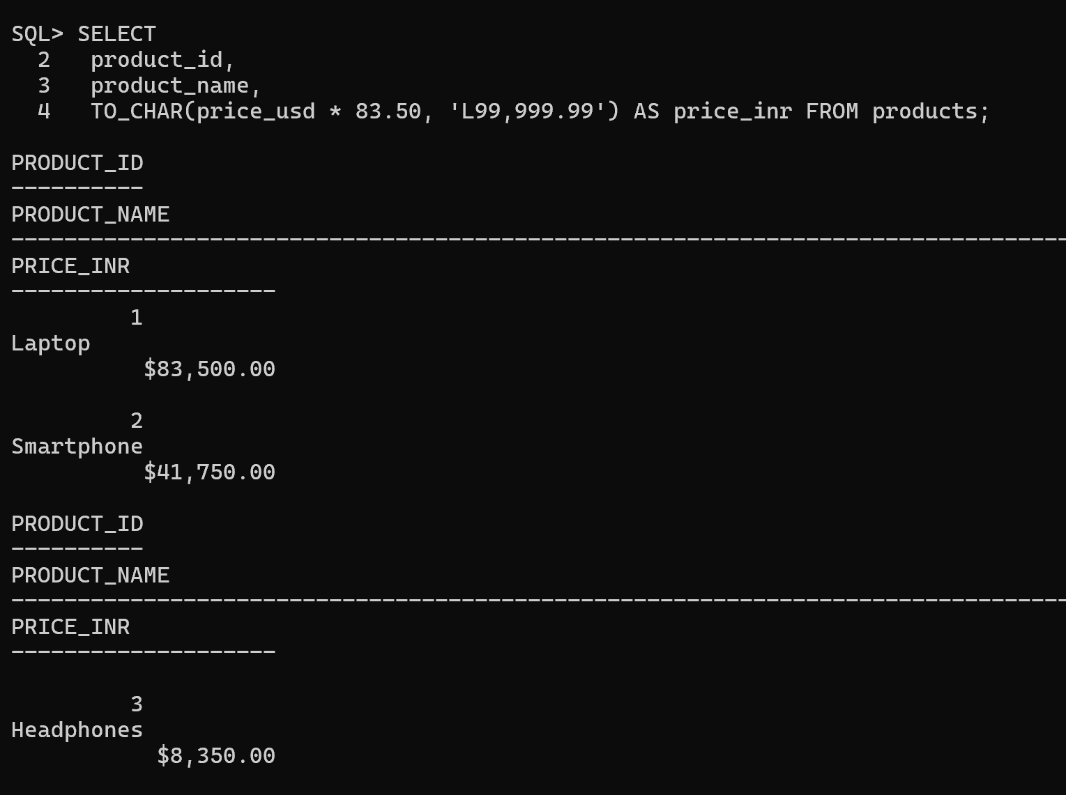

**Why?**

● Uses TO_CHAR() in Oracle and FORMAT() in MySQL to **add currency formatting**.

● 1 USD = **83.50 INR** (exchange rate example).

**Example Output:**

|  |  |  |
| --- | --- | --- |
| **product_id** | **product_name** | **price_inr** |
| 101 | iPhone 15 | ₹99,999.99 |
| 202 | MacBook Pro | ₹2,19,999.99 |

**2️**⃣**Banking: Detecting Fraudulent Transactions Using Da Conversions**

**Scenario:** A bank flags **suspicious transactions** that happened at **odd hours (midnight to 4 AM)**.

**Oracle (SQL*Plus):**

SELECT transaction_id, account_id, amount,

TO_CHAR(transaction_time, 'HH24:MI') AS transaction_hour FROM transactions

WHERE EXTRACT(HOUR FROM transaction_time) BETWEEN 0 AND 4;

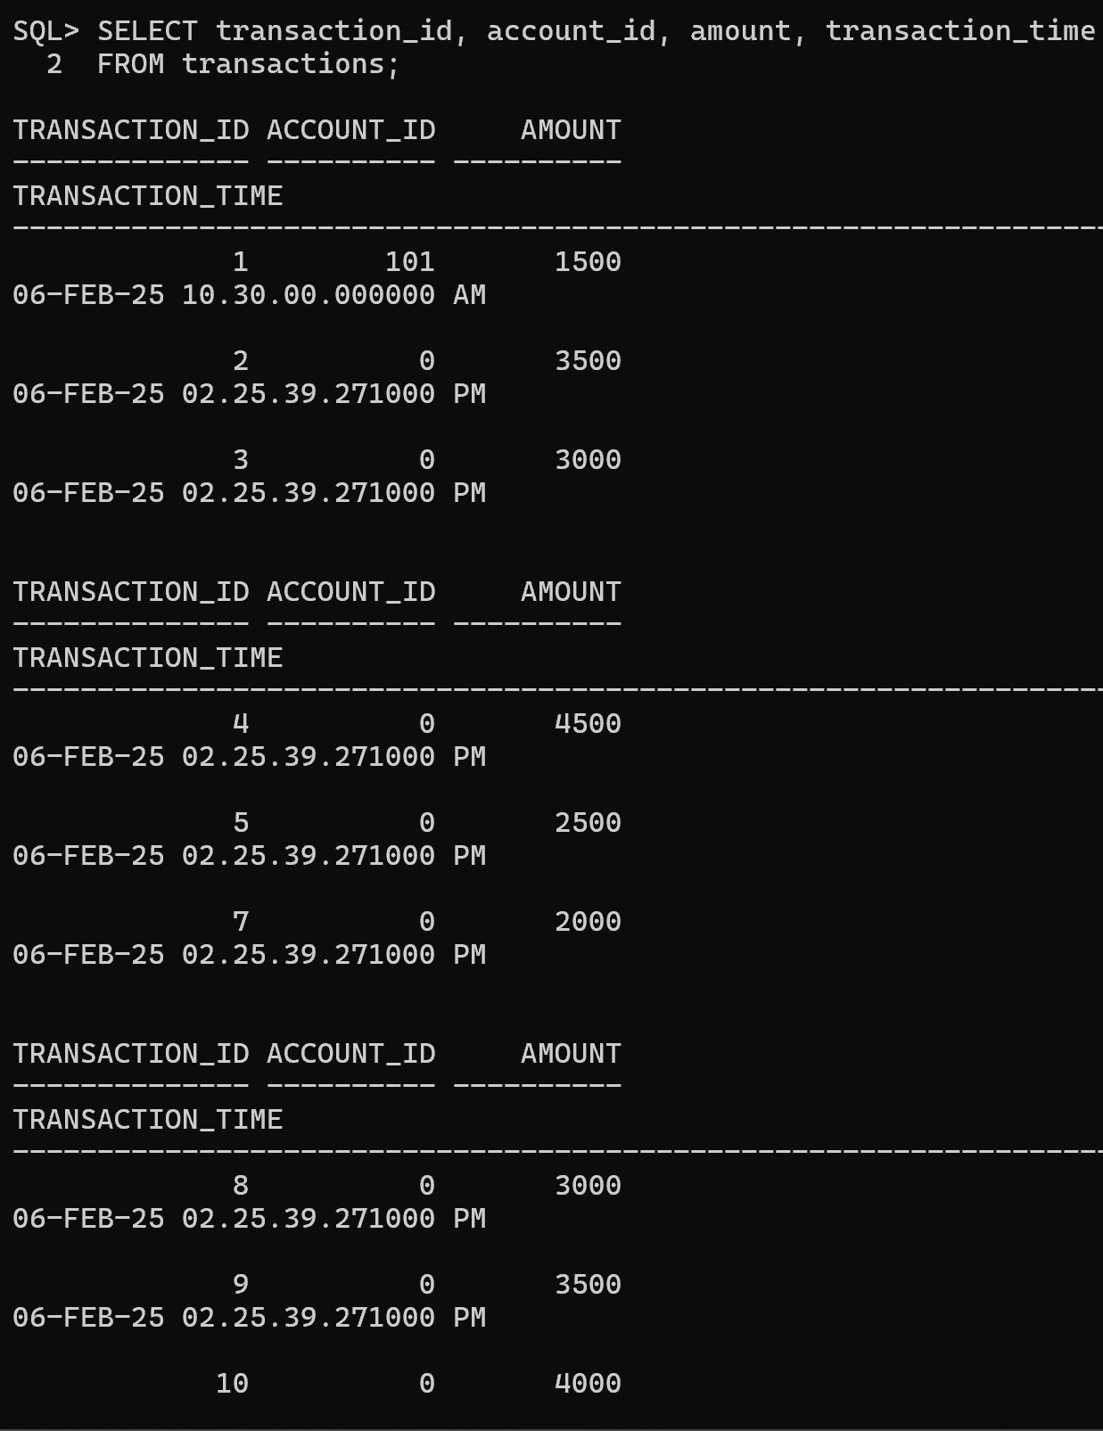

**Why?**

● Uses TO_CHAR() (Oracle) and TIME_FORMAT() (MySQL) to **extract and format time**.

● Filters transactions **between 00:00 and 04:00**.

**Example Output:**

|  |  |  |  |
| --- | --- | --- | --- |
| **transaction_id** | **account_id** | **amount** | **transaction_hour** |
| 89234 | 123456 | 5000 | 02:30 |
| 97345 | 789012 | 25000 | 03:15 |

**3️**⃣**IoT & Smart Devices: Storing and Retrieving Un Timestamps**

**Scenario:** A smart home system stores **sensor readings** as Unix timestamps and needs human-readable timestamps.

**Oracle (SQL*Plus) - Convert Unix Timestamp to Readable Date:**

SELECT sensor_id, FROM_TZ(TO_TIMESTAMP(1706505600), 'UTC') AS reading_time FROM sensor_logs;

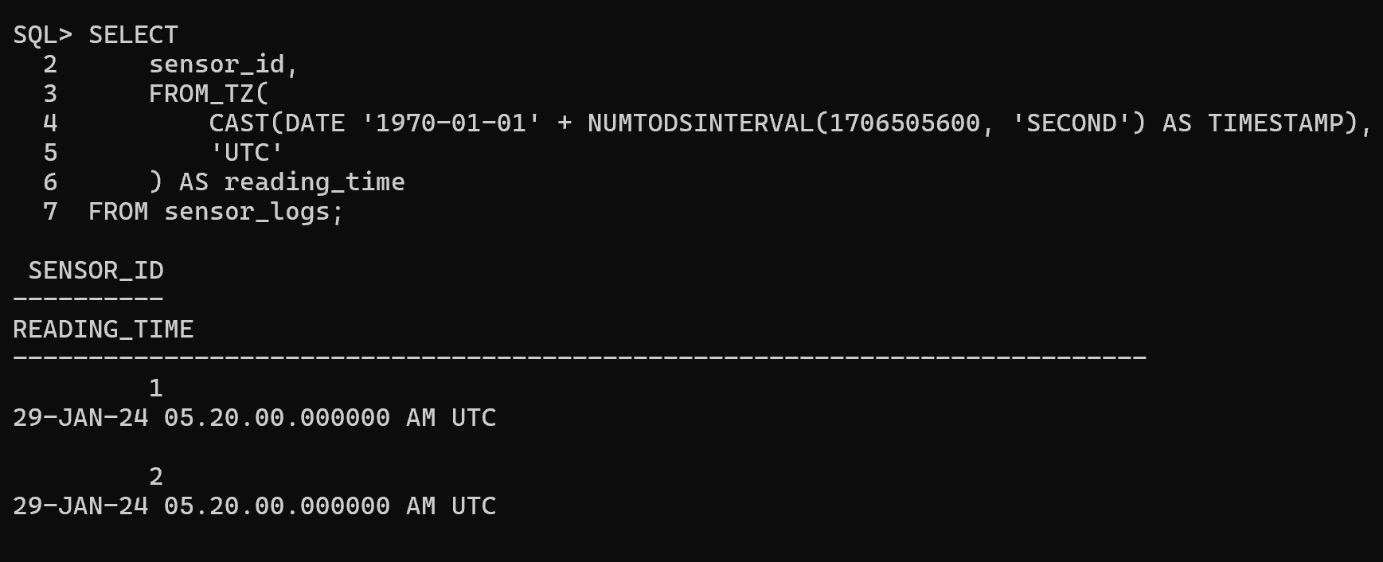

**Why?**

● Converts 1706505600 (Unix timestamp) into a **readable date-time format**. **Example Output:**

|  |  |
| --- | --- |
| **sensor_id** | **reading_time** |

|  |  |
| --- | --- |
| 101 | 2025-01-29 12:00:00 |

**4️**⃣**Marketing Analytics: Extracting Month and Year fr Dates**

**Scenario:** A company wants to analyze customer purchases by **month and year**.

**Oracle (SQL*Plus):**

SELECT

customer_id,

purchase_date,

TO_CHAR(purchase_date, 'Month') AS purchase_month, TO_CHAR(purchase_date, 'YYYY') AS purchase_year FROM purchases;

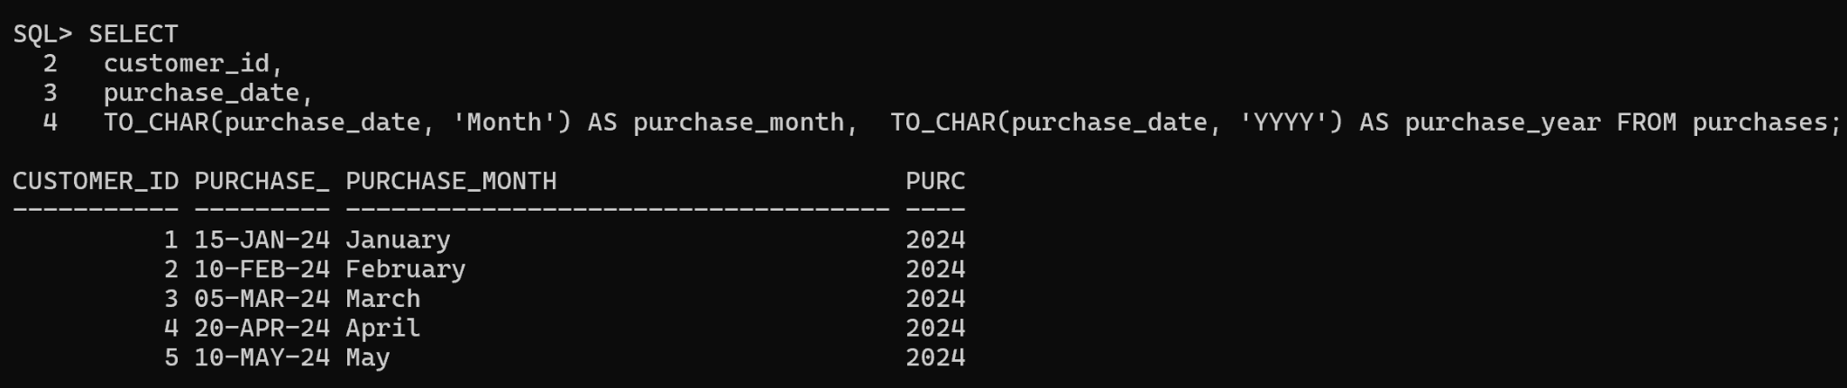

**Why?**

● Uses TO_CHAR() (Oracle) and DATE_FORMAT() (MySQL) to extract **month and year** from a **purchase date**.

**Example Output:**

**customer_id purchase_date purchase_month purchase_year** 501 2025-01-29 January 2025

**5️**⃣**Data Migration: Converting String Dates into Proper Da Format**

**Scenario:** A company migrating old **CSV data** where dates are stored as strings (DD/MM/YYYY).

**Oracle (SQL*Plus):**

SELECT TO_DATE('29/01/2025', 'DD/MM/YYYY') AS formatted_date FROM dual;

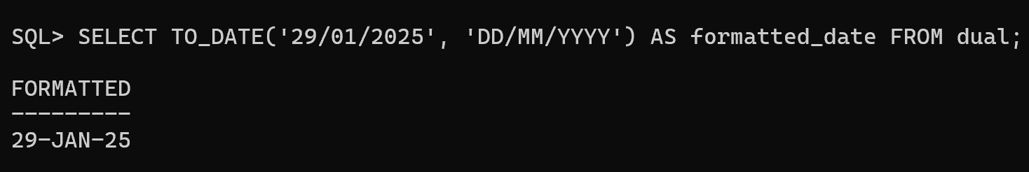

**Why?**

● Converts 29/01/2025 (string) into a **date type** in Oracle (TO_DATE()) and MySQL (STR_TO_DATE()).

**Example Output:**

|  |
| --- |
| **formatted_date** |
| 2025-01-29 |

**6️**⃣**Logistics & Delivery: Calculating Expected Delivery Ti Based on Distance**

**Scenario:** Estimate delivery **ETA** based on **distance traveled** and **average speed**.

**Oracle (SQL*Plus):**

SELECT

order_id,

distance_km,

ROUND(distance_km / 60, 2) AS estimated_hours FROM deliveries;

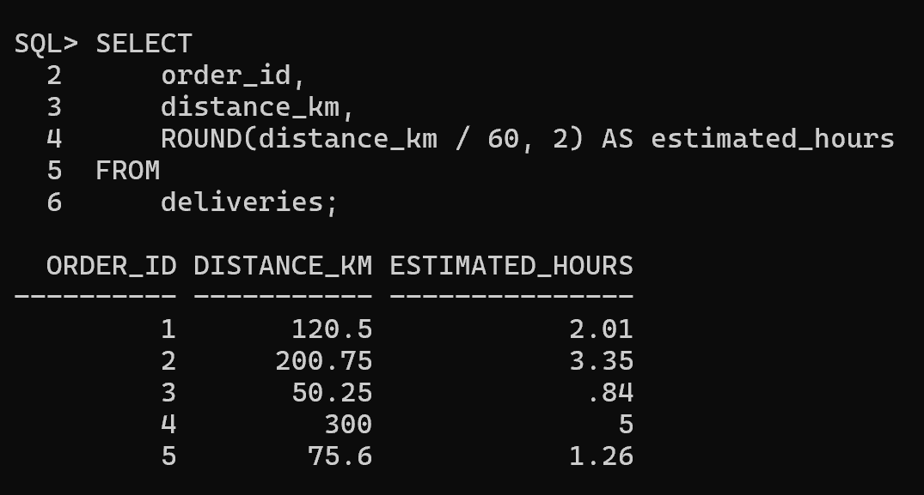

**Why?**

● Divides distance_km by 60 km/h (average speed).

**Example Output:**

|  |  |  |
| --- | --- | --- |
| **order_id** | **distance_km** | **estimated_hours** |
| 1001 | 120 | 2.00 |

**7️**⃣**Social Media Analytics: Converting Post Dates in Readable Formats**

**Scenario:** A social media platform needs to display post timestamps **beautifully**. **Oracle (SQL*Plus):**

SELECT post_id, TO_CHAR(post_date, 'Month DD, YYYY HH24:MI') AS formatted_date FROM posts;

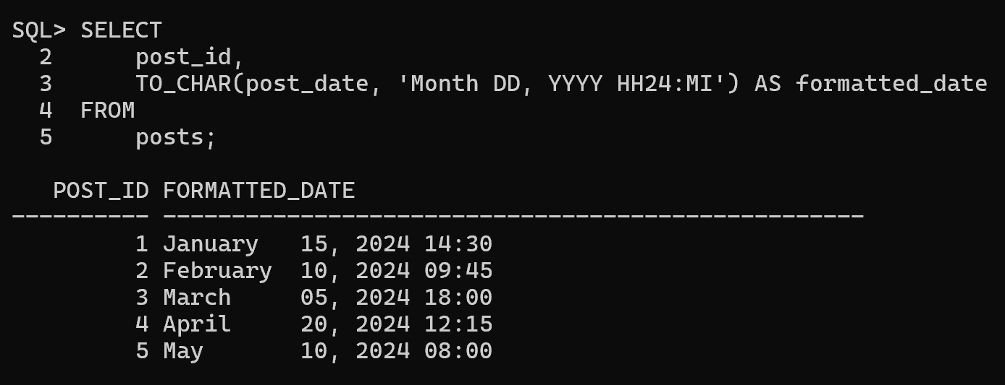

**Why?**

● Converts **date into a social-media friendly format**.

**Example Output:**

|  |  |
| --- | --- |
| **post_id** | **formatted_date** |
| 555 | January 29, 2025 14:35 |

**Summary Table**

|  |  |  |
| --- | --- | --- |
| **Scenario** | **Oracle (SQL*Plus)** | **MySQL** |
| Convert prices to INR | TO_CHAR(price,  'L99,999.99') | FORMAT(price, 2) |
| Detect fraud  based on time | EXTRACT(HOUR FROM  transaction_time) | HOUR(transaction_tim e) |
| Convert Unix timestamp | FROM_TZ(TO_TIMESTAMP( ...), 'UTC') | FROM_UNIXTIME(...) |
| Extract month & year | TO_CHAR(date, 'Month YYYY') | DATE_FORMAT(date, '%M %Y') |
| Convert string to date | TO_DATE('29/01/2025', 'DD/MM/YYYY') | STR_TO_DATE('29/01/2 025', '%d/%m/%Y') |
| Estimate  delivery ETA | ROUND(distance_km / 60, 2) | FORMAT(distance_km / 60, 2) |
| Format social media  timestamps | TO_CHAR(post_date, 'Month DD, YYYY  HH24:MI') | DATE_FORMAT(post_dat e, '%M %d, %Y  %H:%i') |