Week 1 Task Report
Python for Machine Learning & Data Preprocessing
Cleaning and Preprocessing a Sample Customer Dataset using NumPy and Pandas

Field | Details
Name | Sharvin Chaure
Internship | Yuva Intern
Task | Week 1: Python for Machine Learning & Data Preprocessing
Date | 05/10/2026
Tools | Python 3, NumPy, Pandas, Matplotlib

1. Introduction
Machine Learning (ML) models learn patterns from data, so the quality of the data directly decides the quality of the model. Real-world data is rarely ready to use: it contains missing values, duplicate records, inconsistent text, impossible values and outliers, and it often mixes numbers with text categories that algorithms cannot read directly. Data preprocessing is the step that converts such raw data into a clean, numeric and well-scaled form.
The objective of this Week 1 task was to understand the fundamentals of Machine Learning using Python, and to practise data loading, cleaning, handling missing values, feature selection, encoding categorical variables, normalization and exploratory data analysis (EDA) using Pandas and NumPy. The deliverable was to clean and preprocess a sample dataset and document each step, which is what this report does.

2. Tools and Libraries Used
- Python 3: general-purpose language used for the entire workflow.
- NumPy: numerical arrays, random data generation, NaN handling and vectorised calculations.
- Pandas: DataFrames for loading, inspecting, cleaning, transforming and saving data.
- Matplotlib: charts used to visualise missing values, outliers, correlations and distributions.

3. Dataset Description
A sample customer dataset of 200 customers (208 rows including 8 deliberately duplicated rows) was generated with NumPy using a fixed random seed so the results are reproducible. Realistic data problems were injected on purpose so that every preprocessing technique could be demonstrated. The goal of the dataset is to predict whether a customer made a purchase (Purchased = Yes/No).
Column | Type | Description
CustomerID | Integer | Unique identifier of each customer
Age | Numeric | Customer age in years
Gender | Categorical | Male / Female
City | Categorical | Pune, Mumbai, Delhi, Bengaluru, Chennai
Education | Categorical | High School / Graduate / Postgraduate
AnnualIncome | Numeric | Yearly income in rupees
SpendingScore | Numeric | Score from 1 to 100
YearsWithCompany | Numeric | Years since the customer joined
Purchased | Categorical | Target variable (Yes / No)
Country, IncomeMonthly | Mixed | Constant and redundant columns added to test feature selection

Data problems injected: missing values in five columns, 8 duplicate rows, 3 extreme income outliers, one impossible age (150), and inconsistent text such as " pune ", "MUMBAI", "male" and "FEMALE".

4. Preprocessing Steps

Step 1: Data Loading and Initial Inspection
The dataset was loaded with pd.read_csv() and inspected using shape, dtypes, head(), isnull().sum() and duplicated().sum(). This first look tells us what needs fixing before any modelling.
df = pd.read_csv("raw_customer_data.csv")
print(df.shape, df.dtypes)
print(df.isnull().sum())
print(df.duplicated().sum())

Findings: the raw data had 208 rows and 11 columns, 8 duplicate rows, and missing values in Age (14), City (9), Education (6), AnnualIncome (19) and SpendingScore (10).
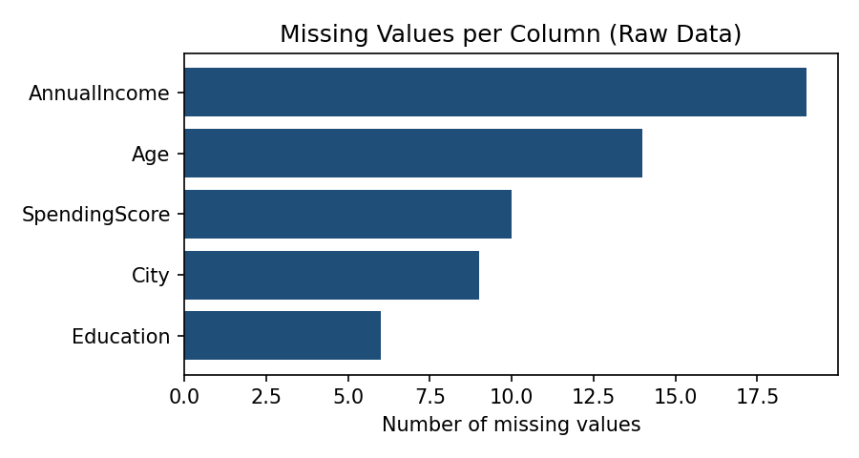
Figure 1: Missing values per column in the raw data

Step 2: Data Cleaning
Duplicate rows were removed with drop_duplicates(), reducing the data from 208 to 200 rows. Text columns were standardised with str.strip() and str.title(), so " pune ", "MUMBAI" and "delhi" became Pune, Mumbai and Delhi, and "male"/"FEMALE" became Male/Female. Without this, Pandas would treat "Pune" and "pune" as different categories.
df = df.drop_duplicates().reset_index(drop=True)
df["City"] = df["City"].str.strip().str.title()
df["Gender"] = df["Gender"].str.strip().str.title()

Step 3: Handling Outliers
Outliers were handled before imputation so that extreme values would not distort the median. The impossible age value (150) was set to NaN so it would be imputed later. For AnnualIncome the Interquartile Range (IQR) method was used: Q1 = 465,897.25, Q3 = 703,284.75, giving a valid range of 109,816 to 1,059,366. 3 outliers above the upper limit were found and capped (winsorised) to the limit instead of being deleted, so no records were lost.
Q1, Q3 = df["AnnualIncome"].quantile([0.25, 0.75])
IQR = Q3 - Q1
low, high = Q1 - 1.5 * IQR, Q3 + 1.5 * IQR
df["AnnualIncome"] = df["AnnualIncome"].clip(lower=low, upper=high)
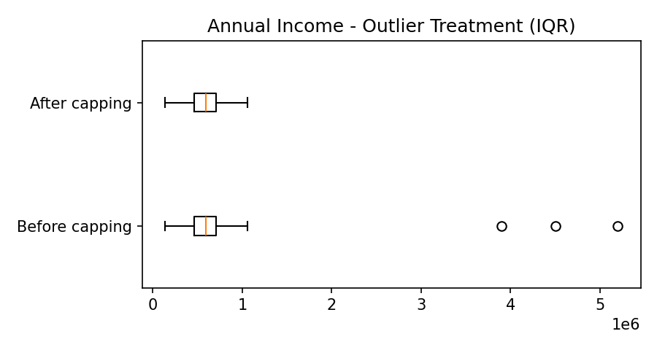
Figure 2: Annual income before and after outlier capping

Step 4: Handling Missing Values
Dropping rows with missing data would have wasted a large share of the dataset, so imputation was used instead. Numeric columns were filled with the median because it is robust to outliers, and categorical columns were filled with the mode (most frequent value).
Column | Strategy | Fill value
Age | Median | 41
AnnualIncome | Median | 593,309
SpendingScore | Median | 46.5
City | Mode | Chennai
Education | Mode | Graduate

df["Age"] = df["Age"].fillna(df["Age"].median())
df["City"] = df["City"].fillna(df["City"].mode()[0])

After imputation the total number of missing values in the dataset was 0.

Step 5: Feature Selection
Not every column helps a model. Three columns were removed:
- CustomerID (unique identifier)
- Country (constant value)
- IncomeMonthly (redundant: AnnualIncome / 12, correlation 0.87)
The correlation matrix of the remaining numeric features was then examined. SpendingScore showed the strongest relationship with the target, while the other features were only weakly related to each other, so no further columns were removed.
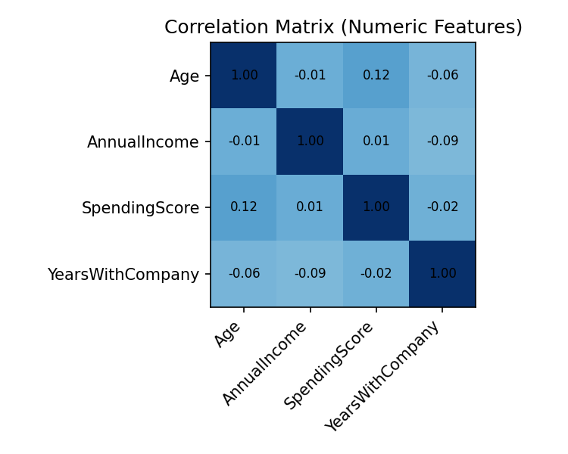
Figure 3: Correlation matrix of numeric features

Step 6: Encoding Categorical Variables
Machine learning algorithms work with numbers, so text categories had to be converted. The encoding technique was chosen according to the nature of each variable:
Column | Technique | Reason
Purchased | Label (No=0, Yes=1) | Binary target variable
Gender | Label (Male=0, Female=1) | Only two categories
Education | Ordinal (0, 1, 2) | Categories have a natural order
City | One-Hot (get_dummies) | Nominal with no order; avoids false ranking

df["Gender"] = df["Gender"].map({"Male": 0, "Female": 1})
df["Education"] = df["Education"].map({"High School": 0, "Graduate": 1, "Postgraduate": 2})
df = pd.get_dummies(df, columns=["City"], prefix="City", dtype=int)

The dataset now has 12 columns, all numeric: Age, Gender, Education, AnnualIncome, SpendingScore, YearsWithCompany, Purchased and five City dummy columns.

Step 7: Normalization and Scaling
The numeric features are on very different scales (Age is about 18 to 64, whereas AnnualIncome is in the hundreds of thousands). Distance-based and gradient-based algorithms would be dominated by the larger values. Two techniques were applied and compared: Min-Max normalization, which rescales values to the range 0 to 1, and Standardization (z-score), which gives mean 0 and standard deviation 1.
# Min-Max: x' = (x - min) / (max - min)
df[c] = (df[c] - df[c].min()) / (df[c].max() - df[c].min())
# Z-score: x' = (x - mean) / std
df[c] = (df[c] - df[c].mean()) / df[c].std(ddof=0)

Feature | Original range | Min-Max range | Z-score mean / std
Age | 18 to 64 | 0 to 1 | 0 / 1
AnnualIncome | 138,346 to 1,059,366 | 0 to 1 | 0 / 1
SpendingScore | 1 to 99 | 0 to 1 | 0 / 1
YearsWithCompany | 0 to 14 | 0 to 1 | 0 / 1

Min-Max scaled data was saved as the final dataset. In a real project the scaler should be fitted on the training set only and then applied to the test set, to avoid data leakage.

Step 8: Exploratory Data Analysis (EDA)
EDA was performed on the cleaned data to understand its patterns. About 52% of customers made a purchase, so the target classes are well balanced. The correlation of each feature with Purchased was: SpendingScore 0.715, AnnualIncome 0.139, Age 0.027 and YearsWithCompany 0.003. SpendingScore is therefore the most useful predictor. Customers who purchased had a higher average income (about 620,010) than those who did not (about 569,048).
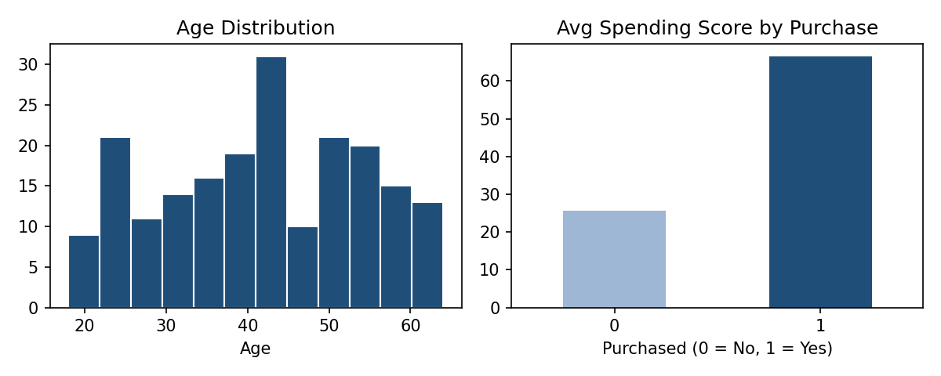
Figure 4: Age distribution and average spending score by purchase status

5. Results: Before vs After
Aspect | Raw dataset | Preprocessed dataset
Rows | 208 | 200
Columns | 11 | 12
Duplicate rows | 8 | 0
Missing values | 58 | 0
Outliers in AnnualIncome | 3 | 0
Text columns | 5 (inconsistent) | 0 (all numeric)
Feature scale | Mixed (18 to 5,200,000) | 0 to 1

The final cleaned file (cleaned_customer_data.csv) contains 200 rows and 12 numeric columns and is ready to be passed to a machine learning algorithm.

6. Key Learnings and Challenges
- The order of steps matters: handling outliers before imputation prevents extreme values from distorting the median.
- Capping outliers keeps all records, whereas deleting them would reduce the dataset size.
- Choosing the right encoding (ordinal vs one-hot) avoids giving algorithms a false sense of order between categories.
- Scaling is essential for algorithms such as KNN, SVM, logistic regression and neural networks, which are sensitive to feature magnitude.
- Inconsistent text formatting is a hidden problem: it is invisible in summary statistics but creates false categories.

7. Conclusion
In this task a raw, messy customer dataset was successfully converted into a clean, fully numeric and scaled dataset using Python, NumPy and Pandas. Each stage, including loading, cleaning, outlier treatment, missing-value imputation, feature selection, encoding, scaling and EDA, was implemented, explained and justified. This exercise showed that preprocessing is the foundation of every machine learning project, and it prepares the ground for building and evaluating models in the coming weeks.

Appendix: Files Submitted
- data_preprocessing.py: complete Python script containing all steps.
- raw_customer_data.csv: original dataset with data-quality problems.
- cleaned_customer_data.csv: final preprocessed dataset.

