- Explain regression- Create a Word document explaining regression. I am a student in a career readiness program in the software industry. Make the explanation easy to understand and have at least two examples of regression.
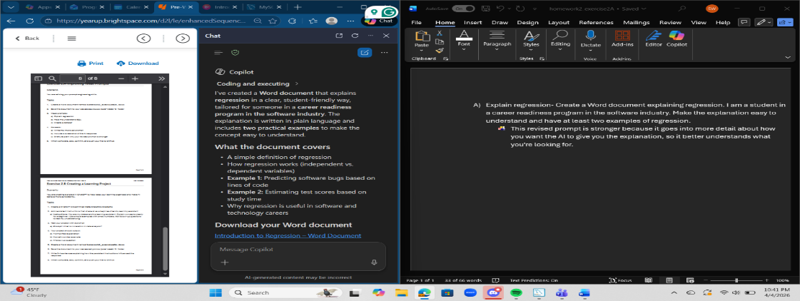
  - This revised prompt is stronger because it goes into more detail about how you want the AI to give you the explanation, so it better understands what you're looking for.
- Help me understand SQL- Create a student's guide on SQL. I am a student at a career readiness program in the software industry. Put the file into a PDF. Make the guide easy for students to understand and follow. Make sure there are visual examples as well as step-by-step instructions.
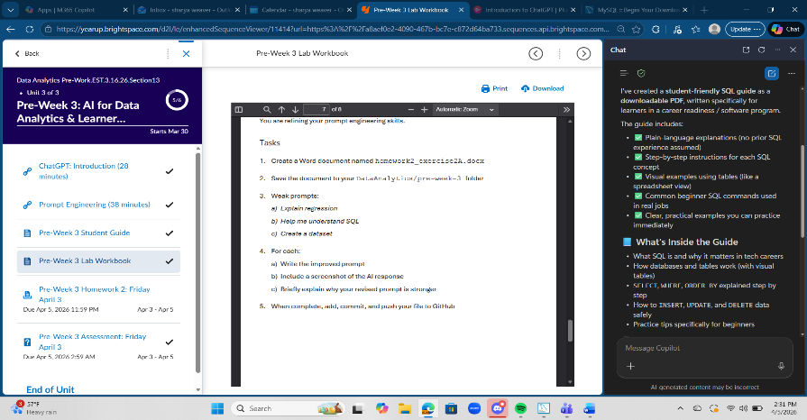
- This prompt is better because it tells how you want it to explain it and at what level. Having the AI knows who it’s addressing helps it to structure the words and learn with the info of addressing beginner students.
- Create a dataset- Create a dataset in table format on the top ten movies in New York in the year 2025-2026. There should be four columns. One with the Movie name, another with the ratings, one with the year, and the last one with the genre. Sort it by highest to lowest rating.
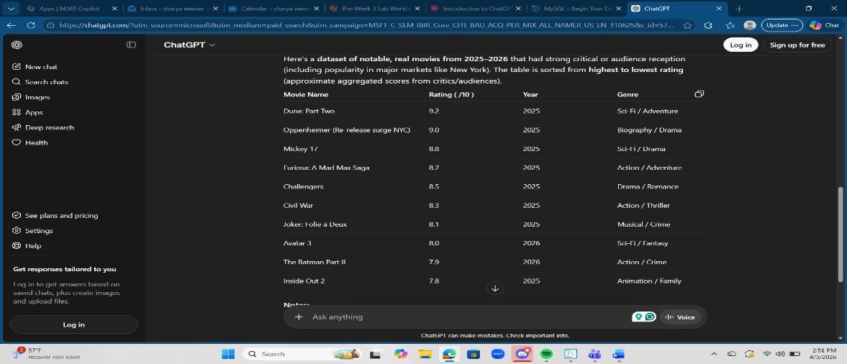
  - This revised prompt is better because it’s clear about what type of dataset you want and how to format it. It also gives information to the AI about what it should be researching.

