

**Course Name:** Software Development Project Management

**Project Title:** CHALAO

**Group Members:**

|  |  |  |
| --- | --- | --- |
| **NAME** | **ID** | **SECTION** |
| Fahim, Hasan Shahriar | 16-32025-2 | C |
| Jishnu Saha | 16-32020-2 | C |
| Md. Abdullah Al Noman Mazumder | 16-32079-2 | C |
| Gazzali, G.M. Mahadi hasan | 17-33889-1 | C |

**Scenario of the proposed system:**

This project is based on cycle riding system which helps people to take cycle rides to save money and time. This system is designed for people who are always being late because of traffic jam, it will help them to reach their destination more easily and they don’t need to wait for a public transport for a long time. The system can be developed as a mobile application and web-based application. In this system users can take this facility by logging into their account, authorized admin panel and employee panel will be responsible for managing that. Users can search cycle or nearest CHALAO zone from his location. One person can take cycle from the nearest zone of CHALAO to go from one place to another by cycling, after reaching his or her desired destination they can handover the cycle easily to the nearest CHALAO zone. So that’s a hassle-free travelling, one can choose when he or she wants to take it and no need to carry the cycle or tensed about it. In our system, registered users can rate the review after completing ride. The application uses GPS connection to fetch and display results and the users can view nearest cycle or CHALAO zone from their location and shortest route of their destination and traffic condition in a map.

**Benefits:**

This system is designed for people who are always being late because of traffic jam, it will help them to reach their destination more easily and they don’t need to wait for a public transport for a long time. The system can be developed as a mobile application and web-based application. In this system users can take this facility by logging into their account, authorized admin panel and employee panel will be responsible for managing that. Users can search cycle or nearest CHALAO zone from his location. One person can take cycle from the nearest zone of CHALAO to go from one place to another by cycling, after reaching his or her desired destination they can handover the cycle easily to the nearest CHALAO zone. So that’s a hassle-free travelling, one can choose when he or she wants to take it and no need to carry the cycle or tensed about it.

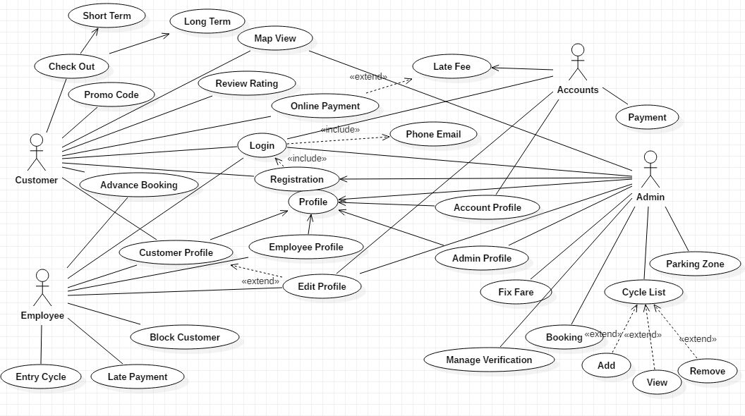

**Figure:** Use Case Diagram

**User Story:**

|  |  |  |  |  |
| --- | --- | --- | --- | --- |
| **Actor** | **User Req.** | **Reason** | **Functional Req.** | **Acceptance** |
| Customer | As a customer I want to login to my account | For taking riding facility | To login to the system customers must sign up by providing credential information’s. | Customer should be able to check their profile and take rides. |
|  | As a customer I want to checkout | For taking ride depending on needs | To checkout customers must be valid user of the system. | Customer should be able to checkout for short term or long term. |
|  | As a customer I want to apply promo codes | So that possible to get various offers and promotions | To get promo codes customers must be a regular user. | Customer should be able to apply promo and offers to get discounts. |
|  | As a customer I want to get map view | To get specific locations, distance, traffic conditions | To get map view customers must have internet connections. | Customer should be able to check latest condition of traffic, specific location viewing using map. |
|  | As a customer I want to give review and ratings | So that possible to share users’ opinions after completing each ride | To give review and ratings customers should be logged in and must complete ride. | Customer should be able to give review and ratings to rate each ride and to let other riders know. |
|  | As a customer I want to get online payment system | For giving more flexibility | To get online payment system customers must have accounts in any online payment system and internet connection. | Customer should be able to pay in online for more flexibility to without going to zone. |
|  | As a customer I want to check my late fees | For giving more flexibility and user friendliness | To check late fees customers, must reach destination after fixed time span. | Customer should be able to check late fees so they will be able to know how much late fees are being added after a fixed time span. |
|  | As a customer I want to confirm bookings in advance | For getting future bookings in time | To confirm bookings in advance customers, must pay in advance. | As per customer needs customer should be able to confirm bookings for future. |
|  | As a customer I want to do registration | To provide all necessary and credential information | To do registration customers have to provide credential information’s. | Customer should be able to do registration for being a valid user. |
|  | As a customer I want to check my profile | So that possible to check all information’s | To check profile customers, must logged in. | Customer should be able to check profile to check all the information’s. |
| Employee | As an employee I want to log in to the system | To manage the system | To log in to the system employee must be verified. | Employee should be able to login to manage zones and cycles. |
|  | As an employee I want to check advance booking | To check availability | To check advance booking needed to check payment. | Employee should be able to check advance bookings to confirm. |
|  | As an employee I want to see customers profile | To check customers information’s are up to date and valid | To check customers profile needed to check all information’s are valid. | Employee should be able to check customers profile so that all of them are verified. |
|  | As an employee I want to see my profile | To check my information’s are up to date and valid | To see profile employee must be logged in to the system. | Employee should be able to see own profile so that information’s are valid and up to date. |
|  | As an employee I want to edit profile accounts | To provide necessary update of selling | To edit account profile needed to provide transactions details. | Employee should be able to edit account profiles for updating transactions. |
|  | As an employee I want to block customer | To remove fake customers or who has not provided proper credential information’s | To block customer confirmation needed from admin. | Employee should be able to block unwanted and non-valid customer. |
|  | As an employee I want to add late payment | After fixed time span to reach the destination, late payment will be added to the total fare | To add late payment, need to check ride details. | Employee should be able to add late payments while customers failed to reach any destination. |
|  | As an employee I want to entry cycle | To provide availability of cycle in a zone or place | To entry cycle needed to check cycle lists. | Employee should be able to entry cycle of any zone. or locations to provide updated information. |
| Admin | As an admin I want to login to the system | To manage the system | To login to the system admin must provide id and password. | Admin should be able to login to the system to manage the whole system. |
|  | As an admin I want to integrate map view | For providing necessary information and directions in map | To integrate map view admin must check all information’s are accurate | Admin should be able to integrate map view for providing necessary information’s and directions. |
|  | As an admin I want to check all profile | To check all the profiles information’s and validity their credential information’s | To check all the profiles information’s admin must check validity and credential information’s | Admin should be able to check all users profile to check their validity. |
|  | As an admin I want to check my profile | To check my information’s are valid and up to date | To check information’s must be logged in to the system. | Admin should be able to check own profile to keep information’s valid and up to date. |
|  | As an admin I want to fix fare | Fared that will be charged according to distance, time, locations, traffic will be fixed by admin | To fix fare needed to check distance, time, traffic, locations etc. | Admin should be able to fix fare as per distance, time, locations, traffic. |
|  | As an admin I want to manage verification | All the verification process must be verified properly to identify every user | To manage verification needed to check all the credential information’s are valid. | Admin should be able to manage all verifications. |
|  | As an admin I want to manage booking | To give clearance depending on availability, time, demand, needs, fare etc. | To manage booking needed to check availability, time, demand, needs, fare etc. | Admin should be able to manage booking for giving clearance depending on availability, time, demand, needs, fare etc. |
|  | As an admin I want to manage cycle list add, view, remove | To provide cycles availability information cycles will be added, viewed and remove from a specific area or zone | To manage cycle lists needed to check the availability. | Admin should be able to manage cycle list to provide updated information’s. |
|  | As an admin I want to manage parking zone | To provide necessary information’s to the user | To mange parking zone needed to check the map view. | Admin should be able to manage parking zones to provide all necessary information’s. |
| Accounts | As an account I want to login to the system | To check account profile | To login to the system needed to provide id, password. | Accounts should be able to login to the system to check account profile. |
|  | As an account I want to check my profile | To check my information’s are valid and up to date | To check profile must have to logged in. | Accounts should be able to check own profile so that information’s will be valid and up to date. |
|  | As an account I want to check payment details | To keep track of every payments and all necessary information’s related to that | To check payment details needed to get all transaction information’s. | Accounts should be able to check payment details to keep record of every transactions. |

**Chosen SDLC Model:**

Our chosen SDLC model is a combination of Prototyping model & Agile model’s scrum methodology. This model is most useful in development of systems having high level of user interactions. In this model functionality can be developed rapidly and demonstrated. In this model, resource requirements are minimum and suitable for fixed requirements deliver early partial working solutions.

**Why we chose Prototyping-model & Agile-model’s Scrum Methodology:**

There are many advantages of Prototyping-model and Agile-Model, as it is interactive to

customers and developers. They are:

* This one helps developer to understand what functionality and system look customer is expecting to build.
* Iteration occurs as the prototype is tuned to satisfy the needs of the customer.
* Understanding of the system being developed.
* Reduces time and cost as the defects can be detected much earlier.
* Resource requirements are minimum and suitable for fixed requirements deliver early partial working solutions.
* Quicker user feedback is available leading to better solutions.
* Missing functionality can be identified easily.
* Every stage of the SDLC can be tested individually.

There are some lacking in using our chosen model. Like in Prototyping model, it takes time to implement the project as it is based on the customer demand. And in Agile model, Not suitable for handling complex dependencies. More risk of sustainability, maintainability and extensibility. An overall plan, an agile leader and agile PM practice is a must without which it will not work. Strict delivery management dictates the scope, functionality to be delivered, and adjustments to meet the deadline.

**Estimation:**

The estimation is a process to find the most accurate sizing figure for the software project effort, for example, how many months we will need to develop the software, how many resources we will need to finish the project in the required time. And this translated to money at the end. The estimation is a process and this process contains steps to reach the estimate, this process is cycling until we reach the final estimate for the project.

We will apply the **Constructive Cost Model** (**COCOMO II**) which is a procedural software cost estimation model developed by Barry W. Boehm.

We assume the diagnostic component had 16 parts and each part took 100 hours to design, develop and test. The resulting estimate would be 1,600 hours for the fault diagnosis component. We used a productivity figure like 2 source lines of code/staff hour or $50/deliverable source line of code as the basis of our estimate

We will sum the source lines of code for the three components for our client-side system to establish our basis of estimate as 44,700 equivalents new SLOC. Our estimate would then be computed as follow:

(44,700 SLOC) / (2 SLOC/staff hour) = 22,350 staff hours

First, the numbers for C++ represent the delta costs (i.e., those in addition to that which would have had to be spent anyway if the C programming language were used). In other words, training costs for C++ would be $50,000 more than that which would have been spent if the C language had been selected for use. Second, the gain in productivity due to selection of the C++ language was computed as follows:

Cost reduction = (% of life cycle affected) (productivity gain) (number of hours) (cost/hour)

= (0.3) (0.5) (25,000) ($50) = $187,500

We made the following very conservative assumptions to perform our analysis:

The gains associated with the use of a programming languages were confined to the code and unit test portion of the life cycle, The relative productivity gain of C++ over C was only 50% (i.e., not the 70% the function point language expansion factors suggest),The cost of developing our application is 25,000 hours (somewhat between our COCOMO and WBS estimates), and The cost per hour is $50 (i.e., does not include overhead and profit).

This trade study shows that it would be beneficial to move to the C++ programming language if we could afford the time needed to bring the staff up to speed on the effective use of the language and the methods it depends on to realize its potential. For both incremental paradigms, we will treat our two deliveries as two separate subprojects. Based upon the estimates & the effective size of first subproject would be 19,900 SLOC. We would estimate the size of Build 2 as follows:

Effective size = Size (0.4(%DM) + 0.3(%CM) + 0.3(%IM)) = 19,900 (0.4(.20) + 0.3(.30) + 0.3(.30)) = 19,900 (0.26) = 5,174 SLOC

Size (Build 2) = 5,174 + 800 + 23,100 = 29,074 SLOC

Where:

%DM = percentage design modified

%CM = percent code modified

%IM = percent integration modified

We assume there is a pool of five senior developers that could be made available to work on the project, but they are also critical to ongoing projects. They would collectively and individually rate as "high" on the developer ICASE experience scale. Also, the ICASE toolset rates “high”. With a “high” productivity of 25 NAP/PM per the application point procedure in section 5.1, the estimated prototype effort for 136.3 NAP would be:

PM = NAP/PROD = 136.3/25 = 23.6 person-weeks

This would require an average of (23.5 person-weeks/6 weeks)=3.9 full-time personnel for the six week period, or 4 of the 5 available developers.

As in the breadboard system, equivalent size calculations are not performed for automatically translated code. Automatic translation productivity was measured during the breadboard development as 1,150 SLOC/person-month. It was also found that only 75% of the original radar item processing code could be successfully translated by tools. The remaining portion to be converted to Ada is 58,320 SLOC. The automatic translation effort alone is:

|  |  |
| --- | --- |
| PMM | = ASLOC (AT/100) / ATPROD |
|  | = 58,320 ASLOC * (.75)/1,150 SLOC/person-month) |
|  | = 38.0 person-months. |

Schedule constraint effects are not applied to the automatic translation effort. The remaining effort for the rest of the system is estimated as:

PM = 459 person-months.

The overall effort is then 459 + 38 = 497 person-months.

**Scheduling:**

Today

Day 1

6

11

16

21

26

31

36

41

46

51

56

**Production**

**Project Approval**

**Image Rolled Out**

**Image Approved**

**Project Hand-Off**

4 days

PC Image Analysis

5 days

PC Image Preparation

6 days

Smartphone Image Preparation

4 days

Optimization

5 days

PC Image Test

5 days

Smartphone Test

7 days

**PC Image Sign-Off**

6 days

**Smartphone Image Sign-Off**

4 days

Documentation

2 days

Helpdesk Training

**Budget:**

In order to determine the price of development app like CHALAO first we need to specify all the essential features of the app. These are standard features we can’t do without when building app like CHALAO:

1. GPS, map and routes drawing
2. Registration and matching system
3. Notifications and communication
4. Payment system
5. Cycle and user details

## GPS, map and routes drawing:

Building app like CHALAO is all about the GPS. It is used for identifying nearest cycle or CHALAO zone from their location and shortest route of their destination and traffic condition in a map. For routing and determining the cost of the ride you would need a routing server. In general, the best choice would be to use maps that are native for the platform. For example, for Android those would be Google Maps.

## Registration and matching system:

CHALAO apps offer several ways of registration for regular users and require phone number from the very beginning. In order to work properly it needs to consider the location of a particular passenger.

## Notifications and communication:

There are several ways to notify passengers that after their reaching destination the location of nearest CHALAO zone & the amount of payment to pay, the major of them being sending SMS or push notifications. While using push notifications is cheaper and easier to implement, we might think of using SMS since they are more reliable.

## Payment system:

CHALAO apps use cashless systems since they are faster and safer.

Offering more payment options helps you to attract more customers:

1. CHALAO supports credit cards, PayPal, American Express points, as well as Apple Pay and Google Wallet.
2. Lyft supports credit and debit cards, PayPal, Apple Pay and Google Wallet.
3. Hailo supports bank cards, as well as Apple Pay.

## Car and user details:

We all prefer to know what (or who) to expect. It gives the sense of safety and reduces anxiety. In terms of your CHALAO app it means that information about cycle (type, color etc.) and passengers (name and photo) should be provided.

## Rating:

While it’s not the most obvious advantage of CHALAO, rating system is a necessary feature contributing to the service value. After the ride is completed passengers are prompted to rate about cycle. It has two important consequences: Detecting any problems occurred in cycle & the behavior of CHALAO zone employees of starting point & finishing point.

## Final cost:

So how much will it cost you to create app like CHALAO? As assumption Development for one platform will take some 500 hours. Design — about 200 hours. API will cost you $20K, and app for one platform — approximately $15K. Of course, these are approximate calculations and the final Uber app development cost will depend on the scale and specifics of the project (such as whether you need an app for carriage company or passenger transportation) and features specified in the technical task.