**Course Name:** Software Development & Project Management

**Project Name:** CHALAO

|  |  |  |
| --- | --- | --- |
| **NAME** | **ID** | **SECTION** |
| Fahim, Hasan Shahriar | 16-32025-2 | C |
| Jishnu Saha | 16-32020-2 | C |
| Md. Abdullah Al Noman Mazumder | 16-32079-2 | C |
| Gazzali, G.M. Mahadi hasan | 17-33889-1 | C |

**Objective:** This project is based on cycle riding system which helps people to take cycle rides to save money and time. This system is designed for people who are always being late because of traffic jam, it will help them to reach their destination more easily and they don’t need to wait for a public transport for a long time. The system can be developed as a mobile application and web-based application. In this system users can take this facility by logging into their account, authorized admin panel and employee panel will be responsible for managing that. Users can search cycle or nearest chalao zone from his location. One person can take cycle from the nearest zone of chalao to go from one place to another by cycling, after reaching his or her desired destination they can handover the cycle easily to the nearest chalao zone. So that’s a hassle-free travelling, one can choose when he or she wants to take it and no need to carry the cycle or tensed about it. In our system, registered users can rate the review after completing ride. The application uses GPS connection to fetch and display results and the users can view nearest cycle or chalao zone from their location and shortest route of their destination and traffic condition in a map.

**Chosen SDLC Model:** Our chosen SDLC model is a combination of Prototyping model & Agile model’s scrum methodology. This model is most useful in development of systems having high level of user interactions. In this model functionality can be developed rapidly and demonstrated. In this model, resource requirements are minimum and suitable for fixed requirements deliver early partial working solutions.

**Why we chose Prototyping-model & Agile-model’s Scrum Methodology:**

There are many advantages of Prototyping-model and Agile-Model, as it is interactive to

customers and developers. They are:

* This one helps developer to understand what functionality and system look customer is expecting to build.
* Iteration occurs as the prototype is tuned to satisfy the needs of the customer.
* Understanding of the system being developed.
* Reduces time and cost as the defects can be detected much earlier.
* Resource requirements are minimum and suitable for fixed requirements deliver early partial working solutions.
* Quicker user feedback is available leading to better solutions.
* Missing functionality can be identified easily.
* Every stage of the SDLC can be tested individually.

There are some lacking in using our chosen model. Like in Prototyping model, it takes time to implement the project as it is based on the customer demand. And in Agile model, Not suitable for handling complex dependencies. More risk of sustainability, maintainability and extensibility. An overall plan, an agile leader and agile PM practice is a must without which it will not work. Strict delivery management dictates the scope, functionality to be delivered, and adjustments to meet the deadline.

**Benefits:**

This system is designed for people who are always being late because of traffic jam, it will help them to reach their destination more easily and they don’t need to wait for a public transport for a long time. The system can be developed as a mobile application and web-based application. In this system users can take this facility by logging into their account, authorized admin panel and employee panel will be responsible for managing that. Users can search cycle or nearest chalao zone from his location. One person can take cycle from the nearest zone of chalao to go from one place to another by cycling, after reaching his or her desired destination they can handover the cycle easily to the nearest chalao zone. So that’s a hassle-free travelling, one can choose when he or she wants to take it and no need to carry the cycle or tensed about it.

**Stakeholders:**

There are three types of users interacting with the system. They are users of the mobile application, employee of the chalao zone and admin. Each of these three types of users has different activity to the system so each of them has their own requirements.

The mobile application users can use the application to take ride, to search nearest cycles and cycle zones also to check necessary information’s. It means that the user will be able to search for nearest cycles or zones, choose nearest one from that search outcome and then navigate to it. In order to get a relevant search result there are multiple criteria such as system can automatically locate user’s location to get more accurate and nearest location.

The employees and admins of the system will be able to use the mobile application and also the web portal. There they will manage the information about cycles, zones, user information’s, payments, and others information’s. They can directly interact with the web portal from that portal they will manage the overall system so there is no incorrect information within it. The admin team has full accessibility to manage and check the whole system.

**Components:**

Our application will help to take cycle riding facility from user current location to desired destination.

User can search for nearest cycle or cycle zone from his or her location and also can check estimated fare from his location.

In this way, people will be capable to compare and eager to use cycle as their transport rather than using other time and money consuming transport.

This application also can detect users’ position and it will suggest nearest cycle and zone.

The application is free to download from either a mobile phone application store or similar services.

Admin team and employee of chalao zone can provide availability of cycle, conditions of cycle and others necessary information using the application.

This information will be displayed to the user on the basis of users or riders’ reviews and comments.

An admin uses the web-portal in order to administer the system and keep the information updated.

The administrator can, for instance, verify users, employee’s information and manage that information.

Furthermore, the application uses GPS connection to fetch and display results.

All system information has been maintained in a database, which is located on a web-server.

The software also interacts with the GPS-Navigator software which is required to be an already installed application on the user’s mobile phone.

By using the GPS-Navigator, users can view nearest zone on a map and be navigated to them

With the mobile application, the users will be able to search for cycles or chalao zones that will help to find nearest one from users’ location.

The result will be based on the criteria the user inputs.

There are several search criteria and it will be possible for the administrator of the system to manage the options for those criteria that have that.

The result of the search will be viewed either in a list view, depending on what criteria included in the search.

The list view will have one list for top cycles and zones with top rated and reviewed by other users and it will also provide its detailed specification, so that users will be able to take best ride.

The map view will show each cycle and zone location as a pin on the map as well as the user’s own location.

In both views, the users will be able to either select a cycle as target destination and confirm booking for taking ride or get information how to get there, or view the information of a specific cycle or a zone.

After starting ride, it will provide the best route follow, shortest route, traffic situation alternative route and route of least cost.

The web portal will provide functionality to manage the system and cycle, zone, user information and the system as a whole by employees and admins.

It will also provide information about the system, for example show when there is a new update.

**Use Case Diagram:**

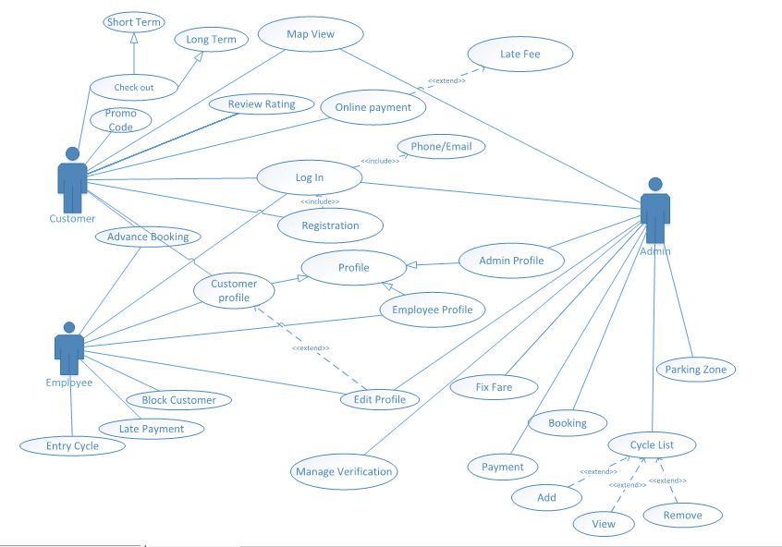

Fig: Use case Diagram