Enterprise Knowledge Assistant
System Design Document
Author: Shashank Sharma
Date: June 2026

1. Objective
The Enterprise Knowledge Assistant is a production-oriented Retrieval-Augmented Generation (RAG) system designed to enable users to query enterprise knowledge using natural language. Instead of relying solely on the reasoning capabilities of a Large Language Model, the system first retrieves semantically relevant information from a document knowledge base and then uses that retrieved context to generate grounded responses.
The primary design goals of the system are:
- Deliver accurate, source-backed answers.
- Minimize hallucinations through retrieval grounding.
- Support multiple enterprise document formats.
- Maintain a modular architecture that is easy to extend and maintain.
- Demonstrate production-oriented AI engineering practices rather than a prototype implementation.
2. High-Level Architecture
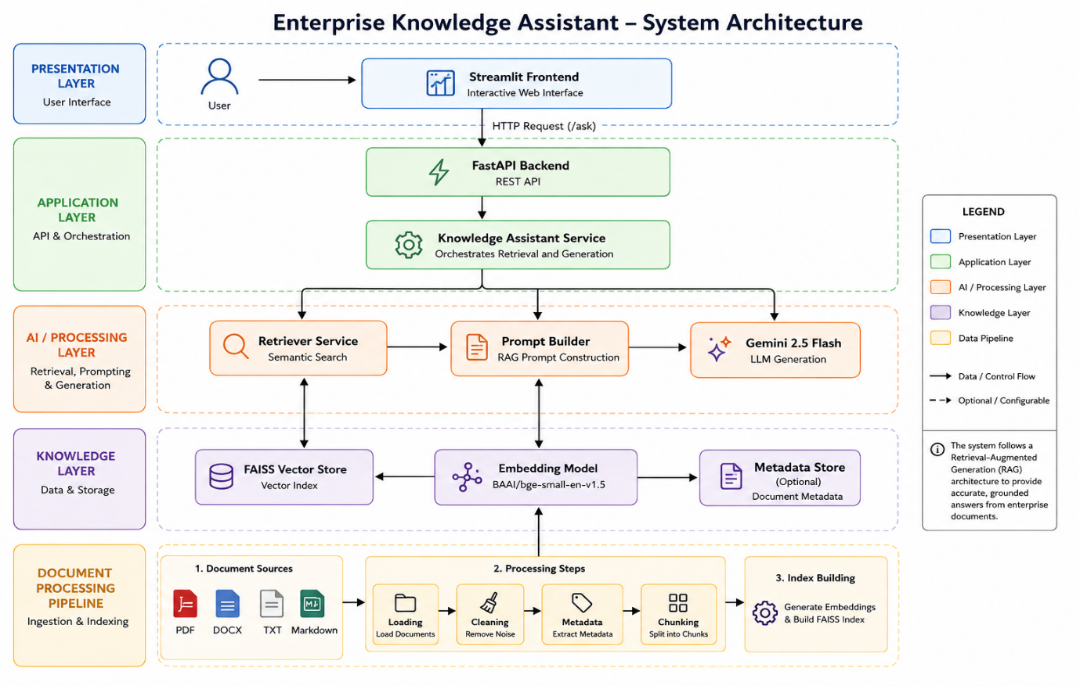
The system follows a layered architecture consisting of four logical layers:
- Presentation Layer – Streamlit provides the user interface for submitting questions and displaying grounded responses.
- Application Layer – FastAPI exposes REST endpoints and coordinates application logic through the Knowledge Assistant Service.
- AI Processing Layer – The Retriever Service performs semantic search over FAISS, while the Prompt Builder assembles retrieved context for the Gemini 2.5 Flash model.
- Knowledge Layer – Enterprise documents are processed into semantic embeddings using the BAAI/bge-small-en-v1.5 embedding model and stored in a FAISS vector index for efficient retrieval.
This separation of responsibilities improves maintainability, scalability, and testability by allowing each component to evolve independently.

3. Component Responsibilities

Component | Responsibility
Streamlit Frontend | Provides a user-friendly interface for entering natural language questions and displaying AI-generated responses with supporting citations.
FastAPI Backend | Exposes REST endpoints, validates requests using Pydantic schemas, and orchestrates communication between application components.
Knowledge Assistant Service | Coordinates the end-to-end RAG pipeline by invoking retrieval, prompt construction, LLM generation, and response formatting.
Retriever Service | Performs semantic similarity search over the FAISS vector store to identify the most relevant document chunks.
Prompt Builder | Combines retrieved context with the user's query to generate a structured prompt that constrains the LLM to answer only from the provided context.
Gemini Provider | Generates grounded natural language responses using Google Gemini 2.5 Flash.
FAISS Vector Store | Stores dense vector embeddings for efficient semantic retrieval.
Embedding Model | Converts document chunks and user queries into semantic vector representations using the BAAI/bge-small-en-v1.5 model.
Document Processing Pipeline | Loads documents, extracts text, enriches metadata, performs chunking, and prepares content for indexing.

4. End-to-End Data Flow
- Enterprise documents are loaded from the document repository.
- Text is extracted, cleaned, enriched with metadata, and divided into semantic chunks.
- Each chunk is converted into dense vector embeddings using the BAAI/bge-small-en-v1.5 embedding model.
- The embeddings are indexed in a FAISS vector database.
- A user submits a question through the Streamlit interface.
- FastAPI forwards the request to the Knowledge Assistant Service.
- The Retriever Service performs semantic similarity search against the FAISS index.
- The top-ranked document chunks are passed to the Prompt Builder, which constructs a RAG prompt.
- Google Gemini 2.5 Flash generates a grounded response using only the retrieved context.
- The API returns the generated answer together with source citations, confidence score, retrieval statistics, and processing latency.

5. Scalability Considerations
Although the current implementation is designed for a moderate-sized enterprise document collection, the architecture can be extended for larger production environments.
Potential improvements include:
- Replacing FAISS with managed vector databases such as Pinecone, Weaviate, or Milvus for distributed retrieval.
- Incremental indexing to support newly added documents without rebuilding the entire knowledge base.
- Hybrid retrieval combining semantic search with keyword-based retrieval.
- Cross-encoder reranking to improve retrieval precision.
- Authentication and role-based access control for secure enterprise deployments.
- Container orchestration using Kubernetes for scalable deployment.

Conclusion
The Enterprise Knowledge Assistant demonstrates a production-oriented implementation of a RAG system by combining modern AI engineering practices with a modular software architecture. The solution emphasizes maintainability, scalability, and grounded response generation while providing a strong foundation for future enterprise-scale enhancements.

