**PROJECT – 1**

**NUMBER GUESSING GAME**

**Q. WRITE A PROGRAM THAT GENERATES A RANDOM NUMBER AND ASKS THE PLAYER TO GUESS IT. IF THE PLAYER’S GUESS IS HIGHER THAN THE ACTUAL NUMBER , THE PROGRAM DISPLAYS “LOWER NUMBER PLEASE”. SIMILARLY IF THE USER’S GUESS IS TOO LOW, THE PROGRAM PRINTS “HIGHER NUMBER PLEASE”.**

**WHEN THE USER GUESSES THE CORRECT NUMBER , THE PROGRAM DISPLAYS THE NUMBER OF GUESSES THE PLAYER USED TO ARRIVE AT THAT NUMBER.**

**HINT 🡪 TO USE LOOPS**

**USE A RANDOM NUMBER GENERATOR**

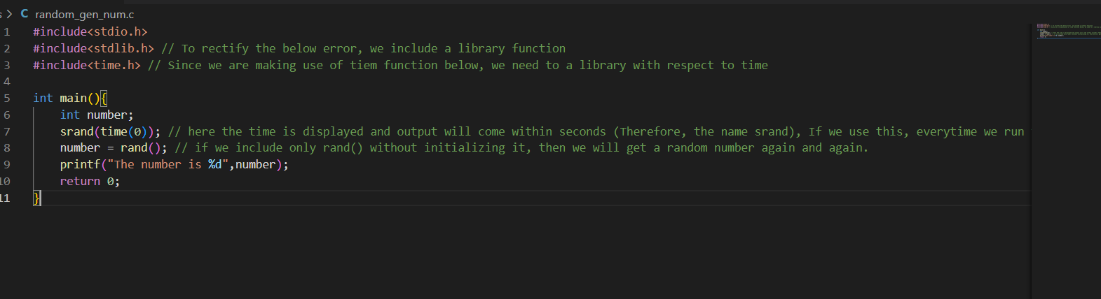

**THIS PIECE OF CODE IS USED TO GENERATE THE NUMBERS RANDOMLY**

**OUTPUT 🡪** 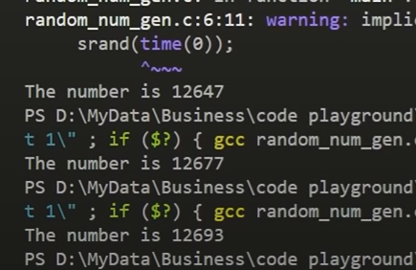

**CONTD 🡪**

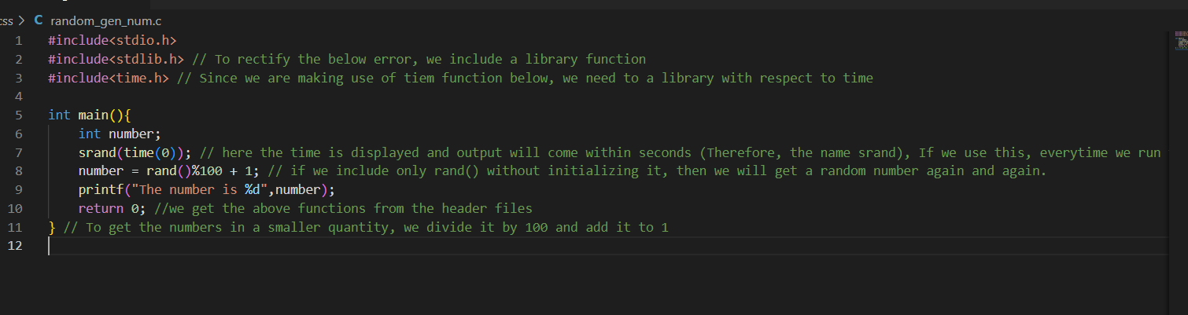**THIS IS THE CODE TO GENERATE RANDOM NUMBERS BETWEEN 1 TO 100**

**(DIVIDING THE RANDOM NUMBER BY 100 AND ADDING IT TO 1)**

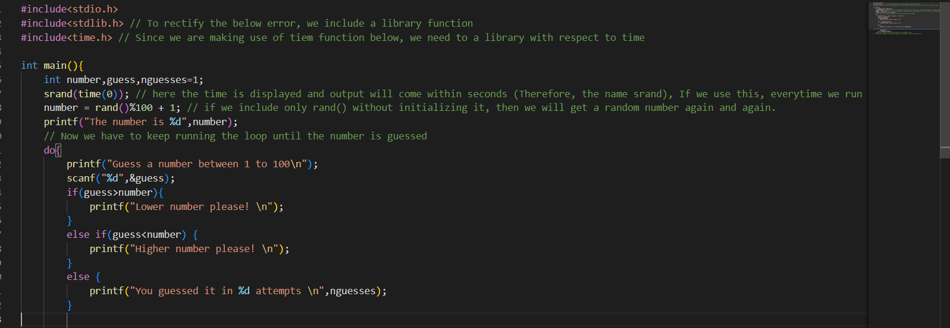

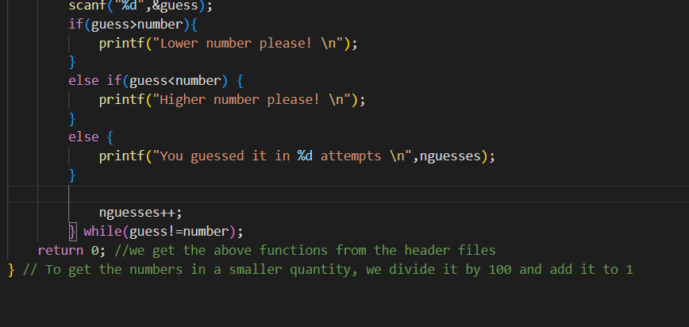

**OUTPUT 🡪** 