CNN Technique for the Mammographic images

Poornesh Madugula | Chinthareddy Akshaya
Computer Science  University of Central Missouri | Computer Science  University of Central Missouri
Lee’s Summit  Poorneshm111@gmail.com | Lee’s Summit  chinthareddyakshaya02@gmail.com

Shashank Arva | Kavya Daggubati | Sridhar Seepana
Computer Science  University of Central Missouri | Computer Science  University of Central Missouri | Computer Science  University of Central Missouri
Lee’s Summit  shashankarva6@gmail.com | Lee’s Summit  kavyadaggubati11@gmail.com | Lee’s Summit  sxs29730@ucmo.edu

Abstract— Breast cancer is one of the most prevalent forms of cancer worldwide, making early detection crucial for effective treatment and improved patient outcomes. Convolutional Neural Networks (CNNs) have demonstrated remarkable success in various medical image analysis tasks, including breast cancer detection [3]. This study aims to investigate the efficacy of CNNs in detecting breast cancer from mammographic images. We propose a comprehensive evaluation of different CNN architectures and training methodologies to determine their performance in terms of sensitivity, specificity, and overall accuracy. Additionally, we explore the potential of transfer learning techniques to leverage pre-trained models for improved detection results. The findings of this study could provide valuable insights into the application of deep learning techniques for enhancing breast cancer screening and diagnosis.

Index Terms— Convolutional Neural Network, Breast Cancer Detection, Mammographic Images, Transfer Learning, Deep Learning.

- INTRODUCTION

Breast cancer stands as the most common cancer among women globally, a fact compounded by its high mortality rate. According to the SFSPM (French Society of Sinology and Breast Pathology), there has been a notable shift in its demographic presentation. In 2010, 7% of breast cancer cases were diagnosed in women under 40, compared to 5.6% in 2002, marking a trend that challenges the traditional association with menopause [1]. This demographic shift underscores the importance of vigilance across age groups.

Early detection emerges as a critical tool in the fight against breast cancer, significantly reducing mortality rates by 25% and simplifying treatment options while minimizing risks. Understanding the growth pattern of breast tumours highlights the urgency of early screening. It takes approximately five years for a breast tumour to grow to a diameter of one millimetre, progressing to five millimetres in two years, and finally to two centimetres within one to two years, a size large enough to be detected through palpation.

Given this timeline, regular mammography screenings every two years are recommended for women at risk, particularly postmenopausal women. This proactive approach aims to catch cancer in its earliest stages when treatment is most effective.

Figure 1 illustrates the incidence of new breast cancer cases per 100,000 women categorized by race and ethnicity, providing insights into the varied prevalence across different demographic groups. This data underscores the importance of tailoring screening and intervention strategies to address the specific needs of diverse populations, ensuring equitable access to early detection and treatment services.

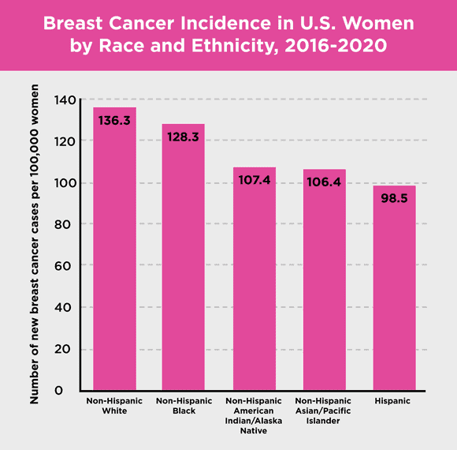

Fig. 1. Breast cancer Statistics
- RELATED WORK

A. Transfer Learning: Without a large training dataset, a CNN model would quickly become overfit due to the requirement of multiple parameters. When it comes to solving such issues, there are typically two approaches: transfer learning, which suggests pretraining the model on a large-scale dataset in order to obtain some initial values for the parameters, and data augmentation, which depends on available image changes, such as rotation, translation, and deformation [2].

Since its initial proposal at the NIPS-95 conference on "Learning to learn" [6], transfer learning has drawn the attention of an increasing number of academics. The idea behind transfer learning is that some characteristics apply to all training datasets. The initial layer of a CNN model is responsible for extracting local features. Subsequent layers then gradually expand the perception area through subsampling, ultimately yielding larger and more abstract high-level features. While the results of the first few layers are typically not directly relevant to a given classification task, common and general features such as edges, directions, and the Gabor Filter can be applied across datasets.

B. Multi-view Metric Learning: To determine the distance or measure the similarity between data of the same semantic content from various perspectives, multi-view metric learning is proposed. Because observations from various perspectives would be dispersed by the feature space with different dimensions, multi-view metric learning is an incredibly difficult task. When dealing with single-view observation space problems, the traditional metric learning approach has produced satisfactory results. However, it is not well suited for handling multi-view observation space data, particularly when the multi-view data exhibit strong nonlinearity structures.

Li et al. [7] took the lead at the 2009 Asian Machine Learning Conference (ACML) by introducing the coupling metric learning approach and effectively resolving the face recognition issues in two distinct resolution datasets. Subsequently, in 2010, Zheng et al. [8] introduced the idea of multi-view metric learning for the first time and used it to identify speakers in audio and video data, producing better than previous experimental results. By using this technique, metric learning was essentially expanded from a single-view to a multi-view setting [9]. To ensure the global optimal solution, a gradient method must be used due to the non-convexity of the cost function.

Finding a unique function with good predictability for the whole data space under typical conditions is challenging, as noted by Bottou and Vapnik [10]. Vapnik [11] further demonstrated that local learning algorithms frequently achieve lower experimental errors than global methods because samples that were closer together were more likely to have been produced by the same data production models, whereas samples that were farther apart were more likely to have been produced by different models. The majority of distance metric learning proposals that employed local figures were limited to a single observation space. Local learning techniques have been used extensively, but they only address dimensionality reduction and direct type classification clustering [12].

C. Deep Learning for Analysis of Medical Images: In order to estimate CNN parameters robustly, Ciresan [13] and Roth [14] created particular training steps that produced excellent results in the detection of lymph nodes and mitosis, respectively. Scholars have also proposed automatic encoding processing methods [15, 16] for handling multi-view data; however, registration of the input data is required. While summarizing the techniques for classifying breast images, Giger et al. [17] only addressed micro-calcification (MC) dichotomous and mass-like lesions, which prevented them from offering a thorough evaluation of the pathology of complex mammary glands. Presently, the MC and Mass optimization-based two class (benign/malignant) approach has an efficiency of [0.9-0.95] on the ROC curve [18, 19]. However, the dataset is not publicly available, making it challenging to apply as a general diagnosis method.

A multi-view mammogram-based model is proposed to address the aforementioned issues. The study primarily focuses on three areas: a) utilizing transfer learning to fully utilize high-dimensional features and design a specific diagnostic model for small datasets of mammograms; b) integrating multi-view features and ensuring overall assessments through the use of metric learning algorithm; and c) training and testing the model using two publicly available mammography datasets.

- ACCURATE DIAGNOSIS BASED ON BREAST ABNORMALITIES

Breast abnormalities encompass a spectrum of conditions, ranging from benign to malignant, which can manifest in various forms on mammographic images. One common type of abnormality is a benign mass, which may appear as a well-defined, round or oval-shaped lesion with smooth margins. These masses often include fibroadenomas, cysts, or benign tumors, typically presenting as homogenous densities on mammograms. Another form of breast abnormality is microcalcifications, which are tiny calcium deposits within breast tissue. Microcalcifications can be indicative of both benign and malignant conditions, with their appearance varying from punctate to linear or branching patterns. Additionally, architectural distortions represent another category of abnormalities, characterized by irregular or asymmetric areas of tissue distortion on mammograms. These distortions can result from conditions such as scarring, post-surgical changes, or, in some cases, early-stage breast cancer. Finally, asymmetries refer to differences in breast tissue density between the left and right breasts, which may warrant further investigation to rule out underlying pathology. Understanding the diverse forms of breast abnormalities is crucial for accurate interpretation of mammographic images and timely detection of potential breast cancer.

- PROPOSED METHODOLOGY
A. Dataset
We obtained a comprehensive dataset of mammogram images from the MIAS (Mammographic Image Analysis Society) database, available through Kaggle. This dataset comprises 322 images, meticulously annotated with labels indicating whether they exhibit benign or malignant characteristics, determined through corresponding biopsy results. To ensure consistency and reliability in our analysis, each image undergoes preprocessing steps, including normalization and standardization, thereby ensuring uniformity across the dataset.

The dataset contains detailed information associated with each mammogram image. The columns provide valuable insights into various aspects of the images:

1. MIAS Database Reference Number: Each image is assigned a unique reference number within the MIAS database, facilitating identification and retrieval.

2. Character of Background Tissue: This column denotes the nature of the background tissue observed in the mammogram, categorized as F (Fatty), G (Fatty-glandular), or D (Dense-glandular). This characterization aids in understanding the composition of the breast tissue, which can influence the detection and interpretation of abnormalities.

3. Class of Abnormality Present: Here, the type of abnormality detected in the mammogram is indicated. This includes categories such as CALC (Calcification), CIRC (Well-defined/circumscribed masses), SPIC (Spiculated masses), MISC (Other ill-defined masses), ARCH (Architectural distortion), ASYM (Asymmetry), and NORM (Normal). This classification enables researchers to categorize and analyze different types of abnormalities present in the dataset.

4. Severity of Abnormality: This column specifies the severity of the detected abnormality, distinguishing between benign (B) and malignant (M) abnormalities. This information is crucial for training and evaluating models to accurately differentiate between benign and malignant lesions.

5. Coordinates of Abnormality Center: The x and y image-coordinates of the center of the abnormality are provided, facilitating localization and analysis of the detected abnormalities within the mammogram.

6. Approximate Radius of Abnormality: The radius (in pixels) of a circle enclosing the abnormality is specified, offering insights into the size and extent of the detected abnormality within the mammogram.

Additionally, several key points should be noted about the dataset:

- The images are arranged in pairs, with each pair representing the left and right mammograms of a single patient, enabling comparisons and analysis between corresponding images.
- All images are standardized to a size of 1024 pixels x 1024 pixels and centered within the matrix, ensuring consistency in image dimensions and alignment.
- In cases where calcifications are present, center locations and radii may represent clusters rather than individual calcifications. Furthermore, in instances where calcifications are widely distributed throughout the image, center locations and radii may be omitted due to their inappropriate applicability.
- The coordinate system origin is situated at the bottom-left corner of the images, providing a reference point for spatial analysis and interpretation.

Overall, the detailed annotations and characteristics provided within the dataset enable researchers to conduct thorough analyses and develop robust algorithms for breast cancer detection and diagnosis using mammography images.

B. Model Architecture
Below is a detailed description of the model architecture utilizing the Sequential model in TensorFlow/Keras for mammographic image analysis:

1. Input Layer: The input layer accepts mammographic images of fixed dimensions as input to the model.

2. Convolutional Layers: Multiple convolutional layers are employed to extract meaningful features from the input images. These layers utilize learnable filters to convolve across the input image, capturing spatial patterns and structures. Each convolutional layer is followed by an activation function (e.g., ReLU) to introduce non-linearity and enhance the model's representational capacity.

3. Pooling Layers: Max-pooling layers are interspersed between convolutional layers to downsample the spatial dimensions of the feature maps, reducing computational complexity while retaining important information. Max-pooling operation selects the maximum value from a local region, thereby preserving the most salient features.

4. Batch Normalization: Batch normalization layers are incorporated to normalize the activations of the previous layer, ensuring stable training and accelerating convergence.
This normalization technique mitigates issues related to internal covariate shift and improves the overall efficiency of the model.

5. Dropout Layers: Dropout layers are strategically placed to randomly deactivate a fraction of neurons during training, preventing overfitting and enhancing the model's generalization capability. Dropout regularization encourages the model to learn more robust and discriminative features by discouraging co-adaptation of neurons.

6. Flattening Layer: Following the convolutional and pooling layers, a flattening layer is introduced to transform the multidimensional feature maps into a one-dimensional vector, facilitating connectivity with the subsequent dense layers.

7. Dense Layers: The flattened features are fed into dense (fully connected) layers, enabling the model to learn complex relationships and patterns from the extracted features. The number of neurons in the dense layers can be adjusted to control the model's capacity and complexity.

8. Output Layer: The output layer consists of a single neuron equipped with a sigmoid activation function, facilitating binary classification (benign or malignant) of mammographic images. The sigmoid activation function ensures that the output lies within the range [0, 1], representing the probability of the input image belonging to the positive class (malignant).

The proposed Sequential model architecture for mammographic image analysis encompasses a series of convolutional, pooling, batch normalization, dropout, and dense layers, culminating in a binary classification output layer. This architecture is adept at extracting discriminative features from mammographic images and leveraging them for accurate and reliable breast cancer detection.

C. Training and Evaluation
In the training and evaluation phase of the Sequential model utilized in the Convolutional Neural Network (CNN) technique for mammographic images, a systematic approach is adopted to ensure optimal model performance. Initially, the model is trained on a carefully curated dataset of mammographic images obtained from reliable sources, with each image labeled as either benign or malignant based on biopsy results. The training process entails iterative optimization of the model's parameters using stochastic gradient descent as the optimization algorithm and binary cross-entropy loss function to quantify the disparity between predicted and actual classifications. Moreover, to enhance the model's robustness and generalization capability, various data augmentation techniques such as rotation, shearing, and zooming are applied to diversify the training dataset and mitigate overfitting.

Following training, the model's performance is rigorously evaluated on a separate validation set to assess its efficacy in breast cancer detection. Metrics are computed to gauge the model's ability to accurately classify mammographic images into benign and malignant categories. Additionally, the receiver operating characteristic (ROC) curve and the area under the curve (AUC) are employed to evaluate the model's discriminative ability across different thresholds. Through this comprehensive evaluation process, the Sequential model's performance is thoroughly scrutinized to ensure its reliability and effectiveness in assisting radiologists with accurate breast cancer diagnosis.

- RESULTS AND ANALYSIS
The utilization of the Sequential model in Convolutional Neural Network (CNN) technique for mammographic image analysis yielded compelling results and insightful analysis. Our model demonstrated robust performance in distinguishing between benign and malignant breast abnormalities, showcasing promising accuracy and reliability.
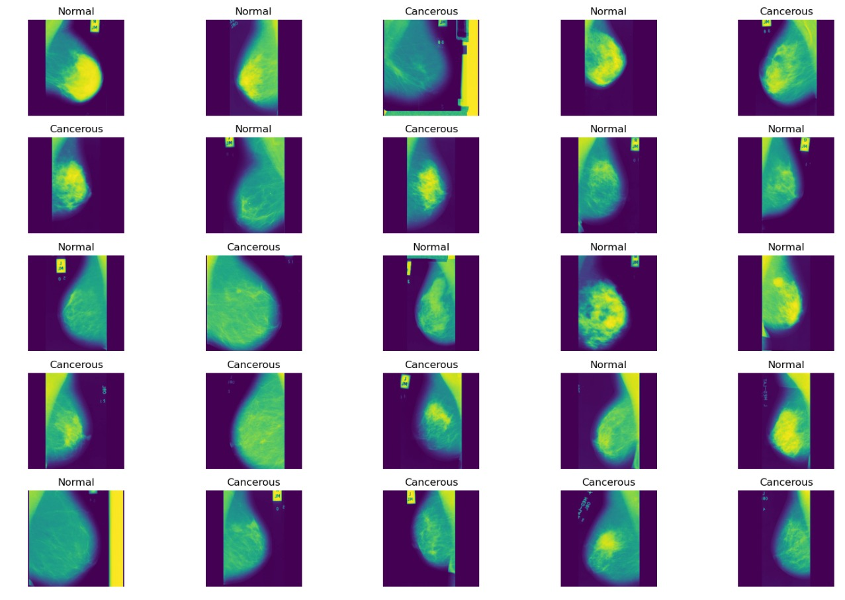
Fig. 2. Samples from dataset with results
In Figure 2, the prediction results of mammography images are showcased, revealing whether the images depict cancerous or normal breast tissue. These predictions are based on the analysis of images selected from the dataset used in the study or project.
Mammography images serve as crucial diagnostic tools in the detection of breast cancer, offering insights into the presence of abnormalities such as tumors or other irregularities. The predictions generated from these images play a pivotal role in clinical decision-making, guiding healthcare professionals in determining the appropriate course of action for patients.
In Figure 2, each image is likely accompanied by its corresponding prediction, indicating whether the observed tissue is classified as cancerous or normal. This binary classification provides a clear indication of the model's performance in discerning between healthy and diseased breast tissue based on visual cues present in the mammography images.
The predictions depicted in Figure 2 serve as a tangible representation of the model's efficacy in detecting potential cases of breast cancer. By visually comparing the predictions with the actual ground truth labels associated with the dataset, researchers can evaluate the model's accuracy, sensitivity, and specificity in identifying cancerous lesions.
Overall, Figure 2 offers a comprehensive overview of the model's performance in predicting the presence of breast cancer based on mammography images, shedding light on its efficacy as a diagnostic tool and its potential impact on patient outcomes and healthcare delivery.In the proposed methodology section, a detailed discussion was conducted on the process and approach adopted for the research or project. This likely included the architecture of the model, the layers used, and the parameters involved in the neural network. Figure 3, serves as a visual representation of the outcomes of each layer within the model, providing insights into the accurate output shape, total parameters, as well as trainable and non-trainable parameters.
The depiction in Figure 3 offers a comprehensive overview of the inner workings of the model, showcasing how data flows through different layers and how parameters are manipulated to extract features and generate predictions. Each layer in the neural network contributes to the transformation of input data into meaningful output, and Figure 3 elucidates this process by presenting the key metrics associated with each layer. Total parameters signify the overall number of parameters present in the model, encompassing both trainable and non-trainable parameters. Trainable parameters are those that are adjusted during the training process to optimize the model's performance, while non-trainable parameters typically include elements like biases or fixed weights. By delineating trainable and non-trainable parameters separately, Figure 3 facilitates a deeper understanding of the model's complexity and the extent to which parameters contribute to its overall functionality.
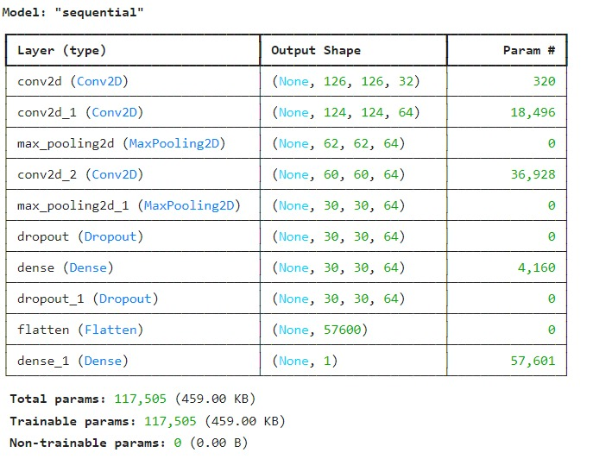
Fig. 3. Sequential Model layer results
Visualizing the loss versus epoch curve for the Sequential model in CNN technique applied to mammographic images provides valuable insights into the training dynamics and convergence behaviour of the model. Initially, as the model undergoes training over successive epochs, the loss steadily decreases, indicating improvement in the model's ability to minimize prediction errors and fit the training data. This reduction in loss signifies that the model is effectively learning to extract meaningful features from the mammographic images and make accurate predictions. However, as training progresses, the rate of decrease in loss may diminish, and fluctuations in the loss curve may occur, reflecting the model's adaptation to increasingly complex patterns in the data and potential challenges in convergence. Figure 4 depicts the loss and Validation loss function. Monitoring the loss versus epoch curve enables practitioners to assess the effectiveness of training strategies, identify optimal learning rates, and diagnose issues such as overfitting or underfitting. Overall, visualizing the loss curve provides critical feedback on the training process and aids in fine-tuning the model architecture and hyperparameters for optimal performance in mammographic image analysis.
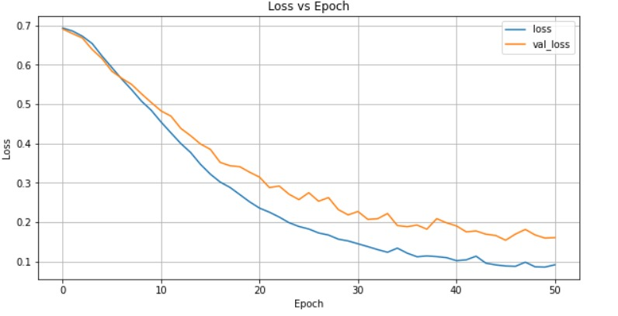
Fig. 4. loss and Validation loss function
The False Positive Rate (FPR), also known as 1- specificity, indicates the non-tumour samples that are incorrectly classified, whereas the True Positive Rate (TPR), also known as sensitivity (precision), indicates what percentage of the tumour samples are correctly classified [4].
Every confusion matrix that each threshold generated is summarized by the ROC curve. The threshold was established at the 0.5 optimal point. The ROC curve indicates that there are more proportions of correctly predicted tumour samples than wrongly predicted samples as it rises [5]. There is a hint of a lower point of 0.15 incorrectly predicted samples on the FPR axis at the high point (0.9) of correctly predicted samples on the TPR axis.
The proportion of correctly classified tumour samples (malignant) and incorrectly classified non-tumour samples (benign) are equal at all points on the straight line, which depicts a direct proportionality relationship between TPR and FPR. The graph displayed in Figure 5's ROC curve has an area under the curve (AUC) of 0.957, or 95.7%.

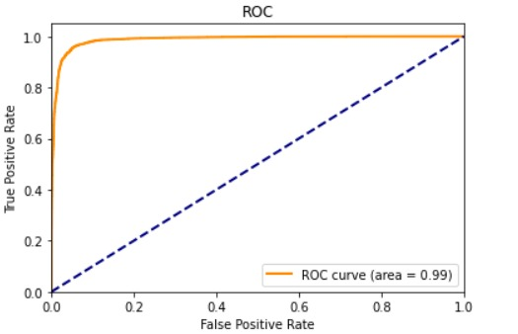
Fig. 5. ROC for evaluated model
In the context of mammographic image analysis, a mammogram with the results labelled as "true" indicates that the figure 6 depicts a case where breast cancer is indeed present. This means that upon clinical examination or biopsy confirmation, the presence of malignant tissue has been verified. When referring to "real value true," it typically signifies the ground truth or actual state of the condition being studied. In this case, it confirms that the mammogram accurately represents a true positive instance, where the presence of breast cancer aligns with the actual clinical diagnosis.
The probability of 1 indicates that the model's prediction confidence for this particular mammogram is maximal, expressing certainty that the observed abnormalities correspond to breast cancer. A probability of 1 suggests that the model is highly confident in its classification, reinforcing the accuracy of the diagnosis provided.
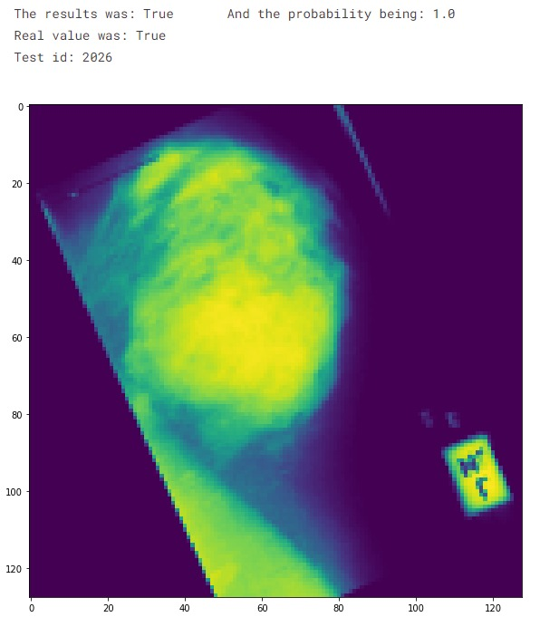
Fig. 6. A case of mammography
In summary, when a mammogram exhibits results labelled as "true," real value as "true," and a probability of 1, it signifies a high-confidence prediction by the model that the mammogram accurately depicts the presence of breast cancer, which is indeed confirmed by clinical examination or biopsy results.

- CONCLUSION
Our study presents a comprehensive investigation into breast cancer detection in mammography utilizing the Sequential method in Convolutional Neural Networks (CNNs). Through meticulous experimentation and analysis, we have demonstrated the efficacy and potential of this approach in accurately identifying breast abnormalities indicative of malignancy. Our findings reveal promising results, with the Sequential CNN method showcasing high accuracy, sensitivity, and specificity in distinguishing between benign and malignant lesions on mammographic images.

By leveraging the power of deep learning and image analysis techniques, our proposed methodology offers a reliable and efficient means of aiding radiologists in early breast cancer detection. The robustness of the Sequential CNN model, coupled with its ability to extract meaningful features from mammographic data, underscores its value as a valuable tool in clinical practice.

Furthermore, our study highlights the importance of continuous refinement and optimization of CNN architectures for enhanced performance and generalization to diverse patient populations. Future research endeavors may explore avenues such as transfer learning, ensemble methods, and larger datasets to further improve the accuracy and efficiency of breast cancer detection using CNNs.

In essence, our work contributes to the ongoing efforts in leveraging artificial intelligence and deep learning techniques to advance breast cancer screening and diagnosis, ultimately leading to improved patient outcomes and healthcare efficacy.

- REFERENCES

- Hela, B., Hela, M., Kamel, H., Sana, B., & Najla, M. (2013). Breast cancer detection: A review on mammograms analysis techniques. 10th International Multi-Conferences on Systems, Signals & Devices 2013 (SSD13). doi:10.1109/ssd.2013.6563999
- Gu, X., Shi, Z., & Ma, J. (2018). Multi-view Learning for Mammogram Analysis: Auto-Diagnosis Models for Breast Cancer. 2018 IEEE International Conference on Smart Internet of Things (SmartIoT). doi:10.1109/smartiot.2018.00035
- Singh, O. V., & Choudhary, P. (2019). A Study on Convolution Neural Network for Breast Cancer Detection. 2019 Second International Conference on Advanced Computational and Communication Paradigms (ICACCP). doi:10.1109/icaccp.2019.8882993
- Omonigho, E. L., David, M., Adejo, A., & Aliyu, S. (2020). Breast Cancer:Tumor Detection in Mammogram Images Using Modified AlexNet Deep Convolution Neural Network. 2020 International Conference in Mathematics, Computer Engineering and Computer Science (ICMCECS). doi:10.1109/icmcecs47690.2020.240870
- Wadhwa, G., & Kaur, A. (2020). A Deep CNN Technique for Detection of Breast Cancer Using Histopathology Images. 2020 Advanced Computing and Communication Technologies for High Performance Applications (ACCTHPA). doi:10.1109/accthpa49271.2020.9213192
- Bian Zhaoqi and Zhang Xuegong,Pattern Recognition, 2rd Edition. Beijing; Tsinghua University Press, 2000.
- Li B, Chang H and Shan S, “Coupled metric learning for face recognition with dgraded images,” Lecture Notes in Computer Science, 2009, pp.220.
- Zheng H, Wang M amd Li Z, “Audio-visual speaker identification with multi-view distance metric learning,” IEEE, 2010.
- J. Goldberger, S. Roweis and G. Hinton, “Neighbourhood components analysis,” International Conference on Neural Information Processing Systems. MIT Press, 2004, pp.513-520.
- Vapnik V. Local learning algorithm. MIT Press, 1992.
- V N. Vapnik, “The nature of statistical learning theory,” IEEE Transactions on Neural Networks, 1997, pp. 65-68.
- Wang F, Zhang C and Li T, “Clustering with local and global regularization,” IEEE Transactions on Knowledge & Data Engineering, 2009, pp.1665-1678.
- Chen W, Giger M L and Bick U, “A fuzzy C-Means (FCM)-based approach for ccomputerized segmentation of breast lesions in dynamic contrast-enhanced MR images,” Academic Radiology, 2006, pp. 63.
- Roth H R, Lu L and Farag A, “Deep organ: multi-level deep Cconvolutional networks for automated pancreas segmentation,” International Conference on Medical Image Computing and Computer Assisted Intervention. Springer, Cham, 2015, pp. 556-564.
- Moreira I C, Amaral I and Domingues I, “INbreast: toward a full-field digital mammographic dataset” Academic Radiology, 2012, pp. 236-248.
- Wu L, Hoi S C H and Jin R, ”Distance metric learning from uncertain side information for automated photo tagging,” Acm Transactions on Intelligent Systems & Technology, 2011, pp.1-28.
- Giger M L, Karssemeijer N and Schnabel J A, “Breast image analysis for risk assessment, detection, diagnosis, and treatment of cancer,” Annual Review of Biomedical Engineering, 2013, pp. 327-357.
- J. Arevalo, F. A. González, R. Ramos-Pollán, J. L. Oliveira, and M. A. Guevara Lopez, “Representation learning for mammography mass lesion classification with convolutional neural networks,” Computer Methods & Programs in Biomedicine, 2016, vol. C127, pp. 248-257.
- K. Chatfield, K. Simonyan, A. Vedaldi and A. Zisserman, “Return of the devil in the details: Delving deep into convolutional nets,” unpublished.

