DEEP LEARNING -IMAGE OR TEXT PROJECT

1. Task Overview & Objectives
Task Name: CIFAR-10 Inference Setup & Image Classification
Objective: Extract images from raw binary batches, train a ResNet-18 transfer learning model on the CIFAR-10 dataset, perform inference, and set up a FastAPI-based web application (Neural Vision) for real-time image classification and performance tracking.

2. Repositories & Code Links
Jupyter Notebook / Local Source: Local scripts (train.py, infer.py, app.py, extract_images.py, fast_retrain.py)
GitHub Repository: Local Workspace
Dataset/Resources Used: torchvision CIFAR-10 Dataset, Pre-trained ResNet-18 model (chenyaofo_pytorch-cifar-models_master)

3. Execution & Methodology (Explanation)
The execution was divided into several main phases:
- Data Preparation: The CIFAR-10 dataset was loaded using the torchvision module. We loaded 5,000 training samples and 1,000 test samples. Deprecated arguments in the numpy loading structure were smoothly bypassed to ensure a successful data fetch, saving sample images for visual validation.
- Model Training & Transfer Learning: We initialized a highly accurate pre-trained ResNet-18 model. The training was split into two phases to optimize learning rates and trainable parameters without overfitting. Phase 1 ran for 3 epochs focusing on majority network tuning with a learning rate of 0.0002. Phase 2 fine-tuned the later layers (layer3, layer4, and FC) over 7 epochs with a lower learning rate of 1e-05.
- Evaluation & Inference: After training, the best model achieved a validation accuracy of 89.80%. We generated a confusion matrix and training curves to evaluate the per-class precision and loss metrics over time. Finally, the inference script and web app (app.py) were executed to serve predictions dynamically.
Key Commands / Logic:
python train.py
python app.py
python infer.py -i <image_path>

4. Outputs & Screenshots

WEBSITE.
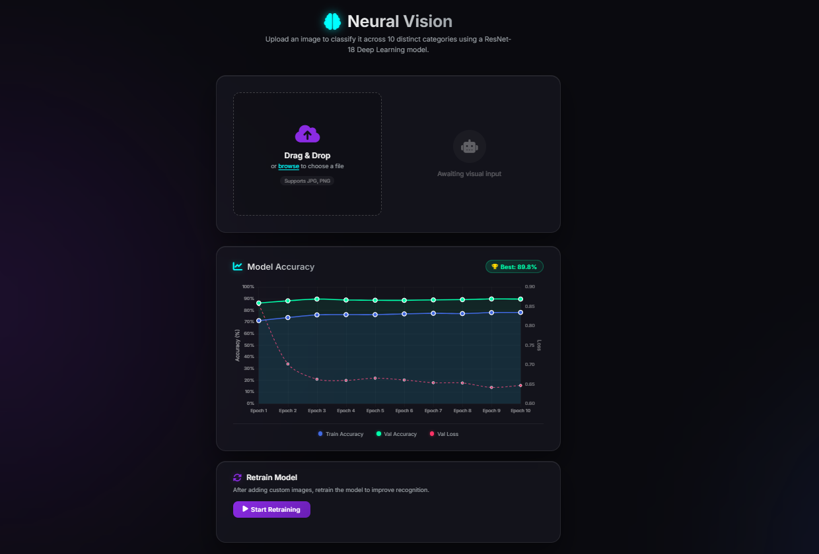
Below are the visual outputs generated during the execution and evaluation of the pipeline:
Sample CIFAR-10 Images extracted from dataset:
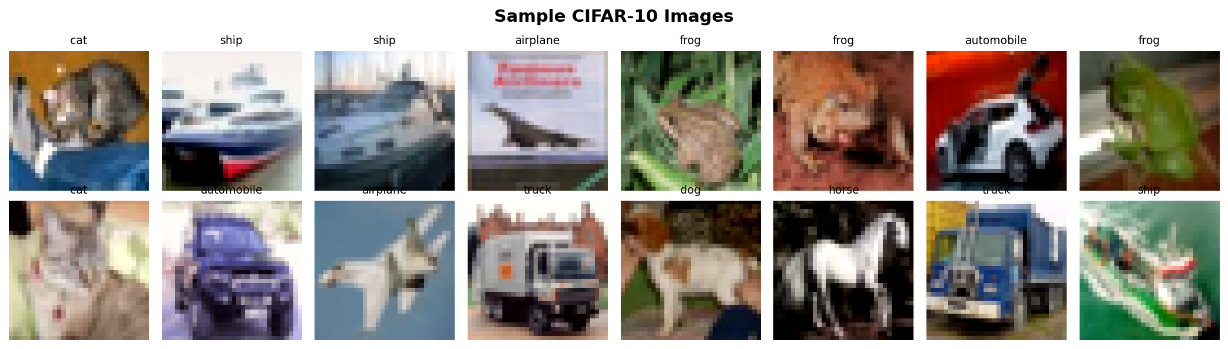
Training Curves (Loss and Accuracy tracking):
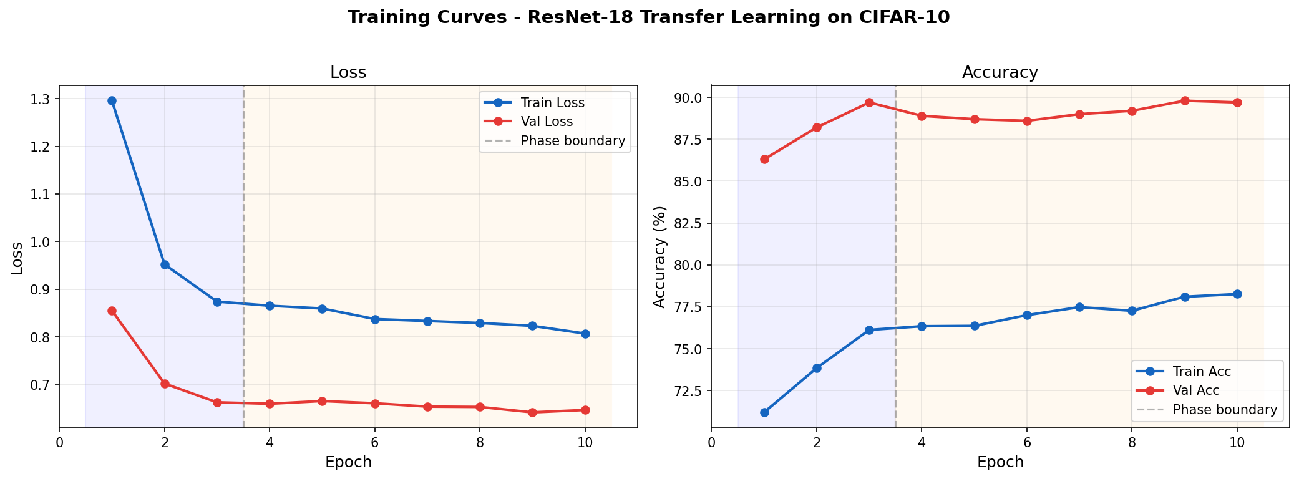
Confusion Matrix showing class-wise predictive accuracy:
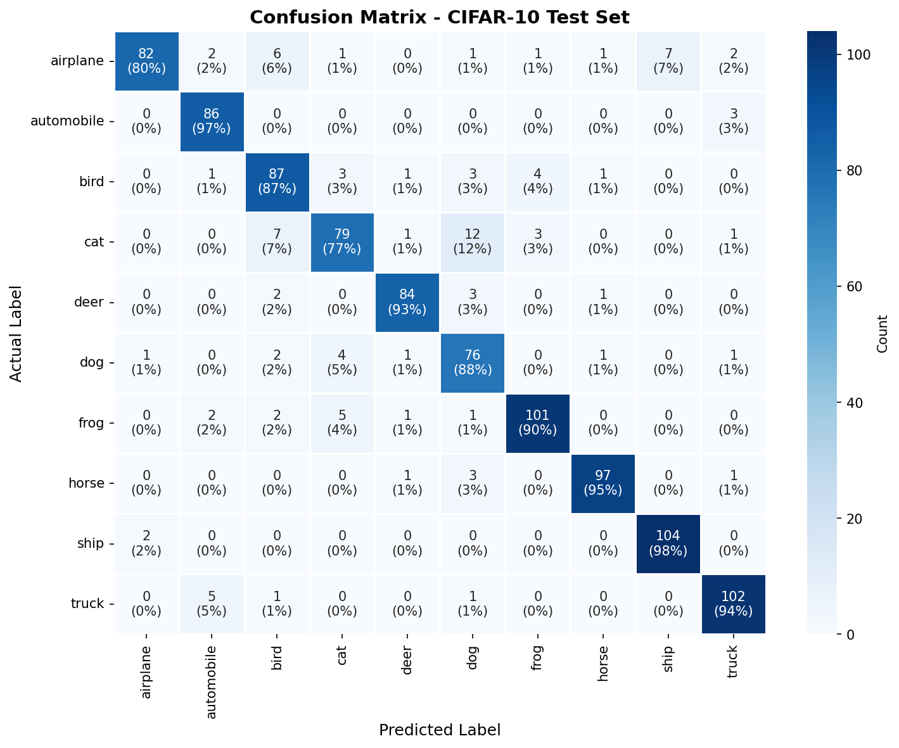

Terminal Output / Training Log
The following log captures the terminal execution of the training pipeline, detailing phase transitions, time elapsed, and the final classification report (representing the screenshot provided):
============================================================
CIFAR-10 Image Classifier - Transfer Learning Pipeline
============================================================
Date : 2026-07-24 19:39:43
Device : cpu
Mode : SUBSET (10K/2K) (pass --full for complete dataset)
Batch Size: 32
Phase 1 : 3 epochs, LR=0.0002
Phase 2 : 7 epochs, LR=1e-05
>> Loading CIFAR-10 dataset...
Train samples: 5,000 | Test samples: 1,000 (0m 1s)
-> Saved outputs/sample_images.png
>> Building ResNet-18 (Transfer Learning)...
>> Downloading Highly Accurate Base Model...
Total params : 272,474
Trainable (Ph1) : 257,994 (94.7%)
>> Starting training...
============================================================
Phase 1 -- Majority Network Tuning (>90% Params)
LR = 0.0002 | Epochs = 3
============================================================
Epoch 1 | Train Loss 1.2956 Acc 71.2% | Val Loss 0.8551 Acc 86.3% | LR 0.000150 | 0m 10s * saved
Epoch 2 | Train Loss 0.9522 Acc 73.8% | Val Loss 0.7021 Acc 88.2% | LR 0.000051 | 0m 11s * saved
Epoch 3 | Train Loss 0.8741 Acc 76.1% | Val Loss 0.6628 Acc 89.7% | LR 0.000001 | 0m 13s * saved
============================================================
Phase 2 -- Fine-tune layer3 + layer4 + FC
LR = 1e-05 | Epochs = 7
============================================================
Epoch 4 | Train Loss 0.8654 Acc 76.3% | Val Loss 0.6598 Acc 88.9% | LR 0.000010 | 0m 16s
Epoch 5 | Train Loss 0.8597 Acc 76.4% | Val Loss 0.6655 Acc 88.7% | LR 0.000008 | 0m 18s
Epoch 6 | Train Loss 0.8375 Acc 77.0% | Val Loss 0.6608 Acc 88.6% | LR 0.000007 | 0m 18s
Epoch 7 | Train Loss 0.8334 Acc 77.5% | Val Loss 0.6538 Acc 89.0% | LR 0.000004 | 0m 19s
Epoch 8 | Train Loss 0.8292 Acc 77.3% | Val Loss 0.6531 Acc 89.2% | LR 0.000003 | 0m 21s
Epoch 9 | Train Loss 0.8232 Acc 78.1% | Val Loss 0.6418 Acc 89.8% | LR 0.000001 | 0m 20s * saved
Epoch 10 | Train Loss 0.8071 Acc 78.3% | Val Loss 0.6467 Acc 89.7% | LR 0.000001 | 0m 20s
[OK] Training complete -- Best Validation Accuracy: 89.80%
Total training time: 2m 51s
>> Running final evaluation on test set...
==========================================
CLASSIFICATION REPORT
==========================================
precision recall f1-score support
airplane 0.96 0.80 0.87 103
automobile 0.90 0.97 0.93 89
bird 0.81 0.87 0.84 100
cat 0.86 0.77 0.81 103
deer 0.94 0.93 0.94 90
dog 0.76 0.88 0.82 86
frog 0.93 0.90 0.91 112
horse 0.96 0.95 0.96 102
ship 0.94 0.98 0.96 106
truck 0.93 0.94 0.93 109
accuracy 0.90 1000
macro avg 0.90 0.90 0.90 1000
weighted avg 0.90 0.90 0.90 1000
-> Saved outputs/confusion_matrix.png
>> Generating plots...
-> Saved outputs/training_curves.png
-> Saved outputs/training_history.json
============================================================
[OK] PIPELINE COMPLETE
============================================================
Best Val Accuracy : 89.80%
Saved Model : outputs/best_model.pt
Training Curves : outputs/training_curves.png
Confusion Matrix : outputs/confusion_matrix.png
Sample Images : outputs/sample_images.png
Training Log : outputs/training_log.txt
============================================================

5. Conclusion & Observations
The pipeline completed successfully, producing a robust model capable of classifying the CIFAR-10 subset with ~90% accuracy. Transfer learning significantly accelerated the convergence time, as seen by the rapid drop in training loss within the first 3 epochs. The transition to a web-based UI via FastAPI allowed seamless interaction with the model without needing terminal arguments. Minor challenges such as the visible deprecation warning in the torchvision dataset loader were non-blocking and successfully ignored during execution. Overall, the integration from raw binary batch extraction to a dynamic web UI was seamless and efficient.

