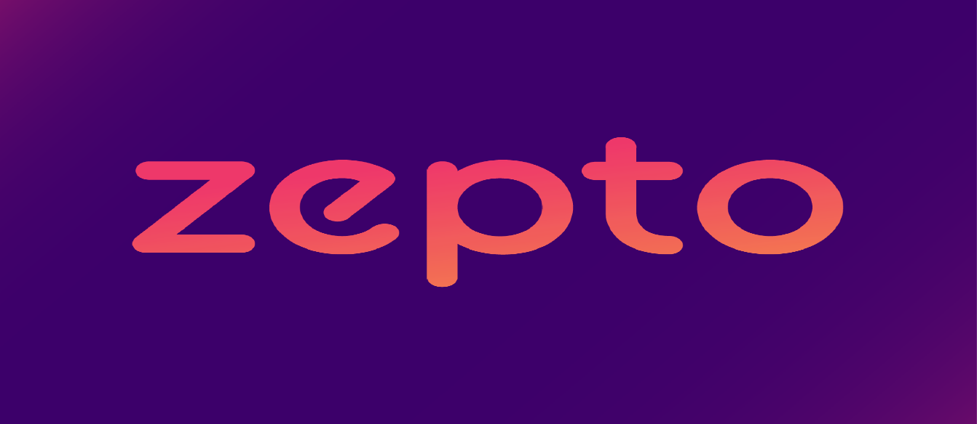

**Product Dissection for Zepto**

**Company Overview:**

Zepto, a rapidly growing startup in the hyperlocal delivery space, was founded with the mission to revolutionize the way people shop for groceries and essentials. By offering ultra-fast delivery services, Zepto addresses the increasing demand for convenience and immediacy in the urban lifestyle. Zepto has quickly emerged as a significant player in the e-commerce landscape, particularly in major metropolitan areas, by combining technology, logistics, and customer-centric services.

**Product Dissection and Real-World Problems Solved by Zepto:**

Zepto’s core product is an ultra-fast delivery service for groceries and everyday essentials, promising delivery within 10 minutes. By addressing the need for immediate access to products, Zepto has successfully filled a gap in the market, catering to urban dwellers who value time and convenience.

**Problem 1: Immediate Access to Essentials**

* **Real-World Challenge**: In fast-paced urban environments, people often require groceries and daily essentials on short notice but find it difficult to make time for shopping.
* **Zepto's Solution**: Zepto's ultra-fast delivery model ensures that users can order groceries and have them delivered in as little as 10 minutes. By strategically positioning micro-warehouses in densely populated areas and using advanced logistics algorithms, Zepto provides a solution to the problem of needing quick access to everyday items.

**Problem 2: Inconsistent Delivery Timelines**

* **Real-World Challenge**: Traditional grocery delivery services often suffer from inconsistent and long delivery windows, which can be inconvenient for users with busy schedules.
* **Zepto's Solution**: Zepto has redefined delivery speed with its promise of delivery within 10 minutes. This consistency in delivery time, backed by real-time tracking, solves the problem of unreliable delivery schedules, giving users confidence that their orders will arrive on time.

**Problem 3: Limited Availability of Fresh Produce**

* **Real-World Challenge**: Ensuring the availability of fresh produce and perishable items in grocery delivery can be challenging, especially in terms of maintaining quality during transit.
* **Zepto's Solution**: Zepto tackles this issue by maintaining a well-organized supply chain that prioritizes freshness. The company sources products directly from farmers and local suppliers, reducing transit times and ensuring that customers receive fresh items. Their micro-warehouse model allows for frequent restocking and ensures that products remain fresh from the warehouse to the doorstep.

**Problem 4: High Delivery Costs**

* **Real-World Challenge**: Many online grocery services charge high delivery fees, making it less appealing for customers to opt for home delivery.
* **Zepto's Solution**: Zepto offers competitive pricing with low or no delivery fees for smaller orders. By optimizing delivery routes and leveraging economies of scale, Zepto keeps operational costs low, passing these savings on to customers.

**Case Study: Real-World Problems and Zepto's Innovative Solutions**

Zepto, as a pioneer in the hyperlocal delivery sector, has not only transformed the grocery shopping experience but has also solved significant real-world problems through its innovative service model. By addressing key pain points such as immediate access to essentials, consistent delivery timelines, availability of fresh produce, and delivery costs, Zepto has positioned itself as a solution-oriented platform that enhances the convenience of modern living.

**Top Features of Zepto:**

1. **Ultra-Fast Delivery**:
   * **Feature**: Zepto's standout feature is its 10-minute delivery service for groceries and essentials.
   * **Benefit**: Provides unparalleled convenience for users needing items on short notice.
2. **Micro-Warehouses**:
   * **Feature**: Zepto operates micro-warehouses across cities to store a variety of products close to customers.
   * **Benefit**: Ensures quick delivery times and maintains product freshness by reducing transit distances.
3. **Real-Time Order Tracking**:
   * **Feature**: Customers can track their orders in real-time through the app.
   * **Benefit**: Increases transparency and customer satisfaction by allowing users to monitor the delivery process.
4. **Wide Product Selection**:
   * **Feature**: Zepto offers a diverse range of products, from fresh produce to household essentials.
   * **Benefit**: Acts as a one-stop shop for users, eliminating the need to visit multiple stores.
5. **Competitive Pricing**:
   * **Feature**: Zepto offers competitive pricing with minimal delivery fees.
   * **Benefit**: Makes online grocery shopping affordable and accessible to a broader audience.

**Schema Description:**

The schema for Zepto includes various entities representing different components of the platform. These entities manage users, orders, products, deliveries, and more, ensuring efficient operations.

1. **User Entity**:
   * **UserID (Primary Key)**: Unique identifier for each user.
   * **Userame**: The full name of the user.
   * **Email**: The user's email address.
   * **Phone Number**: Contact number for communication.
   * **Address**: The delivery address of the user.
   * **Registration Date**: Date the user signed up.
2. **Product Entity**:
   * **ProductID (Primary Key)**: Unique identifier for each product.
   * **Name**: The name of the product.
   * **Category**: The product's category (e.g., fruits, vegetables, dairy).
   * **Price**: The price of the product.
   * **Stock**: The quantity of the product available in the warehouse.
3. **Order Entity**:
   * **OrderID (Primary Key)**: Unique identifier for each order.
   * **UserID (Foreign Key referencing User Entity)**: The user who placed the order.
   * **OrderDate**: The date and time the order was placed.
   * **TotalAmount**: The total cost of the order.
   * **Status**: The current status of the order (e.g., pending, delivered).
4. **Delivery Entity**:
   * **DeliveryID (Primary Key)**: Unique identifier for each delivery.
   * **OrderID (Foreign Key referencing Order Entity)**: The order associated with the delivery.
   * **DeliveryPersonID**: The person responsible for delivering the order.
   * **DeliveryTime**: The time when the delivery was completed.
   * **DeliveryStatus**: The status of the delivery (e.g., in progress, completed).
5. **Warehouse Entity**:
   * **WarehouseID (Primary Key)**: Unique identifier for each warehouse.
   * **Location**: The physical location of the warehouse.
   * **Capacity**: The maximum storage capacity of the warehouse.
   * **Products**: The list of products stored in the warehouse.
6. **Payment Entity**:
   * **PaymentID (Primary Key)**: Unique identifier for the payment.
   * **OrderID (Foreign Key referencing Order Entity)**: The order associated with the product.
   * **PaymentMethod**: The quantity of the product ordered.
   * **Amount**: Total amount of the order
   * **PaymentStatus**: Status of the payment.

**Relationships:**

* **Users place Orders** – A user can place multiple orders.
* **Orders include Products** – An order can consist of multiple products.
* **Orders are delivered by Delivery Persons** – Each order is associated with one delivery person.
* **Products are stored in Warehouses** – Each product is stored in multiple warehouse.
* **Payment is made for orders** – Payment is made for each order.

**ER Diagram:**

The ER diagram for Zepto would visually represent the relationships and attributes mentioned above. It would include entities like Users, Orders, Products, Deliveries, and Warehouses, and illustrate how these entities interact with each other, showing primary and foreign key relationships that maintain the integrity of the data model.

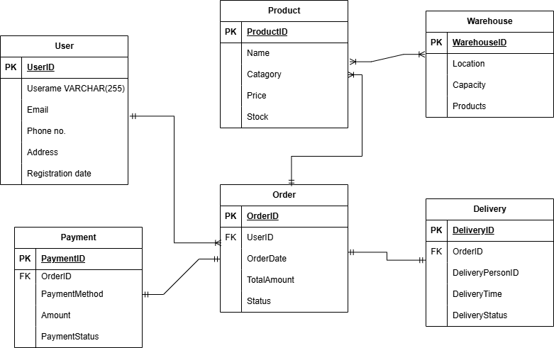

**Conclusion:**

In this case study, we explored the design of Zepto's schema and its corresponding Entity-Relationship diagram. Zepto has transformed the grocery delivery landscape by addressing key urban challenges, such as immediate access to essentials and consistent delivery timelines. The platform's innovative data model supports its operational efficiency and user experience, making it a leader in the hyperlocal delivery industry. Understanding Zepto's schema offers insight into how the company manages its complex logistics and customer interactions, contributing to its rapid growth and success.