Convolution Neural Network-based Agriculture Drought Prediction using Satellite Images
Vandana Sudhakar Sardar¹, Yindumathi K M, Shilpa Shashikant Chaudhari, Prosenjith Ghosh²
¹Dept. of Computer Science and Engineering
M S Ramaiah Institute of Technology, Bengaluru, India (Affiliated to VTU)

²Centre for Earth Science, Indian Institute of Science, C.V. Raman Avenue,

Bengaluru - 560 012, Karnataka, India
*Corresponding author: vandana.s@msrit.edu, kmyindumathi@gmail.com, shilpasc29@msrit.edu, pghosh@iisc.ac.in

Abstract— Water scarcity due to limited water resources and substantial increase in water consumption leads to drought situation many parts of world. Agricultural drought affects all walks of life in varyingly severe magnitudes. No solutions exist to completely avoid drought conditions. Analyzing past patterns through drought monitoring for early warning and predicting future drought conditionshelp to mitigate or control causes of drought in many sectors such as water management, agriculture, dam utilization and other various ecosystems. Traditionally, agriculture drought monitoring is typically supported by drought indices such as standardized precipitation index (SPI), Multivariate SPI, Palmer drought severity index, normalized difference vegetation index (NDVI), crop moisture index, Standard Precipitation Evapotranspiration Index, Z-index and crop specific index, and effective drought index etc to evaluate drought effects in agriculture sector. Artificial intelligence (AI) models complex and uncertain situation scholarly. Research on drought prediction uses various AI models based on rainfall/temperature data or satellite data. Convolution neural network (CNN) based drought prediction does not exist. The main objective of this paper is to predict drought or no drought condition using CNN model on the basis of NDVI computed from satellite images for a given location in Kolar district of Karnataka, India. Satellite images are obtained from National Remote Sensing Center (NRSC) and converted to NDVI images. The evaluation of CNN model includes Nash index, correlation coefficient and root mean square error. The improved accuracy is observed up to 96%.
Keywords - Drought Prediction, Normalized difference vegetation index, Convolution neural network

Introduction
Attributed to the unusual variation in climate, drought has far been identified as a normal, recurrent feature of climate. Drought indicates natural variability in climate cycle that affects the water level in large-regions over extended period of time. It can have a substantial impact on the livestock and ecosystem of the affected region. Droughts are among the most detrimental natural calamities as they cause severe conditions leading to a humanitarian crisis. It is an ecological incident, which is manifested in the reduction of farming production, causing social crisis and transforming into political disputes. This protracted period of deficient precipitation causes extensive damage to crops, and results in loss of yield.
Even though drought is classified into four types such as Agricultural, Hydrological, Meteorological and Socio-Economic, agriculture drought is the topic of the article as agriculture is the main occupation and drought effect on it is major in most part of India. Lack of rainfall indicates meteorological drought condition. Insufficient soil moisture due to meteorological drought or raise in temperature affects the crop growth and its production in agricultural drought. Its impact persists for long time. Insufficient groundwater level leads to hydrological drought. Time duration when good or product availability reduced is socio-economic drought.
As a responsive measure, drought assessment and monitoring missions have been conducted. Monitoring and forecasting agricultural drought is an important issue in agriculture sector. It also helps for water resource management perspectives for agriculture. Agricultural drought monitoring, assessing and predicting is supported by drought indices such as standardized precipitation index (SPI), Multivariate SPI, Palmer drought severity index, normalized difference vegetation index (NDVI), crop moisture index, Standard Precipitation Evapotranspiration Index, Z-index and crop specific index, and effective drought index etc to evaluate drought effects in agriculture sector. These indices identify drought characteristics in terms of magnitude, duration, severity and special event. Drought prediction approaches include stochastic, dynamic, categorized, machine learning and hybrid models. However, most of the efforts so far have been based on conventional methods that rely on the availability of meteorological point data like amount of rainfall and therefore the related indices. These methods require a tiresome data collection, and provide scarce information as a given data represents a wide geographical region. Therefore, producing more reliable information for concerned bodies is very important.
Recently, data availability driven by technological advancement from remote sensing is engrossing to overcome the limitations of the traditional drought indices. Continuous remote sensing data availability helps to detect the onset of a drought, its duration and magnitude. These sensors capture spectral bands reflected from the surface of the world and supply information for monitoring green vegetation conditions on the ground: dense, scarce, or depleted. Through scientific investigations, a number of researchers have tried to derive information from satellite images to accompany other ecosystem’s data for better and more accurate prediction of drought. The image-based analysis provides more profound information, especially, for areas where ground monitoring using meteorological data is scarce. This approach requires a good knowledge of image processing for feature extraction. The remote sensing satellites provide data at specific intervals (e.g., Meteos at Second Generation (MSG) data for every 15 minutes). [11, 15, 16] However, little effort had been exerted to the proper drought feature extraction and interpretation from remote sensing data. Thus, the bulky available information makes it difficult for decision makers to analyze [1, 5].
Remote sensing images consist of spatial resolutions alternative path those are used to derive objects with numerous pixels. These objects are grouped to define objects of interest based on similar pixel reflectance of its pixels and closer spatial location. These objects represent earth feature such as road, water-bodies etc. or virtual geographical condition such as drought. Temporal and spatial drought pattern varies with time and earth area. Future drought impacts can be reduced by identifying the relationships between drought object characteristics with a particular delay for a specific area.
The existing drought prediction literature focuses on SPI computation using rainfall and temperature data which is given as fed to AI model such as ARIMA, ANN, RNN, random forest [18]. Very few works predict the drought using NDVI based satellite image. Even though CNN is more efficient prediction technique using images, no such combination used in the literature for drought prediction. This paper proposes the drought prediction using CNN based on satellite images. Drought prediction should be spatially distributed using spatial vegetation pattern, NDVI is well known for studying spatial vegetation pattern and drought events. Time series NDVI is obtained from the remote sensing-based techniques for drought assessment of crops that has been developed by ISRO and operationalized to Mahalanobis National Crop Forecast Centre (MNCFC), which carries out this activity regularly. NDVI image is computed using CNN on satellite images of the selected area. NDVI forecast based on satellite images investigates the suitability in the topic of the paper. Time series data- mining and prediction algorithms are used to identify relationships between consecutive drought objects for a given spatial location
The rest of the paper is organized into 5 sections. Related work on drought prediction is discussed in Section 2 wherein the drought prediction using rainfall and satellite data is discussed. Section 3 presents the CNN based drought prediction using satellite image. Section 4 discusses the results obtained in terms of accuracy as major performance parameter. Section 5 concludes the proposed work.

Related Work

The existing work in the literature on usage of satellite data for drought prediction is discussed in this section. The drought prediction is based on supervised or unsupervised learning. Supervised learning uses deep belief network while unsupervised learning uses either support vector machine or neural networks. Time series satellite data is used to monitor vegetation index over long periods. The satellite data is considered as two spectral reflections - green vegetation in near infrared (NIR) and red vegetation in the spectrum (RED). The indices used are NDVI, TCI, CHI, VCI, SPI, vegetation temperature condition index (VTCI), LST, and SOI. Survey on satellite remote sensing for drought given in [11] concludes that it offers a unique toolset for drought and its impact on ecosystem. It reveals drought also impacts on the carbon and nitrogen cycle. There is a need for collective model of multiple data sets and/or satellite observations to generate long-term climate data records.
Images for Drought Monitoring [1] extract the drought objects using the concepts of local maxima, local minima and NDVI deviation values. It calibrates NDVI deviation where negative NDVI deviation indicates the drought establishment in the area and positive deviations show the healthy vegetation growth in the area. Geo-spatial analysis shows that approximately 37% of area had less than 40% VCI, indicating the occurrence of a drought which helps to take timely and appropriate actions. Agricultural drought and soil moisture analysis using satellite image-based indices [2] considers SPI computed from observed cumulative rainfallas number of standard deviations in the time scale of 1/3/6 month and VHI based on satellite image for soil moisture assessment with four categories considered for drought region classification such as mild, moderate, severe and extreme if the SPI falls in the range 30-40, 20-30, 10-20, and less than 10 respectively. Deep Belief Networks for Short-Term Prediction of Drought Index [3] discusses the design of a deep belief network to forecast drought index using SPI. The forecasting methods used are non-homogeneous Markov chain, Grey-time series combined method, chaotic Bayesian method, VTCI, ARIMA models, and Back Propagation Network. Rule-based Drought Early Warning Expert Systems using Indigenous Knowledge [4] uses local indigenous expert knowledge on drought. Probabilistic reasoning based expert system automatically generates drought advisory information inference using the dataset that consists of the domain acquired facts and an inference engine for controlling the inference process.
Monitoring of Drought using Satellite Data [5] recognizes the high correlation between ground rainfall stations record and NDVI obtained from satellite sources to identify and extract agricultural and meteorological drought risk areas. Satellite Data and Supervised Learning to prevent impact of drought on crop production [6] discusses meteorological indexes and supervised learning approaches with Support vector regression (SVR), least squares SVR (LS-SVR), Random Forest regression (RFR) for drought prediction. Hybrid models using SPI are used for forecasting hydrological and climatological time series. Multispectral Image-Based Estimation of Drought Patterns and Intensity [7] uses suitable cloudless images from Landsat for analysis. VTCI is computed from thermal stress-based Land Surface Temperature and vegetation state-based NDVI which is used for indicating drought patterns of the wetlands in Lake Chad. Predicting Drought Occurrences [8] quantitatively compares the forecast skills obtained using Auto Regressive model (AR) based on the SPI at one-month time scale as forecast target and Gamma Highest Probability (GAHP) forecasts the precipitation for a future month based on probability density function for that month.
Artificial intelligence models for forecasting meteorological drought using SPI [9] considers SPI-3 as short-term drought index and SPI-12 as long-term drought conditions. These both SPI indices are predicted using wavelet based (ANN) with errors reduced to 88%, regression vector systems (SVR), Fuzzy Logic (FL) and adaptive neuro-fuzzy inference system (ANFIS). Satellite-based hybrid drought monitoring [10] develops commercial classification and regression tree algorithm for monthly prediction of vegetation condition during the growing season in Eastern Africa called as VegOut-Ethiopia. The attributes used are Standardized deviation of NDVI, Soil water holding capacity, Digital elevation model, Pacific decadal oscillation, SPI-3, Atlantic multidecadal oscillation index, North Atlantic oscillation, Pacific North American index and Multivariate ENSO index.
Drought forecasting using ANN and time series of drought indices [12] uses SPI calculated from precipitation records. The computed SPI is initially fitted to gamma distribution and then transformed into a normal distribution so the mean SPI is zero. Four SPI ranges are considered for drought region classification such as near normal, moderately dry, severely dry and extremely dry. Severe Drought Area using Satellite Image and Topography Data [13] designed SDAP model for short-term drought prediction using own Difference Drought Index (DDI) Hungarian study areas. It neither uses meteorological data nor a probability prediction of drought occurrence but a Palmer Drought Sensitivity Index (PDSI) is calculated from precipitation, temperature and soil moisture data. As in [14], for the large-scale drought monitoring various sensors such as National Oceanic Atmospheric Administration (NOAA) satellites, vegetation sensor (VGT) onboard Satellite and Moderate Resolution Imaging Spectroradiometer (MODIS) onboard TERRA and AQUA satellites have been used. Drought Monitoring in Food-Insecure Areas (DMFA) [15] monitors drought using NDVI computed from satellite images obtained from polar orbiting satellites. The computed NDVI monitors the state of the agricultural fields, vegetation cover, estimating crop yield in addition to drought forecasting. Satellite image processing for precision agriculture and agroindustry [16] produces optimum solution in short time using CNN and Genetic Algorithm (GA). Satellite images are processed by CNN to model data in a grid form. Recombination as optimization process of GA stores all best individuals in a multi-objective GA generation process. Agricultural drought forecasting using satellite images, climate indices and ANN [17] monitors vegetation density using NDVI that varies more or less linearly with leaf area index (LAI) values in the range of zero to two. The zero value of LAI indicates bare soil. A high correlation between NDVI and annual monthly rainfall was predicted. Monitoring of agricultural drought in Poland [18] detect and monitor drought for estimating its impact on crop production using satellite images acquired by Terra/Modis. NDVI, VCI and TCI indices are computed.

Methods
First review was started from the year 2009 based on [1] image segmentation and recognition theory. In general, the bank invoice of chinese is a color image. The color invoice image is applied with encryption techniques. The right-up angle in the invoice is the key information that is composed of 0-9 numbers and 26 English criss-cross rows. The backdrop color of the invoice filtered out in the rectiliner region. Thus, the color invoice image is changed into monochrome with filter effect. Through binarization, image enhancement, sharp, filter, any invoice in a database can be extracted by pattern matching theorem exactly.
The study area for the current work is Kolar district, which is located between north latitude 130 02’ 03” and 130 19’11” and east longitude 770 56’ 02” and 780 13’ 02”, It has semi-arid to arid climate. It experiences dryness and hot weather in major part of the year. It is categorized as drough prone area as it falls under Eastern dry agro-climatic zone of Karnataka state. Time series satellite data is used to monitor vegetation index over long periods. The satellite data is considered as two spectral reflections - green vegetation in near infrared (NIR) and red vegetation in the spectrum (RED). Green vegetation has strong spectrum absorption in red region while it has high reflectance in infrared region. Satellite remote sensors quantify fraction of the photo synthetically active radiation to characterize vegetation health in terms of NIR and RED combinations that is absorbed by vegetation. Absorption and reflection of photo synthetically active radiation over a given period of time in the region for indicating vegetation health is given as NDVI that is computed as shown in equation 1.
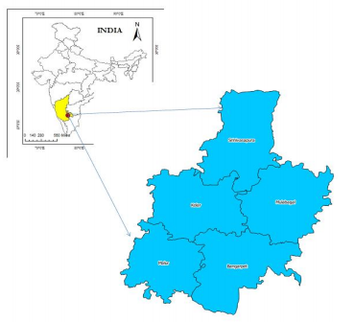

Fig. 1 Study Area

NDVI = (NIR - RED) / (NIR + RED) ….1

Satellite image data is considered in the form of bands wherein each band is a regular matrix with columns and rows in the georasters format with a georeferentiation. GeoTIFF file of Kolar district that is obtained from Linear Imaging Self Scanning sensor-3 of ResourceSat-2 imagery. The imagery is about 39.1 MB consisting of a wide dynamic range is shown figure 2.

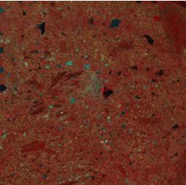

Fig. 2 ResourceSat-2 GeoTIFF image

GeoTIFF file of Kolar district that is in raster format need to be converted to dataset object. Rasterio’s open() function from python library is used, which takes this GeoTIFF file path string and returns an opened dataset object using the proper GDAL format driver from Rasterio python library [2]. The opened databases object attributes indicate GeoTIFF file information that can be accessed for further processing. The successful execution stores raster data properties in terms of bands. Dataset objects of GeoTIFF file of Kolar district have four bands i.e band 2, band 3, band 4, and band 5. Each band represents 2-dimensional array/spaces for partial distribution of a single variable. Same number of rows and columns exists for all bands in a dataset object. Level-3 digital numbers (DN) for wavelengths represents a variable for partial distribution in band 3 and band 4. Figure 3 shows the Level-3 DN for the ResourceSat-2 band 3 (Red) where the wavelengths vary between 0.62-0.68 micro meter while figure 4 shows the band 4 (NIR) where wavelengths vary between 0.770.86 micro meters. The array size for Level-3 DN is 2262 rows by 2262 columns. These values can be scaled to radiance or reflectance values.

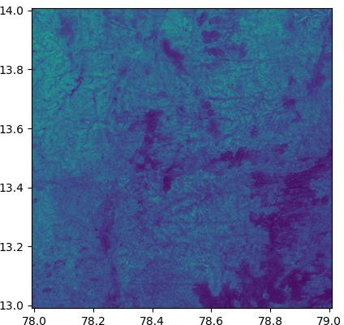

Fig. 3 Band 3 GeoTIFF image

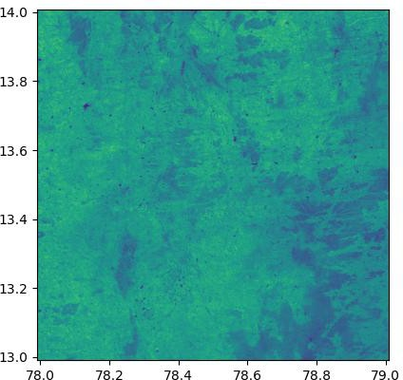

Fig. 4 Band 4 GeoTIFF image

The development environment used for this work includes PYTHON version 3. Python Numpy library is used that is very versatile for the matrix algebra. Various other libraries and pre-trained models used include rasterio, keras sequential, MaxPooling2D, Conv2D, Flatten, Dense etc. As mentioned above, Rasterio library for processing georasters file in Python is used. Even though this library is used for GeoTIFF images collected from satellite, it is capable to work with other satellite images formats, digital elevation models, and drone generated imagery. The Pycharm development environment for python is used for the scripting. NDVI is computed with ResourceSat-2 imagery with python and rasterio.
CNN algorithm is used to identify class of the input image. CNN on images of NDVI satellite is trained to identify class of the input image. Neural network learns to predict the class to which image belongs to. Keras deep learning library is available in python for CNN modeling that requires training and testing dataset. The training dataset of NDVI satellite images for drought and no drought class from the satellite is collected. Each image class holds 40 images of the respective category. Similarly, collected and generated testing dataset of NDVI satellite images for drought and no drought class from the satellite is used. Each image class holds 30 images of the respective category.
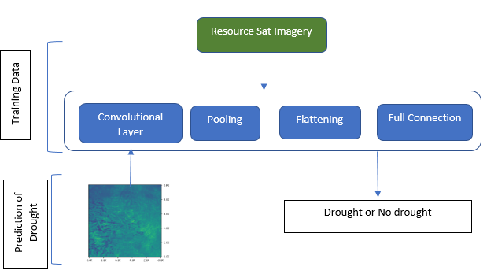
Fig. 5 Proposed System

Sequential library package from Keras models of python for initializing CNN as sequential network is used. The collected and processed satellite images are 2 Dimensional arrays images that need to process using Convolution 2-D layer package from Keras.layers. Convolution, pooling, flattening and full connection are the four steps in the process of building CNN as shown in Figure 5. Each of the CNN steps is configured as follows. (1) The first step of CNN is convolution layer operations, which is performed using imported Conv2D from keras.layers on the training images. Convolution 3-D array is considered when the processing is dealing with videos, where the third dimension is time. Four arguments such as the number of filters, shape each filter, the input shape and the type of image, and activation function respectively are passed to convolution function. 32 filters with 3x3 shape for each filter are used. The input image shape in CNN is of 64x64 resolutions with its type as RGB. Image type can be back and whilte or RGB. The parameter 3 for RGB type to indicate it is color image is passed. “relu” as an activation function that stands for a rectifier function is used and added this operation as: classifier.add(Conv2D(32, (3, 3), input_shape = (64, 64, 3), activation = 'relu')). (2) The second step of CNN reduces the image size as much as possible through pooling operations. This tries to reduce the total number of nodes in the upcoming layers. Pooling operation step of building CNN requires MaxPooling2D library importing from keras.layers. Maxpooling function has different types of pooling operations like Min Pooling, Mean Pooling, etc. MaxPooling operation used in CNN takes the maximum value pixel from the respective region of interest. (3) All the pooled images from second step are converted into 1D single continuous vector in the flattening operation step. This step of building CNN requires Flatten library importing from keras.layers for converting all the resultant 2D arrays of MaxPooling operation into a single long continuous linear vector. (4) Full connection operation step of building CNN requires Dense library importing from keras.layers to add fully connected layer. Dense function passes two arguments such as units and activation function. The units arguments indicates the number of nodes present in the hidden layer. The unit’s argument value varies between the number of input node and the output nodes. Experimental tries help to decide the optimal number of nodes in the hidden layer. It is commonly considered in the power of 2. Similar to first step, the activation function is a rectifier function as fllows: classifier.add(Dense(units = 128, activation = 'relu')). The output layer has only one node in CNN as, it uses binary classification. the binary output value includes either a Drought or No Drought situation. The final layer of CNN contains only one node, with the sigmoid as an activation function as follows: classifier.add(Dense(units = 1, activation = 'sigmoid')).
Before applying CNN to satellite images, there is need to synthesis the training image data using keras.preprocessing library. The same synthesizing used in training image dataset preparation is applied for test image dataset to prepare test image dataset, Training and testing images are properly structured in the directories format. The training image dataset is used during the training phase of CNN while test image dataset is used during the testing phase of CNN. The standard CNN model resolution requirement is 64x64 that is used by converting images into resolution of 64x64. The predict method on classifier objects for predicting the binary out in terms of drought and no drought is used. The output is given as either 1 or 0 repressing a Drought or No Drought respectively.

Results AND DISCUSSION
The causes of drought may include excessive reclamation of cultivated land. This situation decreases the wetland area resulting in less water supply/storage in the soil. The reasons for vegetation destruction in the semi-humid climate zone are related to the mining of mineral deposits, less rain, reservoirs and dams construction, and overgrazing. Increase in temperature increases rapidly substantial evaporation of soil moisture. This section discusses the results related to drought prediction using satellite image in the area of Kolar.
Usage of CNN algorithm for satellite image-based drought prediction increases the prediction accuracy. More the training data better the prediction accuracy is the general observation in the area of neural network-based prediction. AwiFs Landsat 8 image data from 2007 to 2018 obtained from NRSC is used for drought frequency prediction in the areas of Kolar.
NDVI shows the average vegetation coverage in the areas of Kolar during the study period from 2007 to 2018. It is computed as equation 1 for each band during the study period and shown in the Figure 6. The NDVI curve is zig-zag in nature starting with the rise in NDVI values then gradual decrease in repeated manner. It falls in the range between 0.2 to 0.5 for study area during the specified period.
The mean, median, minimum, maximum values are computed and stored as NDVI_{mean}, NDVI_{median}, NDVI_{min} and NDVI_{max} respectively for each band images. The significant differences between the NDVI mean, max and min levels relates with the frequency of drought. Minimum NDVI in the particular region experiences no drought while mean NDVI experiences drought persistence region. The curve corresponds to the NDVI mean indicates almost zero frequency. Maximum NDVI in particular region experiences drought with the NDVI range in 0.4 to 0.6. Maximum NDVI of 0.6 indicates mild drought frequency in most of the region while it is 0.4 in the remaining regions. There is variation with the gradual decrease tendency in mild drought frequency with latitude.
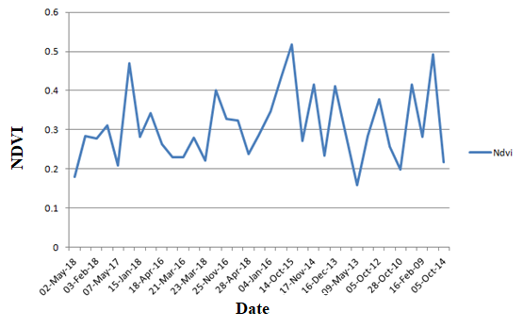
Fig. 6 NDVI Values for Band 3 and 4 in Kolar district

The VCI determines the level of drought in the specific region. Various factors that affect the VCI include human activities in that area, duration of sunlight, temperature, wind velocity, and atmospheric pressure. VCI for each band image is computed as Equation 2 and shown in the Figure 8.
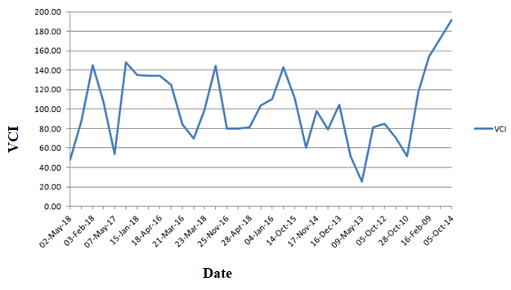
Fig 8. VCI Values for Band 3 and Band 4

VCI=100(NDVI_{mean}-NDVI_{min}) / NDVI_{max}-NDVI_{min})…..2
It is observed that the VCI decreased in some period suggesting that the drought severity gradually increased. Lower VCI value indicates bad vegetation state conditions while higher VCI value shows good vegetation state conditions. If the VCI value is less than 90 then, its considered as bad vegetation state condition indicating drought otherwise it is good vegetation state condition indicating no drought. The drought trend for the collected satellite image during the study period is shown in Figure 9.
The VCI data of all bands images is considered for developing CNN based prediction model. CNN requires training dataset and testing dataset. Band 3 and band 4 images are collected, out of which 80% of the images are considered in training dataset and 20% are considered as testing. The chosen images in training and testing set such that the images indicate drought and no drought situation. Total of 35 satellite images are collected in the area of Kolar which is considered as dataset.
The CNN model is trained using training dataset to predict the drought and no drought situation while testing phase of CNN uses testing dataset for the prediction. The increase in the accuracy by a small margin after running the optimization test is obtained. The default values were found to be strongly efficient, and accurately identified the gap in precision between the optimized algorithms. In the case of CNN algorithm, the variance area corresponds to the difference in time being expressed in Figure 10. With approximately 96% of precision, it is found that this to be very fair though bearing in mind the relatively limited data collection analyzed as seen in Figure10.

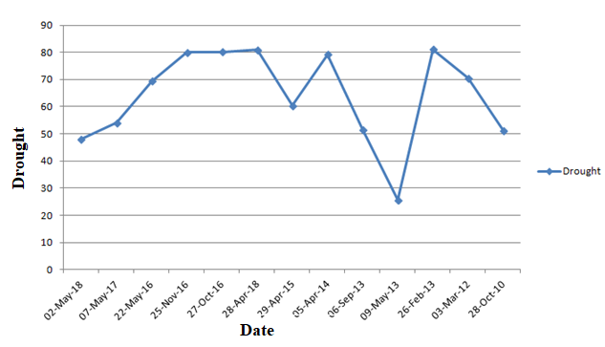
Fig. 9 Drought Analysis

It is assumed that these findings are very positive, but as these findings derive only from principle solution verification, a wider analysis will be required to validate them. Nonetheless, this was achieved with a basic custom-made approach that has tremendous room for development, and predicted to do even better with more complex solutions. As such, these findings are found to be very positive and they could require time and work to determine a more complicated approach.

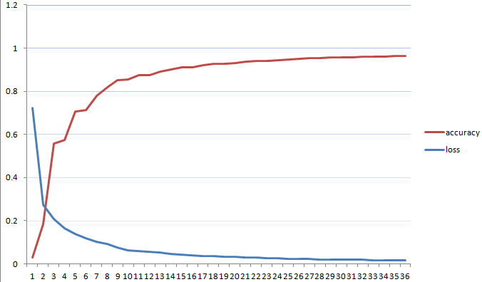

Fig. 10 Loss and Accuracy

Conclusion and future work
Agricultural drought affects the life of human beings in disastrousway and should be managed effectively. There are several models have been developed to predict agricultural drought however the accuracy of model varies depending upon the algorithm used and dataset type. Rare modeling exists for satellite image-based drought prediction using CNN. The proposed work is developed by using the CNN algorithm to improve the accuracy up to 96% which uses satellite images. The current paper focuses on binary classification but work can be extended for multiclass classification for drought such as no drought, mild, moderate, severe and extreme. The various bio-inspired techniques such as genetic algorithm, particle swarm optimization, ant colony optimization can be used to improve the input parameters to CNN which in turn can improve the accuracy.

References
- Wanqing Song， Shen Deng “Bank Bill Recognition Based on an Image Processing “2009 Third International Conference on Genetic and Evolutionary Computing 978-0-7695-3899-0/09 $29.00 © 2009 IEEE
- Berhan G, Hill S, Tadesse T, Atnafu S. Using satellite images for drought monitoring: a knowledge discovery approach. Journal of Strategic Innovation and Sustainability. 2011 Jul 1;7(1):135-53.
- Sreekesh S, Kaur N, SreeramaNaik SR. AGRICULTURAL DROUGHT AND SOIL MOISTURE ANALYSIS USING SATELLITE IMAGE BASED INDICES. International Archives of the Photogrammetry, Remote Sensing & Spatial Information Sciences. 2019 Feb 18.
- Akanbi AK, Masinde M. Towards the Development of a Rule-Based Drought Early Warning Expert Systems Using Indigenous Knowledge. In2018 International Conference on Advances in Big Data, Computing and Data Communication Systems (icABCD) 2018 Aug 6 (pp. 1-8). IEEE.
- Tadesse T, Demisse GB, Zaitchik B, Dinku T. Satellite‐based hybrid drought monitoring tool for prediction of vegetation condition in Eastern Africa: A case study for Ethiopia. Water Resources Research. 2014 Mar;50(3):2176-90.
- Himanshu SK, Singh G, Kharola N. Monitoring of drought using satellite data. International Research Journal of Earth Sciences. 2015;3(1):66-72.
- Kruseman G, Ornella L, Crossa J. Satellite data and supervised learning to prevent impact of drought on crop production: meteorological drought.
- Chen J, Jin Q, Chao J. Design of deep belief networks for short-term prediction of drought index using data in the Huaihe river basin. Mathematical Problems in Engineering. 2012;2012.
- Bordi I, Fraedrich K, Petitta M, Sutera A. Methods for predicting drought occurrences. InProceedings of the 6th International Conference of the European Water Resources Association, Menton, France 2005 Sep 7 (pp. 7-10).
- Agana NA, Homaifar A. A deep learning based approach for long-term drought prediction. InSoutheastCon 2017 2017 Mar 30 (pp. 1-8). IEEE.
- Agana NA, Homaifar A. A hybrid deep belief network for long-term drought prediction. InProceedings of the Workshop on Mining Big Data in Climate and Environment (MBDCE 2017), 17th SIAM International Conference on Data Mining (SDM 2017), Houston, TX, USA 2017 Apr 27 (pp. 27-29).
- Morid S, Smakhtin V, Bagherzadeh K. Drought forecasting using artificial neural networks and time series of drought indices. International Journal of Climatology: A Journal of the Royal Meteorological Society. 2007 Dec;27(15):2103-11.
- Park, H.; Kim, K.; Lee, D.k. Prediction of Severe Drought Area Based on Random Forest: Using Satellite Image and Topography Data. Water 2019, 11, 705
- Yan N, Wu B, Boken VK, Chang S, Yang L. A drought monitoring operational system for China using satellite data: design and evaluation. Geomatics, Natural Hazards and Risk. 2016 Jan 2;7(1):264-77.
- Berhan G, Tadesse T, Atnafu S, Hill S. Drought Monitoring in Food-Insecure Areas of Ethiopia by Using Satellite Technologies. InExperiences of Climate Change Adaptation in Africa 2011 (pp. 183-200). Springer, Berlin, Heidelberg.
- Arkeman Y, Buono A, Hermadi I. Satellite image processing for precision agriculture and agroindustry using convolutional neural network and genetic algorithm. InIOP Conference Series: Earth and Environmental Science 2017 Jan (Vol. 54, No. 1, p. 012102). IOP Publishing.
- Marj AF, Meijerink AM. Agricultural drought forecasting using satellite images, climate indices and artificial neural network. International Journal of Remote Sensing. 2011 Dec 20;32(24):9707-19.
- Dąbrowska-Zielińska K, Ciołkosz A, Malińska A, Bartold M. Monitoring of agricultural drought in Poland using data derived from environmental satellite images. Geoinformation Issues. 2011;3(1):87-97.

