GRAPHS
1.
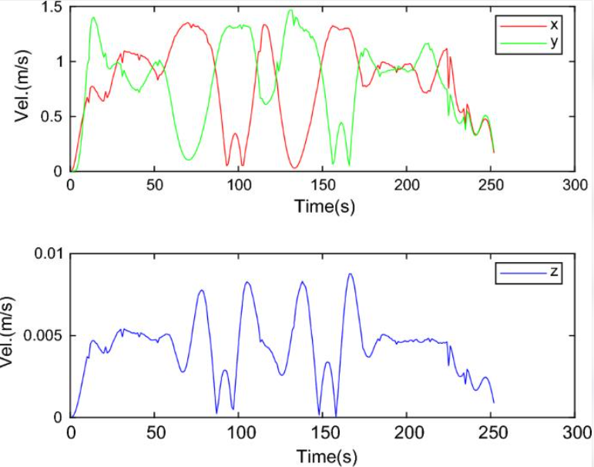
Velocity Analysis During Drone obstacle Avoidance :
This graph represents the variation in the drone's velocity along the three coordinate axes (X, Y, and Z) over time during a simulation. It helps us understand how the drone moves forward, changes direction, and adjusts its vertical movement while navigating through an environment.
The graph contains two plots:
- Top graph: Velocity along the X-axis and Y-axis.
- Bottom graph: Velocity along the Z-axis.
The horizontal axis in both plots represents Time in seconds (s), while the vertical axis represents Velocity in metres per second (m/s).
X-axis and Y-axis Velocity Analysis
The top graph shows the velocity components along the X-axis (red line) and Y-axis (green line).
X-axis velocity (red line)
The red line represents the drone's velocity along the X-axis.
- At the beginning, the velocity increases from approximately zero as the drone starts moving.
- During the simulation, the velocity fluctuates, indicating changes in the drone's movement.
- Some regions show a decrease in velocity towards zero. This may indicate that the drone temporarily reduces its movement along the X-axis while changing its direction or avoiding an obstacle.
- The velocity increases again as the drone continues moving.
Y-axis velocity (green line)
The green line represents the drone's velocity along the Y-axis.
- Initially, the velocity increases as the drone begins moving along the Y-axis.
- The fluctuations indicate changes in lateral movement.
- When the velocity approaches zero, the drone's movement along the Y-axis becomes very small.
- The velocity increases again when the drone resumes lateral movement.
The changes in X-axis and Y-axis velocities help us understand how the drone adjusts its horizontal movement during navigation and obstacle avoidance.
Z-axis Velocity Analysis
The bottom graph represents the drone's velocity along the Z-axis (blue line).
The Z-axis usually represents vertical movement, such as ascending and descending, when the simulation uses the conventional coordinate system in which Z is the vertical axis.
- At the beginning, the Z-axis velocity increases as the drone begins its vertical movement.
- During the middle portion of the simulation, several peaks appear, indicating periods of increased vertical velocity.
- When the velocity approaches zero, the drone has little or no vertical movement at that moment.
- Later, the velocity decreases, indicating reduced vertical movement.
These variations help us study the drone's vertical motion and its response to changes in the flight path.
Note: Velocity approaching zero means that movement along that particular axis is very small. It does not necessarily mean that the entire drone has stopped.
Relationship Between Velocity and Obstacle Avoidance
Obstacle avoidance requires the drone to adjust its movement when an obstacle is detected.
For example, when an obstacle is detected in front of the drone, the controller may reduce forward velocity and generate lateral or vertical movement to navigate around it.
The velocity components can help identify these changes:
- Initial movement: The drone starts moving from its initial position.
- Velocity adjustment: The controller changes the velocity according to the navigation requirements.
- Direction change: Changes in X-axis and Y-axis velocities may indicate a horizontal avoidance manoeuvre.
- Vertical adjustment: Changes in Z-axis velocity may indicate climbing or descending.
- Continued movement: The drone continues towards its destination after the manoeuvre.
The exact obstacle-detection time cannot be identified from this graph alone because obstacle distance and detection events are not shown.
2.
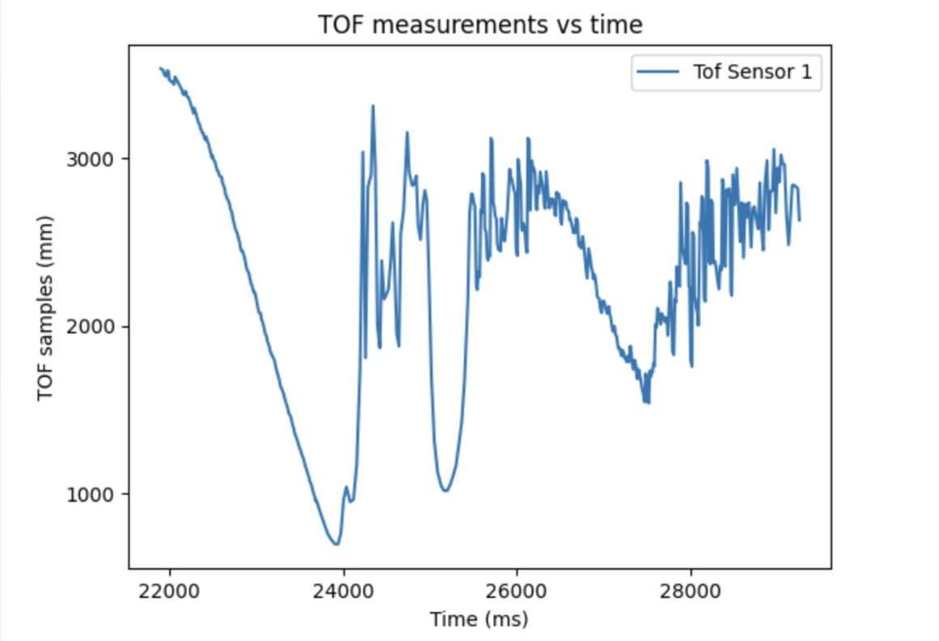
Explanation of TOF Measurements vs Time Graph
This graph shows how the Time-of-Flight (TOF) sensor readings change over time. The sensor measures the distance to an object by calculating the time taken for a light signal to travel to the object and return.
- X-axis – Time (ms): Represents the time at which each sensor measurement is recorded.
- Y-axis – TOF samples (mm): Represents the measured distance values in millimeters.
- Blue line – TOF Sensor 1: Shows how the sensor readings change throughout the observation period.
Graph interpretation:
- Initial phase: The readings decrease from approximately 3,500 mm to 700 mm, indicating that the measured distance is getting smaller.
- Sudden fluctuations: The readings rise and fall sharply between approximately 24,000 and 25,500 ms. This may indicate rapid distance changes, sensor noise, or reflections.
- Middle phase: The measurements remain mostly between 2,500 and 3,100 mm before decreasing to around 1,500 mm.
- Final phase: The readings fluctuate significantly, mostly between 1,800 and 3,000 mm, showing variations in the measured distance.

Trajectory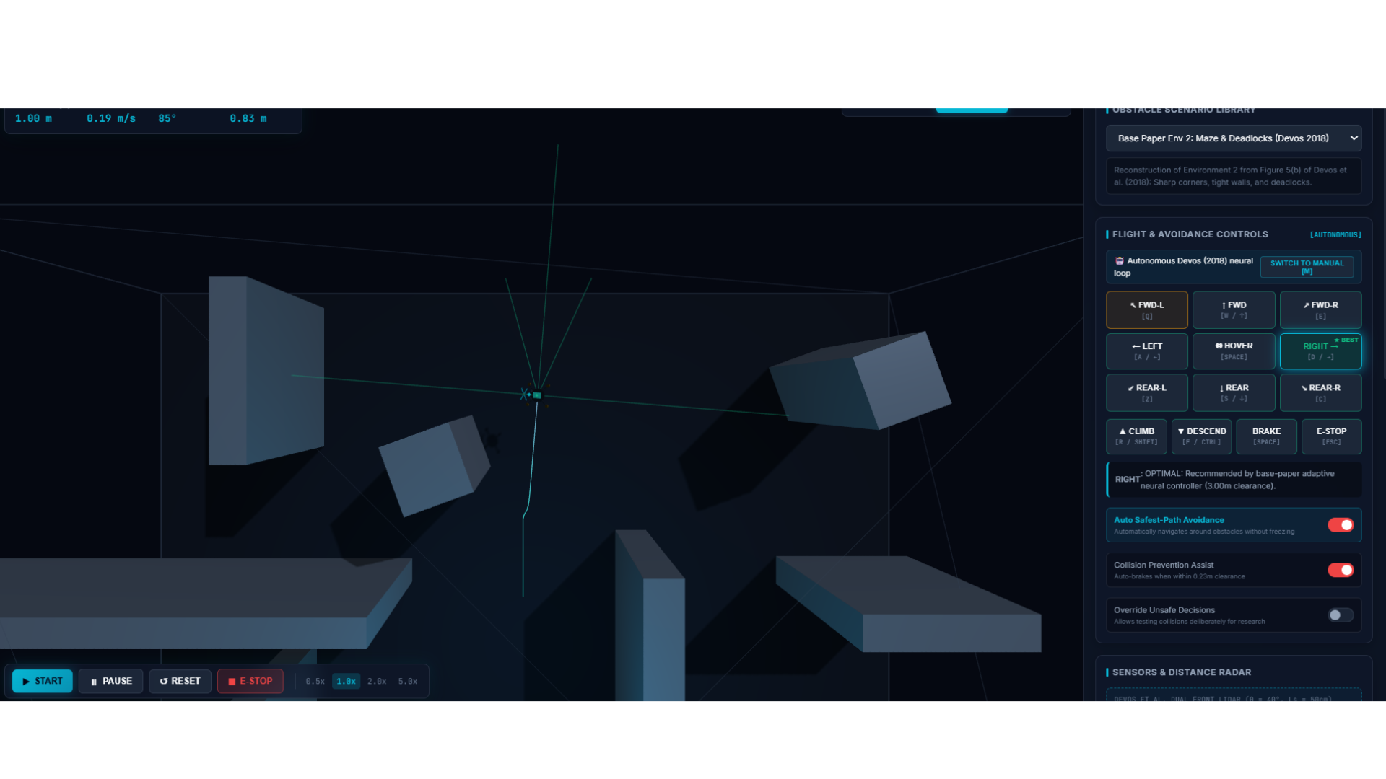
Drone Simulation: LiDAR Sensors and Trajectory Path
Overview
This screenshot shows the drone navigating through an environment containing multiple obstacles using LiDAR sensors and path-tracking visualization.
Graphical Elements
- LiDAR Sensor Rays (5 light-shaded lines): These lines represent the five LiDAR sensor directions used to scan the surrounding environment and detect nearby obstacles. The sensor readings help the drone identify obstacles and select a safe direction.
- Drone Trajectory (Dark Path Line): The dark line represents the drone's movement path through the simulation. It shows the route followed by the drone as it navigates around obstacles.
- Obstacles: The grey 3D blocks represent objects that the drone must avoid during navigation.
- Drone Position: The small drone marker near the centre indicates the drone's current position.
Working Principle
The LiDAR sensors scan the surrounding area and provide distance information about nearby obstacles. Based on these readings, the avoidance controller adjusts the drone's movement to follow a safer path and reduce the risk of collision.

