2.1 Introduction
Management is the process of getting tasks done to achieve a goal. Think of a Joint Hindu Family Business where the KARTA (head of the family) plans everything, directs the family members, and keeps strict control over every task to ensure the business runs smoothly. This is exactly what management does for any organization.
Key Definition:
- L.A. Allen: "Management is what a manager does".
- Henry Fayol: "To manage is to forecast and to plan, to organize, to command and to control".

2.2 The 6 Main Functions of Management
A famous keyword to remember these functions is POSDCORB, given by Luther Gullick:
- P - Planning
- O - Organizing
- S - Staffing
- D - Directing
- CO - Co-ordinating
- R - Reporting
- B - Budgeting
(Note: Reporting and Budgeting are usually included under the "Controlling" function).

2.2.1 Planning: The "First Step"
Meaning: Planning means deciding in advance what to do, how to do it, when to do it, and who will do it. It bridges the gap between where we are now and where we want to be.
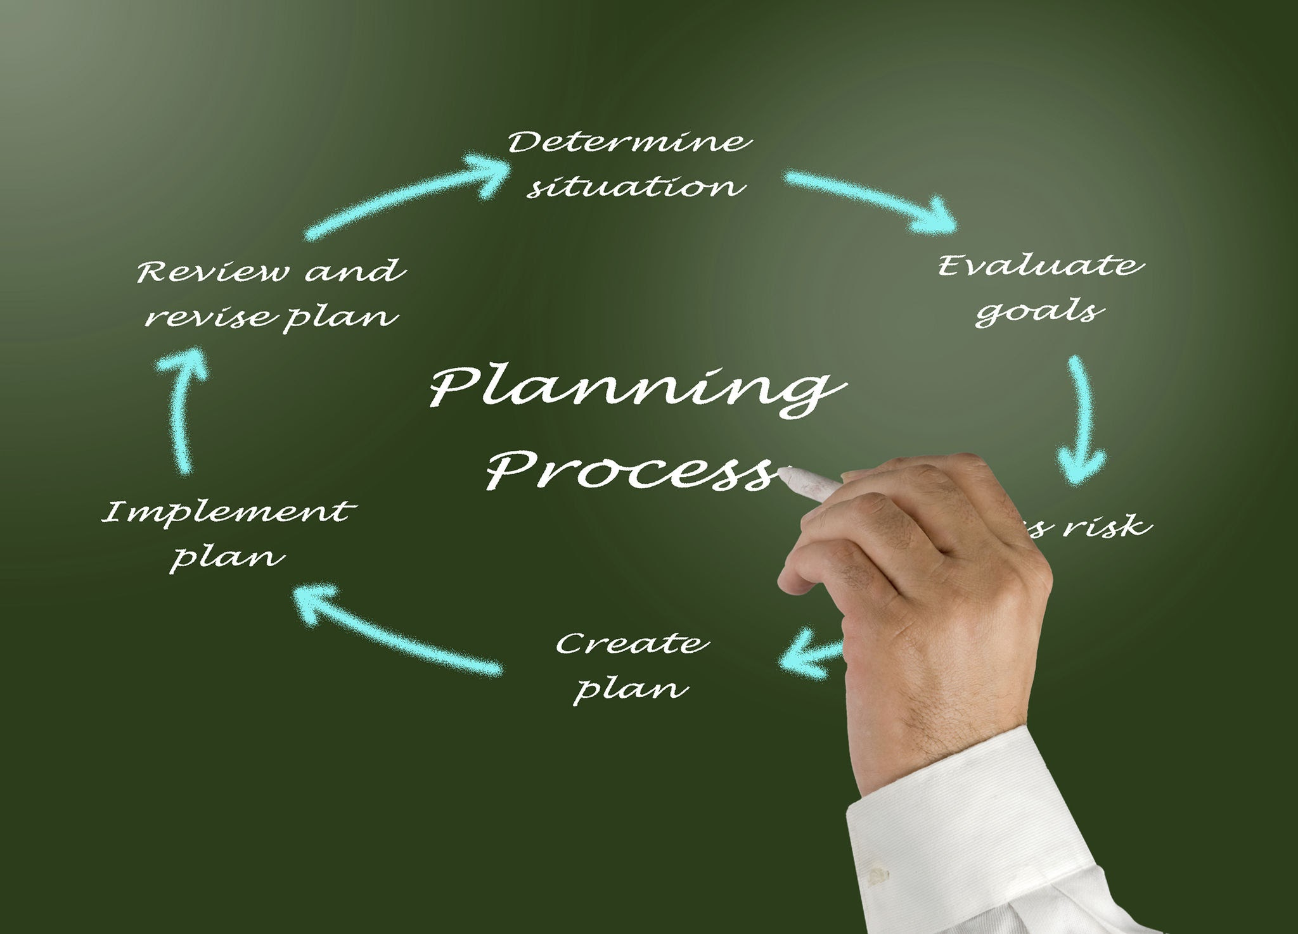
- Daily Life Example: Before going on a class picnic, you decide the destination, the budget, and what food to bring. This is planning.
Why is Planning Important?
- Sets Clear Goals: It tells everyone exactly what they need to achieve.
- Reduces Risk: You can't predict the future, but planning helps you prepare for changes.
- Best Use of Resources: It prevents wastage of time and money.
- Standard for Controlling: You can only check if you are successful if you had a plan to compare against.
EXAM POINT: Planning is the basic and fundamental function of management. Every other function depends on it.

2.2.2 Organizing: The "Resource Arranger"
Meaning: Once you have a plan, you need to bring together your resources—Men, Money, Material, Machines, and Methods. Organizing is the process of grouping activities and assigning them to the right people.
- Daily Life Example: To organize a "Teacher’s Day" event, you divide classmates into groups: one for decoration, one for snacks, and one for the stage program.
Why is Organizing Important?
- Specialization: When work is divided into parts, people become experts in their specific tasks.
- Defines Jobs Clearly: Everyone knows their role, which avoids confusion.
- Clarifies Authority: It settles who is the "boss" and who reports to whom.
- Growth: A well-organized business can expand and diversify easily.

2.2.3 Staffing: The "People Function"
Meaning: Staffing is about "The Right Person at the Right Job with the Right Pay". It involves recruiting, selecting, training, and keeping the best employees.
- Daily Life Example: If you are opening a new restaurant, you carefully interview and hire a chef who knows how to cook the specific food you want to sell.
Why is Staffing Important?
- Human Resource Development: It trains employees to become better at their work.
- Builds Good Relationships: Proper staffing ensures harmony among employees.
- Job Satisfaction: When people are placed in jobs they like and are paid well, they are happy and work harder.

2.2.4 Directing: The "Life Spark"
Meaning: Directing is the "soul" of management. It is the process of instructing, guiding, inspiring, and motivating employees to achieve goals.
- Daily Life Example: A football coach standing on the sidelines, shouting instructions and encouraging the players during a match, is "directing."
Why is Directing Important?
- Initiates Action: Plans and organization are useless until the manager directs people to start working.
- Team Spirit: It motivates employees to work together as one team.
- Coping with Changes: Managers guide employees on how to handle new technology or market changes.

2.2.5 Co-ordinating: The "Essence of Success"
Meaning: Coordination means bringing together (integrating) all the different activities of the business so they work smoothly together. It ensures everyone is moving in the same direction.
- Daily Life Example: In a school play, the actors, the light crew, and the music team must coordinate perfectly so the performance is a success.
Why is Co-ordinating Important?
- Encourages Teamwork: It settles disputes and conflicts between different departments.
- Higher Efficiency: When everyone works together without wasting time, the business makes more profit.
- Goodwill: A smooth-running company earns a good reputation in the market.

2.2.6 Controlling: The "Checking Step"
Meaning: Controlling is the process of checking whether the actual results match the original plan. If there is a "deviation" (a difference), the manager takes corrective action.
The Process of Controlling (Diagram Explanation):
- Standards: Set a target (e.g., "Sell 100 units").
- Measurement: Check what was actually done (e.g., "Sold 80 units").
- Comparison: Find the difference/deviation (e.g., "Short by 20 units").
- Analysis: Figure out why it happened.
- Corrective Action: Fix the problem so it doesn't happen again.
- Daily Life Example: If your "standard" was to score 90% in exams, but you got 70% (actual performance), you "control" the situation by finding out why you lost marks and studying harder next time (corrective action).

Comparative Study: Key Differences
Feature | Planning | Organizing | Staffing | Directing | Co-ordinating | Controlling
Order | 1st Function | Follows Planning | Follows Organizing | Follows Staffing | Throughout process | End Function
Objective | Setting Goals | Arranging Resources | Appointing People | Getting work done | Harmony/Unity | Ensuring targets met
Level | Top Level | Top & Middle | Middle Level | Middle Level | All Levels | Top & Middle

Summary
Management is a cycle. It starts with Planning (deciding what to do), followed by Organizing (gathering resources), Staffing (hiring people), Directing (leading them), Co-ordinating (making them work together), and finally Controlling (checking if the goal was reached).

Key Terms to Remember
- Forecasting: Predicting the future based on the past.
- Specialization: Becoming an expert in one specific task.
- Recruitment: Searching for and attracting new employees.
- Motivation: Encouraging employees to work their best.
- Deviations: The difference between the planned target and the actual result.

Exam-Oriented Questions and Answers
Q1. Which function of management is called the "base" for all other functions?
Ans: Planning is the basic and fundamental function of management because all other functions are based on the plan.
Q2. What is meant by the principle "Right person at the right job"?
Ans: This is the basic principle of Staffing. It means hiring an employee whose skills and qualifications perfectly match the requirements of the job.
Q3. Why is Directing called the "Life Spark" of an enterprise?
Ans: Because action only starts when a manager gives instructions and guides employees. Without direction, resources like machines and money stay idle.
Q4. Explain the process of Controlling in brief.
Ans: Controlling involves four steps:
- Setting standards.
- Measuring actual performance.
- Comparing actuals with standards to find deviations.
- Taking corrective action to fix those deviations.
Q5. State the importance of Co-ordination.
Ans: Co-ordination is the "hidden force" that binds all functions. It is important because it encourages team spirit, ensures unity of direction, reduces conflicts between departments, and improves the overall efficiency of the organization.

