1. What is a Set?
In our daily lives, we use words like "bouquet" for flowers, "bunch" for keys, or "flock" for birds. In math, when we can clearly and definitely decide which objects belong in a group, we call that collection a Set.
- How to tell if it's a Set: If everyone agrees on what belongs in the group, it is a set. If it depends on someone's opinion (like "happy" or "brilliant"), it is not a set because those meanings change from person to person.
- Real-Life Example: "The planets in our solar system" is a set because everyone knows exactly which planets to list. But "The best students in class" is not a set because everyone might have a different opinion on who is "best".
- Exam Tip: Look out for "relative" words like brave, strong, rich, or happy. If you see these, it’s not a set!
2. How to Write a Set
We follow a few simple rules when writing sets:
- Use Capital Letters (A, B, C...) to name the set.
- Use Small Letters (a, b, c...) for the members or "elements" inside the set.
- The Symbol $\in$: If 'a' is a member of set A, we write $a \in A$ (a belongs to A). If it is not, we write $a \notin A$ (a does not belong to A).
- Standard Sets of Numbers you should know:
  - N = {1, 2, 3, ...} (Natural numbers).
  - W = {0, 1, 2, 3, ...} (Whole numbers).
  - I = {..., -3, -2, -1, 0, 1, 2, ...} (Integers).
3. Methods of Writing Sets
There are two ways to describe a set:
I. Listing Method (Roster Method)
You list every element inside curly brackets { } and separate them with commas.
- Rule: Each element is written only once, even if it appears many times in a word.
- Example: The set of letters in the word "remember" is $A = \{r, e, m, b\}$.
- Real-Life Example: A grocery list is like a roster method set!
II. Rule Method (Set Builder Form)
Instead of listing everything, we describe the "rule" or property that the elements share.
- Format: $A = \{x | x \text{ is a property}\}$.
- How to read it: "A is the set of all $x$ such that $x$ is...".
- Example: $B = \{x | x \text{ is a prime number between 1 and 10}\}$. In listing form, this would be $B = \{2, 3, 5, 7\}$.
4. Types of Sets
Sets come in different "sizes":
- Singleton Set: Has only one element.
  - Example: $A = \{2\}$ (The set of even prime numbers).
- Empty Set (Null Set): Has no elements. We write it as $\{\}$ or use the symbol $\phi$ (phi).
  - Example: The set of humans who are 500 years old.
- Finite Set: You can count the elements. It has an end.
  - Example: Days of the week.
- Infinite Set: The elements are unlimited and cannot be counted.
  - Example: The set of natural numbers $\{1, 2, 3, ...\}$.
5. Equal Sets
Two sets, A and B, are equal ($A = B$) if every element in A is also in B, and every element in B is also in A.
- Important: The order doesn't matter!
- Example: $A = \{l, i, s, t, e, n\}$ and $B = \{s, i, l, e, n, t\}$. These are equal because they have the exact same letters.
6. Venn Diagrams and Subsets
Venn Diagrams
A British logician named John Venn used closed shapes like circles or rectangles to show sets. This makes them very easy to see.
Subsets ($\subseteq$)
If every element of set B is also an element of set A, then B is a subset of A. We write it as $B \subseteq A$.
- Diagram: In a Venn diagram, the circle for B would be inside the circle for A.
- Real-Life Example: If set A is "All students in your school" and set B is "Students in your class," then B is a subset of A.
Must-Remember Rules for Subsets:
- Every set is a subset of itself ($A \subseteq A$).
- The Empty set is a subset of every set ($\phi \subseteq A$).
7. Universal Set and Complement
Universal Set (U)
The "Big Set" that contains everything we are currently talking about. In diagrams, we usually show it as a Rectangle.
- Example: If we are talking about a cricket team, the "Universal Set" would be all the students in the school.
Complement of a Set ($A'$)
The complement of A contains all the elements that are in the Universal set but NOT in A.
- Property: If you take the complement of a complement, you get the original set again! $(A')' = A$.
8. Operations on Sets (The "Action" Part)
I. Intersection ($\cap$)
The intersection of sets A and B is the set of elements that are common to both.
- Symbol: $\cap$ (looks like a cap).
- Example: If $A = \{1, 3, 5\}$ and $B = \{2, 3, 6\}$, then $A \cap B = \{3\}$ because 3 is in both.
- Disjoint Sets: If A and B have nothing in common, they are called Disjoint Sets. Their intersection is empty.
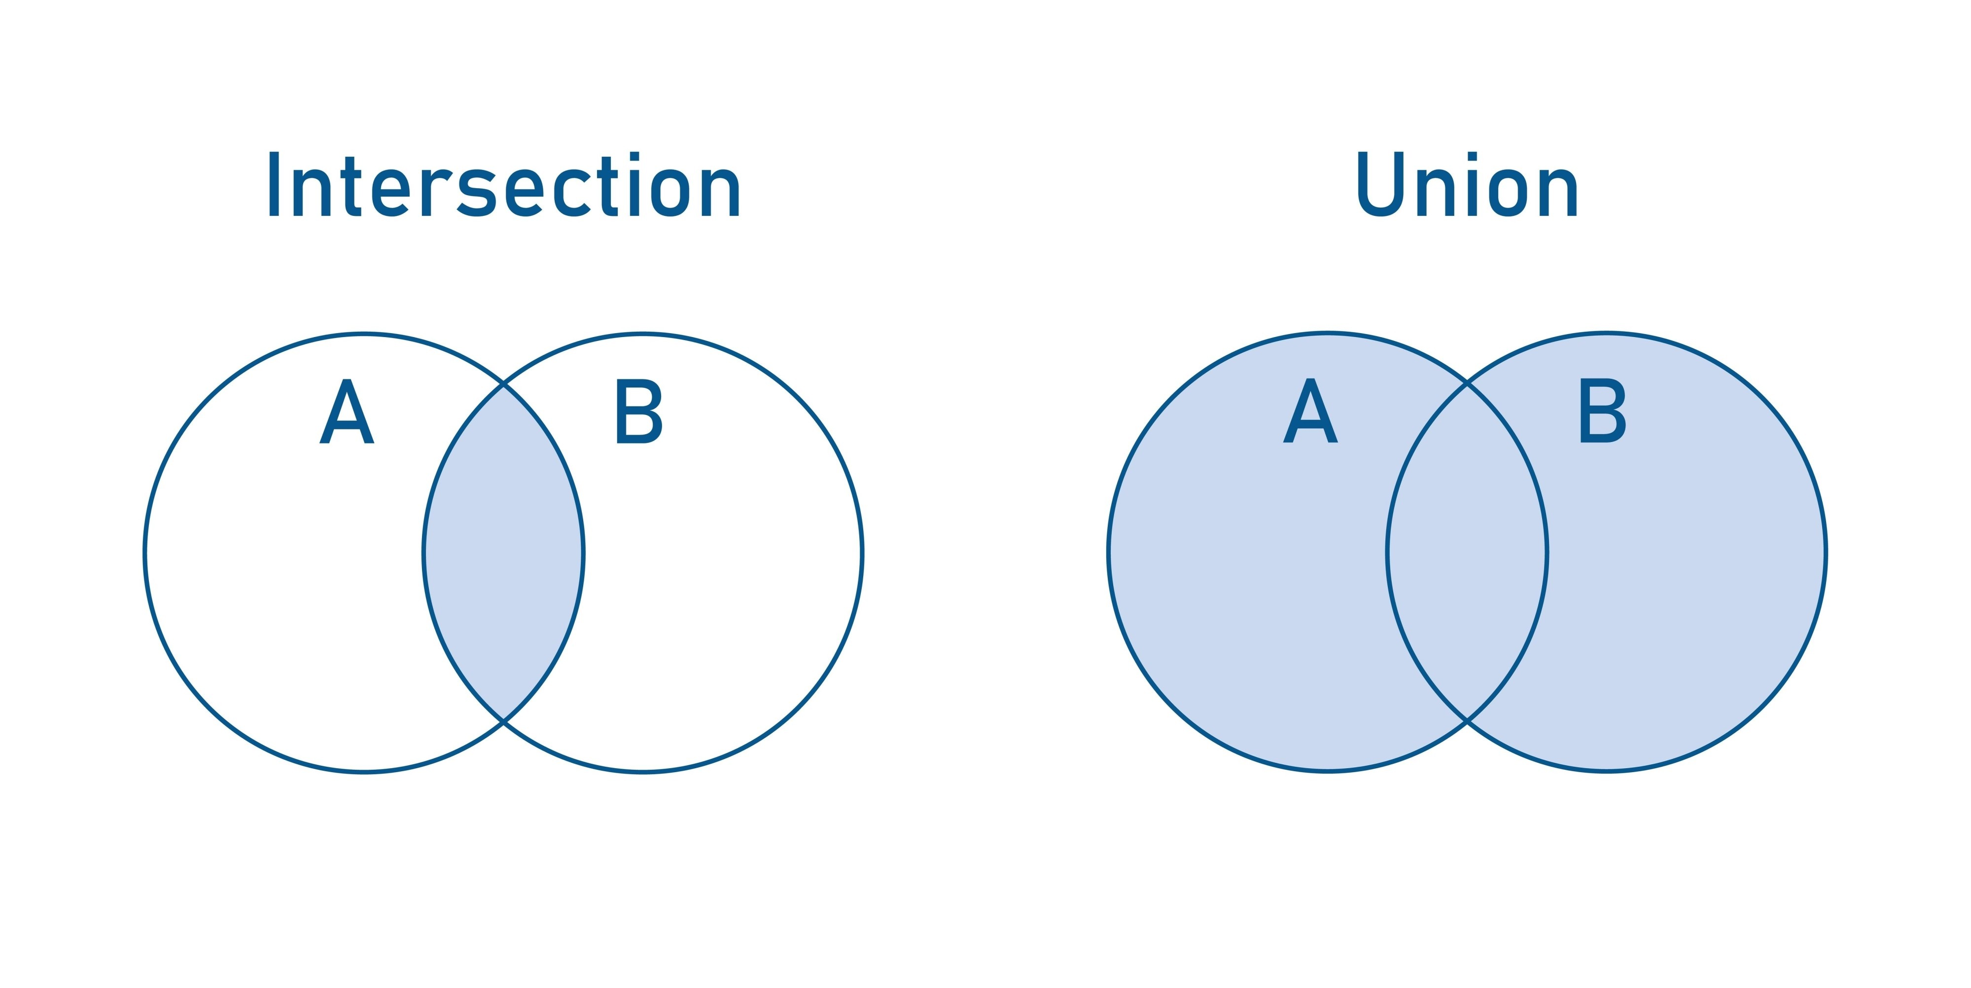
II. Union ($\cup$)
The union of A and B is a set containing all the elements from both sets.
- Symbol: $\cup$ (looks like a cup).
- Rule: Don't repeat common elements; just write them once.
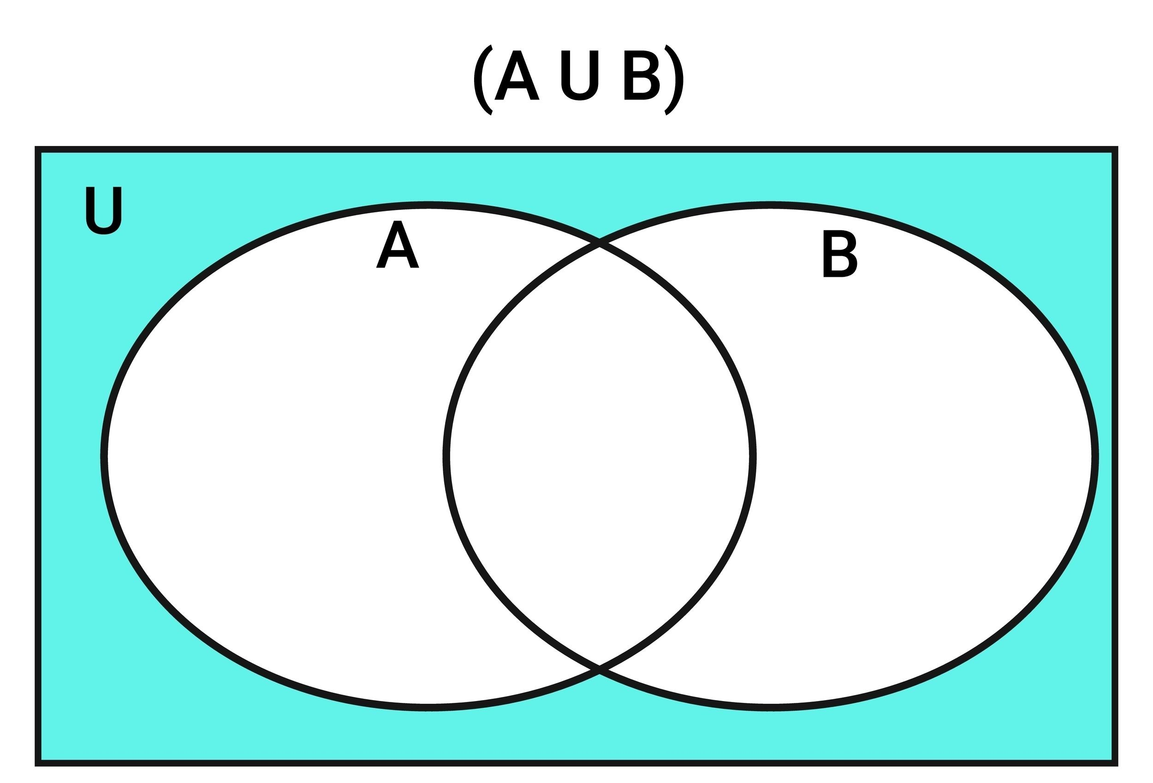
9. Number of Elements and The Master Formula
We write the number of elements in set A as $n(A)$.
The Formula:
$$n(A \cup B) = n(A) + n(B) - n(A \cap B)$$
Why do we use it?
When we add all elements of A and all elements of B, the common elements ($A \cap B$) get counted twice. We subtract them once so our total count is correct.
- $n(A \cup B)$: Total elements in both sets combined.
- $n(A)$: Elements in set A.
- $n(B)$: Elements in set B.
- $n(A \cap B)$: Elements they share.
Example Problem: In a class of 70 students, 45 like Cricket ($A$) and 52 like Kho-kho ($B$). All like at least one game.
- $n(A \cup B) = 70$
- $45 + 52 - n(A \cap B) = 70$
- $97 - n(A \cap B) = 70 \rightarrow n(A \cap B) = 27$ students like both.
Summary
- A Set is a well-defined collection.
- Listing method lists elements; Rule method describes them.
- Subsets are smaller groups inside a larger group.
- Intersection ($\cap$) is what is shared; Union ($\cup$) is everyone combined.
- Use the Master Formula for word problems to avoid double-counting.
Key Terms
- Element: An object belonging to a set.
- $\phi$ (Null Set): A set with absolutely nothing in it.
- Finite: Something you can finish counting.
- Complement ($A'$): Everything in the Universal set except for A.
Exam-Oriented Questions
- Is "Rich people in the village" a set? Why?
  - Answer: No. "Rich" is a relative term. The definition of rich varies from person to person, so it is not well-defined.
- Write the set of letters in the word 'MISSISSIPPI' using the listing method.
  - Answer: $M = \{M, I, S, P\}$. (Remember: do not repeat letters!).
- If $A = \{1, 2, 3, 4, 5, 6\}$ and $B = \{4, 5, 6, 7, 8\}$, find $A \cap B$ and $A \cup B$.
  - Answer: $A \cap B = \{4, 5, 6\}$ (shared items). $A \cup B = \{1, 2, 3, 4, 5, 6, 7, 8\}$ (all items).
- What is a Singleton set? Give an example.
  - Answer: A set with only one element. Example: $A = \{ \text{The even prime number} \}$ which is $\{2\}$.
- In a group of 100 people, 72 speak English and 43 speak French. Each person speaks at least one language. How many speak both?
  - Answer: Use the formula $n(A \cup B) = n(A) + n(B) - n(A \cap B)$.
    - $100 = 72 + 43 - n(A \cap B)$
    - $100 = 115 - n(A \cap B)$
    - $n(A \cap B) = 15$. So, 15 people speak both.

