1. The Number Family (Types of Sets)
Before we start, let's remember the groups of numbers we already know. It’s like a set of boxes where each bigger box contains the smaller ones.
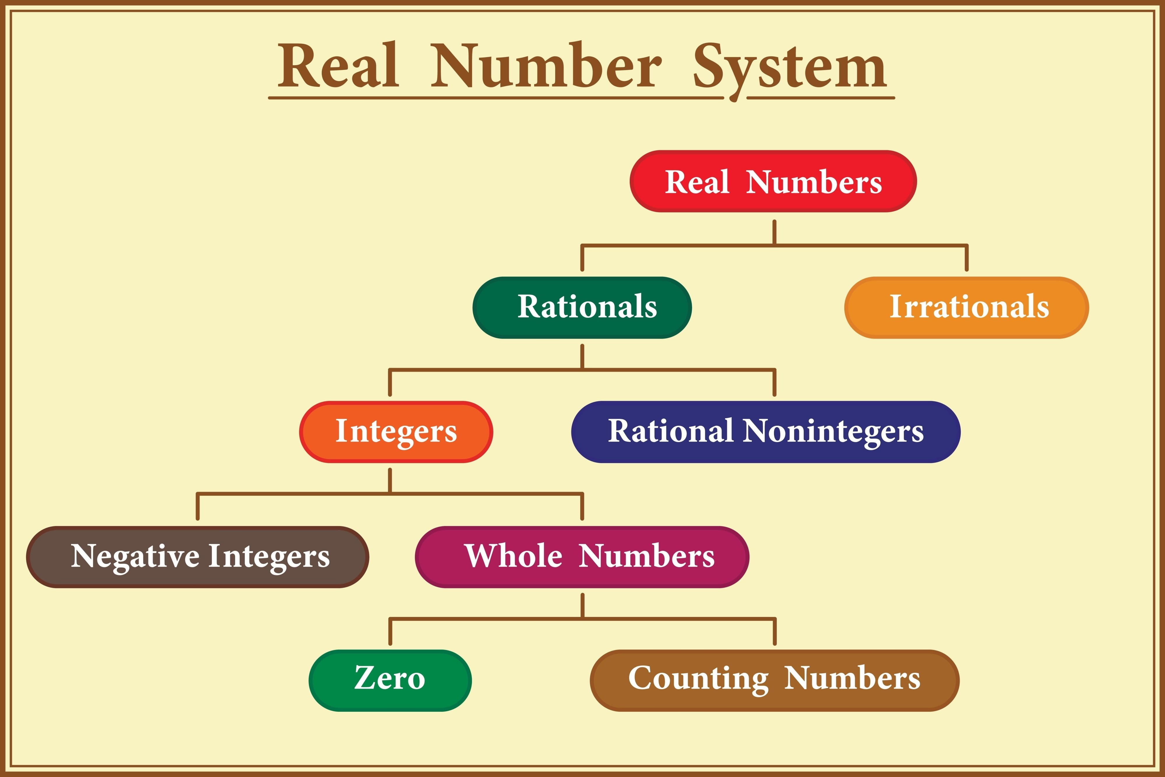
- Natural Numbers (N): These are counting numbers like {1, 2, 3, 4, ...}.
- Whole Numbers (W): Just Natural numbers plus zero {0, 1, 2, 3, ...}.
- Integers (I): These include positive numbers, zero, and negative numbers {..., -3, -2, -1, 0, 1, 2, 3, ...}.
- Rational Numbers (Q): Any number you can write as a fraction $\frac{p}{q}$ (where $q$ is not zero).
- Real Numbers (R): This is the "Big Boss" box that contains all the numbers above.
Daily Life Example:
Think of your address. You live in a Room (Natural Number), which is in a House (Whole Number), in a Street (Integer), in a City (Rational), in a Country (Real Number).

2. Properties of Rational Numbers
When we add or multiply rational numbers ($a, b, c$), they follow specific rules:
Property | Addition (a+b) | Multiplication (a×b)
Commutative | Order doesn't matter: $2+3 = 3+2$ | Order doesn't matter: $2 \times 3 = 3 \times 2$
Associative | Grouping doesn't matter: $(a+b)+c = a+(b+c)$ | Grouping doesn't matter: $(a \times b) \times c = a \times (b \times c)$
Identity | Adding 0 changes nothing: $a+0 = a$ | Multiplying by 1 changes nothing: $a \times 1 = a$
Inverse | $a + (-a) = 0$ | $a \times \frac{1}{a} = 1$ (if $a$ isn't 0)
Exam Point:
Remember the Inverse property! For addition, the inverse is the negative of the number. For multiplication, it is the reciprocal (flipping the fraction).
3. Decimals: Terminating vs. Recurring
Rational numbers can be written as decimals in two ways:
- Terminating: The division ends (e.g., $2/5 = 0.4$).
- Non-terminating recurring: The numbers after the decimal keep repeating forever (e.g., $17/36 = 0.47222...$, written as $0.47\dot{2}$).
How to tell without dividing?
Look at the bottom number (denominator) of the fraction. If its only prime factors are 2 or 5, it will terminate. If it has other factors, it will recur.
Converting Recurring Decimals to Fractions:
To turn $0.777...$ into a fraction:
- Let $x = 0.777...$ (or $0.\dot{7}$)
- Since only 1 digit repeats, multiply by 10: $10x = 7.777...$
- Subtract: $10x - x = 7.777... - 0.777...$
- $9x = 7$, so $x = 7/9$.

4. Irrational Numbers
These are the "wild" numbers. Their decimals never end and never repeat a pattern.
- Examples: $\sqrt{2}, \sqrt{3}$, and $\pi$.
- The Number Line: Every single point on a number line represents a unique Real Number.
The Story of $\pi$:
If you take any circle and divide its Circumference (the distance around) by its Diameter (the distance across), you always get roughly 3.14159... This constant value is called $\pi$ (pi).
5. Surds (The Roots)
If we take the $n^{th}$ root of a number $a$ (written as $\sqrt[n]{a}$) and the result is an irrational number, we call it a Surd.
The Parts of a Surd:
In $\sqrt[n]{a}$:
- $\sqrt{}$ is the Radical sign.
- n is the Order (if no number is there, it's 2, a square root).
- a is the Radicand.
Daily Life Example:
If you are asked for the square root of 25, it's 5 (not a surd). But if you are asked for the square root of 2, you get a messy decimal (1.414...). That is a surd!
Simplest Form:
You can simplify surds by finding square factors.
- Example: $\sqrt{48} = \sqrt{16 \times 3} = 4\sqrt{3}$.
Like Surds:
Two surds are "like" if they have the same order and the same radicand in their simplest form (e.g., $2\sqrt{3}$ and $5\sqrt{3}$).
6. Operations on Surds
- Addition/Subtraction: You can only add or subtract Like Surds, just like you can only add apples to apples.
  - Example: $7\sqrt{3} + 29\sqrt{3} = (7+29)\sqrt{3} = 36\sqrt{3}$.
- Multiplication/Division: You can multiply or divide any surds of the same order.

7. Rationalization (Making it "Clean")
Math experts don't like having surds (roots) in the bottom (denominator) of a fraction. We use a Rationalizing Factor to fix this.
Conjugate Pairs:
For a binomial surd like $(\sqrt{a} + \sqrt{b})$, its conjugate is $(\sqrt{a} - \sqrt{b})$. When you multiply them, the roots disappear!
- $(\sqrt{5} + \sqrt{3})(\sqrt{5} - \sqrt{3}) = 5 - 3 = 2$.
8. Absolute Value
The Absolute Value of a number is simply its distance from zero on the number line. Distance is never negative!
- It is written as $|x|$.
- $|3| = 3$ and $|-3| = 3$.
Summary
In this chapter, we learned that:
- Real Numbers include everything from simple counting numbers to complex decimals.
- We discovered Surds, which are roots that don't result in whole numbers, and how to perform math with them using Simplification and Rationalization.
- Finally, we saw that Absolute Value always gives us a positive distance.
Key Terms
- Rational Number: A number that can be a fraction $\frac{p}{q}$.
- Irrational Number: A decimal that never ends and never repeats.
- Surd: An irrational root of a rational number.
- Radicand: The number inside the root symbol.
- Conjugate Pair: Two-term surds that differ only by the plus/minus sign.
- Absolute Value: The positive distance of a number from zero.
Exam-Oriented Questions
- Q: Is $\sqrt{25}$ a surd?
  - A: No, because $\sqrt{25} = 5$, which is a rational number. A surd must be irrational.
- Q: State the order of the surd $\sqrt[3]{7}$.
  - A: The order is 3.
- Q: Multiply $(\sqrt{5} + \sqrt{3})(\sqrt{5} - \sqrt{3})$.
  - A: Using the formula $(a+b)(a-b) = a^2 - b^2$, we get $(\sqrt{5})^2 - (\sqrt{3})^2 = 5 - 3 = 2$.
- Q: Find the value of $|8 - 13|$.
  - A: $|8 - 13| = |-5| = 5$.
- Q: Write $0.\dot{6}$ in $\frac{p}{q}$ form.
  - A: Let $x = 0.66...$, then $10x = 6.66...$. $10x - x = 6$, so $9x = 6$, $x = 6/9 = 2/3$.
- Q: What are the prime factors of the denominator for a terminating decimal?
  - A: The prime factors must be only 2 or 5.
Keep practicing these, and you will be a Real Numbers expert in no time!
