1. Why does the Earth move?
Imagine the Earth is like a giant machine. Inside its interior, specifically in the upper layer of the mantle, there is a lot of instability. This happens because radioactive materials in the mantle release a massive amount of energy.
This energy creates energy waves that travel from one place to another, causing the Earth’s insides to move. We classify these movements based on three things:
- Velocity: How fast they move (Slow vs. Sudden).
- Direction: Which way they move (Horizontal vs. Upward/Downward).
- Landforms: What they create (Mountains vs. Continents).
Real-life Example: Think of a pot of boiling water with a lid. The heat energy from below makes the water move and the lid rattle. Similarly, the energy inside the Earth makes the crust move!
2. Slow Movements (Creating Mountains and Continents)
These movements happen so slowly that we can't see them happening, but over thousands of years, they build massive landforms.
A. Fold Mountains (The Power of Compression)
When energy moves horizontally and waves move towards each other, they create pressure. This pressure causes soft rocks to push upward and form "folds".
- How it works: Imagine pushing a piece of paper from both ends toward the middle—the paper will lift and fold.
- Famous Examples: The Himalayas, the Alps, the Rockies, and the Andes.
B. Block Mountains (The Power of Tension)
When energy moves away from each other, it creates tension. This causes the hard rocks to crack or "fracture." These cracks are called Faults.
- How it works: If a piece of the Earth's crust between two parallel faults is lifted up, it looks like a solid block.
- Features: They have flat tops and very steep sides.
- Example: The Black Forest mountains in Europe and the Meghalaya Plateau in India.
C. Rift Valleys
Sometimes, instead of lifting, the land between two faults subsides (sinks down). This deep, sunken part is called a Rift Valley.Shutterstock
- Example: The Narmada River valley in India and the Great Rift Valley of Africa.
D. Continent-Building (Epeirogenic Movements)
These movements move toward or away from the Earth's center.
- If the crust is lifted above sea level, a continent is formed.
- If it sinks below sea level, it becomes part of the ocean floor.
3. Sudden Movements: Earthquakes
An earthquake is the sudden shaking or trembling of the Earth's crust.
Why do they happen?
- Plates (huge slabs of Earth's crust) moving, colliding, or sliding past each other.
- Fractures forming in rock layers due to internal tension.
- Volcanic eruptions.
Important Keywords for Exams:
- Focus (Hypocenter): The exact point inside the Earth where the tension is released and the earthquake starts.
- Epicenter: The point on the Earth's surface directly above the focus. This is where the first tremors are felt.
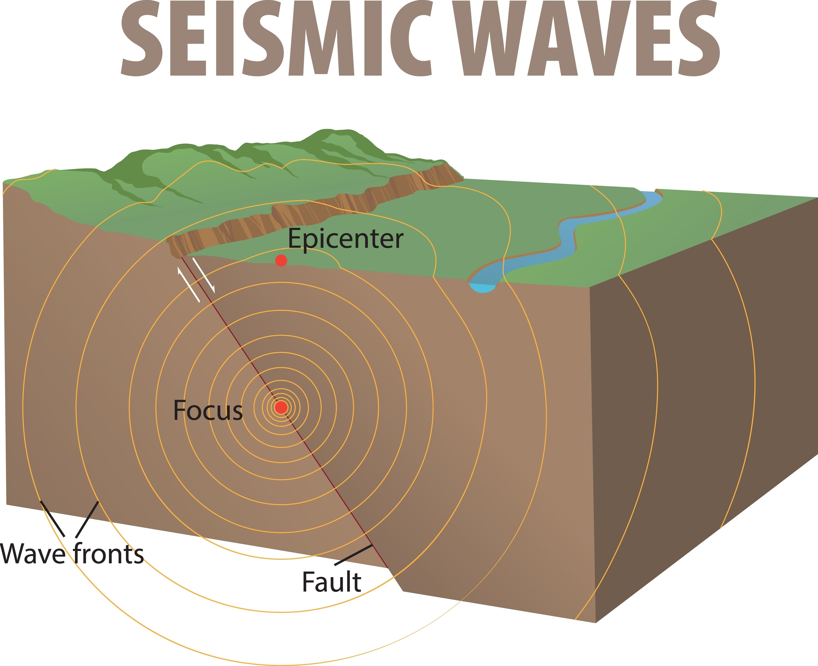
The Three Types of Seismic Waves:
- Primary (P) Waves: These are the fastest and reach the surface first. They move back and forth (like a spring). They can travel through solids, liquids, and gases.
- Secondary (S) Waves: These arrive after P-waves. They move up and down and can only travel through solids. They are more destructive than P-waves.
- Surface (L) Waves: These travel along the Earth’s crust. They are the most destructive of all.
Measuring Tool: We use an instrument called a Seismograph to record these waves, and the Richter Scale is used to measure the magnitude (strength) of the earthquake.
Real-life Example: Have you ever stood on a railway platform when a fast train passes? You feel a small vibration or "tremor." An earthquake is a much larger version of that vibration.
4. Sudden Movements: Volcanoes
A volcano is when hot solid, liquid, and gaseous materials (ash, steam, gases, and molten rock) are thrown out from the Earth's mantle onto the surface.
- Magma: Molten rock inside the Earth.
- Lava: Molten rock once it reaches the surface.
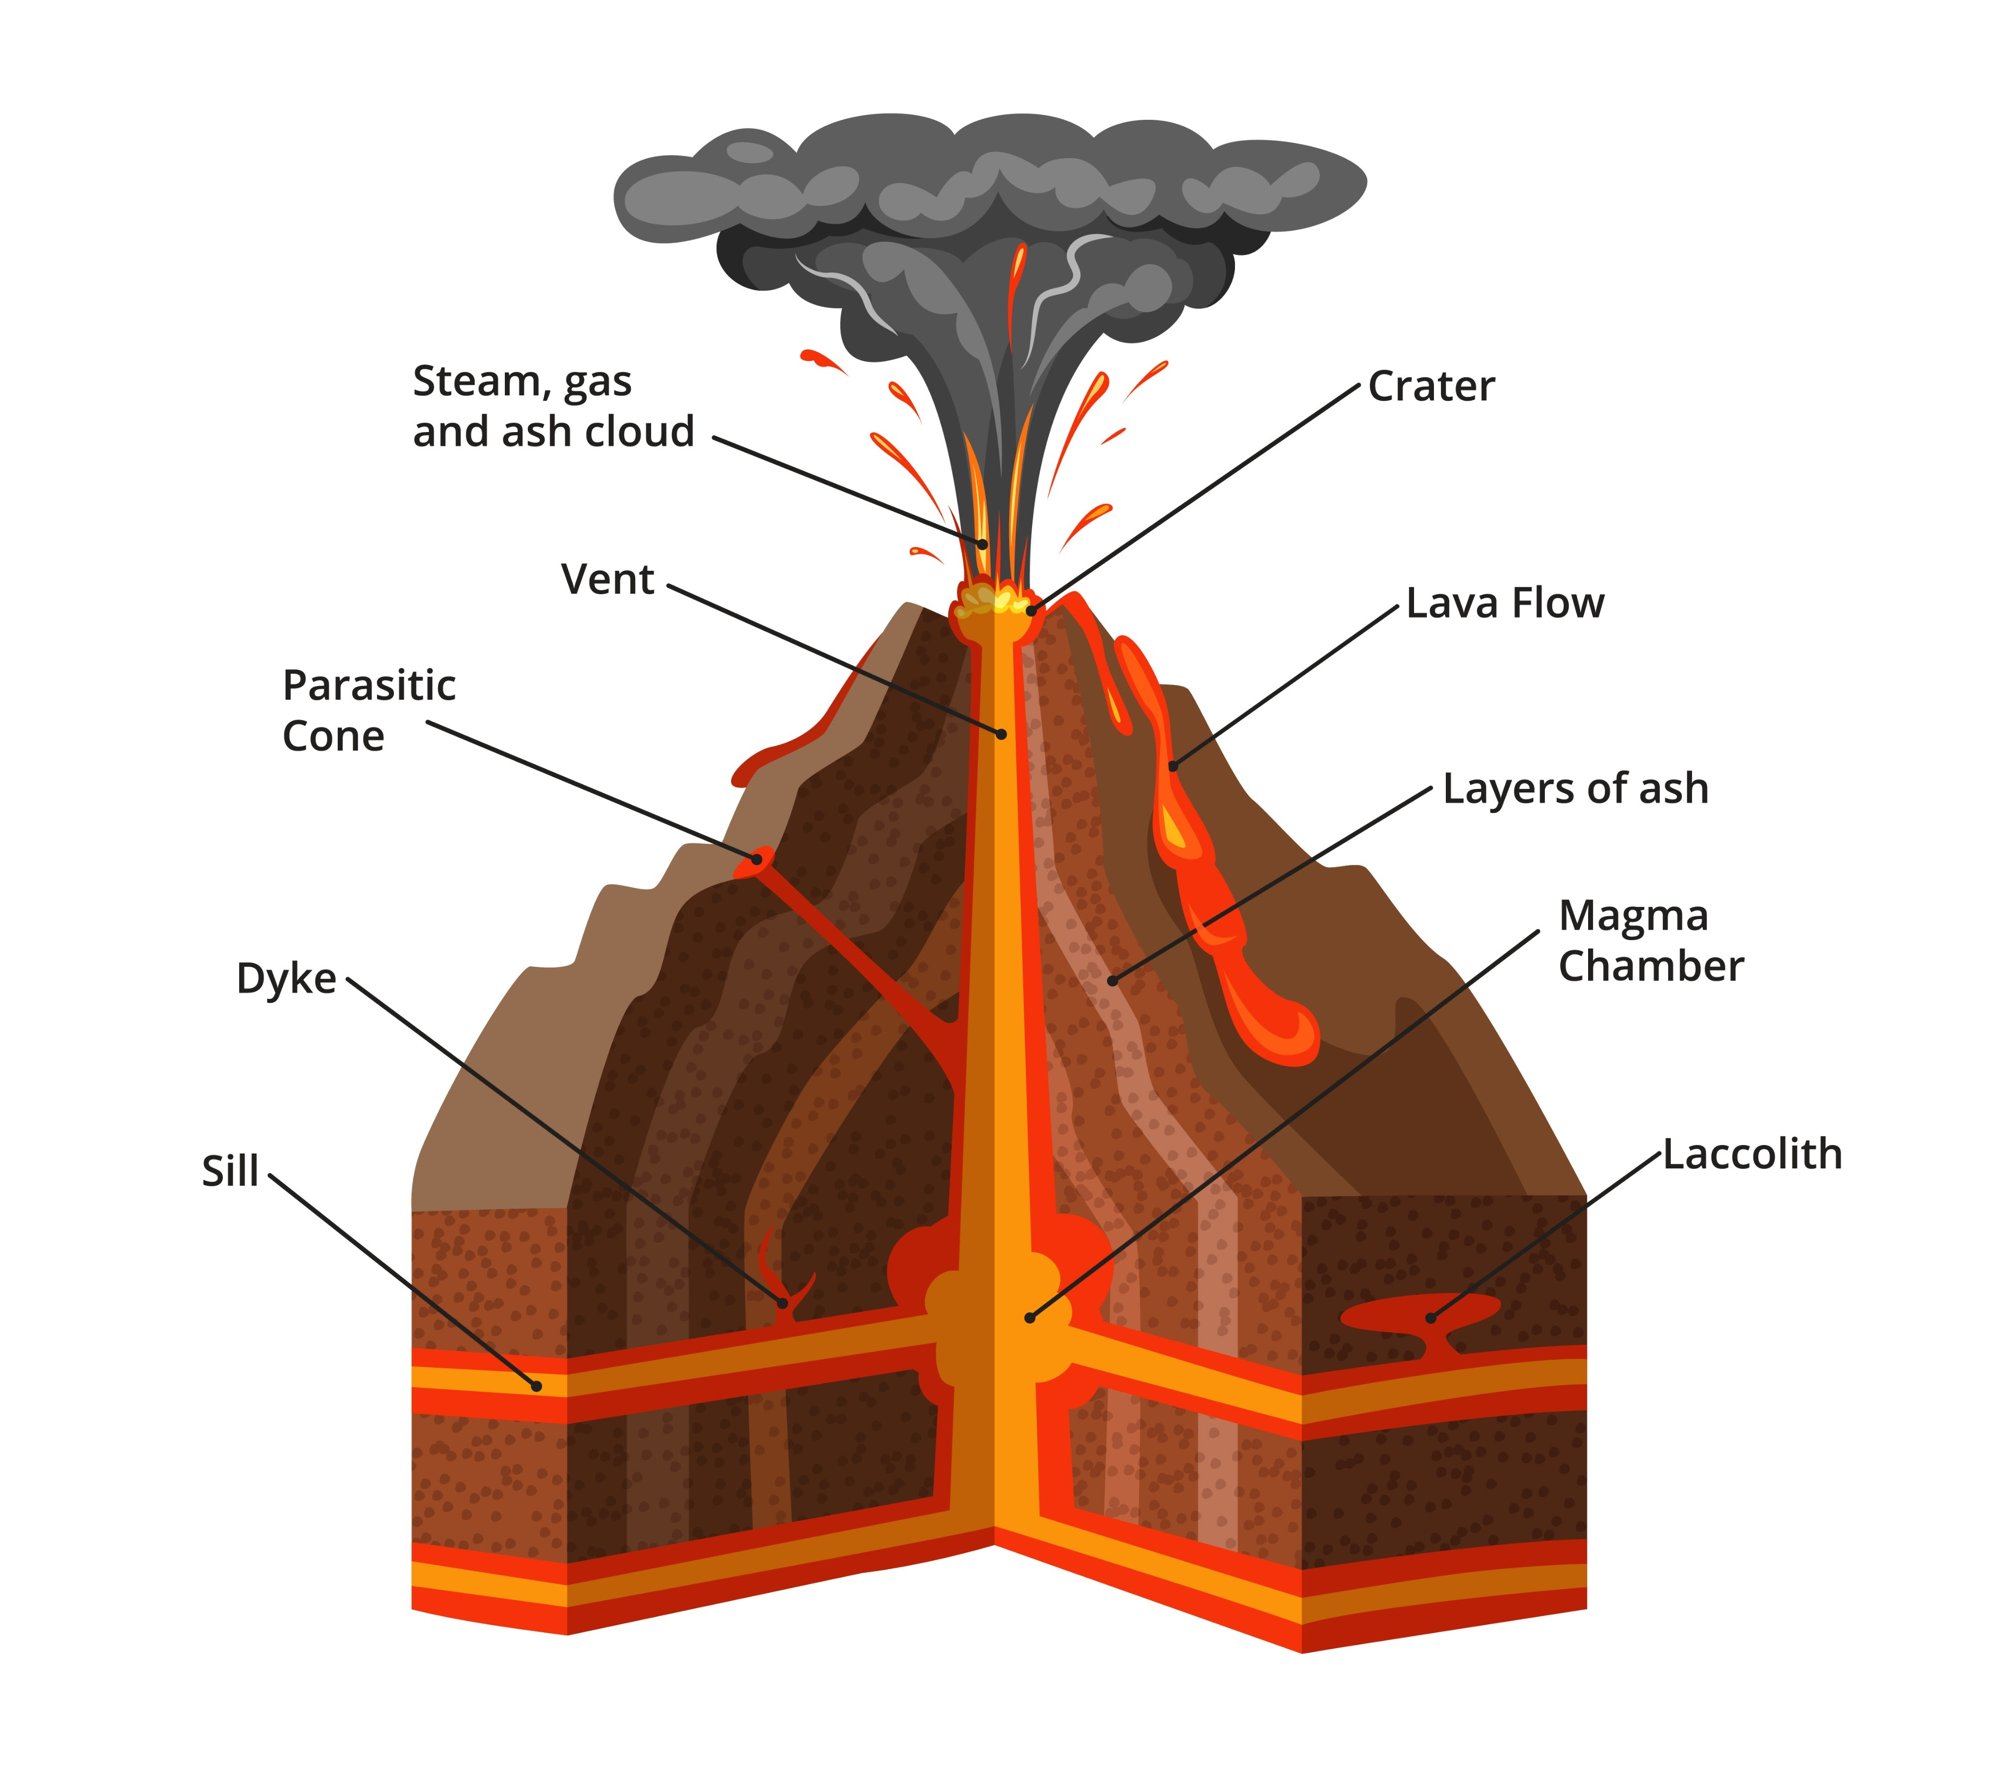
Types of Volcanoes by Shape:
- Central-type (Conical): Lava comes out through a pipe-like vent, creating a cone-shaped mountain (Example: Mt. Fuji in Japan).
- Fissure-type: Lava comes out through many long cracks (fissures) and spreads out, creating plateaus (Example: Deccan Plateau in India).
Types of Volcanoes by Frequency:
- Active: Erupt regularly (Mt. Stromboli).
- Dormant: Have not erupted for a long time but might wake up (Mt. Vesuvius).
- Extinct: Have not erupted in the past and are unlikely to erupt again (Mt. Kilimanjaro).
Summary of the Chapter
- The Earth's interior is active due to energy released by radioactive materials.
- Slow movements create mountains (Folding and Faulting) and continents.
- Sudden movements cause Earthquakes and Volcanoes.
- Earthquakes are measured by seismographs and release P, S, and L waves.
- Volcanoes can be conical or fissure-type and provide both beauty (new land, fertile soil) and danger.
Key Terms with Meanings
- Endogenetic: Internal movements originating from inside the Earth.
- Mantle: The layer of the Earth between the crust and the core where energy waves start.
- Compression: Pressure that pushes rock layers together.
- Tension: Force that pulls rock layers apart.
- Fault: A crack or fracture in the Earth's crust.
- Seismograph: An instrument that records earthquake waves.
Exam-Oriented Questions & Answers
- Q1. What is the main cause of endogenetic movements?
  - Ans: The main cause is the release of huge amounts of energy from radioactive materials in the Earth's mantle.
- Q2. Distinguish between Fold Mountains and Block Mountains.
  - Ans: Fold Mountains are formed by compression (pressure) when rocks are pushed together (e.g., Himalayas). Block Mountains are formed by tension when the crust fractures and a block is lifted up (e.g., Black Forest).
- Q3. Why are Secondary (S) waves considered more dangerous than Primary (P) waves?
  - Ans: S-waves are more destructive because they cause the particles in the ground to move up and down, which causes more damage to buildings than the back-and-forth movement of P-waves.
- Q4. What is a Rift Valley? Give an example.
  - Ans: A Rift Valley is a deep, sunken part of the Earth's crust formed when the land between two parallel faults subsides. Example: The Narmada River valley.
- Q5. Name the three types of volcanoes based on the periodicity of eruption.
  - Ans: 1. Active Volcanoes, 2. Dormant Volcanoes, and 3. Extinct Volcanoes.
- Q6. Mention two effects of a volcanic eruption.
  - Ans: 1. Loss of life and property. 2. Creation of new land or fertile soil from volcanic ash.
- Q7. What is the difference between the Focus and the Epicenter of an earthquake?
  - Ans: The Focus is the point inside the Earth where the earthquake begins, while the Epicenter is the point on the surface directly above the focus where the tremor is felt first.

