1. What are Parallel Lines?
- Imagine you are looking at the straight tracks of a railway. No matter how far they go, they never meet or cross each other. In geometry, we call these Parallel Lines.
- The Definition: Lines that are in the same plane (coplanar) and do not intersect (cross) each other are called parallel lines.
- Real-Life Example: Think of the horizontal bars on a window or the opposite edges of your notebook. They run side-by-side but never touch.
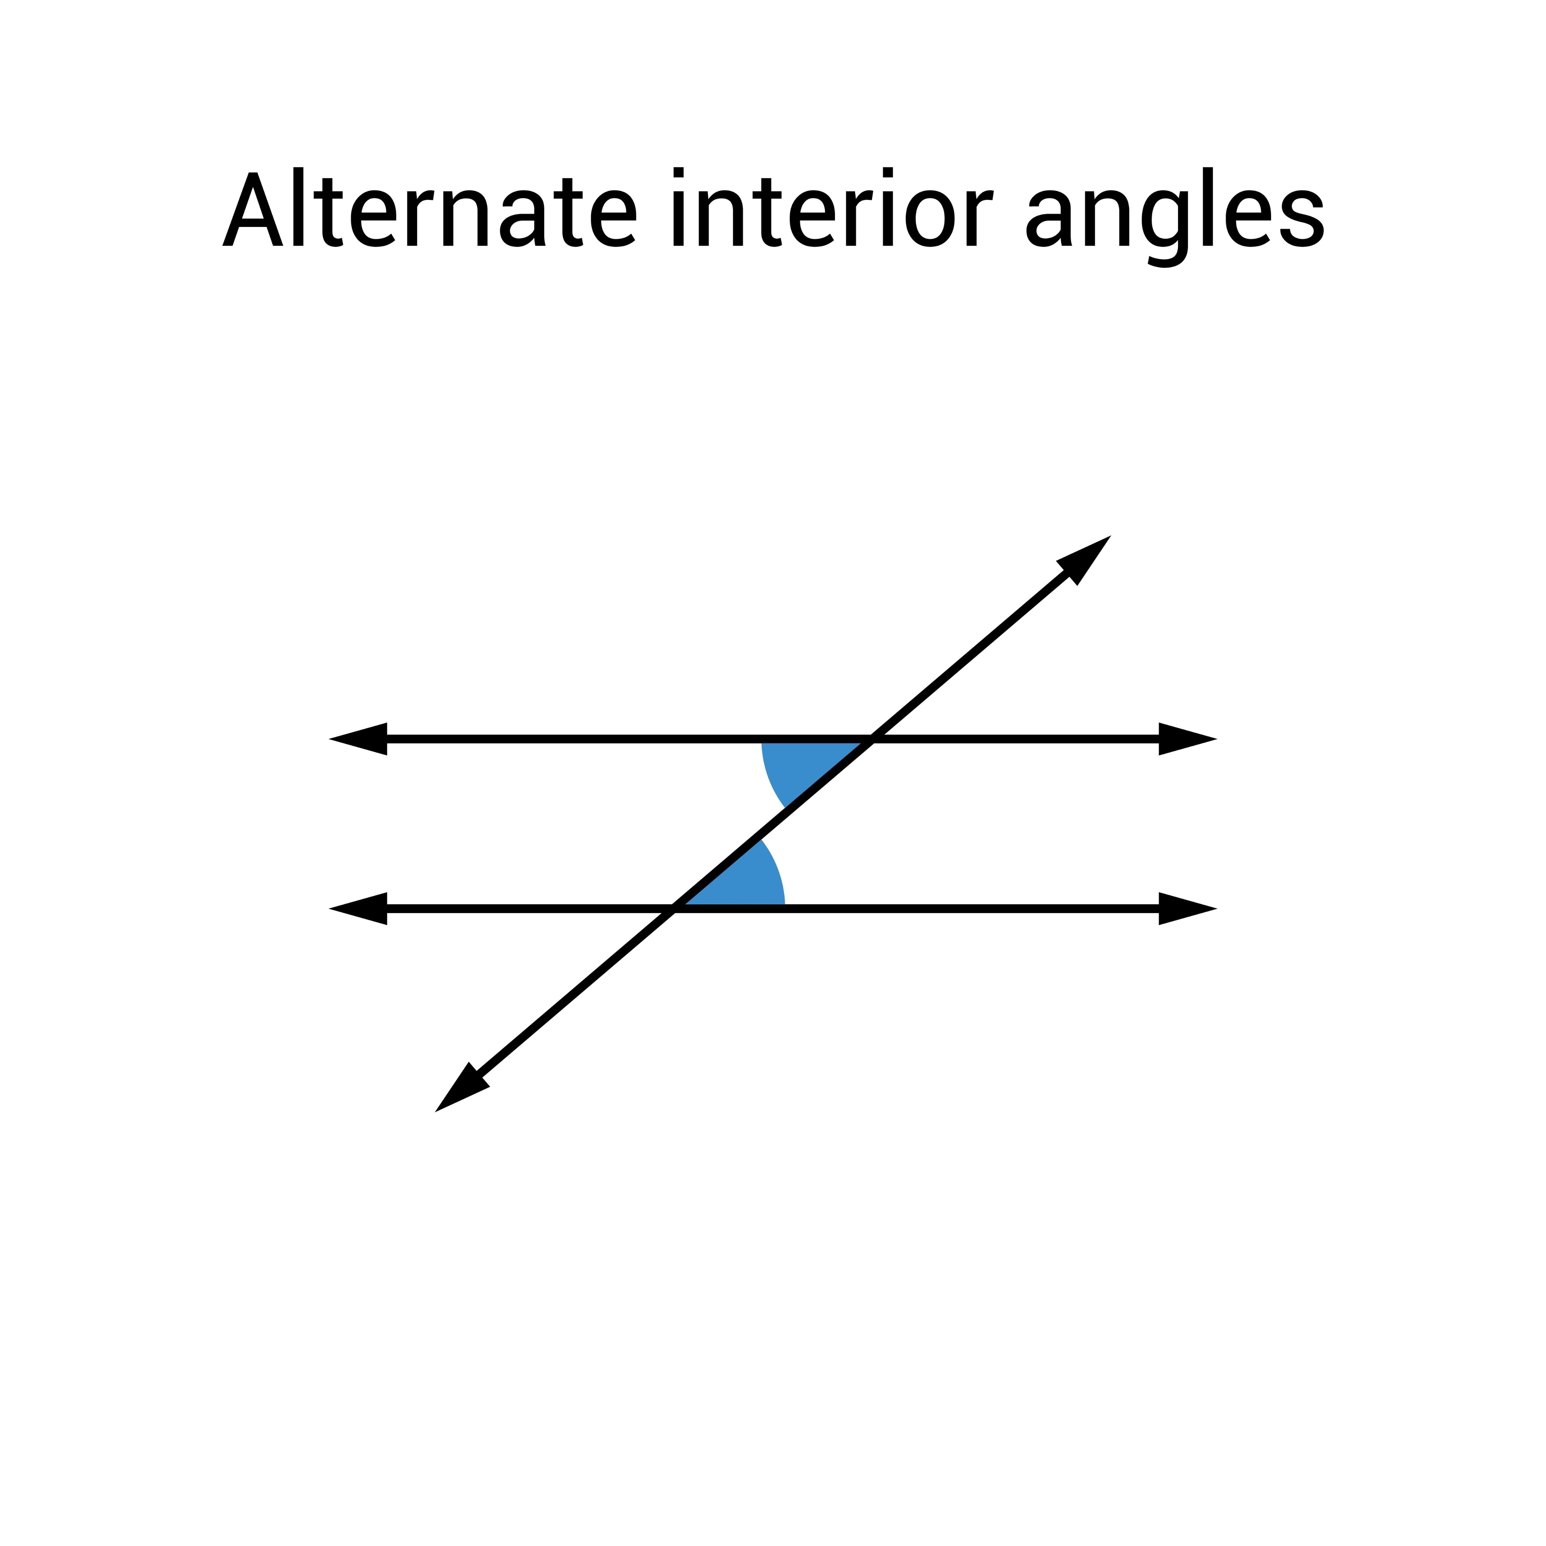
2. Meeting the "Transversal"
When a third line comes along and cuts across two other lines, we call that line a transversal.
- What happens? When a transversal cuts two lines, it creates 8 different angles.
- Daily Life Example: Imagine a road (the transversal) crossing over two parallel sets of train tracks. The corners where the road meets the tracks are the angles.
The Pairs of Angles to Remember
In the sources, we see a diagram with two lines ($l$ and $m$) and a transversal ($n$). Here are the teams of angles they form:
- Corresponding Angles: These are angles in the "same position" at each intersection. (Example: $\angle d$ and $\angle h$).
- Alternate Interior Angles: These are "inside" the two lines but on opposite sides of the transversal. They often look like a 'Z' shape. (Example: $\angle c$ and $\angle e$).
- Alternate Exterior Angles: These are "outside" the lines on opposite sides. (Example: $\angle d$ and $\angle f$).
- Interior Angles on the same side: These are "inside" the lines and on the same side of the transversal. (Example: $\angle c$ and $\angle h$).
3. Important Basic Rules
Before we get to the big theorems, remember these two "golden rules" of angles:
- Opposite Angles: When two lines cross, the angles opposite each other are always congruent (equal).
- Linear Pair: Angles that sit on a straight line together add up to $180^\circ$.
4. The Three Big Theorems (The "Parallel Rules")
When we know for sure that two lines are parallel, three amazing things happen:
A. Interior Angle Theorem
- The Law: If two parallel lines are cut by a transversal, the interior angles on the same side add up to $180^\circ$ (they are supplementary).
- The Formula: $\angle a + \angle b = 180^\circ$.
- Why use it? If you know one interior angle, you can subtract it from $180$ to find its partner.
- Exam Point: This is often proved using an "indirect proof." This means we first assume the lines will meet to form a triangle, and then we show that this assumption leads to a mathematical impossibility.
B. Corresponding Angles Theorem
- The Law: The corresponding angles formed by a transversal of two parallel lines are equal in measure.
- Real-life Example: If you slide a window pane up, the angle it makes with the frame stays exactly the same.
C. Alternate Angles Theorem
- The Law: The alternate angles (the Z-shape ones) are equal in measure.
- The Formula: $\angle d = \angle b$ (based on the diagram in the source).
5. A Special Surprise: The Triangle Theorem
Did you know that the properties of parallel lines help us prove things about triangles?
- The Theorem: The sum of all angles in a triangle is $180^\circ$.
- How we prove it: By drawing a line parallel to one side of the triangle, we can use "alternate angles" to show that the three angles of the triangle fit perfectly onto a straight line ($180^\circ$).
6. Testing for Parallel Lines
Sometimes, we don't know if lines are parallel. We have to "test" them. Think of these as the reverse of the rules we just learned.
- Interior Angle Test: If you add two interior angles on the same side and get $180^\circ$, the lines are parallel.
- Alternate Angle Test: If one pair of alternate angles is equal, the lines are parallel.
- Corresponding Angle Test: If one pair of corresponding angles is equal, the lines are parallel.
- Key Exam Tip: If a question asks you to "Prove line $l \parallel m$," you must use one of these three tests.
7. Summary of the Chapter
- Parallel lines never touch and stay the same distance apart.
- A transversal is a line that intersects two or more lines.
- When lines are parallel:
  - Corresponding angles are equal.
  - Alternate angles are equal.
  - Interior angles add up to $180^\circ$.
- The sum of angles in a triangle is always $180^\circ$.
- If a line is perpendicular to two different lines in the same plane, those two lines must be parallel to each other.
8. Key Terms to Remember
- Coplanar: Lines or points that lie on the same flat surface (plane).
- Intersect: To cross over each other.
- Congruent: A fancy math word for "equal" or "identical in measure."
- Supplementary: Two angles that add up to $180^\circ$.
- Transversal: A line that cuts across other lines.
9. Exam-Oriented Questions & Answers
Q1: Define parallel lines.
- Answer: Parallel lines are lines that are in the same plane and do not intersect each other.
Q2: If two lines are parallel and one interior angle is $75^\circ$, what is the measure of the interior angle on the same side?
- Answer: $105^\circ$. Because interior angles are supplementary ($180^\circ - 75^\circ = 105^\circ$).
Q3: How many angles are formed when a transversal intersects two lines?
- Answer: 8 angles are formed.
Q4: If a transversal intersects two parallel lines and one angle is $40^\circ$, what is the measure of its corresponding angle?
- Answer: $40^\circ$. Corresponding angles of parallel lines are always equal.
Q5: What is the sum of the measures of all angles in a triangle?
- Answer: $180^\circ$.
Q6: What is the "Interior Angle Test"?
- Answer: It states that if the interior angles on the same side of a transversal are supplementary ($180^\circ$), then the two lines are parallel.

