1. Written Sources
Written sources are things that were written down at the time an event happened. In modern times, these are very important because they give us clear, factual details.
The main written sources are:
- Newspapers: These are called the "fourth pillar of democracy". They give us news about politics, sports, art, and social issues.
- Press Trust of India (PTI): After 1953, PTI became the most important source for primary details, reports, and photographs of major events in India.
- Postage Stamps: Even though stamps don’t "speak," historians make them speak! They change over time and show us important people, events, or anniversaries.
- Archives: This is a special place where historical documents are kept.
  - Exam Point: The National Archives of India is located in New Delhi. It is the largest archive in all of Asia!
- Other examples: Encyclopedias, diaries, reference books, and government gazettes.
Daily Life Example:
Think about a school diary or a report card. Years from now, if someone finds your report card, they will know which subjects you studied and how you performed. That is a "written source" of your history!
2. Material Sources
Material sources are physical objects we can touch and see. They show us how people lived and what they valued.
- Coins: The Reserve Bank of India (RBI) prints our money. Coins have changed since 1950. The metals used and the pictures on them tell a story. For example, coins with images of farmers or messages about population control help us understand what India was focused on at that time.
- Museums: All states in India have museums that show our culture and heritage.
  - Example: The Chhatrapati Shivaji Maharaj Museum in Mumbai.
- Private Collectors: Sometimes, people start their own museums for specific things like old lamps, cricket equipment, or even nutcrackers!
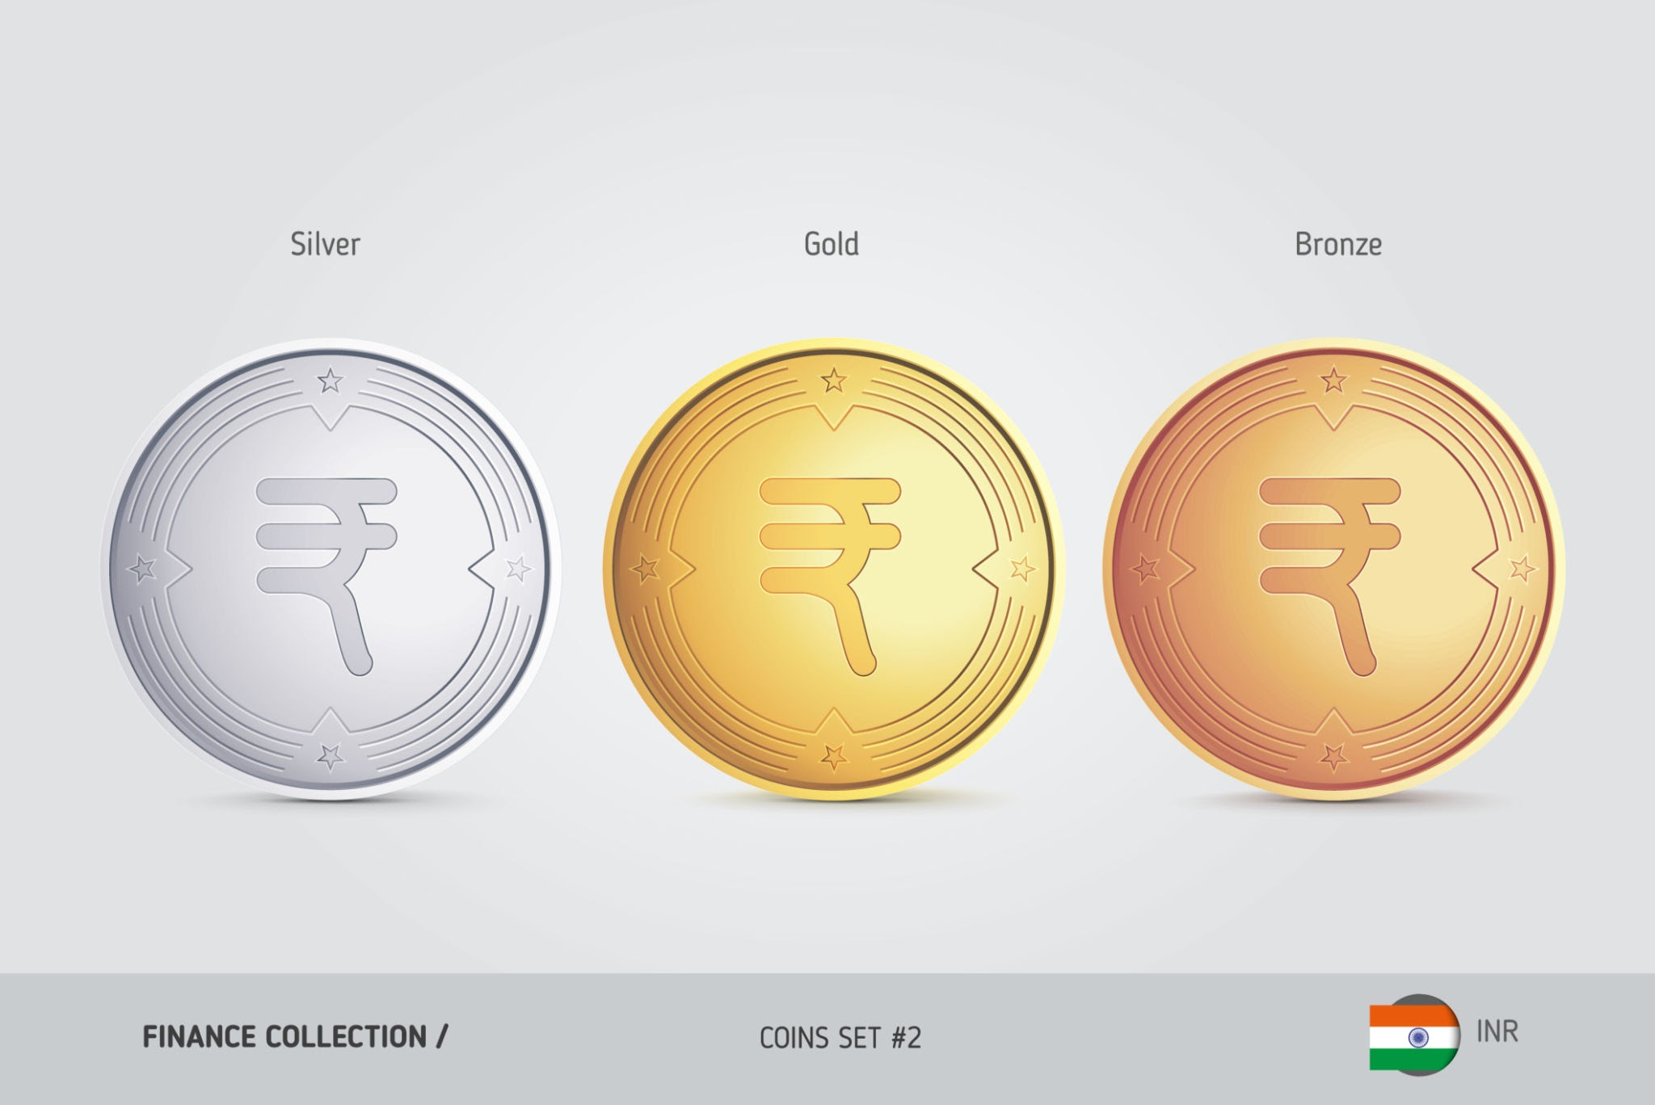
If you find an old 10-paisa coin in your grandmother’s drawer, you are looking at a material source! It shows you that money used to look different and had a different value in the past.
3. Oral Sources
These are stories or information passed from person to person by speaking or singing, rather than being written down.
- Examples: Folktales, folksongs, proverbs, and ballads (called powadas in Marathi).
- Inspiration: Activists like Annabhau Sathe and Shahir Amar Sheikh used these songs to inspire people during the Sanyukta Maharashtra Movement.
Daily Life Example:
A bedtime story your grandfather tells you about how his village looked when he was a boy is an oral source of history.
4. Audio-Visual Sources
In the modern world, we have technology that lets us see and hear history as it happens. These are called Audio-Visual sources.
- Examples: Television, films, and the internet. Channels like the History Channel or Discovery Channel are great examples.
- FTII (Film and Television Institute of India): The government started this in Pune in 1960 to help educate people.
- Indian News Review: This department made newsreels and documentaries about important leaders and social issues in India. These films are a huge help for historians.
Daily Life Example:
When you watch a YouTube video of the Republic Day parade from 10 years ago, you are using an audio-visual source to learn about India's past.
The Changing Face of Sources
As technology moves faster, our sources change too.
- From Pagers to Cellphones: In the 1990s, people used a gadget called a ‘pager’ to send messages, but it disappeared quickly when cellphones arrived.
- The Internet: Today, the internet provides a massive amount of information. However, we must be careful! We must always check if the information on the internet is true and authentic before using it for history.
Summary
To understand modern Indian history (post-1947), we use four main "clues":
- Written (newspapers, archives)
- Material (coins, museums)
- Oral (songs, stories)
- Audio-Visual (films, TV)
These sources are now more easily available than ever before, but we must use them wisely to write the true story of our nation.
Key Terms to Remember
- Archives: A place where historical documents are preserved.
- Philatelist: A person who studies or collects postage stamps (like Jal Cooper).
- PTI (Press Trust of India): An organization that provides news reports and photos to newspapers.
- Audio-Visual: Media that you can both hear and see, like movies or TV.
Exam-Oriented Questions & Answers
- Q1. Where is the National Archives of India situated?
  - Answer: The National Archives of India is situated in New Delhi.
- Q2. Why are newspapers called the 'fourth pillar of democracy'?
  - Answer: They are a major medium of information that keeps people informed about politics, social issues, and the government, ensuring transparency in a democracy.
- Q3. What kind of information do coins provide to historians?
  - Answer: Coins tell us about the time they were made, the metals used, and important contemporary issues through the images printed on them (like agriculture or population control).
- Q4. What is the purpose of the Film and Television Institute of India (FTII)?
  - Answer: It was started in Pune in 1960 to provide public education through films and newsreels on social issues, politics, and great leaders.
- Q5. Why must we be careful when using internet sources for history?
  - Answer: While there is a huge amount of information online, the truth and authenticity of that information must be verified to ensure it is accurate.
- Q6. Give examples of oral sources.
  - Answer: Folktales, folksongs, proverbs, ballads (powadas), and owis (verses) are all oral sources.

