1. The Laws of Chemical Combination
When substances change during a chemical reaction, they don't just do it randomly. They follow strict rules discovered in the 18th and 19th centuries.
A. Law of Conservation of Matter
In 1785, the scientist Antoine Lavoisier discovered that there is no rise or drop in the mass of matter during a chemical reaction.
- The Rule: The total mass of the reactants (the things you start with) is exactly the same as the total mass of the products (the things formed).
- Teacher’s Example: Imagine you weigh 56g of calcium oxide and 18g of water separately. If you mix them together, the new substance formed will weigh exactly 74g ($56 + 18$).
- Daily Life Example: If you weigh the ingredients for a cake (flour, sugar, eggs) and they total 1kg, the baked cake (plus any steam that escaped) will still weigh exactly 1kg.
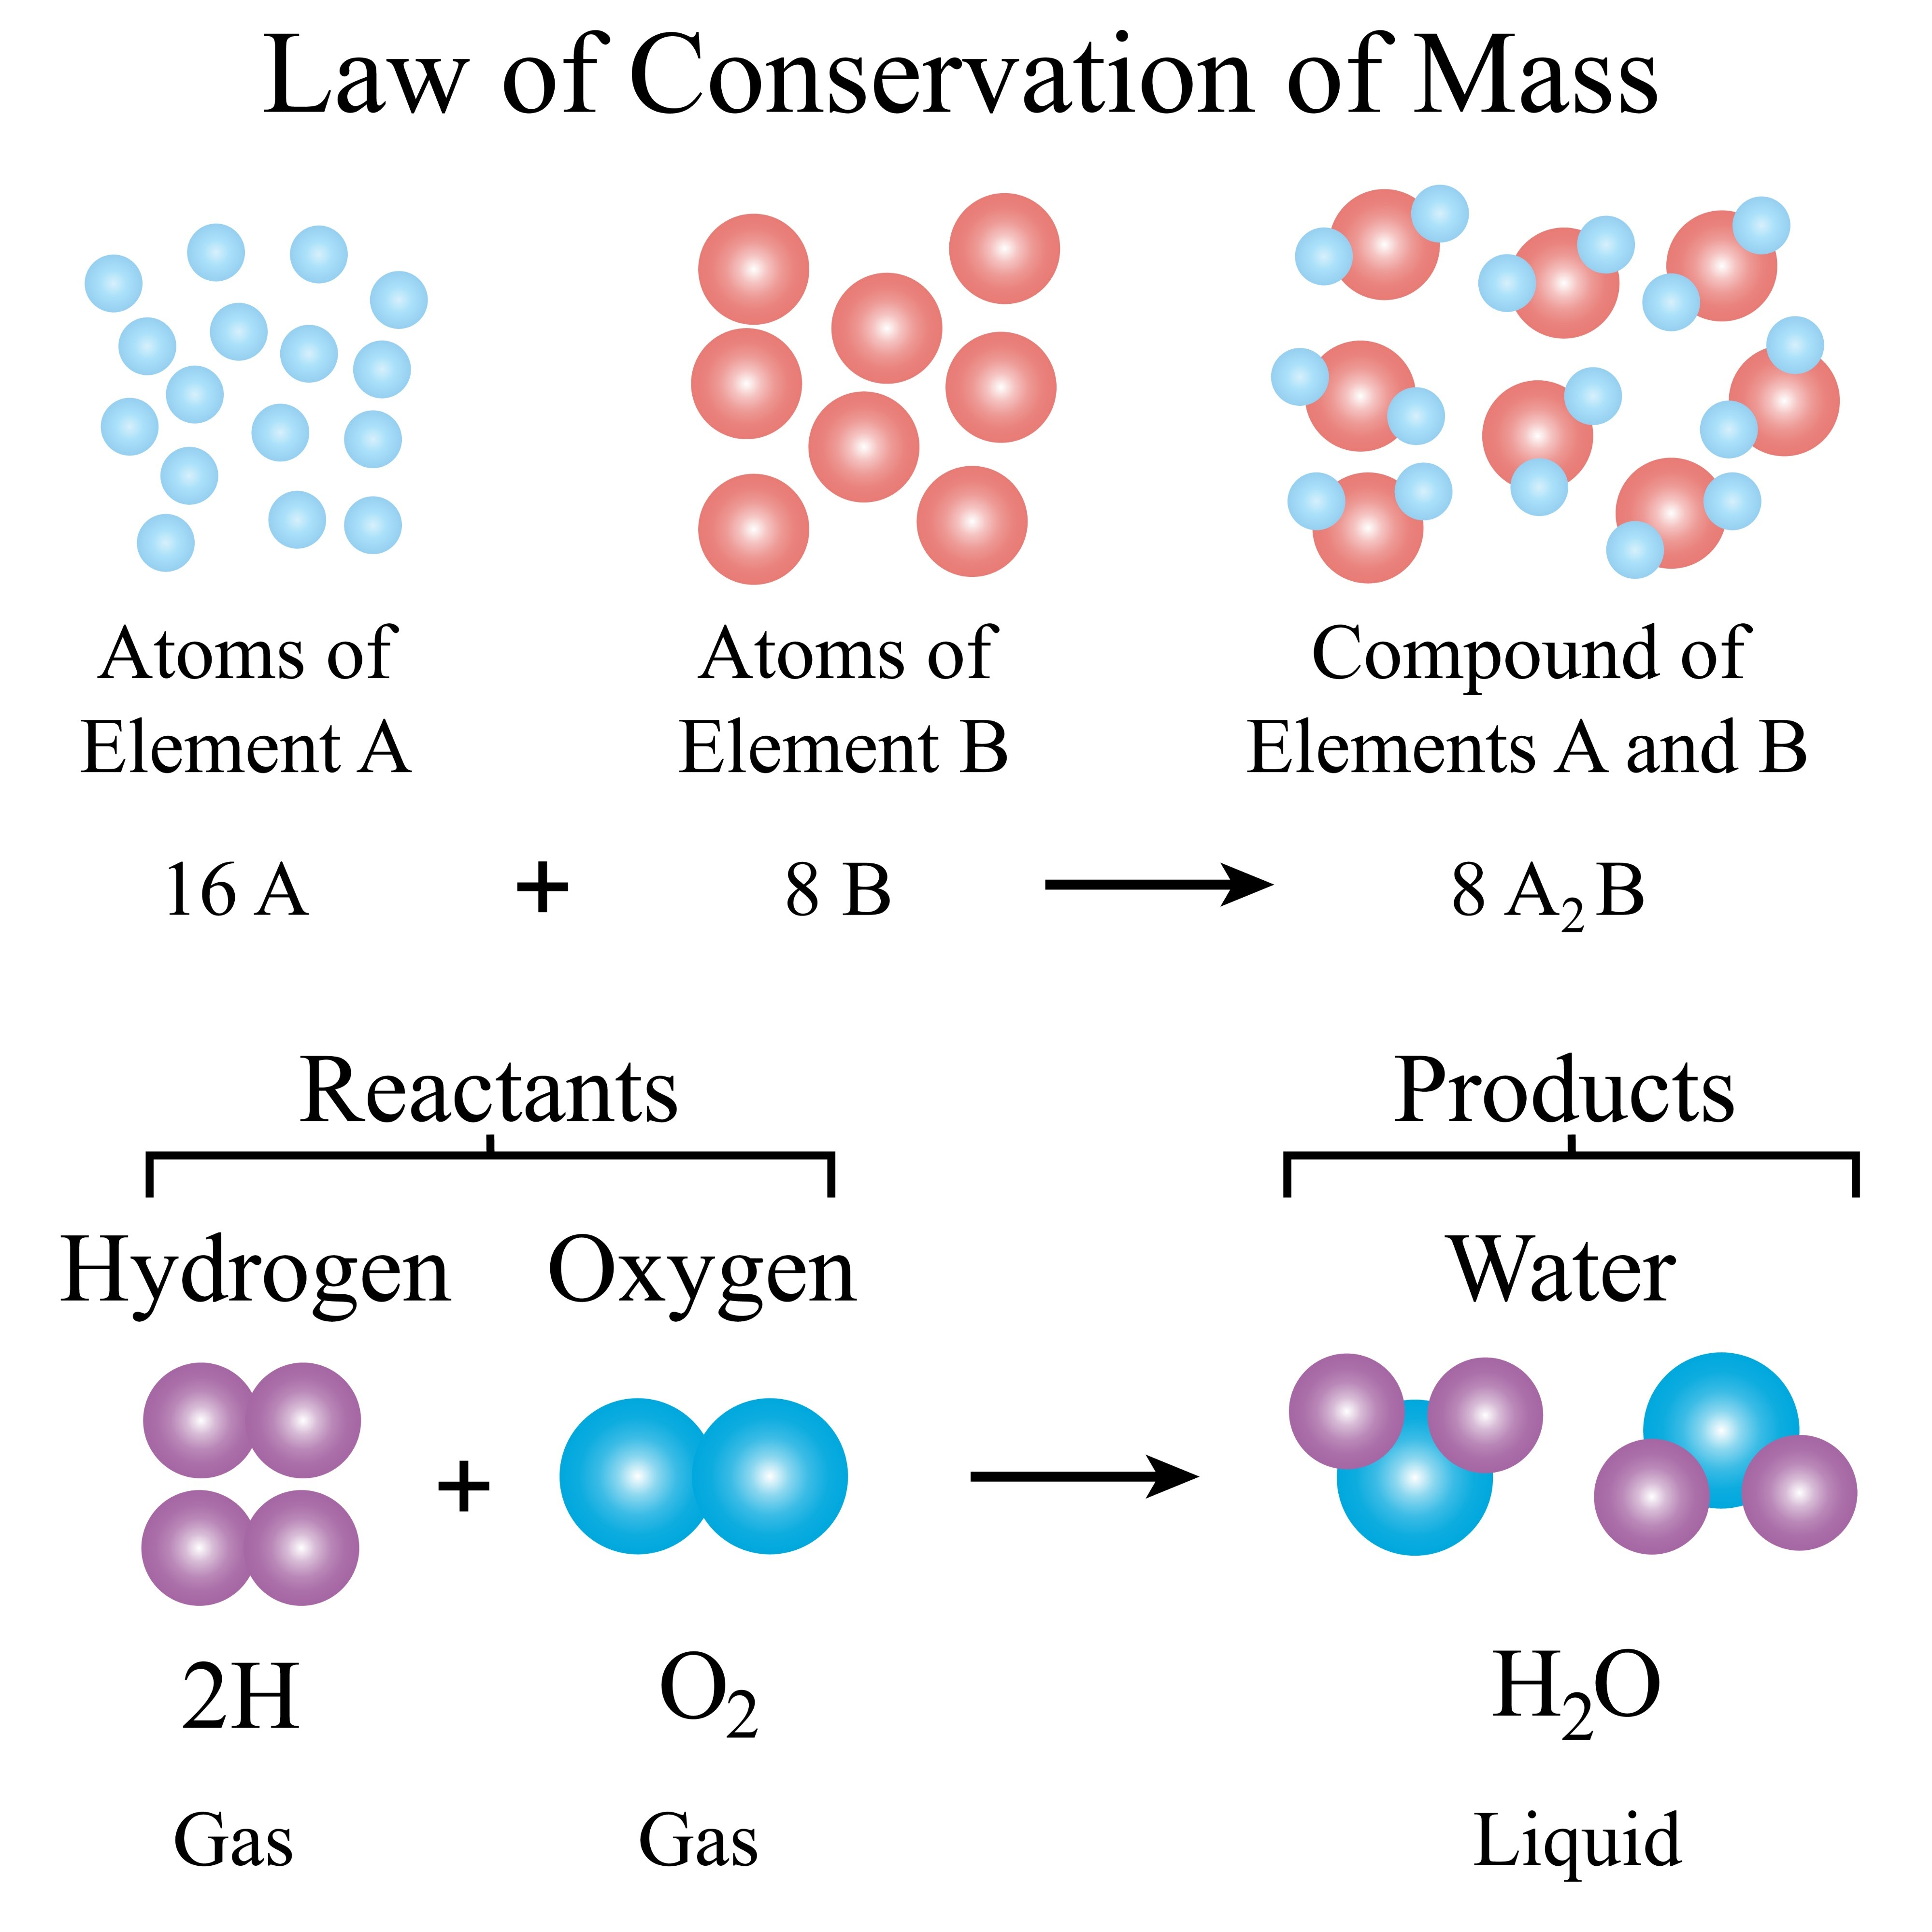

B. Law of Constant Proportion
In 1794, J.L. Proust discovered that in a chemical compound, the elements are always present in a fixed proportion by mass.
- The Rule: No matter where you get a substance from, the ratio of the weights of its elements stays the same.
- Teacher’s Example: In water ($H_2O$), the mass of hydrogen to oxygen is always 1:8. This means if you have 9g of water, it will always have 1g of hydrogen and 8g of oxygen.
- Daily Life Example: Think of a recipe for a specific brand of chocolate. No matter which store you buy it from, it always contains the exact same ratio of cocoa to sugar to taste the same.
2. Atoms: The Tiny Building Blocks
Atoms are so small we need special microscopes, like the "field ion microscope," to see them.
Atomic Size
- Radius: The size of an atom is its "atomic radius," measured from the center (nucleus) to the outermost path of its electrons.
- Measurement: We measure them in nanometers (nm). $1 / 10^9$ meters = 1 nm.
- Exam Point: The size of an atom depends on the number of electron orbits. More orbits mean a bigger atom.
Atomic Mass (The Weight of an Atom)
An atom's mass is concentrated in its center, called the nucleus, which contains protons (p) and neutrons (n).
- Atomic Mass Number: This is the total number of protons and neutrons added together ($p + n$).
- Relative Atomic Mass: Because atoms are too tiny to weigh on a normal scale, scientists compared them to a "reference atom". Today, we use the Carbon-12 atom as the standard.
- Unified Mass (u): This is the modern unit for atomic mass, also called a Dalton. $1u = 1.66053904 \times 10^{-27}$ kg.
3. Chemical Symbols of Elements
We don't always write the full name of an element. Instead, we use symbols decided by the IUPAC (International Union of Pure and Applied Chemistry).
- The Method: Usually, the symbol is the first letter (Capital) or the first and second/specific letter of the name (First is Capital, second is small).
- Examples: * Hydrogen is H
  - Sodium is Na (from its Latin name Natrium)
  - Magnesium is Mg
4. Molecules and Molecular Mass
When atoms join together, they form molecules.
- Molecular Mass: This is simply the sum of the atomic masses of all the atoms in one molecule.
- How to Calculate (Example: $H_2O$):
  - Atomic mass of Hydrogen (H) = 1. There are 2 H atoms. ($1 \times 2 = 2$).
  - Atomic mass of Oxygen (O) = 16. There is 1 O atom. ($16 \times 1 = 16$).
  - Total: $2 + 16 = 18u$.
5. The Concept of "Mole"
Counting individual atoms is impossible. So, chemists use a unit called a Mole.
- Definition: A mole is the amount of a substance whose mass in grams is equal to its molecular mass in Daltons.
- Exam Formula:
$$\text{Number of moles (n)} = \frac{\text{Mass of substance in grams}}{\text{Molecular mass of substance}}$$
- Daily Life Example: Just as "1 dozen" always means 12 items (like bananas), "1 mole" always means a specific, huge number of particles.
Avogadro’s Number ($N_A$)
The number of molecules in 1 mole is always constant. It is $6.022 \times 10^{23}$.
- Example: 1 mole of water (18g) contains $6.022 \times 10^{23}$ molecules.
6. Valency and Radicals
Valency is the "combining capacity" of an atom—how many bonds it can form with other atoms.
How it works:
- Atoms want to have a complete outer shell of electrons (usually 8).
- Cations: Atoms that give away electrons and become positively charged (e.g., $Na^+$).
- Anions: Atoms that take electrons and become negatively charged (e.g., $Cl^-$).
- Variable Valency: Some elements, like Iron (Fe), can have different valencies (2 or 3) depending on the situation.
Radicals
Radicals are groups of atoms that carry a charge and act as a single unit in a reaction.
- Basic Radicals: Usually metal ions with a positive charge (e.g., $Ag^+$, $Cu^{2+}$).
- Acidic Radicals: Usually non-metal ions with a negative charge (e.g., $Cl^-$, $SO_4^{2-}$).
7. Writing Chemical Formulae (The Cross-Multiplication Method)
To write a formula like $Na_2SO_4$, follow these steps:
- Step 1: Write the symbols of the radicals (Basic on left, Acidic on right).
- Step 2: Write their valency below them.
- Step 3: Cross-multiply the valencies.
- Step 4: Write the final formula using the numbers from the cross-multiplication.
Short Summary
- Matter is conserved: Mass doesn't change during reactions.
- Proportions are constant: Compounds always have elements in fixed weight ratios.
- Atoms have mass: Measured in Unified Mass (u) based on Carbon-12.
- The Mole is a counting unit: 1 mole = $6.022 \times 10^{23}$ particles.
- Valency is the power of an atom to join with others.
- Formulae are created by crossing the valencies of basic and acidic radicals.
Key Terms
- Reactant: The starting substances in a chemical reaction.
- Product: The substances formed after a reaction.
- Atomic Radius: The distance from the nucleus to the outer orbit.
- Nucleons: Protons and neutrons together.
- Dalton (u): The unit for measuring atomic or molecular mass.
- Radical: A charged atom or group of atoms.
Exam-Oriented Questions & Answers
- Q: State the Law of Conservation of Matter.
  - A: In a chemical reaction, the total mass of the reactants is equal to the total mass of the products formed.
- Q: What is the ratio by mass of Hydrogen to Oxygen in water?
  - A: The ratio is 1:8.
- Q: Define a 'Mole'.
  - A: A mole is the quantity of a substance whose mass in grams is equal in magnitude to its molecular mass in Daltons.
- Q: What is Avogadro's number?
  - A: It is $6.022 \times 10^{23}$, representing the number of molecules in one mole of any substance.
- Q: How do you find the molecular mass of a compound?
  - A: It is the sum of the atomic masses of all the constituent atoms in that molecule.
- Q: What is a cation and an anion?
  - A: A cation is a positively charged ion (formed by losing electrons), and an anion is a negatively charged ion (formed by gaining electrons).
- Q: Write the formula for the number of moles.
  - A: $n = \text{Mass of substance (g)} / \text{Molecular mass of substance}$.

