**UNIT 1**

**NETWORKS BASICS**

**COMPUTER NETWORK**

A network set up by connecting two or more computers and other supporting hardware devices through communication channels is called a computer network. It enables computers to communicate with each other and to share commands, data, etc., including the hardware and software resources.

Uses of Computer Network:

* It allows you to share resources such as printers, scanners, etc.
* You can share expensive software and database among network users.
* It facilitates communications from one computer to another computer.
* It allows the exchange of data and information among users through a network.

**ELEMENTS OF A COMPUTER NETWORK**

**1.** Sender

**2.** Receiver

**3.** Transmission Medium

**4.** Set of rules (Protocol)

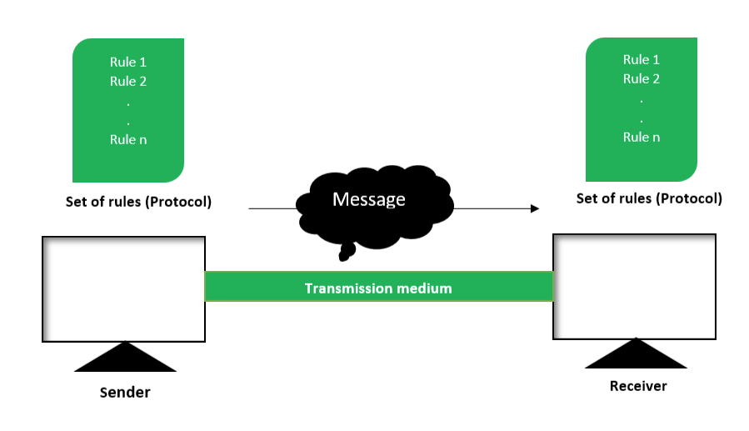

1. **Sender :**  
   To transfer message from source to destination, someone must be there who will play role of a source. Sender plays part of a source in data communication system. It is simple a device that sends data message. The device could be in form of a computer, mobile, telephone, laptop, video camera, or a workstation, etc.
2. **Receiver :**  
   It is destination where finally message sent by source has arrived. It is a device that receives message. Same as sender, receiver can also be in form of a computer, telephone mobile, workstation, etc.
3. [Transmission Medium :](https://www.geeksforgeeks.org/types-transmission-media/)  
   In entire process of data communication, there must be something which could act as a bridge between sender and receiver, Transmission medium plays that part. It is physical path by which data or message travels from sender to receiver. Transmission medium could be guided (with wires) or unguided (without wires), for example, twisted pair cable, fiber optic cable, radio waves, microwaves, etc.
4. **Set of rules (Protocol) :**  
   To govern data communications, various sets of rules had been already designed by the designers of the communication systems, which represent a kind of agreement between communicating devices. These are defined as protocol. In simple terms, the protocol is a set of rules that govern data communication. If two different devices are connected but there is no protocol among them, there would not be any kind of communication between those two devices. Thus the protocol is necessary for data communication to take place.

**TYPES OF COMMUNICATION**

There are 3 types of transmission modes which are given below: Simplex mode, Half duplex mode, and Full duplex mode. These are explained as following below.

1. **Simplex mode:**  
   In simplex mode, Sender can send the data but that sender can’t receive the data. It is a unidirectional communication.

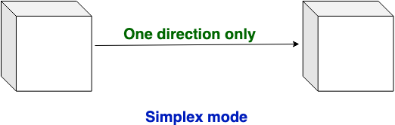

1. **Half-duplex mode:**  
   In half duplex mode, Sender can send the data and also can receive the data but one at a time. It is two-way directional communication but one at a time.

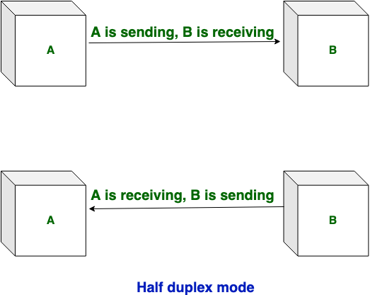

1. **Full duplex mode:**  
   In full duplex mode, Sender can send the data and also can receive the data simultaneously. It is two-way directional communication simultaneously.

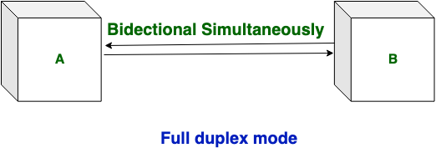

**Difference between Simplex, Half duplex and Full Duplex Transmission Modes:**

|  |  |  |
| --- | --- | --- |
| Simplex | Half duplex | Full duplex |
| Simplex mode is a uni-directional communication. | Half duplex mode is a two-way directional communication but one at a time. | Full duplex mode is a two-way directional communication simultaneously. |
| In simplex mode, Sender can send the data but that sender can’t receive the data. | In half duplex mode, Sender can send the data and also can receive the data but one at a time. | In full duplex mode, Sender can send the data and also can receive the data simultaneously. |
| The simplex mode provides less performance than half duplex and full duplex. | The half duplex mode provides less performance than full duplex. | Full duplex provides better performance than simplex and half duplex mode. |
|  |  |  |

**NETWORK MODELS**

**Client-Server Network:**  
This model are broadly used network model. In Client-Server Network, Clients and server are differentiated, Specific server and clients are present. In Client-Server Network, Centralized server is used to store the data because its management is centralized. In Client-Server Network, Server respond the services which is request by Client.

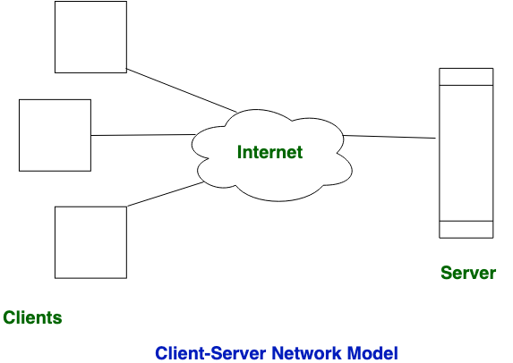

**Peer-to-Peer Network:**  
This model does not differentiate the clients and the servers, In this each and every node is itself client and server. In Peer-to-Peer Network, Each and every node can do both request and respond for the services.

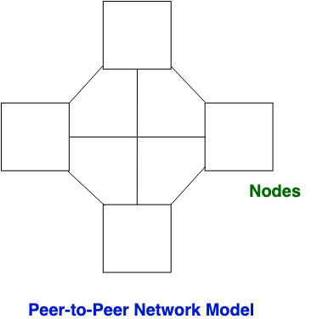

**Difference between Client-Server and Peer-to-Peer Network:**

|  |  |  |
| --- | --- | --- |
| S.NO | Client-Server Network | Peer-to-Peer Network |
| 1. | In Client-Server Network, Clients and server are differentiated, Specific server and clients are present. | In Peer-to-Peer Network, Clients and server are not differentiated. |
| 2. | Client-Server Network focuses on information sharing. | While Peer-to-Peer Network focuses on connectivity. |
| 3. | In Client-Server Network, Centralized server is used to store the data. | While in Peer-to-Peer Network, Each peer has its own data. |
| 4. | In Client-Server Network, Server respond the services which is request by Client. | While in Peer-to-Peer Network, Each and every node can do both request and respond for the services. |
| 5. | Client-Server Network are costlier than Peer-to-Peer Network. | While Peer-to-Peer Network are less costlier than Client-Server Network. |
| 6. | Client-Server Network are more stable than Peer-to-Peer Network. | While Peer-to-Peer Network are less stable if number of peer is increase. |
| 7. | Client-Server Network is used for both small and large networks. | While Peer-to-Peer Network is generally suited for small networks with fewer than 10 computers. |

**TYPES OF COMPUTER NETWORKS**

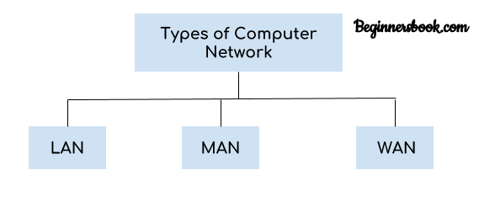

There are mainly three types of computer networks based on their size:  
1. Local Area Network (LAN)  
2. Metropolitan Area Network (MAN)  
3. Wide area network (WAN)

## 1. Local Area Network (LAN)

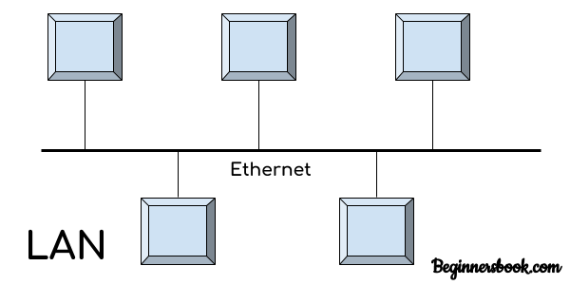  
1. Local area network is a group of computers connected with each other in a small places such as school, hospital, apartment etc.  
2. LAN is secure because there is no outside connection with the local area network thus the data which is shared is safe on the local area network and can’t be accessed outside.  
3. LAN due to their small size are considerably faster, their speed can range anywhere from 100 to 100Mbps.  
4. LANs are not limited to wire connection, there is a new evolution to the LANs that allows local area network to work on a wireless connection.

## 2. Metropolitan Area Network (MAN)

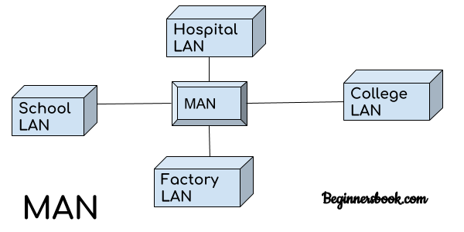  
MAN network covers larger area by connections LANs to a larger network of computers. In Metropolitan area network various Local area networks are connected with each other through telephone lines. The size of the Metropolitan area network is larger than LANs and smaller than WANs(wide area networks), a MANs covers the larger area of a city or town.

## 3. Wide area network (WAN)

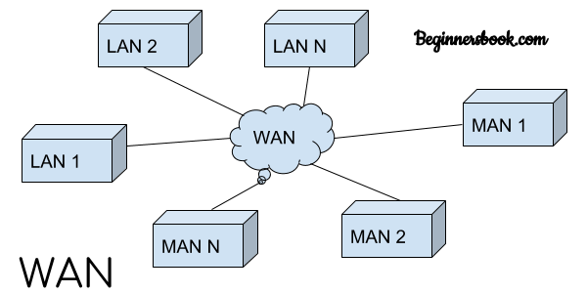  
Wide area network provides long distance transmission of data. The size of the WAN is larger than LAN and MAN. A WAN can cover country, continent or even a whole world. Internet connection is an example of WAN. Other examples of WAN are mobile broadband connections such as 3G, 4G etc.

### Advantages of WAN:

Centralized infrastructure: One of the main advantage of WAN is the that we do not need to maintain the backup and store data on local system as everything is stored online on a data centre, from where we can access the data through WAN.

Privacy: We can setup the WAN in such a way that it encrypts the data that we share online that way the data is secure and minimises the risk of unauthorized access.

Increased Bandwidth: With the WAN we get to choose the bandwidth based on the need, a large organization can have larger bandwidth that can carry large amount of data faster and efficiently.

Area: A WAN can cover a large area or even a whole world though internet connection thus we can connect with the person in another country through WAN which is not possible is other type of computer networks.

### Disadvantages of WAN:

Antivirus: Since our systems are connected with the large amount of systems, there is possibility that we may unknowingly download the virus that can affect our system and becomes threat to our privacy and may lead to data loss.  
Expensive: Cost of installation is very high.  
Issue resolution: Issue resolution takes time as the WAN covers large area, it is really difficult to pin point the exact location where the issues raised and causing the problem.

**NETWORK SERVICES**

Network service is an application running at the network application layer and above, that **provides data storage, manipulation, presentation, communication or other capability** which is often implemented using a client–server or peer-to-peer architecture based on application layer network.

* **File Sharing**

One of the reasons which gave birth to networking was file sharing. File sharing enables its users to share their data with other users. User can upload the file to a specific server, which is accessible by all intended users. As an alternative, user can make its file shared on its own computer and provides access to intended users.

* **File Transfer**

This is an activity to copy or move file from one computer to another computer or to multiple computers, with help of underlying network. Network enables its user to locate other users in the network and transfers files.

* **Email**

Electronic mail is a communication method and something a computer user cannot work without. This is the basis of today’s internet features. Email system has one or more email servers. All its users are provided with unique IDs. When a user sends email to other user, it is actually transferred between users with help of email server.

* **Web Services**

World Wide Web has become the synonym for internet.It is used to connect to the internet, and access files and information services provided by the internet servers.

Network topology

Network topology refers **to the manner in which the links and nodes of a network are arranged to relate to each other**. ... Physical network topology examples include star, mesh, tree, ring, point-to-point, circular, hybrid, and bus topology networks, each consisting of different configurations of nodes and links.

## Star Topology

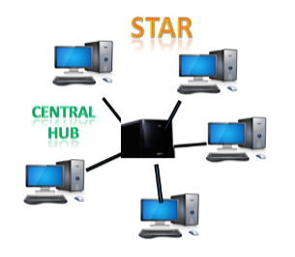

* Star topology is an arrangement of the network in which every node is connected to the central hub, switch or a central computer.
* The central computer is known as a **server**, and the peripheral devices attached to the server are known as **clients**.
* Coaxial cable or RJ-45 cables are used to connect the computers.
* Hubs or Switches are mainly used as connection devices in a **physical star topology**.
* Star topology is the most popular topology in network implementation.

### Advantages of Star topology

* **Efficient troubleshooting:** Troubleshooting is quite efficient in a star topology as compared to bus topology. In a bus topology, the manager has to inspect the kilometers of cable. In a star topology, all the stations are connected to the centralized network. Therefore, the network administrator has to go to the single station to troubleshoot the problem.
* **Network control:** Complex network control features can be easily implemented in the star topology. Any changes made in the star topology are automatically accommodated.
* **Limited failure:** As each station is connected to the central hub with its own cable, therefore failure in one cable will not affect the entire network.
* **Familiar technology:** Star topology is a familiar technology as its tools are cost-effective.
* **Easily expandable:** It is easily expandable as new stations can be added to the open ports on the hub.
* **Cost effective:** Star topology networks are cost-effective as it uses inexpensive coaxial cable.
* **High data speeds:** It supports a bandwidth of approx 100Mbps. Ethernet 100BaseT is one of the most popular Star topology networks.

### Disadvantages of Star topology

* **A Central point of failure:** If the central hub or switch goes down, then all the connected nodes will not be able to communicate with each other.
* **Cable:** Sometimes cable routing becomes difficult when a significant amount of routing is required.

## Ring Topology

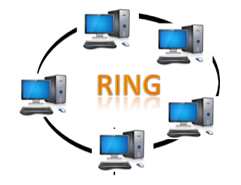

* Ring topology is like a bus topology, but with connected ends.
* The node that receives the message from the previous computer will retransmit to the next node.
* The data flows in one direction, i.e., it is unidirectional.
* The data flows in a single loop continuously known as an endless loop.
* It has no terminated ends, i.e., each node is connected to other node and having no termination point.
* The data in a ring topology flow in a clockwise direction.
* The most common access method of the ring topology is **token passing**.
  + **Token passing:** It is a network access method in which token is passed from one node to another node.
  + **Token:** It is a frame that circulates around the network.
* In a ring topology, a token is used as a carrier.

### Advantages of Ring topology:

* **Network Management:** Faulty devices can be removed from the network without bringing the network down.
* **Product availability:** Many hardware and software tools for network operation and monitoring are available.
* **Cost:** Twisted pair cabling is inexpensive and easily available. Therefore, the installation cost is very low.
* **Reliable:** It is a more reliable network because the communication system is not dependent on the single host computer.

### Disadvantages of Ring topology:

* **Difficult troubleshooting:** It requires specialized test equipment to determine the cable faults. If any fault occurs in the cable, then it would disrupt the communication for all the nodes.
* **Failure:** The breakdown in one station leads to the failure of the overall network.
* **Reconfiguration difficult:** Adding new devices to the network would slow down the network.
* **Delay:** Communication delay is directly proportional to the number of nodes. Adding new devices increases the communication delay.

## Tree topology

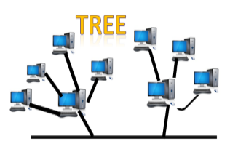

* Tree topology combines the characteristics of bus topology and star topology.
* A tree topology is a type of structure in which all the computers are connected with each other in hierarchical fashion.
* The top-most node in tree topology is known as a root node, and all other nodes are the descendants of the root node.
* There is only one path exists between two nodes for the data transmission. Thus, it forms a parent-child hierarchy.

### Advantages of Tree topology

* **Support for broadband transmission:** Tree topology is mainly used to provide broadband transmission, i.e., signals are sent over long distances without being attenuated.
* **Easily expandable:** We can add the new device to the existing network. Therefore, we can say that tree topology is easily expandable.
* **Easily manageable:** In tree topology, the whole network is divided into segments known as star networks which can be easily managed and maintained.
* **Error detection:** Error detection and error correction are very easy in a tree topology.
* **Limited failure:** The breakdown in one station does not affect the entire network.
* **Point-to-point wiring:** It has point-to-point wiring for individual segments.

### Disadvantages of Tree topology

* **Difficult troubleshooting:** If any fault occurs in the node, then it becomes difficult to troubleshoot the problem.
* **High cost:** Devices required for broadband transmission are very costly.
* **Failure:** A tree topology mainly relies on main bus cable and failure in main bus cable will damage the overall network.
* **Reconfiguration difficult:** If new devices are added, then it becomes difficult to reconfigure.

## Mesh topology

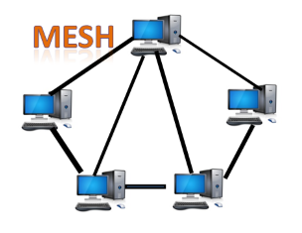

* Mesh technology is an arrangement of the network in which computers are interconnected with each other through various redundant connections.
* There are multiple paths from one computer to another computer.
* It does not contain the switch, hub or any central computer which acts as a central point of communication.
* The Internet is an example of the mesh topology.
* Mesh topology is mainly used for WAN implementations where communication failures are a critical concern.
* Mesh topology is mainly used for wireless networks.

Where n is the number of nodes that represents the network.

**Mesh topology is divided into two categories:**

* Fully connected mesh topology
* Partially connected mesh topology

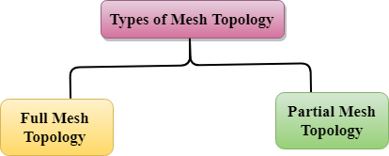

* **Full Mesh Topology:** In a full mesh topology, each computer is connected to all the computers available in the network.
* **Partial Mesh Topology:** In a partial mesh topology, not all but certain computers are connected to those computers with which they communicate frequently.

### Advantages of Mesh topology:

**Reliable:** The mesh topology networks are very reliable as if any link breakdown will not affect the communication between connected computers.

**Fast Communication:** Communication is very fast between the nodes.

**Easier Reconfiguration:** Adding new devices would not disrupt the communication between other devices.

### Disadvantages of Mesh topology

* **Cost:** A mesh topology contains a large number of connected devices such as a router and more transmission media than other topologies.
* **Management:** Mesh topology networks are very large and very difficult to maintain and manage. If the network is not monitored carefully, then the communication link failure goes undetected.
* **Efficiency:** In this topology, redundant connections are high that reduces the efficiency of the network.

## Bus Topology

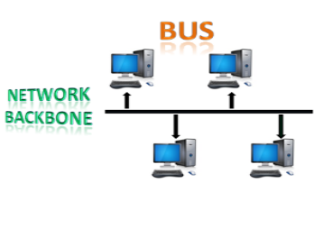

* The bus topology is designed in such a way that all the stations are connected through a single cable known as a backbone cable.
* Each node is either connected to the backbone cable by drop cable or directly connected to the backbone cable.
* When a node wants to send a message over the network, it puts a message over the network. All the stations available in the network will receive the message whether it has been addressed or not.
* The bus topology is mainly used in 802.3 (ethernet) and 802.4 standard networks.
* The configuration of a bus topology is quite simpler as compared to other topologies.
* The backbone cable is considered as a **"single lane"** through which the message is broadcast to all the stations.

### Advantages of Bus topology:

* **Low-cost cable:** In bus topology, nodes are directly connected to the cable without passing through a hub. Therefore, the initial cost of installation is low.
* **Moderate data speeds:** Coaxial or twisted pair cables are mainly used in bus-based networks that support upto 10 Mbps.
* **Familiar technology:** Bus topology is a familiar technology as the installation and troubleshooting techniques are well known, and hardware components are easily available.
* **Limited failure:** A failure in one node will not have any effect on other nodes.

### Disadvantages of Bus topology:

* **Extensive cabling:** A bus topology is quite simpler, but still it requires a lot of cabling.
* **Difficult troubleshooting:** It requires specialized test equipment to determine the cable faults. If any fault occurs in the cable, then it would disrupt the communication for all the nodes.
* **Signal interference:** If two nodes send the messages simultaneously, then the signals of both the nodes collide with each other.
* **Reconfiguration difficult:** Adding new devices to the network would slow down the network.
* **Attenuation:** Attenuation is a loss of signal leads to communication issues. Repeaters are used to regenerate the signal.

# Switching techniques

In large networks, there can be multiple paths from sender to receiver. The switching technique will decide the best route for data transmission.

Switching technique is used to connect the systems for making one-to-one communication.

**Classification of Switching Techniques**

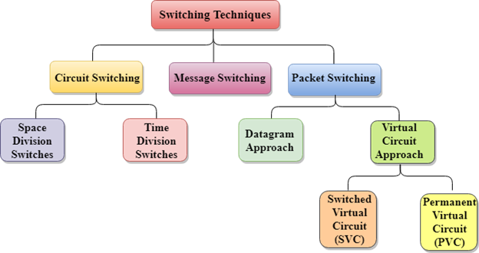

## Circuit Switching

* Circuit switching is a switching technique that establishes a dedicated path between sender and receiver.
* In the Circuit Switching Technique, once the connection is established then the dedicated path will remain to exist until the connection is terminated.
* Circuit switching in a network operates in a similar way as the telephone works.
* A complete end-to-end path must exist before the communication takes place.
* In case of circuit switching technique, when any user wants to send the data, voice, video, a request signal is sent to the receiver then the receiver sends back the acknowledgment to ensure the availability of the dedicated path. After receiving the acknowledgment, dedicated path transfers the data.
* Circuit switching is used in public telephone network. It is used for voice transmission.
* Fixed data can be transferred at a time in circuit switching technology.

**Communication through circuit switching has 3 phases:**

Skip Ad

* Circuit establishment
* Data transfer
* Circuit Disconnect

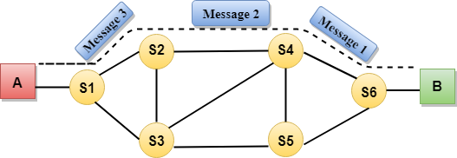

**.**

**Advantages Of Circuit Switching:**

* In the case of Circuit Switching technique, the communication channel is dedicated.
* It has fixed bandwidth.

**Disadvantages Of Circuit Switching:**

* Once the dedicated path is established, the only delay occurs in the speed of data transmission.
* It takes a long time to establish a connection approx 10 seconds during which no data can be transmitted.
* It is more expensive than other switching techniques as a dedicated path is required for each connection.
* It is inefficient to use because once the path is established and no data is transferred, then the capacity of the path is wasted.
* In this case, the connection is dedicated therefore no other data can be transferred even if the channel is free.

## Message Switching

* Message Switching is a switching technique in which a message is transferred as a complete unit and routed through intermediate nodes at which it is stored and forwarded.
* In Message Switching technique, there is no establishment of a dedicated path between the sender and receiver.
* The destination address is appended to the message. Message Switching provides a dynamic routing as the message is routed through the intermediate nodes based on the information available in the message.
* Message switches are programmed in such a way so that they can provide the most efficient routes.
* Each and every node stores the entire message and then forward it to the next node. This type of network is known as **store and forward network.**
* Message switching treats each message as an independent entity.

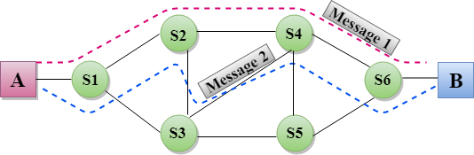

**Advantages Of Message Switching**

* Data channels are shared among the communicating devices that improve the efficiency of using available bandwidth.
* Traffic congestion can be reduced because the message is temporarily stored in the nodes.
* Message priority can be used to manage the network.
* The size of the message which is sent over the network can be varied. Therefore, it supports the data of unlimited size.

**Disadvantages of Message Switching**

* The message switches must be equipped with sufficient storage to enable them to store the messages until the message is forwarded.
* The Long delay can occur due to the storing and forwarding facility provided by the message switching technique.

## Packet Switching

* The packet switching is a switching technique in which the message is sent in one go, but it is divided into smaller pieces, and they are sent individually.
* The message splits into smaller pieces known as packets and packets are given a unique number to identify their order at the receiving end.
* Every packet contains some information in its headers such as source address, destination address and sequence number.
* Packets will travel across the network, taking the shortest path as possible.
* All the packets are reassembled at the receiving end in correct order.
* If any packet is missing or corrupted, then the message will be sent to resend the message.
* If the correct order of the packets is reached, then the acknowledgment message will be sent.

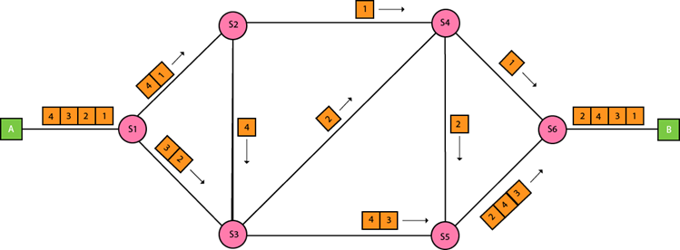

## Approaches of Packet Switching:

There are two approaches to Packet Switching:

### Datagram Packet switching:

* It is a packet switching technology in which packet is known as a datagram, is considered as an independent entity. Each packet contains the information about the destination and switch uses this information to forward the packet to the correct destination.
* The packets are reassembled at the receiving end in correct order.
* In Datagram Packet Switching technique, the path is not fixed.
* Intermediate nodes take the routing decisions to forward the packets.
* Datagram Packet Switching is also known as connectionless switching.

### Virtual Circuit Switching

* Virtual Circuit Switching is also known as connection-oriented switching.
* In the case of Virtual circuit switching, a preplanned route is established before the messages are sent.
* Call request and call accept packets are used to establish the connection between sender and receiver.
* In this case, the path is fixed for the duration of a logical connection.

**Let's understand the concept of virtual circuit switching through a diagram:**

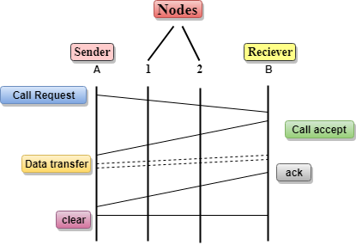

* In the above diagram, A and B are the sender and receiver respectively. 1 and 2 are the nodes.
* Call request and call accept packets are used to establish a connection between the sender and receiver.
* When a route is established, data will be transferred.
* After transmission of data, an acknowledgment signal is sent by the receiver that the message has been received.
* If the user wants to terminate the connection, a clear signal is sent for the termination.

## Differences b/w Datagram approach and Virtual Circuit approach

|  |  |
| --- | --- |
| **Datagram approach** | **Virtual Circuit approach** |
| Node takes routing decisions to forward the packets. | Node does not take any routing decision. |
| Congestion cannot occur as all the packets travel in different directions. | Congestion can occur when the node is busy, and it does not allow other packets to pass through. |
| It is more flexible as all the packets are treated as an independent entity. | It is not very flexible. |

**Advantages of Packet Switching:**

* **Cost-effective:** In packet switching technique, switching devices do not require massive secondary storage to store the packets, so cost is minimized to some extent. Therefore, we can say that the packet switching technique is a cost-effective technique.
* **Reliable:** If any node is busy, then the packets can be rerouted. This ensures that the Packet Switching technique provides reliable communication.
* **Efficient:** Packet Switching is an efficient technique. It does not require any established path prior to the transmission, and many users can use the same communication channel simultaneously, hence makes use of available bandwidth very efficiently.

**Disadvantages of Packet Switching:**

* Packet Switching technique cannot be implemented in those applications that require low delay and high-quality services.
* The protocols used in a packet switching technique are very complex and requires high implementation cost.