- Retrieve all student details along with their department names.

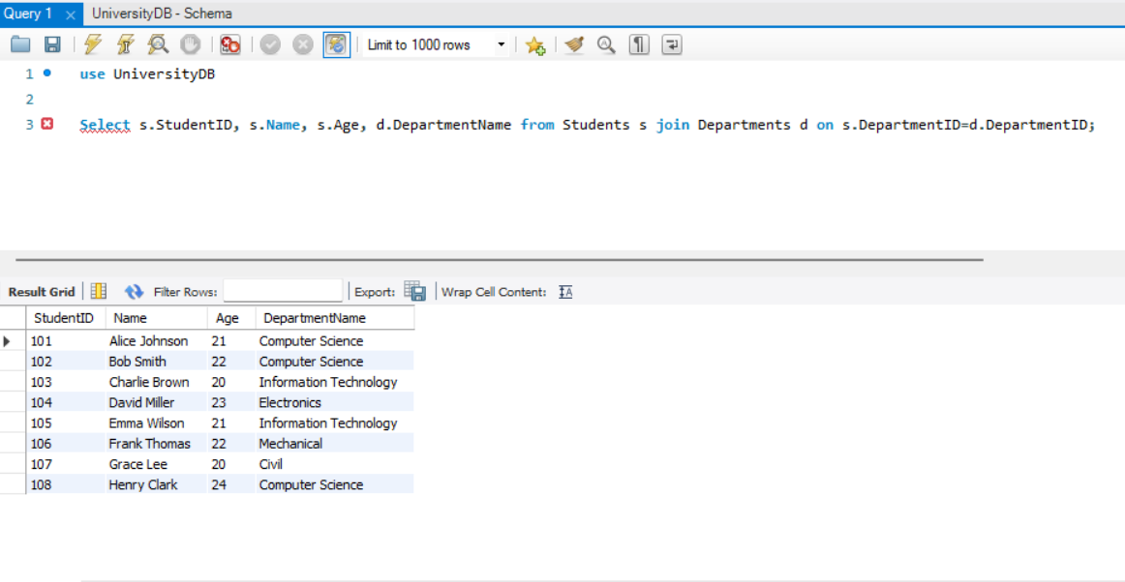

- Find the names of all students who are enrolled in 'Artificial Intelligence'.

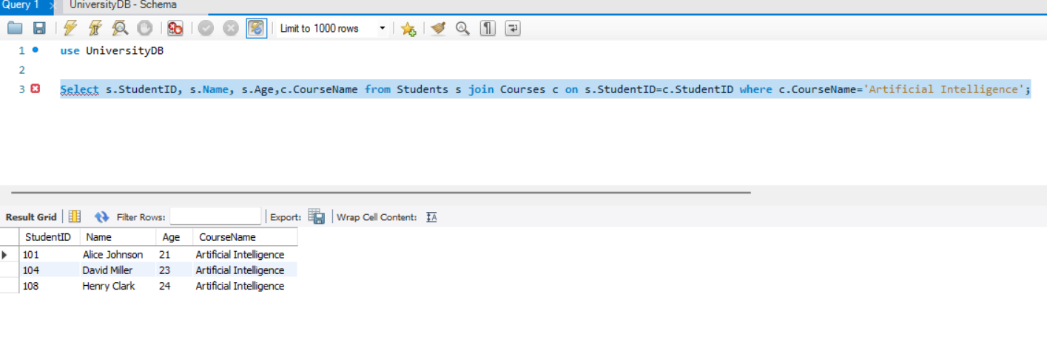

- Count how many students are in each department.

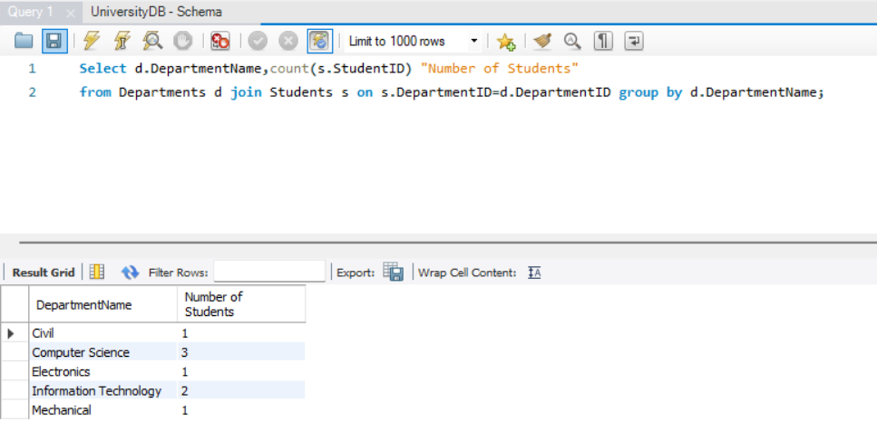

- List the courses taken by 'Alice Johnson'. (assuming Alice Johnson is a student)
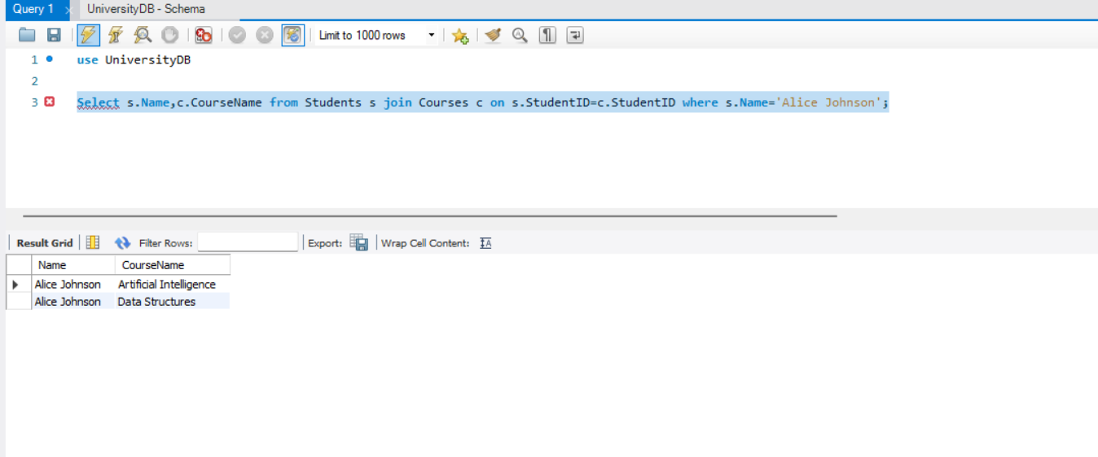

- Find students who are enrolled in more than one course.

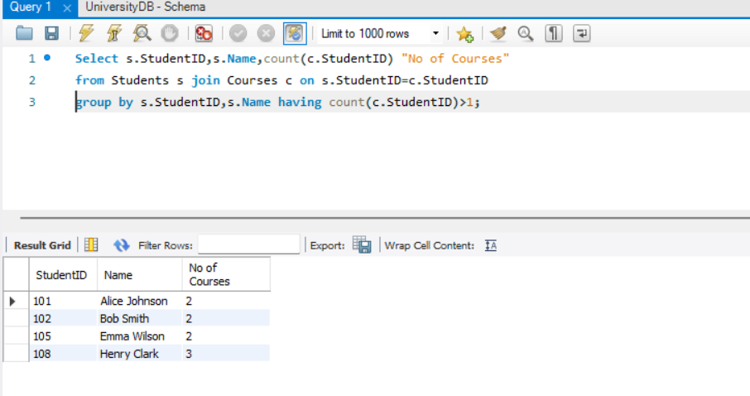

- Get the average age of students in each department.

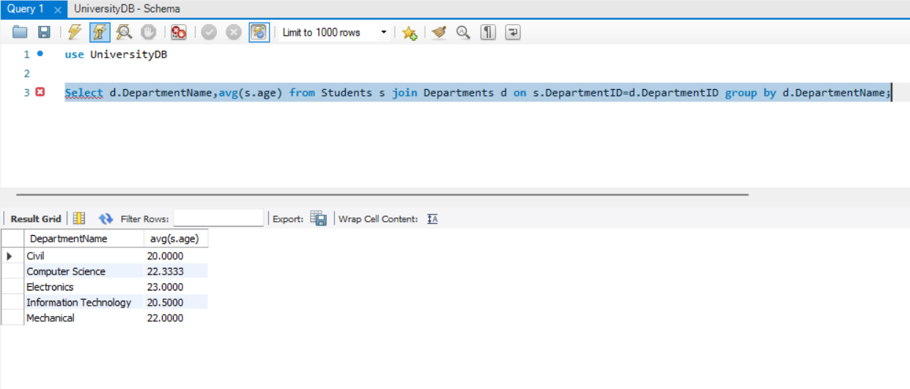

- Find the department with the most students.

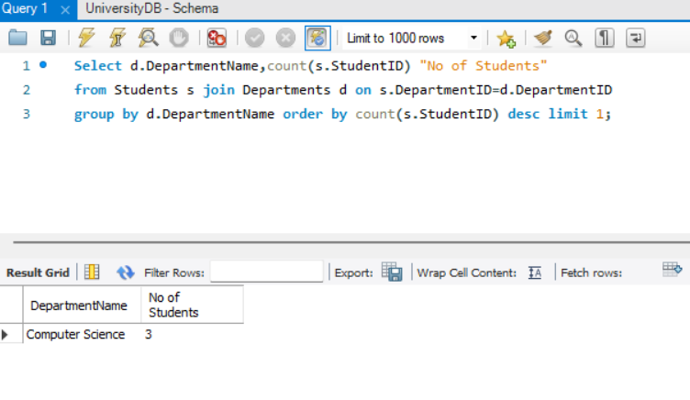
- List all students who are NOT enrolled in any course.

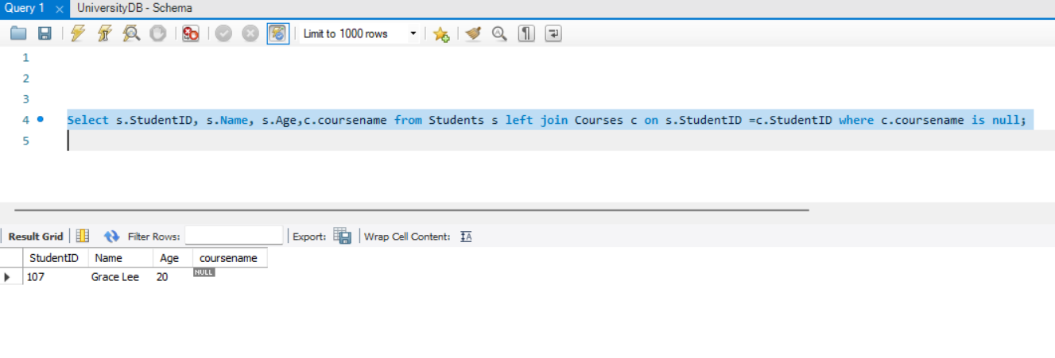
- Retrieve students along with the total number of courses they are enrolled in.

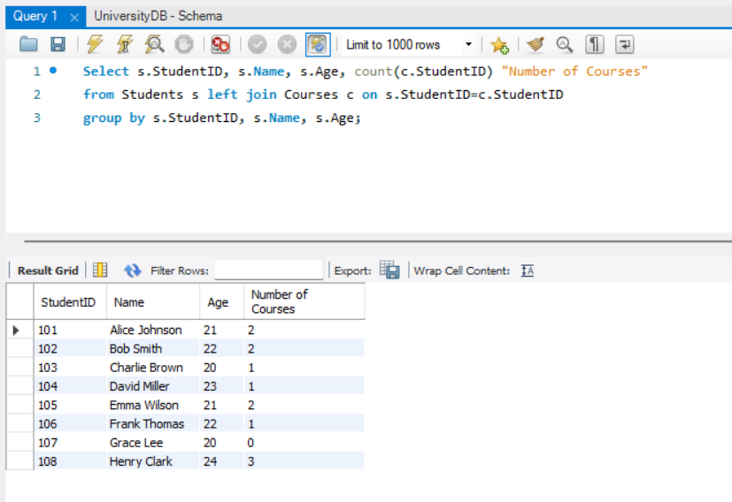

- Find students who belong to 'Computer Science' and are taking a course with 'Data' in its name.

