Retail-Document VCS (Version control system)

Document Version:1.0.0

Author: Shashank Kumar

Requirement:

The proposed tool should be able to upload documents on a server only by authorized employees. Authorized person should be able to create a new version of the document on the server. If needed should have the functionality to delete the same. While the process of creating a new version is in progress, none of the other authorized personnel shall be able to create their own versions.

High Level Design:

Use Case 1:

Tool will show all the uploaded documents with the details(Document Type, Last Modified, Last Modified By, Total Versions) as shown in the figure below. These details will be shown on the homepage where the user will be able to click on the document name and move ahead to a document version page.

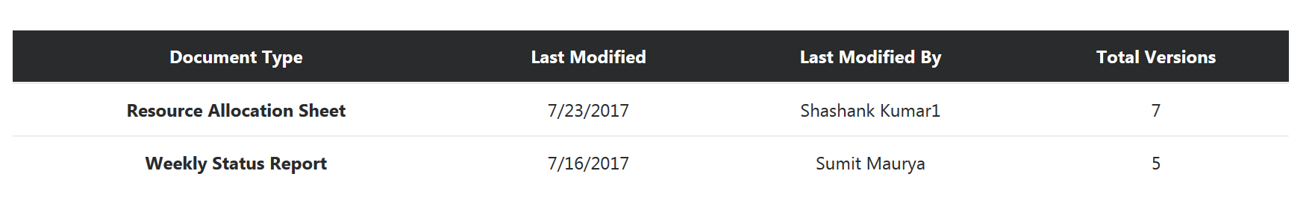

Use Case 2:

Tool will allow user to upload/delete a new document on the home page. Two buttons will be available for the same. 

Use Case 3:

Upload New Document button will trigger a new modal on the same page(Homepage) which will take the file from the user to be uploaded via Choose file button and the name the user wants to give the file i.e. filename without extension.

