Phase 2: Org Setup &Configuration

Goal: Prepare Salesforce environment for the Leave Tracker App.

# Salesforce Editions

* + Use Developer Edition Org (free Dev Org) for building and testing.

# Company Profile Setup

* + Go to Company Settings add company info, set local time zone.
  + Set currency to INR/USD (optional, for future payroll/HR integrations).

# Business Hours &Holidays

* + Define working hours (e.g., 9 AM – 6 PM).
  + Add public holidays no leave approvals should be processed on these days.

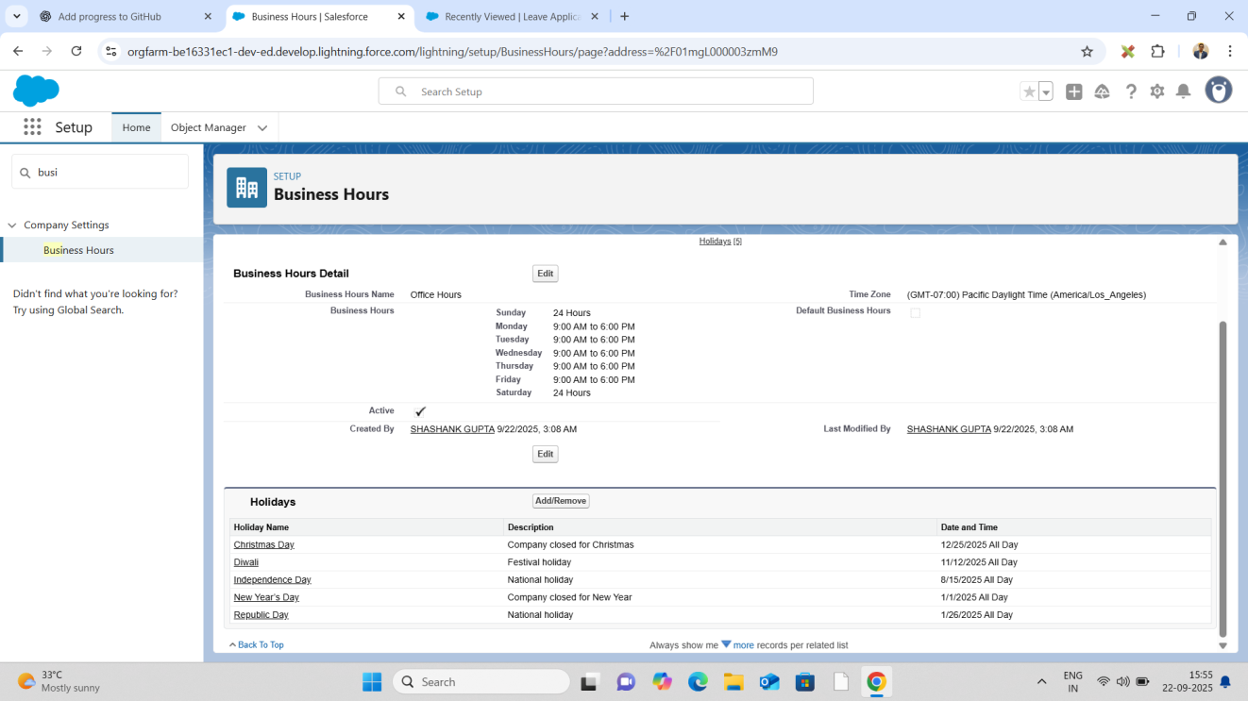

# Fiscal Year Settings

* + Standard (Jan–Dec).
  + Useful if leave policies reset annually.

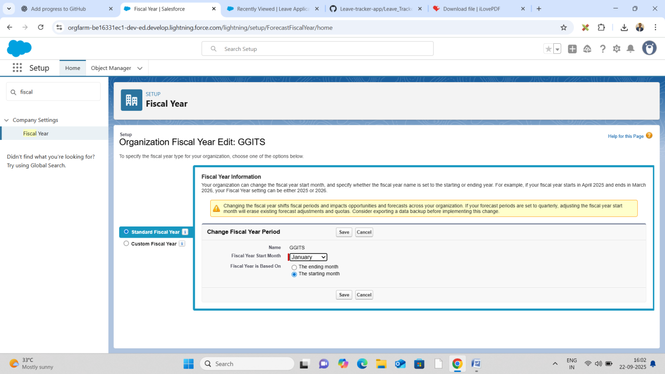

# User Setup &Licenses

* + Create users:
  + • Employee (leave requester)
  + • Manager (approver)
  + • HR (reporting &compliance)
  + Assign Salesforce licenses appropriately.

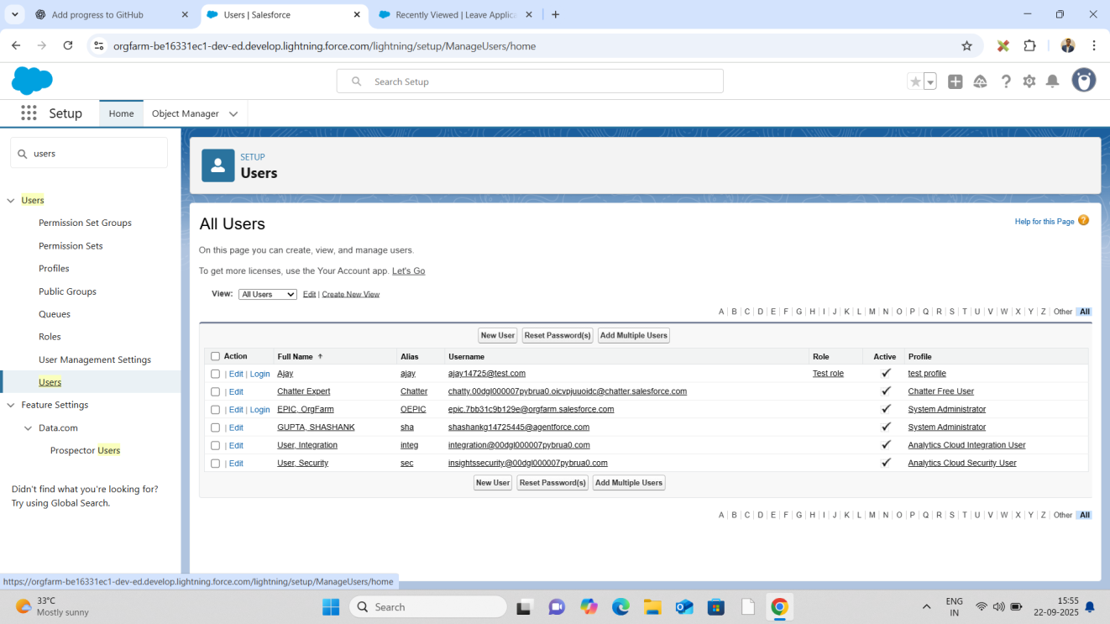

# Profiles

* + Employee Profile: Can create/view their own leave requests.
  + Manager Profile: Can approve/reject leave requests.
  + HR Profile: Full access, including reports and dashboards.

# Roles

* + HR on top  can view leave requests across the entire organization.
  + Manager below HR can view and manage leave requests submitted by their team.
  + Employees at the bottom can only view and submit their own leave requests.

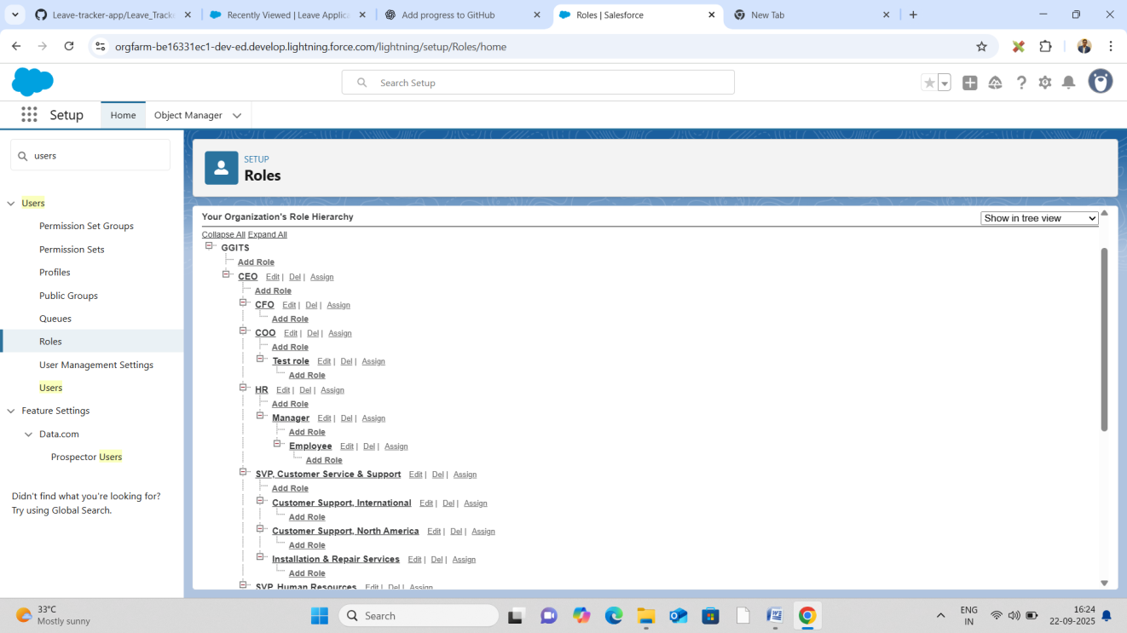

# Permission Sets

* + Ifemployeesneedextraaccess(e.g.,viewleavebalancereports),assignPermissionSets instead of modifying Profiles.

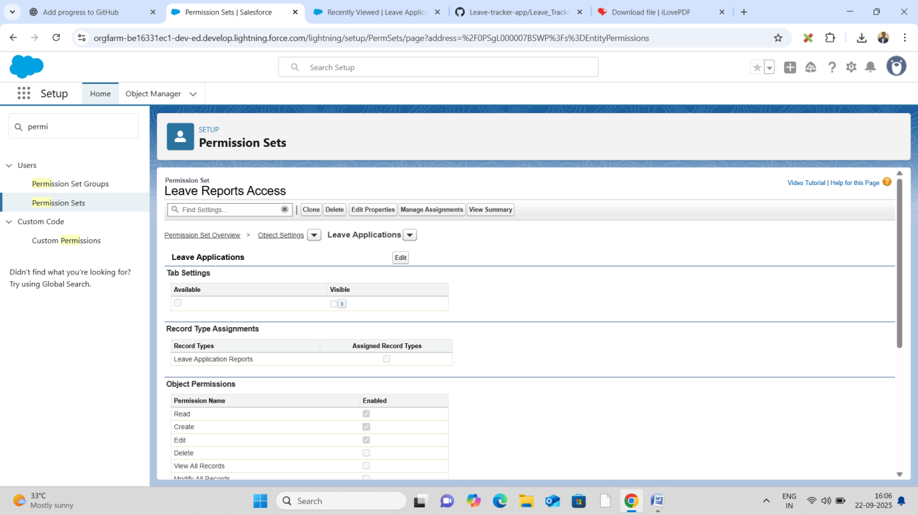

# OWD (Org-Wide Defaults)

* + Leave_Requestcobject: Private only owner and manager can see.
  + Ensures data privacy between employees.

# Sharing Rules

* + If certain leave requests need to be visible to HR or specific managers, create Sharing Rules.

# Login Access Policies

* + Restrict login hours for Employees (optional, e.g., 9 AM – 6 PM).
  + Managers/HR can have extended access.

# Dev Org Setup

* + TheDeveloperOrgactsasasandboxwhereweconfigureobjects,fields,flows,and automation.

# Sandbox Usage

* + In real implementation: Build in Sandbox, test, then deploy to Production.

# Deployment Basics

* + Use Change Sets to move configuration from Sandbox Production.
  + This ensures all automation, objects, and flows are migrated properly.