Phase 3: Data Modeling &Relationships

Goal: Build the data structure for managing employee leave requests.

# Standard & Custom Objects

* + Standard Objects:
  + • User represents employees and managers.
  + • Profile defines access and permissions.
  + Custom Objects:
  + • Leave_Applicationcstores leave applications and approval status.

# Fields

* + Leave_Applicationcfields:
  + • Employee (Lookup to User)
  + • Leave Type (Annual, Sick, Casual)
  + • Start Date
  + • End Date
  + • Total Days
  + • Status (Pending, Approved, Rejected)
  + • Comments

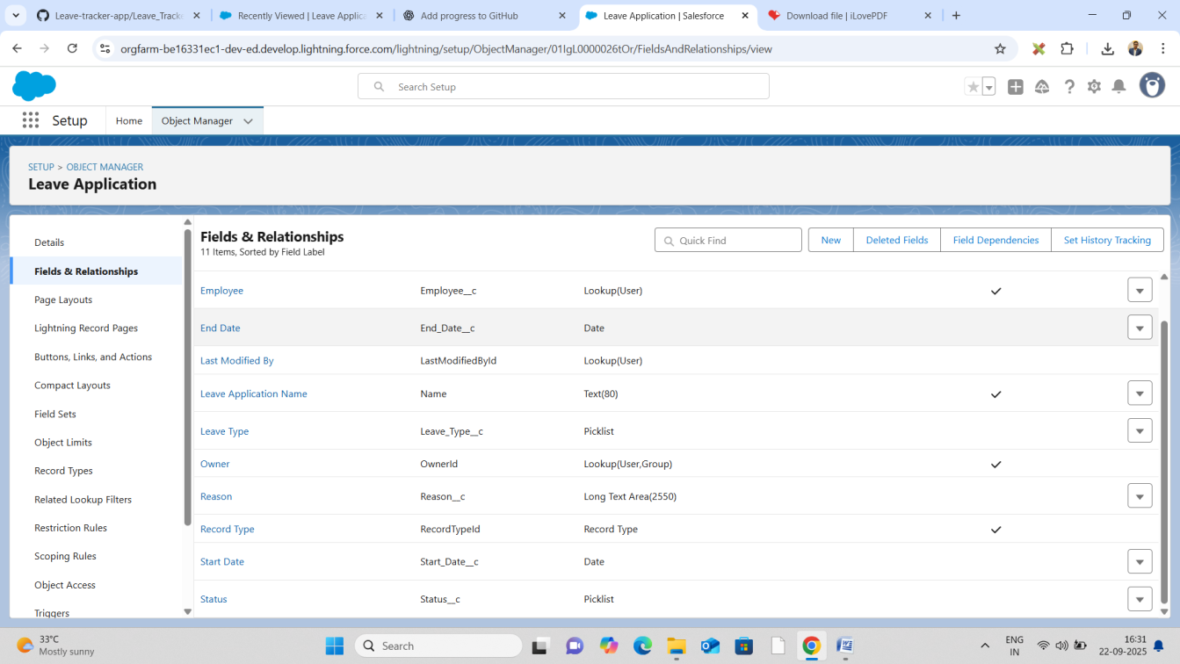

# Record Types

* + Leave_ApplicationcoptionalifyouwantdifferentleaveprocessesforPlannedLeavevsSick Leave.

# Page Layouts

* + LeaveApplicationPageLayout:Showsemployeeinfo,leavedates,type,status,andmanager comments.
  + Employee Page Layout: Displays submitted leave applications.

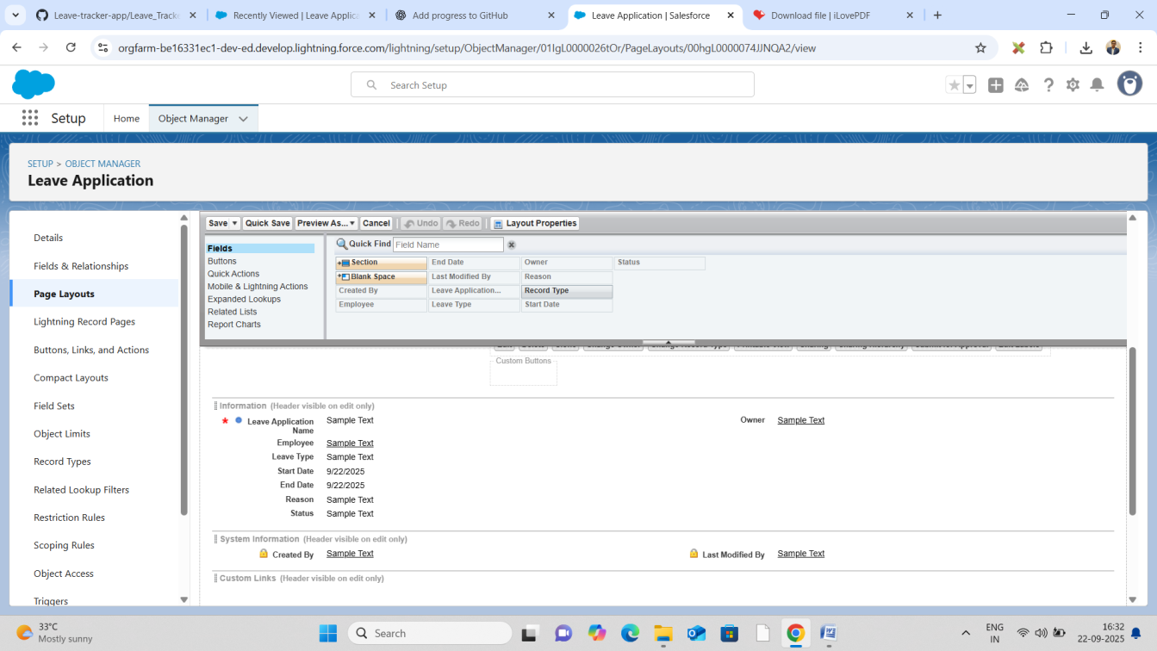

# Compact Layouts

* + For mobile view: show Leave Type, Start Date, End Date, Status.

# Schema Builder

* + Use Schema Builder to visualize relationships between User and Leave_Applicationc.

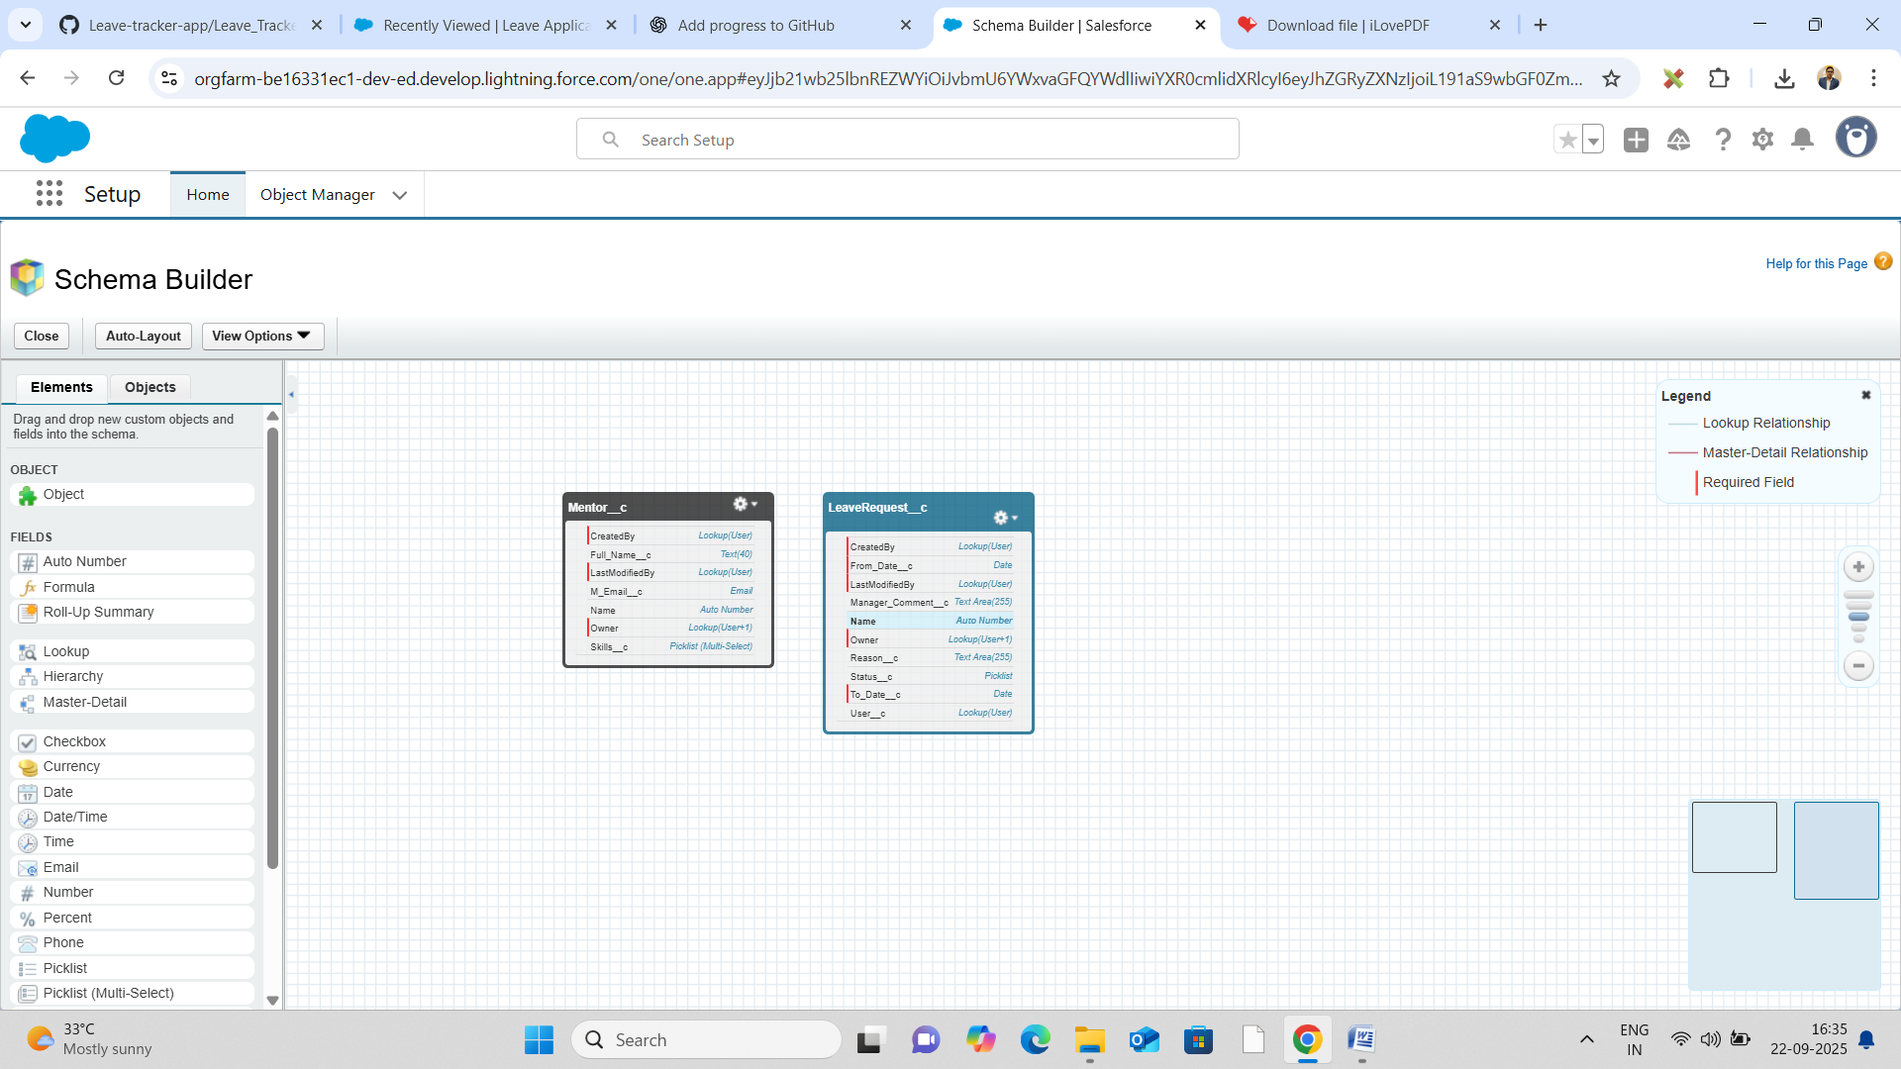

# Lookup vs Master-Detail vs Hierarchical Relationships

* + EmployeeLeave_Applicationc:Lookup(employeescanhavemultipleleaveapplications, applications don’t own employees).
  + Leave_ApplicationcManager (User): Lookup to identify who approves.

# Junction Objects

* + Not required for this project because one leave application belongs to one employee only.

# External Objects

* + Could be used if leave data comes from external HR systems, but not used here.