TenderPilot
by Inventis Labs
CONCEPT NOTE
Win more GeM bids with a co-pilot that never takes the wheel
How TenderPilot helps MSMEs, OEMs and resellers find the right Government e-Marketplace bids, decide faster, and submit complete, compliant bids, while your team keeps control of every price and signature.
Date | Prepared for | Prepared by | Document
November 2026 | [Client name] | Inventis Labs | Concept note, v1.0
Confidential. Prepared for the named recipient only; not for onward distribution.
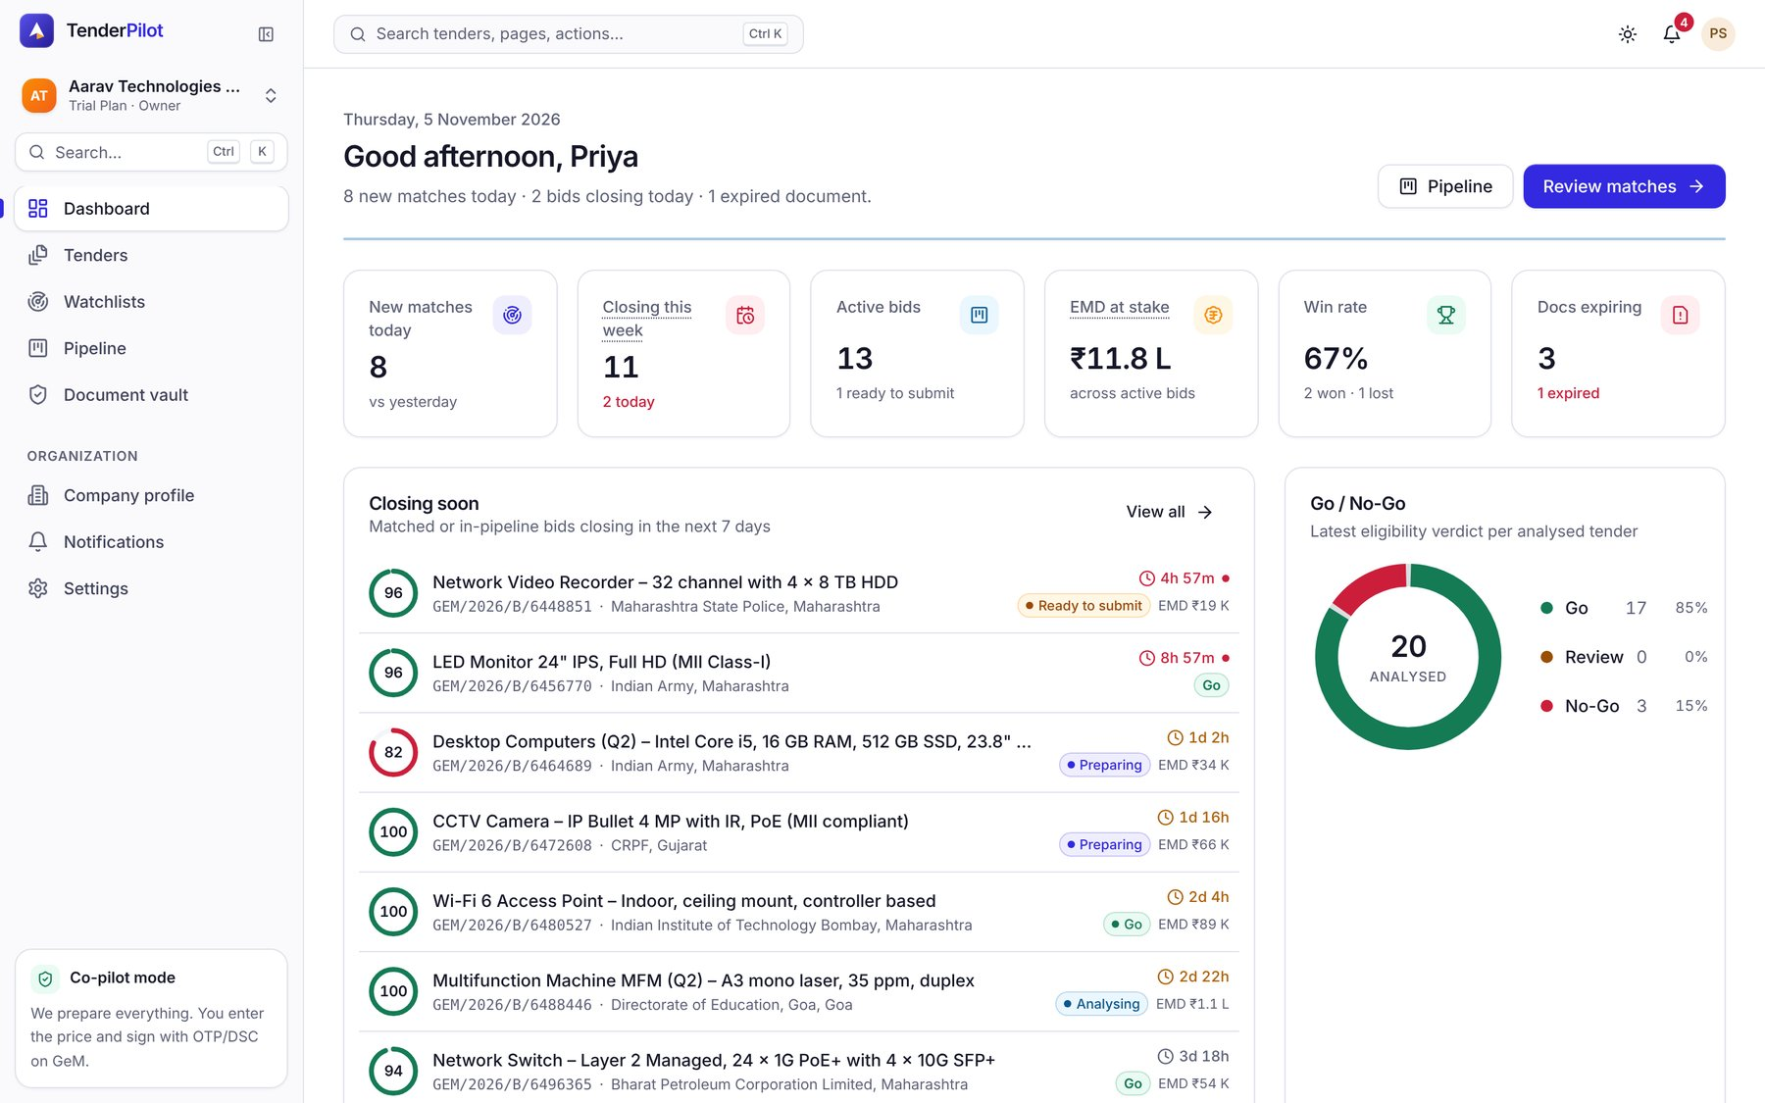

01 EXECUTIVE SUMMARY
TenderPilot turns GeM bidding from a late-night scramble into a ten-minute routine that your team still signs off
GeM publishes more opportunity than any bid desk can read. Most of a bid team's day goes on finding, reading and assembling, not on winning. TenderPilot does that groundwork continuously, explains every recommendation, and hands your team a ready packet. Price, authentication and the final click stay with your people.
1  Identify  TenderPilot watches GeM around the clock for bids that match what you sell, where you sell and to whom.  - Alerts on WhatsApp, email and in-app  - Corrigenda flagged the moment they appear  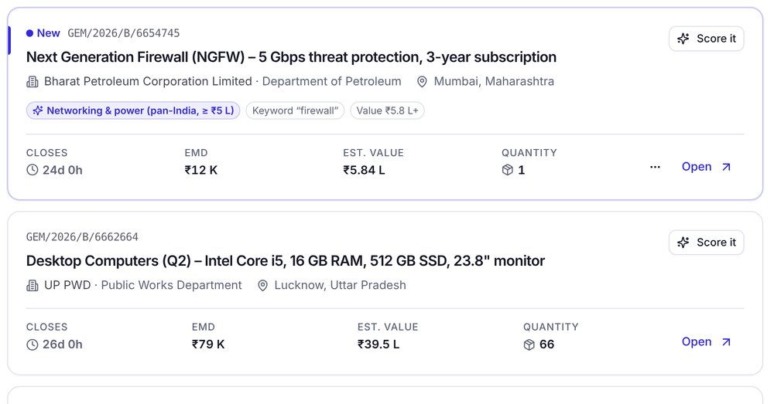 | 2  Analyse  It reads the bid documents, checks them against your company profile and gives a Go/No-Go score with its reasons.  - Each reason linked to the page it came from  - Exemptions and preferences applied  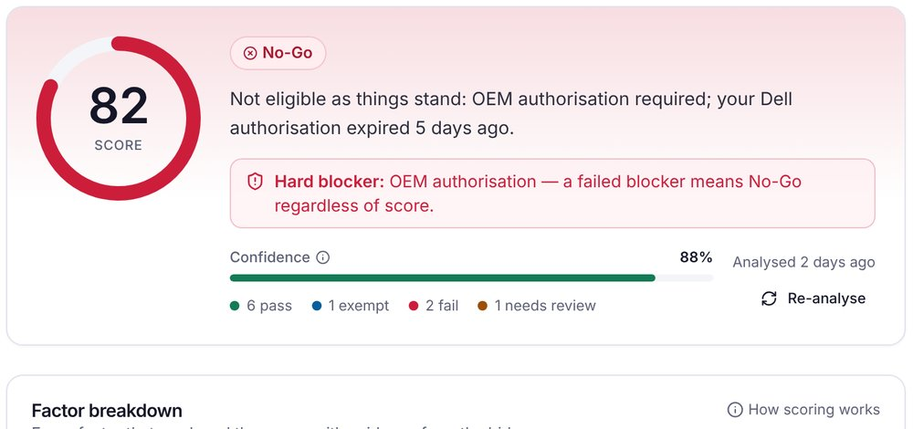 | 3  Apply  It pulls certificates from your vault, fills the undertakings and merges one bid packet in the order GeM expects.  - Expiry alerts before a certificate lapses  - A checklist for the steps only a person can do  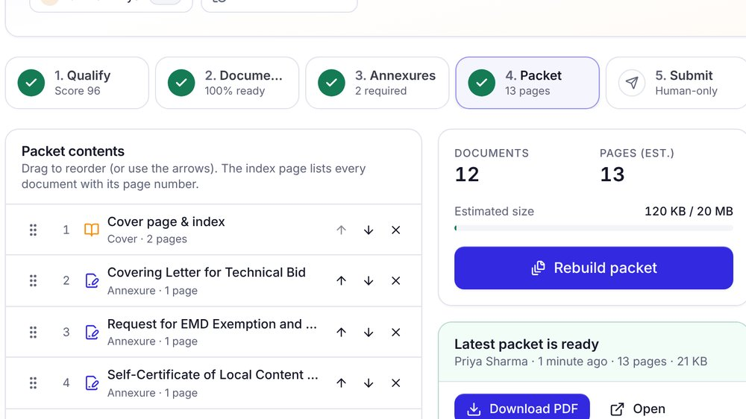
Exhibit 1 What changes for a typical bid desk
3 h → 10 min  to assemble a complete bid packet  TARGET | < 1 hour  from publication on GeM to an alert on your phone  TARGET | Minutes  to a Go/No-Go decision, with reasons and evidence  ILLUSTRATIVE | Zero  GeM passwords held. Your team does every submission.  BY DESIGN
Source: TenderPilot team analysis; illustrative. Figures are targets, not measured client results. They will be baselined during your pilot.
What this means for leadership
More of the right bids  Your team sees every relevant bid early and does not lose one to a missed corrigendum or deadline. | Fewer wasted bids  Bids you cannot win are ruled out in minutes, before anyone spends a day on them. | No risk to the account  Humans keep price, OTP/DSC/e-Sign and the final submit, so your GeM seller account stays protected.

02 THE PROBLEM
GeM is a large market, but bid teams spend most of their time before they even decide to bid
GeM handled more than ₹4 lakh crore of public orders in FY 2023-24, and thousands of bids go live on a typical working day. For a seller the hard part is not access. It is separating the few bids you can win from the many you cannot, and then getting each one right.
Exhibit 2 From the daily flood to the bids worth your time
3,000+ | Bids published on GeM on a typical working day  All categories, all states, all buyers
~60 | In your product categories
~12 | In your states and value range
~4 | You are eligible for and can win  This is where your team's time should go
Source: GeM public statements (order value); TenderPilot team analysis for a typical IT-hardware seller; illustrative.
Where bids are lost
01 | Volume and noise Someone scans the portal every day. Relevant bids get found late, or not at all.
02 | Eligibility fine print Turnover, experience, OEM authorisation and Make in India clauses sit deep in long bid documents.
03 | Corrigenda Changed dates, specifications or terms are easy to miss once a bid is being prepared.
04 | Document chasing Certificates live in inboxes and on personal drives. An expired one is found on the closing day.
05 | Deadlines and rework Undertakings are retyped and PDFs merged by hand at night. A slip can disqualify the bid.
GeM terms in plain words
EMD | Earnest money deposit: a refundable amount that guarantees you will honour your bid. | ePBG | Performance bank guarantee: security the winning seller gives, usually a % of the order value.
MSE | Micro and small enterprise (Udyam-registered). Often exempt from EMD and some turnover or experience rules. | Make in India Class-I / II | Local-content classes (≥50% / ≥20%). Class-I suppliers get purchase preference.
ATC | Additional terms and conditions a buyer adds to the standard GeM terms. Often where the traps are. | BOQ | Bill of quantities: the itemised list of what the buyer wants, in what quantity.
Corrigendum | An official change to a published bid, such as a new date, specification or term. | OTP / DSC / e-Sign | The ways a person legally authenticates a GeM submission: one-time password, digital signature certificate or Aadhaar e-Sign.
03 OUR APPROACH
A co-pilot, not an autopilot: TenderPilot prepares everything, and your team keeps the controls that protect your GeM account
GeM expects a named person to enter the price and authenticate every bid. Shared logins and bots that submit on your behalf risk your seller account. TenderPilot is built around that rule, so it does the most preparation for the least account risk.
Exhibit 3 Bid preparation done for you vs. risk to your account
 | Less done for you | More done for you
Higher risk to your GeM account | Consultant with your login  Some work done for you, but your credentials are shared outside the company. | Auto-submit bots  Fast, but automated logins and submissions can get a seller account suspended.
Lower risk to your GeM account | Do it yourself  Safe, but slow: portal checks, spreadsheets and late nights. | TenderPilot  Most of the work prepared for you. Your login, price and signature never leave your hands.
Source: TenderPilot team analysis; illustrative positioning.
TenderPilot prepares  - Finds and filters matching bids  - Reads bid documents and corrigenda  - Checks eligibility and scores Go/No-Go  - Fills undertakings and annexures  - Merges the bid packet in order  - Pre-fills non-financial GeM fields, only when you click | Your team always does  - Decides whether to bid  - Enters the price on GeM  - Authenticates with OTP, DSC or e-Sign  - Solves the CAPTCHA  - Clicks Final Submit

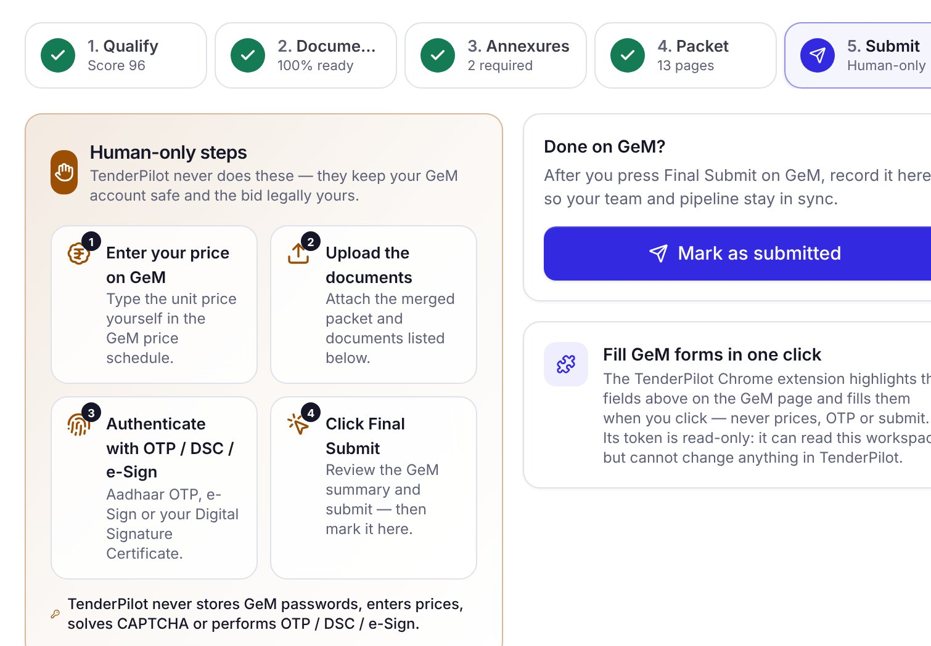  Screenshot: TenderPilot bid workspace, submit step. | Exhibit 4 The human-only steps are part of the product  At the submit step every bid workspace lists the four actions only your team performs: enter the price, upload the packet, authenticate, and click Final Submit. When the bid is in, a named person marks it submitted, so the pipeline and audit trail stay accurate.  Why it matters: your compliance position is simple to explain to auditors, OEM partners and buyers. TenderPilot never holds your GeM password.
04 IDENTIFY
Every bid you can win reaches the right person within the hour, on the channel they already use
Your team describes what you sell once. TenderPilot watches GeM continuously and brings back only the bids that fit, already sorted by closing date and fit.
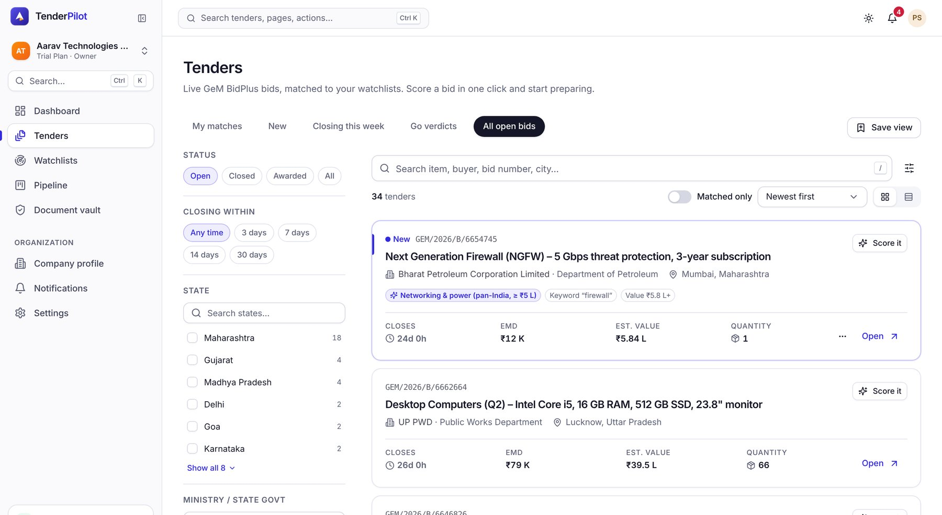
Exhibit 5: The tender feed shows live GeM bids matched to your watchlists, with filters by state, ministry, closing date and value.
Always-on watchlists  Match by product and keyword, GeM category, state and city, buyer ministry or organisation, and order value. One watchlist per product line or region.  Instant alerts, wherever you are  New matches, corrigenda, closing-day reminders and expiring certificates go out on WhatsApp, email and in-app, with a daily digest for the owner.  Triage in one view  Saved views such as "closing this week" or "Go verdicts" let the bid manager plan the week in a few minutes. | 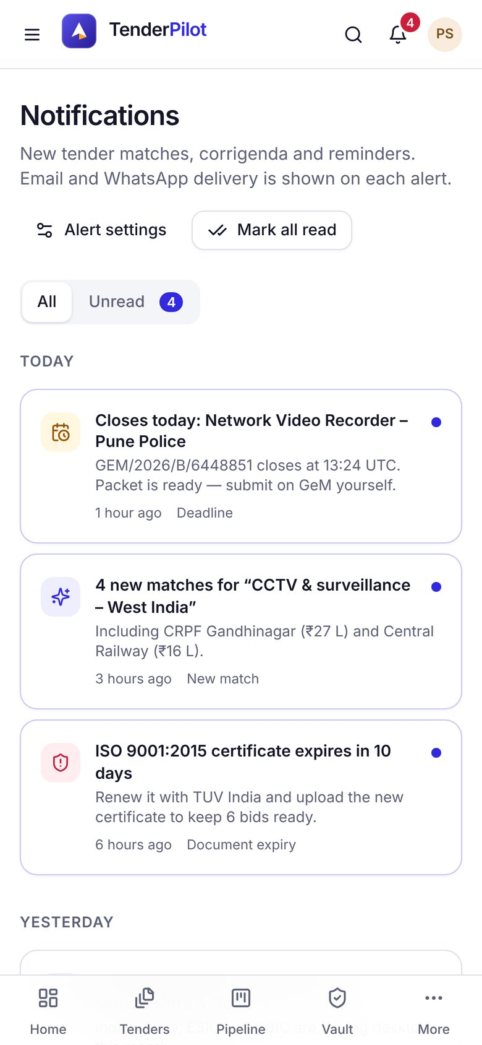  Exhibit 6: Alerts on mobile
05 ANALYSE
A Go/No-Go verdict in minutes, with every reason traced back to the page of the bid it came from
TenderPilot reads the bid document and any corrigenda, checks each condition against your company profile and vault, and explains its verdict. In the example below it stops a bid early: the bid needs an OEM authorisation that expired five days ago.
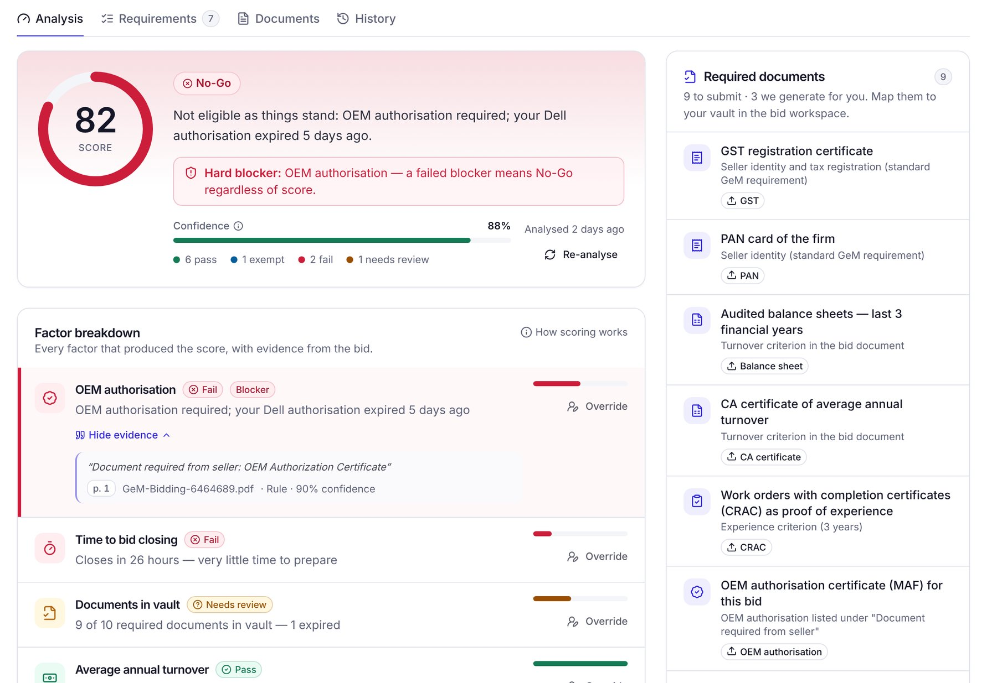
Exhibit 7: Tender analysis for a desktop-computer bid from the Indian Army. Illustrative sample company.
1  Score and verdict  A single score with a plain-language Go, Review or No-Go, and how confident TenderPilot is. | 2  Hard blockers first  Disqualifying conditions override the score, so a high number never hides a fatal gap. | 3  Evidence, not opinion  Each factor quotes the bid text and page. Your analyst can check it, or override it with a note. | 4  Document checklist  Every document the bid asks for, mapped to your vault, with the ones TenderPilot can generate marked.
What TenderPilot checks on every bid
Average annual turnover | Years of experience | Similar work value | OEM authorisation
MSE and Startup exemptions | Make in India Class-I / II | EMD and ePBG | Certificates and validity
Delivery location and time | Time left to prepare | ATC clauses | Documents in your vault
06 APPLY
From a Go decision to a submission-ready bid packet in about ten minutes, with nothing expired and nothing missing
1 · Vault  Certificates matched to the bid's checklist | 2 · Annexures  Undertakings filled from your profile | 3 · Packet  One merged PDF in GeM order | 4 · Submit  Your team prices and signs on GeM

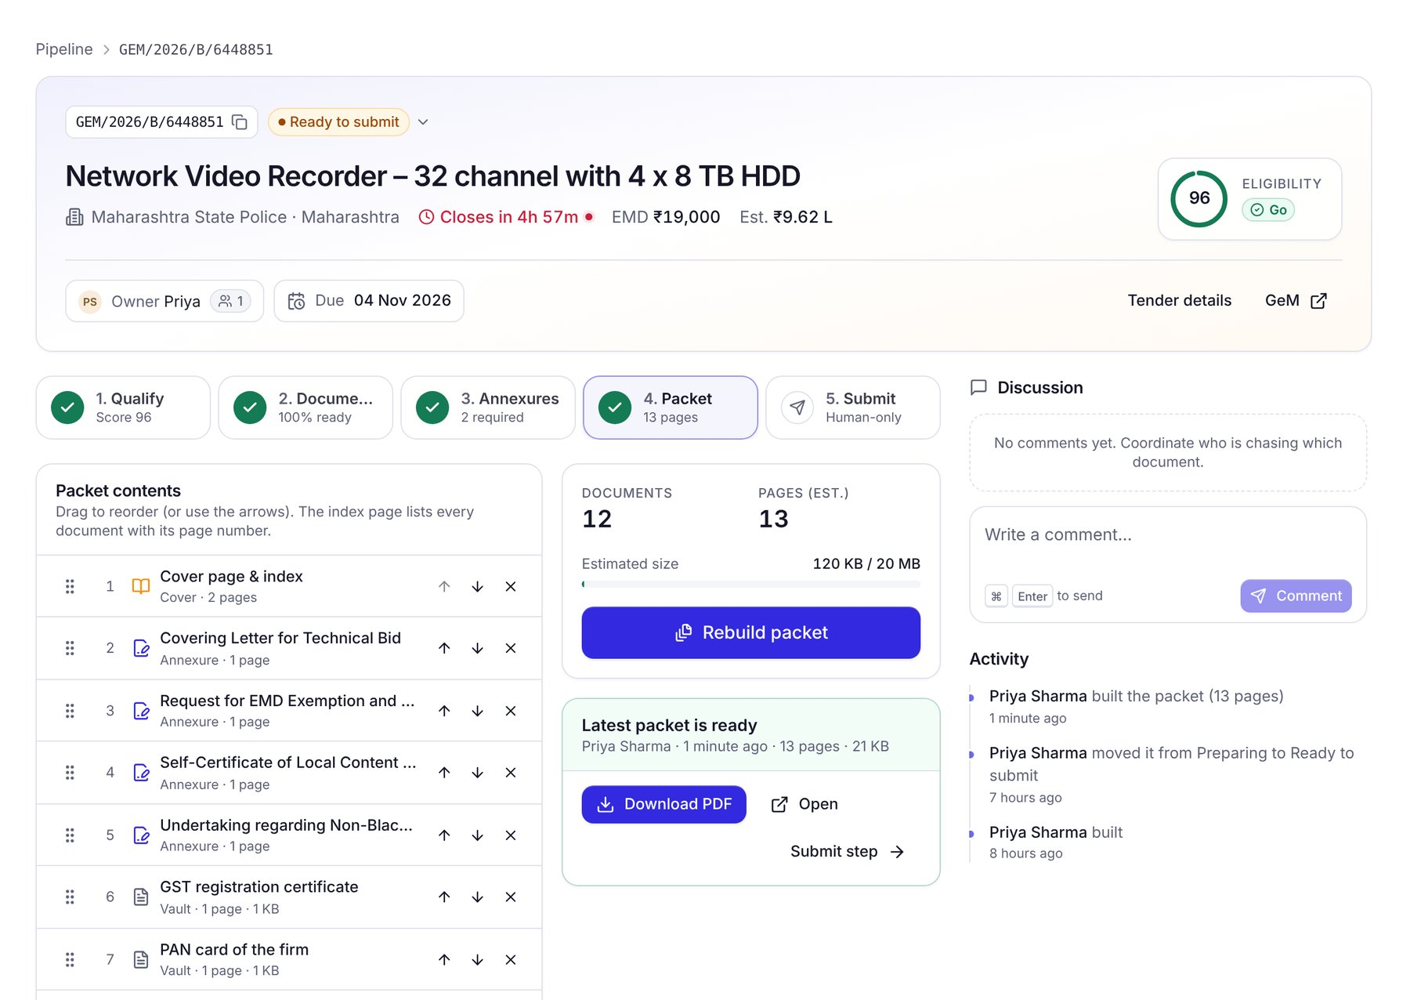  Exhibit 8: The bid workspace: twelve documents, four of them generated annexures, merged into one 13-page packet. | 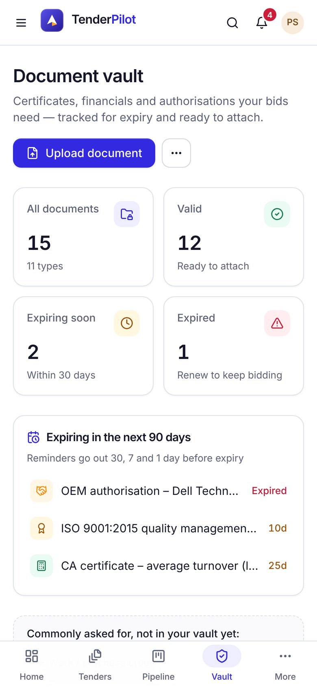  Exhibit 9 (phone): the document vault with its expiry timeline.

Document vault with expiry alerts  GST, PAN, Udyam, ISO, balance sheets, CA certificates, completion certificates and OEM authorisations in one place. Reminders go out 30, 7 and 1 day before expiry. | Undertakings, written for you  EMD exemption requests, Make in India self-certificates, non-blacklisting undertakings and covering letters are filled from your profile and the bid, ready to sign and stamp. | One click to a packet, then you submit  The packet comes with a cover index and the file order GeM expects. A submission assistant lists the values to enter and the steps your team completes on GeM.
07 IMPACT
Your bid desk gets back about three hours on every bid, and spends them on price and buyer relationships
The work does not disappear. It moves from people to TenderPilot, and the time that is left goes to the decisions only your team can make.
Exhibit 10 One bid, before and after TenderPilot
Step | Today | With TenderPilot | Time saved
Find the bid | Daily manual scan of the portal across categories and states | Matched automatically; alert within the hour | ~30 min
Read and qualify | Read a 20 to 60 page bid and ATC; check eligibility by hand | Go/No-Go with reasons and page references | ~45 min
Track corrigenda | Re-open the bid page and hope nothing changed | Changes flagged and re-checked automatically | ~10 min
Gather documents | Chase colleagues and drives; expired certificates found late | Pulled from the vault; expiries flagged weeks ahead | ~40 min
Undertakings and annexures | Retype last bid's Word templates, fix names and numbers | Generated from your profile and the bid | ~25 min
Assemble the packet | Convert, merge, rename and order PDFs by hand | One click; merged PDF with index | ~20 min
Total per bid | ~3 hours, often after hours | ~10 minutes of review | ~2 h 50 min
Source: TenderPilot team analysis of a typical goods bid; illustrative. Price entry and authentication on GeM are not included and stay with your team.
Exhibit 11 Minutes of team effort per bid, by step
Today | Find | Read & qualify | Documents | Annexures | Packet
With TenderPilot |  | ~10 min of review
Bar length is proportional to minutes per bid (today ≈ 180 minutes).
~45 h  returned each month at 15 bids a month  ILLUSTRATIVE | 0  bids lost to expired documents or missed corrigenda  TARGET | 2×  bids your current team can pursue each month  TARGET | Earlier  No-Go calls, so effort goes only to bids you can win  EXPECTED
08 BUILT FOR EVERY ROLE
Each person on the bid desk sees the part of the work they own, from the owner's phone to the analyst's checklist
Exhibit 12 Who uses TenderPilot, and for what
Role | What they see | The question it answers
Owner / MD | Mobile dashboard: new matches, bids closing, EMD at stake, win rate, documents expiring | "Are we bidding on the right things, and is anything about to slip?"
Bid manager | Pipeline board from Identified to Won or Lost, with owners, due dates and packet readiness | "Who is on which bid, and what is blocking it?"
Bid analyst | Tender analysis, requirement checklist, annexures and the packet builder | "Do we qualify, and what is still missing?"
Compliance / accounts | Document vault, expiry timeline and the audit trail of who did what | "Is every certificate valid on the closing date?"
Viewer | Read-only access for partners, OEMs or auditors you invite | "What was submitted, and on what basis?"

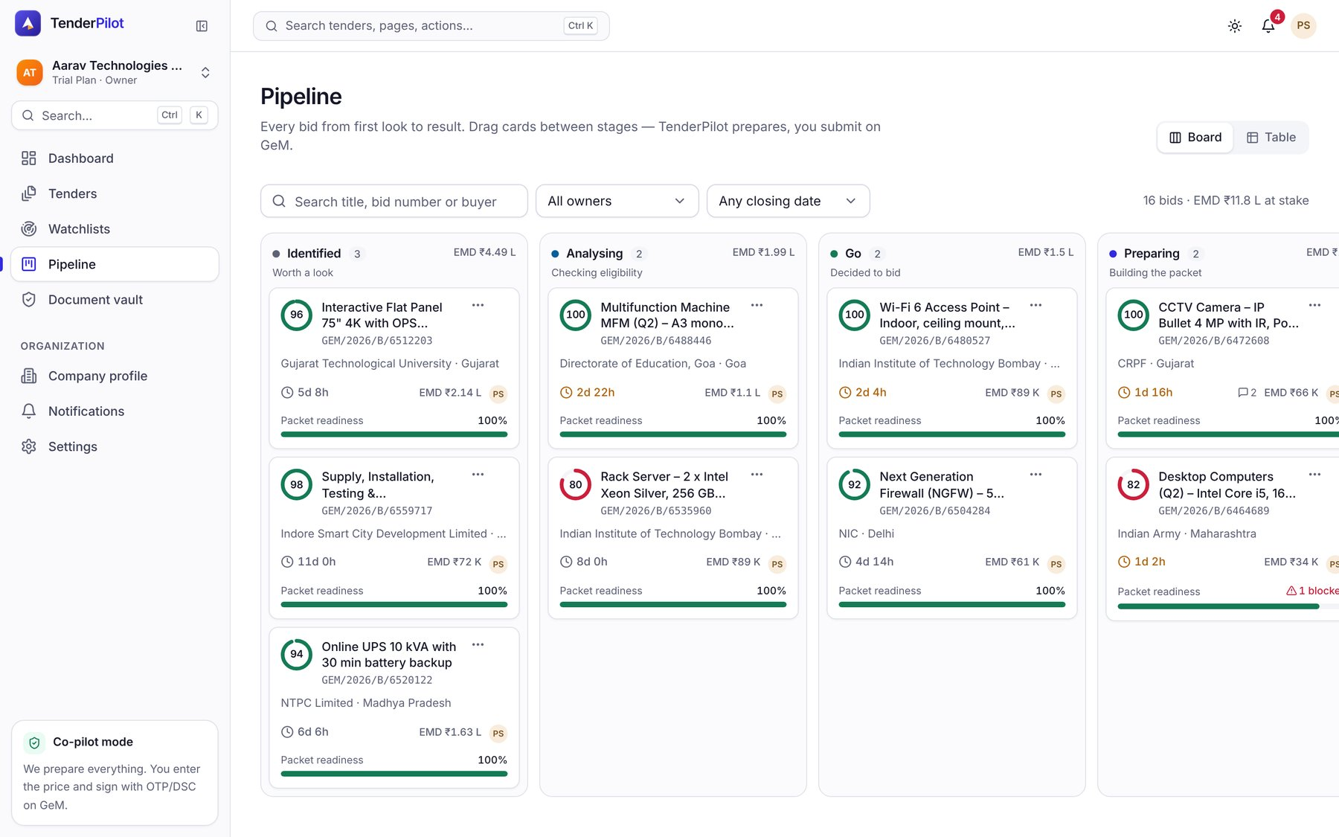  Exhibit 13: The bid manager's pipeline: every bid by stage, with score, closing time, EMD and packet readiness. | 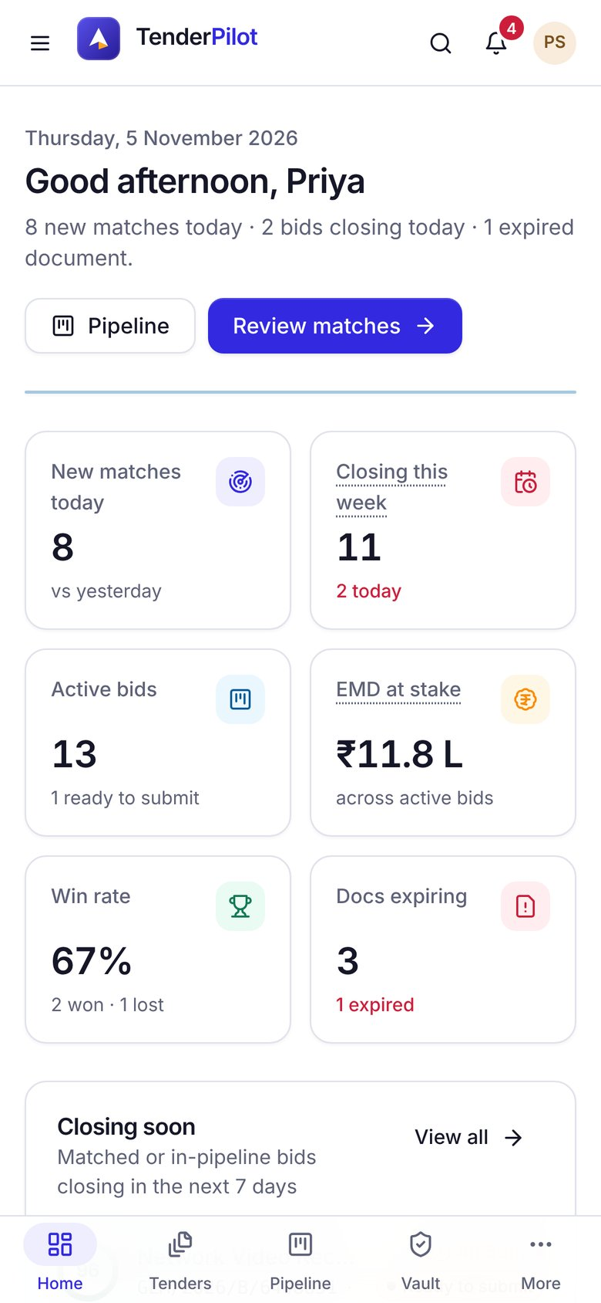  Exhibit 14: The owner's dashboard
09 TRUST, SECURITY AND COMPLIANCE
Your data, your GeM account and your decisions stay yours: security is part of the design
Bid documents, financials and certificates are among the most sensitive files a company holds. TenderPilot treats them that way and keeps your GeM seller account out of reach.
A separate space for each company  Every company's bids, documents and analyses are kept apart. No other customer can see or reach them. | Role-based access  Owners, bid managers, analysts and viewers each see and do only what their role allows. You invite and remove people yourself. | Complete audit trail  Every analysis, override, document change, packet and submission record shows who did it and when.
Your data stays yours  You own everything you upload or create. Export it whenever you like, and have it deleted if you leave. | No GeM credentials stored  TenderPilot reads public bid information only. It never asks for, stores or uses your GeM login. | Enterprise-grade cloud  Hosted on enterprise-grade cloud infrastructure, with encrypted connections and continuous monitoring.

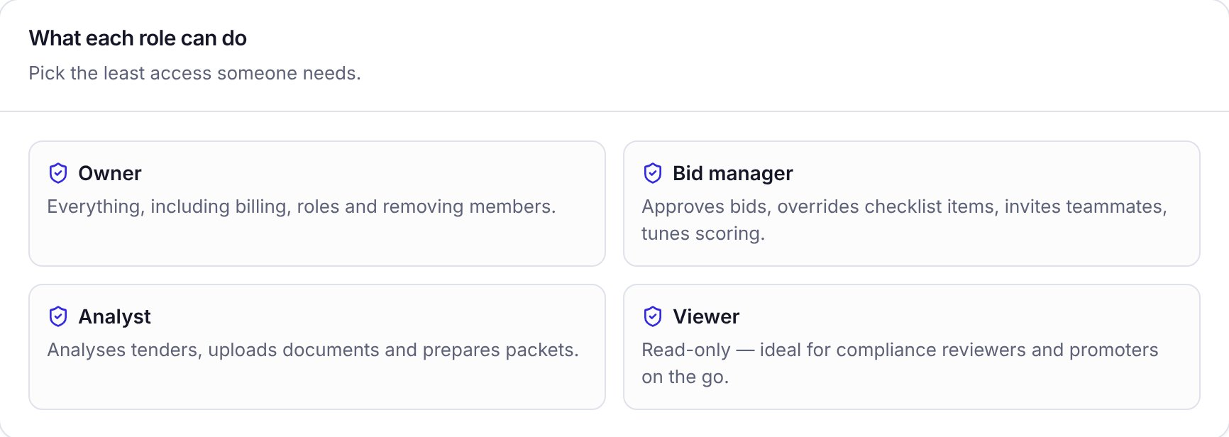  Exhibit 18: Four roles, with least access by default. Viewers suit compliance reviewers and promoters. | 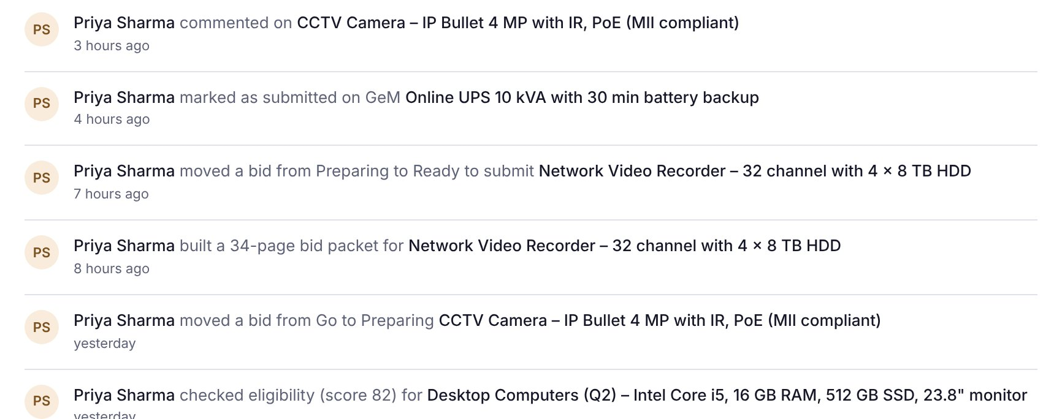  Exhibit 19: The activity log records who did what, and when, in IST.

What TenderPilot never does
These limits are fixed in the product. No setting or plan turns them off.
✕ Ask for your password  Your GeM login stays with your team. | ✕ Enter or suggest a price  Your financial bid is yours alone. | ✕ Authenticate for you  No OTP, DSC or Aadhaar e-Sign. | ✕ Solve a CAPTCHA  No bots on your seller account. | ✕ Click Final Submit  A named person does that, every time.

10 ENGAGEMENT MODEL
Live in days, proven in a four-week pilot, then scaled on success metrics we agree at the start
Exhibit 15 From kick-off to full rollout
Onboard · days 1 to 5  Company profile, watchlists for each product line, upload certificates to the vault | Pilot · weeks 1 to 4  Live bids and alerts; weekly review with your bid manager; tune watchlists and templates | Rollout · month 2 onward  Whole team on board, WhatsApp digests, more categories, entities and regions
Exhibit 16 Success metrics we track together
Metric | Pilot target
Time from GeM publication to alert | < 1 hour
Time to a Go/No-Go decision | same day
Time to assemble a bid packet | ~10 min
Relevant bids reviewed per week | vs. baseline
Bids missed or lost on documents | zero
Win rate on bids submitted | tracked
Baselines are measured in week 1 of the pilot. Targets are indicative.
A named bid owner  About 2 hours in week 1, then 30 minutes a week | Company documents  Registrations, financials, experience and OEM letters | Your product focus  Categories, states and value bands you want to win
Exhibit 17 Indicative pricing, per company per month, excluding GST
Starter  ₹2,999 / month  For a founder-led MSME bidding a few times a month  - 3 team members, 5 watchlists  - Email and in-app alerts  - Go/No-Go scoring, vault, packet builder | Pro · recommended  ₹7,999 / month  For growing teams bidding every week  - 10 members, unlimited watchlists  - WhatsApp alerts and daily digest  - Assisted bid reading, annexure templates  - Form-fill assistant, pipeline and win-rate analytics | Enterprise  Custom  For OEMs, distributors and consultants with many entities  - Unlimited members and entities  - Single sign-on and audit exports  - Custom eligibility rules, success manager
Indicative only; final commercials are agreed in the proposal. Every plan starts with a 14-day free trial of Pro.

TenderPilot
by Inventis Labs
NEXT STEPS
See it on your own bids in thirty minutes
We run TenderPilot live on your product categories, so the first bids you see are ones you could bid on this week.
1 | A 30-minute walkthrough  Live on GeM bids in your categories and states, with your bid manager in the room. | This week
2 | Onboarding in days  Company profile, watchlists and document vault set up together. Alerts start the same day. | Days 1 to 5
3 | Four-week pilot review  We compare the success metrics with your baseline and agree the rollout plan. | Week 4

YOUR CONTACT
Shashank
Head of Technology, Inventis Labs
[email] · [phone]
Product screenshots show TenderPilot with a sample company, Aarav Technologies Pvt Ltd, and illustrative bid data. Figures marked target or illustrative are not measured client results. GeM is the Government of India's procurement platform; TenderPilot is an independent product and is not affiliated with or endorsed by GeM.

