**Internship report on**

**“Encryption and Decryption of Text By Using Caesar Cipher”**

*A Report submitted in partial fulfilment of the requirement for the award of degree*

**MASTER OF COMPUTER APPLICATIONS**

OF

**VISVESVARAYA TECHNOLOGICAL UNIVERSITY**



By

**NAME : Shashank Katti**

**USN : 1BY22MC047**

**Under the Guidance of**

**External Guide**

**Mr Aravind Kumar   
R & D Engineer  
Exposys Data Labs  
Bengaluru**



Department of Master of Computer Applications

**BMS Institute of Technology and Management**

**Bengaluru – 560064**

**July-2024**

**BMS INSTITUTE OF TECHNOLOGY AND MANAGEMENT**

**Bengaluru – 560064**

**July-2024**

**CERTIFICATE**

This is to certify that Shashank Katti bearing USN **1BY22MC047** has satisfactory completed the Internship — 22MCA401 with title “**Cyber Security**” as prescribed by VTU for IV Semester of Master of Computer Applications.

Signature of the Candidate

|  |  |
| --- | --- |
| Marks Obtained | |
| Presentation — Max Marks 25 |  |
| Report- Max Marks 25 |  |
| **Total** Marks – **50** |  |

Signature of the Guide/Coordinator Signature of the HO

**Internship Certificate**

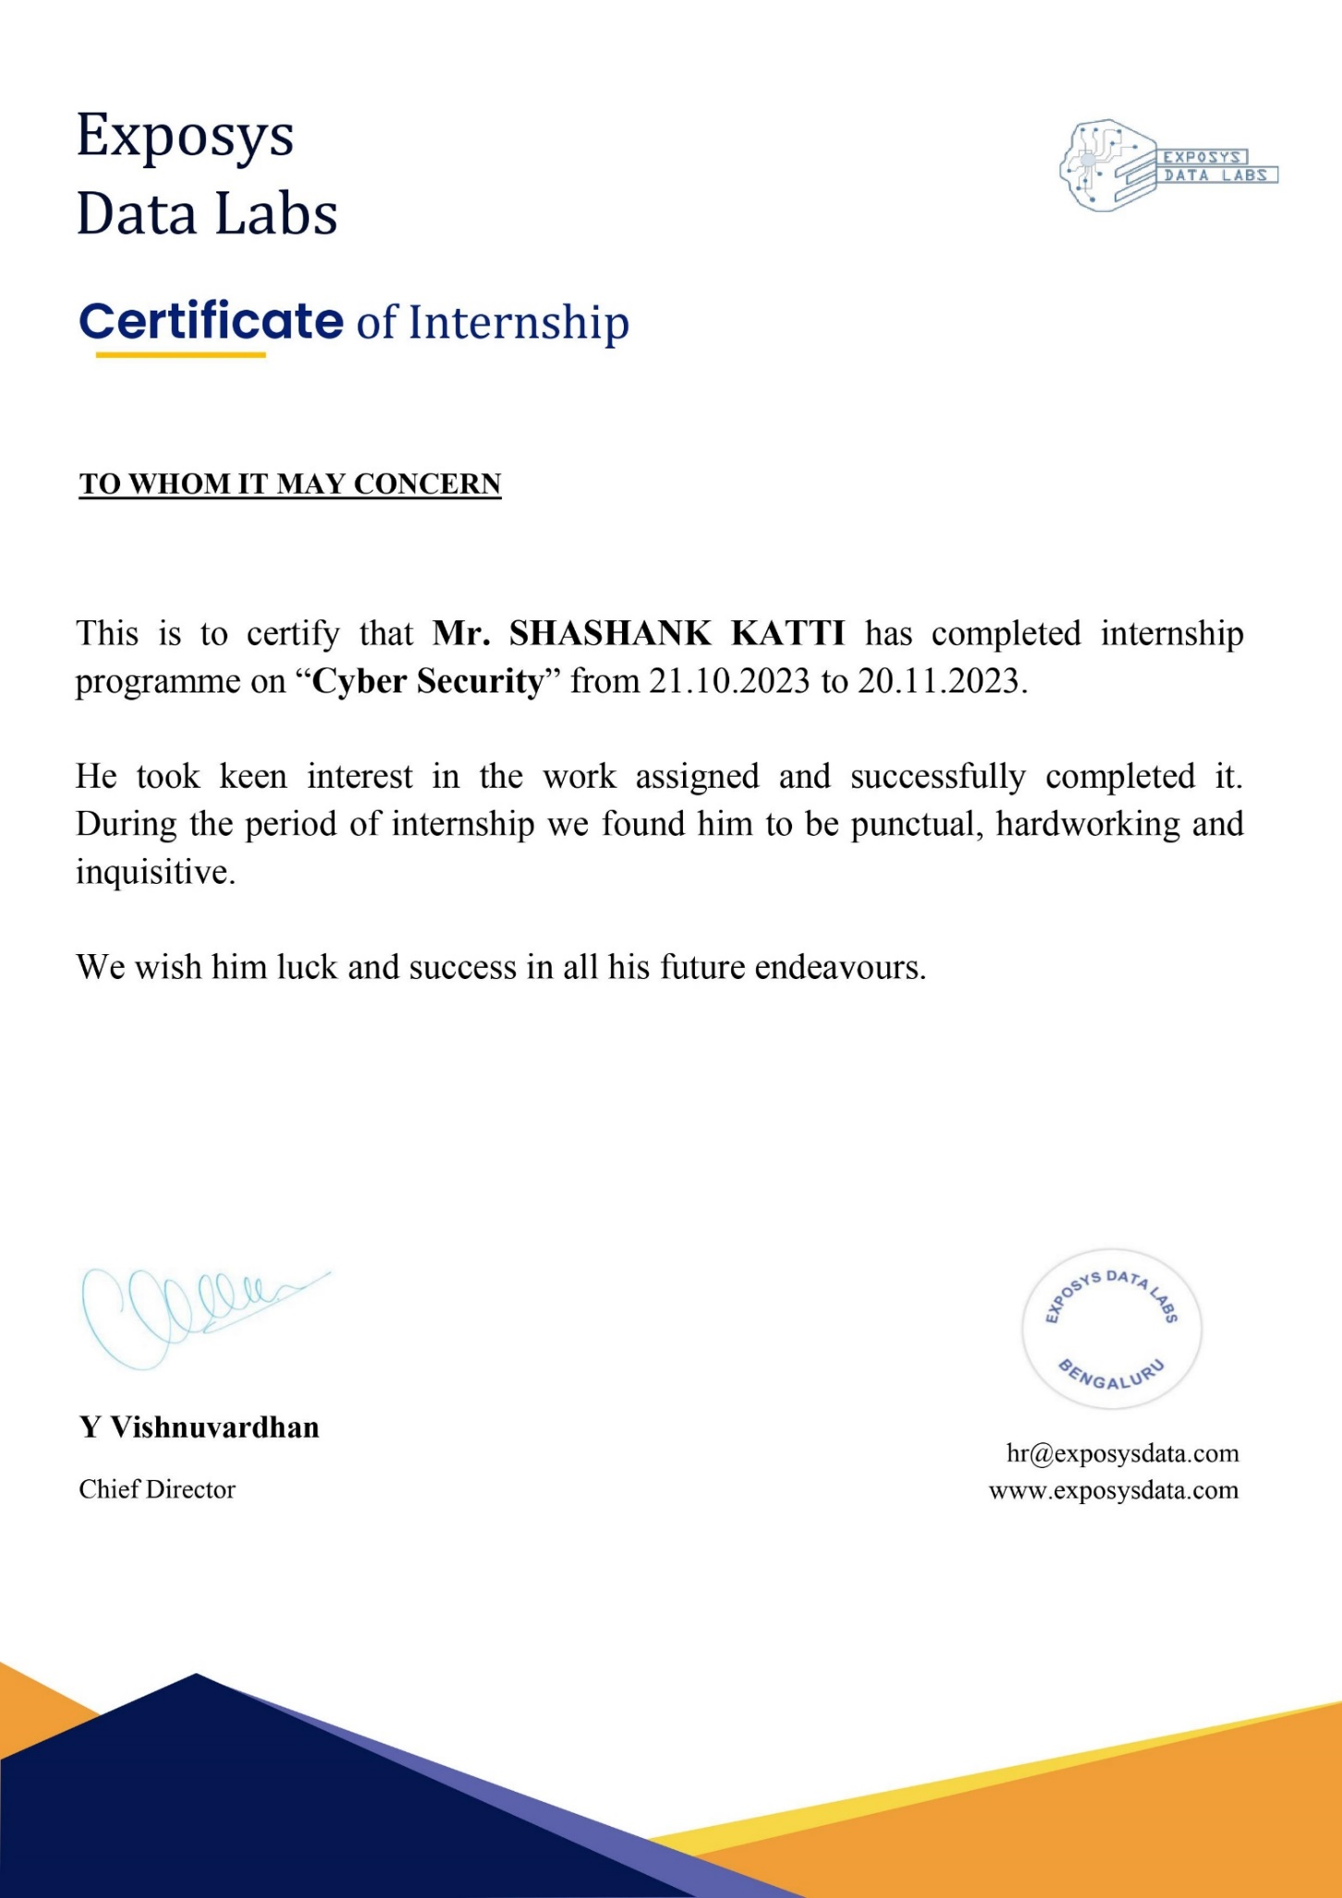

**DECLARATION**

I, **Shashank Katti** student of 4th semester of MCA, **BMS Institute of Technology and Management,**

**Yelahanka, Bangalore – 560064,** bearing USN 1BY22MC047**,** hereby declare that the internship

entitled “**Cyber Security intern”** at **EXPOSYS-Data-Labs** guided by Y Vishnuvardhan, Director and

Founder for the academic year 2023-24. I also declare that the matter embodied in this internship is a genuine

work done by me and has not been submitted in full fill of any curriculum described by the university.

**Shashank Katti 1BY22MC047**

# ACKNOWLEDGEMENT

I would like to express my sincere gratitude for the opportunity to undertake an internship program in Cyber Security. This experience has been invaluable in enhancing my knowledge and skills in the field.

I am deeply thankful to Mr. Y Vishnuvardhan, the Chief Director of EXPOSYS DATA LABS, for his invaluable guidance and support throughout the internship period from 21.10.2023 to 20.11.2023. His insights and expertise have been instrumental in my learning experience. Under his leadership, I gained practical exposure to various aspects of Cyber Security, which has greatly contributed to my professional development.

I also wish to acknowledge the encouragement and support of my faculty and peers, whose constant motivation has been a driving force in my academic and professional journey. Their support has helped me navigate through challenges and has been crucial in my growth.

Additionally, I extend my gratitude to the entire team at EXPOSYS DATA LABS for providing a conducive learning environment. The collaborative spirit and the wealth of knowledge shared by my colleagues have enriched my internship experience.

Finally, I would like to thank my family and friends for their unwavering support and encouragement. Their belief in me has been a source of strength and inspiration throughout this journey.

**Your Name: Shashank Katti**

**USN: 1BY22MC047**

**BMS INSTITUTE OF TECHNOLOGY AND MANAGEMENT**

**Bengaluru – 560064**

**Department of MCA**



**VISION**

To develop quality professionals in Computer Applications who can provide sustainable solutions to the societal and industrial needs.

**MISSION**

Facilitate effective learning environment through quality education, state-of-the-art facilities, and orientation towards research and entrepreneurial skills.

**Programme Educational Objectives (PEOs)**

**PEO 1:** Develop innovative IT applications to meet industrial and societal needs.

**PEO 2:** Adapt themselves to changing IT requirements through life-long learning.

**PEO 3:** Exhibit leadership skills and advance in their chosen career.

**BMS INSTITUTE OF TECHNOLOGY AND MANAGEMENT**

**Bengaluru – 560064**

**Department of MCA**

**Course Outcomes (COs)**

**CO1:** Analyze the real-time industry/research work environment with emphasis on organizational structure/job process/different departments and functions/tools technology.

**CO2:** Develop applications using modern tools and technologies.

**CO3:** Demonstrate self-learning capabilities with an effective report and detailed presentation.

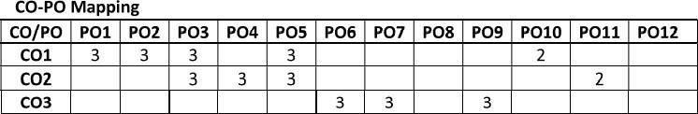

**Rubrics for Internship Presentation Assessment**

|  |  |  |  |  |  |  |
| --- | --- | --- | --- | --- | --- | --- |
|  | **Excellent (5)** | **V. Good (4)** | **Good (3)** | **Satisfactory (2)** | **Poor (1)** | **Final Score** |
| **Knowledge on industry experience /Research work** | Demonstrates in depth knowledge about Industry Research processes; answered all  Questions with elaboration. | Adequate knowledge on most of the industry/Research processes. Answered all Questions but failed to elaborate. | Knowledge to a limited extent on major processes.  Able to  answer most of the questions though not elaborate. | Superficial knowledge of topic; only able to answer basic questions | Does not  have any knowledge; Unable to answer questions. |  |
| **Organization of the presentation** | Presented in logical sequence; introduction and background given in proper context; key  points and conclusions are clear and well presented with citations and references. | Most information presented in logical sequence; clear introduction; adequate background; some irrelevant information. Some references are overlooked. | Organized in a presentable manner though lacks details of some of the topics. Or  very less references and citations. | Problems with sequencing, lacks clear transitions; incomplete or overly detailed introduction, emphasis given to less important information | Little or no organization, difficult to follow; missing or in effective introduction; confusing background; key points  unclear. |  |
| **Usage of Modern tools and technologies** | Effectively  Utilized appropriate tools and technologies  for implementation | Involved  sufficiently in developing  applications by utilizing  modern tools  and  technologies. | Developed  applications, though not very effectively.  Fair enough. | Sufficient for understanding but not  clearly elaborated about usage of tools and technologies | Too brief or  insufficient for understanding or too detailed. |  |
| **Presentation Skills** | Clear articulation  About tools /technology  , steady  delivery rate,  good posture  and eye  contact, confident and appropriately dressed. | Clear articulation  About tools /technology but not very polished.  Able to recover from minor mistakes.  appropriately dressed. | Good  articulation about tools /technology  and not very  polished. Not  able to realize  minor mistakes**.**  presentable attire. | Refers to slides to  make points, occasional eye  contact,  incorrect  pronunciation  s, and Voicefluctuation. | No clarity in sentence, Inaudible or too loud, no eye contact, delivery rate is too slow or too fast**,** not in formal attire. |  |
| **Question and Answers** | Student confidently answered all the questions appropriately. Has deep knowledge on concepts learnt | Student confidently answered all the questions. Has good knowledge on concepts learnt | Student answered only few questions. Has good knowledge on concepts learnt | Student has minimal knowledge on concepts learnt and answered very few questions | Student has inadequate knowledge on conepts learnt, doesn’t answered any questions |  |
| **Total Score** |  | | | | | |

**Rubrics for Internship Report Assessment**

|  |  |  |  |  |  |  |
| --- | --- | --- | --- | --- | --- | --- |
|  | **Excellent (5)** | **V. Good (4)** | **Good (3)** | **Satisfactory (2)** | **Poor (1)** | **Final Score** |
| **Purpose and Objective of Internship** | The purpose and objective of the Internship report is made clear, and the report addresses the objective(s) in a focused and logical manner. | The purpose and objective of the Internship report is made clear, and the report addresses the objective(s). | Documented well but with slight ambiguity in analysing the problems | Purpose and objectives are stated ambiguously | The report  does not clearly address the objective(s) of Internship. |  |
| **Documenting the Tools/Technology used, Grammar & Spelling** | Complete  information is provided about tools/technology, very few spelling errors, correct  punctuation,  grammatically  correct,  complete  sentences. | Information is  Provided about tools/technology, Occasional lapses in spelling, punctuation, grammar, but  not enough to  seriously distract  the reader. | Average  technical details on tools/ Technology usage, Grammatical  mistakes  not  corrected. | Less  technical details, sentences are not framed properly and with a few  spelling  mistakes | No details  about tools/ technology, Numerous spelling errors, non-existent or  incorrect  punctuation,  and/or severe  Errors in Grammar that  interfere with  understanding. |  |
| **Report Format** | All required  elements of the  report are present and completed efficiently. | All required  elements of the  report are present and completed to a satisfactory standard. | All  required  elements are present but some of  them are  not given  completely. | All required  elements are  provided but in a  haphazard way. | Key elements  of the report  are not  provided. Overall  presentation of the document is not to a professional  standard. |  |
| **Furnishing Proofs for Concepts/Tools learnt/Problems solved** | All the proofs are neatly documented to convey his/her work | All the proofs are documented to convey his/her work. Still there is scope to document in a better way | Some of the proofs are neatly documented to convey his/her work | Some of the proofs are neatly documented to convey his/her work. Still there is scope to document in a better way | Proofs are incomplete and fails to convey the acquired knowledge |  |
| **Plagiarism Check** | Uniqueness and Above | 90% | Uniqueness to 89% | 85% | Uniqueness 80% to 85% |  |
| **Total Score** |  | | | | | |

**Rubrics for Internship Presentation Assessment (out of 25 marks) =**

**Rubrics for Internship Report Assessment (out of 25 marks) =**

**Total Marks (Out of 50 marks) =**

**Signature of Faculty in Charge**

**Contents**



|  |  |  |
| --- | --- | --- |
| **SL No** | **Topics** | **Page No** |
| 1 | Introduction |  |
| 2 | Company Profile |  |
| 3 | Weekly Progress |  |
| 4 | Tools and Technologies used |  |
| 5 | Outcome of Internship |  |
| 6 | Conclusion |  |

**INTRODUCTION**

Cybersecurity encompasses various practices and technologies to protect systems, networks, and data from

cyber threats. A critical aspect of cybersecurity is encryption and decryption, which involve transforming

readable data (plaintext) into an unreadable format (ciphertext) and converting it back to plaintext,

respectively. Encryption ensures that only authorized parties can access the data, thus maintaining confidentiality

and integrity. It is widely used in securing communications, protecting sensitive information, and ensuring data

privacy. One of the fundamental aspects of cybersecurity is encryption and decryption, crucial for maintaining

data confidentiality, integrity, and security.

What is Encryption?

Encryption is the process of converting readable data, known as plaintext, into an unreadable format called

ciphertext. This transformation is achieved using an algorithm and a key. The primary goal of encryption is to

ensure that the data remains confidential and can only be accessed by those who have the correct decryption key.

How Encryption Works:

Plaintext: The original, readable data.

Encryption Algorithm: A set of rules or procedures used to transform the plaintext into ciphertext.

Encryption Key: A piece of information used by the encryption algorithm to perform the transformation.

The combination of the encryption algorithm and the encryption key produces ciphertext, which appears as a

random string of characters and is meaningless without the key to decrypt it.

What is Decryption?

Decryption is the reverse process of encryption. It involves converting the ciphertext back into plaintext so that it

can be read and understood. Decryption uses a key, which is typically the same as the encryption key

How Decryption Works:

Ciphertext: The encrypted data that needs to be transformed back to plaintext.

Decryption Algorithm: A set of rules or procedures used to convert the ciphertext back into plaintext.

Decryption Key: A piece of information used by the decryption algorithm to reverse the encryption process.

The Caesar Cipher is a type of substitution cipher where each letter in the plaintext is shifted a certain number

of places down or up the alphabet.

For example, with a shift of 3, 'A' becomes 'D,' 'B' becomes 'E,' and so on. This method, though simple,

lays the foundation for understanding more complex encryption techniques.

**COMPANY PROFILE**

Exposys Data Labs is a technology-focused company based in Bengaluru, India, specializing in solving real

world business problems through automation, big data, and data science. Their team of experts leverages

advanced technologies like artificial intelligence, machine learning, deep learning, and blockchain to help

businesses identify opportunities and prototype solutions.

The company's mission is to harness and train top talent to provide solutions for real-world challenges. They

offer a range of services including training courses, internships, and workshops in collaboration with prestigious

institutions like IITs and NITs. These programs cover various domains such as data science, machine

learning, blockchain, and digital marketing​

Exposys-Data-Labs also provides business solutions aimed at enhancing productivity and innovation

across various sectors including defense technology, medical technology, energy, and e-security. Additionally,

they focus on promoting digital marketing through email marketing, automated SMS, ad creation, and social

media marketing​

Internship opportunities at Exposys-Data-Labs are particularly well-regarded, with participants praising the

industry-level experience and supportive mentorship they receive. The company aims to bridge the gap

between academic learning and industry requirements, preparing students and professionals for real-world

applications​.

**WEEKLY PROGRESS**

**Week 1 (19/10/2023 - 25/10/2023)**

* **Objective**: Familiarization with the project requirements and initial setup.
* **Activities**:
* Attended orientation and introduction sessions at Exposys Data Labs.
* Met with Mr. Aravind Kumar R to discuss project details and expectations.
* Conducted research on the Caesar Cipher and basic cryptography concepts.
* Set up the development environment with Python and Streamlit.
* Drafted initial design and layout for the software interface.

**Week 2 (26/10/2023 - 01/11/2023)**

* **Objective**: Begin the development of the software's core functionality.
* **Activities**:
* Implemented basic text input and output features using Streamlit.
* Developed the Caesar Cipher encryption function.
* Created user interface components for text entry and shift value selection.
* Tested the encryption function with various shift values and text inputs.
* Conducted debugging sessions to ensure accuracy and functionality.

**Week 3 (02/11/2023 - 08/11/2023)**

* **Objective**: Expand the software to include decryption capabilities.
* **Activities**:
* Developed the Caesar Cipher decryption function.
* Integrated decryption features into the existing user interface.
* Added options for users to upload text files containing plaintext or ciphertext.
* Enhanced the interface to allow users to select between encryption and decryption.
* Conducted thorough testing of both encryption and decryption functionalities.

**Week 4 (09/11/2023 - 15/11/2023)**

* **Objective**: Improve user experience and add additional features.
* **Activities**:
* Implemented features to download or copy the encrypted or decrypted text.
* Enhanced the user interface for better usability and aesthetics.
* Added error handling for invalid inputs and edge cases.
* Conducted user testing sessions and gathered feedback for improvements.
* Began documenting the code and user manual.

**Week 5 (16/11/2023 - 22/11/2023)**

* **Objective**: Finalize the software and prepare for deployment.
* **Activities**:
* Made final adjustments and improvements based on user feedback.
* Conducted comprehensive testing to ensure all features work as intended.
* Completed the software documentation and user manual.
* Prepared a presentation and demonstration of the software for the project review.
* Conducted a review meeting with Mr. Aravind Kumar R and received final feedback.

**Week 6 (23/11/2023 - 29/11/2023)**

* **Objective**: Wrap up the internship and reflect on the experience.
* **Activities**:
* Made any final tweaks and polished the software.
* Deployed the software on the web using stream lit cloud.
* Submitted the final version of the software to Exposys Data Labs.
* Completed and submitted the internship report.
* Attended a wrap-up meeting with Mr. Aravind Kumar R and the team.
* Reflected on the internship experience and identified key learnings and skills gained

**TOOLS AND TECHNOLOGIES USED**

In the development of the "Encryption and Decryption of Text Using Caesar Cipher" software, several tools

and technologies were utilized to ensure a robust and user-friendly application. The primary tools and technology

used are as follows:

**1. Python**

* **Description**: Python is a high-level, interpreted programming language known for its simplicity

and readability. It is widely used in various domains, including web development, data analysis,

artificial intelligence, and cybersecurity.

* **Usage in Project**: Python was the core programming language used to implement the Caesar Cipher

encryption and decryption functions. Its extensive standard library and supportive community made it an

ideal choice for this project.

**2. Streamlit**

* **Description**: Streamlit is an open-source app framework for Machine Learning and Data Science projects.

It allows developers to create interactive and visually appealing web applications quickly and easily.

* **Usage in Project**: Streamlit was used to develop the user interface of the software. It facilitated the

creation of an intuitive and interactive interface where users could input text, select shift values, and

choose to encrypt or decrypt the text. Streamlit's simplicity and effectiveness in building web applications

made it a suitable choice for this project.

**3. Streamlit Cloud**

* **Description**: Streamlit Cloud is a platform that allows developers to deploy and share their

streamlit applications easily on the cloud.

* **Usage in Project**: Streamlit Cloud was used to deploy the application, making it accessible to users

via the web. This ensured that the application could be easily shared and used without the need for

installations.

**4. Git**

* **Description**: Git is a distributed version control system that tracks changes in source code during

software development. It helps manage project versions and collaborates with team members efficiently.

* **Usage in Project**: Git was used for version control throughout the development process. It allowed

for systematic tracking of changes, facilitated collaboration, and ensured that the project could be rolled

back to previous versions if necessary.

**5. GitHub**

* **Description**: GitHub is a web-based platform that uses Git for version control. It provides a

collaborative environment for developers to share and work on projects together.

* **Usage in Project**: The project repository was hosted on GitHub, enabling seamless collaboration,

code review, and project management. It also served as a backup for the codebase and documentation.

**6. PyCharm**

* **Description**: PyCharm is an integrated development environment (IDE) for Python developed by

JetBrains. It provides code analysis, a graphical debugger, an integrated unit tester, integration with

version control systems, and supports web development with Django.

* **Usage in Project**: PyCharm was the primary code editor used during the development of the project. Its

powerful features, such as intelligent code completion, code inspections, and integrated debugging tools,

significantly enhanced productivity and code quality.

]

**IMPLEMENTATION**

import time

import streamlit as st

import streamlit.components.v1 as components

def Caesar_Cipher(inp,val):

enstr = ""

for i in inp:

if 'A' <= i <= 'Z':

enstr += chr(((ord(i) - ord('A') + val) % 26) + ord('A'))

elif 'a' <= i <= 'z':

enstr += chr(((ord(i) - ord('a') + val) % 26) + ord('a'))

else:

enstr += i

return enstr

def User_Interface(str1, str2):

with st.spinner(text="Please Wait", cache=True):

time.sleep(2)

with st.status(f"{str1} data"):

time.sleep(2)

st.write(f"{str2} done")

pg = st.progress(0)

for i in range(101):

pg.progress(i)

time.sleep(0.01)

st.success(f"{str2} done :smiley:")

flag=0

components.html('''<style> body{padding:20px;}</style><body bgcolor = "powderblue"><h1><center>

<b>Caesar Cipher</h1></body>''')

st1 = st.file_uploader("Click here to upload file",type="txt")

if st1 is not None:

f_open = st1.read()

f_open = f_open.decode('utf-8')

inp = f_open

if st1 is None:

st.markdown("### OR")

st.subheader("Enter the text")

inp = st.text_input("Text")

opt = st.selectbox("Select the operation",("Encrypt","Decrypt"))

if opt== "Decrypt":

val1= st.selectbox("Choose the value to decrypt",(-1,-2,-3,-4,-5))

btn = st.button("Click to decrypt")

if btn == True:

flag = 1

elif opt== "Encrypt":

val = st.selectbox("Choose the Value to Encrypt",(1,2,3,4,5))

btn = st.button("Click to Encrypt")

if btn == True:

flag =2

if flag== 2:

User_Interface("Encrypting","Encryption")

res = Caesar_Cipher(inp,val)

st.code(res)

st.download_button(label="Download Encrypted File:open_file_folder:",data=res,

file_name="Encrypted.txt", help="Click to download")

elif flag==1:

User_Interface("Decrypting","Decryption")

res = Caesar_Cipher(inp,val1)

st.code(res)

st.download_button(label="Download Decrypted File :open_file_folder:",

data=res, file_name="Decrypted.txt",help="Click to download")

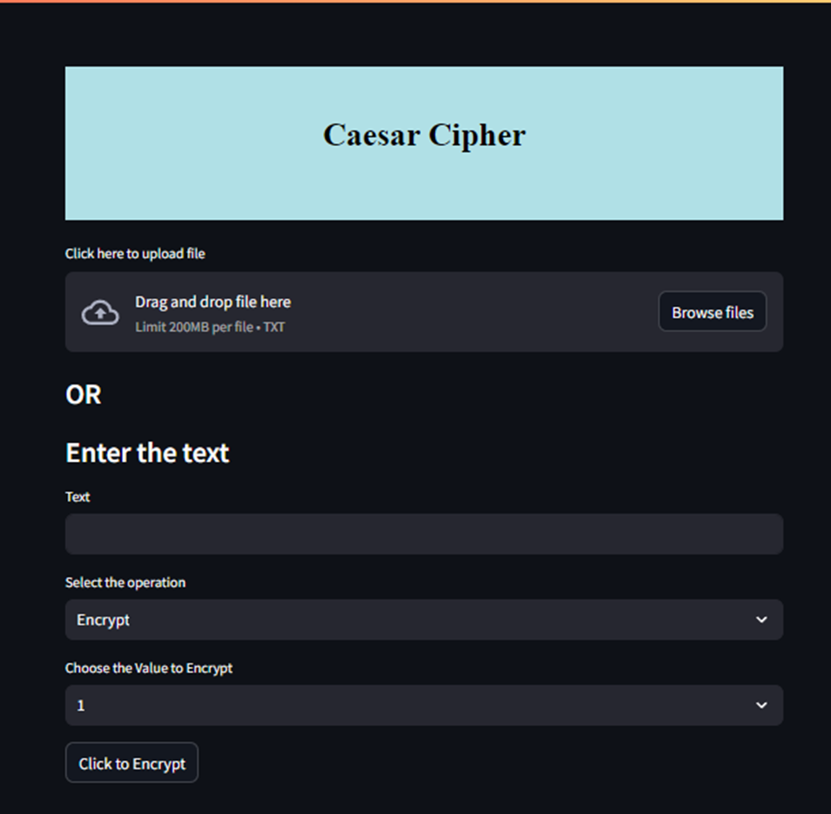

URL - https://text-encryptor-decryptor.streamlit.app

**OUTCOME OF THE INTERNSHIP**

The internship at Exposys Data Labs was an enriching experience that provided significant practical l

earning in cybersecurity and software development. The primary objective of developing a software application

for the encryption and decryption of text using the Caesar Cipher was successfully achieved.

The application built with Streamlit and Python includes a user-friendly interface that allows users to

input or upload text, select a shift value, and perform encryption or decryption. The functionality to

download or copy the processed text further enhanced the user experience.

Throughout the internship, I gained valuable technical skills, including improved proficiency in Python,

hands-on experience with Streamlit, and knowledge of version control using Git and GitHub. Additionally,

deploying the application on Streamlit Cloud provided insights into cloud computing. This experience also

improved my problem-solving and debugging abilities, as well as my documentation and communication

skills. Overall, the internship offered a comprehensive understanding of applying cryptographic techniques in

software development, bridging the gap between theoretical knowledge and practical application..

**CONCLUSION**

The internship at Exposys Data Labs provided an invaluable opportunity to apply theoretical knowledge to a practical project. Developing the Caesar Cipher tool involved understanding the fundamentals of cryptography, designing and implementing a user-friendly application, and addressing various challenges along the way.

The experience has not only enhanced my technical skills in programming and software development but also provided insights into project management, problem-solving, and effective communication. I am grateful for the support and guidance provided by Mr. Aravind Kumar R and the entire team at Exposys Data Labs.

By successfully completing this project, I have gained a solid foundation in cryptography and software

development, which will be instrumental in my future endeavors. This internship has been a significant stepping stone towards achieving my career goals in the field of computer science and cybersecurity.