The graphs show the percentage of accuracy for each test. This percentage is calculated by comparing the number of pictures that have been correctly recognized and the total number of pictures tested. The first observation that can be done is the increase of the accuracy when the number of pictures per person is also increasing. All the algorithms were able to recognize all the pictures correctly when at least 20 pictures per person were used to train the algorithms.

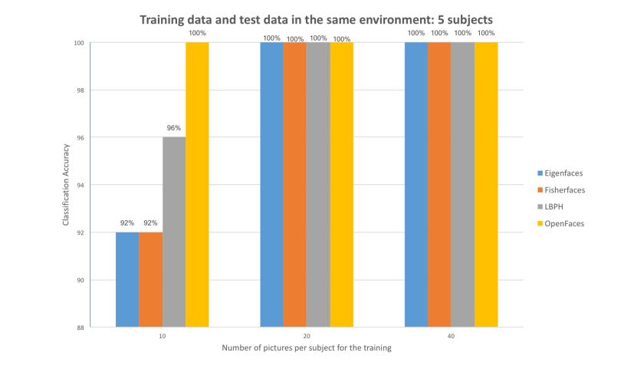
FIG1: Tests results with 5 subjects and the same environment of the training data and test data.

In figure 2 the accuracy with 10 pictures for the training has increased compared to the previous one.Fisherfaces is the only algorithm that did
not recognize correctly all the subjects with 20 pictures for the training phase. The ranking of the algorithm related to the accuracy is the same as the previous figure. The same observation can be noticed on figure 1,
the bigger the training set is, the more accurate the result is.

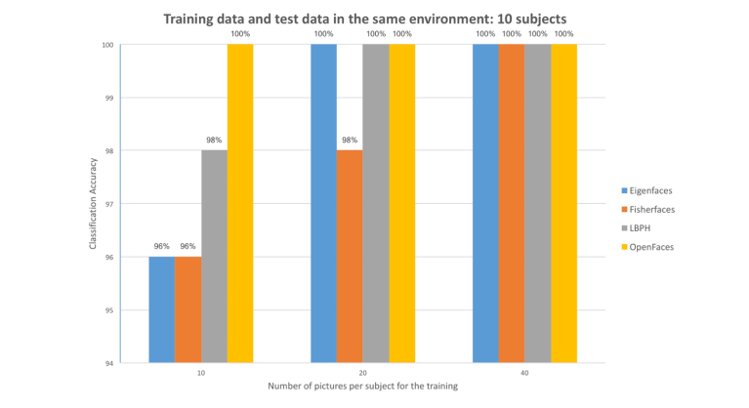
Fig2:Tests results with 10 subjects and the same environment of the training data and test data.

This figure shows how the same pictures have been affected by a change of the number of subjects. An increase from 5 subjects to 10
transformed a correct prediction into a wrong one for Fisherfaces (training: 20 pics per subj). However, the other predictions are stable.
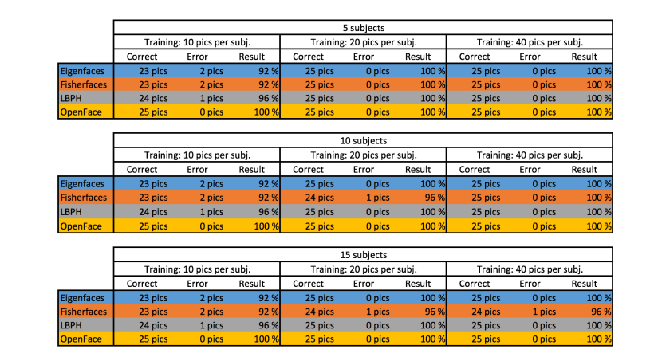

Figure 3 shows that a large amount of data improves the accuracy.
Fisherfaces had the worst result. LBPH is the second best, and the leader is OpenFace with an accuracy of 100% in each test. Only Fisherfaces has been affected by a change in the number of subjects for the same pictures (FIG2). However, the accuracy of all the algorithms has never been below 92%.
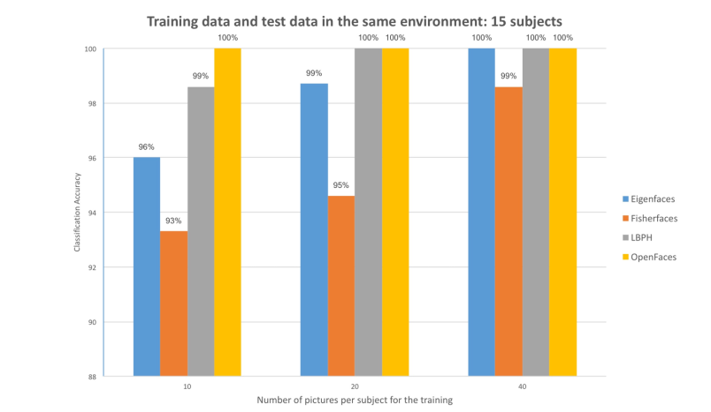
FIG3:-Tests results with 15 subjects and a different environment of the training data and test data.

