WEBSITE DETAILS

1. When the website will open the first page will be the Home page of the of the website .

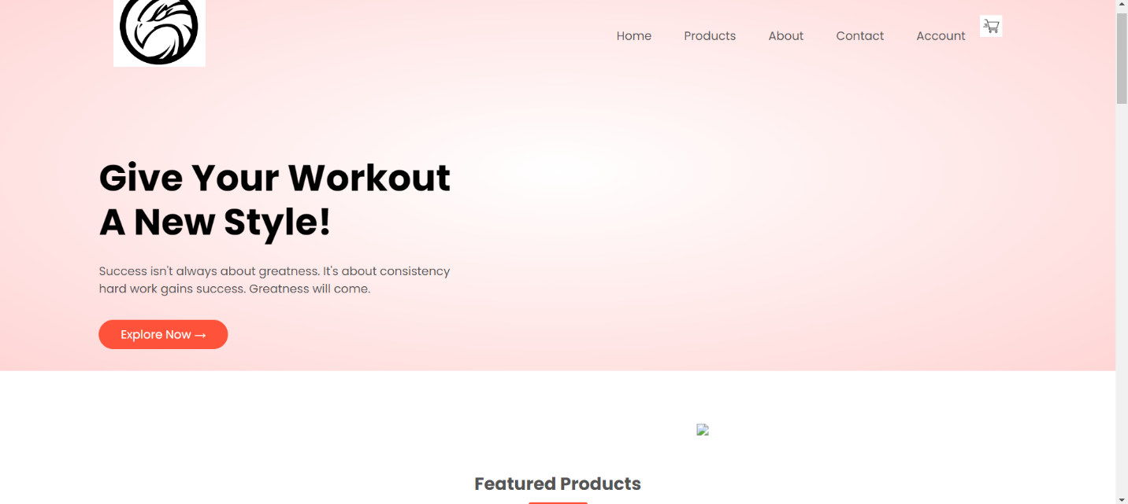

2. Then the user has to log in with his/her account in the account section.

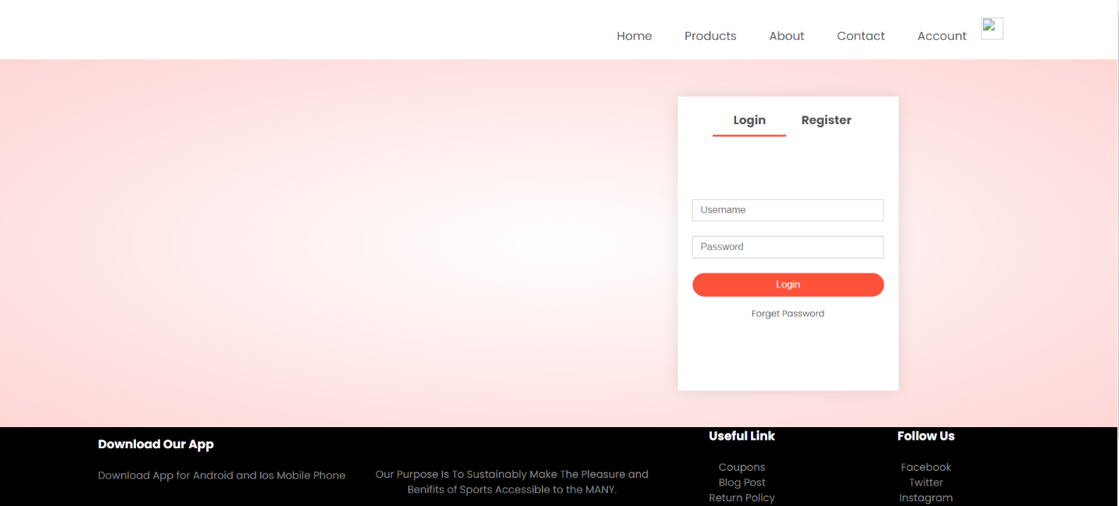

3. IF the account is not present the he/she has to register it and make a new account .

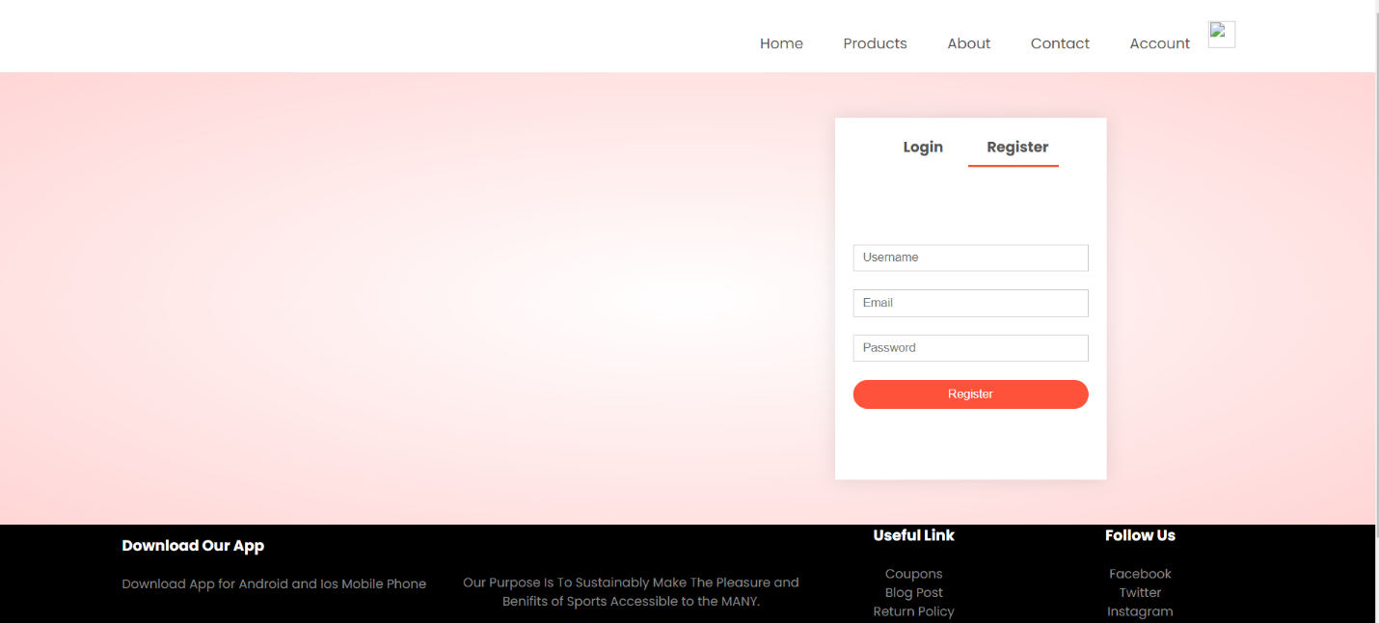

4. After the account is created he/she can visit to the product page to purchase any product.

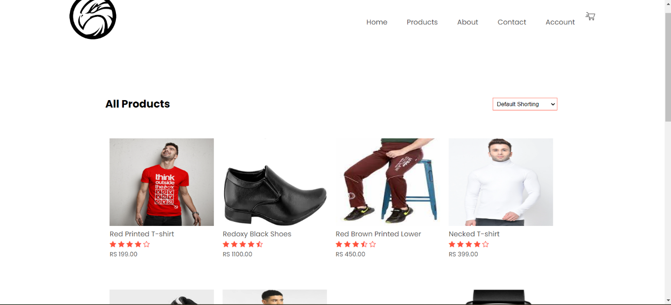

5. And if there is any complain regarding the product aur other . He/she can give there complain in contact us page where he/she has to fill all the necessary detail regarding there complain on the form.

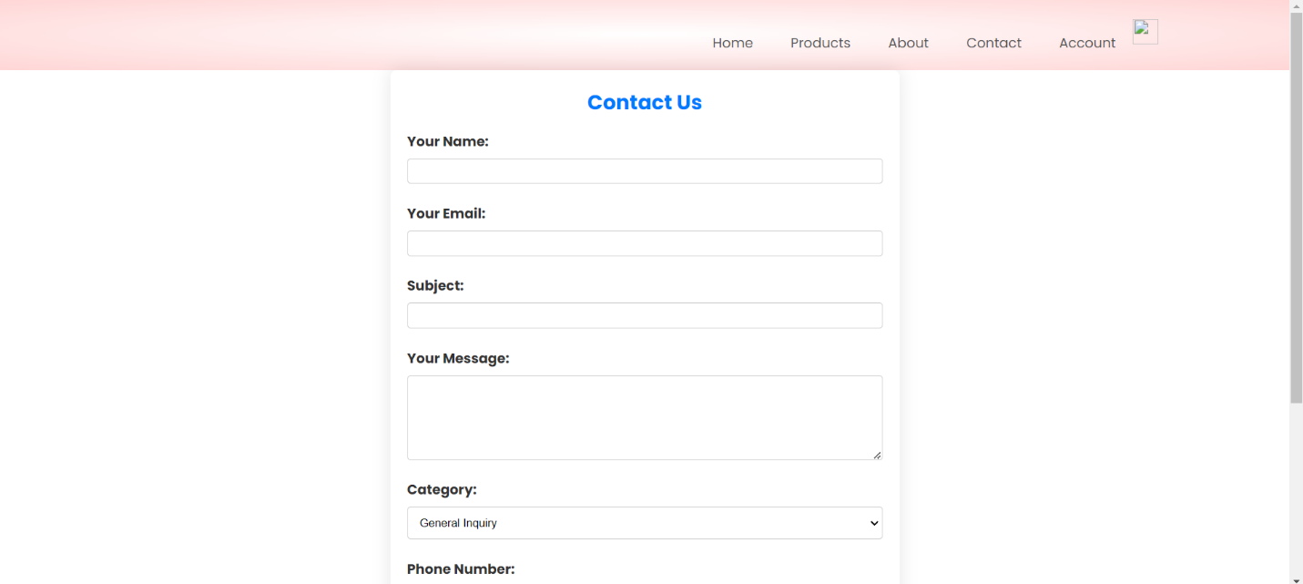

6. If the submit the form without filling any important area the error msg will flash

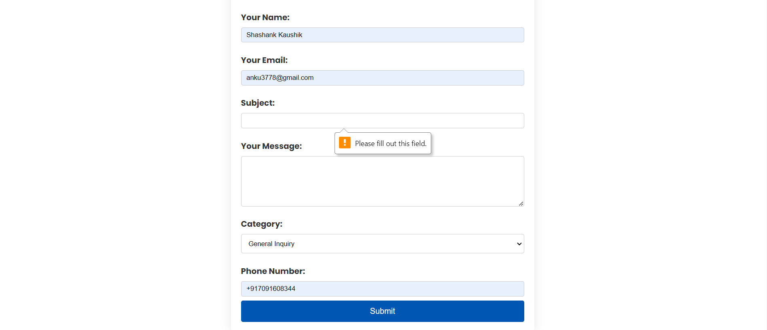

7. And if the user want to know about the company policy and specific information they can visit to our About page.

