RDBMS Concepts

Lab Book

Table of Contents

Getting Started 3

This lab book is a guided tour for learning Data Modeling Concepts. 3

2.1. : Using the below Conceptual Model using ER of Online Book store, perform the Normalization up to 3NF for each entity used in the below conceptual model. 6

3. Logical data modeling 8

Getting Started

This lab book is a guided tour for learning Data Modeling Concepts.

1. **Conceptual Data Modeling**

|  |  |
| --- | --- |
| Goals | • Understand Conceptual data modeling using ER modeling |
| Time | 2 Hours. |

* 1. Draw an ER diagram using Chen notation for a Training Database (Relational database) schema taking all the assertions given into account.

**Assertions:**

* Details of each Faculty (id,name, tenure, skillset etc )should be available in the database
* The faculty may teach one or more courses in a given term
* The faculty must direct the research of at least one student
* Course details should be available in the database
* A course may have none, one, or two prerequisites
* A course may exist even if no students are currently enrolled.
* A student must select at least one course per term

Distinguish the Simple/Composite/Multi-valued/Stored/Derived attributes in ER diagram.

Specify the Weak entity, Partial key if any & Degree of relationship/cardinality in the ER diagram.

* 1. Draw an ER diagram for a company-wide database for a large engineering firm that keeps track of all full-time personnel, their skills and projects assigned, the departments (and divisions) worked in, the engineer professional associations belonged to, and the engineer desktop computers allocated.

**Assertions:**

* Each employee is working in a single department.
* The division is the basic unit in the company, consisting of many departments.
* Each division and department has a manager.
* Each employee is having a job title: engineer, admin, secretary, manager, and so on.
* Engineers typically belong to professional associations and are allocated an engineering workstation (or computer). Secretaries and managers are each allocated a desktop computer.
* Any employee may be married to another employee. Keep track of these relationships to avoid assigning an employee to be managed by his or her spouse.
* Employees may work on several projects at one time, and each project could be headquartered at different locations (cities).
* Each employee at a given location works on only one project at that location.
* Employee skills can be individually selected for a given project, but no individual has a monopoly on skills, projects, or locations.
* Distinguish the Simple/Composite/Multi-valued/Stored/Derived attributes in ER diagram.

Specify the Weak entity, Partial key if any & Degree of relationship/cardinality in the ER diagram.

* 1. The following ER diagrams represent two views of a library database as described to a database designer. Show how the two views can be integrated in the simplest and most useful way by making all necessary changes on the two diagrams. State any assumptions you need to make

Employee View Customer View

Book-Store Branch

Book

Book-Category

Customer

Employee

Book-Copy

N

1

M

N

1

N

1

1

M

N

works in

carries

includes

Currently issued to

Formerly issued to

1. **Normalization**

|  |  |
| --- | --- |
| Goals | * Understand Normalization and Minimum Set of Tables |
| Time | 2 Hrs. |

## 

## : Using the below Conceptual Model using ER of Online Book store, perform the Normalization up to 3NF for each entity used in the below conceptual model.

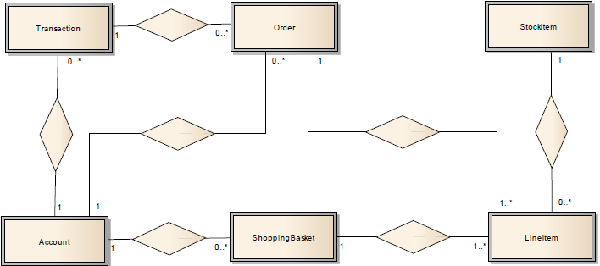

## 

* 1. Given below is the relation with Unnormalized Data:

Messaging_Data (USER_ID, USER_NAME, MSG_ID, REC_DATE, SUBJECT, TEXT, SRVR_ID, SERVER_NAME)

Implement the normalization up to 3NF for the below data

|  |  |  |  |  |  |  |  |
| --- | --- | --- | --- | --- | --- | --- | --- |
| **User Id** | **User Name** | **MSG ID** | **Rec Date** | **Subject** | **Text** | **Server Id** | **Server Name** |
| 2301 | Smith | 54101 | 05/07 | Meeting Today | Ther is… | 3786 | IMAP05 |
| 2301 | Smith | 54098 | 07/12 | Promotions | I like to.. | 3786 | IMAP05 |
| 2301 | Smith | 54445 | 10/06 | Next Assignment | Your next.. | 3786 | IMAP05 |
| 5607 | Jones | 54101 | 05/07 | Meeting Today | Ther is… | 6001 | IMAP08 |
| 5607 | Jones | 54512 | 06/07 | Lunch? | Can you… | 6001 | IMAP08 |
| 5607 | Jones | 54660 | 12/01 | Jogging Today? | Can you… | 6001 | IMAP08 |
| 7773 | Walsh | 54101 | 05/07 | Meeting Today | Ther is… | 9988 | EMEA01 |
| 7773 | Walsh | 54554 | 03/17 | Stock Quote | The latest.. | 9988 | EMEA01 |
| 0022 | Patel | 54101 | 05/07 | Meeting Today | There | 2201 | EMEA09 |
| 0022 | Patel | 54512 | 06/07 | Lunch? | Can we… | 2201 | EMEA09 |

1. Logical data modeling

|  |  |
| --- | --- |
| **Goals** | Understand Logical data modeling using ER diagram |
| **Time** | 1. Hrs |

* 1. **Course management**

A training company wishes to create a database of its course information. The company delivers a number of seminars and training courses. Each course is delivered by one member of staff at some location (such as internal seminar PKP, Mumbai). The fees vary for each course and on the number of delegates a company sends. For example, if a company sends one person, the charge may be Rs.10000. If the company sends two people, the first may be charged Rs. 10000, but the second may be charged Rs. 7500. The course can be attended by a number of delegates, subject to some upper limit for the course. A delegate can register as an individual or through his or her company. The name of the employee who registers the delegate is recorded. An invoice is sent either to the delegate or to his or her company.

Design the logical data model and the associated tables listing for the given problem.

* 1. **: Vehicle rentals**

A vehicle rental company wishes to create a database to monitor the renting of vehicles to clients. The company has various outlets and each outlet has staff including a Manager and several Senior Mechanics who are responsible for supervising the work of allocated groups of Mechanics. Each outlet has a stock of vehicles for rent that may be rented by clients for various periods of time, from a minimum of four hours to a maximum of six months. Each rental agreement between a client and the company is uniquely identified using a rental number. A client must take out insurance cover for each vehicle rental period. Each vehicle is checked for faults after each rental.

Design the logical data model and the associated tables listing for the given problem.