**Project Charter Document**



**Project Name:** AI ChatBot For Education

**Department:** Data Science**/**Artificial Intelligence

**Focus Area:** Machine Learning

**Product/Process:** Natural Language Processing(NLP)



**Prepared By**

|  |  |
| --- | --- |
| **Document Owner(s)** | **Project/Organization Role** |
| Pavitra Mandal | AI Chatbot for Education |

**Project Charter Version Control**

|  |  |  |  |
| --- | --- | --- | --- |
| **Version** | **Date** | **Author** | **Change Description** |
| 1.0 | 22/02/2022 |  | Document created |
| 2.0 | 22/02/2022 |  | Document created |

**TABLE OF CONTENTS**

**1** **PROJECT CHARTER PURPOSE 3**

**2** **PROJECT EXECUTIVE SUMMARY 3**

**3** **PROJECT OVERVIEW 3**

**4** **PROJECT SCOPE 4**

4.1 Goals and Objectives 4

4.2 Project Deliverables 4

4.3 Deliverables Out of Scope 4

4.4 Project Duration 4

**5** **PROJECT CONDITIONS 5**

5.1 Project Assumptions 5

5.2 Project Issues 5

5.3 Project Risks 5

5.4 Project Constraints 5

**6** **Project Structure Approach 6**

**7** **Project Team Organization Plans 6**

**8** **PROJECT REFERENCES 6**

**9** **APPROVALS 6**

**10** **APPENDICES 8**

10.1 Document Guidelines 8

10.2 Project Charter Document Sections Omitted 8

# PROJECT CHARTER PURPOSE

The project charter defines the scope, objectives, and overall approach for the work to be completed. It is a critical element for initiating, planning, executing, controlling, and assessing the project. It should be the single point of reference on the project for project goals and objectives, scope, organization, estimates, work plan, and budget. In addition, it serves as a contract between the Project Team and the Project Sponsors, stating what will be delivered according to the budget, time constraints, risks, resources, and standards agreed upon for the project. To Provide support it is 24/7 available.



# PROJECT EXECUTIVE SUMMARY

* Project goals
* Our Goal is to Build an AI based chatbot, which can be used globally 24/7.
* Objectives
* To create a Chat Bot which can mimic the responses of human and can perform better than human being.
* To provide the answers for different types of questions that customer may ask.
* Scope
* Chatbots can bring technological advancements and vastly improve customer engagement.
* Chatbots can communicate with clients to create enhanced lead generation.
* Chatbots can understand and perform better in responding for the customer queries.
* Chatbots can learn about the human experience, can also proactively greet people with quick replies.
* Chatbots can provide better guidance by which they enhance customer experience.
* Constraints
* These chatbots are programmed in a way that they only know what they are taught.
* Out of box questions need to be handled carefully.
* Large memory space is required for better and fast response.
* Duration
* 1 month

# PROJECT OVERVIEW

* A chatbot is a computer program that simulates and processes human conversation (either written or spoken), allowing humans to interact with digital devices as if they were communicating with a real person. Chatbots can be as simple as rudimentary programs that answer a simple query with a single-line response or as sophisticated as digital assistants that learn and evolve to deliver increasing levels of personalization as they gather and process information.



# PROJECT SCOPE

## Goals and Objectives

|  |  |
| --- | --- |
| **Goals** | **Objectives** |
| * To create a Chat Bot which can mimic the responses of human and can perform better than human being. * To provide the answers for different types of questions that customer may ask**.** | * Enhance customer engagement * Automated lead generation * Higher potential for human like conversation * Save lot of time in the long run * Work well for companies that have lot of data |

## Project Deliverables

|  |  |
| --- | --- |
| **Milestone** | **Deliverable** |
| * Identifying Constraints and design the project architecture | * Deliverable 1.1—Identifying Constraints and design the project architecture. * Deliverable 1.2— Data collection * Deliverable 1.3— Data Preparation |
| * Model Building | * Deliverable 2.1— using regex,NLTK * Deliverable 2.2 — Model building with the help of NLP |
| * Model Evaluation, tuning and insights, Deployment | * Deliverable 3.1— Model Evaluation * Deliverable 3. 2— Deployment |
| * Show case and review, Final Presentation and documentation, Handover it over. | * Deliverable4.1 – show case and review * Deliverable4.2 – Final Presentation and documentation * Deliverable4.3 – Handover |

## Deliverables Out of Scope

* Queries
* utterances in the evaluation data is key to identify both true negatives and false positives.



## Project Duration (start date: 12/01/2022 End date: 22/02/2022)

|  |  |  |  |
| --- | --- | --- | --- |
| **Project Milestone** | **Date Estimate** | **Deliverable(s) Included** | **Confidence Level** |
| * Identifying Constraints and design the project architecture | [12/01/2022]  -  [20/01/2022] | * Deliverable 1.1—Identifying Constraints and design the project architecture. * Deliverable 1.2— Data collection * Deliverable 1.3— Data Preparation | [High] |
| * Model Building | [21/01/2022]  -  [31/01/2022] | * Deliverable 2.1— using regex,NLTK * Deliverable 2.2 — Model building with the help of NLP | [High] |
| * Model Evaluation, tuning and insights, Deployment | [1/02/2022]  -  [14/02/2022] | * Deliverable 3.1— Model Evaluation * Deliverable 3. 2— Deployment | [High] |
| * Show case and review, Final Presentation and documentation, Handover it over. | [15/02/2022]  -  [22/02/2022] | * Deliverable4.1 – show case and review * Deliverable4.2 – Final Presentation and documentation * Deliverable4.3 – Handover | [Medium] |



# PROJECT CONDITIONS

## Project Assumptions

* Work on data which is extracted from JSON file and Google.
* Can create a Telegram API by using Python
* Cloud deployment should be done.



## Project Issues

**Priority Criteria**

1 − High-priority/critical-path issue; requires immediate follow-up and resolution.

2 − Medium-priority issue; requires follow-up before completion of next project milestone.

3 − Low-priority issue; to be resolved prior to project completion.

4 − Closed issue.

|  |  |  |  |  |  |
| --- | --- | --- | --- | --- | --- |
| **#** | **Date** | **Priority** | **Owner** | **Description** | **Status & Resolution** |
| 1 | 22/02/2022 | High |  | Need to find a strategy to handle out of JSON file questions. | Resolved by using Python package google, we can get results through “Googlesearch” to handle out JSON file questions. |
| 2 |  |  |  |  |  |

## Project Risks

|  |  |  |  |  |
| --- | --- | --- | --- | --- |
| **#** | **Risk Area** | **Likelihood** | **Risk Owner** | **Project Impact-Mitigation Plan** |
| 1 | Json | [High/Medium/Low] | Low | Medium |
| 2 | Google search | [High/Medium/Low] | Low | Low |

## Project Constraint

* Large memory space is required for better and fast response.
* A bot is not a person
* Domain specific
* Needs maintenance
* Chatbots Are Often Repetitive



# Project Structure Approach

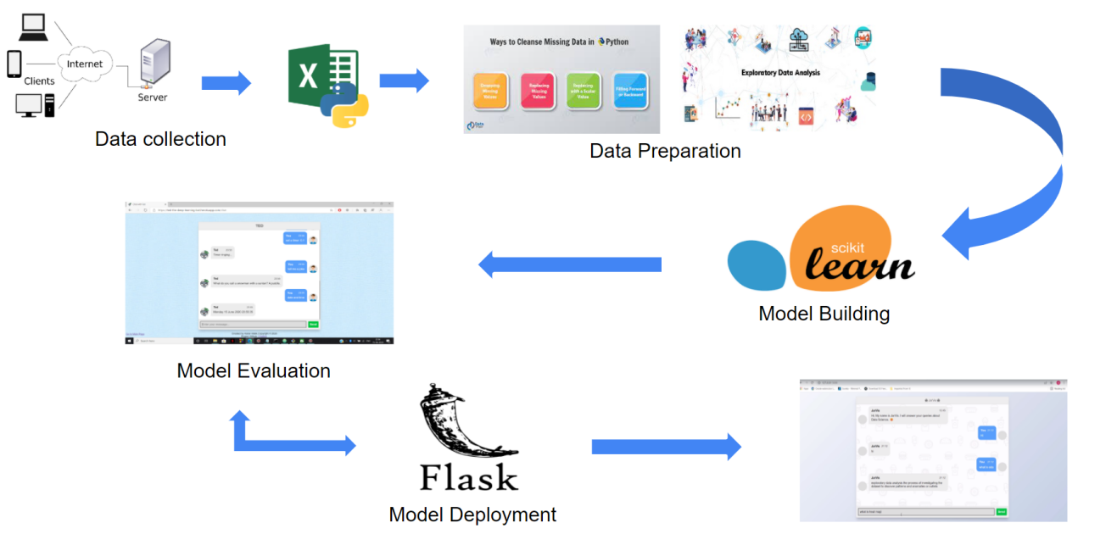



# Project Team Organization Plans

|  |
| --- |
| Deliverable 1.1— Data Collection  Deliverable 1.2— Data Preparation  Deliverable 1.3—Project Overview |
| Deliverable 2.1— Model Building  Deliverable 2.2— Model Evaluation |
| Deliverable 3.1— Model Deployment |
| Deliverable4.1 – Showcase,review,final presentation  Deliverable4.2 – Documentation  Deliverable4.3 – Handover |



# PROJECT REFERENCES

|  |  |
| --- | --- |
| **Milestone** | **Deliverable** |
| [ YouTube, Google | Ideas regarding Building a chatbot using Machine Learning and some concepts of AI |
| Model Building | Python codes, Libraries |
| Deployment | Cloud |

# 

# APPROVALS

**Prepared by**

Project Manager

**Approved by** Sharat Chandra M____________________

Project Sponsor

__________________________________

Executive Sponsor

__________________________________

Client Sponsor



# APPENDICES

## Document Guidelines

## Project Charter Document Sections Omitted

