**Library management system**   
  
  
  
1.component diagram:  
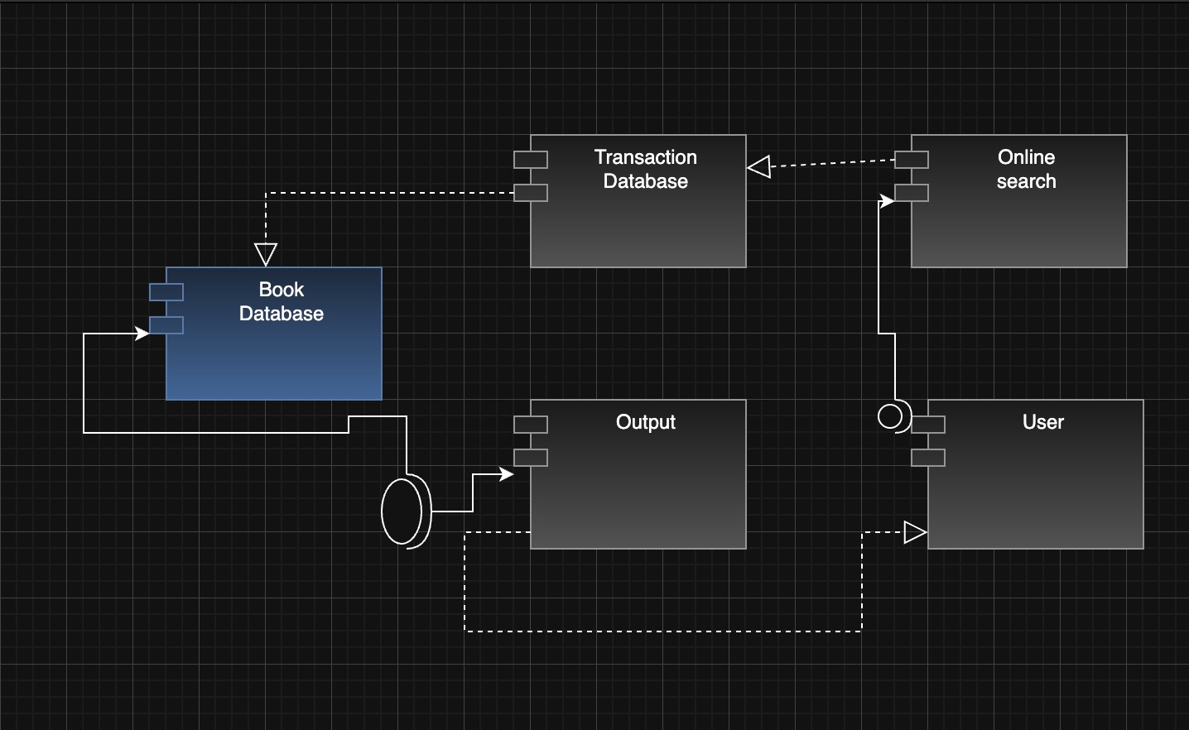  
2.Collabration diagram:  
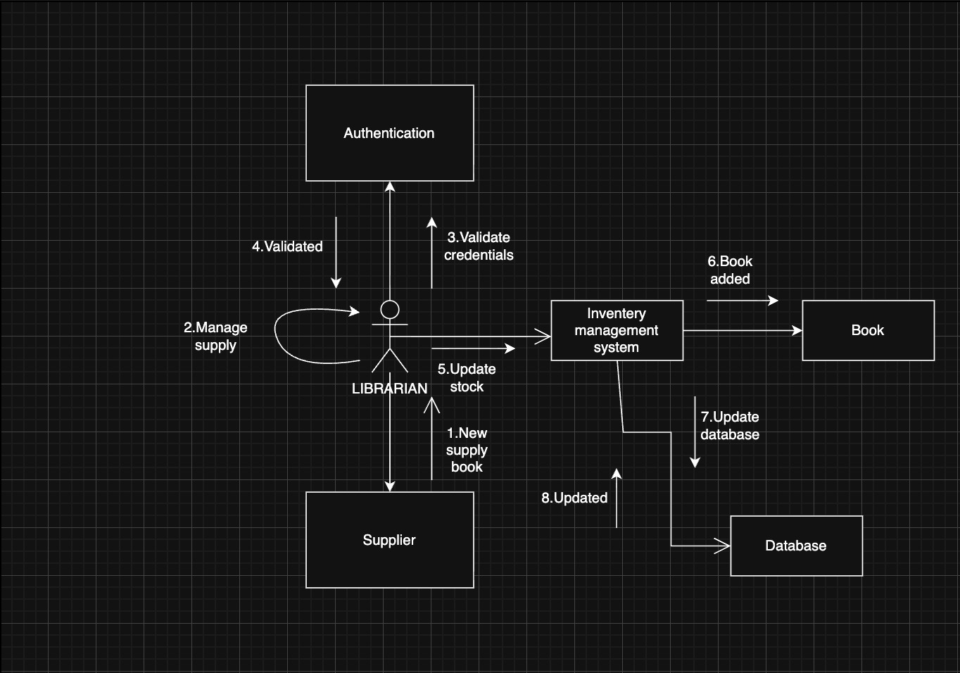  
  
3.Deployment diagram:  
