**KIT-CHAT Authentication Management**

The entire log-in flow for Kit-Chat is divided into multiple phases as it comprises of multi-touch points to acquire CyberArk password first and then using it to sign-in to Azure services and portal using CLD credentials.

**Prerequisites:**

One must have fully functional CLD account set-up beforehand to take-part in the process to authenticate.

**For starters or first-timers**, one can reach out to AZSA ITS Team and request via Microsoft Form by selecting appropriate purpose and actions. Upon review, a representative from AZSA ITS will grant the necessary permissions and create CLD account with few training videos to operate on.

**Phase 1: CyberArk Access**

As everything in CLD account with One Country Hosting is tagged with rotating passwords, we first need to undertake various steps as follows to acquire the dynamic (changing-daily) password from Cyberark to get things started.

1. Log in to [CyberArk](https://cyberark-tokyo.jp.kworld.kpmg.com/PasswordVault/v10/logon/radius) using your windows AD credentials , For instance.

**Username** - *<your_windows_AD_username>*

**Password** *- <VPN Passkey + Changing 6-Digit Passcode>*

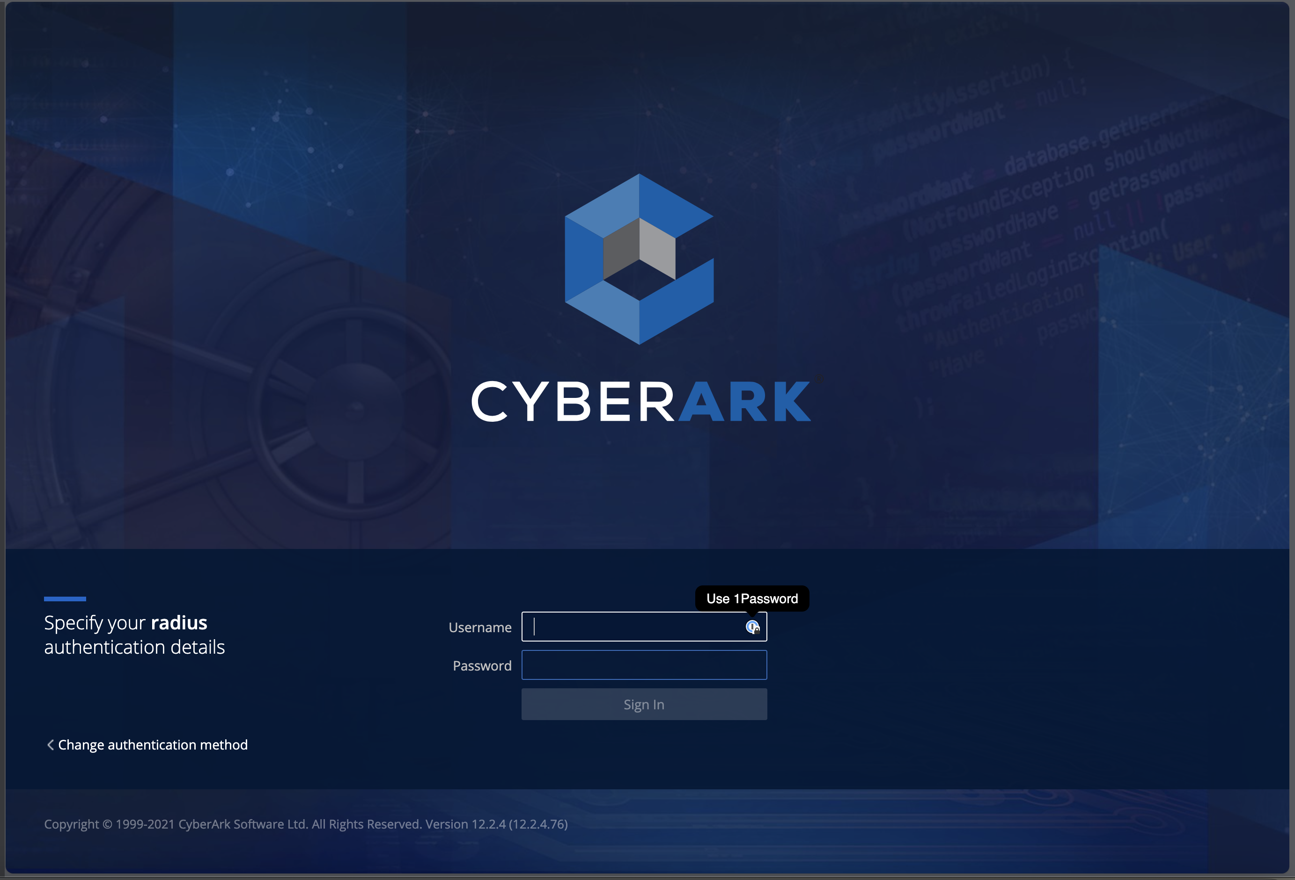

1. Click on `**Show**` here to reveal your daily changing CLD password after entering a valid reason to access.

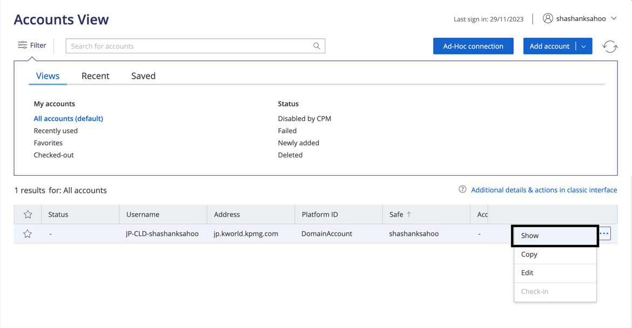

1. Enter the access reason, when prompted.

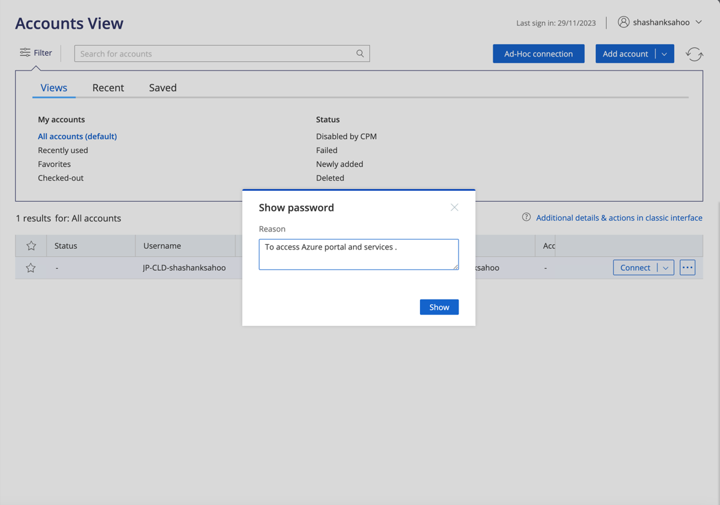

1. A 30-second timer with password will be revealed upon clicking to Show and it will disappear once the timer expires. It is important to keep note of it and use it in later phases for accessing Azure services with CLD credentials.

**Phase 2: Azure Portal Access**

Once the CyberArk password has been retrieved, one can follow the steps below to log-in to Azure.

1. Head over to a secondary browser of choice which does not have any linkage or default routing to Cloud Next.
2. Access the Azure portal : portal.azure.com/ by entering the following credentials.

MSFT Account Email – <CLD_email_account>@jp.kworld.kpmg.com

MSFT Account Username – CLD Email Account username

MSFT Password – Password obtained from CyberArk

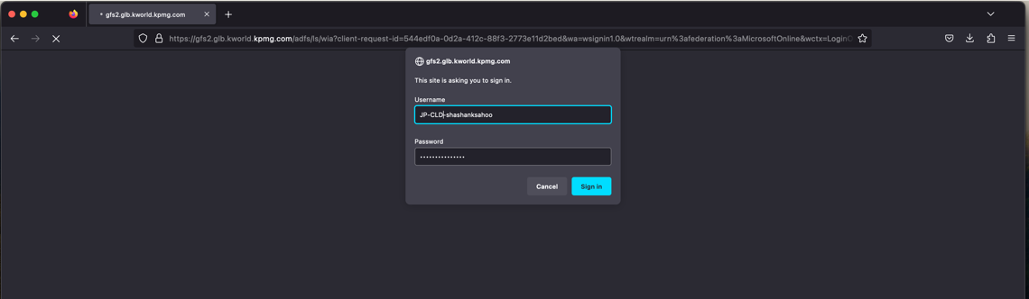

1. Upon authentication, MFA will be triggered on KIT iPhone via Authenticator App or via SMS as used during initial set-up. Now the MFA code is required to be used to obtain.

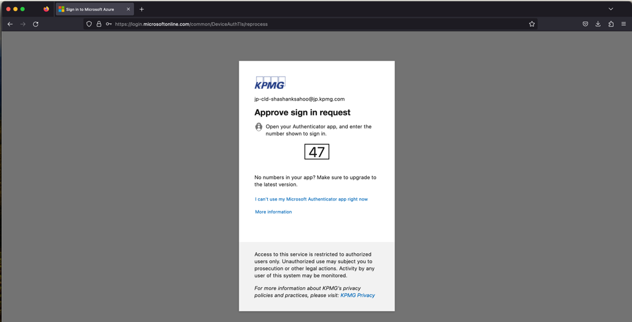

1. After successful verification of entered access credentials, CLD users will now get access to the following homepage of Azure Portal.

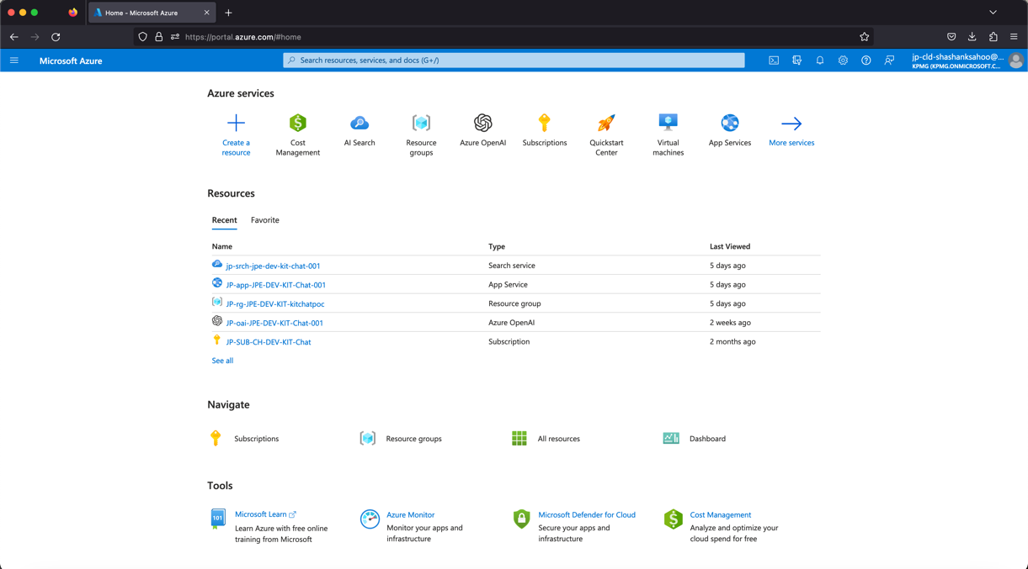

1. Depending on role configured as `**Admin**` or `**Contributor**` , one can browse the resource groups and operate various Azure resources and services.

**Phase 3: Kit-Chat App Authentication for Backend**

To access and log-in with CLD credentials when using the KitChat Application, a user needs to follow the steps below.

1. Install `**azd**`, or Azure Developer Command Line first on your VS Code terminal or bash terminal of choice. You can follw the installation steps from here.

[Install the Azure Developer CLI | Microsoft Learn](https://learn.microsoft.com/en-us/azure/developer/azure-developer-cli/install-azd?tabs=winget-windows%2Cbrew-mac%2Cscript-linux&pivots=os-mac)

1. Create a Python virtual environment of choice and activate it for backend.
2. Change to **app/backend** directory
3. In your backend terminal , first run **azd auth login --use-device-code**
4. Then open the url in new or incognito browser and enter code to login with azure credentials successfully.
5. Ensure to enter the AuthCode from terminal to process further with CLD credentials.

**Phase 4: Launching Frontend of Kit Chat Locally**

To run frontend locally. Below steps works :

1. Create a new python virtual env for frontend
2. Change to app/frontend directory
3. Run npm ci
4. Then, run npm run dev
5. Visit. <http://127.0.0.1:5173/>