MICROSOFT AZURE COGNITIVE SERVICES: TEXT TRANSLATOR API | 1

Microsoft Azure Cognitive Services- Text Summarization API

Release: Summarization API

Version: 1.0.0

©Shashank Bidwai (#801312898)

University of North Carolina at Charlotte
Text Summarization API | 2

Abstract

Summarizing text and conversation API is using Microsoft Azure Cognitive Services – Summarization API which is an AI service for summarizing text data. Summarization is one of the features offered by Azure AI Language, a collection of machine learning and AI algorithms in the cloud for developing intelligent applications that involve written language.
Custom Summarization enables users to build custom AI models to summarize unstructured text, such as contracts or novels. By creating a Custom Summarization project, developers can iteratively label data, train, evaluate, and improve model performance before making it available for consumption. The quality of the labeled data greatly impacts model performance.

The given APIs are designed for abstractive summarization.
Abstractive summarization: Generates a summary that may not use the same words as those in the document, but captures the main idea.
Summary texts: Abstractive summarization returns a summary for each contextual input range within the document. A long document may be segmented so multiple groups of summary texts may be returned with their contextual input range.
Contextual input range: The range within the input document that was used to generate the summary.

API Details:

1. URL : “http://164.90.154.233:3000/azure-ai/summarize_text”

Request Payload:

The Api is a HTTP Post request that accepts the following request payload.

[
{
"text": String
},
{
"text": String
}
]

For example:
[
{
"text": "At Microsoft, we have been on a quest to advance AI beyond existing techniques..."
},
{
"text": "Create a project plan for your own personal brand..."
}
]

Request Headers:

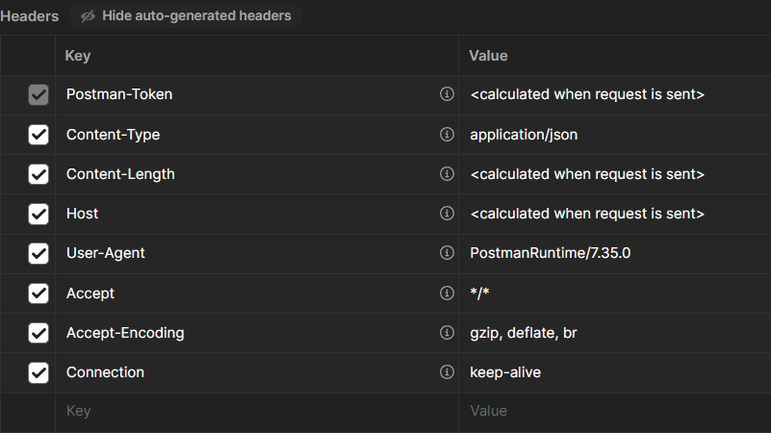

Response Payload Structure:

[
{
"summarizedText": String
},
{
"summarizedText": String
}
]

Postman example:
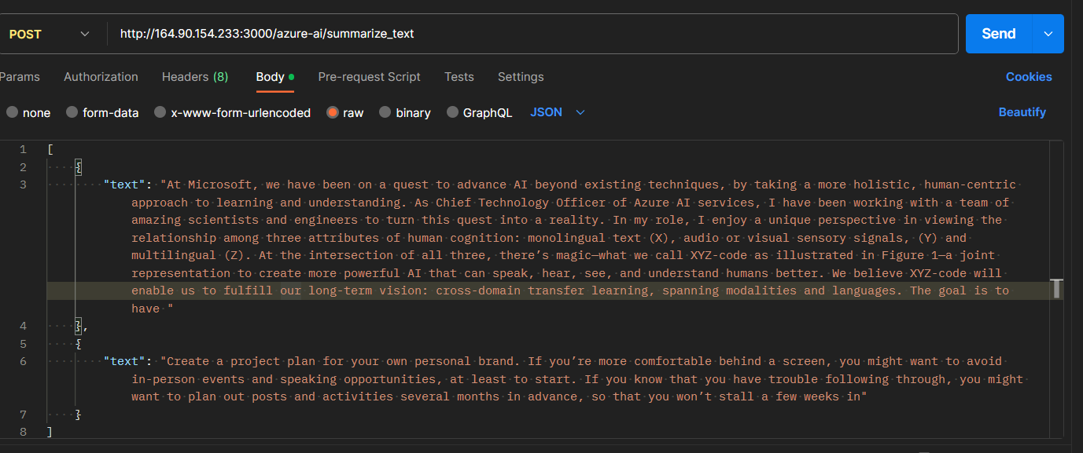

RESPONSE.
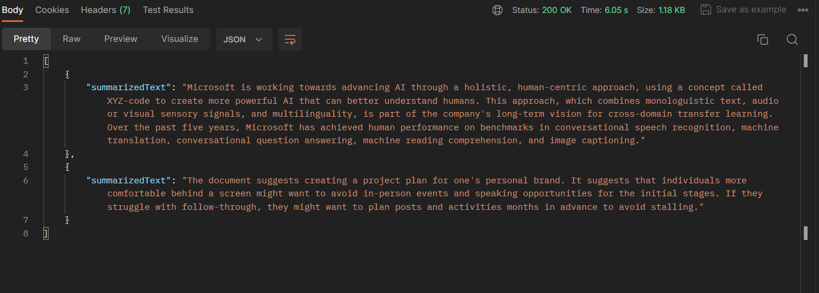

For better understanding below are the swagger Screenshots to get the idea of the usage of the apis.

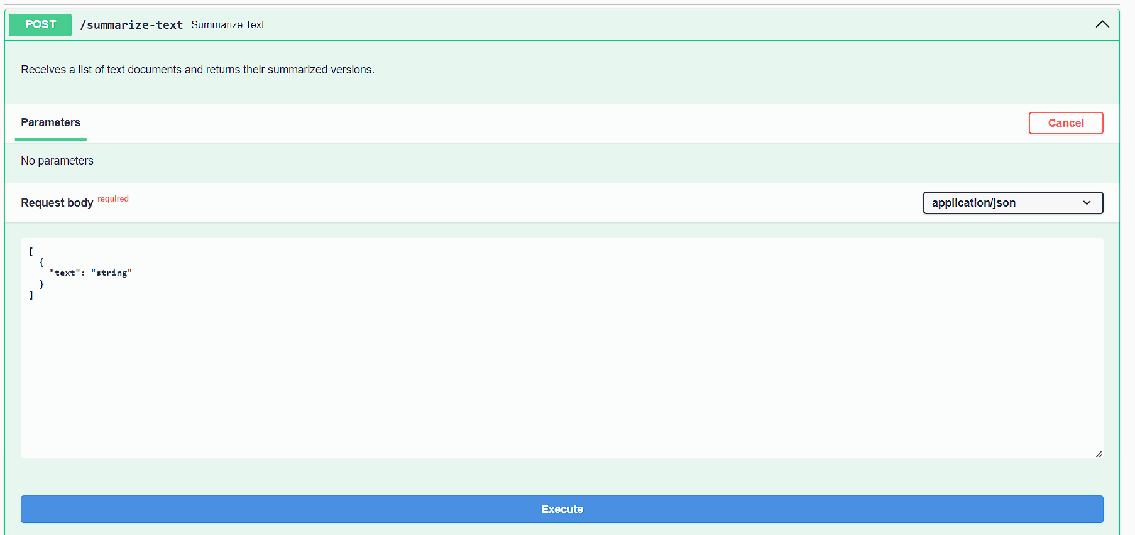

Response
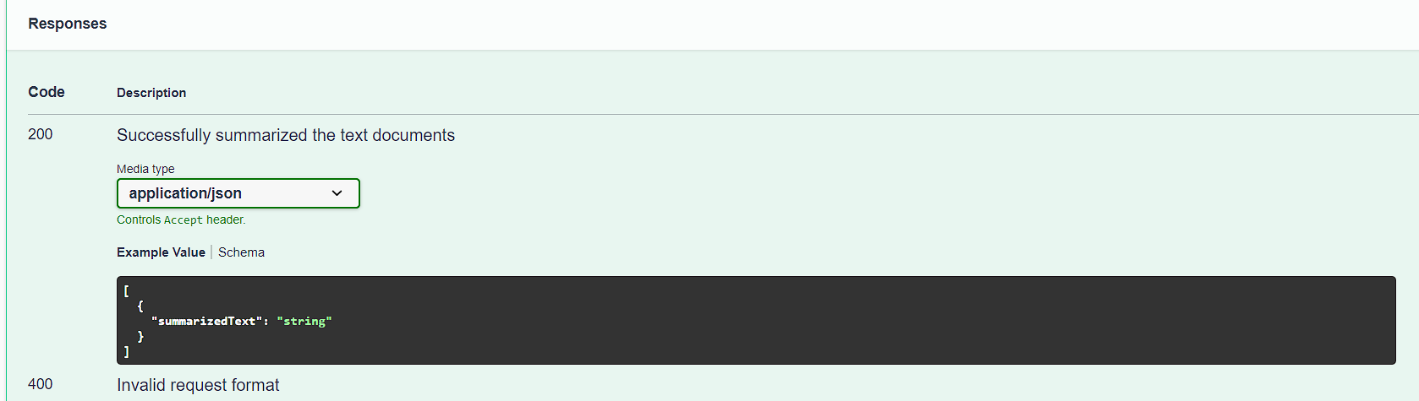

2. URL : http://164.90.154.233:3000/azure-ai/summarize_conversations

Request Payload:

For example:

{
"displayName": "Conversation Task Example",
"analysisInput": {
"conversations": [
{
"conversationItems": [
{
"text": "Hello, you’re chatting with Rene. How may I help you?",
"id": "1",
"role": "Agent",
"participantId": "Agent_1"
},
{
"text": "Hi, I tried to set up wifi connection for Smart Brew 300 espresso machine, but it didn’t work.",
"id": "2",
"role": "Customer",
"participantId": "Customer_1"
},
{
"text": "I’m sorry to hear that. Let’s see what we can do to fix this issue. Could you please try the following steps for me? First, could you push the wifi connection button, hold for 3 seconds, then let me know if the power light is slowly blinking on and off every second?",
"id": "3",
"role": "Agent",
"participantId": "Agent_1"
},
{
"text": "Yes, I pushed the wifi connection button, and now the power light is slowly blinking.",
"id": "4",
"role": "Customer",
"participantId": "Customer_1"
},
{
"text": "Great. Thank you! Now, please check in your Contoso Coffee app. Does it prompt to ask you to connect with the machine? ",
"id": "5",
"role": "Agent",
"participantId": "Agent_1"
},
{
"text": "No. Nothing happened.",
"id": "6",
"role": "Customer",
"participantId": "Customer_1"
},
{
"text": "I’m very sorry to hear that. Let me see if there’s another way to fix the issue. Please hold on for a minute.",
"id": "7",
"role": "Agent",
"participantId": "Agent_1"
}
],
"modality": "text",
"id": "conversation1",
"language": "en"
}
]
},
"tasks": [
{
"taskName": "Conversation Task 1",
"kind": "ConversationalSummarizationTask",
"parameters": {
"summaryAspects": [
"issue"
]
}
},
{
"taskName": "Conversation Task 2",
"kind": "ConversationalSummarizationTask",
"parameters": {
"summaryAspects": [
"resolution"
],
"sentenceCount": 1
}
}
]
}

Here the user only needs to change the conversations array, rest of the Json should be as it is.

Request Headers:

Response Payload:

For example:
{
"jobId": "f7987abb-bb34-4b65-b0b0-75280d094afd",
"lastUpdatedDateTime": "2023-12-11T22:19:16Z",
"createdDateTime": "2023-12-11T22:19:14Z",
"expirationDateTime": "2023-12-12T22:19:14Z",
"status": "succeeded",
"errors": [],
"displayName": "Conversation Task Example",
"tasks": {
"completed": 2,
"failed": 0,
"inProgress": 0,
"total": 2,
"items": [
{
"kind": "conversationalSummarizationResults",
"taskName": "Conversation Task 1",
"lastUpdateDateTime": "2023-12-11T22:19:16.407148Z",
"status": "succeeded",
"results": {
"conversations": [
{
"summaries": [
{
"aspect": "issue",
"text": "Customer is unable to set up wifi connection for Smart Brew 300 espresso machine."
}
],
"id": "conversation1",
"warnings": []
}
],
"errors": [],
"modelVersion": "latest"
}
},
{
"kind": "conversationalSummarizationResults",
"taskName": "Conversation Task 2",
"lastUpdateDateTime": "2023-12-11T22:19:16.5429826Z",
"status": "succeeded",
"results": {
"conversations": [
{
"summaries": [
{
"aspect": "resolution",
"text": "The agent instructed the customer to push the wifi connection button, hold for 3 seconds, and check if the power light blinks on and off every second."
}
],
"id": "conversation1",
"warnings": []
}
],
"errors": [],
"modelVersion": "latest"
}
}
]
}
}

Postman Example:

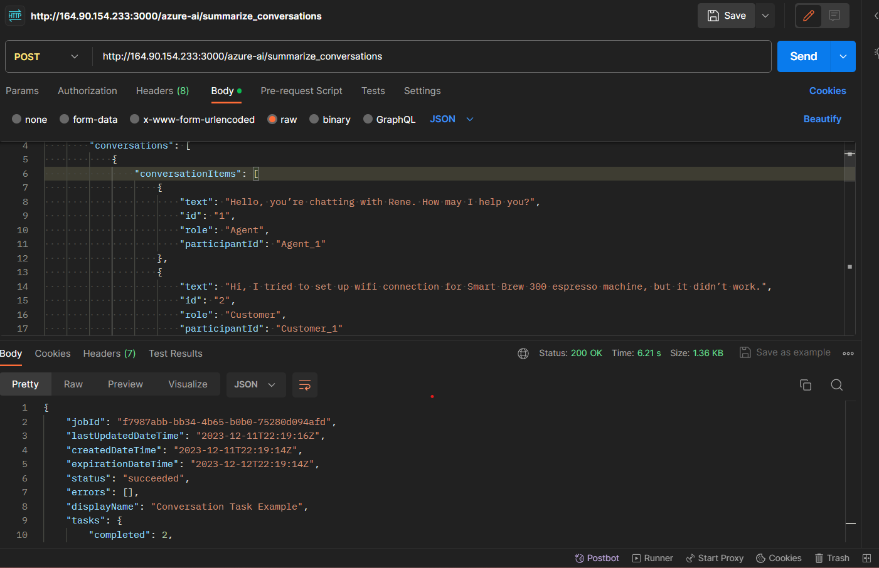

For clear understanding below are the swagger screenshots.

