Table of Contents

SSL certificate generation

Tools Installation

Keycloak

Jenkins

Gitlab

Jira

MySQL

ADOPT Installation

ADOPT-portal installation

ADOPT-services installation

Manual steps

**SSL Certificate generation**

Steps to Generate SSL certificates to run applications using HTTPS domain are as below:

**Command to generate certificate for domain name of system (certbot command install required)**

sudo certbot certonly --standalone --preferred-challenges http -d exampleDomainNameHere.com

**Directory in which certificate generates**

cd /etc/letsencrypt/live/exampleDomainNameHere.com

Copy generated certificates to tools_installation folder

sudo sh certcopy.sh

**Command to convert certificate to jks(for Jenkins,jira)**

openssl pkcs12 -export -in cert.pem -inkey privkey.pem -out certificate.p12 -name "certificate"

keytool -importkeystore -srckeystore certificate.p12 -srcstoretype pkcs12 -destkeystore sslcert.jks

**Command to import certificate into java cacerts**

keytool -importcert -noprompt -storepass changeit -file /usr/local/tomcat/conf/cert.pem -keystore ./cacerts -alias "jenkins"

**Command to check entries in keystore**

keytool -list -keystore ./cacerts

**TOOLS INSTALLATION**

To install tools user need to run (sh tools_install.sh) script.

Below is details of individual tools installation procedure

**Keycloak:**

**->run keycloak_install.sh to install keycloak**

**->Detailed process of how installation is automated is described below**

* Customising keycloak using official docker image using dockerfile and copying necessary ssl certificate files into container which are generated by certbot command above.
* Importing realm export to automatically create required clients for devops tools.

Contents of keycloak folder as below

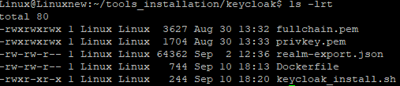

**Keycloak Dockerfile:**

**Keycloak install script**

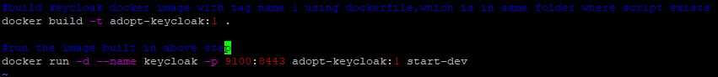

**Gitlab:**

**->run gitlab_install.sh to install gitlab with sso & ssl configured**

**->Detailed process of how installation is automated is described below:**

Gitlab official docker image is run with hostname of our system as parameter and gitlab configuration file which is updated with certificate, is copied into container and configuration changes applied for automating ssl and sso configuration.

Contents of gitlab folder as below :



**Gitlab install script:**

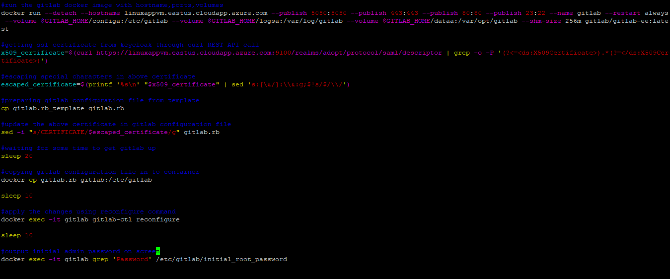

**Jenkins:**

**->run Jenkins_install.sh to install Jenkins with sso & ssl configured.**

**-> Detailed process of how installation is automated is described below:**

Jenkins official image is customized by installing required plugins, softwares like maven, docker,sonar-scanner and configuring ssl certificates path.

Contents of Jenkins folder as below:

**Jenkins Dockerfile:**

**Jenkins install script:**



**JIRA :**

**-> run jira_install.sh to install Jenkins with only ssl configured.remaining configuration like admin user and sso integration requires manual steps**

**-> Detailed process of how installation is automated is described below:**

Jira official image is run and server configuration file,server.xml and ssl JKS type file copied into the container for ssl configuration.

Contents of Jira folder as below:

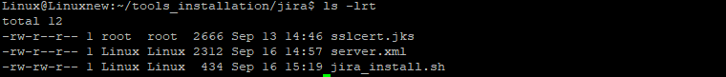

**Jira install script:**

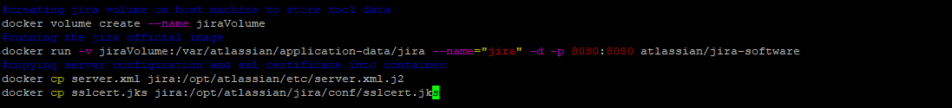

**MySQL :**

**->Run mysql_install.sh to install mysql db.**

**-> Detailed process of how installation is automated is described below:**

Official mysql:8.0 image is run and user with name adopt and database schema with name adoptdb is created.

Contents of MySQL folder as below:

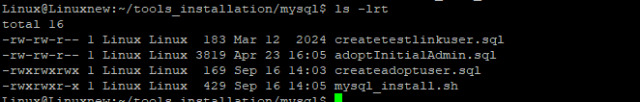

**MySQL install script:**

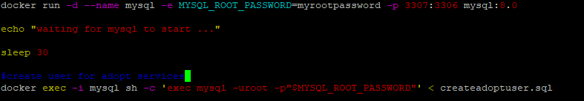

**ADOPT INSTALLATION**

For adopt installation we have updateProp.sh script which when executed, asks details of all tools like url, credentials etc and prepare the tools related properties files for backend with values given as input.

The above script can be configured to capture details of any tool required by mentioning the tool name and related properties in a file with name tools_props.txt in below formatA black screen with a black background

When above script is executed, it will ask for properties as below

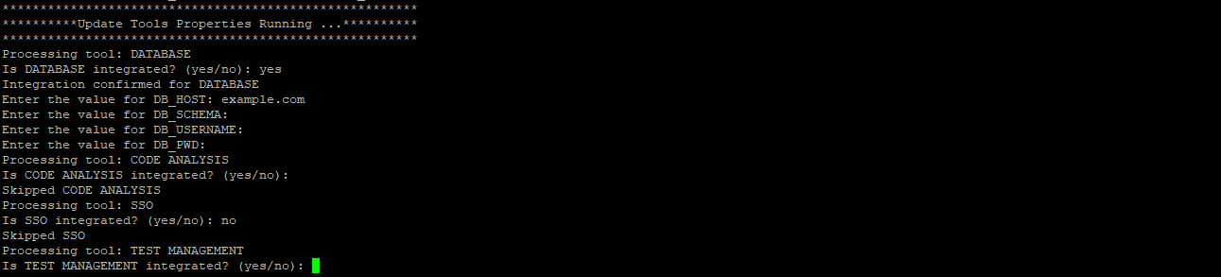

After executing above script in respective adopt frontend and backend folders, all properties file will be ready for installing the ADOPT.

**ADOPT-portal Installation**:

**->execute updateProp.sh to prepare tools properties files and then execute adopt-portal-install.sh for installing ADOPT portal.**

**-> Detailed process of how installation is automated is described below:**

Source code of application is built inside a container and official tomcat image is customized by copying certificate files and server.xml file into the image.

Contents of ADOPT-portal Installation folder:

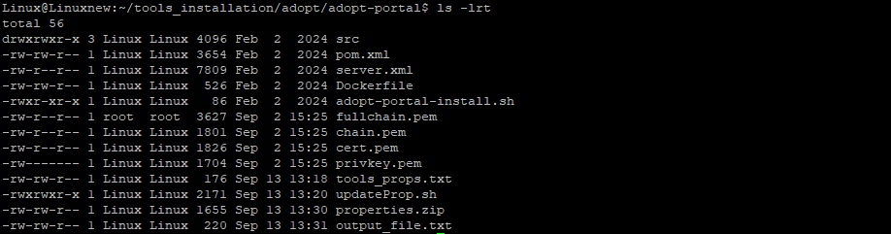

**ADOPT-portal Dockerfile:**

**ADOPT-portal Install script:**



**ADOPT-services Installation**:

**->execute updateProp.sh to prepare tools properties files and then execute adopt-services-install.sh for installing ADOPT services.**

**-> Detailed process of how installation is automated is described below:**

Source code of application is built inside a container and official tomcat image is customized by copying certificate files and server.xml file into the image.

Contents of ADOPT-services Installation folder:

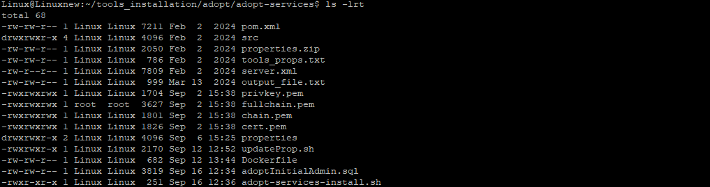

**ADOPT-services Dockerfile:**

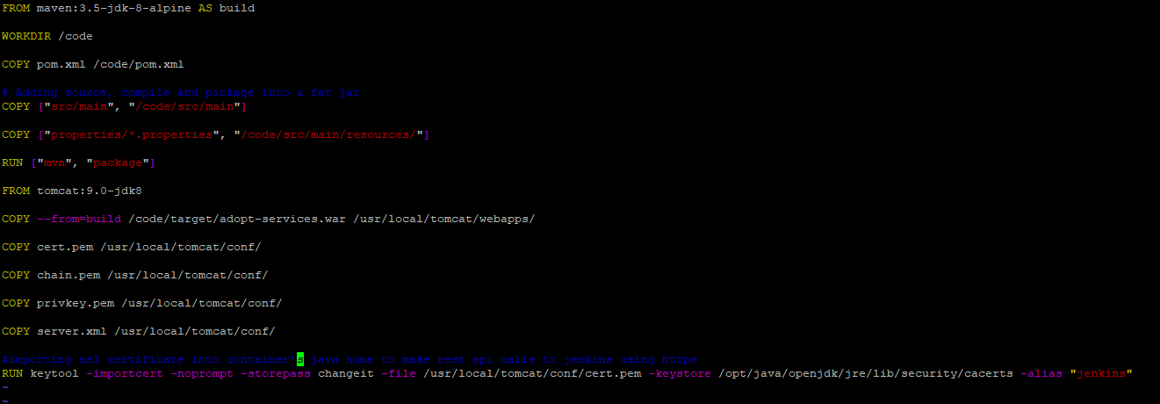

**ADOPT-services Install script:**

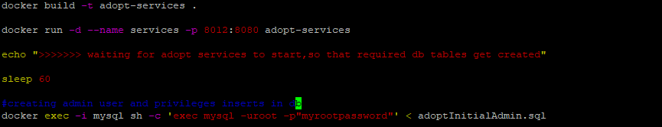

**Manual steps :**

Below configurations we need to do manually after all tools installed.

* Need to create role with name adopt-admin in keycloak
* Need to create admin user in keycloak and assign him adopt-admin role.
* Need to create access token in gitlab,Jenkins,sonarqube.
* Save gitlab credentials in Jenkins to access repo.
* Update adopt backend url in manage Jenkins to send feedback of reports.
* SSO configuration for jira and sonarqube need to be done manually.
* If any DevOps tool installed on another domain name then certificate of that domain need to be imported into java keystore of services inside container.