SCHEMA DESIGN for following condition

1. User should be able to follow other user.
2. User should be able to unfollow other user.
3. User should be able to see total followers and following count.
4. User should be able to see followers list.
5. User should be able to see following list.
6. User should be able to remove follower or following. [single follower at once]
7. User should be able to see profile of another user.
8. User profile should consist basic details
a. name
b. image
c. age
d. username
e. EmailId

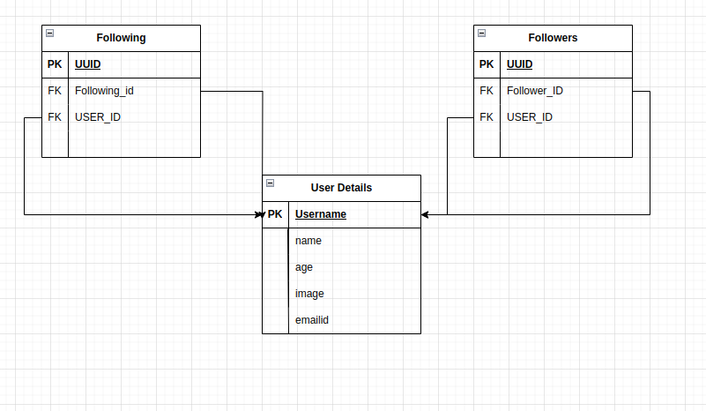

Queries are

1. User should be able to follow other user.

INSERT INTO followers VALUES(' ',' ');

2. User should be able to unfollow other user.

DELETE FROM followers WHERE USER_ID=' ' & follower_ID=' ';

3. User should be able to see total followers and following count.

SELECT COUNT(UUID) FROM follower where user_id=' '

SELECT COUNT(UUID) FROM following where user_id=' '

4. User should be able to see followers list.

Select user_details.name
from user_details
JOIN Followers ON username=user_id
where user_id=' '

5. User should be able to see following list.

Select user_details.name
from user_details
JOIN following ON username=user_id
where user_id=' '

6. User should be able to remove follower or following. [single follower at once]

DELETE FROM followers WHERE USER_ID=' ' & follower_ID=' ';

7. User should be able to see profile of another user.

SELECT * from user_details where Username=' ' & username <>' '

Assignment questions

Q. Find all the comments for phoyod woth id=3 ,along with the username of the comment author?

SELECT comments.contents,users.username
FROM COMMENTS JOIN photos
ON comments.photo_id=photos.id
JOIN users
on comments.user_id=users.id
WHERE photos.id=3

Q find the photo with the most comments attached to it?

SELECT COUNT(comments.id) AS counter,comments.photo_id
FROM comments
GROUP BY comments.photo_id
ORDER BY counter desc
LIMIT 1;

Q find the photo id=10 & get the number of comment attached to it?

SELECT COUNT(comments.id) AS counter , comments.photo
FROM comments
GROUP BY comments.photo_id
HAVING photo_id=10

Q. Find the user with the most activity(most comment + most photos)

SELECT users.id, users.username,
COUNT(comments.id) AS num_comments,
COUNT(photos.id) AS num_photos
FROM users
JOIN comments ON users.id = comments.user_id
JOIN photos ON users.id = photos.user_id
GROUP BY users.id, users.username
ORDER BY (COUNT(comments.id)+COUNT(photos.id)) DESC
LIMIT 1

Q Find the average number of comment per photo

Q Calculate average number of characters per comments?

