L&T EduTech | VLSI Principles, RTL Design and Verification | Project 1
ADAS Multi-Channel DMA Controller Subsystem
How to Run the Project and Analyse the Results
A step-by-step guide for running the project on your own laptop: setup, simulation, logs, coverage, waveforms, synthesis and debugging

You will need | Details
Operating system | Windows 10 or 11 (64-bit)
Software | AMD Vivado 2025.2 (the free Vivado ML Standard edition is enough - it contains the xsim simulator, UVM 1.2, the xcrg coverage tool and synthesis)
Project | The folder ADAS_DMA_Subsystem (from LNT_ADAS_DMA_Subsystem_Submission.zip)
Time | About 5 minutes for the full regression on a typical laptop; about 1 minute for synthesis

Contents

Overview: what you will do
Step 1. Copy the project to your laptop
Step 2. Tell the scripts where Vivado is installed
2.1 Find your Vivado bin folder
2.2 Edit sim\env.bat
2.3 Check that it works
Step 3. Run the full regression
3.1 What happens
3.2 What you should see
3.3 Files created by the run
Step 4. Read the console and the log files
4.1 How to read each line
4.2 What a test is allowed to print
4.3 Extra lines printed by specific tests
Step 5. Open the coverage reports
5.1 Functional coverage
5.2 Code coverage
Step 6. Run single tests with your own seeds
Step 7. Look at the waveforms in the Vivado GUI
7.1 What to look for
Step 8. Run synthesis and read the reports
Step 9. Compare with the golden results
Step 10. Analysing a failure (if a test ever fails)
10.1 Debug procedure
Step 11. Troubleshooting
Quick reference card
(In Word: right-click the list and choose Update Field to add page numbers.)

Overview: what you will do
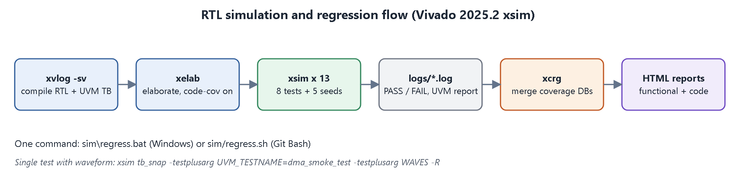
Figure 1. The simulation flow that the scripts run for you.
Table 1. The nine steps
Step | What you do | What you get
1 | Copy the project to your laptop | The project folder in a short path
2 | Tell the scripts where Vivado is | A one-line edit in sim\env.bat
3 | Run the full regression with one command | 13 test runs, PASS/FAIL lines, logs, coverage database
4 | Read the console and the log files | Proof that every test passed and what each test checked
5 | Open the coverage reports | 100 % functional coverage, 100 % statement coverage
6 | Run single tests with your own seeds | Extra confidence, specific scenarios
7 | Look at the waveforms in the Vivado GUI | Cycle-by-cycle view of bursts, arbitration, interrupts
8 | Run synthesis and read the reports | LUTs, flip-flops, timing at 100 MHz
9 | Compare with the golden results | Confirmation that your run matches the expected numbers

Important
All commands in this guide are typed in the Windows Command Prompt (cmd). If you use PowerShell, put cmd /c in front of a .bat command, for example cmd /c sim\regress.bat.

Step 1. Copy the project to your laptop
1. Copy LNT_ADAS_DMA_Subsystem_Submission.zip to your laptop and extract it (right-click > Extract All).
2. Move the extracted ADAS_DMA_Subsystem folder to a short path without spaces, for example C:\Projects\ADAS_DMA_Subsystem or your Desktop. Very long paths can make Vivado tools fail on Windows.
3. Check that the folder contains: docs, rtl, tb, sim, synth, scripts and README.md.
Table 2. Project folders
Folder | What is inside
rtl\ | The design: 6 SystemVerilog files
tb\ | The UVM testbench, interfaces and assertions
sim\ | The scripts you run (build, run_test, regress, coverage_report, run_gui) and, after a run, the logs and reports
synth\ | The synthesis script and its reports
docs\ | Specifications, reports and figures

Step 2. Tell the scripts where Vivado is installed
The scripts need the path of Vivado's bin folder. It is set in one place: sim\env.bat.

2.1 Find your Vivado bin folder
1. Right-click your Vivado 2025.2 desktop shortcut and choose Open file location.
2. You land in a folder such as C:\AMDDesignTools\2025.2\Vivado\bin\unwrapped\win64.o or D:\Vivado\2025.2\Vivado\bin\....
3. The folder you need is the ...\Vivado\bin folder that contains xvlog.bat, xelab.bat, xsim.bat and xcrg.bat.

2.2 Edit sim\env.bat
Open sim\env.bat in Notepad and change the path on the third line to your own bin folder:
sim\env.bat
@echo off
rem Path to the Vivado "bin" folder (edit if your install is elsewhere)
if not defined VIVADO_BIN set VIVADO_BIN=D:\Vivado\2025.2\Vivado\bin <-- change this path
set PATH=%VIVADO_BIN%;%PATH%

If you use Git Bash and the .sh scripts instead, change the export PATH=... line at the top of each sim\*.sh file in the same way (Git Bash writes D:\Vivado as /d/Vivado).

2.3 Check that it works
Command Prompt
cd C:\Projects\ADAS_DMA_Subsystem
call sim\env.bat
xvlog --version

You should see a line such as Vivado Simulator v2025.2. If you see 'xvlog' is not recognized, the path in env.bat is wrong - go back to 2.1.

Step 3. Run the full regression
The regression compiles everything, runs all 13 test runs, merges the coverage and writes the HTML reports. One command:
Command Prompt
cd C:\Projects\ADAS_DMA_Subsystem
sim\regress.bat

3.1 What happens
Table 3. Regression stages
Stage | Script | What it does
Compile | build.bat (xvlog) | Compiles the 6 RTL files, the interfaces, the assertions, the UVM package and tb_top
Elaborate | build.bat (xelab) | Builds the simulation snapshot tb_snap with code coverage switched on
Simulate | run_test.bat (xsim) x 13 | 8 directed tests with seed 1, then dma_random_test with seeds 11-15 (40 iterations each)
Coverage | coverage_report.bat (xcrg) | Merges the coverage of all runs and writes HTML reports

3.2 What you should see
While it runs, compile messages scroll by, then one line per test:
Expected console output (shortened)
Built simulation snapshot tb_snap
... [RESULT] *** TEST PASSED: dma_regs_test ***
... [RESULT] *** TEST PASSED: dma_smoke_test ***
... [RESULT] *** TEST PASSED: dma_sensor_fusion_test ***
... [RESULT] *** TEST PASSED: dma_burst_sweep_test ***
... [RESULT] *** TEST PASSED: dma_priority_test ***
... [RESULT] *** TEST PASSED: dma_error_test ***
... [RESULT] *** TEST PASSED: dma_cfg_err_test ***
... [RESULT] *** TEST PASSED: dma_backpressure_test ***
... [RESULT] *** TEST PASSED: dma_random_test *** (x 5, one per seed)
Reports: sim\report\functional\functionalCoverageReport\dashboard.html and
sim\report\code\codeCoverageReport\dashboard.html

Success criterion
13 lines with TEST PASSED and no line with TEST FAILED. If a line is missing or says FAILED, see Step 10 (Analysing a failure) and Step 11 (Troubleshooting).

3.3 Files created by the run
Table 4. Outputs
Location | Content
sim\work\ | Compiled snapshot and the code-coverage database (re-created by every build)
sim\logs\<test>_s<seed>.log | Full log of every run - the main evidence
sim\cov\ | Functional coverage database of every run
sim\report\functional\ | Merged functional coverage report (HTML)
sim\report\code\ | Code coverage report (HTML)

Step 4. Read the console and the log files
Every run writes a log in sim\logs\, for example sim\logs\dma_smoke_test_s1.log (s1 = seed 1). Open it in Notepad. Most of the top is the standard UVM banner; the useful part is at the end:
End of sim\logs\dma_smoke_test_s1.log
UVM_INFO @ 0: reporter [RNTST] Running test dma_smoke_test...
UVM_INFO .../dma_tb_env.svh(410) @ 5595000: uvm_test_top.env.cov [COV] cfg=40.0% axi=48.1% arb=28.6% irq=41.7% err=18.8% sensor=29.2% apb=66.7%
UVM_INFO .../dma_tb_env.svh(234) @ 5595000: uvm_test_top.env.scb [SCB] checks=110 rd_bursts=4 wr_bursts=8 wr_beats=96 apb=18 arbitrations=8 (wins 4/4/0/0)
UVM_INFO .../dma_tb_tests.svh(39) @ 5595000: uvm_test_top [RESULT] *** TEST PASSED: dma_smoke_test ***
--- UVM Report Summary ---
** Report counts by severity
UVM_INFO : 8
UVM_WARNING : 0
UVM_ERROR : 0
UVM_FATAL : 0

4.1 How to read each line
Table 5. Reading a log
Line | Meaning
Running test dma_smoke_test | Which test (scenario) ran
@ 5595000 | Simulation time in picoseconds: 5 595 000 ps = 5.6 us = 559 clock cycles at 100 MHz
[COV] cfg=40.0% ... | Functional coverage reached by THIS test alone (one test never covers everything - the merged number in Step 5 is what counts)
[SCB] checks=110 | The scoreboard made 110 independent checks (addresses, burst lengths, data words, interrupts) - all passed
rd_bursts / wr_bursts / wr_beats | AXI read bursts, write bursts and write data beats seen on the bus
arbitrations=8 (wins 4/4/0/0) | 8 arbitration decisions; how many each channel 0/1/2/3 won
*** TEST PASSED *** | Printed only when UVM_ERROR = 0 and UVM_FATAL = 0
UVM_ERROR : 0, UVM_FATAL : 0 | No check failed. Any assertion failure, scoreboard mismatch or test check would be counted here

4.2 What a test is allowed to print
Table 6. Expected messages
Message | Harmless? | Why
UVM release notes (UVM_NO_DEPRECATED undefined) | Yes | Standard UVM library banner
[NO_DPI_TSTNAME] | Yes | Information from xsim's UVM package; the test name is passed by plusarg instead
XSIM 43-4127 'Cover is not supported yet' (during build) | Yes | xsim ignores cover property; covergroups are used instead
UVM_ERROR or UVM_FATAL with a count above 0 | No | A real failure - see Step 10

4.3 Extra lines printed by specific tests
Table 7. Scenario-specific results
Test | Line to look for | What it proves
dma_sensor_fusion_test | [FUSION] CH1 radar 256 words done after 1120 cycles (and one line per channel) | Radar (highest priority) finishes first; all four streams complete
dma_priority_test | [PRIO] equal-priority grant sequence: '{1,2,3,0,1,2,3,0,...} | Round-robin between equal priorities
dma_backpressure_test | [BACKPRESSURE] cycles with a full sensor FIFO: 12561 (no data lost) | Sensors were held off by a full FIFO and no word was lost
dma_random_test | [RANDOM] 40 random iterations completed, [SCB] checks=20089 ... | About 20 000 automatic checks per run

Quick way to list all results at once:
Command Prompt
findstr /C:"TEST PASSED" /C:"TEST FAILED" sim\logs\*.log
findstr /C:"UVM_ERROR :" sim\logs\*.log
findstr /C:"[FUSION]" /C:"[PRIO]" /C:"[BACKPRESSURE]" sim\logs\*.log

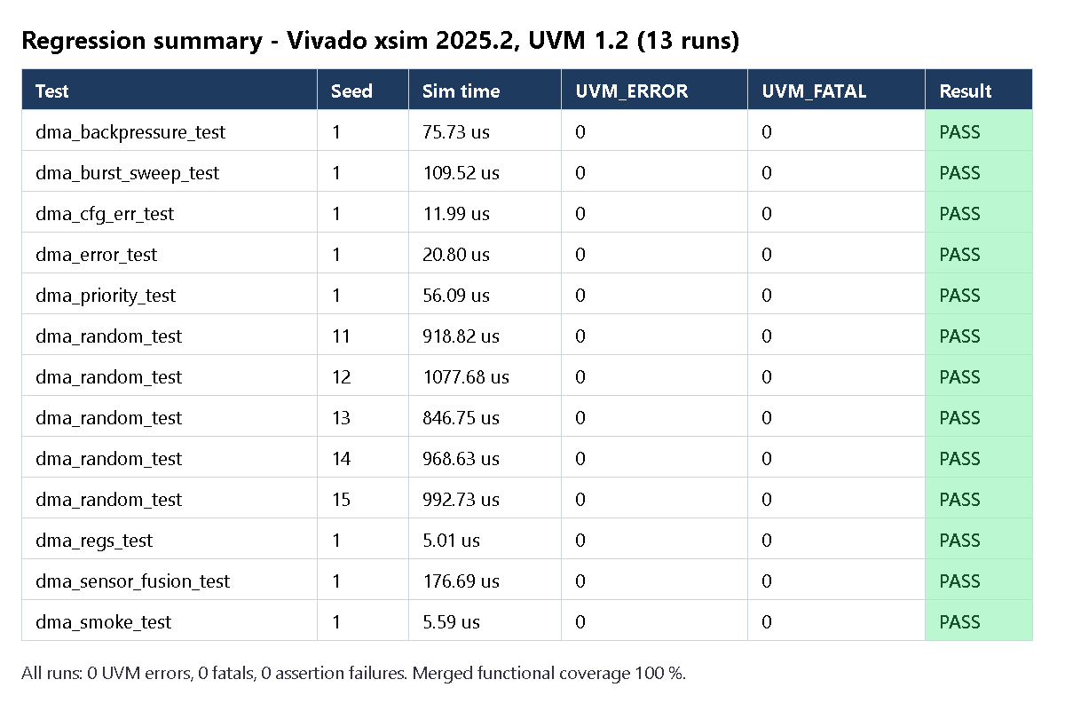
Figure 2. Expected regression result: 13 of 13 runs pass with 0 UVM_ERROR and 0 UVM_FATAL.

Step 5. Open the coverage reports

5.1 Functional coverage
Double-click sim\report\functional\functionalCoverageReport\dashboard.html (it opens in your browser), then click Groups.
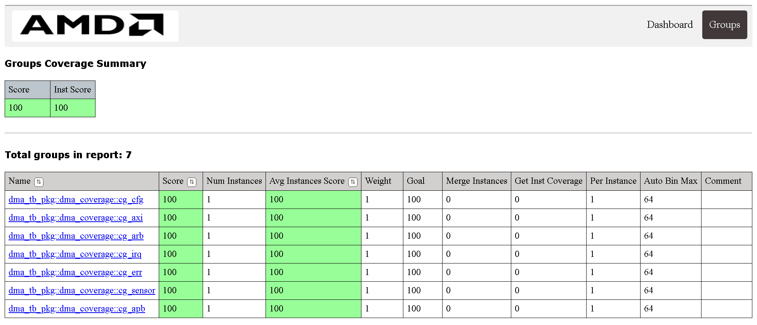
Figure 3. Functional coverage report: overall score 100 %, all 7 covergroups at 100 %.
Table 8. Reading the functional report
Column | Meaning
Score | Merged coverage of all 13 runs - should be 100
Name | The covergroup, e.g. dma_coverage::cg_arb (arbitration)
Click a covergroup name | Shows every coverpoint and cross with its bins and hit counts; a bin with 0 hits would be a test gap

5.2 Code coverage
Open sim\report\code\codeCoverageReport\dashboard.html and click Modules.
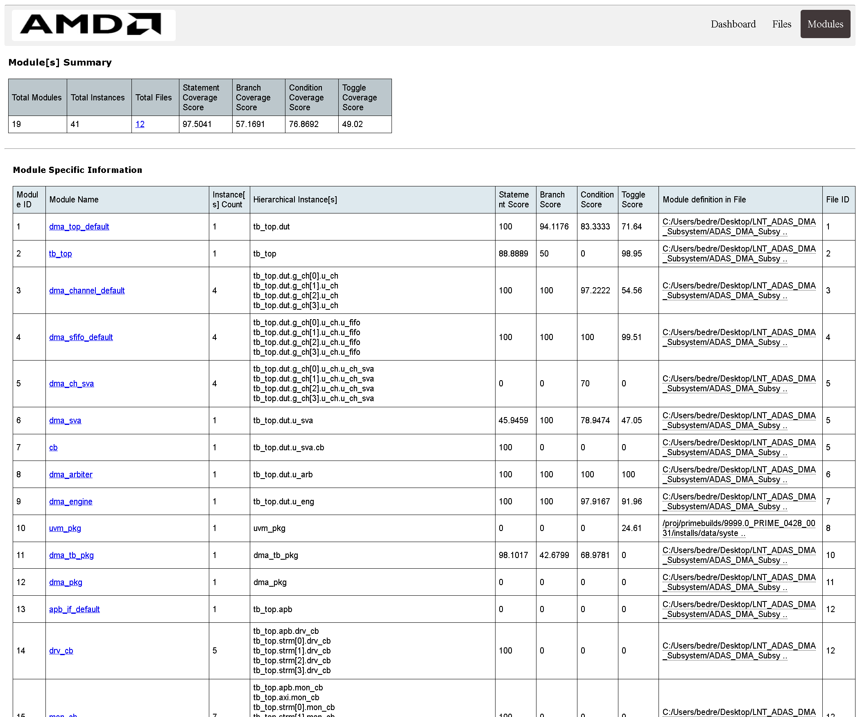
Figure 4. Code coverage per module.
Table 9. Expected values for the 5 RTL modules
Module | Statement | Branch | Condition | Toggle
dma_top | 100 | 94.1 | 83.3 | 71.6
dma_channel | 100 | 100 | 97.2 | 54.6
dma_sfifo | 100 | 100 | 100 | 99.5
dma_arbiter | 100 | 100 | 100 | 100
dma_engine | 100 | 100 | 97.9 | 92.0

- Only the 5 RTL modules matter (dma_top, dma_channel, dma_sfifo, dma_arbiter, dma_engine). The other rows (tb_top, interfaces, dma_sva, dma_tb_pkg, uvm_pkg) are testbench code, so the overall totals at the top of the page are lower - that is normal.
- Statement 100 % means every line of the design was executed at least once.
- Toggle is lower for dma_top and dma_channel because the upper bits of 32-bit addresses never change in the small simulated memory - not a design gap.
- Click a module name to see the source code with covered and uncovered lines highlighted.

Step 6. Run single tests with your own seeds
You do not have to run the whole regression every time. Build once, then run any test:
Command Prompt
sim\build.bat (only needed once, or after changing a .sv file)
sim\run_test.bat dma_priority_test
sim\run_test.bat dma_random_test 42 100 (seed 42, 100 random iterations)
sim\coverage_report.bat (update the HTML reports from the runs in sim\cov)

Table 10. run_test.bat arguments
Argument | Meaning | Default
1: test name | One of the 9 tests below | -
2: seed | Random seed; a different seed gives different random stimulus | 1
3: iterations | Only for dma_random_test: number of random transfer groups | 25

Table 11. Available tests
Test | What it checks
dma_regs_test | Register reset values, read/write, read-only, PSLVERR for unmapped addresses, write-1-to-clear
dma_smoke_test | One memory-to-memory and one sensor transfer
dma_sensor_fusion_test | Camera, radar, LiDAR and diagnostics at once; radar must finish first
dma_burst_sweep_test | All burst lengths 1-16 and 4 KB boundary splitting
dma_priority_test | Priority order and round-robin rotation
dma_error_test | SLVERR / DECERR on each channel, isolation and restart
dma_cfg_err_test | Zero length, unaligned addresses, START without EN, START while busy
dma_backpressure_test | Very slow memory: FIFOs fill, sensors wait, no data lost
dma_random_test | Constrained-random mix of everything

Good practice
Running dma_random_test with a few new seeds (for example 101, 202, 303) is a quick way to show an examiner that the design is robust: every new seed generates different traffic and must still pass.

Step 7. Look at the waveforms in the Vivado GUI
Logs tell you *whether* the design works; waveforms show *how*. The script sim\run_gui.bat opens the Vivado simulator window with the important signals already grouped:
Command Prompt
sim\build.bat (if not built yet)
sim\run_gui.bat dma_smoke_test
sim\run_gui.bat dma_priority_test

1. The Vivado simulator window opens and runs the test to the end (watch the Tcl Console at the bottom).
2. Click the waveform tab. Press the Zoom Fit button in the waveform toolbar to see the whole run.
3. Drag a box with the mouse over the area you want to zoom into; use the + and - zoom buttons to adjust.
4. Right-click a bus such as awaddr > Radix > Hexadecimal to read addresses easily.
5. state (engine FSM) is shown with its state names (IDLE, RD_AR, WR_W, ...).
6. Every signal of the DUT is recorded: to add another one, find it in the Scope / Objects panels and drag it into the waveform.
7. Close the window when finished. The waveform is also saved as sim\work\gui_<test>.wdb and can be reopened from the GUI (File > Open Waveform Database).

7.1 What to look for
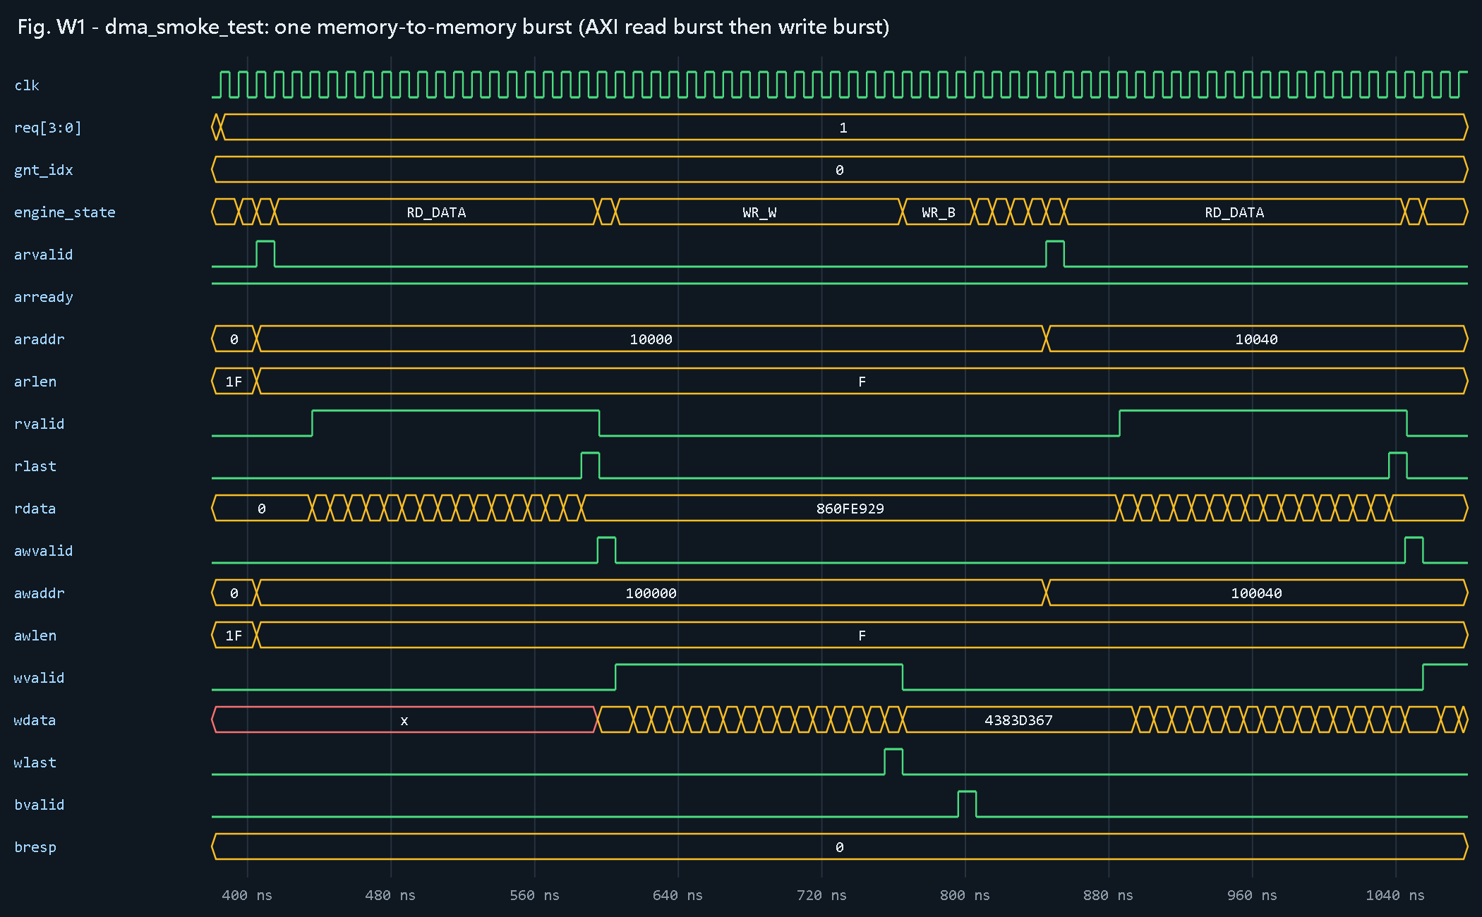
Figure 5. dma_smoke_test - one AXI burst (zoom into about 380-1080 ns).
Table 12. Reading an AXI burst
Check in the waveform | Correct behaviour
arvalid / arready | One-cycle handshake; araddr = source address, arlen = F (16 beats)
rvalid ... rlast | 16 read beats, rlast on the 16th
awvalid / awready, awaddr | Address handshake for the write; awaddr = destination address
wvalid ... wlast | 16 write beats, wlast exactly on the last beat
bvalid, bresp = 0 | Write response OKAY ends the burst
Next burst | Addresses advance by 0x40 (16 words x 4 bytes)

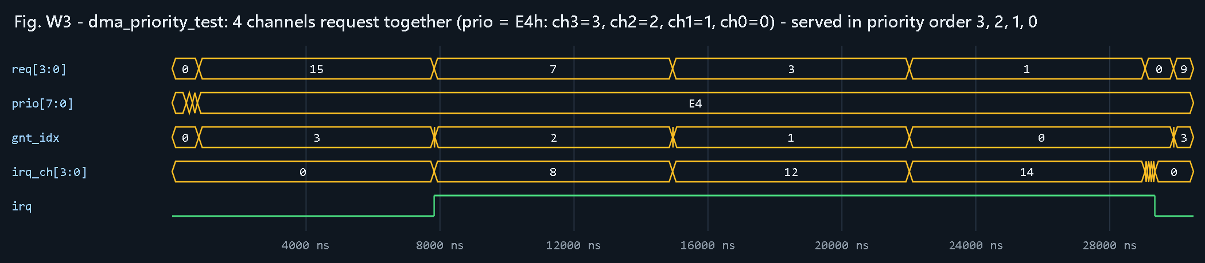
Figure 6. dma_priority_test - 4 channels with priorities 3, 2, 1, 0 (zoom into 0-30 us).
Check: gnt_idx stays at 3 until channel 3 is done (its irq_ch bit rises), then 2, then 1, then 0 - strict priority.
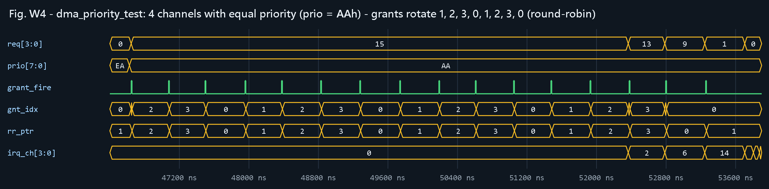
Figure 7. dma_priority_test - 4 channels with equal priority (zoom into about 46-54 us).
Check: at every grant_fire pulse, gnt_idx moves to the next channel 1, 2, 3, 0, ... and rr_ptr follows - round-robin.
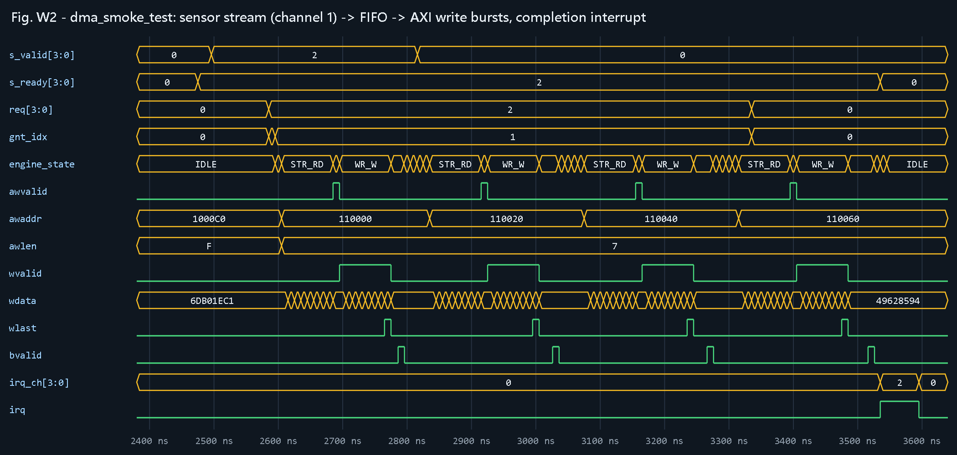
Figure 8. dma_smoke_test - sensor stream on channel 1 (zoom into about 2.4-3.6 us).
Check: s_valid/s_ready accept sensor words into the FIFO, the engine goes STR_RD -> WR_AW -> WR_W -> WR_B, the addresses advance by 0x20 per 8-beat burst, and irq_ch[1] and irq rise at the end.
Alternative without the GUI
Add -testplusarg WAVES to a batch run to write a standard dma.vcd file in sim\work, which any VCD viewer (for example GTKWave) can open.

Step 8. Run synthesis and read the reports
Command Prompt
cd C:\Projects\ADAS_DMA_Subsystem\synth
call ..\sim\env.bat
vivado -mode batch -source synth.tcl

Synthesis takes about one minute and ends with SYNTHESIS DONE. It writes three files in synth\:
Table 13. Reading the synthesis reports
File | What to look for | Expected
utilization_synth.rpt | Table '1. Slice Logic': rows Slice LUTs and Slice Registers | 1 660 LUTs (2.62 %), 1 065 registers (0.84 %)
utilization_synth.rpt | Rows LUT as Memory, Block RAM Tile, DSPs | 128 LUT-RAM (the FIFOs and burst buffer), 0 BRAM, 0 DSP
timing_synth.rpt | 'Design Timing Summary': WNS(ns) | +1.742 ns (positive = timing met at 100 MHz)
timing_synth.rpt | The sentence below the summary | All user specified timing constraints are met.
synth.log | Last summary line | 0 Critical Warnings and 0 Errors

- WNS (Worst Negative Slack) is the timing margin of the slowest path. Positive means the design can run at the constrained 100 MHz; negative would mean it is too slow.
- WHS is the hold-time margin; it must also be positive (0.227 ns expected).
- These are post-synthesis estimates; a full place-and-route would give final numbers.

Step 9. Compare with the golden results
If your run is correct, your numbers match this table exactly (the simulation is deterministic for a given seed).
Table 14. Golden regression results (the time is the @ value of the TEST PASSED line)
Test (seed) | Simulation end time | Result
dma_regs_test (1) | 5.01 us | PASS
dma_smoke_test (1) | 5.59 us | PASS
dma_sensor_fusion_test (1) | 176.69 us | PASS
dma_burst_sweep_test (1) | 109.52 us | PASS
dma_priority_test (1) | 56.09 us | PASS
dma_error_test (1) | 20.80 us | PASS
dma_cfg_err_test (1) | 11.99 us | PASS
dma_backpressure_test (1) | 75.73 us | PASS
dma_random_test (11) | 918.82 us | PASS
dma_random_test (12) | 1077.68 us | PASS
dma_random_test (13) | 846.75 us | PASS
dma_random_test (14) | 968.63 us | PASS
dma_random_test (15) | 992.73 us | PASS

Table 15. Other golden numbers
Metric | Expected value
Merged functional coverage | 100 %
RTL statement coverage | 100 % on all 5 modules
Radar completion in dma_sensor_fusion_test | 1 120 cycles, first of the four channels
Equal-priority grant sequence | 1, 2, 3, 0, 1, 2, 3, 0, ...
Synthesis | 1 660 LUTs, 1 065 FFs, WNS +1.742 ns

Step 10. Analysing a failure (if a test ever fails)
A failing test prints *** TEST FAILED *** and a non-zero UVM_ERROR count. To show what this looks like, four bugs were deliberately injected into a copy of the RTL; these are the real messages they produced:
Example error messages
[SCB] CH0 DATA MISMATCH word 5 addr 0x00100014: got 0x00fb406c exp 0x00fb406d
[CHK] strict priority order wrong: '{0,1,2,3}
[SCB] CH2 read burst len 2 expected 1 (addr 0x00030ffc)
[CHK] CH1 err code: got 0x00000001 expected 0x00000002

Table 16. Who reports what
Tag in the message | Who reported it | What it means
[SCB] | Scoreboard (reference model) | The bus traffic differs from the prediction: wrong data, address or burst length, or a stray burst
[CHK] | The test sequence | A register value, interrupt or completion order is not what the test expected
[TIMEOUT] | The test sequence | A channel never finished (no DONE/ERR interrupt within the allowed time)
AXI: / APB: / Arbiter: / CH: | An assertion (tb/sva/dma_sva.sv) | A protocol or design rule was broken at that exact simulation time
[AXI_SLV] | AXI memory model | Wrong WLAST position or missing WLAST

10.1 Debug procedure
1. Open the log and search for the first UVM_ERROR - later errors are often consequences of the first.
2. Note the time (@ ... ps), the channel and the message.
3. Re-run only that test with the same seed: sim\run_test.bat <test> <seed> - the failure repeats exactly.
4. Open it in the GUI: sim\run_gui.bat <test> <seed>, go to the reported time and look at req, gnt_idx, the engine state and the AXI signals of that channel.
5. Fix the RTL, then run sim\regress.bat again - always the full regression after any change.

Step 11. Troubleshooting
Table 17. Common problems
Problem | Cause | Solution
'xvlog' / 'xsim' is not recognized | Wrong Vivado path in sim\env.bat | Fix the path (Step 2) and check with xvlog --version
Compile errors mentioning a file path | Project in a very long path or a path with spaces | Move the folder to e.g. C:\Projects\ADAS_DMA_Subsystem
Nothing happens when typing sim\regress.bat in PowerShell | PowerShell does not run .bat the same way | Use cmd, or type cmd /c sim\regress.bat
A run takes much longer than expected | Antivirus scanning the many files xsim writes | Exclude the project folder from real-time scanning, or just wait
run_test.bat says the log file is not found | build.bat was not run first | Run sim\build.bat once
Coverage report is empty | No runs in sim\cov | Run some tests first, then sim\coverage_report.bat
The GUI opens but the waveform is empty | Test still running or waveform tab not selected | Wait for the Tcl Console to show the test result, then press Zoom Fit
Git Bash: 'xvlog.bat: command not found' | Path in the .sh files | Edit the export PATH line at the top of each sim\*.sh file

Quick reference card
Table 18. Commands
I want to ... | Command (Command Prompt, in the project folder)
Run everything | sim\regress.bat
Compile only | sim\build.bat
Run one test | sim\run_test.bat dma_smoke_test
Run random with my seed | sim\run_test.bat dma_random_test 42 100
Update coverage reports | sim\coverage_report.bat
See waveforms | sim\run_gui.bat dma_priority_test
List pass/fail | findstr /C:"TEST PASSED" /C:"TEST FAILED" sim\logs\*.log
Synthesize | cd synth then vivado -mode batch -source synth.tcl

