L&T EduTech | VLSI Principles, RTL Design and Verification
Project 1
Multi-Channel DMA Controller Subsystem
for an Automotive ADAS Platform

Milestone-wise Project Report
Milestone 1: Requirements and Architecture Design
Milestone 2: RTL Implementation
Milestone 3: Verification and Validation

Item | Details
Student name
Registration / LMS ID
Language and methodology | SystemVerilog RTL, SystemVerilog Assertions, UVM 1.2
Tools | AMD Vivado 2025.2 (xsim simulator, xcrg coverage, synthesis)
Target | 4-channel DMA, APB control + AXI4 data, 100 MHz (Artix-7 xc7a100t)
Final results | 13/13 tests pass, 100 % functional coverage, 100 % RTL statement coverage

Contents

1. Introduction
1.1 The problem statement given in the brief
1.2 What we were asked to build, and what we delivered
1.3 Verification requirements of the brief
1.4 The design at a glance
1.5 How this report is organised
2. Milestone 1: Requirements and Architecture Design
2.1 Study DMA architecture used in SoCs
2.2 Define channel configuration registers
2.3 Design arbitration scheme for multiple DMA requests
2.4 Create datapath and controller architecture
2.5 Develop RTL block diagram
3. Milestone 2: RTL Implementation
3.1 Implement DMA channel controller
3.2 Design arbitration logic
3.3 Implement transfer state machine
3.4 Integrate interrupt and status registers
3.5 Perform RTL simulation
4. Milestone 3: Verification and Validation
4.1 Develop SystemVerilog testbench
4.2 Create UVM agents and sequences
4.3 Implement scoreboarding and checking
4.4 Add assertions for protocol compliance
4.5 Generate functional and code coverage reports
5. Milestone compliance checklist
6. Conclusion
Possible future work
Appendix A. Project files
Appendix B. Glossary
(In Word: right-click the list and choose Update Field to add page numbers.)

1. Introduction

1.1 The problem statement given in the brief
A leading automotive SoC manufacturer is building a next-generation Advanced Driver Assistance System (ADAS) platform. The platform must continuously move high-bandwidth sensor data from cameras, radar and LiDAR into memory while keeping CPU overhead low. In the existing design the processor itself moves the data (processor-centric data movement). This creates performance bottlenecks and extra latency during real-time operation. The company therefore needs a configurable DMA subsystem that can:
- manage multiple concurrent data streams,
- prioritise critical sensor transfers (for example radar, which feeds emergency braking),
- support burst transactions on the memory bus,
- generate status interrupts, and
- provide reliable error handling.
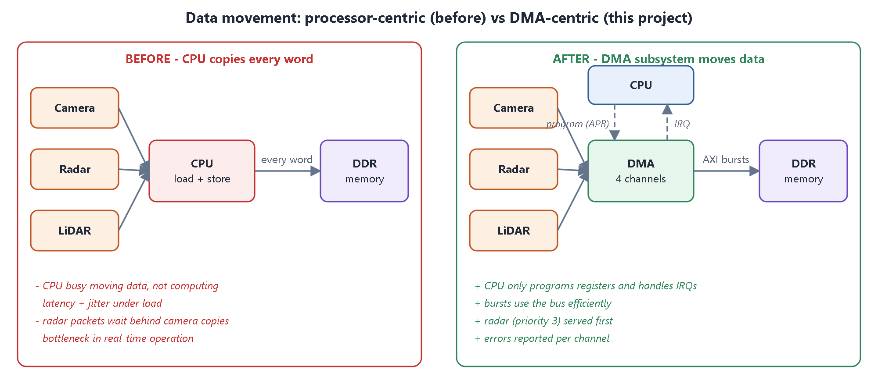
Figure 1. Why a DMA is needed: on the left the CPU copies every sensor word; on the right the DMA moves the data in bursts and the CPU only programs registers and handles interrupts.

1.2 What we were asked to build, and what we delivered
Every requirement in the brief is mapped below to the feature that satisfies it and the file where it is implemented. The rest of this report follows the three milestones exactly, point by point.
Table 1. Brief requirements mapped to the design
Requirement in the brief | How the design meets it | Where
Multiple concurrent data streams | 4 independent channels; each can be memory-to-memory or sensor-stream-to-memory; a shared burst engine serves them one burst at a time | rtl/dma_channel.sv, rtl/dma_engine.sv
Prioritise critical sensor transfers | 2-bit priority per channel (3 = most critical) + round-robin between equal priorities | rtl/dma_arbiter.sv
Burst transactions | AXI4 INCR bursts of 1 to 16 beats, automatically split so that no burst crosses a 4 KB page | rtl/dma_channel.sv (sizing), rtl/dma_engine.sv
Status interrupts | Per-channel DONE / ERR interrupt bits (write-1-to-clear) + mask + global irq line | rtl/dma_channel.sv, rtl/dma_top.sv
Reliable error handling | AXI SLVERR / DECERR capture, illegal configuration check, restart after an error; an error stops only the affected channel | rtl/dma_engine.sv, rtl/dma_channel.sv

1.3 Verification requirements of the brief
Table 2. Verification requirements of the brief
Brief says | What we did | Section
Develop a SystemVerilog transaction-based testbench | UVM testbench: transaction items (APB, sensor, AXI), drivers, monitors, interfaces with clocking blocks | 4.1, 4.2
Develop assertions to verify ... | 25 SVA properties (52 instances) for APB, AXI handshake, AXI legality incl. 4 KB rule, arbitration order, channel and IRQ rules | 4.4
Create covergroups to measure ... | 7 covergroups: configuration, AXI bursts and responses, arbitration, interrupts, errors, sensor back-pressure, APB access | 4.5
Generate functional coverage reports | Merged HTML reports from Vivado xcrg: 100 % functional, 100 % statement coverage on every RTL module | 4.5

1.4 The design at a glance
Table 3. Key specifications
Parameter | Value
Number of channels | 4 (CH0 camera, CH1 radar, CH2 LiDAR, CH3 diagnostics in the ADAS scenario)
Control interface | APB slave, 12-bit address, 32-bit data, zero wait states
Data interface | AXI4 master, 32-bit address and data, INCR bursts, 1-16 beats, single outstanding burst
Sensor inputs | 4 valid/ready word streams, each with a 32-word FIFO
Transfer length | 1 to 16 M words per channel (24-bit LEN)
Transfer modes | memory-to-memory or sensor-to-memory
Arbitration | fixed priority (0-3) + round-robin among equals, one decision per burst
Interrupts | irq_ch[3:0] + global irq; causes DONE and ERR
Errors detected | SLVERR, DECERR, illegal configuration
Clock / reset | single clock, asynchronous active-low reset, 100 MHz timing met
RTL size | 6 SystemVerilog files, about 690 lines, fully synthesizable

1.5 How this report is organised
Table 4. Milestones and where each item is answered
Milestone | Items in the brief | Report sections
Milestone 1: Requirements and Architecture Design | 1. Study DMA architecture used in SoCs  2. Define channel configuration registers  3. Design arbitration scheme  4. Create datapath and controller architecture  5. Develop RTL block diagram | 2.1 - 2.5
Milestone 2: RTL Implementation | 1. Implement DMA channel controller  2. Design arbitration logic  3. Implement transfer state machine  4. Integrate interrupt and status registers  5. Perform RTL simulation | 3.1 - 3.5
Milestone 3: Verification and Validation | 1. Develop SystemVerilog testbench  2. Create UVM agents and sequences  3. Implement scoreboarding and checking  4. Add assertions for protocol compliance  5. Generate functional and code coverage reports | 4.1 - 4.5

Each milestone item starts with a small box: what the milestone asks, what we built, and the files that prove it.

2. Milestone 1: Requirements and Architecture Design
Milestone 1 turns the problem into a precise specification: how DMA engines work in SoCs, what the software sees (registers), how competing requests are resolved (arbitration), how data and control flow (datapath and controller), and the resulting block diagram. Nothing is coded yet; every decision made here is implemented in Milestone 2.

2.1 Study DMA architecture used in SoCs
What the milestone asks | Study how DMA controllers are built and used inside SoCs.
What we built | A study of DMA concepts, buses and design options, and a requirements list (R1-R10) derived from the ADAS problem.
Evidence (files) | docs/01_problem_and_requirements.md, docs/02_architecture.md

2.1.1 What a DMA controller is
A Direct Memory Access (DMA) controller is a small hardware block that copies data from a source to a destination without the CPU touching each word. The CPU only writes a few registers (source, destination, length, mode) and starts the channel. The DMA then becomes a bus master, reads and writes memory on its own using efficient bursts, and raises an interrupt when the job is finished or when something went wrong.

2.1.2 Where a DMA sits in an SoC
A typical SoC has two kinds of buses. A slow, simple control bus (APB) is used by the CPU to program peripherals. A fast data bus (AXI4) connects bus masters (CPU, DMA, accelerators) to memory. A DMA is therefore a slave on APB (it is programmed) and a master on AXI (it moves data).
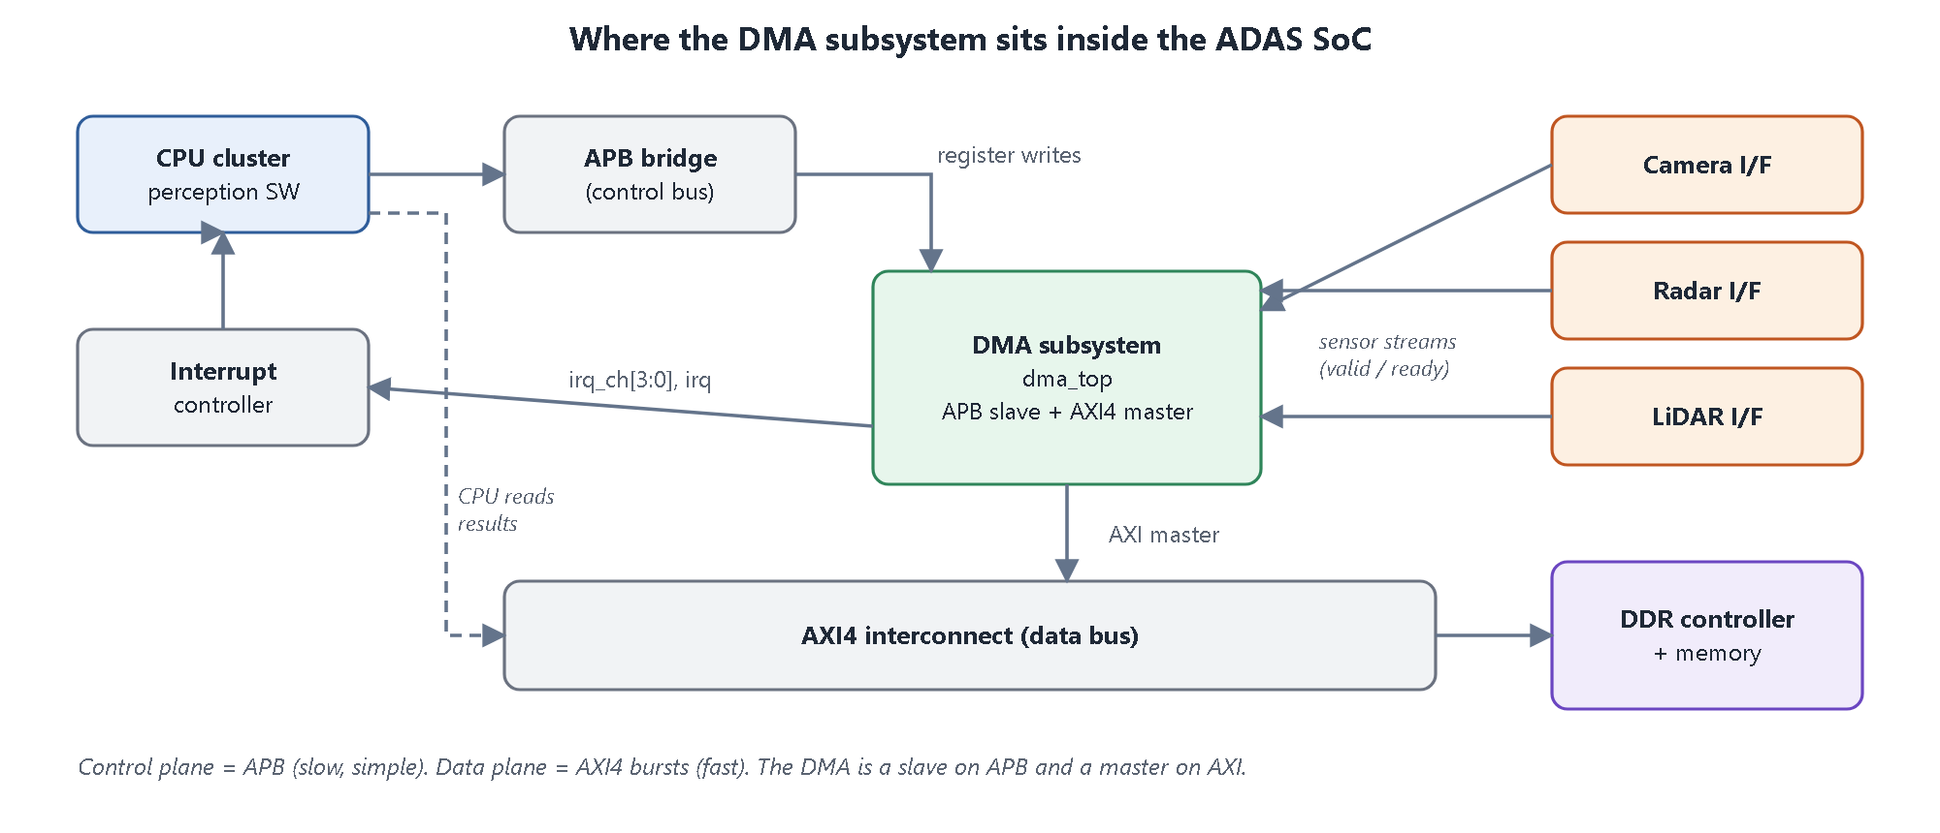
Figure 2. System context: the DMA subsystem is programmed over APB, streams data from the sensor interfaces and writes it to DDR through the AXI4 interconnect.

2.1.3 Building blocks found in SoC DMA controllers
Table 5. Typical DMA building blocks and our choices
Building block | Purpose | Used in this design
Channels | Independent jobs, each with its own source/destination/length | Yes, 4 channels
Register-based or descriptor-based setup | Registers = simple; descriptors in memory = long scatter-gather chains | Register-based (simple, deterministic)
Arbiter | Chooses which channel uses the bus next | Yes, priority + round-robin
Burst engine | Turns a transfer into legal bus bursts | Yes, AXI4 INCR, 1-16 beats
Data buffer / FIFO | Holds data between read and write, absorbs rate differences | 16-word burst buffer + 32-word FIFO per sensor
Interrupt / status logic | Tells software about completion and errors | Yes, DONE / ERR per channel
Error handling | Bus errors, illegal settings | SLVERR, DECERR, ERR_CFG

2.1.4 Bus protocol essentials
AXI4 has five independent channels: read address (AR), read data (R), write address (AW), write data (W) and write response (B). Every channel uses a VALID / READY handshake: a transfer happens on a clock edge where both are high, and the sender must keep VALID and the payload stable until READY arrives. Key rules used in this design:
- INCR bursts: one address, then AxLEN+1 beats at consecutive addresses (we use 1 to 16 beats of 4 bytes).
- 4 KB rule: a burst must never cross a 4 KB address boundary.
- WLAST marks the last write beat; RLAST marks the last read beat.
- Responses: OKAY (00), SLVERR (10, slave error) and DECERR (11, no slave at that address).
APB is a two-phase protocol: a SETUP cycle (PSEL=1, PENABLE=0) followed by an ACCESS cycle (PENABLE=1) that completes when PREADY=1. PSLVERR flags an illegal access.

2.1.5 One DMA transfer, step by step
1. Software writes SRC, DST, LEN and INT_EN of a channel, then writes CTRL with EN=1 and START=1.
2. The channel checks the configuration. If it is illegal it raises ERR (code 3) and stays idle.
3. The channel becomes active and computes the size of its next burst.
4. When it has a burst ready, it raises a request to the arbiter.
5. The arbiter grants the bus to the most important requester.
6. The engine reads one burst (from memory over AXI, or from the sensor FIFO) into the burst buffer.
7. The engine writes the burst to the destination over AXI and waits for the write response.
8. The channel advances its addresses and remaining count; steps 3-7 repeat.
9. After the last word the channel sets DONE and the interrupt line rises. Software reads and clears INT_STAT.

2.1.6 ADAS sensors and the requirements derived from them
Table 6. ADAS sensor characteristics
Sensor | Behaviour | What matters | Our setting
Front camera | very high bandwidth, continuous frames | throughput, no lost pixels | CH0, priority 1, 16-beat bursts
Radar | small bursty packets | latency (emergency braking) | CH1, priority 3, 4-beat bursts
LiDAR | medium-bandwidth point clouds | throughput + bounded latency | CH2, priority 2
Diagnostics | bulk memory-to-memory copy | must not disturb the sensors | CH3, priority 0

Table 7. Functional requirements (all verified in Milestone 3)
ID | Requirement
R1 | 4 independent channels, each memory-to-memory or sensor-stream-to-memory.
R2 | AXI4 memory interface: 32-bit, INCR bursts up to 16 beats, never crossing a 4 KB boundary.
R3 | Channels configured through an APB register interface.
R4 | A higher-priority channel is served before lower ones at every burst boundary.
R5 | Equal-priority channels share the bus fairly (round-robin).
R6 | Per-channel interrupt on completion and on error; maskable, write-1-to-clear.
R7 | SLVERR/DECERR stops only the affected channel and records the cause; others continue.
R8 | Illegal configurations are rejected at START (ERR_CFG) with no bus traffic.
R9 | After an error a channel can be restarted by software.
R10 | Data is never lost or reordered; a sensor that cannot be accepted is back-pressured.

2.1.7 Architecture decisions taken from the study
Table 8. Design choices
Decision | Options considered | Chosen | Reason
Setup method | registers / descriptors in memory | registers | simple, deterministic, enough for 4 streams
Bus engine | one per channel / shared | one shared engine | one AXI master port, smaller area, arbitration point is clear
Data movement | cut-through / store-and-forward | store-and-forward (16 words) | a write burst never stalls waiting for data, AXI rules trivially met
Arbitration point | per word / per burst / per transfer | per burst | critical channel waits at most one burst
Tie-break | fixed order / round-robin | round-robin | equal channels share the bus fairly

2.2 Define channel configuration registers
What the milestone asks | Define the registers software uses to configure each channel.
What we built | A complete APB register map: 4 global registers and 9 registers per channel, with bit fields, access types, reset values and hardware-enforced rules.
Evidence (files) | docs/03_register_map.md, rtl/dma_pkg.sv (offsets), rtl/dma_channel.sv, rtl/dma_top.sv

The register space is 4 KB (12-bit APB address). Global registers live at the bottom; each channel has its own 64-byte window starting at 0x100 + n x 0x40. Any other address returns PSLVERR, so software bugs are caught immediately.
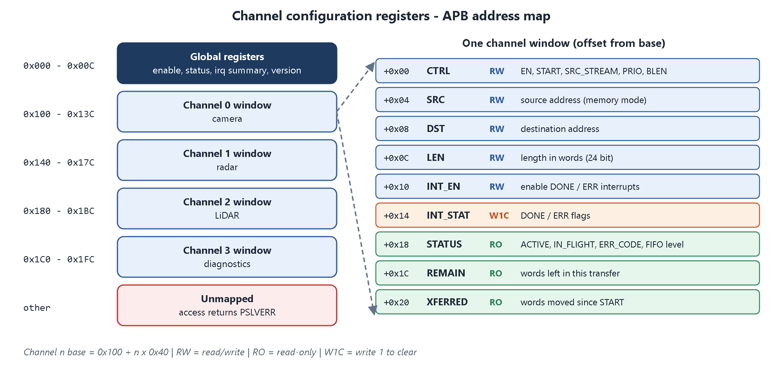
Figure 3. APB address map: global registers, four channel windows and the registers inside one window.
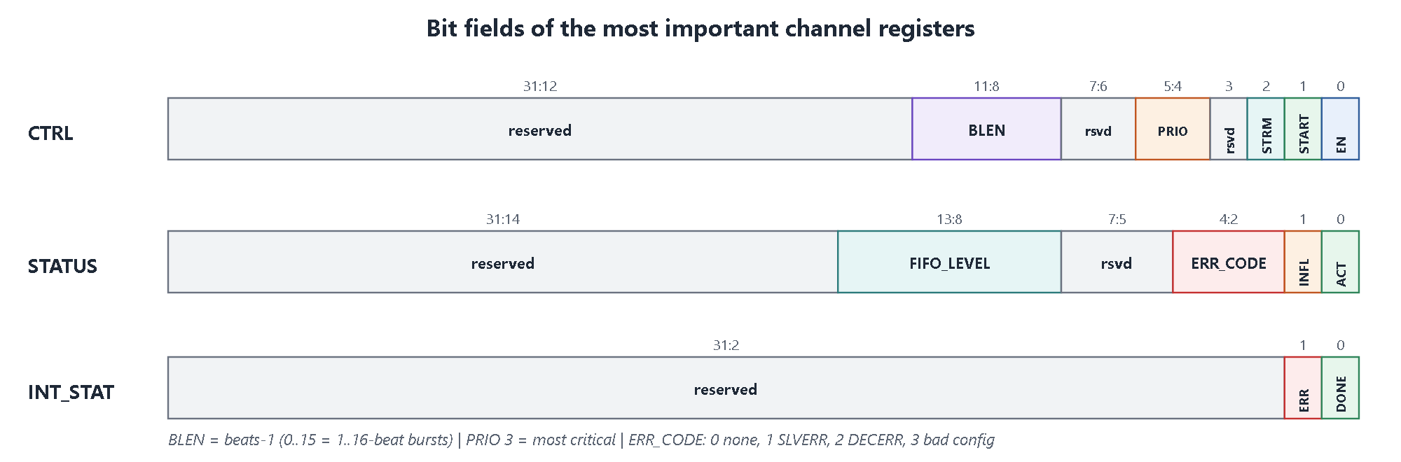
Figure 4. Bit fields of CTRL, STATUS and INT_STAT.
Table 9. Global registers
Offset | Name | Access | Reset | Fields / meaning
0x000 | GCTRL | RW | 0 | [0] EN global enable
0x004 | GSTAT | RO | 0 | [3:0] channel active, [8] engine busy
0x008 | IRQ_SUM | RO | 0 | [3:0] per-channel interrupt lines
0x00C | VERSION | RO | 0x00010000 | design version

Table 10. Channel registers (offset from the channel base)
Offset | Name | Access | Fields / meaning
+0x00 | CTRL | RW | [0] EN, [1] START (pulse), [2] SRC_STREAM (1 = sensor), [5:4] PRIO, [11:8] BLEN = beats-1
+0x04 | SRC | RW | source byte address (word aligned; ignored for sensor streams)
+0x08 | DST | RW | destination byte address (word aligned)
+0x0C | LEN | RW | transfer length in words [23:0]
+0x10 | INT_EN | RW | [0] DONE, [1] ERR interrupt enables
+0x14 | INT_STAT | W1C | [0] DONE, [1] ERR flags; write 1 to clear
+0x18 | STATUS | RO | [0] ACTIVE, [1] IN_FLIGHT, [4:2] ERR_CODE, [13:8] FIFO_LEVEL
+0x1C | REMAIN | RO | words left in the current transfer
+0x20 | XFERRED | RO | words moved since START

ERR_CODE values: 0 none, 1 SLVERR, 2 DECERR, 3 illegal configuration.

Rules the hardware enforces
- START while the channel is already active is ignored.
- START with EN=0, LEN=0, an unaligned DST, or (memory source) an unaligned SRC sets ERR with ERR_CODE=3 and causes no bus traffic.
- After an error the channel is idle; software restarts it with a new START.
- A new START clears ERR_CODE and XFERRED and flushes the channel FIFO.
- INT_STAT: if a new event and a software clear happen in the same cycle, the event wins (no lost interrupt).
Programming example (what a driver does)
write(GCTRL, 1); // global enable
// radar: sensor stream, priority 3, 4-beat bursts, 256 words
write(CH1_DST, 0x80100000);
write(CH1_LEN, 256);
write(CH1_INT_EN, 0b11); // DONE | ERR
write(CH1_CTRL, (3<<8)|(3<<4)|(1<<2)|(1<<1)|1); // BLEN=3 PRIO=3 STREAM START EN
// ... wait for irq ...
st = read(CH1_INT_STAT); write(CH1_INT_STAT, st); // acknowledge (W1C)

2.3 Design arbitration scheme for multiple DMA requests
What the milestone asks | Design how the DMA decides which of several requesting channels uses the bus.
What we built | A per-burst arbiter: static 2-bit priority, round-robin between equal priorities.
Evidence (files) | docs/02_architecture.md section 2.5, rtl/dma_arbiter.sv

2.3.1 What the arbiter must guarantee
- Criticality: radar (priority 3) must be served before camera and diagnostics.
- Bounded latency: a critical channel must never wait for a whole long transfer of another channel.
- Fairness: channels with the same priority share the bus.
Table 11. Arbitration schemes compared
Scheme | Advantage | Problem for ADAS
Fixed priority with fixed tie order | simple, radar always first | equal channels are not treated fairly
Round-robin only | perfectly fair | radar waits behind camera; criticality ignored
Weighted round-robin | bandwidth shares | more logic, latency of radar not strictly bounded
Priority + round-robin (chosen) | criticality first, fairness among equals | very small: one 2-bit pointer

2.3.2 The chosen scheme
1. Each channel presents req (active, enabled and - for sensors - enough data in its FIFO) and a 2-bit PRIO.
2. The requester with the highest PRIO wins.
3. Ties are broken by a round-robin pointer that starts just after the last winner.
4. Arbitration happens once per burst, so a critical channel waits at most one burst (at most 16 beats) of another channel.
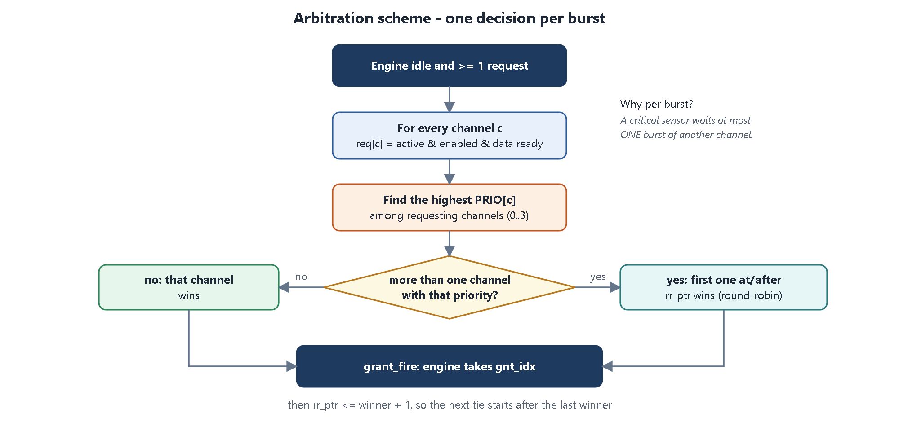
Figure 5. Arbitration decision flow, executed every time the engine is ready for a new burst.
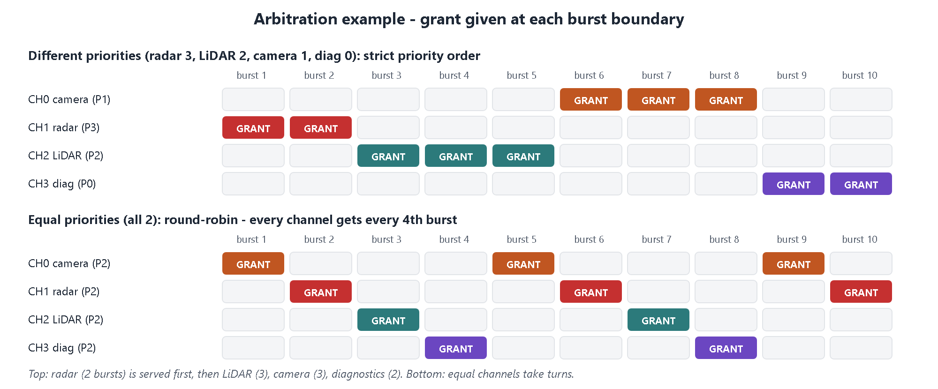
Figure 6. Worked example. Top: different priorities - the channels are served strictly in priority order. Bottom: equal priorities - the grant rotates (round-robin).

2.3.3 Worst-case latency of the critical channel
When radar requests, the engine may be in the middle of a burst of another channel. The longest burst is 16 beats. A 16-beat memory-to-memory burst takes roughly 16 read beats + 16 write beats + address, response and the two pipeline states, i.e. about 40 to 45 clock cycles (about 0.45 us at 100 MHz) with a zero-wait memory. After that burst radar is granted immediately, because it has the highest priority. This bound is independent of the transfer length of the other channels - exactly the property that the processor-centric design lacked.

2.4 Create datapath and controller architecture
What the milestone asks | Define how data moves (datapath) and which blocks make the decisions (controller).
What we built | A store-and-forward datapath through one 16-word burst buffer, and a three-level controller: channel controllers, arbiter, engine FSM.
Evidence (files) | docs/02_architecture.md sections 2.2-2.4, rtl/dma_engine.sv, rtl/dma_channel.sv

2.4.1 Datapath
Every burst passes through a single 16 x 32-bit burst buffer inside the engine. For a memory source the buffer is filled by an AXI read burst; for a sensor source it is filled from that channel's FIFO. The buffer is then emptied by an AXI write burst to the destination.
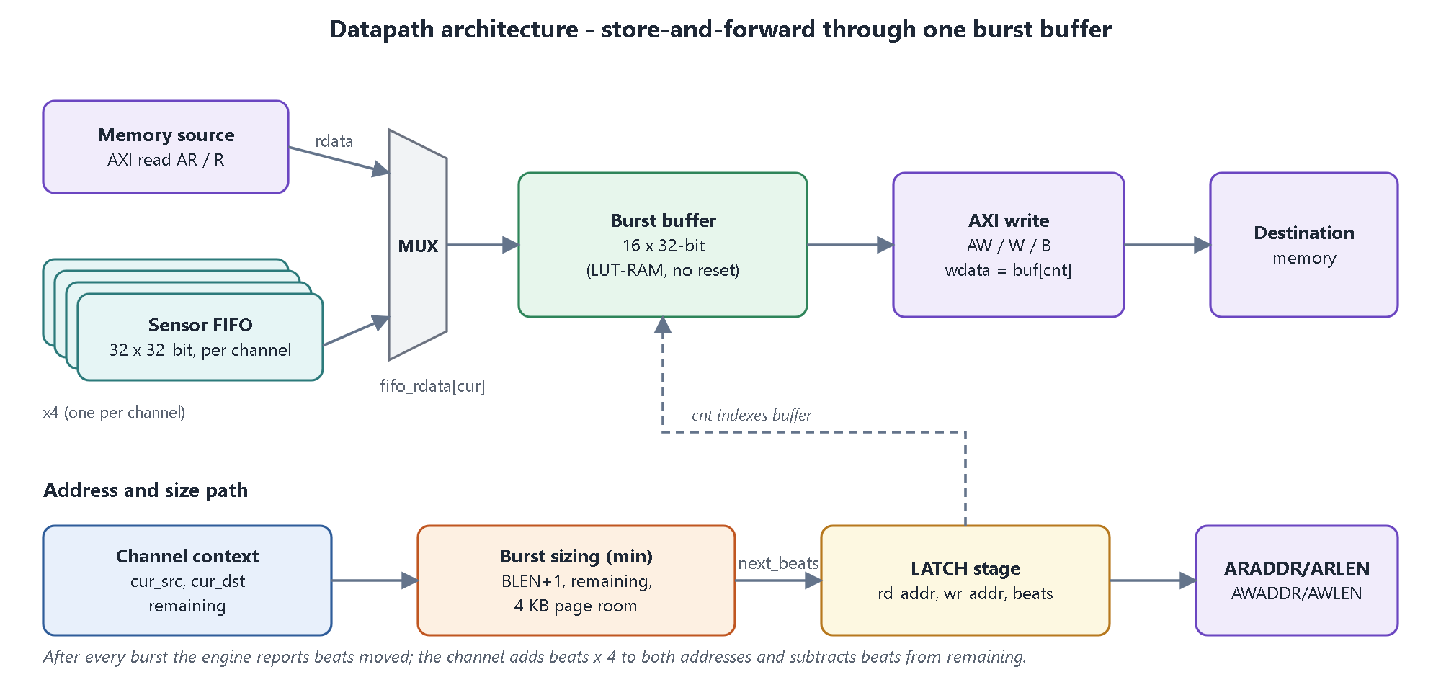
Figure 7. Datapath: sources, multiplexer, burst buffer and AXI write path (top); address and burst-size path (bottom).
Why store-and-forward? The write burst starts only when all its data is already in the buffer, so WVALID never has to drop in the middle of a burst and WLAST is trivially correct. The bus is free between bursts so the arbiter can switch channels. The cost is one burst of latency, which is why bursts are limited to 16 beats and the burst length is programmable per channel (radar uses 4 beats for lower latency, the camera 16 for higher efficiency).

2.4.2 Burst sizing and the 4 KB rule
Before each burst the channel computes the number of beats:
beats = min( BLEN + 1, // programmed burst size
remaining words, // do not overrun the transfer
words left in destination 4 KB page,
words left in source 4 KB page ) // memory source only

Example. DST = 0x0000_0FEC (5 words below a 4 KB boundary), LEN = 40, BLEN = 15. Bursts: 5 (reach the boundary) + 16 + 16 + 3 = 40 words. No burst crosses 0x1000, so the AXI rule is met without any software effort.

2.4.3 Controller architecture
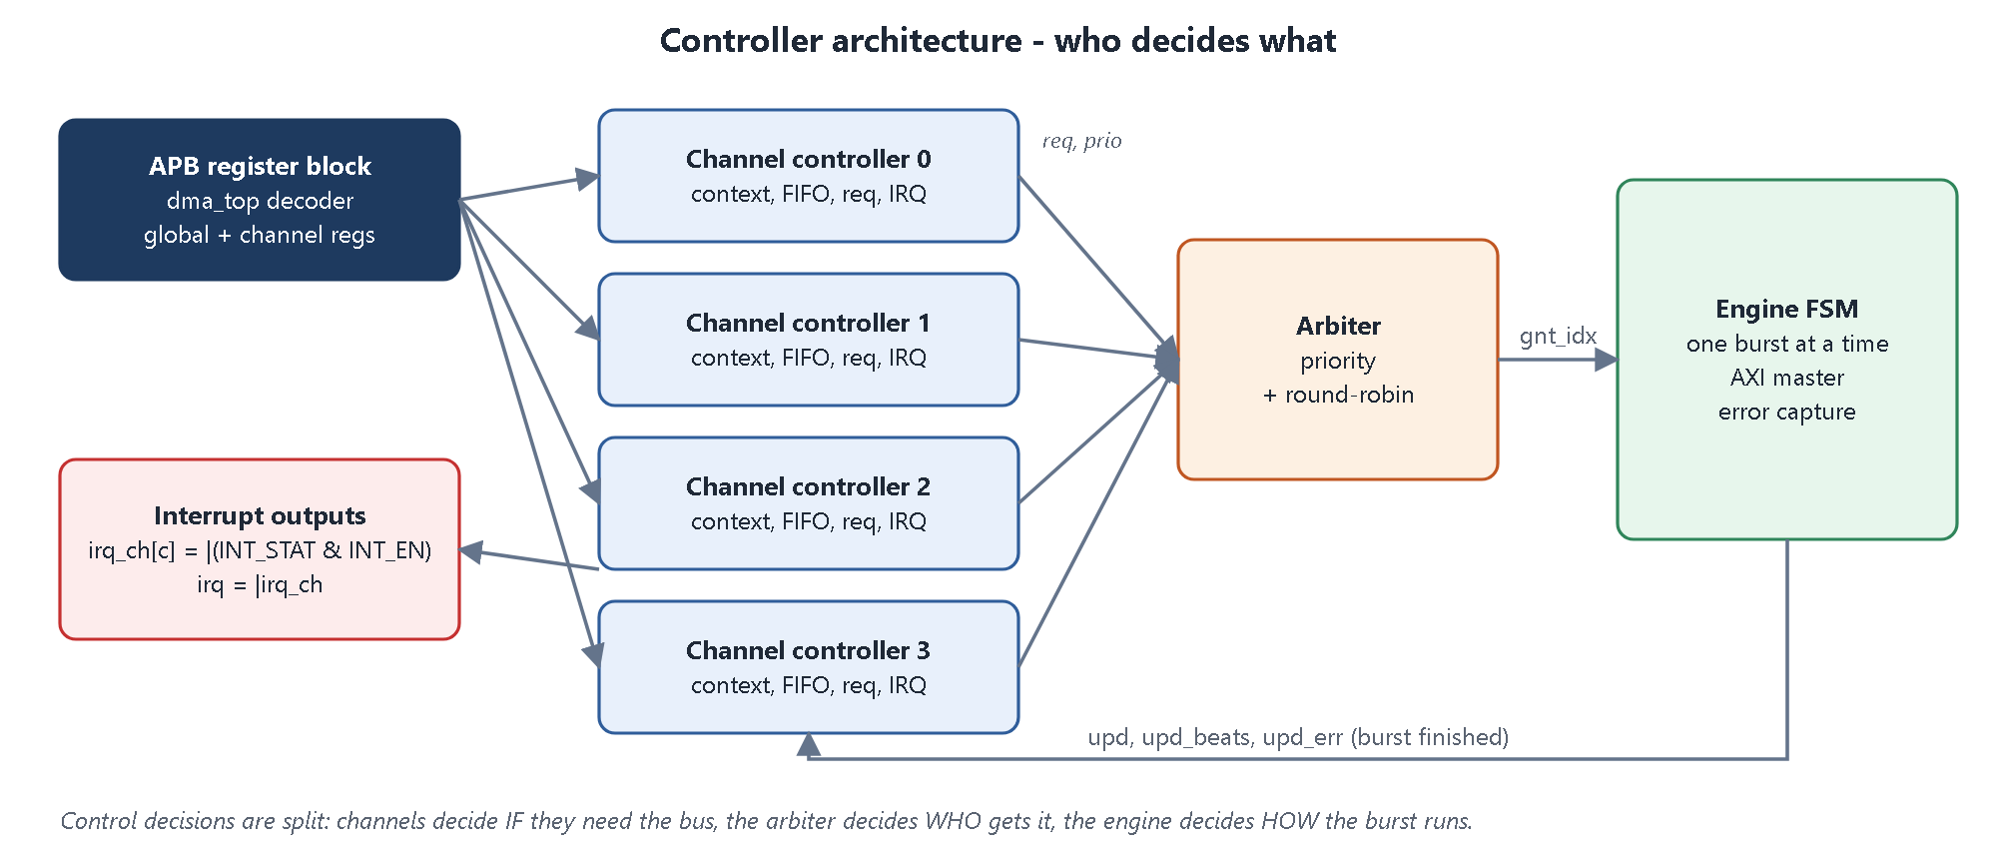
Figure 8. Controller split: channel controllers decide IF they need the bus, the arbiter decides WHO gets it, the engine decides HOW the burst runs.
Table 12. Interfaces between the controller blocks
Signal | From -> To | Meaning
req[c], prio[c] | channel -> arbiter | channel c has a burst ready; its static priority
next_beats[c], src_addr[c], dst_addr[c] | channel -> engine | parameters of the next burst
gnt_valid, gnt_idx | arbiter -> engine | a winner exists and which channel it is
grant_fire | engine -> arbiter | engine accepts the grant (updates rr_ptr)
fifo_pop[c], fifo_rdata[c] | engine <-> channel | read sensor words out of the channel FIFO
inflight[c] | engine -> channel | engine is currently serving channel c
upd[c], upd_beats, upd_err | engine -> channel | burst finished: how many words moved and the error code
irq_ch[c] | channel -> top | interrupt of channel c; ORed into irq

2.5 Develop RTL block diagram
What the milestone asks | Draw the RTL block diagram of the subsystem.
What we built | The top-level block diagram, the module hierarchy and the full port list of dma_top.
Evidence (files) | docs/block_diagram.svg, rtl/dma_top.sv

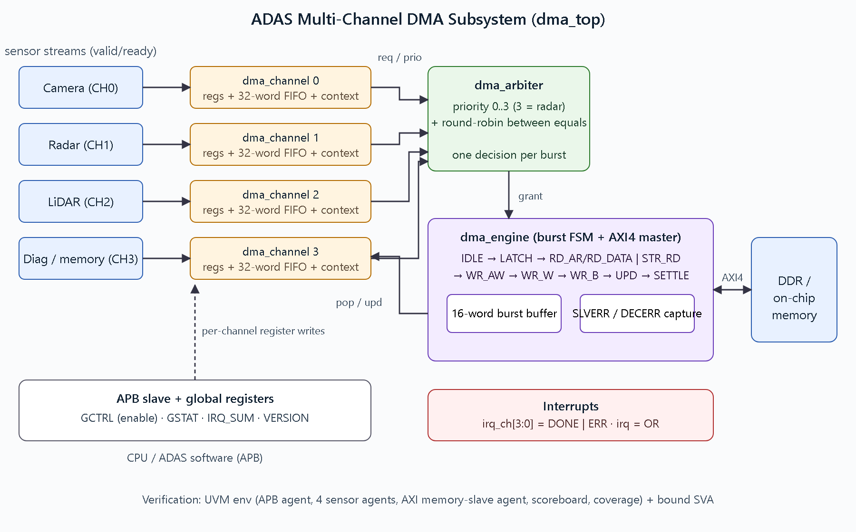
Figure 9. RTL block diagram of the ADAS multi-channel DMA subsystem.
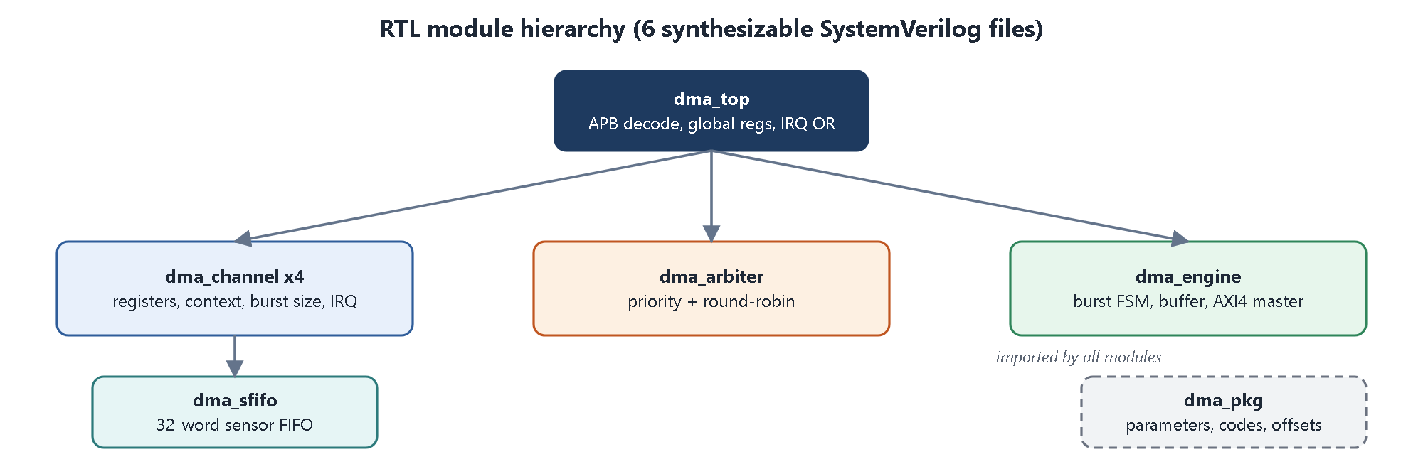
Figure 10. Module hierarchy: one top, four channel instances (each with a FIFO), one arbiter, one engine, shared package.
Table 13. dma_top ports
Port group | Signals | Direction
Clock / reset | clk, rst_n (asynchronous, active low) | in
APB slave | psel, penable, pwrite, paddr[11:0], pwdata[31:0] / prdata[31:0], pready, pslverr | in / out
Sensor streams (x4) | s_valid[3:0], s_data[3:0][31:0] / s_ready[3:0] | in / out
AXI write address | awaddr, awlen, awsize, awburst, awvalid / awready | out / in
AXI write data | wdata, wstrb, wlast, wvalid / wready | out / in
AXI write response | bresp, bvalid / bready | in / out
AXI read address | araddr, arlen, arsize, arburst, arvalid / arready | out / in
AXI read data | rdata, rresp, rlast, rvalid / rready | in / out
Interrupts | irq_ch[3:0], irq | out

Table 14. Design parameters
Parameter (dma_pkg) | Value | Meaning
N_CH | 4 | number of channels
DATA_W / ADDR_W | 32 / 32 | bus widths
MAX_BEATS | 16 | longest burst
FIFO_DEPTH | 32 | words per sensor FIFO
LEN_W | 24 | width of LEN

Milestone 1 - outcome
All five items are complete: SoC DMA study and requirements (2.1), register map (2.2), arbitration scheme (2.3), datapath and controller architecture (2.4), and RTL block diagram (2.5).
Every later RTL module and every test traces back to a requirement R1-R10 defined here.

3. Milestone 2: RTL Implementation
Milestone 2 implements the architecture in synthesizable SystemVerilog. The design is split into the six modules shown in Figure 10. All of them use one clock and an asynchronous active-low reset, and all constants come from dma_pkg.
Table 15. RTL files
Module | Lines | Role
dma_pkg.sv | 54 | parameters, error codes, register offsets, AXI constants
dma_sfifo.sv | 44 | 32-word first-word-fall-through FIFO for one sensor (maps to LUT-RAM)
dma_channel.sv | 199 | channel controller: registers, context, burst sizing, request, interrupts
dma_arbiter.sv | 47 | priority + round-robin arbiter
dma_engine.sv | 173 | transfer state machine, burst buffer, AXI4 master
dma_top.sv | 169 | APB decoder, global registers, instances, irq OR

3.1 Implement DMA channel controller
What the milestone asks | Implement the logic that holds one channel's configuration and drives its transfer.
What we built | dma_channel: configuration registers, START handling with configuration check, run-time context, sensor FIFO, burst sizing, registered request, interrupt and status logic. Instantiated 4 times.
Evidence (files) | rtl/dma_channel.sv, rtl/dma_sfifo.sv

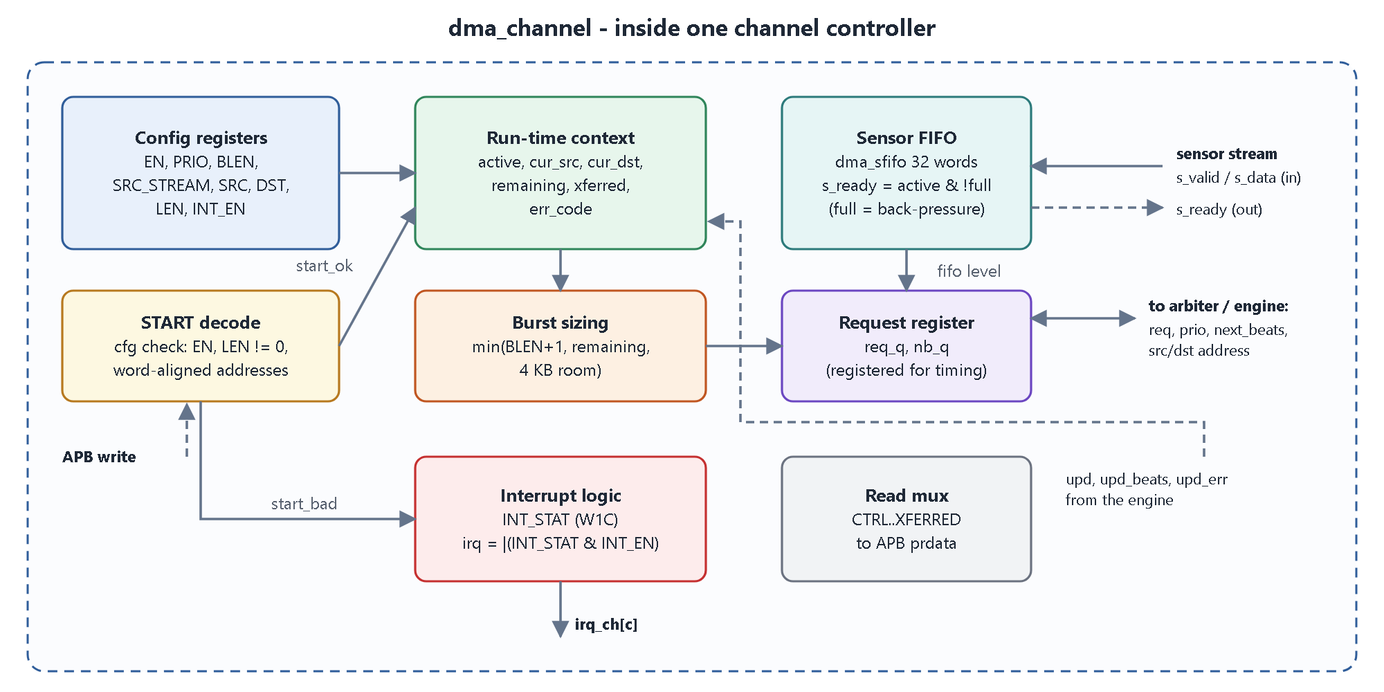
Figure 11. Inside one channel controller.

3.1.1 Responsibilities
- Configuration registers written over APB: EN, PRIO, BLEN, SRC_STREAM, SRC, DST, LEN, INT_EN.
- START check: a START is accepted only if EN=1, LEN != 0 and the addresses are word aligned; otherwise ERR_CFG.
- Run-time context: cur_src, cur_dst, remaining, xferred, err_code; updated after every burst.
- Sensor FIFO: accepts words while s_ready = active & stream & !full; a full FIFO holds the sensor off (back-pressure).
- Burst sizing with the min() formula of section 2.4.2.
- Request: raised when the channel has work and, for sensors, enough words in the FIFO for the next burst.
- Completion: on the last burst it raises DONE and goes idle; on a bus error it raises ERR and goes idle.
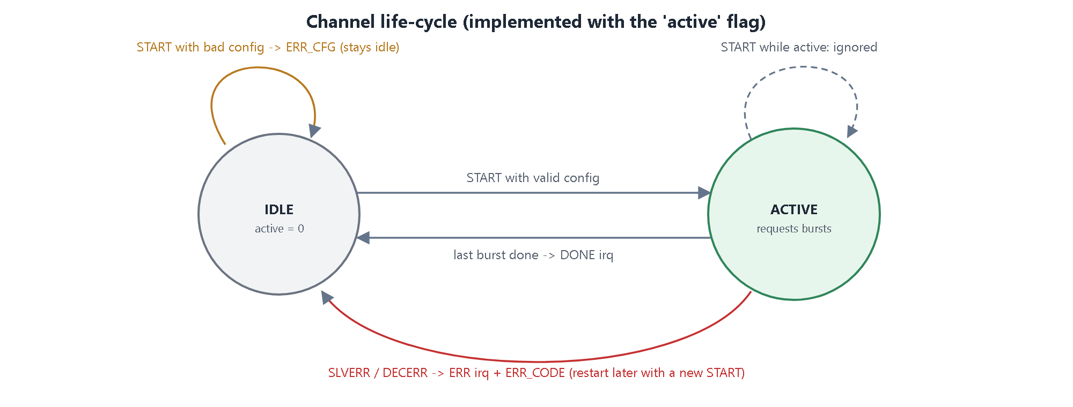
Figure 12. Channel life-cycle.
dma_channel.sv - START check and burst completion (simplified excerpt)
wire cfg_bad = !new_en || (len == '0) ||
(dst_base[1:0] != 2'b00) ||
(!new_strm && src_base[1:0] != 2'b00);
wire start_ok = start_w && !active && !cfg_bad; // accepted START
wire start_bad = start_w && !active && cfg_bad; // rejected -> ERR_CFG, no bus traffic

// after every burst the engine calls back with upd / upd_beats / upd_err
if (upd) begin
cur_src <= cur_src + (upd_beats << 2);
cur_dst <= cur_dst + (upd_beats << 2);
remaining <= remaining - upd_beats;
if (upd_err != ERR_NONE) begin active <= 0; err_code <= upd_err; end // error: stop
else if (remaining == upd_beats) active <= 0; // last burst
end

Timing detail. The request and next-burst size are registered (req_q, nb_q). This removed a long combinational path (context -> min() -> arbiter -> engine) found during synthesis; the engine waits one SETTLE cycle after each burst so that the registered request is up to date.

3.2 Design arbitration logic
What the milestone asks | Implement the arbitration scheme of section 2.3 in RTL.
What we built | dma_arbiter: a rotating scan that finds the highest-priority requester, and a 2-bit round-robin pointer for ties.
Evidence (files) | rtl/dma_arbiter.sv

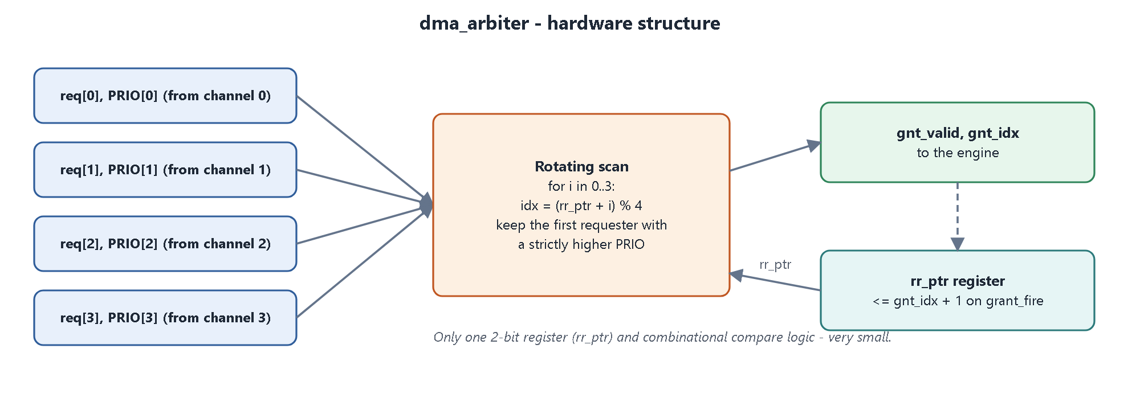
Figure 13. Arbiter hardware structure.
dma_arbiter.sv - core of the arbiter (excerpt)
// winner: highest priority, ties broken by round-robin order
for (int i = 0; i < N_CH; i++) begin
idx = (rr_ptr + i) % N_CH;
if (req[idx] && (!gnt_valid || prio[idx] > best)) begin
gnt_valid = 1; gnt_idx = idx; best = prio[idx];
end
end

// next tie starts after the last winner
always_ff @(posedge clk or negedge rst_n)
if (!rst_n) rr_ptr <= '0;
else if (grant_fire) rr_ptr <= (gnt_idx == N_CH-1) ? '0 : gnt_idx + 1'b1;

Because the scan starts at rr_ptr and only replaces the current best with a strictly higher priority, the first channel after the previous winner wins any tie. This gives round-robin among equals with no extra logic.
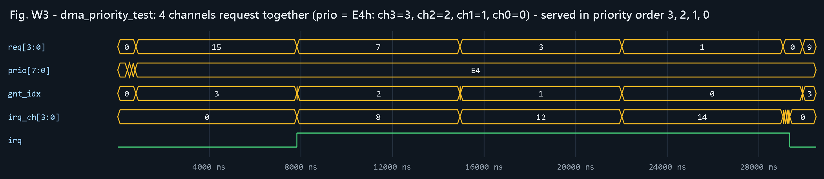
Figure 14. Simulation of dma_priority_test, part 1: four channels with priorities E4h (ch3=3, ch2=2, ch1=1, ch0=0) request at the same time; gnt_idx serves them strictly in the order 3, 2, 1, 0.
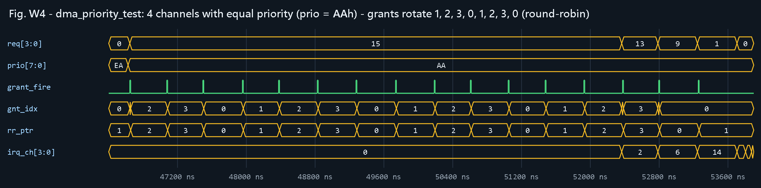
Figure 15. Simulation of dma_priority_test, part 2: four channels with equal priority (AAh); at every grant_fire gnt_idx and rr_ptr rotate 1, 2, 3, 0, ... - round-robin. The test checks that every 4 consecutive grants cover all 4 channels.

3.3 Implement transfer state machine
What the milestone asks | Implement the FSM that performs the bus transfers.
What we built | dma_engine: a 10-state FSM that runs one burst per pass (read or sensor pop, then write), the burst buffer, the AXI4 master signals and error capture.
Evidence (files) | rtl/dma_engine.sv

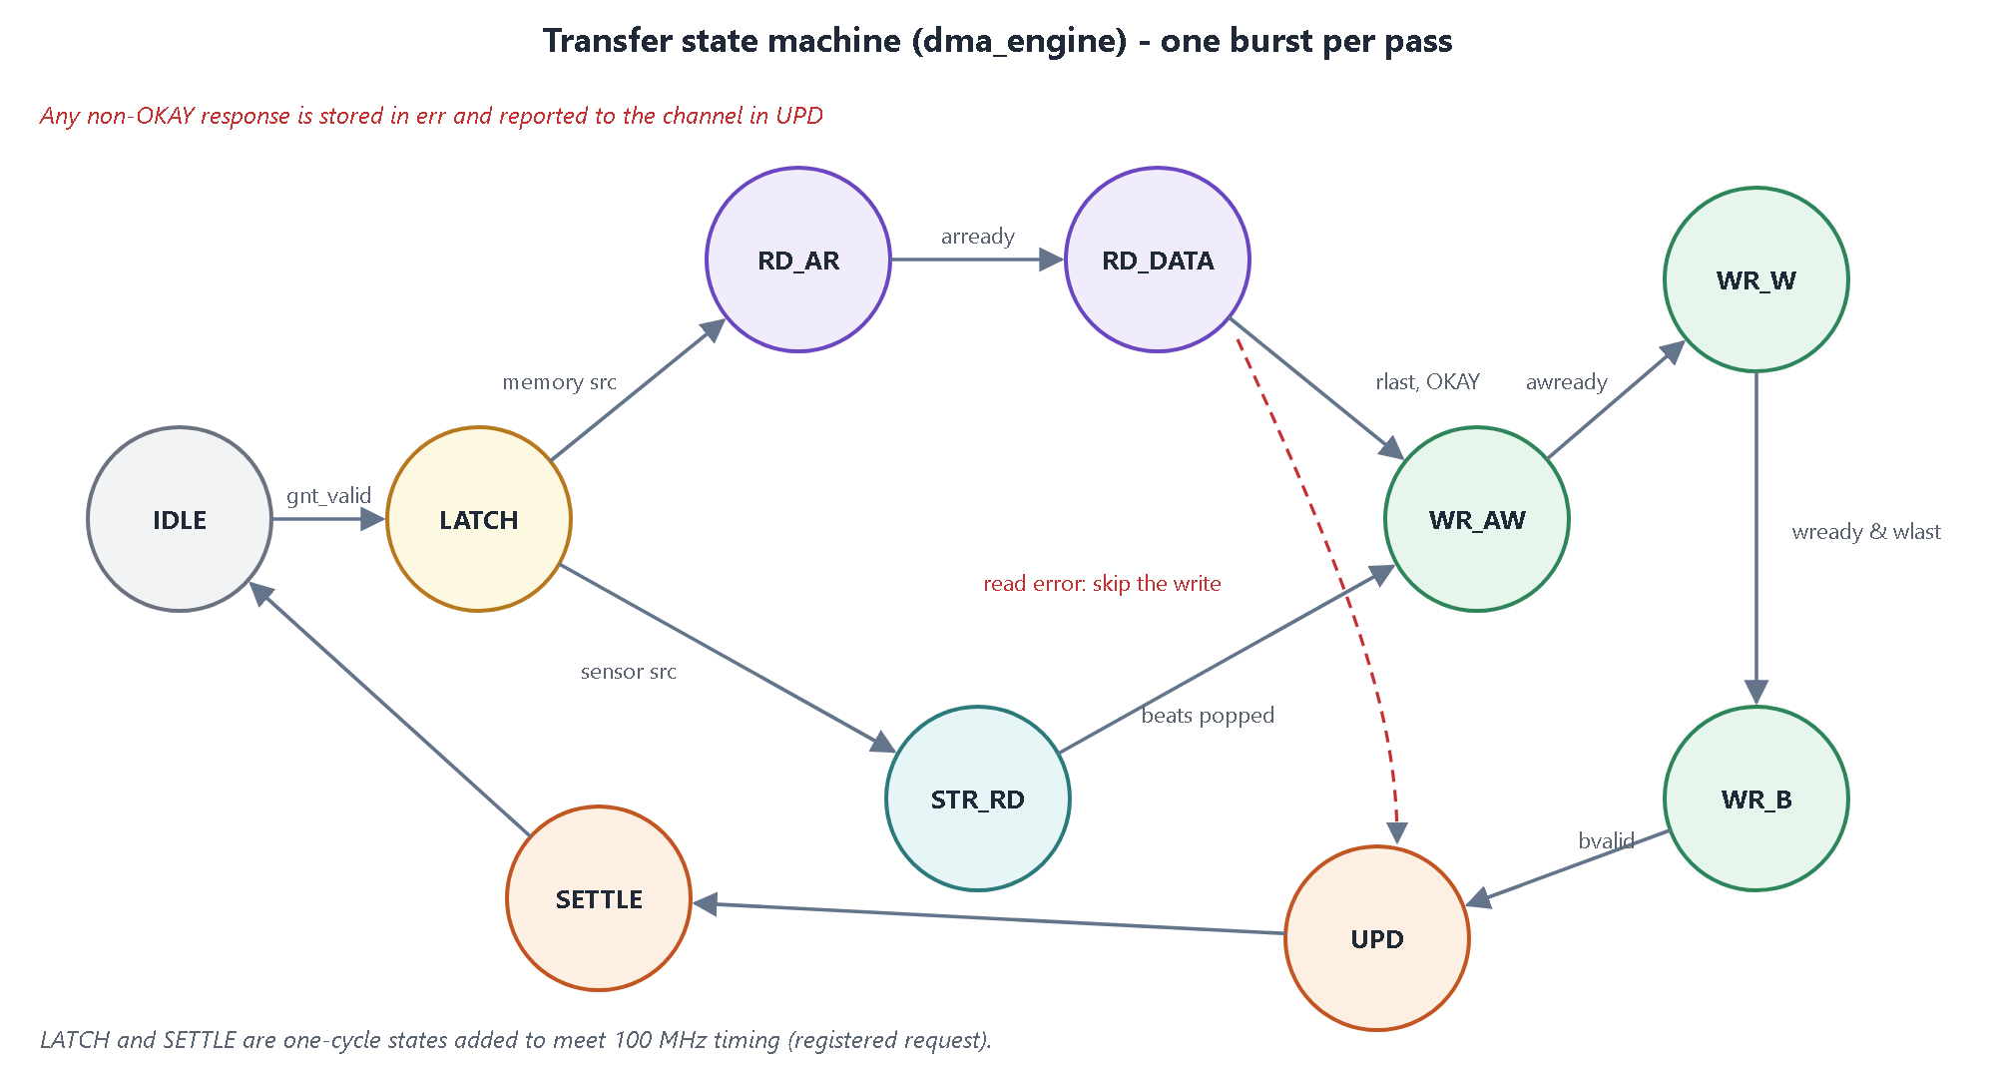
Figure 16. Transfer state machine of dma_engine.
Table 16. Engine states
State | What happens | Leaves when
IDLE | waits; grant_fire = gnt_valid; remembers the winning channel | a grant is valid
LATCH | copies beats, source and destination address of the winner | next cycle
RD_AR | ARVALID = 1 with ARADDR/ARLEN | ARREADY
RD_DATA | RREADY = 1, stores each beat in the buffer, keeps the first non-OKAY response | RVALID & RLAST
STR_RD | pops beats words from the channel FIFO into the buffer | last word popped
WR_AW | AWVALID = 1 with AWADDR/AWLEN | AWREADY
WR_W | WVALID = 1, WDATA = buffer[cnt], WLAST on the last beat | WREADY & WLAST
WR_B | BREADY = 1, records BRESP | BVALID
UPD | tells the channel how many words moved and the error code (a read error skips the write) | next cycle
SETTLE | one idle cycle so the channel's registered request is up to date | next cycle

3.3.1 Error handling
- The engine keeps the first non-OKAY response of a burst in an err register.
- A SLVERR/DECERR during the read phase skips the write (no corrupted data reaches memory); during the write phase it is reported from BRESP.
- On any error the channel moves 0 words (upd_beats = 0), stops and records ERR_CODE; other channels continue (R7).
dma_engine.sv - next-state logic (excerpt)
case (state)
S_IDLE: if (gnt_valid) nstate = S_LATCH;
S_LATCH: nstate = src_stream[cur] ? S_STR_RD : S_RD_AR;
S_RD_AR: if (arready) nstate = S_RD_DATA;
S_RD_DATA: if (rvalid && rlast) nstate = (read error) ? S_UPD : S_WR_AW;
S_STR_RD: if (cnt == beats-1) nstate = S_WR_AW;
S_WR_AW: if (awready) nstate = S_WR_W;
S_WR_W: if (wready && wlast) nstate = S_WR_B;
S_WR_B: if (bvalid) nstate = S_UPD;
S_UPD: nstate = S_SETTLE;
S_SETTLE: nstate = S_IDLE;
endcase

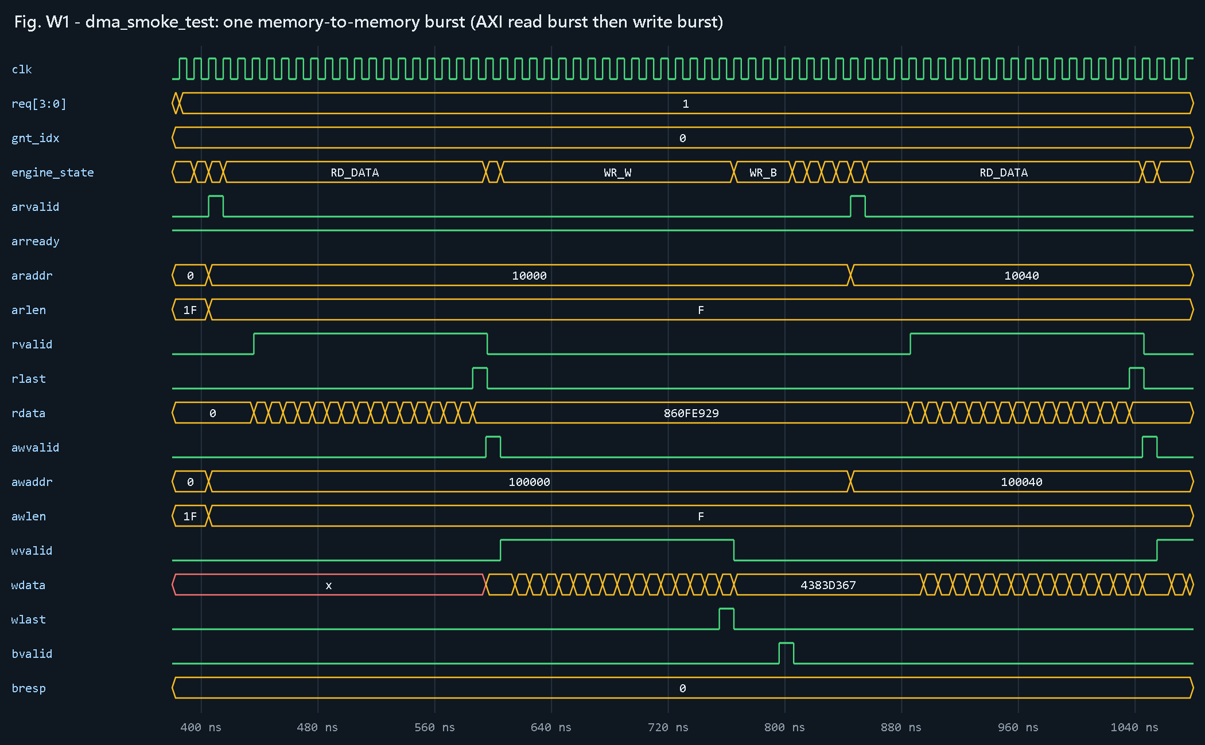
Figure 17. Simulation of one memory-to-memory burst: AR handshake, 16 read beats ending with RLAST, AW handshake, 16 write beats ending with WLAST, then the B response. Next burst starts at address +0x40.
Reading the waveform. engine_state goes RD_AR -> RD_DATA (16 beats of rdata) -> WR_AW -> WR_W (16 beats of wdata, wlast on the last) -> WR_B (bvalid, bresp = 0 OKAY) -> UPD -> SETTLE -> next burst. arlen = awlen = F means 16 beats, and the second burst starts at 0x10040 / 0x100040 (16 words x 4 bytes = 0x40 later).

3.4 Integrate interrupt and status registers
What the milestone asks | Add interrupt and status registers and connect them to the controller.
What we built | Per-channel INT_STAT (W1C) / INT_EN, STATUS, REMAIN, XFERRED; global GSTAT and IRQ_SUM; irq_ch[3:0] and irq outputs.
Evidence (files) | rtl/dma_channel.sv, rtl/dma_top.sv

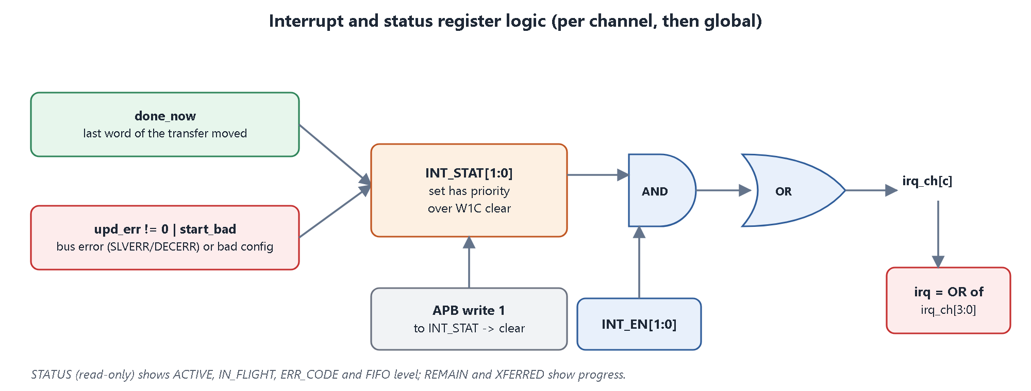
Figure 18. Interrupt logic: two event sources set INT_STAT; software clears it by writing 1; INT_EN masks it; the channel lines are ORed into irq.
Table 17. Interrupt causes
Bit | Name | Set when | Typical software reaction
0 | DONE | all LEN words moved | process the buffer, start the next transfer
1 | ERR | SLVERR, DECERR or bad configuration; cause in STATUS.ERR_CODE | log, fix, restart the channel

dma_channel.sv - interrupt status (excerpt)
assign int_set = { (upd && upd_err != ERR_NONE) || start_bad, // ERR
done_now }; // DONE
// set has priority over a simultaneous write-1-to-clear
int_stat <= (int_stat & ~(wr_int_stat ? reg_wdata[1:0] : 2'b00)) | int_set;
assign irq = |(int_stat & int_en); // per channel; top: irq = |irq_ch

Status visibility. STATUS gives ACTIVE, IN_FLIGHT, ERR_CODE and the FIFO level; REMAIN and XFERRED give progress. Globally, GSTAT shows which channels are active and whether the engine is busy, and IRQ_SUM shows all channel interrupt lines in one read.
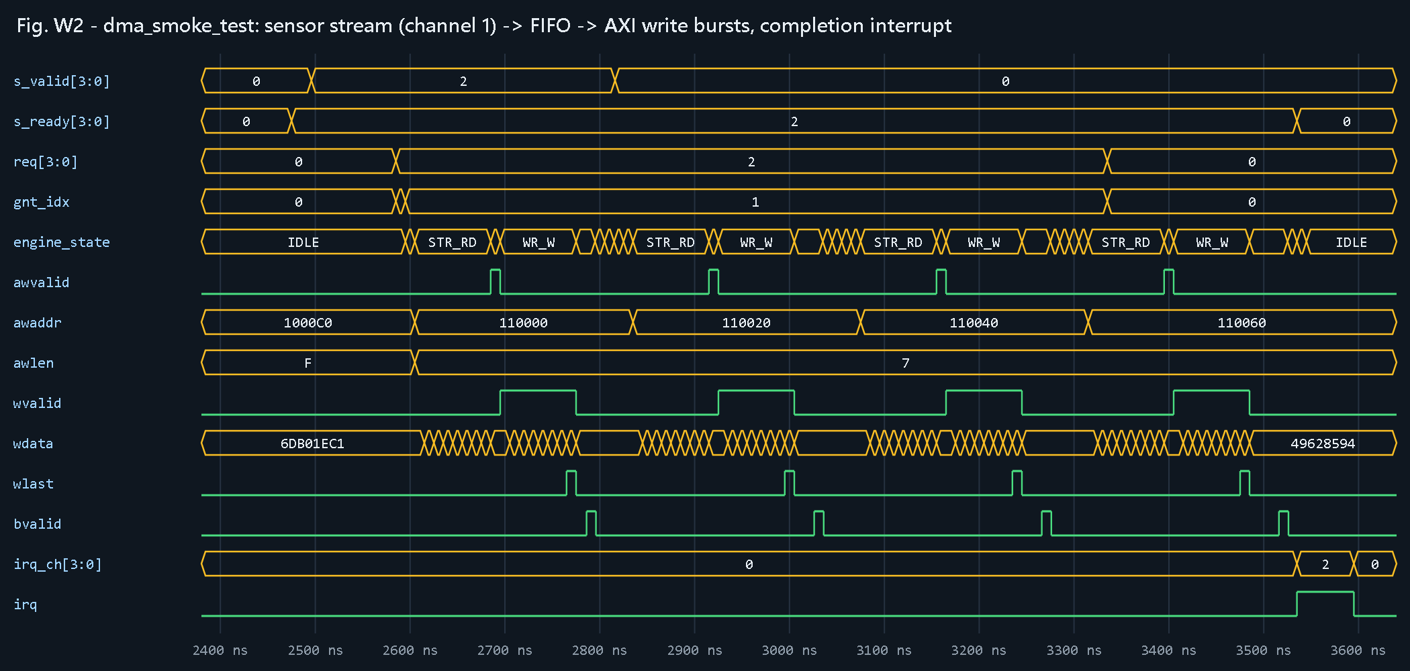
Figure 19. Simulation of a sensor transfer on channel 1: words enter the FIFO (s_valid / s_ready), the engine drains them as 8-beat bursts to consecutive addresses, and irq_ch[1] and irq rise when the transfer is complete.

3.5 Perform RTL simulation
What the milestone asks | Simulate the RTL to show that it works.
What we built | A scripted compile / elaborate / simulate flow in Vivado xsim, 8 directed tests + constrained-random tests with 5 seeds, waveform dumps, logs and coverage databases. FPGA synthesis as an extra check.
Evidence (files) | sim/ (build, run_test, regress, coverage_report scripts), sim/logs/, synth/

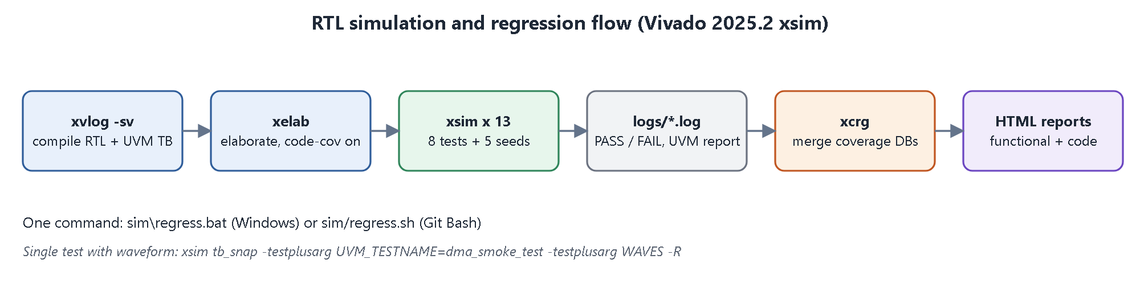
Figure 20. Simulation and regression flow.
Commands
sim\regress.bat :: build + all 13 runs + coverage reports
sim\run_test.bat dma_sensor_fusion_test :: one test (args: test [seed] [iterations])
xsim tb_snap -testplusarg UVM_TESTNAME=dma_smoke_test -testplusarg WAVES -R :: with VCD

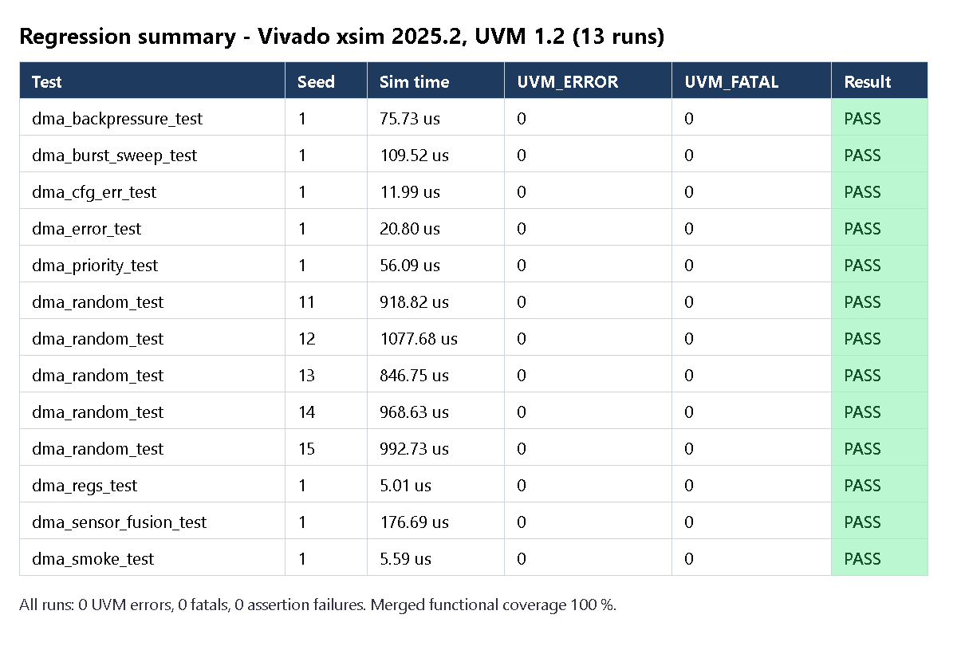
Figure 21. Regression result of the final run: 13 of 13 runs pass, 0 UVM errors, 0 fatals.

3.5.1 The ADAS scenario in simulation
dma_sensor_fusion_test runs all four streams at the same time:
Table 18. Sensor-fusion scenario
Channel | Words | Finished after (cycles) | Observation
CH1 radar (P3) | 256 | 1 120 | finishes first although it started together with the camera (checked by the test)
CH2 LiDAR (P2) | 1 024 | 4 277 | served before camera and diagnostics
CH0 camera (P1) | 4 608 | 15 978 | crosses a 4 KB page; bursts split automatically
CH3 diagnostics (P0) | 512 | 17 345 | lowest priority: uses the bus when the sensors are idle

All 6 400 words were checked by the scoreboard; the completion order follows the priorities exactly.

3.5.2 Synthesis check (beyond the brief)
Table 19. Synthesis results
Metric | Result (xc7a100t, Vivado 2025.2, out-of-context)
LUTs | 1 660 (2.6 %)
Flip-flops | 1 065 (0.8 %)
BRAM / DSP | 0 / 0
Clock | 100 MHz, WNS +1.742 ns, all constraints met, 0 critical warnings (post-synthesis estimate)

During development the first synthesis attempt failed timing (WNS -8.1 ns) and used far too many flip-flops. Two RTL fixes solved it: memories without reset (so they map to LUT-RAM) and registering the channel request (the LATCH and SETTLE states).
Milestone 2 - outcome
All five items are complete: channel controller (3.1), arbitration logic (3.2), transfer state machine (3.3), interrupt and status registers (3.4), RTL simulation with passing regression (3.5).
The RTL is synthesizable and meets 100 MHz on an Artix-7 FPGA.

4. Milestone 3: Verification and Validation
Milestone 3 proves that the RTL meets requirements R1-R10. The approach is a self-checking, coverage-driven UVM testbench: stimulus is generated as transactions, a reference model predicts what the DUT must do, assertions check protocol rules every clock cycle, and covergroups measure which scenarios have really been exercised.

4.1 Develop SystemVerilog testbench
What the milestone asks | Develop a SystemVerilog transaction-based testbench.
What we built | tb_top with clock/reset, four interface types with clocking blocks, the DUT, bound assertions, and transaction classes for every bus.
Evidence (files) | tb/tb_top.sv, tb/if/dma_ifs.sv, tb/uvm/dma_tb_items.svh

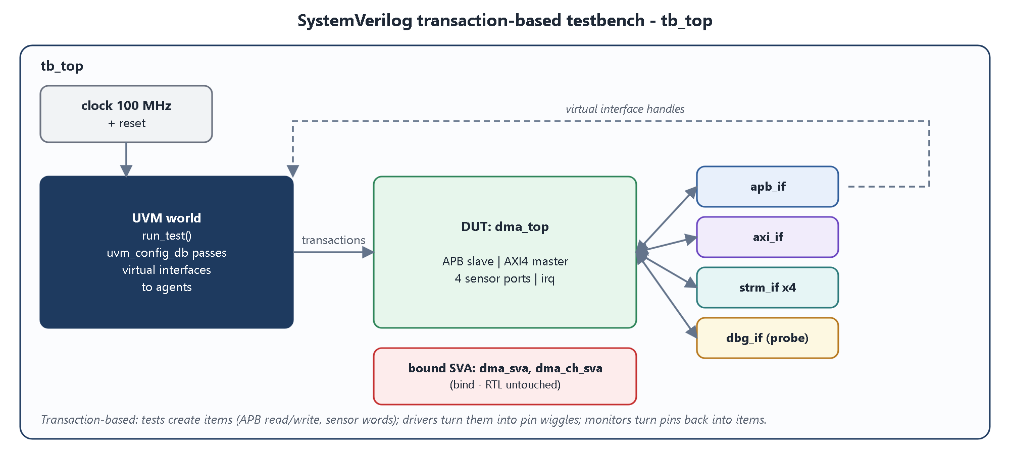
Figure 22. Testbench top level.
Table 20. Testbench interfaces
Interface | Connects | Clocking blocks
apb_if | APB master side of the DUT | drv_cb (drive), mon_cb (sample)
axi_if | AXI4 slave side (memory model) | slv_cb (respond), mon_cb (sample)
strm_if x4 | one per sensor stream | drv_cb, mon_cb
dbg_if | hierarchical probe of arbiter req/grant | mon_cb

Clocking blocks drive outputs 1 ns after the clock edge and sample inputs just before it (#1step), so the testbench never races with the DUT.
Table 21. Transaction classes
Transaction | Fields | Used by
apb_item | write, addr, data, delay | APB driver / monitor
strm_item | nwords, gap_pct, start_delay | sensor driver (random gaps model a real sensor)
strm_mon_item | channel, word, accepted / stalled | stream monitor -> scoreboard, coverage
axi_item | direction, address, length, data[], response | AXI monitor -> scoreboard, coverage
arb_item | requests, priorities, winner | arbitration monitor -> coverage

4.2 Create UVM agents and sequences
What the milestone asks | Create UVM agents (driver, monitor, sequencer) and sequences for the stimulus.
What we built | 3 agent types (APB, sensor stream x4, reactive AXI memory slave), an arbitration monitor, a virtual sequencer and 9 virtual sequences / tests.
Evidence (files) | tb/uvm/dma_tb_agents.svh, dma_tb_seqs.svh, dma_tb_tests.svh, dma_tb_env.svh

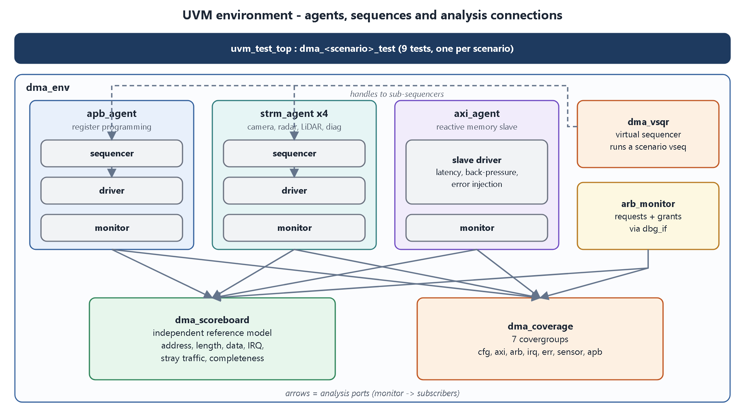
Figure 23. UVM environment.
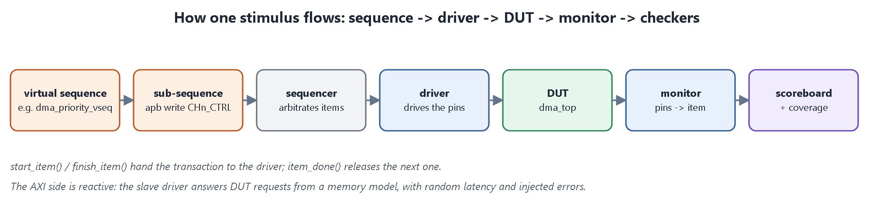
Figure 24. Life of one transaction.
Table 22. Agents
Agent | Components | Role
apb_agent | sequencer, driver, monitor | programs registers like the CPU would; monitor reports every access
strm_agent x4 | sequencer, driver, monitor | plays camera / radar / LiDAR / diag data with random gaps; monitor reports accepted and stalled words
axi_agent | reactive slave driver, monitor | memory model; random latency, back-pressure, SLVERR / DECERR injection
arb_monitor | monitor | records every arbitration decision for coverage

Table 23. Tests (each runs one virtual sequence)
Test / sequence | Scenario | Requirements
dma_regs_test | reset values, RW/RO, LEN mask, unmapped -> PSLVERR, W1C, interrupt lines | R3, R6
dma_smoke_test | one memory transfer and one sensor transfer | R1, R2
dma_sensor_fusion_test | the ADAS scenario: camera, radar, LiDAR and diag together; radar must finish first | R1, R4, R10
dma_burst_sweep_test | every BLEN 0..15, random lengths, addresses just below a 4 KB page | R2
dma_priority_test | strict priority order; long high-priority job before short low-priority job; equal priority rotation | R4, R5
dma_error_test | SLVERR read, DECERR write, error on a sensor channel, recovery, 4x4 error matrix | R6, R7, R9
dma_cfg_err_test | zero length, unaligned addresses, START without EN, START while busy | R8
dma_backpressure_test | very slow memory, three fast sensors: FIFOs fill, sensors are held off, no data lost | R10
dma_random_test | constrained-random mix of everything; 5 seeds x 40 iterations | all

4.3 Implement scoreboarding and checking
What the milestone asks | Implement a scoreboard that checks the DUT automatically.
What we built | dma_scoreboard with an independent per-channel reference model built only from observed APB writes; seven classes of checks; a mutation experiment proving the checks work.
Evidence (files) | tb/uvm/dma_tb_env.svh (ch_model, dma_scoreboard)

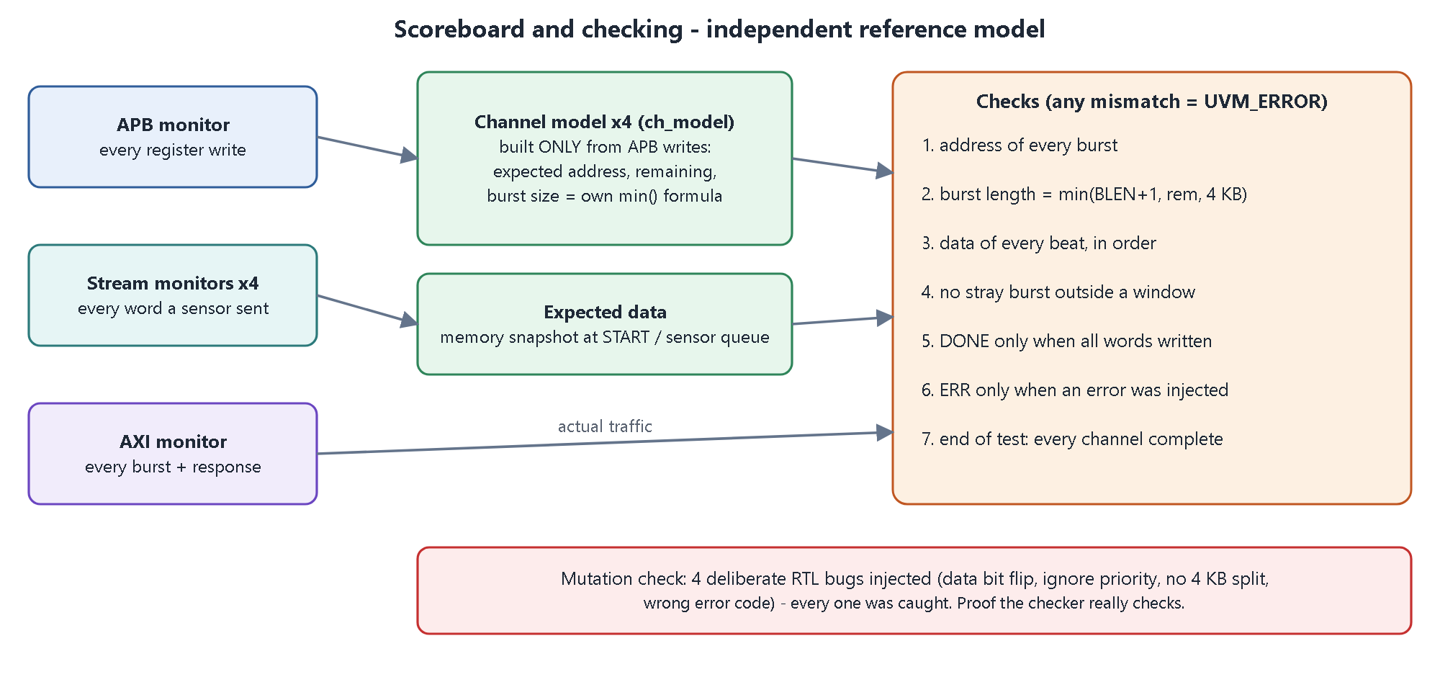
Figure 25. Scoreboard structure and checks.
The model does not look inside the RTL. It re-derives the expected burst sizes with its own copy of the min() formula and its own 4 KB arithmetic, and it remembers the source data (a memory snapshot at START, or the exact words each sensor sent) to compare with every beat written to memory. Any difference is reported as a UVM_ERROR and fails the test.
Table 24. Mutation check on the final RTL - each injected bug made its test FAIL
Injected bug (one at a time) | Caught by
data bit flipped on beat 5 of a burst | dma_smoke_test: scoreboard DATA MISMATCH word 5
arbiter ignores priority | dma_priority_test: strict priority order check
4 KB splitting removed | dma_burst_sweep_test: scoreboard burst-length check
DECERR reported as SLVERR | dma_error_test: ERR_CODE check (got 1, expected 2)

4.4 Add assertions for protocol compliance
What the milestone asks | Add SystemVerilog Assertions that check protocol rules.
What we built | 25 SVA properties (52 instances including per-channel copies) in two checker modules, attached with bind so the RTL is not modified.
Evidence (files) | tb/sva/dma_sva.sv

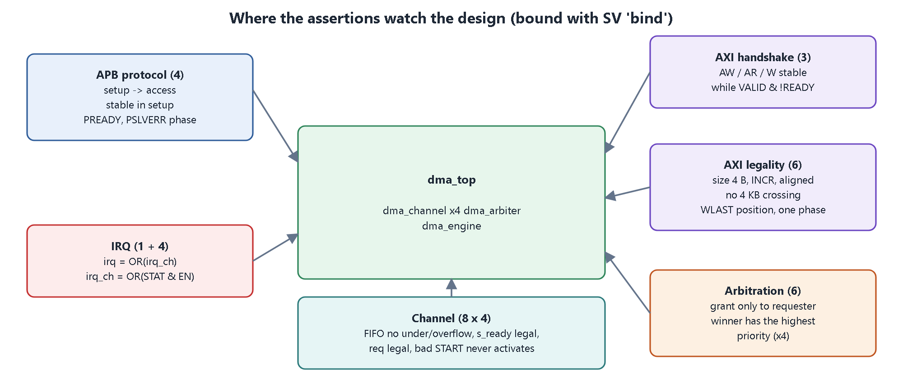
Figure 26. Assertion groups and where they are attached.
Table 25. Assertion list
Assertion | Rule checked
a_apb_access_follows_setup | a SETUP cycle is always followed by an ACCESS cycle
a_apb_stable_in_setup | PADDR / PWRITE / PWDATA stable from SETUP to ACCESS
a_apb_pready, a_apb_slverr_phase | PREADY in ACCESS; PSLVERR only in ACCESS
a_aw_stable, a_ar_stable, a_w_stable | AXI payload and VALID stable until READY
a_aw_attr, a_ar_attr | size = 4 bytes, INCR burst, word-aligned address
a_aw_4k, a_ar_4k | no burst crosses a 4 KB boundary
a_wlast_pos | WLAST exactly on beat AWLEN+1
a_one_phase | only one of AW / W / AR / B / R active at a time (single outstanding burst)
a_gnt_is_req, a_fire_has_gnt | grant only to a requesting channel; fire only with a valid grant
a_prio_order (x4) | the winner has the highest priority of all requesters
a_irq_or | irq = OR of irq_ch
a_sready_only_active | s_ready only when the channel is an active sensor channel
a_no_underflow, a_fifo_bound | no FIFO pop when empty; level never exceeds 32
a_upd_needs_inflight | completion only for the channel being served
a_req_legal, a_beats_range | request only from an enabled active channel; burst size 1..16
a_irq_def | irq_ch = OR(INT_STAT & INT_EN)
a_bad_start_inactive | an illegal START never activates the channel

dma_sva.sv - two examples
a_aw_4k : assert property (disable iff (!rst_n)
awvalid |-> ({1'b0, awaddr[11:0]} + ((13'(awlen) + 13'd1) << 2)) <= 13'd4096)
else $error("AXI: write burst crosses a 4KB boundary");

a_aw_stable : assert property (disable iff (!rst_n)
awvalid && !awready |=> awvalid && $stable(awaddr) && $stable(awlen))
else $error("AXI: AW changed/dropped before AWREADY");

Result: 0 assertion failures in all 13 regression runs. (xsim 2025.2 does not execute cover property; the same scenarios are measured with covergroups instead.)

4.5 Generate functional and code coverage reports
What the milestone asks | Measure coverage and generate functional and code coverage reports.
What we built | 7 covergroups with crosses, merged over all 13 runs with xcrg; HTML functional and code coverage reports.
Evidence (files) | tb/uvm/dma_tb_env.svh (dma_coverage), sim/report/functional/, sim/report/code/

Table 26. Covergroups
Covergroup | What it measures
cg_cfg | channel x mode (memory/sensor) x priority x burst length x transfer length, with crosses
cg_axi | read/write x burst length x response (OKAY/SLVERR/DECERR) x burst ending on a 4 KB boundary
cg_arb | number of simultaneous requesters x winner; winner priority x best competing priority
cg_irq | channel x interrupt cause (DONE / ERR)
cg_err | channel x error code (none, SLVERR, DECERR, bad config)
cg_sensor | channel x word accepted vs back-pressured
cg_apb | register region (global / channel / unmapped) x read/write x PSLVERR

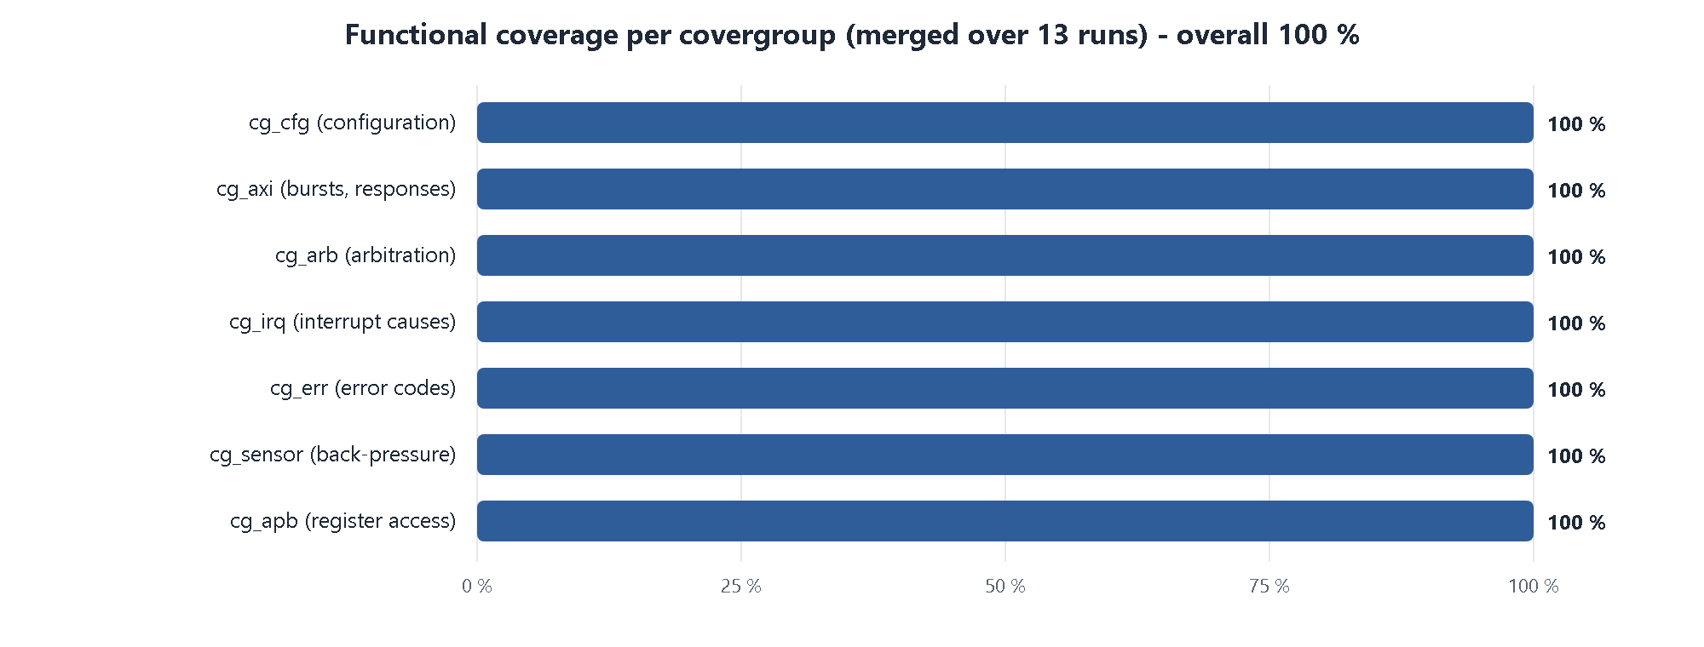
Figure 27. Functional coverage per covergroup.
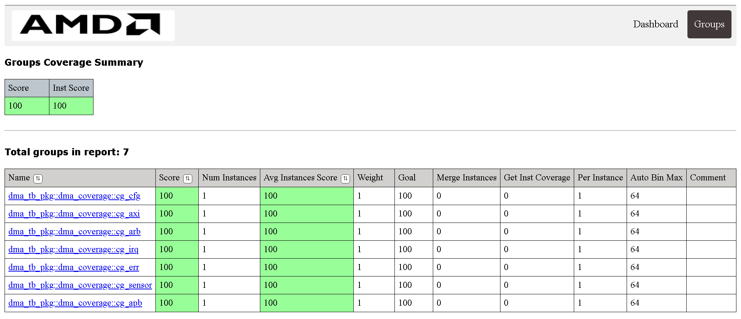
Figure 28. Merged functional coverage report generated by Vivado xcrg.
Table 27. Code coverage of the RTL modules
RTL module | Statement % | Branch % | Condition % | Toggle %
dma_top | 100 | 94.1 | 83.3 | 71.6
dma_channel | 100 | 100 | 97.2 | 54.6
dma_sfifo | 100 | 100 | 100 | 99.5
dma_arbiter | 100 | 100 | 100 | 100
dma_engine | 100 | 100 | 97.9 | 92.0

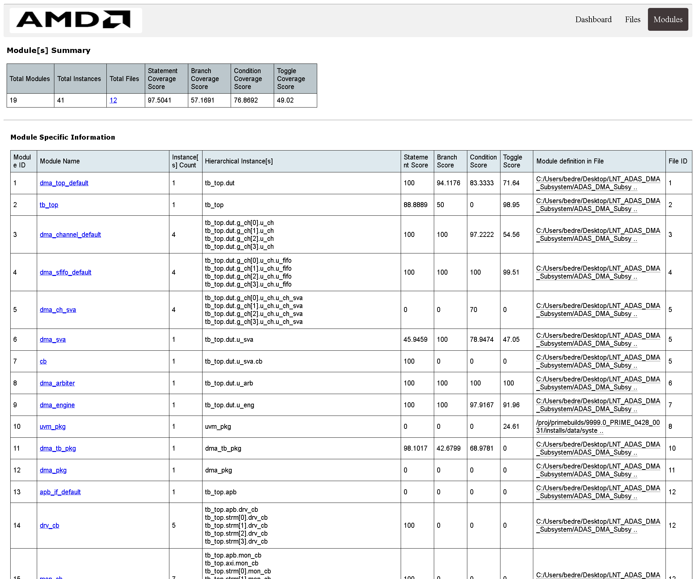
Figure 29. Code coverage report (Vivado xcrg, per module).

4.5.1 Coverage analysis
- Functional coverage 100 %. Every bin of all 7 covergroups was hit at least once over the regression.
- Statement coverage 100 % on every RTL module: every line of design code was executed.
- Toggle coverage is lower in dma_top / dma_channel because the high bits of 32-bit addresses and the 24-bit length never change in a small test memory; this is expected and documented.
- Testbench modules (interfaces, assertion checkers, UVM package) appear in the tool totals but are not design code.
Milestone 3 - outcome
All five items are complete: SV testbench (4.1), UVM agents and sequences (4.2), scoreboard and checking (4.3), protocol assertions (4.4), functional and code coverage reports (4.5).
13/13 runs pass, 0 UVM errors, 0 assertion failures, 100 % functional coverage, 100 % statement coverage.

5. Milestone compliance checklist
Table 28. Every milestone item and its evidence
# | Milestone item | Status | Evidence
M1.1 | Study DMA architecture used in SoCs | Done | Section 2.1, docs/01, docs/02
M1.2 | Define channel configuration registers | Done | Section 2.2, docs/03_register_map.md
M1.3 | Design arbitration scheme | Done | Section 2.3, Figures 5-6
M1.4 | Create datapath and controller architecture | Done | Section 2.4, Figures 7-8
M1.5 | Develop RTL block diagram | Done | Section 2.5, docs/block_diagram.svg
M2.1 | Implement DMA channel controller | Done | rtl/dma_channel.sv, rtl/dma_sfifo.sv
M2.2 | Design arbitration logic | Done | rtl/dma_arbiter.sv
M2.3 | Implement transfer state machine | Done | rtl/dma_engine.sv
M2.4 | Integrate interrupt and status registers | Done | rtl/dma_channel.sv, rtl/dma_top.sv
M2.5 | Perform RTL simulation | Done | sim/, sim/logs/ (13/13 pass)
M3.1 | Develop SystemVerilog testbench | Done | tb/tb_top.sv, tb/if/
M3.2 | Create UVM agents and sequences | Done | tb/uvm/ (3 agents, 9 sequences)
M3.3 | Implement scoreboarding and checking | Done | dma_scoreboard, mutation check
M3.4 | Add assertions for protocol compliance | Done | tb/sva/dma_sva.sv (25 properties)
M3.5 | Generate functional and code coverage reports | Done | sim/report/ (100 % functional)

6. Conclusion
The project delivers a complete, verified multi-channel DMA subsystem for an ADAS platform. Four channels move camera, radar, LiDAR and diagnostic data into memory with AXI4 bursts while the CPU only programs registers and handles interrupts. A per-burst arbiter with priority and round-robin keeps the critical radar latency bounded to about one burst and shares the bus fairly between equal channels. Errors from the memory system and illegal configurations are detected and isolated to the affected channel.
A UVM environment with an independent reference model, 25 protocol assertions and 7 covergroups verified the design: all 13 regression runs pass, functional coverage is 100 % and every RTL line was executed. The RTL also synthesizes for an Artix-7 FPGA at 100 MHz.

Possible future work
- anti-starvation aging, so a low-priority channel is guaranteed the bus even under constant high-priority load;
- a bus watchdog that reports a memory that never answers;
- continuous (ring) mode for back-to-back camera frames without software restarts;
- descriptor (scatter-gather) chains in memory for longer, non-contiguous transfers;
- multiple outstanding AXI bursts to overlap reads and writes and raise efficiency;
- 64- or 128-bit data paths for higher camera bandwidth;
- a UVM register model (RAL) and formal proofs of the arbiter properties;
- place-and-route and on-board testing on an FPGA.

Appendix A. Project files
Table 29. Folder structure
Folder / file | Content
docs/ | requirements, architecture, register map, verification plan, block diagram, this report
docs/figures/ | all diagrams, waveforms and coverage screenshots used in the reports
rtl/ | dma_pkg, dma_sfifo, dma_channel, dma_arbiter, dma_engine, dma_top
tb/tb_top.sv, tb/if/ | testbench top and interfaces
tb/sva/ | assertion checkers (bound to the DUT)
tb/uvm/ | items, agents, scoreboard, coverage, environment, sequences, tests
sim/ | build / run / regression / coverage scripts (.bat and .sh), logs, HTML reports
synth/ | Vivado synthesis script, utilisation and timing reports
scripts/ | waveform and diagram generators used for the figures

Appendix B. Glossary
Table 30. Terms used in this report
Term | Meaning
ADAS | Advanced Driver Assistance System
DMA | Direct Memory Access - hardware that copies data without the CPU
APB | Advanced Peripheral Bus - simple control bus
AXI4 | Advanced eXtensible Interface - high-performance burst bus
Beat | one data transfer of a burst (here 4 bytes)
INCR burst | burst whose address increments each beat
W1C | write-1-to-clear register bit
FIFO | first-in first-out buffer
Round-robin | taking turns: the next tie goes to the channel after the last winner
UVM | Universal Verification Methodology
SVA | SystemVerilog Assertions
Scoreboard | testbench component that compares DUT output with expected results
Covergroup | SystemVerilog construct that counts which scenarios were exercised

