L&T EduTech | VLSI Principles, RTL Design and Verification | Project 1
Multi-Channel DMA Controller Subsystem
Project Status Report
Status of every item in the problem statement, the verification requirements and the three milestones

Item | Details
Student name
Registration / LMS ID
Report date | 21 October 2026
Overall status | COMPLETE - all items of the brief implemented, verified and documented
Tools | SystemVerilog, UVM 1.2, SVA, AMD Vivado 2025.2 (xsim, xcrg, synthesis)

Contents

1. Executive summary
2. What was asked
3. Status of the problem-statement capabilities
3.1 Proof from simulation: the ADAS scenario
4. Status of the verification requirements
5. Status of the milestones
5.1 Milestone 1: Requirements and Architecture Design
5.2 Milestone 2: RTL Implementation
5.3 Milestone 3: Verification and Validation
6. Requirements traceability (R1 - R10)
7. Verification results
7.1 Regression
7.2 Coverage
7.3 Does the testbench really catch bugs?
8. Implementation results (synthesis)
9. Scope of the delivered design
10. Deliverables
11. Known limits and remaining actions
11.1 Known limits (documented, not defects)
11.2 Remaining actions before submission
(In Word: right-click the list and choose Update Field to add page numbers.)

1. Executive summary
Overall status: COMPLETE
All 5 capabilities required by the problem statement are implemented in synthesizable SystemVerilog RTL.
All 4 verification requirements are met: transaction-based testbench, assertions, covergroups and functional coverage reports.
All 15 milestone items (3 milestones x 5 items) are complete, each with files that prove it.
Final regression: 13 of 13 test runs pass, 0 UVM errors, 0 assertion failures.
Coverage: 100 % functional, 100 % statement coverage on every RTL module.
Synthesis on an Artix-7 FPGA: 1 660 LUTs, 1 065 flip-flops, 100 MHz met (+1.74 ns slack), 0 errors, 0 critical warnings.

Table 1. Status at a glance
Area | Items | Complete | Status
Problem-statement capabilities | 5 | 5 | COMPLETE
Verification requirements | 4 | 4 | COMPLETE
Milestone 1: Requirements and Architecture Design | 5 | 5 | COMPLETE
Milestone 2: RTL Implementation | 5 | 5 | COMPLETE
Milestone 3: Verification and Validation | 5 | 5 | COMPLETE
Functional requirements R1 - R10 (derived from the brief) | 10 | 10 | COMPLETE
Total | 34 | 34 | COMPLETE

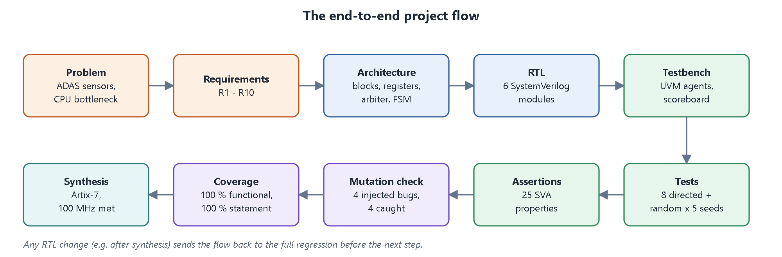
Figure 1. Project flow followed from problem to synthesis - every step is complete.

2. What was asked
The problem statement describes an automotive SoC manufacturer building an ADAS platform that must continuously move high-bandwidth sensor data from cameras, radar and LiDAR into memory while minimising CPU overhead. The existing processor-centric data movement causes performance bottlenecks and latency. The company asked for a configurable DMA subsystem that can:
- manage multiple concurrent data streams,
- prioritise critical sensor transfers,
- support burst transactions,
- generate status interrupts, and
- provide reliable error handling.
It also asked for a SystemVerilog transaction-based testbench, assertions, covergroups and functional coverage reports, delivered through three milestones of five items each.
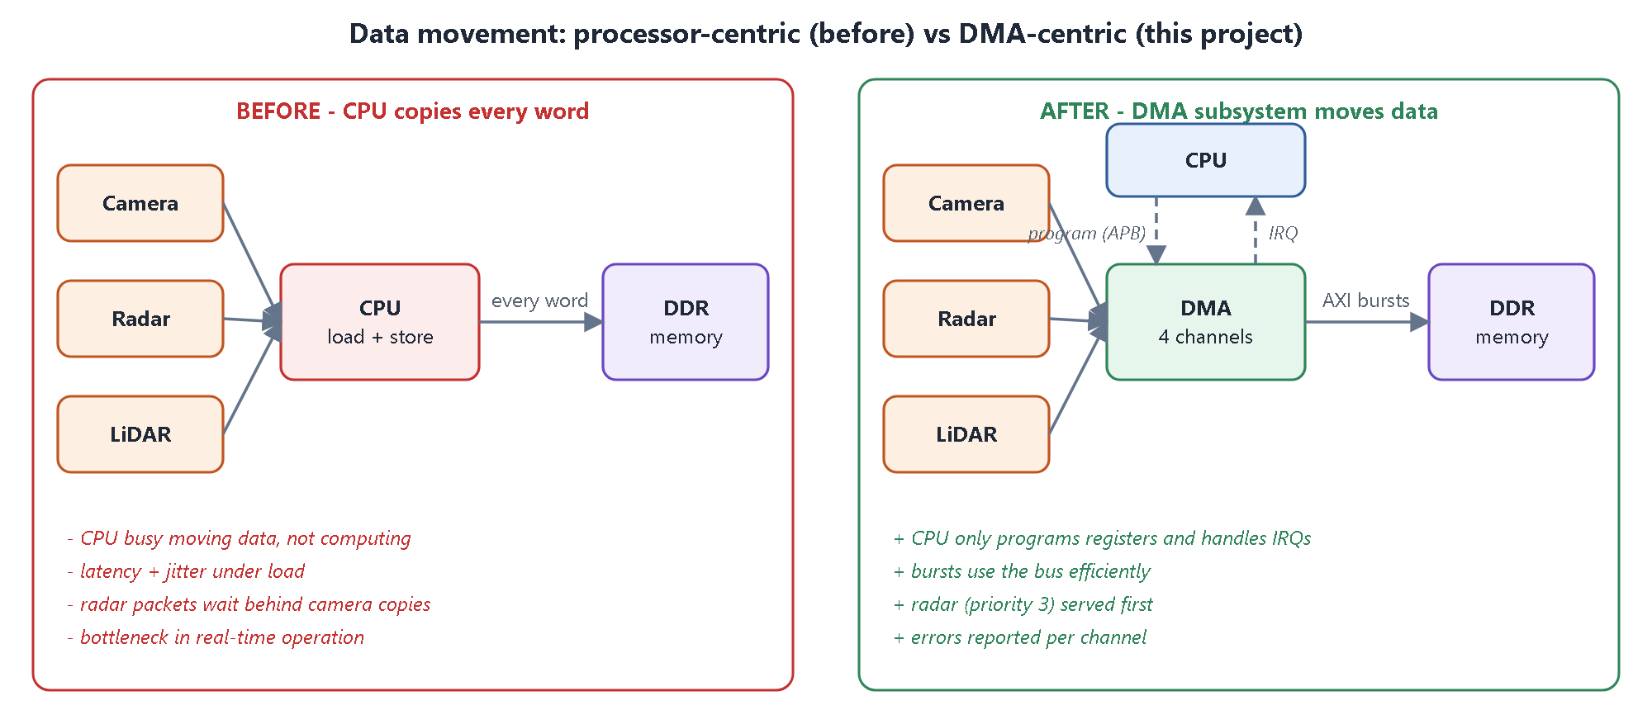
Figure 2. The problem (CPU copies every word) and the solution delivered (DMA moves the data in bursts).

3. Status of the problem-statement capabilities
Table 2. Problem-statement capabilities
# | Item asked for | Status | Evidence
C1 | Manage multiple concurrent data streams | COMPLETE | 4 independent channels (memory-to-memory or sensor-to-memory) sharing one burst engine - rtl/dma_channel.sv, rtl/dma_engine.sv. Verified by dma_sensor_fusion_test (4 streams at once) and dma_random_test.
C2 | Prioritise critical sensor transfers | COMPLETE | 2-bit priority per channel, decided at every burst boundary; round-robin among equal priorities - rtl/dma_arbiter.sv. Verified by dma_priority_test and assertion a_prio_order; radar finishes first in the ADAS test.
C3 | Support burst transactions | COMPLETE | AXI4 INCR bursts of 1-16 beats, automatically split at 4 KB boundaries. Verified by dma_burst_sweep_test (all 16 burst lengths), scoreboard length check and assertions a_aw_4k / a_ar_4k.
C4 | Generate status interrupts | COMPLETE | DONE and ERR per channel, maskable (INT_EN), write-1-to-clear (INT_STAT), global irq; STATUS / REMAIN / XFERRED registers. Verified by dma_regs_test and assertions a_irq_def / a_irq_or.
C5 | Reliable error handling | COMPLETE | SLVERR / DECERR detected and isolated to one channel with an error code; illegal configurations rejected with no bus traffic; restart after error. Verified by dma_error_test (4 x 4 error matrix) and dma_cfg_err_test.

3.1 Proof from simulation: the ADAS scenario
Table 3. All four streams running together (dma_sensor_fusion_test)
Channel | Words | Priority | Finished after (cycles)
CH1 radar | 256 | 3 (highest) | 1 120 - first
CH2 LiDAR | 1 024 | 2 | 4 277
CH0 camera | 4 608 | 1 | 15 978
CH3 diagnostics | 512 | 0 | 17 345

All 6 400 words were checked by the scoreboard, and the completion order follows the priorities exactly - the critical radar data is never stuck behind the camera frame.

4. Status of the verification requirements
Table 4. Verification requirements
# | Item asked for | Status | Evidence
V1 | Develop a SystemVerilog transaction-based testbench | COMPLETE | UVM environment: APB agent, 4 sensor-stream agents, reactive AXI memory agent, arbitration monitor, scoreboard, coverage, virtual sequencer - tb/.
V2 | Develop assertions to verify ... | COMPLETE | 25 SVA properties (52 instances) for APB protocol, AXI handshake and legality (incl. 4 KB rule and WLAST), arbitration order, channel rules and interrupts - tb/sva/dma_sva.sv. 0 failures.
V3 | Create covergroups to measure ... | COMPLETE | 7 covergroups: configuration, AXI bursts and responses, arbitration, interrupts, error codes, sensor back-pressure, APB access - tb/uvm/dma_tb_env.svh.
V4 | Generate functional coverage reports | COMPLETE | Merged HTML reports from Vivado xcrg - sim/report/functional/ (100 %) and sim/report/code/ (100 % statement).

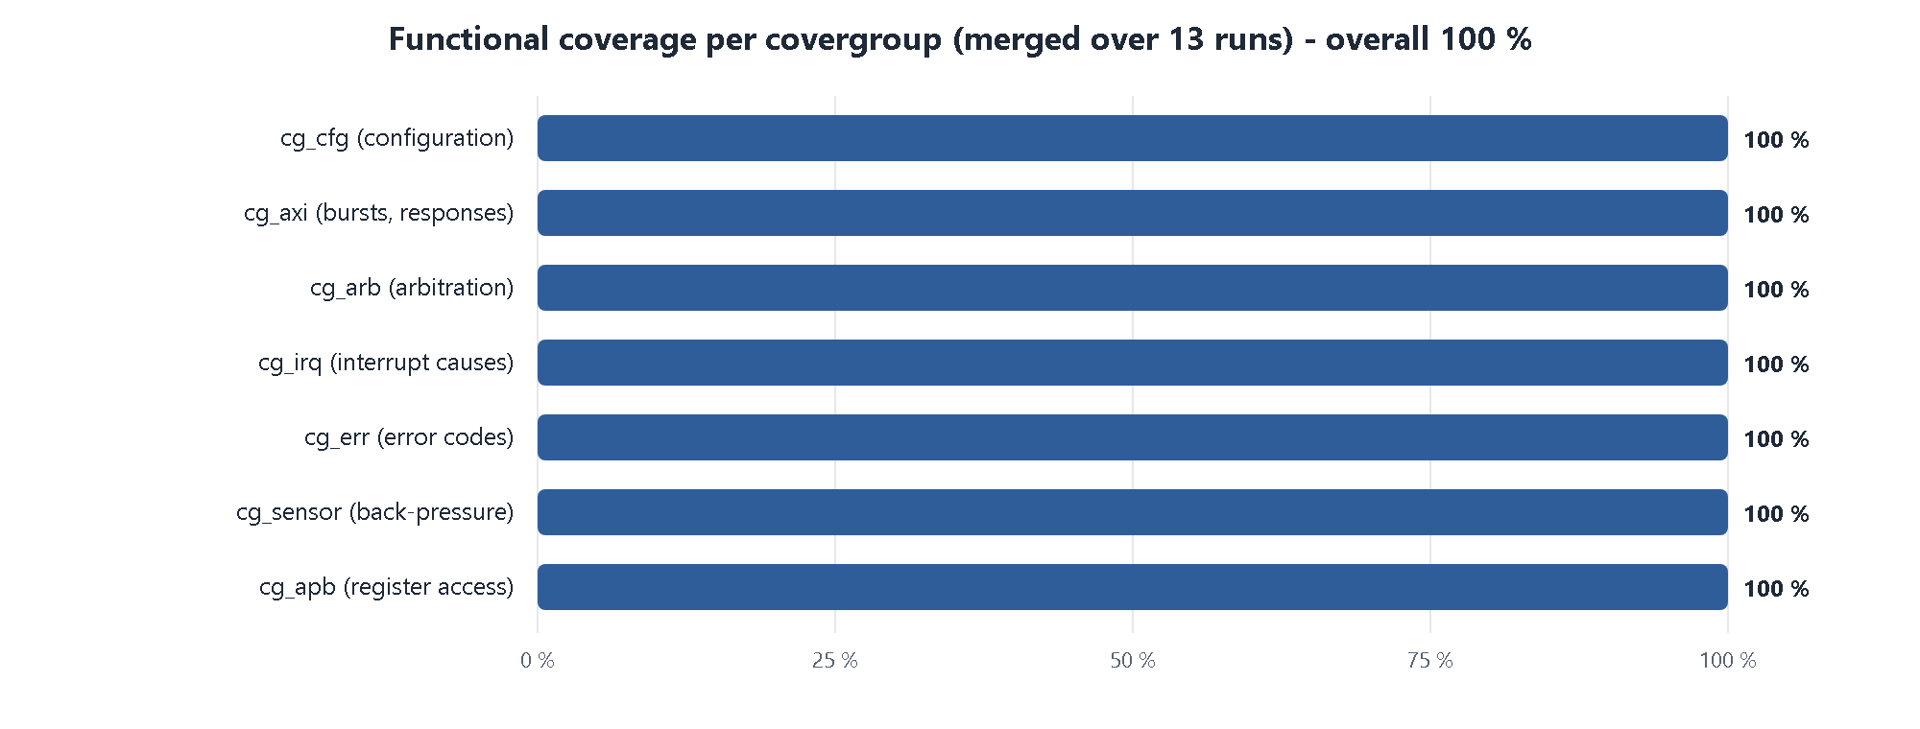
Figure 3. Functional coverage per covergroup - every covergroup at 100 %.

5. Status of the milestones

5.1 Milestone 1: Requirements and Architecture Design
Table 5. Milestone 1
# | Item asked for | Status | Evidence
M1.1 | Study DMA architecture used in SoCs | COMPLETE | docs/01_problem_and_requirements.md, docs/02_architecture.md; Milestones Report section 2.1
M1.2 | Define channel configuration registers | COMPLETE | docs/03_register_map.md - 4 global + 9 per-channel registers with bit fields; rtl/dma_pkg.sv
M1.3 | Design arbitration scheme for multiple DMA requests | COMPLETE | Priority + round-robin, one decision per burst - docs/02_architecture.md section 2.5
M1.4 | Create datapath and controller architecture | COMPLETE | Store-and-forward datapath, channel / arbiter / engine controller split - docs/02_architecture.md sections 2.2-2.4
M1.5 | Develop RTL block diagram | COMPLETE | docs/block_diagram.svg; module hierarchy and port list in the reports

5.2 Milestone 2: RTL Implementation
Table 6. Milestone 2
# | Item asked for | Status | Evidence
M2.1 | Implement DMA channel controller | COMPLETE | rtl/dma_channel.sv (+ rtl/dma_sfifo.sv), instantiated 4 times
M2.2 | Design arbitration logic | COMPLETE | rtl/dma_arbiter.sv - priority scan from a round-robin pointer
M2.3 | Implement transfer state machine | COMPLETE | rtl/dma_engine.sv - 10-state burst FSM, AXI4 master
M2.4 | Integrate interrupt and status registers | COMPLETE | INT_EN / INT_STAT / STATUS / REMAIN / XFERRED in rtl/dma_channel.sv; GSTAT / IRQ_SUM in rtl/dma_top.sv
M2.5 | Perform RTL simulation | COMPLETE | sim/ scripts, sim/logs/ - 13 of 13 runs pass; waveforms in docs/figures/

5.3 Milestone 3: Verification and Validation
Table 7. Milestone 3
# | Item asked for | Status | Evidence
M3.1 | Develop SystemVerilog testbench | COMPLETE | tb/tb_top.sv, tb/if/dma_ifs.sv, transaction items
M3.2 | Create UVM agents and sequences | COMPLETE | tb/uvm/ - 3 agent types, 9 virtual sequences / tests
M3.3 | Implement scoreboarding and checking | COMPLETE | dma_scoreboard with an independent reference model; mutation check: 4 of 4 injected bugs caught
M3.4 | Add assertions for protocol compliance | COMPLETE | tb/sva/dma_sva.sv - 25 properties, 0 failures
M3.5 | Generate functional and code coverage reports | COMPLETE | sim/report/ - 100 % functional, 100 % statement on all RTL modules

6. Requirements traceability (R1 - R10)
The brief was turned into ten testable requirements. Each one is implemented in a named RTL block and checked by named tests and assertions.
Table 8. Traceability matrix
ID | Requirement | Implemented in | Verified by | Status
R1 | 4 channels, memory or sensor source | dma_channel x4 | smoke, sensor_fusion, random | COMPLETE
R2 | AXI4 INCR bursts 1-16 beats, no 4 KB crossing | dma_engine, dma_channel | burst_sweep, a_aw_4k, a_ar_4k, scoreboard | COMPLETE
R3 | APB register interface | dma_top, dma_channel | regs_test, APB assertions | COMPLETE
R4 | Higher priority served first | dma_arbiter | priority_test, sensor_fusion, a_prio_order | COMPLETE
R5 | Round-robin among equal priorities | dma_arbiter | priority_test (grant rotation check) | COMPLETE
R6 | DONE / ERR interrupts, maskable, W1C | dma_channel, dma_top | regs_test, a_irq_def, a_irq_or | COMPLETE
R7 | Bus error isolated to one channel | dma_engine, dma_channel | error_test (4 x 4 matrix) | COMPLETE
R8 | Illegal configuration rejected, no traffic | dma_channel | cfg_err_test, a_bad_start_inactive | COMPLETE
R9 | Restart after error | dma_channel | error_test, cfg_err_test | COMPLETE
R10 | No data loss (back-pressure) | dma_channel, dma_sfifo | backpressure_test, scoreboard data check | COMPLETE

7. Verification results

7.1 Regression
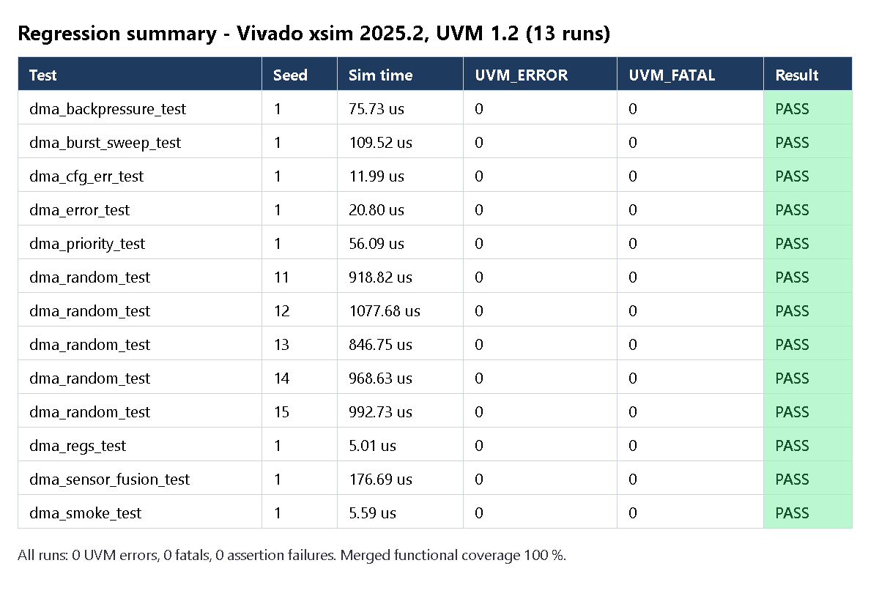
Figure 4. Final regression: 13 of 13 runs pass, 0 UVM errors, 0 fatals.
Table 9. Tests
Test | Purpose | Result
dma_regs_test | Register reset values, access types, PSLVERR, write-1-to-clear | PASS
dma_smoke_test | One memory and one sensor transfer | PASS
dma_sensor_fusion_test | ADAS scenario: 4 streams at once, radar first | PASS
dma_burst_sweep_test | All burst lengths, 4 KB splitting | PASS
dma_priority_test | Priority order and round-robin rotation | PASS
dma_error_test | SLVERR / DECERR isolation and recovery | PASS
dma_cfg_err_test | Illegal configurations rejected | PASS
dma_backpressure_test | Slow memory, sensors held off, no data lost | PASS
dma_random_test (5 seeds) | Constrained-random mix, about 20 000 checks per run | PASS x 5

7.2 Coverage
Table 10. Code coverage (functional coverage: 100 %)
RTL module | Statement % | Branch % | Condition % | Toggle %
dma_top | 100 | 94.1 | 83.3 | 71.6
dma_channel | 100 | 100 | 97.2 | 54.6
dma_sfifo | 100 | 100 | 100 | 99.5
dma_arbiter | 100 | 100 | 100 | 100
dma_engine | 100 | 100 | 97.9 | 92.0

Toggle coverage is lower in dma_top and dma_channel only because the upper bits of 32-bit addresses never change in the small simulated memory; it is not a functional gap.

7.3 Does the testbench really catch bugs?
Table 11. Mutation check on the final RTL
Injected bug | Caught by | Result
Data bit flipped on beat 5 | dma_smoke_test (scoreboard) | Caught
Arbiter ignores priority | dma_priority_test | Caught
4 KB splitting removed | dma_burst_sweep_test (scoreboard) | Caught
DECERR reported as SLVERR | dma_error_test | Caught

8. Implementation results (synthesis)
Table 12. Synthesis (post-synthesis estimate)
Metric | Result (xc7a100t, Vivado 2025.2, out-of-context)
Slice LUTs | 1 660 (2.6 % of the device)
Flip-flops | 1 065 (0.8 %)
Block RAM / DSP | 0 / 0
Clock | 100 MHz met, worst slack +1.742 ns
Errors / critical warnings | 0 / 0

Synthesis is beyond what the brief requires; it shows the RTL is real, implementable hardware.

9. Scope of the delivered design
Table 13. What is in and out of scope
Category | Features
Required by the brief | 4 concurrent channels; priority arbitration; AXI4 burst transfers; DONE / ERR interrupts and status registers; error detection, isolation and restart
Basic extras (needed for correctness) | Sensor-stream input with a 32-word FIFO per channel; round-robin between equal priorities; automatic 4 KB burst splitting; illegal-configuration detection
Not included (future work) | Anti-starvation aging, continuous / ring mode, bus watchdog, abort, performance counters, scatter-gather descriptors

10. Deliverables
Table 14. Deliverables
Deliverable | Location | Status
Requirements and architecture documents | docs/01 - docs/04, docs/block_diagram.svg | COMPLETE
RTL source (6 modules) | rtl/ | COMPLETE
UVM testbench and assertions | tb/ | COMPLETE
Simulation and regression scripts | sim/*.bat, sim/*.sh | COMPLETE
Regression logs | sim/logs/ | COMPLETE
Functional and code coverage reports (HTML) | sim/report/ | COMPLETE
Synthesis script and reports | synth/ | COMPLETE
Milestones Report | docs/ADAS_DMA_Milestones_Report.docx | COMPLETE
Complete Project Flow | docs/ADAS_DMA_Complete_Project_Flow.docx | COMPLETE
Project Status Report (this document) | docs/ADAS_DMA_Project_Status_Report.docx | COMPLETE
Submission package | LNT_ADAS_DMA_Subsystem_Submission.zip (next to the project folder) | COMPLETE

11. Known limits and remaining actions

11.1 Known limits (documented, not defects)
- One outstanding AXI burst at a time (reads and writes do not overlap).
- 32-bit data, INCR bursts only; one transfer per channel (no descriptor chains).
- Strict priority: a long high-priority transfer delays lower priorities until it finishes (intentional for safety-critical radar).
- No formal verification or UVM register model; xsim ignores cover property; synthesis numbers are pre-route estimates.

11.2 Remaining actions before submission
Table 15. Remaining actions
Action | Who | Status
Fill in student name and LMS ID on the cover pages of the three reports | Student | To do
Open each report in Word and update the table of contents (right-click, Update Field) | Student | To do
Export to PDF if the LMS portal requires PDF | Student | If required
Upload LNT_ADAS_DMA_Subsystem_Submission.zip to the LMS portal | Student | To do

