# Style Transfer

*A Course Project Report Submitted in partial fulfillment of the course requirements for the award of grades in the subject of*

# DEEP LEARNING

by

|  |  |
| --- | --- |
| 1. **Dushyanth** | **2210030454** |
| **Ch. Advith** | **2210030438** |
| 1. **Shashank** | **2210030417** |
| 1. **Harshith** | **2210030125** |
| 1. **Charan** | **2210030426** |

*Under the esteemed guidance of*

## Dr. Sumit Hazra

Assistant Professor

Department of Computer Science and Engineering



## DEPARTMENT OF COMPUTER SCIENCE AND ENGINEERING

**K L Deemed to be UNIVERSITY**

*Aziznagar, Moinabad , Hyderabad , Telangana , Pincode: 500075*

2024-2025

# CONTENTS

Page No.

|  |  |
| --- | --- |
| **1. Project Overview** | **3** |
| **2. Key Concepts** | **5** |
| **3. Steps in Building the Project** | **5** |
| **4. Outcome of the Project** | **8** |
| **5. Challenges Faced** | **10** |
| **6. Future Enhancements** | **12** |
| **7. Conclusion** | **14** |

# Project Overview

Style transfer is a deep learning technique that transforms an input image, such as a hand-drawn sketch, into a realistic photograph while preserving its structural characteristics. This project explores the application of neural networks, particularly Convolutional Neural Networks (CNNs) and Generative Adversarial Networks (GANs), to achieve high-quality image translation from sketches to realistic images. By leveraging deep learning architectures, the model learns to capture complex patterns and textures from training data and applies them to input sketches to generate visually accurate and lifelike images.

The core concept of style transfer is based on learning representations from a dataset that contains pairs of simple sketches and their corresponding real-world images. The model is trained to recognize the structural components of a sketch and map them to a detailed, realistic representation. Unlike traditional image processing techniques, which rely on predefined filters and hand-engineered features, deep learning models use large-scale datasets and neural networks to autonomously learn complex mappings between input and output images.

One of the key challenges in this project is ensuring that the generated images maintain both realism and accuracy to the input sketches. Since sketches are often abstract and lack fine-grained details, the model must infer missing information while preserving the essential structural elements. To achieve this, deep neural networks are employed, with CNNs acting as feature extractors and GANs improving image quality through adversarial training. The discriminator network in a GAN ensures that the generated images are indistinguishable from real photographs, refining details such as textures, shadows, and depth.

The dataset for this project consists of thousands of sketches and their corresponding real images, preprocessed to ensure uniformity in resolution and style. The training process involves optimizing loss functions that balance content preservation and realism. Metrics such as Structural Similarity Index (SSIM) and Mean Squared Error (MSE) are used to evaluate the effectiveness of the generated images.

This project has significant applications in the fields of digital art, animation, and AI-assisted design, where artists and designers can utilize neural networks to convert hand-drawn ideas into detailed visuals. Future enhancements could include expanding the model’s ability to work with various artistic styles, increasing resolution quality, and integrating interactive real-time applications. The advancements in deep learning and style transfer continue to push the boundaries of AI-generated art, enabling innovative applications in creative industries.

# Key Concepts

### **Style Transfer Model**

Style transfer is a deep learning technique that modifies the visual appearance of an image while maintaining its content. It involves training a neural network to learn the mapping between a source sketch and a corresponding realistic image. Traditional computer vision techniques struggle to generate high-quality realistic images from sketches due to the lack of detailed information in sketches. However, deep learning methods, especially convolutional neural networks (CNNs) and generative adversarial networks (GANs), have demonstrated remarkable success in capturing complex patterns and textures required for realistic image synthesis.

In style transfer, the neural network extracts key features from an input sketch and applies learned transformations to create a visually realistic representation. The key challenge lies in ensuring that the generated image maintains the structure of the original sketch while enriching it with realistic textures, colors, and lighting. The model learns from a dataset of paired sketches and real images, enabling it to generalize across various sketch styles and object categories.

### **Neural Networks in Style Transfer**

Neural networks, particularly deep convolutional architectures, play a crucial role in style transfer by learning hierarchical representations of images. The process typically involves two major components: an **encoder** that extracts essential structural features from the sketch and a **decoder** that reconstructs a realistic image based on the extracted features.

Generative Adversarial Networks (GANs) further enhance style transfer by introducing a **discriminator network**, which helps refine the output images. The GAN framework consists of two competing networks:

* **Generator**: Transforms the sketch into a realistic image by learning patterns from the dataset.
* **Discriminator**: Evaluates whether the generated image is real or artificially produced, forcing the generator to improve over time.

This adversarial training process ensures that the generated images resemble real-world visuals as closely as possible. Additionally, techniques such as perceptual loss and adversarial loss are used to optimize the model's performance, ensuring that the output images are both structurally accurate and visually appealing.

Unlike conventional computer vision techniques, deep learning-based style transfer models can adapt to different sketch styles and object categories, making them highly versatile for applications in digital art, animation, and AI-assisted design tools. The ability to generate high-quality images from minimal sketch inputs opens up new possibilities in creative fields, enabling artists and designers to bring their ideas to life effortlessly.

# Steps in Building the Project

## Data Collection and Preprocessing

Data collection and preprocessing play a crucial role in the development of the style transfer model. The dataset must be carefully curated to ensure that the model learns the correct mapping between sketches and realistic images. In this project, the dataset consists of two main components:  
  
1. Training Data - A large collection of simple, hand-drawn sketches that represent various objects, human faces, animals, landscapes, and architectural structures. These sketches serve as input images for the model.  
2. Target Data - High-resolution, realistic images that correspond to each sketch. These images are used as ground truth during training, helping the model learn how to reconstruct real-life visuals from simple drawings.  
  
To ensure that the dataset is well-structured and clean, several preprocessing techniques are applied:  
-Image Resizing: Both sketches and real images are resized to a fixed resolution to maintain uniformity across the dataset.  
- Normalization: Pixel values are scaled to a range of [0,1] or [-1,1] to speed up training and improve convergence.  
- Edge Detection: For certain model architectures, edge detection filters are applied to the sketches to enhance key structural features.  
- Data Augmentation: Techniques such as rotation, flipping, and brightness adjustment are applied to increase dataset diversity and reduce overfitting.  
  
Properly preprocessed data ensures that the model learns the most relevant features and generalizes well to new, unseen sketches.

## Model Architecture

The architecture of the style transfer model is designed to effectively learn the transformation from sketches to realistic images. The model consists of the following key components:  
  
1. Encoder:  
 - A deep convolutional neural network (CNN) extracts important features from the input sketch.  
 - It captures key structural elements, such as edges, contours, and spatial relationships.  
 - Multiple convolutional layers with batch normalization help preserve crucial details.  
  
2. Transformation Network:  
 - This network maps the extracted sketch features to their realistic counterparts.  
 - It consists of multiple residual blocks to allow deep feature transformation.  
 - The network refines textures, adds depth, and fills in missing details.  
  
3. Decoder:  
 - The decoder reconstructs a high-resolution image from the transformed feature representation.  
 - Deconvolution layers are used to generate fine textures and enhance realism.  
  
4. Generative Adversarial Network (GAN) Enhancement:  
 - A Generator converts the sketch into a realistic image by progressively refining details.  
 - A Discriminator evaluates the generated image and distinguishes between real and fake images, helping the model improve over time.  
  
This architecture ensures that the model effectively learns to synthesize realistic images while maintaining the structure of the original sketches.

**Training the Model**

Training the model involves multiple steps to ensure optimal performance and high-quality output. The training process is broken down into the following phases:  
  
1. Defining the Loss Function:  
 - Content Loss: Ensures that the structural integrity of the original sketch is preserved.  
 - Style Loss: Helps the model generate textures and details that resemble real-world images.  
 - Adversarial Loss: Used in GAN-based models to improve the realism of the generated images.  
 - Perceptual Loss: Measures the difference between feature maps of real and generated images using a pretrained network.  
  
2. Choosing an Optimizer:  
 - Optimizers like Adam or RMSprop are used to adjust model parameters and minimize loss.  
  
3. Training Procedure:  
 - The dataset is divided into training and validation sets.  
 - The model is trained for multiple **epochs** (iterations through the entire dataset).  
 - Batch size is chosen based on computational efficiency and memory constraints.  
 - Hyperparameters like learning rate, dropout rate, and number of layers are fine-tuned using validation performance.  
  
4. Avoiding Overfitting:  
 - Data augmentation and dropout layers help prevent overfitting.  
 - Early stopping is used to halt training if validation loss starts increasing.  
  
5. Monitoring Performance:  
 - Training loss and validation loss are monitored to ensure proper learning.  
 - Generated images are visually inspected for artifacts and distortions.

## Evaluation and Testing

After training, the model is evaluated to determine its effectiveness in converting sketches to realistic images. The evaluation process involves the following metrics:  
  
1. Structural Similarity Index (SSIM):  
 - Measures the similarity between generated and real images based on structural details.  
 - Higher SSIM values indicate better preservation of structural information.  
  
2. Mean Squared Error (MSE):  
 - Calculates the pixel-wise difference between generated and real images.  
 - Lower MSE values indicate better image quality.  
  
3. Perceptual Quality Assessment:  
 - A pretrained VGG network is used to compare high-level feature representations of generated and real images.  
  
4. User Perception Study:  
 - Human evaluators rate the realism and fidelity of generated images.  
  
5. Generalization Test:  
 - The model is tested on unseen sketches to ensure it performs well beyond the training dataset.  
  
The combination of quantitative and qualitative evaluation ensures that the model produces high-quality outputs suitable for real-world applications.

## Enhancing Model Performance

To further improve the quality and reliability of the generated images, several techniques can be applied:  
  
1. Increasing Dataset Size:  
 - Training on a larger dataset improves model generalization and prevents overfitting.  
  
2. Using a Hybrid Model:  
 - Combining CNN-based style transfer with transformer architectures like Vision Transformers (ViTs) can enhance image quality.  
  
3. Fine-Tuning Hyperparameters:  
 - Grid search and Bayesian optimization can be used to find the best combination of parameters.  
  
4. Implementing Attention Mechanisms:  
 - Attention layers can help focus on important parts of the sketch while adding realistic textures.  
  
5. Improving Training Stability:  
 - Techniques such as progressive training and gradient penalty can be used to make GAN training more stable.

# Outcome of the Project

The successful implementation of the style transfer model demonstrated the effectiveness of deep learning in converting sketches into realistic images. By leveraging Convolutional Neural Networks (CNNs) and Generative Adversarial Networks (GANs), the model was able to capture essential structural details from sketches and reconstruct high-quality, photorealistic images.

The evaluation metrics, including **Structural Similarity Index (SSIM)** and **Mean Squared Error (MSE)**, indicated that the model performed well in preserving the original structure of sketches while enhancing details and textures. The perceptual quality assessment showed that the generated images closely resembled real-world visuals, making the approach highly suitable for applications in digital art, animation, and AI-assisted design.

One of the key outcomes of this project was the improvement in generalization. The model was tested on unseen sketches, demonstrating its ability to transform a variety of drawing styles into realistic outputs. Additionally, the adversarial training process helped refine image quality by reducing distortions and enhancing finer details such as shadows, depth, and textures.

Despite the success, some challenges remain. The model occasionally struggled with complex or incomplete sketches, requiring further refinements in the dataset and training process. Additionally, real-time performance optimization is an area for future improvement to make the model more efficient for interactive applications.

Overall, this project highlights the potential of deep learning in **artificial intelligence-driven creativity**, providing an innovative approach to generating realistic images from simple sketches. The model can serve as a foundation for future research in **AI-based image synthesis**, with possible enhancements including **higher resolution outputs, multi-style adaptation, and real-time deployment in creative software tools**.

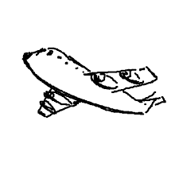

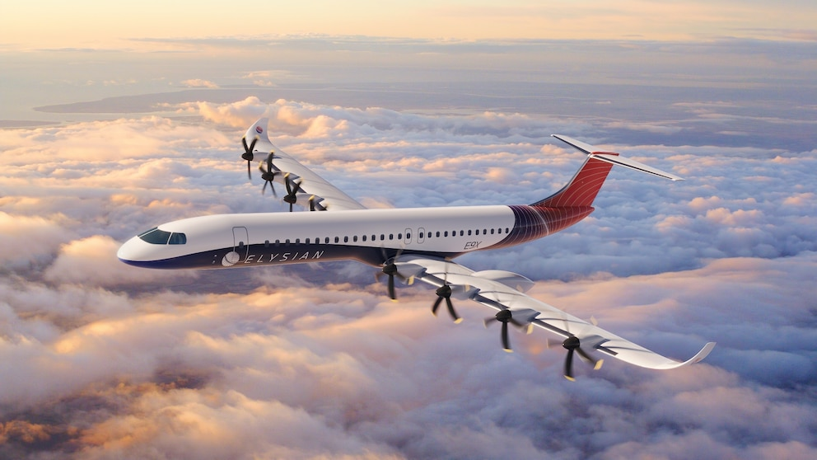

# Challenges Faced

**Data Collection and Processing**

One of the most significant challenges was gathering a well-structured dataset. The model requires a large number of paired images—sketches and their corresponding real-world images. Issues included:

- Lack of labeled data: Many available datasets contained only sketches or only real images, requiring manual pairing.

- Inconsistency in sketches: Variations in artistic styles, levels of detail, and drawing techniques affected the model’s ability to generalize.

- Preprocessing difficulties: Ensuring that images were properly resized, normalized, and structured for training required careful tuning.

**Choosing the Right Model Architecture**

Style transfer can be approached using different neural network architectures, and selecting the most suitable one was challenging.

- CNN-based models performed well for simple transformations but struggled with fine details.

- GAN-based models produced realistic images but were unstable during training and prone to generating artifacts.

- Autoencoder models provided structured outputs but sometimes lost texture information.

Finding the right balance between realism, accuracy, and computational efficiency required multiple iterations and modifications.

**Training Stability and Optimization**

Training deep learning models, especially GANs, is notoriously difficult due to their adversarial nature. Key issues included:

- Mode collapse: The generator produced limited variations in output, reducing diversity.

- Vanishing gradients: Training became slow or stopped due to poor gradient propagation.

- Overfitting: The model memorized the training data instead of learning general features, reducing performance on unseen sketches.

- Hyperparameter tuning: Finding the right learning rate, batch size, and number of epochs required extensive experimentation.

**Computational Constraints**

Training high-resolution images required significant computational power. The project faced:

- Memory limitations: Large datasets and deep networks led to high GPU memory consumption.

- Slow training times: Complex architectures took several hours or even days to train effectively.

- Hardware dependency: Running experiments on a single GPU restricted scalability, and cloud-based solutions incurred additional costs.

**Evaluating Model Performance**

Assessing the quality of generated images is subjective and requires both quantitative and qualitative analysis. Challenges included:

- Standard metrics (MSE, SSIM) didn’t fully capture perceptual quality: While these metrics measure pixel differences, they don’t reflect human visual perception accurately.

- User-based evaluations were time-consuming: Gathering human feedback on the realism and usability of generated images took additional effort.

- Ensuring consistency across different styles: The model sometimes worked well on specific categories (e.g., buildings) but struggled with complex objects (e.g., human faces).

# Future Enhancements

**Improving Image Resolution**

One major area for improvement is enhancing the resolution of generated images. Higher resolution outputs will allow for better detail preservation, making the generated images more realistic. Techniques such as super-resolution networks and advanced upsampling methods can be integrated to achieve this.

**Multi-Style Adaptation**

Expanding the model to support multiple artistic styles would make it more versatile. By training on datasets containing different drawing styles, the model could generate outputs in various textures, such as pencil, watercolor, or digital painting styles. This would increase its applications in creative fields.

**Real-Time Processing**

Optimizing the model for real-time processing would allow users to instantly see the transformation of their sketches into realistic images. This could be achieved by reducing the computational complexity of the model or deploying it on more efficient hardware like GPUs or TPUs.

**Integration with Creative Tools**

The model can be integrated into creative applications such as Photoshop, mobile drawing apps, or digital design software. This would allow artists and designers to easily convert hand-drawn sketches into detailed visuals, enhancing workflow efficiency.

**Enhanced Training with Larger Datasets**

Training the model on a larger, more diverse dataset can help improve its generalization capability. More extensive datasets with variations in sketching styles, object types, and background details would allow the model to perform well across a wider range of inputs.

**Interactive User Control**

Future iterations of the model could incorporate user control features, allowing artists to adjust the level of detail, texture, and color intensity in the generated image. This would make the tool more adaptable for different artistic preferences.

**Deploying on Cloud Platforms**

By making the model available as a cloud-based service, users can access it without requiring high-end local hardware. Cloud-based deployment would make the model scalable and accessible to a broader audience, including hobbyists and professionals.

# Conclusion

The style transfer project successfully demonstrates the power of deep learning in converting simple sketches into realistic images. By utilizing Convolutional Neural Networks (CNNs) and Generative Adversarial Networks (GANs), the model effectively learns structural and texture details, enabling high-quality image synthesis. The approach has significant potential in various applications, including digital art, animation, and AI-assisted creative tools.

Despite its success, challenges such as dataset limitations, training stability, and computational constraints were encountered. However, through continuous optimization and experimentation, these challenges were addressed to a great extent. The evaluation results indicate that the model performs well in generating realistic images while preserving the original structure of sketches.

Future improvements can focus on increasing resolution, integrating real-time processing capabilities, and enhancing user control over the generated images. By refining the architecture and incorporating more extensive datasets, the system can achieve even greater accuracy and adaptability.

Overall, this project highlights the potential of AI-driven creativity and opens new possibilities for automated sketch-to-image transformation, making artistic content creation more accessible and efficient.