- Design an application that contains Phone Contacts in vertical linear manner. Selected contact appears at the top of the list with a large italicized font and a blue background.
Solution:
- Activity.xml file
<?xml version="1.0" encoding="utf-8"?>
<androidx.constraintlayout.widget.ConstraintLayout xmlns:android="http://schemas.android.com/apk/res/android"
xmlns:app="http://schemas.android.com/apk/res-auto"
xmlns:tools="http://schemas.android.com/tools"
android:layout_width="match_parent"
android:layout_height="match_parent"
tools:context=".MainActivity">
<TextView
android:id="@+id/pc"
android:layout_width="142dp"
android:layout_height="49dp"
android:capitalize="words"
android:text="@string/phone"
app:layout_constraintBottom_toBottomOf="parent"
app:layout_constraintEnd_toEndOf="parent"
app:layout_constraintHorizontal_bias="0.099"
app:layout_constraintStart_toStartOf="parent"
app:layout_constraintTop_toTopOf="parent"
app:layout_constraintVertical_bias="0.103" />
<ListView
android:id="@+id/listview"
android:layout_width="321dp"
android:layout_height="510dp"
app:layout_constraintBottom_toBottomOf="parent"
app:layout_constraintEnd_toEndOf="parent"
app:layout_constraintHorizontal_bias="0.633"
app:layout_constraintStart_toStartOf="parent"
app:layout_constraintTop_toTopOf="parent"
app:layout_constraintVertical_bias="0.814" />
</androidx.constraintlayout.widget.ConstraintLayout>

- String.xml file in values
<resources>
<string name="app_name">First Lab Program</string>
<string name="phone">Selected Phone Contacts will Display Here</string>
<string-array name="li_contact">
<item>Dr M A Jayaram 1234567899</item>
<item>Dr Prashanth G K 9980933552</item>
<item>Mr H K Virupakshaiah 234567887</item>
<item>Dr Bharathi P T 9980933552</item>
<item>Mr H S Vijayakumar 9980933552</item>
<item>Mr T M Kirankumar 9980933552</item>
<item>Mr Bhanu Prakash C 9980933552</item>
<item>Mr C N Ramesh 9980933552</item>
</string-array>
</resources>
- Main java file
- package com.example.firstlabprogram;
import androidx.appcompat.app.AppCompatActivity;
import android.graphics.Typeface;
import android.os.Bundle;
import android.view.View;
import android.widget.ArrayAdapter;
import android.widget.AdapterView;
import android.widget.ListView;
import android.widget.TextView;
public class MainActivity extends AppCompatActivity {
ListView lv;
TextView tv;
String [] li;
@Override
protected void onCreate(Bundle savedInstanceState) {
super.onCreate(savedInstanceState);
setContentView(R.layout.activity_main);
// my codeing
li=getResources().getStringArray(R.array.li_contact);
lv=(ListView) findViewById(R.id.listview);
tv=(TextView) findViewById(R.id.pc);
final ArrayAdapter<String> adapter=new ArrayAdapter<String>(this,android.R.layout.simple_list_item_1,android.R.id.text1,li);
lv.setAdapter(adapter);
lv.setOnItemClickListener(new AdapterView.OnItemClickListener() {
@Override
public void onItemClick(AdapterView<?> adapterView, View view, int i, long l) {
String value=adapter.getItem(i);
tv.setText(value);
tv.setTypeface(null, Typeface.ITALIC);
}
});
}
}

Output: -

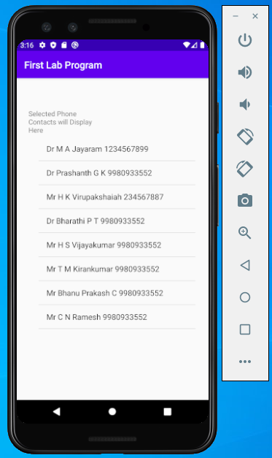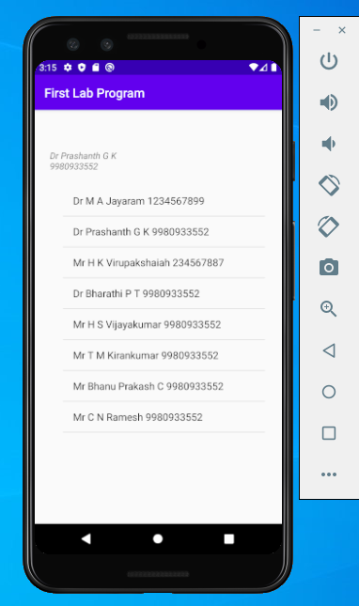

- Create an application that uses Layout Managers and Event Listeners.
Activity.xml file
<?xml version="1.0" encoding="utf-8"?>
<androidx.constraintlayout.widget.ConstraintLayout xmlns:android="http://schemas.android.com/apk/res/android"
xmlns:app="http://schemas.android.com/apk/res-auto"
xmlns:tools="http://schemas.android.com/tools"
android:id="@+id/Form_one"
android:layout_width="match_parent"
android:layout_height="match_parent"
android:background="#41939E"
tools:context=".MainActivity">
<TextView
android:id="@+id/txt_view"
android:layout_width="254dp"
android:layout_height="44dp"
android:text="@string/EV"
android:textSize="24sp"
app:layout_constraintBottom_toBottomOf="parent"
app:layout_constraintHorizontal_bias="0.191"
app:layout_constraintLeft_toLeftOf="parent"
app:layout_constraintRight_toRightOf="parent"
app:layout_constraintTop_toTopOf="parent"
app:layout_constraintVertical_bias="0.088" />
<TextView
android:id="@+id/txt_disp"
android:layout_width="360dp"
android:layout_height="52dp"
android:layout_marginTop="52dp"
android:text="@string/Display_Name"
android:textSize="30sp"
app:layout_constraintBottom_toTopOf="@+id/Butt_Convert"
app:layout_constraintEnd_toEndOf="parent"
app:layout_constraintHorizontal_bias="0.313"
app:layout_constraintStart_toStartOf="parent"
app:layout_constraintTop_toBottomOf="@+id/txt_view"
app:layout_constraintVertical_bias="0.011" />
<Button
android:id="@+id/Butt_Convert"
android:layout_width="200dp"
android:layout_height="49dp"
android:layout_marginBottom="384dp"
android:text="@string/butt_valu1"
app:layout_constraintBottom_toBottomOf="parent"
app:layout_constraintEnd_toEndOf="parent"
app:layout_constraintHorizontal_bias="0.142"
app:layout_constraintStart_toStartOf="parent" />
<TextView
android:id="@+id/txt_Dept"
android:layout_width="346dp"
android:layout_height="51dp"
android:layout_marginTop="56dp"
android:text="@string/Dept"
android:textSize="30sp"
app:layout_constraintEnd_toEndOf="parent"
app:layout_constraintHorizontal_bias="0.246"
app:layout_constraintStart_toStartOf="parent"
app:layout_constraintTop_toBottomOf="@+id/Butt_Convert" />
<Spinner
android:id="@+id/Disp_Spinner"
android:layout_width="322dp"
android:layout_height="43dp"
android:layout_marginStart="8dp"
android:layout_marginLeft="8dp"
android:layout_marginTop="64dp"
android:layout_marginEnd="8dp"
android:layout_marginRight="8dp"
android:prompt="@string/Spinner_value"
android:spinnerMode="dropdown"
app:layout_constraintBottom_toBottomOf="parent"
app:layout_constraintEnd_toEndOf="parent"
app:layout_constraintHorizontal_bias="0.109"
app:layout_constraintStart_toStartOf="parent"
app:layout_constraintTop_toBottomOf="@+id/txt_Dept"
app:layout_constraintVertical_bias="0.0" />
</androidx.constraintlayout.widget.ConstraintLayout>

String.xml file
<resources>
<string name="app_name">Second Lab Program</string>
<string name="EV">Event Listereners</string>
<string name="Display_Name">SIT, MCA</string>
<string name="butt_valu1">Convert to Italic</string>
<string name="Dept">Department</string>
<string name="Spinner_value">Select the Department</string>
<string-array name="depts">
<item>Select the Your Department</item>
<item>MCA</item>
<item>MBA</item>
<item>BE</item>
</string-array>
</resources>

mainActivity.class file
package com.example.secondlab;
import androidx.appcompat.app.AppCompatActivity;
import android.graphics.Typeface;
import android.opengl.EGLExt;
import android.os.Bundle;
import android.view.View;
import android.widget.ArrayAdapter;
import android.widget.AdapterView;
import android.widget.AdapterView.OnItemSelectedListener;
import android.widget.Button;
import android.widget.Spinner;
import android.widget.TextView;
import android.widget.Toast;
public class MainActivity extends AppCompatActivity {
Button btn_convet;
TextView txtview;
String[] dept;
@Override
protected void onCreate(Bundle savedInstanceState) {
super.onCreate(savedInstanceState);
setContentView(R.layout.activity_main);
btn_convet=(Button)findViewById(R.id.Butt_Convert);
dept=getResources().getStringArray(R.array.depts);
Spinner s1=(Spinner)findViewById(R.id.Disp_Spinner);
ArrayAdapter<String> adapter=new ArrayAdapter<String>(this,android.R.layout.simple_dropdown_item_1line,dept);
s1.setAdapter(adapter);
s1.setOnItemSelectedListener(new OnItemSelectedListener() {
@Override
public void onItemSelected(AdapterView<?> adapterView, View view, int i, long l) {
int index=adapterView.getSelectedItemPosition();
if(index>0){
Toast.makeText(getBaseContext(),"You Have Selected " + dept[index], Toast.LENGTH_SHORT).show();
}
}
@Override
public void onNothingSelected(AdapterView<?> adapterView) {
}
});
btn_convet.setOnClickListener(new View.OnClickListener() {
@Override
public void onClick(View view) {
txtview=(TextView)findViewById(R.id.txt_disp);
txtview.setTypeface(null, Typeface.ITALIC);
}
});
}
}

OUTPUT:

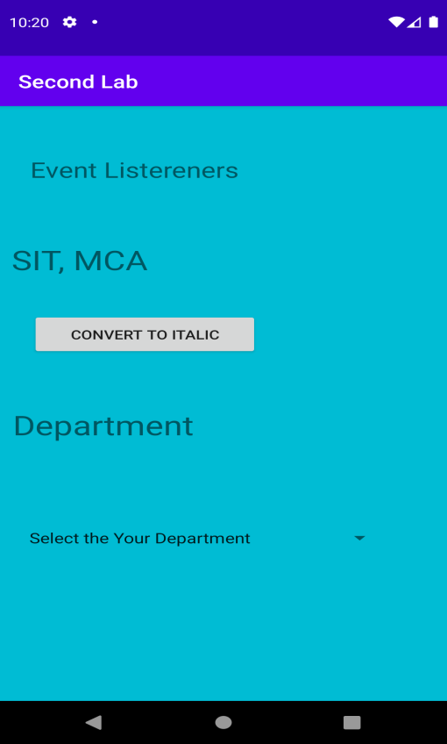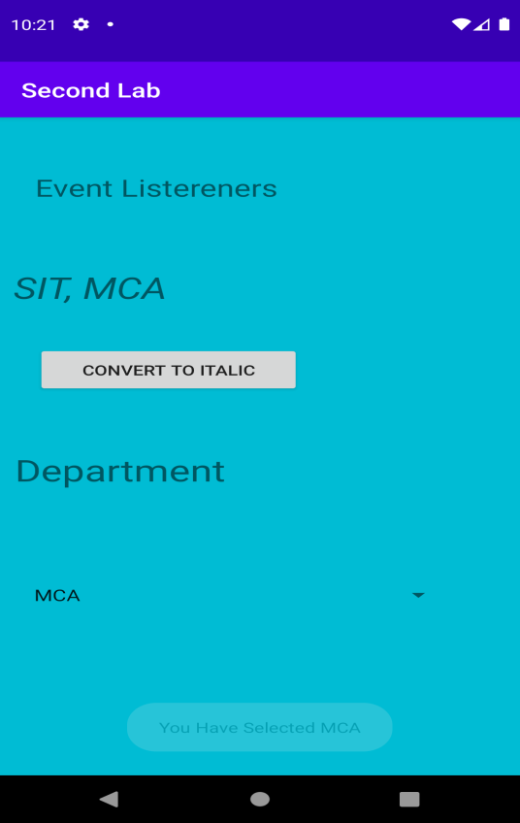

- Develop a standard calculator application to perform basic calculations like addition, subtraction, multiplication and division.

Solution:
Activity Xml File
<?xml version="1.0" encoding="utf-8"?>
<androidx.constraintlayout.widget.ConstraintLayout xmlns:android="http://schemas.android.com/apk/res/android"
xmlns:app="http://schemas.android.com/apk/res-auto"
xmlns:tools="http://schemas.android.com/tools"
android:layout_width="match_parent"
android:layout_height="match_parent"
android:background="#00BFA5"
tools:context=".MainActivity">
<TextView
android:id="@+id/txt_Num-"
android:layout_width="149dp"
android:layout_height="35dp"
android:layout_marginStart="24dp"
android:layout_marginLeft="24dp"
android:layout_marginTop="188dp"
android:text="@string/second_num"
app:layout_constraintEnd_toStartOf="@+id/Edit_num-2"
app:layout_constraintStart_toStartOf="parent"
app:layout_constraintTop_toTopOf="parent" />
<TextView
android:id="@+id/Txt_Num-1"
android:layout_width="162dp"
android:layout_height="41dp"
android:layout_marginStart="24dp"
android:layout_marginLeft="24dp"
android:layout_marginTop="84dp"
android:text="@string/fn"
android:textSize="18sp"
app:layout_constraintEnd_toStartOf="@+id/Edit_First_num"
app:layout_constraintHorizontal_bias="0.0"
app:layout_constraintStart_toStartOf="parent"
app:layout_constraintTop_toTopOf="parent" />

<EditText
android:id="@+id/Edit_First_num"
android:layout_width="182dp"
android:layout_height="40dp"
android:layout_marginEnd="8dp"
android:layout_marginRight="8dp"
android:ems="10"
android:inputType="numberDecimal"
app:layout_constraintBottom_toBottomOf="parent"
app:layout_constraintEnd_toEndOf="parent"
app:layout_constraintHorizontal_bias="0.93"
app:layout_constraintStart_toStartOf="parent"
app:layout_constraintTop_toTopOf="parent"
app:layout_constraintVertical_bias="0.121" />
<EditText
android:id="@+id/Edit_num-2"
android:layout_width="wrap_content"
android:layout_height="wrap_content"
android:layout_marginEnd="12dp"
android:layout_marginRight="12dp"
android:ems="10"
android:inputType="numberDecimal"
app:layout_constraintBottom_toBottomOf="parent"
app:layout_constraintEnd_toEndOf="parent"
app:layout_constraintTop_toTopOf="parent"
app:layout_constraintVertical_bias="0.274" />
<TextView
android:id="@+id/txt_Result"
android:layout_width="248dp"
android:layout_height="47dp"
android:hint="Result Displayed Here"
android:text="@string/Result"
android:textSize="18sp"
app:layout_constraintBottom_toBottomOf="parent"
app:layout_constraintEnd_toEndOf="parent"
app:layout_constraintHorizontal_bias="0.2"
app:layout_constraintStart_toStartOf="parent"
app:layout_constraintTop_toTopOf="parent"
app:layout_constraintVertical_bias="0.433" />
<Button
android:id="@+id/Btt_Add"
android:layout_width="wrap_content"
android:layout_height="wrap_content"
android:layout_marginStart="32dp"
android:layout_marginLeft="32dp"
android:layout_marginTop="412dp"
android:onClick="add"
android:text="Add"
app:layout_constraintStart_toStartOf="parent"
app:layout_constraintTop_toTopOf="parent" />
<Button
android:id="@+id/Btt_Sub"
android:layout_width="wrap_content"
android:layout_height="wrap_content"
android:layout_marginTop="412dp"
android:layout_marginEnd="28dp"
android:layout_marginRight="28dp"
android:onClick="sub"
android:text="Subtraction"
app:layout_constraintEnd_toStartOf="@+id/Btt_Mul"
app:layout_constraintTop_toTopOf="parent" />
<Button
android:id="@+id/Btt_Mul"
android:layout_width="wrap_content"
android:layout_height="wrap_content"
android:layout_marginTop="412dp"
android:layout_marginEnd="28dp"
android:layout_marginRight="28dp"
android:onClick="mul"
android:text="Mul"
app:layout_constraintEnd_toEndOf="parent"
app:layout_constraintTop_toTopOf="parent" />
<Button
android:id="@+id/Btt_Div"
android:layout_width="wrap_content"
android:layout_height="wrap_content"
android:layout_marginStart="24dp"
android:layout_marginLeft="24dp"
android:onClick="div"
android:text="Division"
app:layout_constraintBottom_toBottomOf="parent"
app:layout_constraintEnd_toStartOf="@+id/Btt_Clr"
app:layout_constraintHorizontal_bias="0.38"
app:layout_constraintStart_toStartOf="parent"
app:layout_constraintTop_toTopOf="parent"
app:layout_constraintVertical_bias="0.812" />
<Button
android:id="@+id/Btt_Clr"
android:layout_width="wrap_content"
android:layout_height="wrap_content"
android:layout_marginEnd="136dp"
android:layout_marginRight="136dp"
android:onClick="clear_data"
android:text="Clear"
app:layout_constraintBottom_toBottomOf="parent"
app:layout_constraintEnd_toEndOf="parent"
app:layout_constraintTop_toTopOf="parent"
app:layout_constraintVertical_bias="0.812" />
</androidx.constraintlayout.widget.ConstraintLayout>

String File
<resources>
<string name="app_name">Simple Calculator</string>
<string name="fn">Enter First Number</string>
<string name="second_num">Enter Second Number</string>
<string name="Result">Result Will be Displayed Here</string>
</resources>

Java File
package com.example.thirdlab;
import androidx.appcompat.app.AppCompatActivity;
import android.os.Bundle;
import android.widget.EditText;
import android.widget.TextView;
import android.view.View;
import android.widget.Toast;
import org.w3c.dom.Text;
import java.io.IOException;
import java.text.DecimalFormat;
public class MainActivity extends AppCompatActivity {
@Override
protected void onCreate(Bundle savedInstanceState) {
super.onCreate(savedInstanceState);
setContentView(R.layout.activity_main);
}
public void add(View v){
Float num1,num2,sum;
EditText t1=(EditText)findViewById(R.id.Edit_First_num);
EditText t2=(EditText)findViewById(R.id.Edit_num_2);
TextView t3=(TextView)findViewById(R.id.txt_Result);
t3.setText("Result");
if(t1.length()==0 || t2.length()==0)
Toast.makeText(this, "Enter the values for number1 or Number 2", Toast.LENGTH_SHORT).show();
else {
try {
num1 = Float.parseFloat(t1.getText().toString());
num2 = Float.parseFloat(t2.getText().toString());
sum = num1 + num2;
t3.setText("Result :" + Float.toString(sum));
}
catch (NumberFormatException e){
Toast toast=Toast.makeText(getApplicationContext(),"Enter Number only",Toast.LENGTH_LONG);
toast.show();
}
}
}
public void sub(View v){
Float num1,num2,sum;
EditText t1=(EditText)findViewById(R.id.Edit_First_num);
EditText t2=(EditText)findViewById(R.id.Edit_num_2);
TextView t3=(TextView)findViewById(R.id.txt_Result);
t3.setText("Result");
if(t1.length()==0 || t2.length()==0)
Toast.makeText(this, "Enter the values for number1 or Number 2", Toast.LENGTH_SHORT).show();
else {
try {
num1 = Float.parseFloat(t1.getText().toString());
num2 = Float.parseFloat(t2.getText().toString());
sum = num1 - num2;
t3.setText("Result :" + Float.toString(sum));
}
catch (NumberFormatException e){
Toast toast=Toast.makeText(getApplicationContext(),"Enter Nmber only",Toast.LENGTH_LONG);
toast.show();
}
}
}
public void mul(View v){
Float num1,num2,sum;
EditText t1=(EditText)findViewById(R.id.Edit_First_num);
EditText t2=(EditText)findViewById(R.id.Edit_num_2);
TextView t3=(TextView)findViewById(R.id.txt_Result);
t3.setText("Result");
if(t1.length()==0 || t2.length()==0)
Toast.makeText(this, "Enter the values for number1 or Number 2", Toast.LENGTH_SHORT).show();
else {
try {
num1 = Float.parseFloat(t1.getText().toString());
num2 = Float.parseFloat(t2.getText().toString());
sum = num1 * num2;
t3.setText("Result :" + Float.toString(sum));
}
catch (NumberFormatException e){
Toast toast=Toast.makeText(getApplicationContext(),"Enter Nmber only",Toast.LENGTH_LONG);
toast.show();
}
}
}
public void div(View v){
Float num1,num2,sum;
EditText t1=(EditText)findViewById(R.id.Edit_First_num);
EditText t2=(EditText)findViewById(R.id.Edit_num_2);
TextView t3=(TextView)findViewById(R.id.txt_Result);
t3.setText("Result");
if(t1.length()==0 || t2.length()==0)
Toast.makeText(this, "Enter the values for number1 or Number 2", Toast.LENGTH_SHORT).show();
else {
try {
num1 = Float.parseFloat(t1.getText().toString());
num2 = Float.parseFloat(t2.getText().toString());
if(num2!=0) {
sum = num1 / num2;
t3.setText("Result :" + Float.toString(sum));
}
else
Toast.makeText(this, "Enter the Second Number Other Than Zero", Toast.LENGTH_SHORT).show();
}
catch (NumberFormatException e){
Toast toast=Toast.makeText(getApplicationContext(),"Enter Nmber only",Toast.LENGTH_LONG);
toast.show();
}
}
}
public void clear_data(View v){
Float num1,num2,sum;
EditText t1=(EditText)findViewById(R.id.Edit_First_num);
EditText t2=(EditText)findViewById(R.id.Edit_num_2);
TextView t3=(TextView)findViewById(R.id.txt_Result);
t1.setText("");
t1.setSelection(0);
t2.setText("");
t3.setText("Result");
}
}

OUTPUT:

- Devise an application that draws basic graphical primitives (rectangle, circle) on the screen.

Solution:
Activity Xml File
<?xml version="1.0" encoding="utf-8"?>
<androidx.constraintlayout.widget.ConstraintLayout xmlns:android="http://schemas.android.com/apk/res/android"
xmlns:app="http://schemas.android.com/apk/res-auto"
xmlns:tools="http://schemas.android.com/tools"
android:id="@+id/cc"
android:layout_width="match_parent"
android:layout_height="match_parent"
android:background="#7A7878"
tools:context=".MainActivity">
<ImageView
android:id="@+id/ivg"
android:layout_width="324dp"
android:layout_height="160dp"
android:contentDescription="@string/todo"
android:saveEnabled="true"
app:layout_constraintBottom_toTopOf="@+id/btt_rec"
app:layout_constraintEnd_toEndOf="parent"
app:layout_constraintHorizontal_bias="0.37"
app:layout_constraintStart_toStartOf="parent"
app:layout_constraintTop_toTopOf="parent"
app:layout_constraintVertical_bias="0.517"
tools:srcCompat="@tools:sample/avatars" />
<Button
android:id="@+id/btt_rec"
android:layout_width="wrap_content"
android:layout_height="wrap_content"
android:text="@string/rec"
app:layout_constraintBottom_toBottomOf="parent"
app:layout_constraintEnd_toEndOf="parent"
app:layout_constraintHorizontal_bias="0.051"
app:layout_constraintStart_toStartOf="parent"
app:layout_constraintTop_toTopOf="parent"
app:layout_constraintVertical_bias="0.579" />
<Button
android:id="@+id/Btt_Circle"
android:layout_width="116dp"
android:layout_height="56dp"
android:text="@string/cir"
app:layout_constraintBottom_toBottomOf="parent"
app:layout_constraintEnd_toEndOf="parent"
app:layout_constraintHorizontal_bias="0.464"
app:layout_constraintStart_toStartOf="parent"
app:layout_constraintTop_toTopOf="parent"
app:layout_constraintVertical_bias="0.585" />
<Button
android:id="@+id/btt_line"
android:layout_width="116dp"
android:layout_height="62dp"
android:text="@string/SL"
app:layout_constraintBottom_toBottomOf="parent"
app:layout_constraintEnd_toEndOf="parent"
app:layout_constraintHorizontal_bias="0.945"
app:layout_constraintStart_toStartOf="parent"
app:layout_constraintTop_toTopOf="parent"
app:layout_constraintVertical_bias="0.591" />
<Button
android:id="@+id/butt_reset"
android:layout_width="139dp"
android:layout_height="59dp"
android:onClick="pgk"
android:text="@string/CLN"
app:layout_constraintBottom_toBottomOf="parent"
app:layout_constraintEnd_toEndOf="parent"
app:layout_constraintStart_toStartOf="parent"
app:layout_constraintTop_toTopOf="parent"
app:layout_constraintVertical_bias="0.748" />
<Button
android:id="@+id/butt_square"
android:layout_width="109dp"
android:layout_height="62dp"
android:text="@string/Button_square"
app:layout_constraintBottom_toBottomOf="parent"
app:layout_constraintEnd_toEndOf="parent"
app:layout_constraintHorizontal_bias="0.033"
app:layout_constraintStart_toStartOf="parent"
app:layout_constraintTop_toTopOf="parent"
app:layout_constraintVertical_bias="0.751" />
<Button
android:id="@+id/Button_Eixt"
android:layout_width="115dp"
android:layout_height="66dp"
android:text="@string/exit"
app:layout_constraintBottom_toBottomOf="parent"
app:layout_constraintEnd_toEndOf="parent"
app:layout_constraintHorizontal_bias="0.979"
app:layout_constraintStart_toStartOf="parent"
app:layout_constraintTop_toTopOf="parent"
app:layout_constraintVertical_bias="0.766" />
<TextView
android:id="@+id/txtview"
android:layout_width="331dp"
android:layout_height="51dp"
android:foregroundGravity="center"
android:gravity="center"
android:text="@string/namedisp"
android:textColor="@android:color/holo_orange_dark"
android:textSize="30sp"
app:layout_constraintBottom_toBottomOf="parent"
app:layout_constraintEnd_toEndOf="parent"
app:layout_constraintHorizontal_bias="0.355"
app:layout_constraintStart_toStartOf="parent"
app:layout_constraintTop_toTopOf="parent"
app:layout_constraintVertical_bias="0.036" />
</androidx.constraintlayout.widget.ConstraintLayout>

String File
<resources>
<string name="app_name">Drawing Shapes</string>
<string name="CLN">Clear The Image</string>
<string name="SL">Straight Line</string>
<string name="rec">Rectangle</string>
<string name="cir">Circle</string>
<string name="todo">TODO</string>
<string name="Button_square">Square</string>
<string name="exit">exit</string>
<string name="namedisp">Drawing the Shapes</string>
</resources>

Java File

package com.example.mca_lab_4;
import android.widget.ImageView;
import android.graphics.Bitmap;
import android.graphics.Canvas;
import android.graphics.Color;
import android.graphics.Paint;
import android.graphics.Rect;
import android.view.View;
import android.widget.Button;
import android.app.Activity;
import android.widget.Toast;
import android.graphics.drawable.BitmapDrawable;
//import android.support.v4.app.AppCompatActivity;
import android.os.Bundle;
public class MainActivity extends Activity {
ImageView iv;
Button button, button1, button2, button4, button5,button6;
Bitmap bitmap;
Canvas canvas;
Paint paint;
int sp = 55;
Rect rect;
int CanvasRadius;
int CanvasPadding = 7;
int height, width;
@Override
protected void onCreate(Bundle savedInstanceState) {
super.onCreate(savedInstanceState);
setContentView(R.layout.activity_main);
iv = (ImageView) findViewById(R.id.ivg);
button = (Button) findViewById(R.id.btt_rec);
button1 = (Button) findViewById(R.id.Btt_Circle);
button2 = (Button) findViewById(R.id.btt_line);
button4 = (Button) findViewById(R.id.butt_square);
button5 = (Button) findViewById(R.id.Button_Eixt);
button6=(Button)findViewById(R.id.butt_reset);
}
public void Draw_pgk (View view){
bitmap = Bitmap.createBitmap(400, 250, Bitmap.Config.RGB_565);
canvas = new Canvas(bitmap);
canvas.drawColor(Color.CYAN);
paint = new Paint();
paint.setStyle(Paint.Style.FILL_AND_STROKE);
paint.setColor(Color.BLUE);
paint.setAntiAlias(true);// smoothen the edges
if (view == button) {
rect = new Rect(55, 55, 350, 200);
canvas.drawRect(rect, paint);
iv.setImageBitmap(bitmap);
Toast toast = Toast.makeText(getApplicationContext(), "Recangle Image Drawn", Toast.LENGTH_LONG);
toast.show();
}
if (view == button1) {
CanvasRadius = Math.min(canvas.getWidth(), canvas.getHeight() / 2);
canvas.drawCircle(canvas.getWidth() / 2,
canvas.getHeight() / 2,
CanvasRadius - CanvasPadding,
paint
);
iv.setImageBitmap(bitmap);
Toast toast = Toast.makeText(getApplicationContext(), "Circle Image Drawn", Toast.LENGTH_LONG);
toast.show();
}
if (view == button2) {
canvas.drawLine(200, 55, 200, 300, paint);
iv.setImageBitmap(bitmap);
Toast toast = Toast.makeText(getApplicationContext(), "Straight Line Drawn", Toast.LENGTH_LONG);
toast.show();
}
if (view == button4) {
rect = new Rect(55, 55, 200, 200);
canvas.drawRect(rect, paint);
iv.setImageBitmap(bitmap);
Toast toast = Toast.makeText(getApplicationContext(), "Square Drawn", Toast.LENGTH_LONG);
toast.show();
}
if (view == button5) {
finish();
}
if(view==button6){
iv.setImageDrawable(null);
}
}
}

*Note :- 1. Select the Draw_pgk() in the onclick event for all the buttons

OUTPUT:
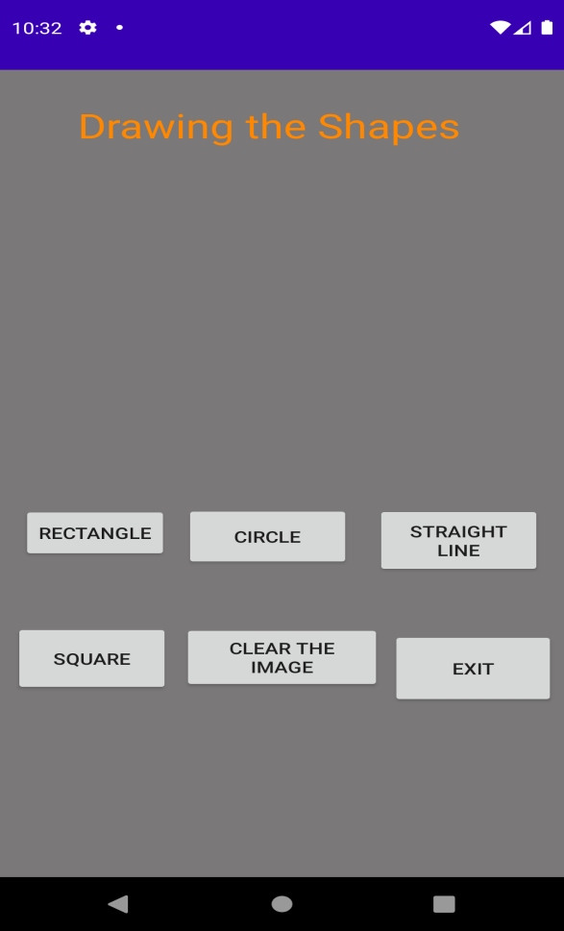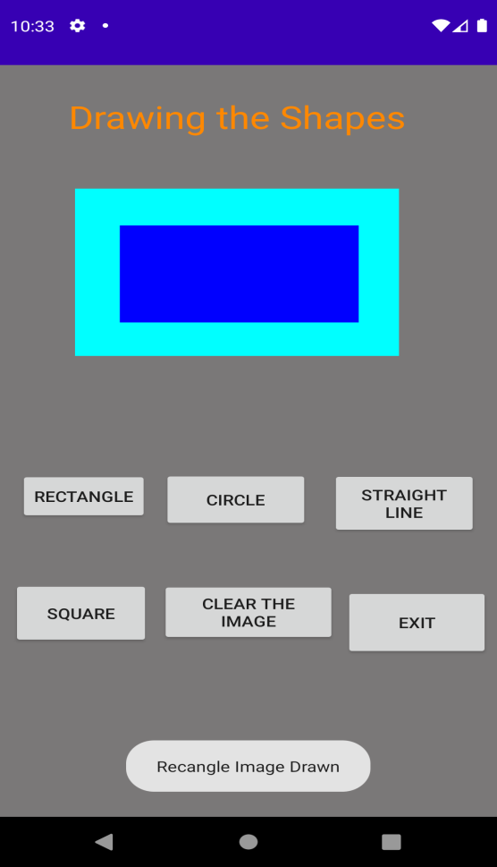
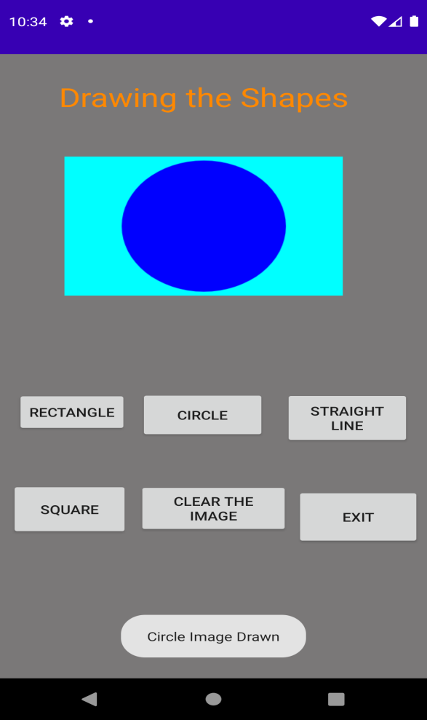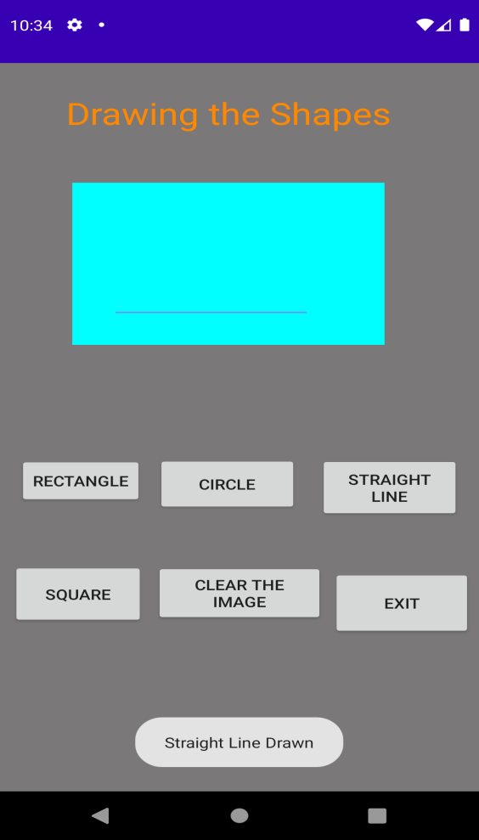
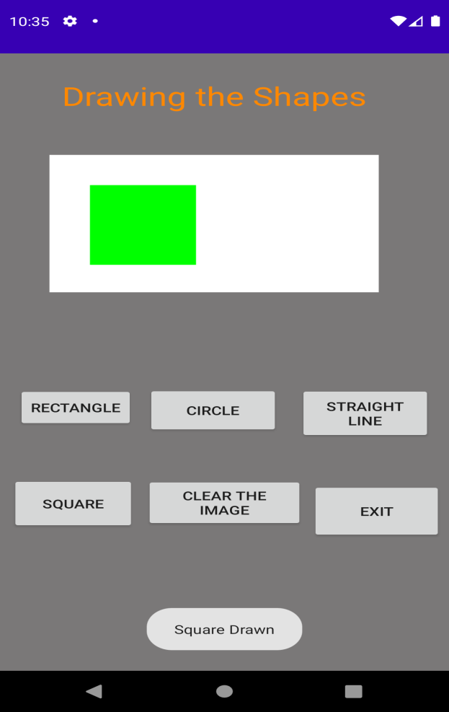

- Build a mobile application that create, save, update and delete data in a database.

Activity File
<?xml version="1.0" encoding="utf-8"?>
<androidx.constraintlayout.widget.ConstraintLayout xmlns:android="http://schemas.android.com/apk/res/android"
xmlns:app="http://schemas.android.com/apk/res-auto"
xmlns:tools="http://schemas.android.com/tools"
android:id="@+id/database"
android:layout_width="match_parent"
android:layout_height="match_parent"
android:background="#00BFA5"
tools:context=".MainActivity">
<TextView
android:id="@+id/txt_name"
android:layout_width="126dp"
android:layout_height="34dp"
android:layout_marginLeft="28dp"
android:layout_marginTop="8dp"
android:layout_marginEnd="248dp"
android:layout_marginRight="248dp"
android:text="@string/Name"
android:textSize="18sp"
app:layout_constraintBottom_toBottomOf="parent"
app:layout_constraintEnd_toEndOf="parent"
app:layout_constraintLeft_toLeftOf="parent"
app:layout_constraintTop_toTopOf="parent"
app:layout_constraintVertical_bias="0.085" />
<EditText
android:id="@+id/ed_name"
android:layout_width="184dp"
android:layout_height="43dp"
android:autofillHints="@string/eyn"
android:ems="10"
android:hint="@string/eyn"
android:inputType="textPersonName"
android:textSize="18sp"
app:layout_constraintBottom_toBottomOf="parent"
app:layout_constraintEnd_toEndOf="parent"
app:layout_constraintHorizontal_bias="0.812"
app:layout_constraintStart_toStartOf="parent"
app:layout_constraintTop_toTopOf="parent"
app:layout_constraintVertical_bias="0.098" />
<TextView
android:id="@+id/txt_surname"
android:layout_width="85dp"
android:layout_height="41dp"
android:text="@string/surname"
android:textSize="18sp"
app:layout_constraintBottom_toBottomOf="parent"
app:layout_constraintEnd_toEndOf="parent"
app:layout_constraintHorizontal_bias="0.11"
app:layout_constraintStart_toStartOf="parent"
app:layout_constraintTop_toTopOf="parent"
app:layout_constraintVertical_bias="0.168" />
<EditText
android:id="@+id/ed_surname"
android:layout_width="196dp"
android:layout_height="40dp"
android:autofillHints="@string/Surname"
android:ems="10"
android:hint="@string/Surname"
android:inputType="textPersonName"
android:textSize="18sp"
app:layout_constraintBottom_toBottomOf="parent"
app:layout_constraintEnd_toEndOf="parent"
app:layout_constraintHorizontal_bias="0.851"
app:layout_constraintStart_toStartOf="parent"
app:layout_constraintTop_toTopOf="parent"
app:layout_constraintVertical_bias="0.183" />
<EditText
android:id="@+id/ed_id"
android:layout_width="209dp"
android:layout_height="42dp"
android:autofillHints="@string/Id"
android:ems="10"
android:hint="@string/Id"
android:inputType="textPersonName"
android:textSize="18sp"
app:layout_constraintBottom_toBottomOf="parent"
app:layout_constraintEnd_toEndOf="parent"
app:layout_constraintHorizontal_bias="0.905"
app:layout_constraintStart_toStartOf="parent"
app:layout_constraintTop_toTopOf="parent"
app:layout_constraintVertical_bias="0.267" />
<TextView
android:id="@+id/txt_id"
android:layout_width="83dp"
android:layout_height="36dp"
android:text="@string/Did"
android:textSize="18sp"
app:layout_constraintBottom_toBottomOf="parent"
app:layout_constraintEnd_toEndOf="parent"
app:layout_constraintHorizontal_bias="0.115"
app:layout_constraintStart_toStartOf="parent"
app:layout_constraintTop_toTopOf="parent"
app:layout_constraintVertical_bias="0.264" />
<Button
android:id="@+id/btt_add"
android:layout_width="wrap_content"
android:layout_height="wrap_content"
android:text="@string/AddData"
app:layout_constraintBottom_toBottomOf="parent"
app:layout_constraintEnd_toEndOf="parent"
app:layout_constraintHorizontal_bias="0.112"
app:layout_constraintStart_toStartOf="parent"
app:layout_constraintTop_toTopOf="parent"
app:layout_constraintVertical_bias="0.411" />
<Button
android:id="@+id/btt_view"
android:layout_width="86dp"
android:layout_height="41dp"
android:text="@string/ViewAll"
app:layout_constraintBottom_toBottomOf="parent"
app:layout_constraintEnd_toEndOf="parent"
app:layout_constraintHorizontal_bias="0.129"
app:layout_constraintStart_toStartOf="parent"
app:layout_constraintTop_toTopOf="parent"
app:layout_constraintVertical_bias="0.527" />
<Button
android:id="@+id/btt_update"
android:layout_width="93dp"
android:layout_height="45dp"
android:text="@string/Update"
app:layout_constraintBottom_toBottomOf="parent"
app:layout_constraintEnd_toEndOf="parent"
app:layout_constraintStart_toStartOf="parent"
app:layout_constraintTop_toTopOf="parent"
app:layout_constraintVertical_bias="0.413" />
<Button
android:id="@+id/btt_delete"
android:layout_width="75dp"
android:layout_height="46dp"
android:text="@string/Delete"
app:layout_constraintBottom_toBottomOf="parent"
app:layout_constraintEnd_toEndOf="parent"
app:layout_constraintHorizontal_bias="0.869"
app:layout_constraintStart_toStartOf="parent"
app:layout_constraintTop_toTopOf="parent"
app:layout_constraintVertical_bias="0.41" />
<Button
android:id="@+id/Button_exit"
android:layout_width="wrap_content"
android:layout_height="wrap_content"
android:text="@string/exit"
app:layout_constraintBottom_toBottomOf="parent"
app:layout_constraintEnd_toEndOf="parent"
app:layout_constraintHorizontal_bias="0.492"
app:layout_constraintStart_toStartOf="parent"
app:layout_constraintTop_toTopOf="parent"
app:layout_constraintVertical_bias="0.532" />
</androidx.constraintlayout.widget.ConstraintLayout>

String file
<resources>
<string name="app_name">Data Base Lab SQL Lite</string>
<string name="eyn">Enter your Name</string>
<string name="AddData">Add Data</string>
<string name="ViewAll">View all</string>
<string name="Update">Update</string>
<string name="Delete">Delete</string>
<string name="Name">Name:</string>
<string name="Surname">Enter your Surname</string>
<string name="Id">Id</string>
<string name="Did">ID</string>
<string name="surname">Surname</string>
<string name="exit">Clear</string>
</resources>

Java file( 3 files)
- Customer model
package com.example.pgk_database_sql;
public class CustomerModel {
public String id;
public String name;
public String Sname;
public CustomerModel() {
}
public CustomerModel(String id, String name, String Sname) {
this.id = id;
this.name = name;
this.Sname = Sname;
}
@Override
public String toString() {
return "CustomerModel{" +
"id='" + id + '\'' +
", name='" + name + '\'' +
", Sname='" + Sname + '\'' +
'}';
}
public String getId() {
return id;
}
public void setId(String id) {
this.id = id;
}
public String getName() {
return name;
}
public void setName(String name) {
this.name = name;
}
public String getSname() {
return Sname;
}
public void setSname(String Sname) {
this.Sname = Sname;
}
}

- DB Helper
package com.example.pgk_database_sql;
import android.content.ContentValues;
import android.content.Context;
import android.database.Cursor;
import android.database.sqlite.SQLiteDatabase;
import android.database.sqlite.SQLiteOpenHelper;
import androidx.annotation.Nullable;
import android.content.Context;
import android.widget.Toast;
import org.w3c.dom.Text;
public class DBHelper extends SQLiteOpenHelper {
public static final String Database_Name="student.db";
public static final String Table_name="student_table";
public static final String Col_1="Id";
public static final String Col_2="Name";
public static final String Col_3="Surname";
public DBHelper(@Nullable Context context) {
super(context, Database_Name, null, 1);
}
@Override
public void onCreate(SQLiteDatabase db) {
String query=("Create Table "+Table_name+"( Id Integer Primary key Autoincrement ,Name Text,Surname Text)");
db.execSQL(query);
}
@Override
public void onUpgrade(SQLiteDatabase db, int oldVersion, int newVersion) {
db.execSQL(" Drop Table If Exists "+Table_name);
onCreate(db);
}
public boolean insertData(String id, String Name,String Surname)
{
SQLiteDatabase db=this.getWritableDatabase();
ContentValues contentValues=new ContentValues();
if(id.length()==0 || Name.length()==0 || Surname.length()==0)
return false;
else {
contentValues.put(Col_1, id);
contentValues.put(Col_2, Name);
contentValues.put(Col_3, Surname);
long result = db.insert(Table_name, null, contentValues);
if (result == 1)
return false;
else
return true;
}
}
public Cursor getAllData()
{
SQLiteDatabase db=this.getWritableDatabase();
Cursor res=db.rawQuery(" select * from "+Table_name,null);
return res;
}
public boolean updateData(String id,String name,String surname)
{
int i;
SQLiteDatabase db=this.getWritableDatabase();
if(name.isEmpty() || surname.isEmpty() || id.isEmpty())
return false;
ContentValues contentValues=new ContentValues();
contentValues.put(Col_1,id);
contentValues.put(Col_2,name);
contentValues.put(Col_3,surname);
i=db.update(Table_name,contentValues,"Id=?",new String[]{id});
if(i>0)
return true;
else
return false;
}
public Integer DeleteData(String id)
{
SQLiteDatabase db=this.getWritableDatabase();
return db.delete(Table_name,"ID=?",new String[]{id});
}
}

- Main activity
package com.example.pgk_database_sql;
import androidx.appcompat.app.AppCompatActivity;
import android.database.Cursor;
import android.os.Bundle;
import android.view.View;
import android.widget.Adapter;
import android.widget.ArrayAdapter;
import android.widget.Button;
import android.widget.EditText;
import android.widget.ListView;
import android.widget.Toast;
import android.app.AlertDialog;
import java.util.ArrayList;
import java.util.List;
public class MainActivity extends AppCompatActivity {
DBHelper mydb;
EditText ename, esurname, eid;
Button btt_add, btt_view, btt_delete, btt_update,bclear;
@Override
protected void onCreate(Bundle savedInstanceState) {
super.onCreate(savedInstanceState);
setContentView(R.layout.activity_main);
mydb = new DBHelper(this);
ename = (EditText) findViewById(R.id.ed_name);
esurname = (EditText) findViewById(R.id.ed_surname);
eid = (EditText) findViewById(R.id.ed_id);
btt_add = (Button) findViewById(R.id.btt_add);
btt_delete = (Button) findViewById(R.id.btt_delete);
btt_update = (Button) findViewById(R.id.btt_update);
btt_view = (Button) findViewById(R.id.btt_view);
bclear=(Button)findViewById(R.id.Button_exit);
AddData();
viewAllData();
UpdateData();
DeleteData();
Cleardata();
}
private void Cleardata() {
bclear.setOnClickListener(new View.OnClickListener() {
@Override
public void onClick(View v) {
ename.setText("");
eid.setText("");
esurname.setText("");
ename.setCursorVisible(true);
}
});
}
public void AddData() {
btt_add.setOnClickListener(new View.OnClickListener() {
@Override
public void onClick(View v) {
boolean isInserted = mydb.insertData(eid.getText().toString(), ename.getText().toString(), esurname.getText().toString());
System.out.println(isInserted);
if (isInserted == true)
Toast.makeText(MainActivity.this, "Data Inserted", Toast.LENGTH_SHORT).show();
else
Toast.makeText(MainActivity.this, "Data Not Inserted", Toast.LENGTH_SHORT).show();
}
});
}
public void DeleteData() {
btt_delete.setOnClickListener(new View.OnClickListener() {
@Override
public void onClick(View v) {
Integer dr = mydb.DeleteData(eid.getText().toString());
if (dr > 0)
Toast.makeText(MainActivity.this, "Record Deleted", Toast.LENGTH_SHORT).show();
else
Toast.makeText(MainActivity.this, "Record not found", Toast.LENGTH_SHORT).show();
}
});
}
public void UpdateData() {
btt_update.setOnClickListener(new View.OnClickListener() {
@Override
public void onClick(View v) {
boolean ud = mydb.updateData(eid.getText().toString(), ename.getText().toString(), esurname.getText().toString());
if (ud == true)
Toast.makeText(MainActivity.this, "Record Updated", Toast.LENGTH_SHORT).show();
else
Toast.makeText(MainActivity.this, "Data not updated", Toast.LENGTH_SHORT).show();
}
});
}
public void viewAllData() {
btt_view.setOnClickListener(new View.OnClickListener() {
@Override
public void onClick(View v) {
Cursor res = mydb.getAllData();
if (res.getCount() == 0)
Toast.makeText(MainActivity.this, "No record", Toast.LENGTH_SHORT).show();
else {
StringBuffer buffer = new StringBuffer();
while (res.moveToNext()) {
buffer.append("Id:" + res.getString(0) + "\t");
buffer.append("Name:" + res.getString(1) + "\t");
buffer.append("Surname:" + res.getString(2) + "\t");
buffer.append("\n");
}
showMessage("Data from Database", buffer.toString());
}
}
});
}
public void showMessage(String title, String Message) {
AlertDialog.Builder builder = new AlertDialog.Builder(this);
builder.setCancelable(true);
builder.setTitle(title);
builder.setMessage(Message);
builder.show();
}
}
OUTPUT:

- Devise an application that implements Multi-threading.

Soln:
XML file

<?xml version="1.0" encoding="utf-8"?>
<LinearLayout xmlns:android="http://schemas.android.com/apk/res/android"
xmlns:app="http://schemas.android.com/apk/res-auto"
xmlns:tools="http://schemas.android.com/tools"
android:layout_width="match_parent"
android:layout_height="match_parent"
android:orientation="vertical"
tools:context=".MainActivity">
<TextView
android:layout_width="389dp"
android:layout_height="65dp"
android:gravity="center"
android:text="@string/DT"
android:textColor="@android:color/holo_orange_dark"
android:textSize="25sp"
app:layout_constraintBottom_toBottomOf="parent"
app:layout_constraintLeft_toLeftOf="parent"
app:layout_constraintRight_toRightOf="parent"
app:layout_constraintTop_toTopOf="parent" />
<ImageView
android:id="@+id/imageView"
android:layout_width="250dp"
android:layout_height="250dp"
android:layout_gravity="center"
android:layout_margin="50dp" />
<Button
android:id="@+id/button"
android:layout_width="wrap_content"
android:layout_height="wrap_content"
android:layout_gravity="center"
android:layout_margin="10dp"
android:text="Load Image 1"
app:backgroundTint="#EA5E8E" />
<Button
android:id="@+id/button2"
android:layout_width="wrap_content"
android:layout_height="wrap_content"
android:layout_gravity="center"
android:layout_margin="10dp"
android:text="Load image 2"
app:backgroundTint="#EA5E8E" />
</LinearLayout>

Java files

package com.example.mad_sixth;
import androidx.appcompat.app.AppCompatActivity;
import android.os.Bundle;
import android.view.View;
import android.widget.Button;
import android.widget.ImageView;
public class MainActivity extends AppCompatActivity {
ImageView img;
Button bt1, bt2;
int count=0;
@Override
protected void onCreate(Bundle savedInstanceState) {
super.onCreate(savedInstanceState);
setContentView(R.layout.activity_main);
bt1 = (Button)findViewById(R.id.button);
bt2= (Button) findViewById(R.id.button2);
img = (ImageView)findViewById(R.id.imageView);
bt1.setOnClickListener(new View.OnClickListener(){
@Override
public void onClick(View v) {
new Thread(new Runnable(){
@Override
public void run(){
img.post(new Runnable(){
@Override
public void run(){
if(count==0) {
img.setImageResource(R.drawable.india);
count=count+1;
}
else {
img.setImageResource(R.drawable.kar_1);
count=count-1;
}
}
});
}
}).start();
}
});
bt2.setOnClickListener(new View.OnClickListener(){
@Override
public void onClick(View v)
{
new Thread(new Runnable(){
@Override
public void run(){
img.post(new Runnable(){
@Override
public void run() {
img.setImageResource(R.drawable.swamy);
}
});
}
}).start();
}
});
}
}



Place three images in the drawable folder

Output:

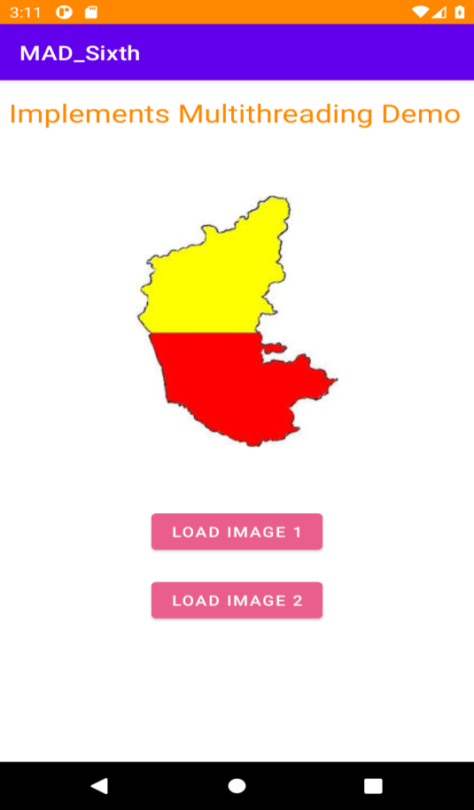
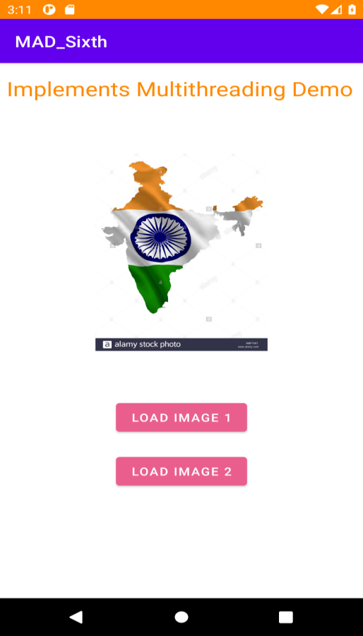

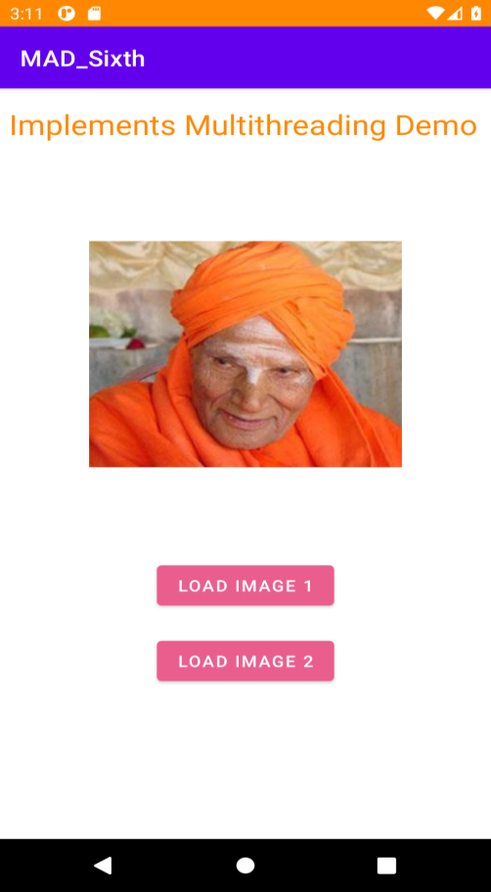

- Develop a mobile application that uses GPS location information

Xml file

<?xml version="1.0" encoding="utf-8"?>
<androidx.constraintlayout.widget.ConstraintLayout xmlns:android="http://schemas.android.com/apk/res/android"
xmlns:app="http://schemas.android.com/apk/res-auto"
xmlns:tools="http://schemas.android.com/tools"
android:id="@+id/linearLayout"
android:layout_width="match_parent"
android:layout_height="match_parent"
tools:context=".MainActivity">
<TextView
android:id="@+id/showLocation2"
android:layout_width="316dp"
android:layout_height="66dp"
android:hint="Location"
android:textColor="#E91E63"
android:textSize="24sp"
app:layout_constraintBottom_toBottomOf="parent"
app:layout_constraintEnd_toEndOf="parent"
app:layout_constraintHorizontal_bias="0.294"
app:layout_constraintStart_toStartOf="parent"
app:layout_constraintTop_toTopOf="parent"
app:layout_constraintVertical_bias="0.627" />
<TextView
android:id="@+id/textView"
android:layout_width="273dp"
android:layout_height="66dp"
android:gravity="center"
android:text="Google Location "
android:textColor="#E91E63"
android:textSize="30sp"
app:layout_constraintBottom_toBottomOf="parent"
app:layout_constraintHorizontal_bias="0.34"
app:layout_constraintLeft_toLeftOf="parent"
app:layout_constraintRight_toRightOf="parent"
app:layout_constraintTop_toTopOf="parent"
app:layout_constraintVertical_bias="0.069" />
<TextView
android:id="@+id/showLocation"
android:layout_width="316dp"
android:layout_height="66dp"
android:hint="Location"
android:textColor="#E91E63"
android:textSize="24sp"
app:layout_constraintBottom_toBottomOf="parent"
app:layout_constraintEnd_toEndOf="parent"
app:layout_constraintHorizontal_bias="0.294"
app:layout_constraintStart_toStartOf="parent"
app:layout_constraintTop_toTopOf="parent"
app:layout_constraintVertical_bias="0.478" />
<Button
android:id="@+id/retrieve_location_button"
android:layout_width="244dp"
android:layout_height="wrap_content"
android:onClick="getLocation"
android:text="Retrieve Location"
android:textColor="#FFFFFF"
app:backgroundTint="#E91E63"
app:layout_constraintBottom_toBottomOf="parent"
app:layout_constraintEnd_toEndOf="parent"
app:layout_constraintHorizontal_bias="0.598"
app:layout_constraintStart_toStartOf="parent"
app:layout_constraintTop_toTopOf="parent"
app:layout_constraintVertical_bias="0.812" />
</androidx.constraintlayout.widget.ConstraintLayout>

Java file

package com.example.madseventh;
import androidx.appcompat.app.AppCompatActivity;
import androidx.core.app.ActivityCompat;
import androidx.core.content.ContextCompat;
import android.Manifest;
import android.app.AlertDialog;
import android.content.Context;
import android.content.DialogInterface;
import android.content.Intent;
import android.content.pm.PackageManager;
import android.location.Location;
import android.location.LocationListener;
import android.location.LocationManager;
import android.os.Bundle;
import android.provider.Settings;
import android.view.View;
import android.widget.Button;
import android.widget.TextView;
import android.widget.Toast;
public class MainActivity extends AppCompatActivity {
GpsTracker gpsTracker;
TextView tvLatitude,tvLongitude;
@Override
protected void onCreate(Bundle savedInstanceState) {
super.onCreate(savedInstanceState);
setContentView(R.layout.activity_main);
tvLatitude = (TextView)findViewById(R.id.showLocation);
tvLongitude = (TextView)findViewById(R.id.showLocation2);
try {
if (ContextCompat.checkSelfPermission(getApplicationContext(), android.Manifest.permission.ACCESS_FINE_LOCATION) != PackageManager.PERMISSION_GRANTED ) {
ActivityCompat.requestPermissions(this, new String[]{android.Manifest.permission.ACCESS_FINE_LOCATION}, 101);
}
} catch (Exception e){
e.printStackTrace();
}
}
public void getLocation(View view){
gpsTracker = new GpsTracker(MainActivity.this);
if(gpsTracker.canGetLocation()){
double latitude = gpsTracker.getLatitude();
double longitude = gpsTracker.getLongitude();
tvLatitude.setText("Latitude---"+String.valueOf(latitude));
tvLongitude.setText("Longitude---"+String.valueOf(longitude));
}else{
gpsTracker.showSettingsAlert();
}
}
}

Gps Tracker java file

package com.example.madseventh;
import android.Manifest;
import android.app.Activity;
import android.app.AlertDialog;
import android.app.Service;
import android.content.Context;
import android.content.DialogInterface;
import android.content.Intent;
import android.content.pm.PackageManager;
import android.location.Location;
import android.location.LocationListener;
import android.location.LocationManager;
import android.os.Bundle;
import android.os.IBinder;
import android.provider.Settings;
import android.util.Log;
import android.widget.Toast;
import androidx.core.app.ActivityCompat;
import java.security.Provider;
public class GpsTracker extends Service implements LocationListener {
private final Context mContext;
// flag for GPS status
boolean isGPSEnabled = false;
// flag for network status
boolean isNetworkEnabled = false;
// flag for GPS status
boolean canGetLocation = false;
Location location; // location
double latitude; // latitude
double longitude; // longitude
// The minimum distance to change Updates in meters
private static final long MIN_DISTANCE_CHANGE_FOR_UPDATES = 10; // 10 meters
// The minimum time between updates in milliseconds
private static final long MIN_TIME_BW_UPDATES = 1000 * 60 * 1; // 1 minute
// Declaring a Location Manager
protected LocationManager locationManager;
public GpsTracker(Context context) {
this.mContext = context;
getLocation();
}
public Location getLocation() {
try {
locationManager = (LocationManager) mContext.getSystemService(LOCATION_SERVICE);
// getting GPS status
isGPSEnabled = locationManager.isProviderEnabled(LocationManager.GPS_PROVIDER);
// getting network status
isNetworkEnabled = locationManager
.isProviderEnabled(LocationManager.NETWORK_PROVIDER);
if (!isGPSEnabled && !isNetworkEnabled) {
// no network provider is enabled
} else {
this.canGetLocation = true;
// First get location from Network Provider
if (isNetworkEnabled) {
//check the network permission
if (ActivityCompat.checkSelfPermission(mContext, Manifest.permission.ACCESS_FINE_LOCATION) != PackageManager.PERMISSION_GRANTED && ActivityCompat.checkSelfPermission(mContext, Manifest.permission.ACCESS_COARSE_LOCATION) != PackageManager.PERMISSION_GRANTED) {
ActivityCompat.requestPermissions((Activity) mContext, new String[]{android.Manifest.permission.ACCESS_FINE_LOCATION, Manifest.permission.ACCESS_COARSE_LOCATION}, 101);
}
locationManager.requestLocationUpdates(
LocationManager.NETWORK_PROVIDER,
MIN_TIME_BW_UPDATES,
MIN_DISTANCE_CHANGE_FOR_UPDATES, this);
Log.d("Network", "Network");
//Toast.makeText(this, "Check the network", Toast.LENGTH_SHORT).show();
if (locationManager != null) {
location = locationManager
.getLastKnownLocation(LocationManager.NETWORK_PROVIDER);
if (location != null) {
latitude = location.getLatitude();
longitude = location.getLongitude();
}
}
}
// if GPS Enabled get lat/long using GPS Services
if (isGPSEnabled) {
if (location == null) {
//check the network permission
if (ActivityCompat.checkSelfPermission(mContext, Manifest.permission.ACCESS_FINE_LOCATION) != PackageManager.PERMISSION_GRANTED && ActivityCompat.checkSelfPermission(mContext, Manifest.permission.ACCESS_COARSE_LOCATION) != PackageManager.PERMISSION_GRANTED) {
ActivityCompat.requestPermissions((Activity) mContext, new String[]{android.Manifest.permission.ACCESS_FINE_LOCATION, Manifest.permission.ACCESS_COARSE_LOCATION}, 101);
}
locationManager.requestLocationUpdates(
LocationManager.GPS_PROVIDER,
MIN_TIME_BW_UPDATES,
MIN_DISTANCE_CHANGE_FOR_UPDATES, this);
Log.d("GPS Enabled", "GPS Enabled");
// Toast.makeText(this, "Enable GPS", Toast.LENGTH_SHORT).show();
if (locationManager != null) {
location = locationManager
.getLastKnownLocation(LocationManager.GPS_PROVIDER);
if (location != null) {
latitude = location.getLatitude();
longitude = location.getLongitude();
}
}
}
}
}
} catch (Exception e) {
e.printStackTrace();
}
return location;
}
/**
* Stop using GPS listener
* Calling this function will stop using GPS in your app
* */
public void stopUsingGPS(){
if(locationManager != null){
locationManager.removeUpdates(GpsTracker.this);
}
}
/**
* Function to get latitude
* */
public double getLatitude(){
if(location != null){
latitude = location.getLatitude();
}
// return latitude
return latitude;
}
/**
* Function to get longitude
* */
public double getLongitude(){
if(location != null){
longitude = location.getLongitude();
}
// return longitude
return longitude;
}
/**
* Function to check GPS/wifi enabled
* @return boolean
* */
public boolean canGetLocation() {
return this.canGetLocation;
}
/**
* Function to show settings alert dialog
* On pressing Settings button will lauch Settings Options
* */
public void showSettingsAlert(){
AlertDialog.Builder alertDialog = new AlertDialog.Builder(mContext);
// Setting Dialog Title
alertDialog.setTitle("GPS is settings");
// Setting Dialog Message
alertDialog.setMessage("GPS is not enabled. Do you want to go to settings menu?");
// On pressing Settings button
alertDialog.setPositiveButton("Settings", new DialogInterface.OnClickListener() {
public void onClick(DialogInterface dialog,int which) {
Intent intent = new Intent(Settings.ACTION_LOCATION_SOURCE_SETTINGS);
mContext.startActivity(intent);
}
});
// on pressing cancel button
alertDialog.setNegativeButton("Cancel", new DialogInterface.OnClickListener() {
public void onClick(DialogInterface dialog, int which) {
dialog.cancel();
}
});
alertDialog.show();
}
@Override
public void onLocationChanged(Location location) {
}
@Override
public void onProviderDisabled(String provider) {
}
@Override
public void onProviderEnabled(String provider) {
}
@Override
public void onStatusChanged(String provider, int status, Bundle extras) {
}
@Override
public IBinder onBind(Intent arg0) {
return null;
}
}
These lines in manifest files

<uses-permission android:name="android.permission.ACCESS_FINE_LOCATION" />
<uses-permission android:name="android.permission. ACCESS_COARSE_LOCATION" />
<uses-permission android:name="android.permission.INTERNET"/>

output

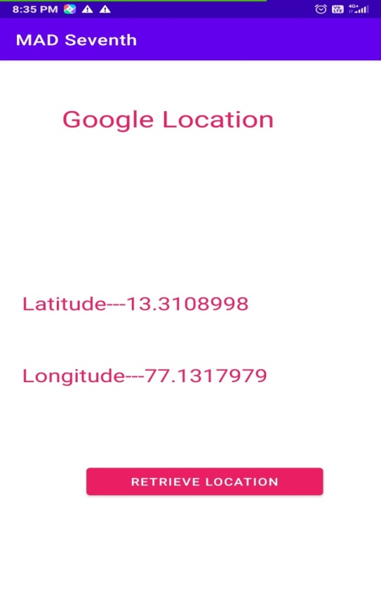

- Create an application that writes data to the SD card.

Xml file

<?xml version="1.0" encoding="utf-8"?>
<LinearLayout xmlns:android="http://schemas.android.com/apk/res/android"
xmlns:app="http://schemas.android.com/apk/res-auto"
xmlns:tools="http://schemas.android.com/tools"
android:layout_width="match_parent"
android:layout_height="match_parent"
android:background="#F1C2BE"
android:orientation="vertical"
tools:context=".MainActivity">
<TextView
android:layout_width="fill_parent"
android:layout_height="110dp"
android:background="#E3A0B7"
android:text="Reading and Writing to External Storage"
android:textSize="24sp" />
<EditText
android:id="@+id/myInputText"
android:layout_width="match_parent"
android:layout_height="150dp"
android:background="#D57696"
android:ems="10"
android:gravity="top|left"
android:inputType="textMultiLine"
android:lines="5"
android:minLines="3">
<requestFocus />
</EditText>
<LinearLayout
android:layout_width="match_parent"
android:layout_height="wrap_content"
android:layout_marginTop="20dp"
android:orientation="horizontal"
android:weightSum="1.0">
<Button
android:id="@+id/saveExternalStorage"
android:layout_width="match_parent"
android:layout_height="wrap_content"
android:layout_weight="0.5"
android:text="SAVE"
app:backgroundTint="#2C89D3" />
<Button
android:id="@+id/getExternalStorage"
android:layout_width="match_parent"
android:layout_height="wrap_content"
android:layout_weight="0.5"
android:text="READ"
app:backgroundTint="#2C89D3" />
</LinearLayout>
<TextView
android:id="@+id/response"
android:layout_width="match_parent"
android:layout_height="wrap_content"
android:padding="25sp"
android:text=""
android:textAppearance="?android:attr/textAppearanceMedium" />
</LinearLayout>

Java File
package com.example.mad_lab8;
import androidx.appcompat.app.AppCompatActivity;
import android.content.SharedPreferences;
import android.os.Bundle;
import android.os.Environment;
import android.view.View;
import android.widget.Button;
import android.widget.EditText;
import android.widget.TextView;
import android.widget.Toast;
import java.io.BufferedReader;
import java.io.DataInputStream;
import java.io.File;
import java.io.FileInputStream;
import java.io.FileOutputStream;
import java.io.FileReader;
import java.io.FileWriter;
import java.io.IOException;
import java.io.InputStreamReader;
public class MainActivity extends AppCompatActivity {
EditText inputText;
TextView response;
Button saveButton, readButton;
private String filename = "SampleFile.txt";
private String filepath = "MyFileStorage";
File myExternalFile;
String myData = "";
@Override
protected void onCreate(Bundle savedInstanceState) {
super.onCreate(savedInstanceState);
setContentView(R.layout.activity_main);
inputText = (EditText) findViewById(R.id.myInputText);
response = (TextView) findViewById(R.id.response);
saveButton =(Button) findViewById(R.id.saveExternalStorage);
saveButton.setOnClickListener(new View.OnClickListener() {
@Override
public void onClick(View v) {
try {
FileOutputStream fos = new FileOutputStream(myExternalFile);
fos.write(inputText.getText().toString().getBytes());
fos.close();
} catch (IOException e) {
e.printStackTrace();
}
inputText.setText("");
inputText.setFocusable(true);
response.setText("SampleFile.txt saved to External Storage...");
}
});
readButton = (Button) findViewById(R.id.getExternalStorage);
readButton.setOnClickListener(new View.OnClickListener() {
@Override
public void onClick(View v) {
try {
FileInputStream fis = new FileInputStream(myExternalFile);
DataInputStream in = new DataInputStream(fis);
BufferedReader br =
new BufferedReader(new InputStreamReader(in));
String strLine;
while ((strLine = br.readLine()) != null) {
myData = myData + strLine;
}
in.close();
} catch (IOException e) {
e.printStackTrace();
}
inputText.setText(myData);
response.setText("SampleFile.txt data retrieved from Internal Storage...");
}
});
if (!isExternalStorageAvailable() || isExternalStorageReadOnly()) {
saveButton.setEnabled(false);
}
else {
myExternalFile = new File(getExternalFilesDir(filepath), filename);
}
}
private static boolean isExternalStorageReadOnly() {
String extStorageState = Environment.getExternalStorageState();
if (Environment.MEDIA_MOUNTED_READ_ONLY.equals(extStorageState)) {
return true;
}
return false;
}
private static boolean isExternalStorageAvailable() {
String extStorageState = Environment.getExternalStorageState();
if (Environment.MEDIA_MOUNTED.equals(extStorageState)) {
return true;
}
return false;
}
}

Manifest file

<?xml version="1.0" encoding="utf-8"?>
<manifest xmlns:android="http://schemas.android.com/apk/res/android"
package="com.example.mad_lab8">
<uses-permission android:name="android.permission.WRITE_EXTERNAL_STORAGE"/>
<uses-permission android:name="android.permission.READ_EXTERNAL_STORAGE"/>
<application
android:allowBackup="true"
android:icon="@mipmap/ic_launcher"
android:label="@string/app_name"
android:roundIcon="@mipmap/ic_launcher_round"
android:supportsRtl="true"
android:theme="@style/Theme.MAD_Lab8">
<activity android:name=".MainActivity">
<intent-filter>
<action android:name="android.intent.action.MAIN" />
<category android:name="android.intent.category.LAUNCHER" />
</intent-filter>
</activity>
</application>
</manifest>

Output:
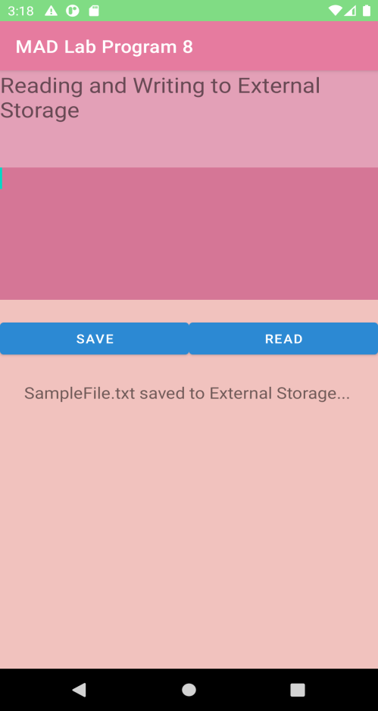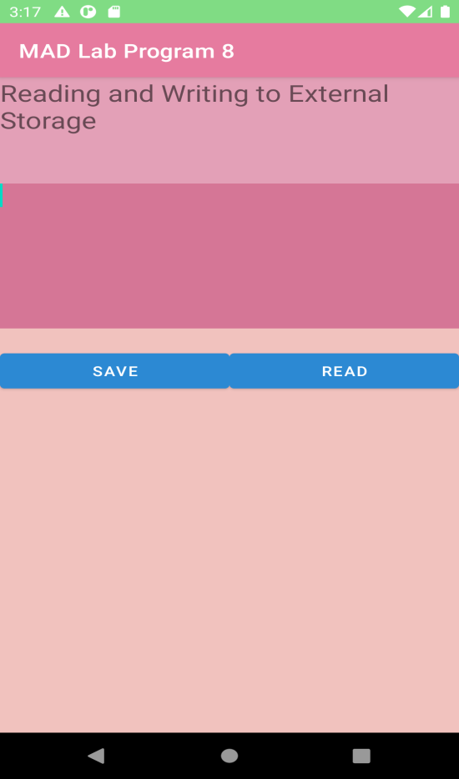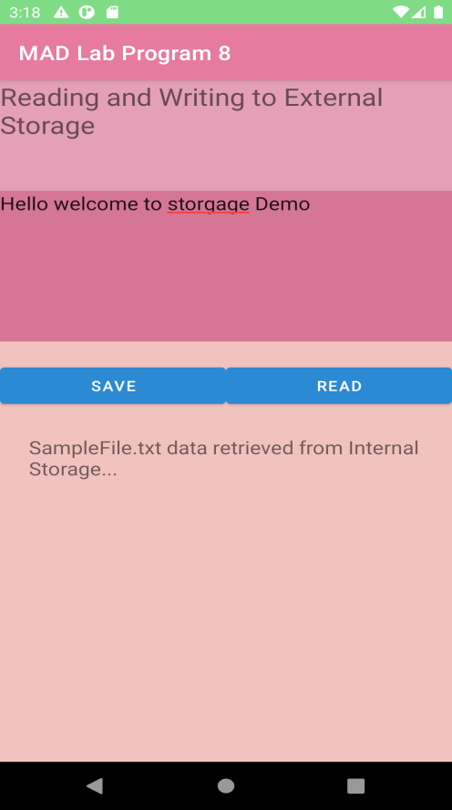

- Implement an application that creates an alert upon receiving a message.

activity_main.xml
<?xml version="1.0" encoding="utf-8"?>
<LinearLayout xmlns:android="http://schemas.android.com/apk/res/android"
xmlns:app="http://schemas.android.com/apk/res-auto"
xmlns:tools="http://schemas.android.com/tools"
android:layout_width="match_parent"
android:layout_height="match_parent"
tools:context=".MainActivity"
android:orientation="vertical">
<TextView
android:layout_width="wrap_content"
android:layout_height="wrap_content"
android:text="Message!"
android:textSize="30sp"/>
<EditText
android:id="@+id/editText"
android:layout_width="match_parent"
android:layout_height="wrap_content"
android:singleLine="true"
android:textSize="30sp"/>
<Button
android:id="@+id/button"
android:layout_width="wrap_content"
android:layout_height="wrap_content"
android:layout_margin="30dp"
android:layout_gravity="center"
android:text="notify"
android:textSize="30sp"
/>
</LinearLayout>
MainActivity.java
package com.example.administrator.expg09;
import android.support.v7.app.AppCompatActivity;
import android.os.Bundle;
import android.app.Notification;
import android.app.NotificationManager;
import android.app.PendingIntent;
import android.content.Intent;
import android.os.Bundle;
import android.support.v7.app.AppCompatActivity;
import android.view.View;
import android.widget.Button;
import android.widget.EditText;

public class MainActivity extends AppCompatActivity{

Button notify;
EditText e;

@Override
protected void onCreate(Bundle savedInstanceState){
super.onCreate(savedInstanceState);
setContentView(R.layout.activity_main);
notify=(Button) findViewById(R.id.button);
e=(EditText)findViewById(R.id.editText);
notify.setOnClickListener(new View.OnClickListener(){
@Override
public void onClick(View view){
Intent intent = new Intent(MainActivity.this, SecondActivity.class);
PendingIntent pending = PendingIntent.getActivity(MainActivity.this,0,intent,0);
Notification noti= new Notification.Builder(
MainActivity.this).setContentTitle("New Message"). setContentText(e.getText().toString()). setSmallIcon(R.mipmap.ic_launcher). setContentIntent(pending).build();
NotificationManager manager=(NotificationManager) getSystemService(NOTIFICATION_SERVICE);
noti.flags|=Notification.FLAG_AUTO_CANCEL;
manager.notify(0,noti);
}
});
}
}

Output:

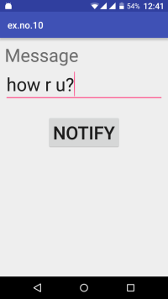

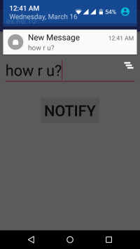

- Devise a mobile application that creates alarm clock.
XML file
<?xml version="1.0" encoding="utf-8"?>
<LinearLayout xmlns:android="http://schemas.android.com/apk/res/android"
xmlns:app="http://schemas.android.com/apk/res-auto"
xmlns:tools="http://schemas.android.com/tools"
android:layout_width="match_parent"
android:orientation="vertical"
android:layout_height="match_parent"
tools:context=".MainActivity">
<TimePicker
android:id="@+id/timePicker"
android:layout_width="wrap_content"
android:layout_height="wrap_content"
android:layout_gravity="center" />
<ToggleButton
android:id="@+id/toggleButton"
android:layout_width="wrap_content"
android:layout_height="wrap_content"
android:layout_gravity="center"
android:layout_margin="20dp"
android:checked="false"
android:onClick="OnToggleClicked" />
</LinearLayout>

Java file

package com.example.madlabprogram10;
import androidx.appcompat.app.AppCompatActivity;
import android.app.AlarmManager;
import android.app.PendingIntent;
import android.content.Intent;
import android.os.Bundle;
import android.view.View;
import android.widget.TimePicker;
import android.widget.Toast;
import android.widget.ToggleButton;
import java.util.Calendar;
public class MainActivity extends AppCompatActivity {
TimePicker alarmTimePicker;
PendingIntent pendingIntent;
AlarmManager alarmManager;
@Override
protected void onCreate(Bundle savedInstanceState) {
super.onCreate(savedInstanceState);
setContentView(R.layout.activity_main);
alarmTimePicker = (TimePicker) findViewById(R.id.timePicker);
alarmManager = (AlarmManager) getSystemService(ALARM_SERVICE);
}
public void OnToggleClicked(View view) {
long time;
if (((ToggleButton) view).isChecked()){
Toast.makeText(MainActivity.this, "ALARM ON", Toast.LENGTH_SHORT).show();
Calendar calendar = Calendar.getInstance();
calendar.set(Calendar.HOUR_OF_DAY,alarmTimePicker.getCurrentHour());
calendar.set(Calendar.MINUTE,alarmTimePicker.getCurrentMinute());
Intent intent = new Intent(this, AlarmReceiver.class);
pendingIntent=PendingIntent.getBroadcast(this, 0, intent,0);
time=(calendar.getTimeInMillis()-(calendar.getTimeInMillis()%60000));
// the operating system for some the time is measured in milliseconds
if(System.currentTimeMillis()>time){
if (calendar.AM_PM == 0)
time = time + (1000*60*60*12);
else
time = time + (1000*60*60*24);
}
alarmManager.setRepeating(AlarmManager.RTC_WAKEUP, time,10000, pendingIntent);
}
else{
alarmManager.cancel(pendingIntent);
Toast.makeText(MainActivity.this, "ALARM OFF",Toast.LENGTH_SHORT).show();
}
}
}

Alaram reaciver java file
package com.example.madlabprogram10;
import androidx.appcompat.app.AppCompatActivity;
import android.app.AlarmManager;
import android.app.PendingIntent;
import android.content.Intent;
import android.os.Bundle;
import android.view.View;
import android.widget.TimePicker;
import android.widget.Toast;
import android.widget.ToggleButton;
import java.util.Calendar;
public class MainActivity extends AppCompatActivity {
TimePicker alarmTimePicker;
PendingIntent pendingIntent;
AlarmManager alarmManager;
@Override
protected void onCreate(Bundle savedInstanceState) {
super.onCreate(savedInstanceState);
setContentView(R.layout.activity_main);
alarmTimePicker = (TimePicker) findViewById(R.id.timePicker);
alarmManager = (AlarmManager) getSystemService(ALARM_SERVICE);
}
public void OnToggleClicked(View view) {
long time;
if (((ToggleButton) view).isChecked()){
Toast.makeText(MainActivity.this, "ALARM ON", Toast.LENGTH_SHORT).show();
Calendar calendar = Calendar.getInstance();
calendar.set(Calendar.HOUR_OF_DAY,alarmTimePicker.getCurrentHour());
calendar.set(Calendar.MINUTE,alarmTimePicker.getCurrentMinute());
Intent intent = new Intent(this, AlarmReceiver.class);
pendingIntent=PendingIntent.getBroadcast(this, 0, intent,0);
time=(calendar.getTimeInMillis()-(calendar.getTimeInMillis()%60000));
// the operating system for some the time is measured in milliseconds
if(System.currentTimeMillis()>time){
if (calendar.AM_PM == 0)
time = time + (1000*60*60*12);
else
time = time + (1000*60*60*24);
}
alarmManager.setRepeating(AlarmManager.RTC_WAKEUP, time,10000, pendingIntent);
}
else{
alarmManager.cancel(pendingIntent);
Toast.makeText(MainActivity.this, "ALARM OFF",Toast.LENGTH_SHORT).show();
}
}
}
Output
