**Assignment – 01**

Aim: Design a webpage using HTML tags

Code:

Page 1) Landing Page:  
  
<!DOCTYPE html>

<html lang="en">

  <head>

    <meta charset="UTF-8" />

    <meta http-equiv="X-UA-Compatible" content="IE=edge" />

    <meta name="viewport" content="width=device-width, initial-scale=1.0" />

    <title>Sign Up</title>

  </head>

  <body>

    <nav>

      <div>

        <span> Home </span>

        <span> Dashboard </span>

        <span> About us </span>

        <span> Contact Us </span>

      </div>

      <div>

        <span> Profile </span>

        <span> Signup </span>

        <span> Login </span>

        <span> Settings </span>

      </div>

    </nav>

    <section class="hero">

      <div>

        <h1>Company Name</h1>

        <p>

          Lorem ipsum dolor sit amet consectetur adipisicing<br />

          elit. Illum saepe placeat sapiente! Quod, adipisci!<br />

          Aut, quis impedit sapiente rerum exercitationem<br />

          numquam officia voluptatem totam quasi corrupti.<br />

          Consequuntur, animi! Itaque, aut!

        </p>

      </div>

      <div>

        <img src="../assets/hero.svg" alt="" />

      </div>

      <button type="button">Get Started</button>

    </section>

    <section class="services">

      <div class="service">

        <img src="../assets/service-1" alt="" />

        <h2>The service that we provide</h2>

        <p>

          Lorem ipsum dolor, sit amet<br />

          consectetur adipisicing elit.<br />

          Repellendus doloremque dolore<br />

          voluptatem facilis labore

        </p>

      </div>

      <div class="service">

        <img src="../assets/service-2" alt="" />

        <h2>The service that we provide</h2>

        <p>

          Lorem ipsum dolor, sit amet<br />

          consectetur adipisicing elit.<br />

          Repellendus doloremque dolore<br />

          voluptatem facilis labore

        </p>

      </div>

      <div class="service">

        <img src="../assets/service-3" alt="" />

        <h2>The service that we provide</h2>

        <p>

          Lorem ipsum dolor, sit amet<br />

          consectetur adipisicing elit.<br />

          Repellendus doloremque dolore<br />

          voluptatem facilis labore

        </p>

      </div>

    </section>

    <section class="network">

      <h2>Huge network</h2>

      <h2>Around the World</h2>

      <p>

        Lorem ipsum dolor sit amet consectetur, adipisicing elit. Eaque laborum

        incidunt vel corporis iste sunt

      </p>

      <img src="../assets/network.jpg" alt="" />

    </section>

    <section class="data">

      <div>

        <h2>Enriching Lives</h2>

        <h2>Everyday with Shashank</h2>

      </div>

      <div>

        <div>

          <img src="../assets/" alt="" />

          <h2>30000+</h2>

          <p>members</p>

        </div>

        <div>

          <img src="../assets/profile.svg" alt="" />

          <h2>100000+</h2>

          <p>happy customers</p>

        </div>

        <div>

          <img src="../assets/order.svg" alt="" />

          <h2>1000+</h2>

          <p>Orders Everyday</p>

        </div>

        <div>

          <img src="../assets/money.svg" alt="" />

          <h2>10 million+</h2>

          <p>Worth of Transactions</p>

        </div>

      </div>

    </section>

  </body>

</html>

aim

<code></code>

ss

conclusin

tags that i have used

Page 2) Sign up Page:

<!DOCTYPE html>

<html lang="en">

  <head>

    <meta charset="UTF-8" />

    <meta http-equiv="X-UA-Compatible" content="IE=edge" />

    <meta name="viewport" content="width=device-width, initial-scale=1.0" />

    <title>Sign Up</title>

  </head>

  <body>

    <nav>

      <div>

        <span> Home </span>

        <span> Dashboard </span>

        <span> About us </span>

        <span> Contact Us </span>

      </div>

      <div>

        <span> Profile </span>

        <span> Logout </span>

        <span> Settings </span>

      </div>

    </nav>

    <section>

      <form>

        <label for="firstName">First Name</label>

        <input type="text" name="firstName" id="" />

        <br />

        <label for="lastName">Last Name</label>

        <input type="text" name="lastName" id="" />

        <br />

        <label for="username">Username</label>

        <input type="text" name="username" id="" />

        <br />

        <label for="password">Password</label>

        <input type="password" name="password" id="" />

        <br />

        <label for="confirm-password">Confirm Password</label>

        <input type="password" name="confirm-password" id="" />

        <br />

        <label for="Age">Age</label>

        <input type="text" name="Age" id="" />

        <br />

        <label for="gender">Gender</label>

        <select name="gender" id="">

          <option value="Male">Male</option>

          <option value="Female">Female</option>

        </select>

        <br />

        <label for="firstName">First Name</label>

        <input type="text" name="firstName" id="" />

        <br />

        <button type="submit">Submit</button>

        Already a member? <a href="login.html">Login</a>

      </form>

    </section>

  </body>

</html>

Page 3) Login Page:

<!DOCTYPE html>

<html lang="en">

  <head>

    <meta charset="UTF-8" />

    <meta http-equiv="X-UA-Compatible" content="IE=edge" />

    <meta name="viewport" content="width=device-width, initial-scale=1.0" />

    <title>Sign Up</title>

  </head>

  <body>

    <nav>

      <div>

        <span> Home </span>

        <span> Dashboard </span>

        <span> About us </span>

        <span> Contact Us </span>

      </div>

      <div>

        <span> Profile </span>

        <span> Logout </span>

        <span> Settings </span>

      </div>

    </nav>

    <section>

      <form>

        <label for="username">Username</label>

        <input type="text" name="username" id="" />

        <br />

        <label for="password">Password</label>

        <input type="password" name="password" id="" />

        <br />

        <button type="submit" onc>Submit</button>

        Not already a user? <a href="signup.html">Sign Up</a>

      </form>

    </section>

  </body>

</html>

Page 4) Dashboard Page:

<!DOCTYPE html>

<html lang="en">

  <head>

    <meta charset="UTF-8" />

    <meta http-equiv="X-UA-Compatible" content="IE=edge" />

    <meta name="viewport" content="width=device-width, initial-scale=1.0" />

    <title>Sign Up</title>

  </head>

  <body>

    <nav>

      <div>

        <span> Home </span>

        <span> Dashboard </span>

        <span> About us </span>

        <span> Contact Us </span>

      </div>

      <div>

        <span> Profile </span>

        <span> Logout </span>

        <span> Settings </span>

      </div>

    </nav>

    <section class="sidebar"></section>

    <section class="main-ele">

      <div>Dashboard Element</div>

      <div>Dashboard Element</div>

      <div>Dashboard Element</div>

      <div>Dashboard Element</div>

    </section>

  </body>

</html>

Page 5) About us Page:

<!DOCTYPE html>

<html lang="en">

  <head>

    <meta charset="UTF-8" />

    <meta http-equiv="X-UA-Compatible" content="IE=edge" />

    <meta name="viewport" content="width=device-width, initial-scale=1.0" />

    <title>Sign Up</title>

  </head>

  <body>

    <nav>

      <div>

        <span> Home </span>

        <span> Dashboard </span>

        <span> About us </span>

        <span> Contact Us </span>

      </div>

      <div>

        <span> Profile </span>

        <span> Logout </span>

        <span> Settings </span>

      </div>

    </nav>

    <section class="about-us">

      <div>

        <p>

          Lorem ipsum dolor, sit amet<br />

          consectetur adipisicing elit.<br />

          Repellendus doloremque dolore<br />

          voluptatem facilis labore

        </p>

        <img src="../assets/aboutus.svg" alt="" />

      </div>

    </section>

    <section class="data">

      <div>

        Shashank Store STORY The first Shashank store was our own Over a decade

        ago, we started a store to sell snowboards online. None of the ecommerce

        solutions at the time gave us the control we needed to be successful—so

        we built our own. Today, businesses of all sizes use Shashank Store,

        whether they're selling online, in retail stores, or on-the-go.

      </div>

    </section>

  </body>

</html>

Page 6) Contact Us Page

<!DOCTYPE html>

<html lang="en">

  <head>

    <meta charset="UTF-8" />

    <meta http-equiv="X-UA-Compatible" content="IE=edge" />

    <meta name="viewport" content="width=device-width, initial-scale=1.0" />

    <title>Sign Up</title>

  </head>

  <body>

    <nav>

      <div>

        <span> Home </span>

        <span> Dashboard </span>

        <span> About us </span>

        <span> Contact Us </span>

      </div>

      <div>

        <span> Profile </span>

        <span> Logout </span>

        <span> Settings </span>

      </div>

    </nav>

    <section>

        <p>

            Lorem ipsum dolor sit amet consectetur adipisicing<br />

            elit. Illum saepe placeat sapiente! Quod, adipisci!<br />

            Aut, quis impedit sapiente rerum exercitationem<br />

            numquam officia voluptatem totam quasi corrupti.<br />

            Consequuntur, animi! Itaque, aut!

          </p>

        </div>

        <div>

          <img src="../assets/contact.svg" alt="" />

        </div>

    </section>

    <section class="contact-us">

        <div><img src="../assets/facebook.svg" alt=""><h2>Facebook</h2><p>Lorem ipsum dolor, sit amet<br /> consectetur adipisicing elit.<br /> Repellendus doloremque dolore<br /> voluptatem facilis labore</p></div>

        <div><img src="../assets/twitter.svg" alt=""><h2>Twitter</h2><p>Lorem ipsum dolor, sit amet<br /> consectetur adipisicing elit.<br /> Repellendus doloremque dolore<br /> voluptatem facilis labore</p></div>

        <div><img src="../assets/instagram.svg" alt=""><h2>Instagram</h2><p>Lorem ipsum dolor, sit amet<br /> consectetur adipisicing elit.<br /> Repellendus doloremque dolore<br /> voluptatem facilis labore</p></div>

        <div><img src="../assets/linkedin.svg" alt=""><h2>LinkedIn</h2><p>Lorem ipsum dolor, sit amet<br /> consectetur adipisicing elit.<br /> Repellendus doloremque dolore<br /> voluptatem facilis labore</p></div>

    </section>

  </body>

</html>

Screenshots:

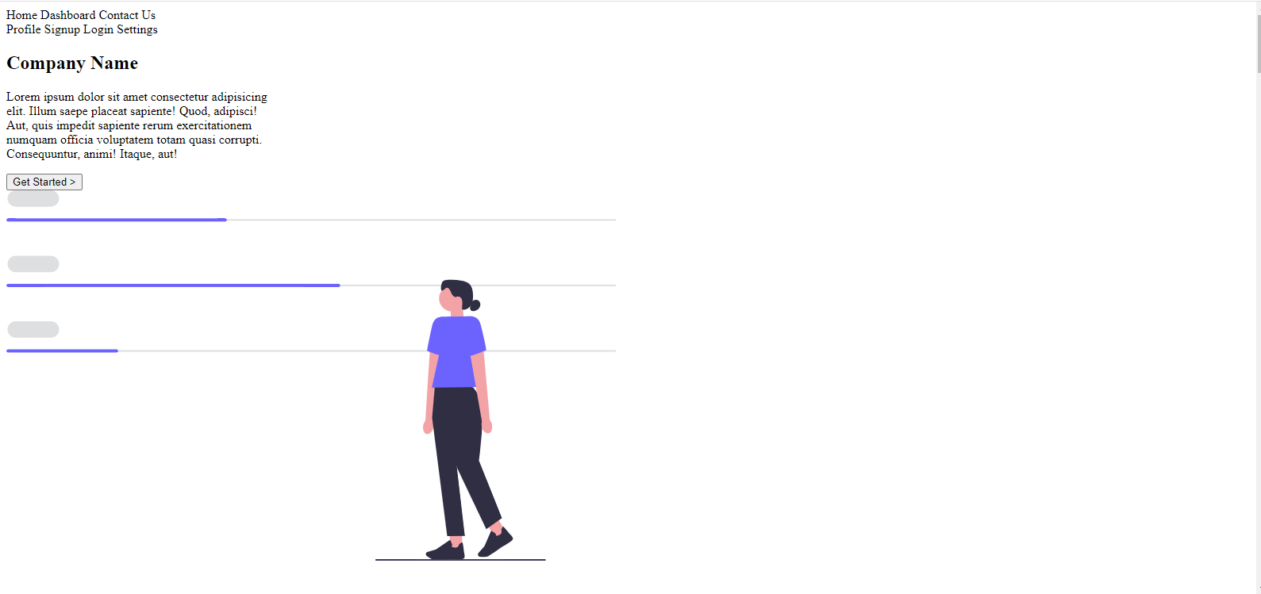

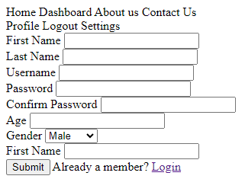

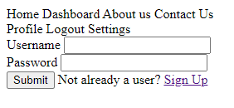

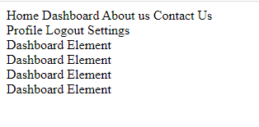

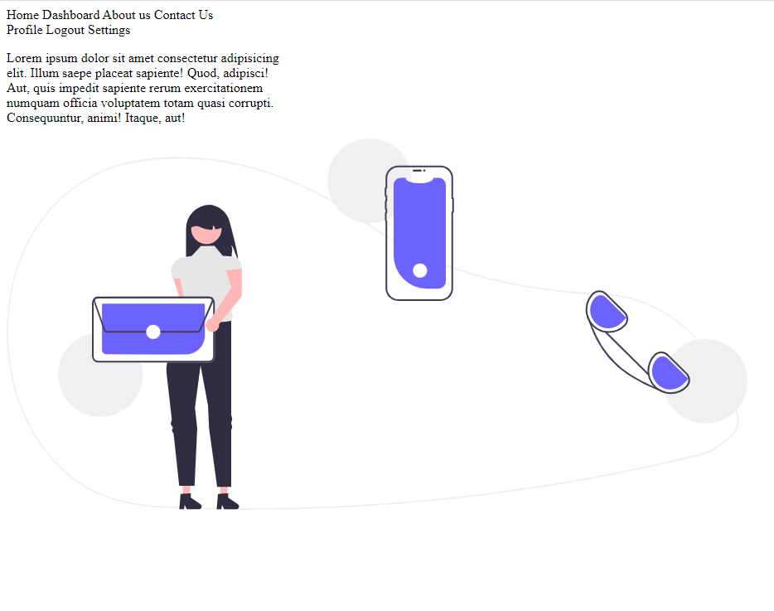

Conclusion:

Tags Used:

1. <html>
2. <body>
3. <div>
4. <section>
5. <p>
6. <img>
7. <label>
8. <input>
9. <span>
10. <form>
11. <select>
12. <option>
13. <br>
14. <button>
15. <nav>
16. <head>
17. <title>
18. <meta>
19. <h1>
20. <h2>