Required parts of the project:
1. Introduction
2. Pseudocode of ‘float chart’.
3. Write your own code (in Matlab or python). Attach your code.
4. Result
The total point is 100, distributed as 20/20/30/30 points for Section 1/2/3/4.

Final Project Math-III
Due Aug. 12, 2021

Solving 1-d Schrödinger equation by the shooting method

Use Runge-Kutta (4th order) method to solve a one-dimensional double-well problem
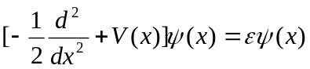
where the atomic unit (a.u.) is used. The potential V is a double-well (as shown below)
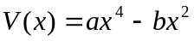
with a=2 and b=8.
- Find all the energy eigenvalues below zero (ε < 0). (at least 4 significant figures)

- plot the lowest two states (orthonormal wave functions) together with V(x) in (-2.5<x<2.5).

- Discuss that if V(x) is approximated as a simple harmonic oscillator around x0, where x0 is one of the two bottoms, what kind of structures for the energy eigenvalues and wavefunctions will be. Compared (qualitatively) with your results from a) and b).

Please use the general format we used in other projects for the report.

