Midterm Exam

1. Context Diagram

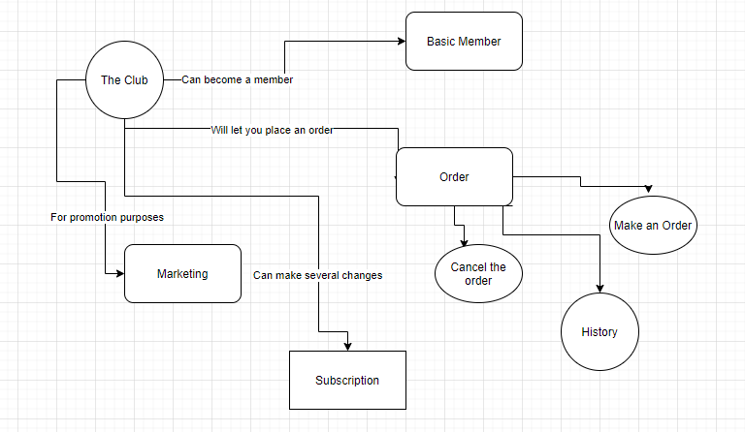

Data Flow Diagram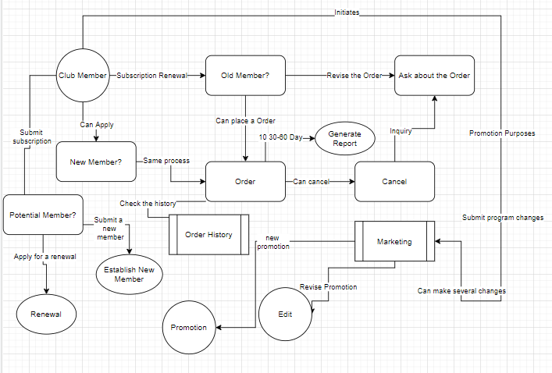

Use Case #1. Use Case Name: **Order Subsystem**

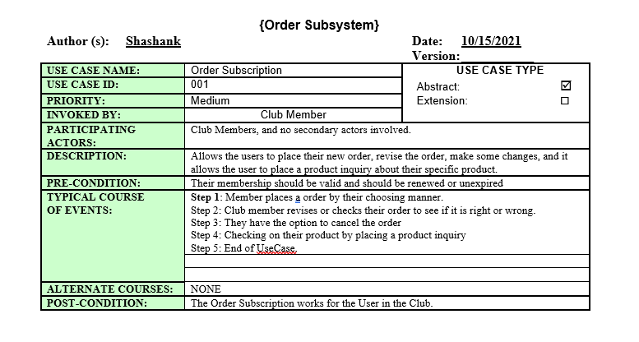

UseCase #2

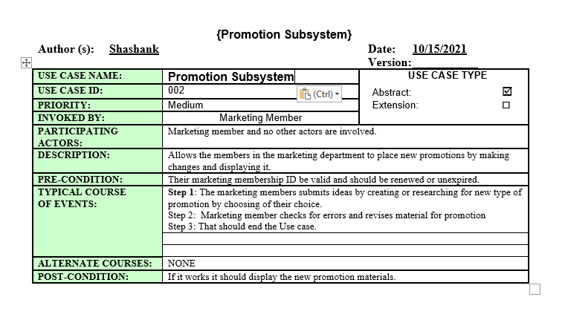

Use Case #3.

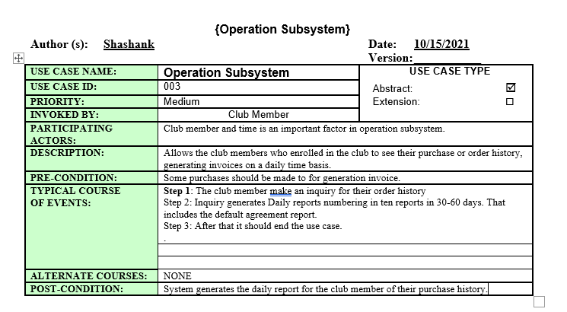

**2**. Given the following diagram

1. Possible Use Cases include for the actor (Customer) to place an order, when they do item master makes sure it is in the inventory. When the order is in pending, ships from the warehouse it is in, and ships to customers. When it is done, a statement is generated so that the order is confirmed and ready for shipping for the customer who ordered it.  
   Customers can also get the description of the item, and information about the item they placed.The customer master, responsible for managing business transactions can produce receipts available for the accounting department.

Use Case Diagram...**First Use Case: Priority: Medium to High**

1. 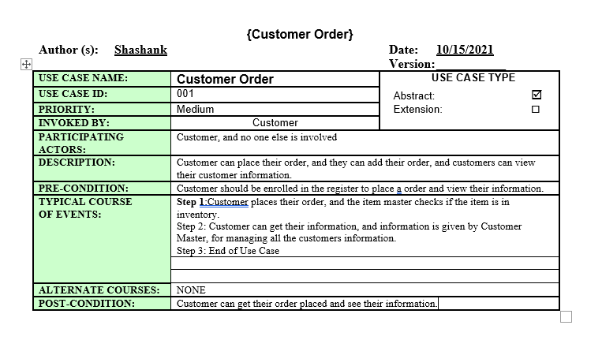
2. Use Case Diagram  
   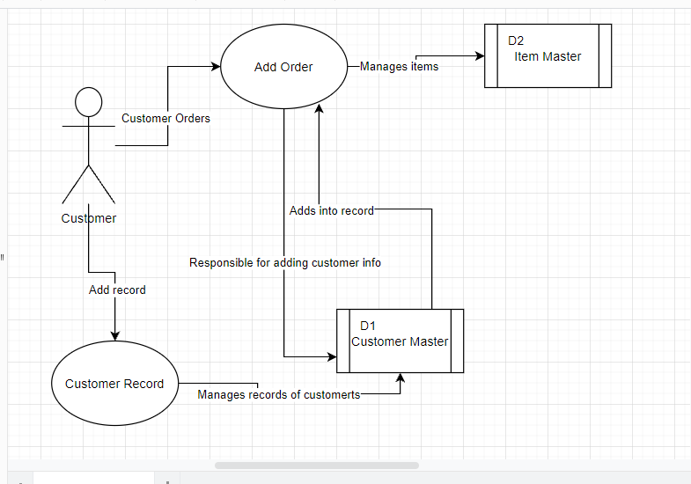  
     
     
     
     
     
     
     
     
     
     
     
     
     
     
     
     
     
     
     
     
     
   **3**. Activity Diagram for Problem #1

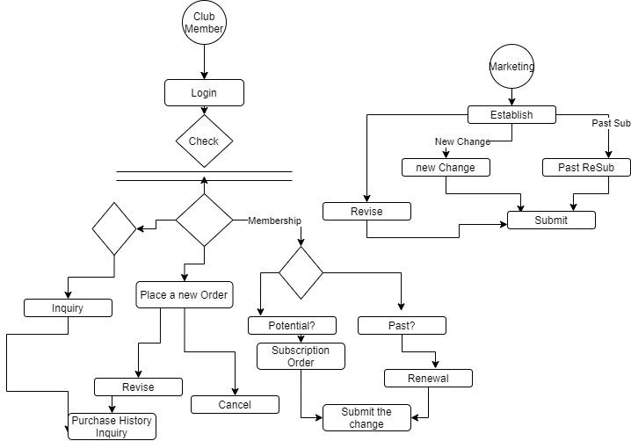

4. Activity Diagram for Problem# 2

