SIP Report (R – 3)

**Swiggy Bangalore Outlet Data Analysis**

Shashank Nishad

2021 – 23

**Company Guide (Name): Mr Krish Naik**

**Mr Dibyanshu**

Signature of the Student*: _________________*

|  |  |
| --- | --- |
| Name of student | : Shashank Nishad |
| Date | : 1-8-2022 |
| Place | : Lucknow |

Executive Summary

iNeuron Intelligence Private Limited a core Data Science company there are every type of data related project I have enrolled for business intelligence project they give me Swiggy Bangalore Outlet Data Analysis during my internship I have worked on high level design. The purpose of this High-Level Design (HLD) Document is to add the necessary detail to the current project description to represent a suitable model for coding. This document is also intended to help detect contradictions before coding and can be used as a reference manual for how the modules interact at a high level. I have worked on Low Level Design The purpose of this document is to present a detailed description of the swiggy prediction analysis technique. It will explain the necessary steps which have to be followed before any analysis can begin. The document would also describe the algorithms and techniques used to predict the presence and absence of the food industry and present a comparative result for the same. I have worked on architecture design Any software needs the architectural design to represent the design of the software. IEEE defines architectural design as “the process of defining a collection of hardware and software components and their interfaces to establish the framework for the development of a computer system.” The software that is built for computer-based systems can exhibit one of these many architectures. During the internship I have work on unstructured data and missing value and visit different different website to read the article and l have register on TATA Data visualization camp for learning power bi after complete all the things I have create a dashboard to collect all the information at one place in the from of data visualization.

.



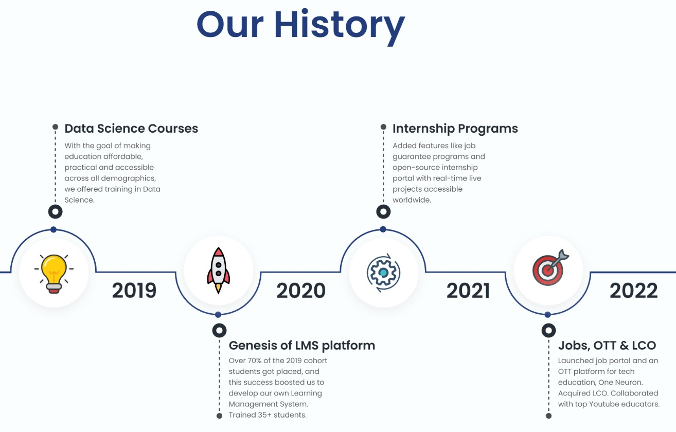

Table of contents

|  |  |  |
| --- | --- | --- |
|  | Chapters | Page No. |
| 1 | Introduction | 9 |
| 2 | Review of Literature | 11 - 19 |
| 3 | Industry Analysis | 20 - 26 |
| 4 | Company Analysis | 27 - 31 |
| 5 | Task/ Research | 32 - 50 |
| 6 | Strategy | 51 - 59 |
| 7 | Analysis and Findings | 60 - 61 |
| 8 | Conclusion and Limitations | 62 - 63 |
| Bibliography | | 64 |
| Annexure | | 65 - 68 |

Acronyms (if any)

|  |  |
| --- | --- |
| Acronym | Full Form |
| BI | Business Intelligence |
| BMI | Business Model Intelligence |
| DH | Data Handling |
| FI | Food Industry |
| MV | Missing Value |

**Chapter 1**

**Introduction**

I Shashank Shekhar Nishad Started my internship in iNeuron Intelligence Private Limited where I got the privilege to work in Business Intelligence department through which I get great learning and experience in Data. It was my first experience in the corporate sector which help me to choose my career path in Data Science. I chose Data Science to learn more about the how real data can work in every daily life how can find the inside from the data and give a right predict report to the company so that can work on that predication. In my internship starting, there was work on missing data and the data is very unstructured from to learn many things from my internship.

**Chapter 2**

**Review of Literature**

Due to the rapid growth of new technologies, the Business Intelligence (BI) market is growing as well that forces the corporations to adopt their offerings to the needs of the customer. Adoption of Business Intelligence system has become one of the most important technological and organizational innovations in modern organization that promote knowledge diffusion, and cornerstone of business decision making processes. Since the way of BI integrated and implemented is quite different among organizations, it is important to approach BI literature by adaption of BI application and its implementation, BI architects, and enabling factors in BI projects. Furthermore, we are also going to discuss how technological capabilities such as user access, data quality and the integration of BI with other systems in the firm, as well as organizational capabilities such as flexibility and risk management support, are essential for BI success, regardless of the decision environment. Last but not least, this paper will also discuss how the idea of BI has been built on the school of thought. We expect that results could create the value and input for enterprises that plan to implement a BI application in their organization. Keywords: Business Intelligence, BI Capabilities, BI Architectures, Enabling Factors INTRODUCTION Present day association settings are very convoluted and continually evolving. Organizations, in both public and private sector, are under extraordinary pressure for offering an explanation to the top management about change condition and innovation. To do so, it requires an organization to possess strategic, operational and tactical decisions; however, they are complicated and are taken rapidly. The basic leadership requires a lot of data, information, and knowledge. One ought to process this data as required basic leadership and fast, on time and ongoing preparing is expected to end up modernized (Turban et al, 2010). Furthermore, nowadays business life cycle has turned out to be shorter. Henceforth, to gain the competitive advantage organization must have quick and proper decision making. Decision maker indeed needs good data, to make the right decision at the right time and place (Farjami, 2015). -2- The concept of BI existed during the 1950s and it grew out from a technology called decision support. Decision support is still used by many companies to come up with decisions that would help them to gain competitive advantage amongst their competitors. BI has grown strong during the recent years mainly due to increased data collection and better technology with greater storage capacity. Due to the improvement of technology, the company can use BI to store a large amount of data with cheaper rate. Companies have access to a lot of data in the form of smartphone, internet records, social media activities and so on. BI can sift through these data to find patterns and trends (Raisinghani, 2004). In any organization regardless its size, the business activities include the administration of extensive amounts of data from both inner and outside business conditions; all these data identified with interior operations, advertise, clients, providers, economic assets, and so forth., historically cumulated, on action times of the organization, shape the reason for some complex and greatly helpful economic and money related problems in the organization's administration decision making process (Mihaelia and Rozalia, 2012). METHODOLOGY In this paper, we are going to use secondary data from the previous literature review of the Business Intelligence with dozens of article and secondary sources of data collection. The paper is concluded with the literature review of Business Intelligence. Business Intelligence mainly focuses how to collect, organize and interpret the data to relevant department to make an effective decision under the uncertainty to obtain the organizational goal. In the discussion session, we will try to draw a link between Business Intelligence aspect and Thematic School of Thought under the theme of uncertainty, information and game theory which mainly related to decision making. Furthermore, we will rationalize how Business Intelligence is related or has been built on the School of Thought. LITERATURE REVIEW 1. Business Intelligence There is another issue with a great number of definitions; they tend to change after some time, in light of the fact that the way of what they consider changes. This is the situation with BI for instance. Initially, software business engaged with BI, BI used to be comprehended as private insight, rather than state or open knowledge. Even after many years, BI is still used by engineers and programmers (Solberg Søilen, 2015). BI is characterized as frameworks that gather, change, and present organized information from various sources lessening the required time to acquire significant business data and enable their efficiency use in management decision making process (Den Hamer, 2004), permitting dynamic enterprise information look, recovery, examination, and clarification of the necessities of administrative choices (Nofal and Yusof, 2013). As indicated by Tyson (1986), BI concentrates on gathering, process and present information concerning customers, contenders, the business sectors, technology, and products. Pirttimäki (2007) depicts BI as a procedure that incorporates a series of activities, being driven by the particular data needs of decision makers and the objective of achieving competitive advantage. BI is a framework that transforms information into data and afterward into learning, consequently enhancing company's basic decision-making process (Singh and Samalia, 2014). BI is characterized as a framework which gathers, changes and shows organized information -3- from various sources. BI is a system and an answer that helps decision makers to comprehend the economic circumstance of the firm (Nofal et al., 2013). BI is termed to as a set of numerical and methodological models for examination utilized for extracting data and valuable information from raw information for utilizing confused basic leadership prepare (Vercellis, 2013). Similarly, Wixom and Watson (2010, p.14) mention that ―Business intelligence (BI) is a broad category of technologies, applications, and processes for gathering, storing, accessing, and analyzing data to help its users make better decisions.‖ We can upgrade the bits of knowledge gave by BI applications—particularly by utilizing information mining procedures, through simulation and modeling of real world under a "systems thinking" approach, enhancing forecasts, and adding to a superior comprehension of the business progression of any organization (Raisinghani, 2004). BI helps administrators by breaking down information from various resources in better basic leadership at both tactical and strategic level, for customary utilization, conventional data frameworks farewell, yet for hierarchical and functional planning; new tools are required for business analysis (Rasoul and Mohammad, 2016). 2. Data, Information, and Knowledge In BI context, we always see the word data, information, and knowledge which could lead us getting confused on its use and implication. Carlo (2009) distinguishes their definition. Data: It refers to a structured codification of single primary entities and as well as of transactions involving two or more primary entities Carlo (2009). BI is popular among companies mainly because of analysis of data that is of any form and formulate a strategy accordingly. Generally data is classified into three types—structured data, semi-structured data, and unstructured data. Structured data are information that is fixed form, the data may be a collection of forms of websites, and detailed address that can be easily read by the computers since the data is already standardized. Unstructured data are information that cannot be easily read by computers, which may be text, documents, video tapes, websites, and pictures (Jermol et al. 2003), or any other type of information that cannot be clearly sorted or organized into rows and columns. Information is used many times to Company data are found across different locations and places in the form of Customer Relation Management (CRM) programs, marketing automation systems and social media platforms. Information: It refers to the result of extraction and processing activities carried out on data, and it appears meaningful for those who receive it in a specific domain. Knowledge: It is formed from information which is used to make decisions and develop the corresponding actions. Hence, we could say that knowledge consists of information that puts to work into a specific domain, and it is enhanced by the experience and competence of decision makers in tackling and solving complex problems. 3. Business Intelligence Architectures Carlo (2009) uses the following pyramid to describe how business intelligence system is constructed. Data sources: The sources mostly consist of data belonging to operationalize systems, but may also include unstructured data, such as emails, and data received from external providers. -4- Data warehouse/Data mart: Data warehouses are used to consolidate different kinds of data into a central location using a process known as extract, transform and load (ETL) and standardize these results across systems that are allowed to be queried. Data marts are generally small warehouses that focus on information on a single department, instead of collecting data across a company. They limit the complexity of databases and are cheaper to implement than full warehouses. Data exploration: Data exploration is a passive BI analysis consisting of query and reporting systems, as well as statistical method. Data mining: Data mining is active BI methodologies with the purpose of information and knowledge extraction from data. Optimization: Optimization model allows us to determine the best solution out of a set of alternative actions, which is usually fairly extensive and sometimes even infinite. Decisions: When business intelligence methodologies are available and successfully adopted, the choice of a decision pertains to the decision makers, who may also take advantage of informal and unstructured information available to adapt and modify the recommendations and the conclusions achieved through the use of mathematical models. Figure: The main components of a Business Intelligence System (Carlo, 2009:10) 4. Business Intelligence Capabilities One underlying theme that is evident through the research is that BI used in an organization should be suited for decision making, which in turn contributes to BI success (Clark, Jones & Armstrong, 2007). However, many scholars gained that this success is yet to be realized by many organizations (Hostmann, Herschel, & Rayner, 2007). BI capacities are basic capacities that help organizations enhance both its adjustment to change and its execution (Watson & Wixom, 2007). Many researchers state that failure in adopting BI in an organization because of an absence of fit -5- between organization’s BI and its characteristics and objectives. An organization that has made progress with their BI usage have attempted to guarantee that their BI is steady with their corporate business targets and much research on BI achievement concentrates on the alignment amongst BI and business targets (McMurchy, 2008). However, little is known about the part BI abilities play in accomplishing this objective. In-spite, the fact that there is a collection of research tending to BI abilities, it has remained to a great extent quiet on the part of BI capacities in accomplishing the important match amongst BI and the decision environment in which it is implemented. Nonetheless, numerous BI examples of overcoming adversity demonstrate the significance of utilizing BI with the essential abilities and for the correct purposes to make BI progress (Schlegel & Sood, 2007). According to Oyku et al. (2012), BI can be examined from both organizational and technological views. Technological BI capabilities are referring to the data quality (data standard), technical platforms that could be integrated with other systems in the organization and user access. Organizational BI is the assets supporting the BI application that runs in the organization such as flexibility and shared risks and responsibilities (Ross, Beath and Goodhue, 1996). 4.1 Data Quality BI has largely relied on numerical and/or structured data, which can be measured on a numerical scale and analyzed with statistical methods and computing equipment (Isik et al. 2013, p.14). Ponniah (2001) stated that data quality is the most important element leading to BI success. Similarly, Kimball et al. (2008) also stated that the data quality is the most important factor, and they added that the massive data from many different sources of a large enterprise can be integrated into a coherent body to provide a clear view of its business, therefore, meaningful information can be delivered at the right time, in the right location, and in the right form to assist individuals, departments, divisions or even larger units to facilitate improved decision making. Data quality refers to the data which is consistent and comprehensive. Poor data reliability is because of poor data handling processes, poor data maintenance procedures, and errors in the migration process from one system to another. If the information that we collect is not accurately or consistently analyzed, organizations cannot satisfy their customers’ expectations nor keep up with new information-centric regulations. According to Oyku et al. (2012), in order to improve the business agility, the organization should develop the technological ability that could deliver accurate, consistent and timely information to its users. Moreover, clean and relevant data are one of the most essential factors of BI success. As companies incorporate data from a wider variety of sources, they will continue to face new and ever-increasing issues surrounding the quality of the data on which they rely. 4.2 Integration with other systems Since BI system is a new system for organization, the integration between BI system and other systems in the organization is another crucial activity behind the BI success. The integrating activity is involving with the connection between various systems and their application or data together, either physically or functionally, thus each individual system can create and provide value to the organization (White, 2005). Furthermore, the organization using data from multiple sources and feeding the data into multiple information systems, the performance of integration will be affected directly by the quality of the communication between these systems (Oyku, 2012). -6- 4.3 User access BI tools according to Oyku et al. (2012) have different capabilities and serve different purposes so that one size does not fit with all BI. Whether the organization prefers to use a single BI suite or best-of-breed applications, it is essential to match tool capabilities with user types. While some organizations limit user access through practicing authorization/authentication and access control, others prefer to allow full access to all types of users through a web-centric approach. It is critical that organizations achieve the necessary balance to allow the way BI users access information to fit the types of decisions they make using BI. 4.4 Flexibility In order to achieve the competitive advantages provided by BI, organizations must consider carefully on selecting the underlying technology to support BI and also be flexible with the strictness of the business process rules and regulations since flexibility is one of the key factors to run BI successfully in the organization (Oyku et al. 2012). 4.5 Risk Management Support Risk management is one of the major supports in BI, as it helps in decision making, where the conditions tend to be uncertain, for example, when all the factors are known (Harding, 2003). Risk management is crucial for organizations that operate in high-risk environments, as well as, it is important for organizational success (Davenport, 2006). Despite, hazard and instability exist in each business decisions, and organizations may utilize BI to limit vulnerability and settle on better choices. The impact of BI in decision-making capabilities affects its success. According to Alaskar and Efthimios (2015), not all of BI solutions succeed in all organizations, and, there are signs, before a project begins, that could indicate whether the project will succeed, struggle, or fail and it is essential that organizations are aware of the key indicators of success in adopting BI, so as to overcome the challenges or risks that are associated with the BI project during its implementation. 5. Enabling factors in business intelligence projects Some factors such as technologies, analytics and human resources that Carlo (2009) mentions are more critical than others to the success of a BI project. 5.1 Technologies The crucial enabling factors that have facilitated the development of BI systems in the complex organization and enterprise are hardware and software technologies. This pattern has empowered the utilization of advanced processes which are required to utilize inductive learning strategies and enhancement models, keeping the processing times inside a sensible range. Additionally, it allows the appropriation of best in class graphical perception strategies, featuring real-time animations. A further important factor gets from the exponential increment in the limit of mass storage's, again at low costs, enabling any organization to store terabytes of information for business insight analysis. What's more, system network, as Extranets or Intranets, has played an essential part in the diffusion inside organizations of data and learning separated from BI. Finally, the simple integration of hardware and software obtained by various providers, or grew inside by an organization, is another factor influencing the diffusion of data analysis of tools. -7- 5.2 Analytics Mathematical model and analytical methodologies play an important role in information advancement and knowledge taking out from the accessible data inside most organizations. The mere visualization of the data according to timely and flexible logical views, plays a relevant role in facilitating the decision-making process, but still, represents a passive form of support. Hence, it is essential to apply more advanced models of inductive learning and optimization in order to achieve active forms of support for the decision-making process. 5.3 Human resources The human resources of an organization are built up by the competencies of those who operate within its boundaries, whether as individuals or collectively. When employees possess the ability of knowledge that could acquire information and then translate it into the practical way, they will have a major influence on the quality of decision-making process. The organization must emphasize the personal skills of its knowledge workers to work out creative solutions and to devise effective action plan if it implements an advanced BI systems. Every company could access to available analytical tools equally, but if a company wants to have the competitive advantage over its competitors, it should employ human resources endowed with a greater mental agility and willing to accept changes in decision-making style. DISCUSSION ON HOW ECONOMIC SCHOOL OF THOUGHT RELATES TO BI Jack (1971) states that information is considered to be a classic example of a ―collective good‖, the type of commodity for which private incentives is supposed to lead to under-provision rather than over-provision on the market. According to Richard et al. (1983), information plays two crucial roles which the first role refers to the physical state of the world that can indicate the quality of the goods one considers acquiring. Another role of information is about one’s potential competitors including their number, their preferences, and the information which they could, in turn, possess indicate the degree of competition that one must expect to encounter. The understanding that competitive markets facilitate the efficient production and allocation of resources in a decentralized manner, that is without a complete exchange of information among economic agents (Radner). In another way, it could be emphasized the premise that economic agents come to markets with diverse information that is not publicly available, or at least only at substantial cost. The mention of information implies the prior existence of uncertainty about something, whether that uncertainty is probabilistic or not. Likewise, Paul (1981) mentions that when each trader is able to access his/her own private source of information, or when traders can acquire information at a cost, the traders’ strategic options may be drastically different than in the case where all information is public. It may be possible, for example, for a trader to infer information from the terms of the trade he is offered or, more generally, from any observations he makes concerning the behavior of other traders. The prices vary directly with underlying qualities. Higher prices indicate better quality. Another perspective from the school of thought under the theme of Game Theory, decision theory is the primary framework that Radner (2011) extended to formalize the theory of teams. Decision theory refers to making choices under uncertainty. The core of the problem is for many players with a common payoff to make a choice under uncertainty with only partial knowledge, so the extension seems natural. Furthermore, according to Radner, a decentralized organization is -8- defined as one with more than one decision maker, in which different decision makers are responsible for different decision variables and make those decisions on the basis of different information, and in which the outcome to the organization depends jointly on the several decisions and on some stochastic environmental variables. Similarly, the concept of BI is to make an effective decision making in the organization, only data or information from one or two departments is not adequate to optimize the overcome of the decision, but the joint data or information from all related departments is very crucial to gather enough information to make the right decision. Base on the concept extracting from the School of Thought and the literature reviews, we observe that BI has been built on the ideas from the Thematic School under the theme of game theory and information and uncertainty. Basically, the idea of BI is about extracting information or private information within the organization by using mathematical and methodological models for analysis and using that information for making the decision which is under uncertainty. By doing so, the organization must invest an amount of budget in the process of collecting data, transforming data and presenting the meaningful data or information to related departments to make the right decision (Rajnoha et al., 2016). Hence, this would confirm to the idea of school of thought that there are different decision variables referring to diverse information to make the right decision as well as to get the diverse information, organization must pay for substantial cost. CONCLUSION Even though the concept of BI just emerged several decades ago, it now is becoming a major concern for enterprises regardless of its size to take it into consideration whether they should invest in this system or not in order to satisfy the customer needs and wants. Nowadays, BI establishes a real business value of data asset and provides remarkable improvement in recognizing and taking advantage of business opportunities. Many multinational corporations have adopted BI system, but some of them failed in adapting this system. Operational and organizational factors such as strategy, human capital, leadership, culture, quality management and strategic orientation of a firm significantly affect BI system’s implementation and integration. Understanding capabilities of both technological and management aspect is a key success in adopting BI system in the firm.

**Chapter 3**

**Industry Analysis**

**What are Political Factors in PESTEL / PEST Analysis**

The political factors play a huge role in not only investment decision by transnational corporations but also by companies such as – Sysco Bi. Political environment and other factors not only impact the cost of doing business but also long term sustainability. Some of the political factors are – governance system, democracy & institutions, military coup chances, probability of armed conflict, law and order in market etc.

Political Factors that Impact Business Intelligence Software at SYSCO

- Role of Non-Government Organization, Civil Society & Protest Groups – The country has a vibrant civil society community and Sysco Bi should build bridges with them and seek out areas of co-operations. Civil society groups are influential not only in policy making but also in building a society wide narrative.

- Size of Government Budgets – both Local Governments and National Government – The government at both national level and local levels are running deficit budgets which is boosting growth in the short term but may lead to increase in inflation over medium term. The bond rating of national government is investment grade.

- Segregation of Political Responsibilities between Different Government Agencies – There are numerous government agencies which reduces the risk of overwhelming pressure by one agency. But on the flip side it does increases both time and cost of doing business and getting certifications and clearances.

- International Trade & Other Treaties – The country has a good record of adhering to international treaties it has done with various global partners. The government of each party has adhered to the treaties done by previous governments, so there is a consistency in both rule of law and regulations.

- Political Governance System – Based on the information provided in the Business Intelligence Software at SYSCO case study, it seems that the country have a stable political system. Sysco Bi can make strategies based on the stable political environment.

- Judiciary Independence – In the matter of commercial and business decisions, judiciary of the country is independent to a large extent. Business do face problem when the conflict is between public interest and proprietary technology similar to ruling in South Africa where government & judiciary allowed generic AIDS drug irrespective of patents of global companies.

- Government Regulations and Deregulations – The government is adhering to all the rules and regulations under World Trade Organization norms. There is consistency in both policy making and implementations of those policies.

- Unrest within the Country & Chances of Civil Unrest – We don’t think that Sysco Bi business operations are facing any dangers from any kind of civil unrest or internal militant operations in the country.

**What are Economic Factors in PESTEL / PEST Analysis**

Economic factors of a country and region have a direct impact on the potential attractiveness of a given market. Some of the economic factors that Sysco Bi should evaluate both in the present market and one in which it wants to enter are – inflation rate, GDP growth rate, disposable income level etc.

Economic Factors that Impact Business Intelligence Software at SYSCO

- GDP Trend & Rate of Economic Growth – The higher GDP growth rate signals growing demand in the economy. Sysco Bi can leverage this trend by expanding its product range and targeting new customers. One way to start is by closely mapping the changes in – consumer buying behavior and emerging value proposition.

- Inflation Rate – The inflation rate can impact the demand of Sysco Bi products. Higher inflation may require Sysco Bi to continuously increase prices in line of inflation which could lead to lower levels brand loyalty and constant endeavors to manage costs. Cost Based Pricing could be a bad strategy under such conditions.

- Consumer Disposable Income – The household income of the country has increased constantly in the last decade and half, compare to the USA market where household income is still below 2007 levels and not increased in real terms since early 1980’s. Sysco Bi can leverage this trend to expand the market beyond its traditional customers by employing a differentiated marketing campaign.

- Inequality Index / Ranking on Gini Index – Gini Index and level of inequality are a great barometer for harmony and development of a society. If there is huge income inequality in the society then the likelihood of conflict and crime increases. It can lead to uncertainty and suppression of consumption in both short term and long term.

- Demand Shifts from Goods Economy to Service Economy – The share of services in the economy is constantly increasing compare to the share of manufacturing, goods, and agriculture sector.

- Price Fluctuations in both Local and International Markets – Compare to the level of quantitative easing in last decade the prices of Sysco Bi products and prices of overall products have remained sticky in the US market. Sysco Bi should consider the fact that at deficit levels of United States in an emerging economy can lead to rampant inflation and serious risks of currency depreciation.

- Government Spending – As mentioned in the political factors, government of the country is running deficit budgets. The implication for Sysco Bi is that it can boost sales of its product in short run but also expose Sysco Bi to medium term forex and currency depreciation risks.

**What are Social Factors in PESTEL / PEST Analysis**

Social factors such as demography trends, power structure in the society, women participation in workforce etc have immense impact over not only the country's economy but also on workforce talent availability and level of consumer demand.

Social Factors that Impact- Business Intelligence Software at SYSCO

- Immigration Policies and Level of Immigration – What are the immigration policies of the country, what is the level of immigration, and in which sectors immigration is encouraged. This will enable the Sysco Bi to determine – if required can it hire talent globally to work in that particular market.

- Attitude towards Savings – The culture of saving in US and China is totally different where savings rate in China is around 30% , it is well below 15% in United States. This culture of consumption and savings impact both type of consumption and magnitude of consumption.

- Power Structure in Society – Sysco Bi should carefully analyze both - What is the power structure in the society? How it impacts the demand in the economy. For example the power structure in US economy is slowly moving towards the older generation as that generation has higher disposable income compare to the younger generation.

- Demographic Trend – The demographic trend is one of the key factors in demand forecasting of an economy. For example as the population of USA and EU is growing old the demand for products mostly catering to this segment will grow. Sysco Bi should consider demographic trends before new product developments and integrate features that cater to this segment. As population is ageing it will require less tech intensive products.

- Types of Immigration & Attitude towards Immigrants – Given the latest developments such as Brexit and Immigrant detention on Southern border of United States. Attitude towards immigration has come under sharp focus. Sysco Bi should have capabilities to navigate under this hyper sensitive environment.

- Attitude towards Authority – Various cultures in different part of the world have different attitude towards authority. In Asia authority is respected while in west it is something to rebel against. Sysco Bi should carefully analyze the attitude towards authority before launching a marketing campaign for its products and services.

- Societal Norms and Hierarchy – What sort of hierarchy and norms are acceptable in society also influence the types and level of consumption in a society. In highly hierarchical societies the power of decision making often reside at the top

- Level of Social Concerns & Awareness in Society – Higher level of social concerns in the society often result higher consumer activism and pressure from non-governmental organizations, & pressure groups.

**What are Technological Factors in PESTEL / PEST Analysis**

Technology is fast disrupting business models across various industries. Some of the technology trends that are impacting the macro environment are – developments in artificial intelligence, use of machine learning and big data analytics to predict consumer behavior, growing importance of platforms over service providers etc.

Technological Factors that Impact Business Intelligence Software at SYSCO

- Preparedness for 5G Related Infrastructure – Countries across the world are trying to prepare themselves to install 5G infrastructure. Sysco Bi should assess to what level the local market is prepared to roll out the 5G connectivity.

- Property Rights & Protection of Technology Oriented Assets – Sysco Bi should analyze the legal status of various property rights and intellectual property rights protections that are common in US.

- Empowerment of Supply Chain Partners – Sysco Bi should analyze areas where technology can empower supply chain partners. This can help Sysco Bi to bring in more transparency and make supply chain more flexible.

- Cost of Production and Trends – Sysco Bi should assess - What are the cost of production trends in the economy and level of automatization. We at EMBA Pro believe that in near future the sector most disrupted by technological innovation is manufacturing and production.

- Likelihood of Technology Disruption – If the country is hub of technology companies then there is a high chance of technology disruption among various industries. Sysco Bi has to assess whether it can live with the fast pace of technology disruption in its industry.

- Intellectual Property Rights and Patents Protection – Before entering new market Sysco Bi should focus on the environment for intellectual property rights.

- Level of Acceptance of Technology in the Society – Sysco Bi has to figure out the level of technology acceptance in the society before launching new products. Often companies enter the arena without requisite infrastructure to support the technology oriented model.

- Acceptance of Mobile Payments and Fintech Services – One of the areas where US are lacking behind China is Mobile Payments. Sysco Bi should assess what are preferred choice of mobile payments in local economy and chose the business model based on it.

**What are Environmental Factors in PESTEL / PEST Analysis**

Environmental factors are fast gaining traction not only among consumers but also among regulators and policy makers. Climate change and changing ecosystem is leading to the extinction of more than 20% of species on the planet by the turn of this century.

Environmental Factors that Impact Business Intelligence Software at SYSCO

- Environmental Standards and Regulations both at National & Local Levels – Often the environment policy at national and local level can be different. This can help Sysco Bi in numerous decisions such as plant location, product development, and pricing strategy.

- Influence of Climate Change – How climate change will impact Sysco Bi business model and supply chain. For example if the supply chain is not flexible it can lead to bottlenecks if shipments from one part of the world are delayed because of sudden climate shift.

- Influence and Effectiveness of Environmental Agencies – The role of environment standards enforcement agencies is critical in safeguarding norms. But often in emerging countries these agencies delay the process as a tactic to extract bribes. Sysco Bi should be aware of presence of such practices in a country.

- Focus & Spending on Renewable Technologies – How much of the budget is spend on renewable energy sources and how Sysco Bi can make this investment as part of its competitive strategy.

- Paris Climate Agreement and Commitment of National Government under the Agreement – What are the commitments of the country under the Paris Agreement and what is the general level of consensus regarding Paris Climate Agreement in the country. For example Trump not standing by US commitments created an environment of uncertainty.

- Recycle Policies – What are the recycle policies in prospective market and how Sysco Bi can adhere to those policies.

- Waste Management – What is the policy of waste management in the prospective market and how Sysco Bi can adhere to the waste management requirements in that market.

**What are Legal Factors in PESTEL / PEST Analysis**

Legal factors often govern – conditions to enter the market, laws to operate in the market, and procedure to resolve any dispute with other stakeholders. If the legal system is not strong then Sysco Bi can face numerous challenges – from consumer petitions to shakedowns from authorities.

Legal Factors that Impact Business Intelligence Software at SYSCO

- Independence of Judiciary and Relative Influence of Government – The judiciary independence often reflect both strength and credibility of the institutions in the country.

- Securities Law – What are the securities law in the country and what are the conditions to list the company on national or regional stock exchange.

- Health & Safety Laws – What are the health and safety laws in the country and what Sysco Bi needs to do to comply with them. Different countries have different attitude towards health and safety so it is better for Sysco Bi to conduct a thorough research before entering the market.

- Business Laws – Before entering into new market – Sysco Bi has to assess what are the business laws and how they are different from home market.

- Employment Laws – What are the employment laws in the country and are they consistent with the business model of Sysco Bi. For example Uber employment system is not consistent with French laws and it is facing challenges in the country.

- Consumer Protection Laws – Sysco Bi needs to know what are the consumer laws, what is the rate of enforcement, what is the attitude of authorities towards consumer protection laws, and what is the role activist groups in enforcement of consumer protection laws.

- Adherence to Common Law – Is the country following common law which is uniform for all parties – whether domestic or international. If there is arbitrariness in the judicial process then Sysco Bi can’t be sure of the judgments.

**Chapter 4**

**Company Analysis**

**What is the Business Intelligence Model (BIM)**

The Business Intelligence Model (BIM) is a model that offers opportunities for businesses to transform raw data into meaningful and useful information, in order to build an effective [strategic plan](https://www.toolshero.com/strategy/strategic-planning/), as well as create tactical and operational insights for decision-making within a given timeframe.

In the end, this knowledge needs to get to the right people, at the right moment, and via the right channel. Organisations collect large quantities of information. These are often raw data, such as facts and large data chains.

This information, data, needs to be processed and interpreted because it opens up new opportunities within the organisation, which may result in a competitive advantage.

The purpose of Business Intelligence (BI) depends on the strategy of the organisation. This is often derived from the business goal or [mission statement](https://www.toolshero.com/strategy/mission-statement/).

Richard Millar Devens presented the term Business Intelligence (BI) to the Cyclopaedia of Commercial and Business Anecdotes in 1865. Later, in 1958, IBM computer scientist Hans Peter Luhn published an article about the potential of BI through the use of technology.

## Business Intelligence Applications and Tools

Business Intelligence (BI) is not a product or system in itself. More often, the Business Intelligence Model (BIM) is referred to as an architecture that includes a collection of integrated applications and databases which support operations and the decision-making process.

These provide the business world with easy access to business and market data. Such [Business Intelligence applications](https://www.contactout.com/) support activity and decision support systems (DSS), systems, reports, online analytical processing (OLAP), static data analyses, prognosis, and data mining.

### DSS

The Decision Support System (DSS) is a computer support system used by managers and planners for decision-making. DSS combines human thinking and modelling systems in order to make well-informed and considered decisions.

For instance, DSS is used in logistical solutions. A business with a large inventory list can use DSS to generate movement in the supply chain.

### OLAP

Online Analytical Processing (OLAP) is another effective IT solution that is much used in the decision-making process of the business world. With this system, it is possible to quickly make calculations for analyses and reporting, two important elements in the decision-making process.

The system has access to centralised business data which it rapidly analyses. The insights formed here are used in the decision-making process. Applications such as DSS and OLAP also appear in the Business Intelligence Model (BIM).

OLAP, not to be confused with OLTP, is often accompanied by huge quantities of data, Big Data. Think of bank employees who analyse what the online banking behaviour of their customers looks like.

OLAP first requests data from the bank accounts of all customers, analyses user activity, and then presents the insights in a uncomplicated way.

### Data Warehouses

The software needs to access a lot of data, centralised or decentralised, for the use described above. Data comes in different shapes and sizes.

Some data comes from systems, other comes from a database that was managed by a certain department, etc. It often concerns automatically generated reports, or manually kept lists in Excel.

## Business Intelligence Model (BIM)

Business Intelligence (BI) is often considered to be more difficult than it really is. Naturally, the collecting and processing of business or market sensitive information is a delicate process, but it becomes easier with the six-step roadmap from the Business Intelligence Model (BIM).

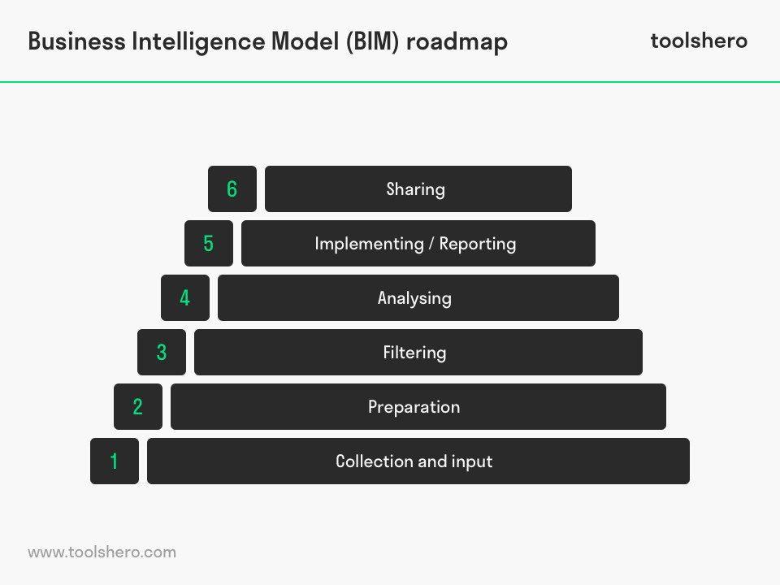

### 1. Collection and Input

The first step is collecting the data and connecting them to the Business Intelligence (BI) system. Depending on which system is used, the system can be ordered to get as much relevant data from a centralised database as possible, but Excel documents can also be added. There is a high diversity in types of sources and data and those all have their own way of requesting and input.

### 2. Preparation

Following input, not all data is available in the correct format. This is especially the case when multiple types of data, for example qualitative and quantitative information, are to be used together.

This means the data must often be prepared for the analysis. This happens in the preparation phase. Here, raw data is transformed into a clear collection of data.

This phase generally takes a lot of time, but it is essential for reliable and efficient analysis. Raw data can be logged in statistical software like IBM’s SPSS, which cleans it and divides it into categories. If the data sets are large, as is the case with Big Data, other, advanced technologies are needed.

### 3. Filtering

Now that all the data has been collected, cleaned, and entered, a selection must be made with relevant data. It may be the case that the customer behaviour data of the past five years are available, but the manager only wants to use the data of the past two years.

### 4. Analysing

Once the data are in a workable format, actual analysis can start. This is what it is about in the Business Intelligence Model (BIM). This it where it is decided which cross-section must be made of the data.

Averages per month and year, per segment, correlations between two variables, everything the organisation desires at that moment. The possibilities with data are endless and additional insights can be made by adding calculations.

### 5. Implementing / Reporting

The analysis is summarised in an analysis model. An effective analysis model makes it possible to easily and clearly gain insight based on reports and dashboards.

This is called implementation and forms the basis for, for instance, a strategic choice. The implementation can take place in different ways: professional reports, simple number lists, interactive graphic result tables, infographics, etc.

### 6. Sharing

During the final phase of the Business Intelligence Model (BIM), one considers how the results that were given shape in the previous phase will get to the right people at the right time.

This is often done by composing a quick email with an Excel document attached. However, there is a danger that different versions of the same file will get mixed up.

More complex information solutions often have an internal information portal. Reports and dashboards are available here for everyone who has been given access.

## Business Intelligence Model: Privacy and Data

Organisations collect and analyse so much data about, for instance, consumers that governments all around the world have created strict provisions intended to give consumers control over the way in which their data are being collected and used.

The European Union has the GDPR for example: The [General Data Protection Regulation](https://en.wikipedia.org/wiki/General_Data_Protection_Regulation) became effective in 2018. The United States use the comparable [California Consumer Privacy Act (CCPA)](https://en.wikipedia.org/wiki/California_Consumer_Privacy_Act).

These general regulations implement provisions for businesses when collecting, storing, using, and sharing of data. If organisations do not follow the rules they can expect severe punishment.

**Chapter 5**

**Task/Research**

**High Level Design (HLD)**

**Swiggy Data Analysis**



**Revision Number - 1.2**

**Last Date of Revision – 03/07/2022**

HIGH LEVEL DESIGN (HLD)

**Document Version Control**

|  |  |  |  |
| --- | --- | --- | --- |
| **Date Issued** | **Version** | **Description** | **Author** |
|  |  |  |  |
| 19/07/2022 | 1.0 | Abstract, | Shashank Nishad |
|  |  | Introduction, |  |
|  |  | General Description |  |
|  |  |  |  |
| 26/07/2022 | 1.1 | Design Detail, KPI, | Shashank Nishad |
|  |  | Deployment |  |
|  |  |  |  |
| 03/07/2022 | 1.2 | Final Revision | Shashank Nishad |
|  |  |  |  |

High Level Design (HLD)

**Contents**

Document Version Control.........................................................................................................2

Abstract...................................................................................................................3

1 Introduction .........................................................................................................5

1.1 Why this High-Level Design Document?..........................................................5

1.2 Scope .................................................................................................................5

2 General Description .............................................................................................6

2.1 Product Perspective & Problem Statement .......................................................6

2.2 Tools used............................................................................................................6

3 Design Details..........................................................................................................7

3.1 Functional Architecture .......................................................................................7

3.2 Optimization .........................................................................................................8

4 KPIs..............................................................................................................................9

4.1 KPIs (Key Performance Indicators) .......................................................................9

5 Deployment...................................................................................................................9

**Abstract**

Working as a bridge between restaurants and customers, Swiggy utilizes an innovative technology platform that works as a single point of contact. Their app allows urban foodies to order food from nearby restaurants and get it delivered at their doorstep. Customer Segments of Swiggy The customer segments of Swiggy include those people who do not wish to go out to restaurants and eateries to buy food. People who want to order food online and want to get it delivered at their doorsteps are the principal customers of Swiggy

**1 Introduction**

**1.1 Why this High-Level Design Document?**

The purpose of this High-Level Design (HLD) Document is to add the necessary detail to the current project description to represent a suitable model for coding. This document is also intended to help detect contradictions before coding and can be used as a reference manual for how the modules interact at a high level.

**The HLD will:**

* Present all of the design aspects and define them in detail
* Describe the user interface being implemented
* Describe the hardware and software interfaces
* Describe the performance requirements
* Include design features and the architecture of the project
* List and describe the non-functional attributes like:

-Security

-Reliability

-Maintainability

-Portability

-Reusability

-Application compatibility

-Resource utilization

-Serviceability

**1.2 Scope**

The HLD documentation presents the structure of the system, such as the database architecture, application architecture (layers), application flow (Navigation), and technology architecture. The HLD uses non-technical to mildly-technical terms which should be understandable to the administrators of the system.

**2 General Description**

2.1 Product Perspective & Problem Statement

This is one of the major challenges faced by swiggy. Often it happens that restaurants fail in developing a second or alternative line of operations to deal with online delivery orders. Unreliability in Delivery & Logistics Staff.

The objective of the project is to perform data visualization techniques to understand the insight of the data. This project aims apply various Business Intelligence tools such as Tableau or Power BI to get a visual understanding of the data.

**2.2 Tools used**

**Importance of Business Intelligence tools**

1. Gain insight into customer behaviour. It boosts your ability to analyze the customer buying trend.
2. To make data useful. If you know how to use a BI tool, you won’t have to skim through hundreds and hoards of pages.
3. Increases Sales or Marketing Intelligence. Whether you are a salesperson or a marketing person, you would probably like to keep a track of customers.
4. To increase Efficiency. Such a system can improve efficiency within the organization and as a result, increases productivity.

 

  

**3 Design Details**

**3.1 Functional Architecture**

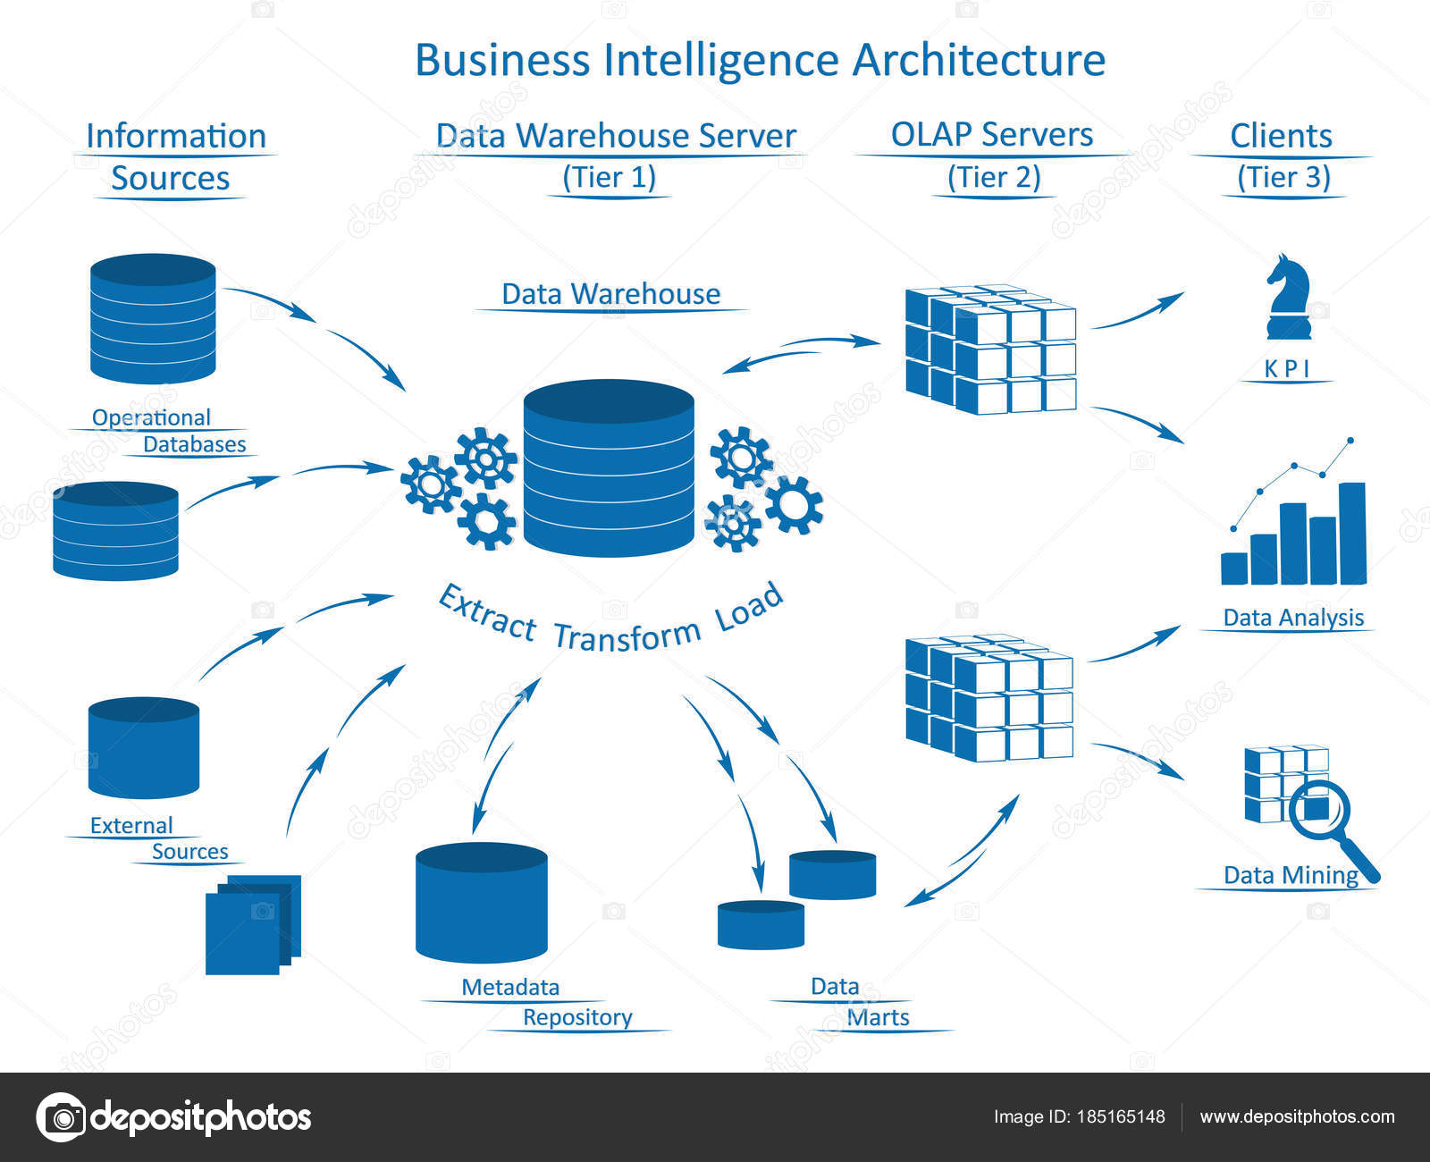

**HOW BI REALLY WORKS**

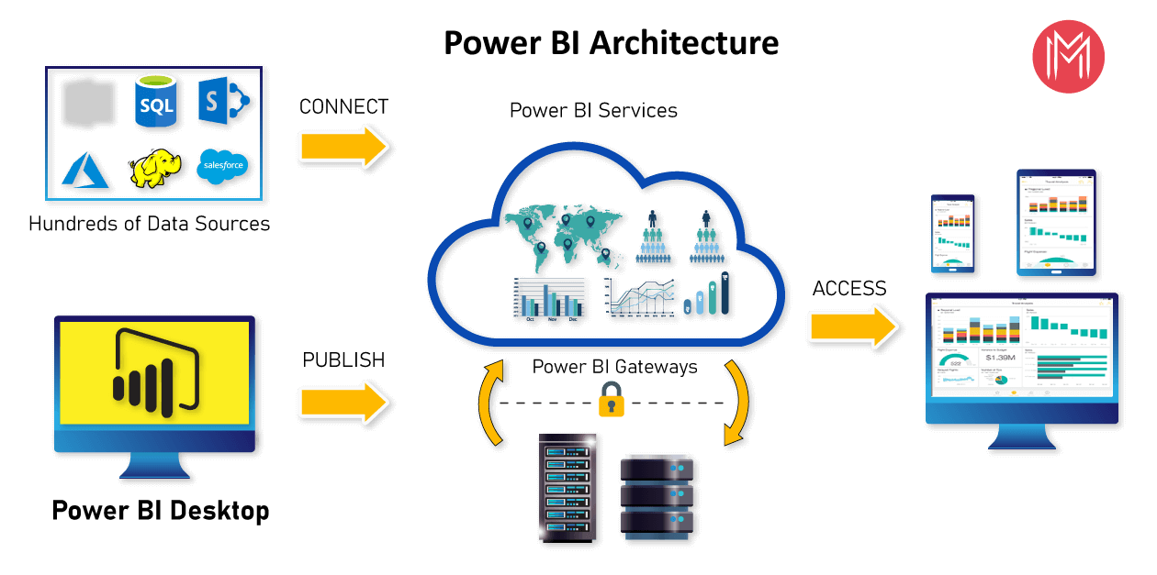

**3.2 Optimization**

Swiggy generate terabytes of data every week and leverage this data for delivery efficiency and to connect customers to the right restaurant. With our expansion across cities, our order volume has also grown over 200%. We have gone from being an app that would just get the job done to an app that delights the user every time they come to place an order. Real-time, micro-optimization of dynamic demand-supply, done millions of times every day.

* Logistic Optimization: Optimizing the cost of delivery while ensuring that customers get their product within the promised delivery times. This involves a combination of ML based models and a mathematical multi-objective function for optimizing across multiple business and customer experience constraints.
* Greater Personalisation: Aided by machine learning, the app personalizes the list of restaurants that users can view, based on their past orders, searches, and interactions with the app. This reduces the time to arrive at the choice of restaurants and dishes by half
* Faster Reordering: “Repeat” tags for preferred restaurants and dishes, and a complete order history helps users reorder their favourites with just a tap
* Simpler Order Tracking: Live order tracking is one of the most loved features of the Swiggy app. The app shares the expected time of arrival (ETA) of the order in real-time
* Smart Kitchen: Optimizing in-kitchen operations through AI driven initiatives such as forecasting demand, inventory optimization, dynamic order prioritization, intelligent kitchen capacity management, food quality management through computer vision and more.

**KPI AND DEPLOYMENT 4 KPI**

Dashboards will be implemented to display and indicate certain KPIs and relevant indicators for the disease.



As and when the system starts to capture the historical/periodic data for a user, the dashboards will be included to display charts over time with progress on various indicators or factors

**4.1 KPIs (Key Performance Indicators)**

Key indicators displaying a summary of the Heart Disease Analysis and its relationship with different metrics

1. Percentage of People Having Online Order for the Geographical Area.
2. Number Of Item Sold In a Year.
3. Average Number Day Of Delivery.
4. Which item most sold its depend upon the number of quantity.
5. Total number of sale.

**5 Deployment**

Power BI prioritizes choice in flexibility to fit, rather than dictate, your enterprise architecture. Power BI Desktop and Power BI Service leverage your existing technology investments and integrate them into your IT infrastructure to provide a self-service, modern analytics platform for your users. With on-premises, cloud, and hosted options, there is a version of Power BI to match your requirements.

The Dashboard is published on Power BI service and an auto-refresh mode has been set so that the dashboard keeps on updating as the real time data loads into the log file.

The Dashboard showcases the multiple insights that has been drawn from the log files as follows:

1. **Summary:** The dashboard contains the statistical summary of the dataset and the visual displaying the effect of different feature to swiggy food industry.
2. **Critical Factors:** This swiggy Bangalore outlate data show there are purchasing power of a customer for a particular location and particular product is low so the standard deviation graph decrease the mean.

Low Level Design (LLD)

Swiggy Bangalore Data Analysis



## Revision Number - 1.2

**Last Date of Revision - 03/07/2022**

**Shashank Shekhar Nishad**

**Document Control**

|  |  |  |  |
| --- | --- | --- | --- |
| **Date** | **Version** | **Description** | **Author** |
| 19/07/2022 | 1.0 | Introduction, Problem Statement | Shashank Nishad |
| 26/07/2022 | 1.1 | Dataset Information, Architecture Description | Shashank Nishad |
| 03/07/2022 | 1.2 | Final Revision | Shashank Nishad |
|  |  |  |  |

**Low level document**

Contents

1. Introduction........................................................................................................... 04

1.1 What is Low-Level Design Document? .............................................................. 04

1.2 Scope .................................................................................................................04

2. Architecture ......................................................................................................... 05

3. Architecture Description ....................................................................................... 08

3.1 Data Description .................................................................................................08

3.2 Web Scrapping ...................................................................................................08

3.3 Data Transformation .......................................................................................... 08

3.4 Data insertion into database .............................................................................. 08

3.5 Connection with SQL server .............................................................................. 08

3.5 Export Data from database .................................................................................12

3.6 Deployment ........................................................................................................ 12

4. Unit test cases ......................................................................................................15

4 SWIGGY DATA ANALYSIS

4 LOW LEVEL DESIGN

1. Introduction

1.1 What is Low-Level design document?

## Why this Low-Level Design Document?

The purpose of this document is to present a detailed description of the swiggy prediction analysis technique. It will explain the necessary steps which have to be followed before any analysis can begin. The document would also describe the algorithms and techniques used to predict the presence and absence of the food industry and present a comparative result for the same. LLD describes the class diagrams with the methods and relations between classes and programs specs. It describes the modules so that the programmer can directly code the program from the document. This document is intended for both the stakeholders and the developers of the system and will be proposed to the higher management for its approval.

The LLD will be focusing on the below objectives:

* Problem Understanding.
* Data Acquisition.
* Data Pre-Processing and Exploratory Analysis
* Development of models
* Auditing accuracy and retrain if require
* Finalizing the model
* Dashboard report for important activities

1.2 Scope

Low-level design (LLD) is a component-level design process that follows a step-by-step refinement process. The process can be used for designing data structures, required software architecture, source code and ultimately, performance algorithms. Overall, the data organization may be defined during requirement analysis and then refined during data design work.

Project introduction

Food Industry is one of the most common now a day most of the people buy online food they have order online so we have a data of Swiggy Bangalore outlet data and I worked on that data. The food industries collect huge amounts of data that contain some hidden information, which is useful for making effective decisions. For providing appropriate results and making effective decisions on data, some data science techniques need to be used. The data analysit predicts the inside from the data. It enables significant knowledge.

1. **Technical specifications**

**Dataset**

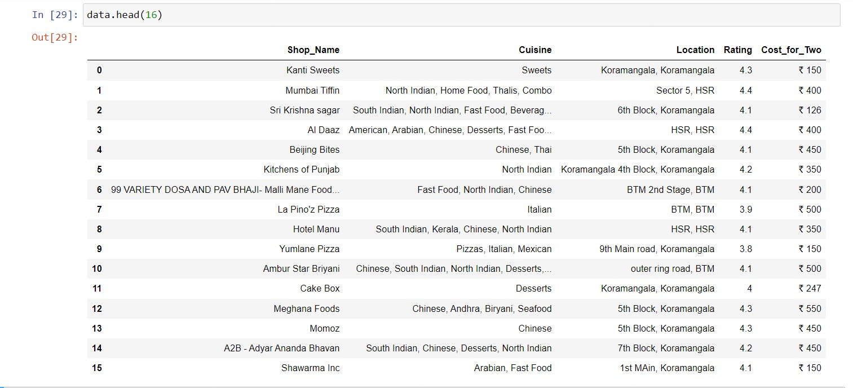

**Problem statement**

The online food ordering market includes foods prepared by restaurants, prepared by independent people, and groceries being ordered online and then picked up or delivered. The first online food ordering service, World Wide Waiter (now known as Waiter.com), was founded in 1995. Online food ordering is the process of ordering food from a website or other application. The product can be either ready-to-eat food or food that has not been specially prepared for direction consumption.

**2. Architecture**

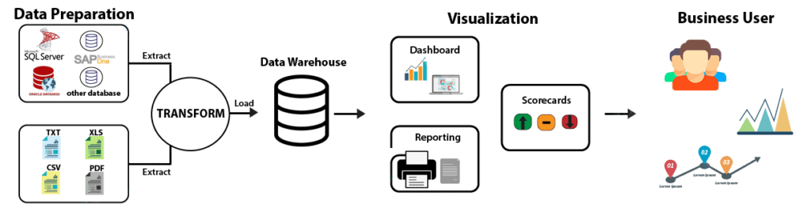

**Tableau Server Architecture**

**Architecture Description**

* 1. **Architecture Description**
     1. **Raw Data Collection** The Dataset was taken from iNeuron’s provided Project Description Document.

[ETL - Google Drive](https://drive.google.com/drive/folders/1FkmFVL8wlJmQWP1z52TD8PlhOJhitTyI)

### Data Pre-Processing

Before building any model, it is crucial to perform data pre-processing to feed the correct data to the model to learn and predict. Model performance depends on the quality of data feeded to the model to train.

This Process includes-

* + - 1. Handling Null/Missing Values
      2. Handling Skewed Data
      3. Outliers Detection and Removal

### Data Cleaning

Data cleaning is the process of fixing or removing incorrect, corrupted, incorrectly formatted, duplicate, or incomplete data within a dataset.

* + - 1. Remove duplicate or irrelevant observations
      2. Filter unwanted outliers
      3. Renaming required attributes

### Exploratory Data Analysis (EDA)

Exploratory Data Analysis refers to the critical process of performing initial investigations on data to discover patterns, spot anomalies, test hypothesis and to check assumptions with the help of summary statistics and graphical representations.

### Reporting

Reporting is a most important and underrated skill of a data analytics field. Because being a Data Analyst you should be good in easy and self-explanatory report because your model will be used by many stakeholders who are not from technical background.

* + - 1. High Level Design Document (HLD)
      2. Low Level Design Document (LLD)
      3. Architecture
      4. Wireframe
      5. Detailed Project Report
      6. Power Point Presentation

### Modelling

Data Modelling is the process of analysing the data objects and their relationship to the other objects. It is used to analyse the data requirements that are required for the business processes. The data models are created for the data to be stored in a database. The Data Model's main focus is on what data is needed and how we have to organize data rather than what operations we have to perform.

### Deployment

We created a Power BI Dashboard

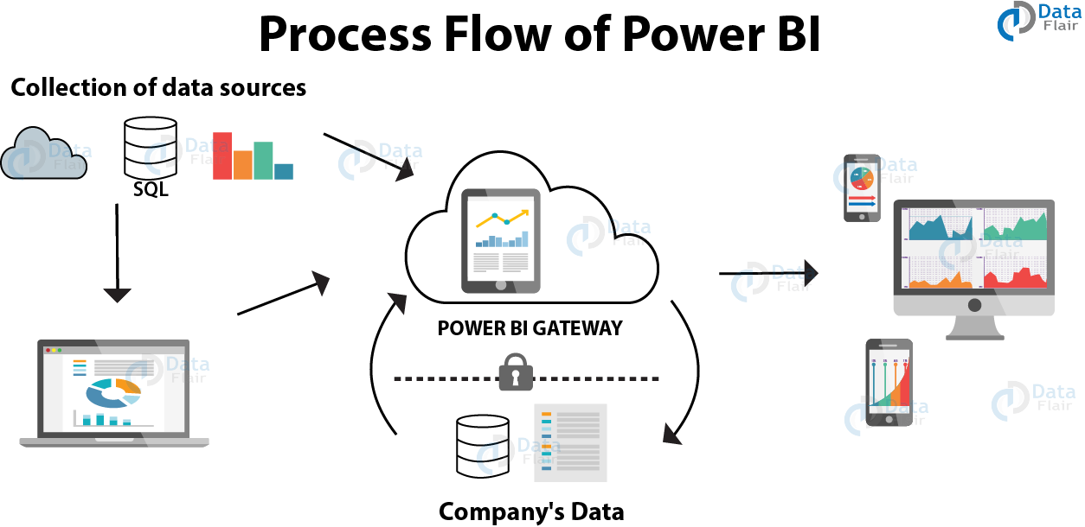

**Chapter 6**

**Strategy**

**Architecture Design**

**Swiggy Data Analysis**



**Revision Number - 1.1**

**Last Date of Revision - 03/07/2022**

**Shashank Nishad**

**Document Control**

|  |  |  |  |
| --- | --- | --- | --- |
| **Date** | **Version** | **Description** | **Author** |
|  |  |  |  |
| 26/07/2022 | 1.0 | Introduction, | Shashank Nishad |
|  |  | Architecture, |  |
|  |  | Deployment |  |
|  |  |  |  |
| 03/07/2022 | 1.1 | Final Revision | Shashank Nishad |
|  |  |  |  |

**Contents**

Document Version Control…………………………………………………………………………2

1. Introduction………………………………………………………………….4

1.1 What is Architecture Design Document? 4

1.2 Scope……………………………………………………………………………4

* Architecture……….……………………………………………………….……...5

2.1 Power BI Architecture………………………………………………………………….5

2.2 Components of Power BI Architecture……………………………………….6

3.1 Power BI Deployment………………………………………………………………….7

3.2 Publish datasets and reports from Power BI Desktop………………………………7





RCHITECTURE DESIGN

**1. Introduction**

**1.1 What is Architecture Design Document?**

Any software needs the architectural design to represent the design of the software. IEEE defines architectural design as “the process of defining a collection of hardware and software components and their interfaces to establish the framework for the development of a computer system.” The software that is built for computer-based systems can exhibit one of these many architectures.

Each style will describe a system category that consists of:

* A set of components (eg: a database, computational modules) that will perform a function required by the system.
* The set of connectors will help in coordination, communication, and cooperation between the components.
* Conditions that how components can be integrated to form the system.
* Semantic models help the designer to understand the overall properties of the system.

**1.2 What is Scope?**

Architecture Design Document (ADD) is an architectural design process that follows a step-by-step refinement process. The process can be used for designing data structures, required software architecture, source code and ultimately, performance algorithms. Overall, the design principles may be defined during requirement analysis and then refined during architectural design work.



ARCHITECTURE DESIGN

**2. Architecture**

**2.1** **Power BI Architecture**

Power BI is a business suite that includes several technologies that work together. To deliver outstanding business intelligence solutions.

Microsoft Power BI technology consists of a group of components such as:

1. Power Query (for data mash-up and transformation)
2. Power BI Desktop (a companion development tool)
3. Power BI Mobile (for Android, iOS, Windows phones)
4. Power Pivot (for in-memory tabular data modelling)
5. Power View (for viewing data visualizations)
6. Power Map (for visualizing 3D geo-spatial data)
7. Power Q&A (for natural language Q&A)

In simple terms, a Power BI user takes data from various data sources such as files, Azure source, online services, Direct Query or gateway sources. Then, they work with that data on a client development tool such as Power BI Desktop. Here, the imported data is cleaned and transformed according to the user’s needs.

Once the data is transformed and formatted, it is ready to use in making visualizations in a report. A report is a collection of visualizations like graphs, charts, tables, filters, and slicers.



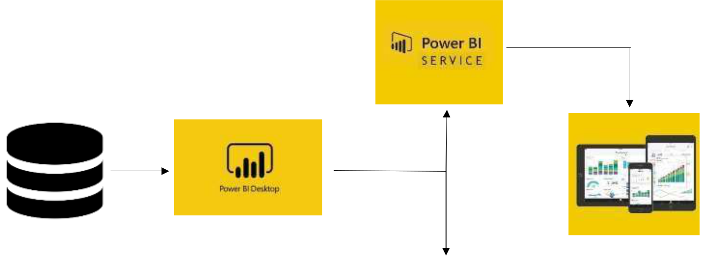

**Delivery**



**Data Source**



RCHITECTURE DESIGN

**2.2 Components of Power BI Architecture**

**1. Data Sources**

An important component of Power BI is its vast range of data sources. You can import data from files in your system, cloud-based online data sources or connect directly to live connections. If you import from data on-premise or online services there is a limit of 1 GB. Some commonly used data sources in Power BI are: a) Excel

1. Text/CSV
2. XML
3. JSON
4. Oracle Database
5. IBM DB2 Database
6. MySQL Database
7. PostgreSQL Database
8. Sybase Database
9. Teradata Database
10. SAP HANA Database
11. SAP Business Warehouse server
12. Amazon Redshift
13. Impala
14. Google Big Query (Beta)
15. Azure SQL Database
16. Salesforce Reports
17. Google Analytics
18. Facebook
19. GitHub

**2. Power BI Desktop**

Power BI Desktop is a client-side tool known as a companion development and authoring tool.

This desktop-based software is loaded with tools and functionalities to connect to data sources, transform data, data modelling and create reports.

**3. Power BI Service**

Power BI Service is a web-based platform from where you can share reports made on Power BI Desktop, collaborate with other users, and create dashboards. It is available in three versions:

* 1. Free version
  2. Pro version
  3. Premium version

# Power BI Report Server

The Power BI Report Server is similar to the Power BI Service. The only difference between these two is that Power BI Report Server is an on-premise platform. It is used by organizations who do not want to publish their reports on the cloud and are concerned about the security of their data.



ARCHITECTURE DESIGN

**3. Deployment**

**3.1 Power BI Deployment**

The deployment process lets you clone content from one stage in the pipeline to another, typically from development to test, and from test to production.

During deployment, Power BI copies the content from the current stage, into the target one. The connections between the copied items are kept during the copy process. Power BI also applies the configured deployment rules to the updated content in the target stage. Deploying content may take a while, depending on the number of items being deployed. During this time, you can navigate to other pages in the Power BI portal, but you cannot use the content in the target stage.

**3.2 Publish datasets and reports from Power BI Desktop**

When you publish a Power BI Desktop file to the Power BI service, you publish the data in the model to your Power BI workspace. The same is true for any reports you created in Report view. You’ll see a new dataset with the same name, and any reports in your Workspace navigator.

Publishing from Power BI Desktop has the same effect as using Get Data in Power BI to connect to and upload a Power BI Desktop file.

**Chapter 7**

**Analysis and Findings**

**I am attaching a jupyter notebook file below what I am finding in that project.**



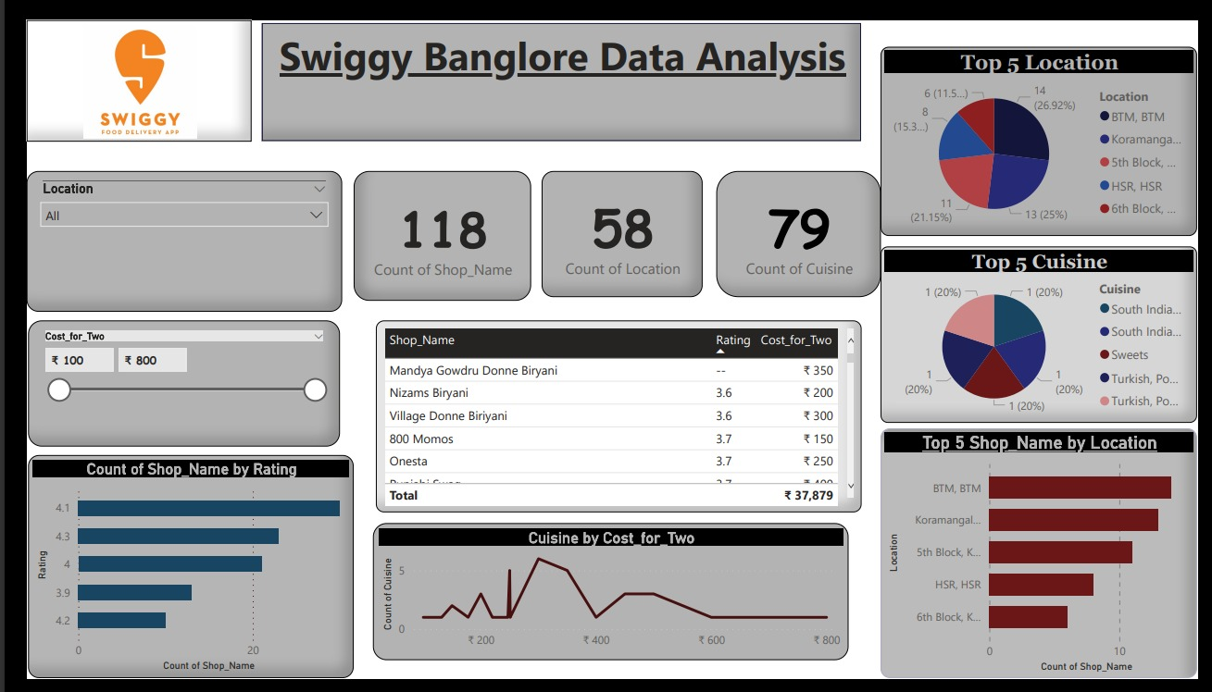

**Chapter 8**

**Conclusion and Limitation**

In this chapter, a summary of conclusions about the internship realised are presented and analysed against the objectives considered. Furthermore, after those appreciations, in the second part of this chapter, some recommendations are considered, as a result of the developed internship study. These will be, expectantly, useful for future advances in the company.

Conclusions

This internship report explains the main activities carried out in iNeuron Intelligence Pvt Ltd. This internship was carried out as the non-lecturing component of the Master’s degree in Data Science. Concerning the objectives that had been proposed for the internship theme, some of them were fully achieved, while the other objectives needed to be reworked as a consequence of the company’s situation and its involvement in the Information.

One of the objectives of the internship was to develop the key performance indicators for the power BI. In this way, the first step towards find the missing value what factors that influence the missing value and data industry as a whole. In accordance with present research, one of the crucial factors is the capability to view the unstructured data. When all Factors in the data interact together with common goals and objectives, the opportunity for the achievement raises. The recommendation for KPIs is based on a thorough evaluation of all the metrics that are currently measured within the iNeuron Intelligence Pvt Ltd . There are different source to pull the data and load to the power bi there are so many missing value fill with the help of pandas interplot clean the data with power bi using slicer to make a better way to create a dashboard to show all the important details at one place.

.

**Bibliography**

[Home :: iNeuron](https://old.ineuron.ai/) -  [iNeuron.ai](https://ineuron.ai/)

[GeeksforGeeks | A computer science portal for geeks](https://www.geeksforgeeks.org/)

[(PDF) Missing Data (researchgate.net)](https://www.researchgate.net/publication/308007055_Missing_Data)

[Data Handling and Analysis: Definitions, Examples & Types (studysmarter.us)](https://www.studysmarter.us/explanations/psychology/data-handling-and-analysis/)

**Data set -** [ETL - Google Drive](https://drive.google.com/drive/folders/1FkmFVL8wlJmQWP1z52TD8PlhOJhitTyI)

[Business Intelligence Model (BIM) - Toolshero](https://www.toolshero.com/strategy/business-intelligence-model-bim/)

[What Is Business Intelligence? (pestleanalysis.com)](https://pestleanalysis.com/business-intelligence/)

[Power BI Dashboard Tutorial | DataCamp](https://www.datacamp.com/tutorial/power-bi-dashboard-tutorial)

Annexure I

**We Performed Exploratory Data Analysis on Jupyter Notebook and then created a Power BI Desktop Dashboard.**

