ASSIGNMENT_2

Shashank Raj
25SCS1003001227 – (2CSE_14)

Screenshot of the Java source code (HelloWorld.java).

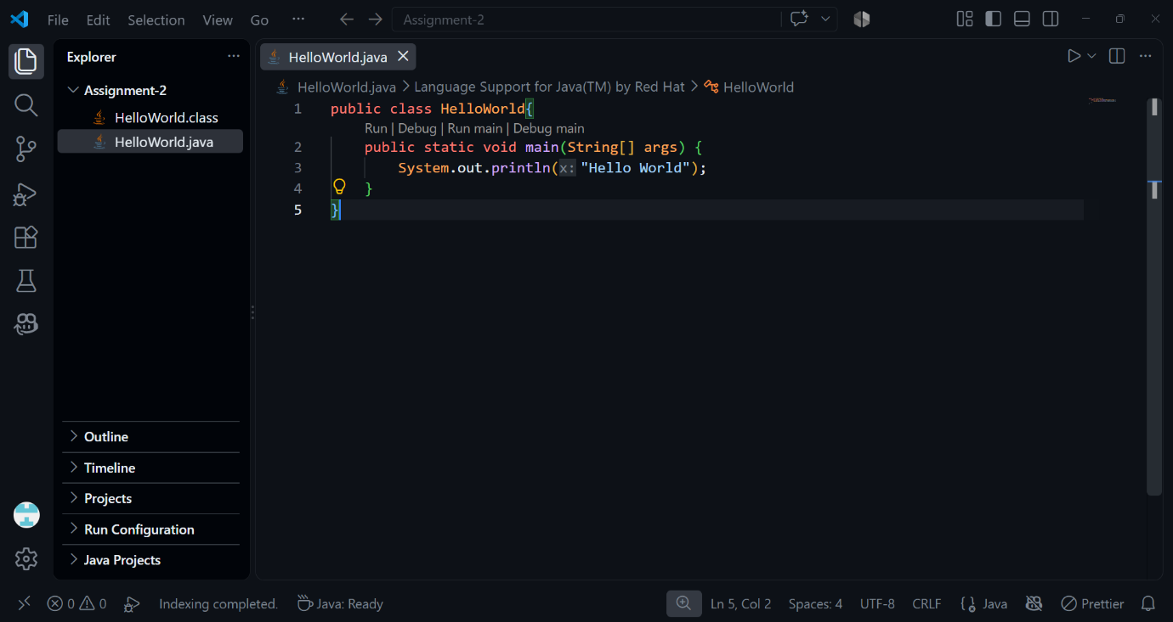

Screenshot of the compilation command (javac HelloWorld.java).

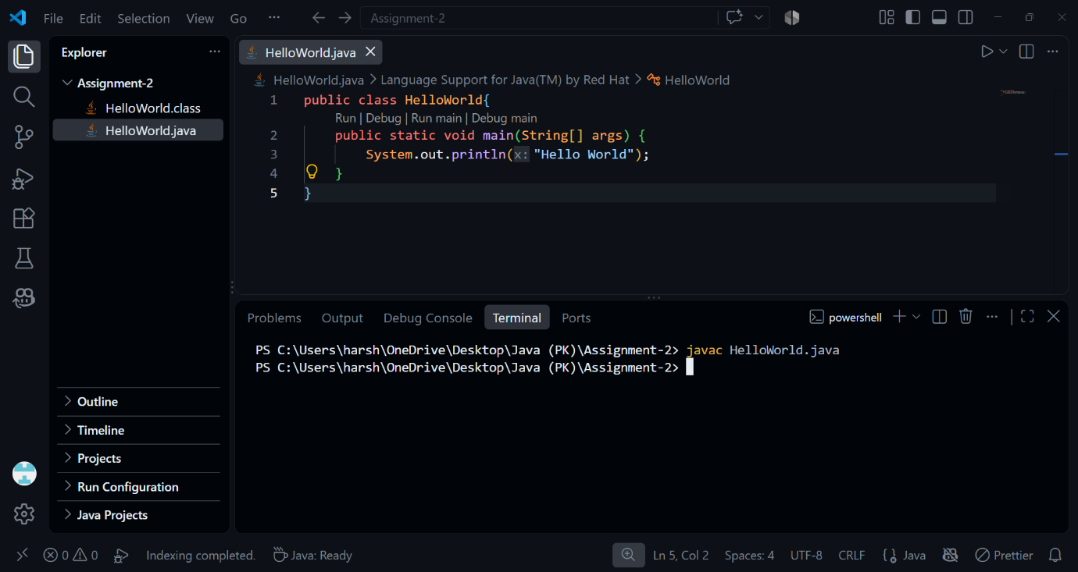

Screenshot showing the generated .class file.

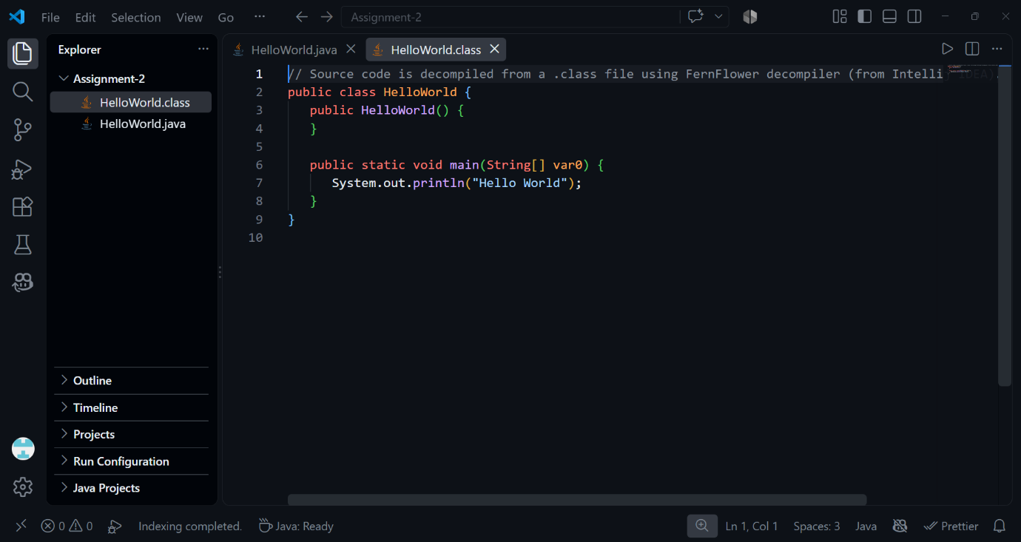

Screenshot of the execution command (java HelloWorld).

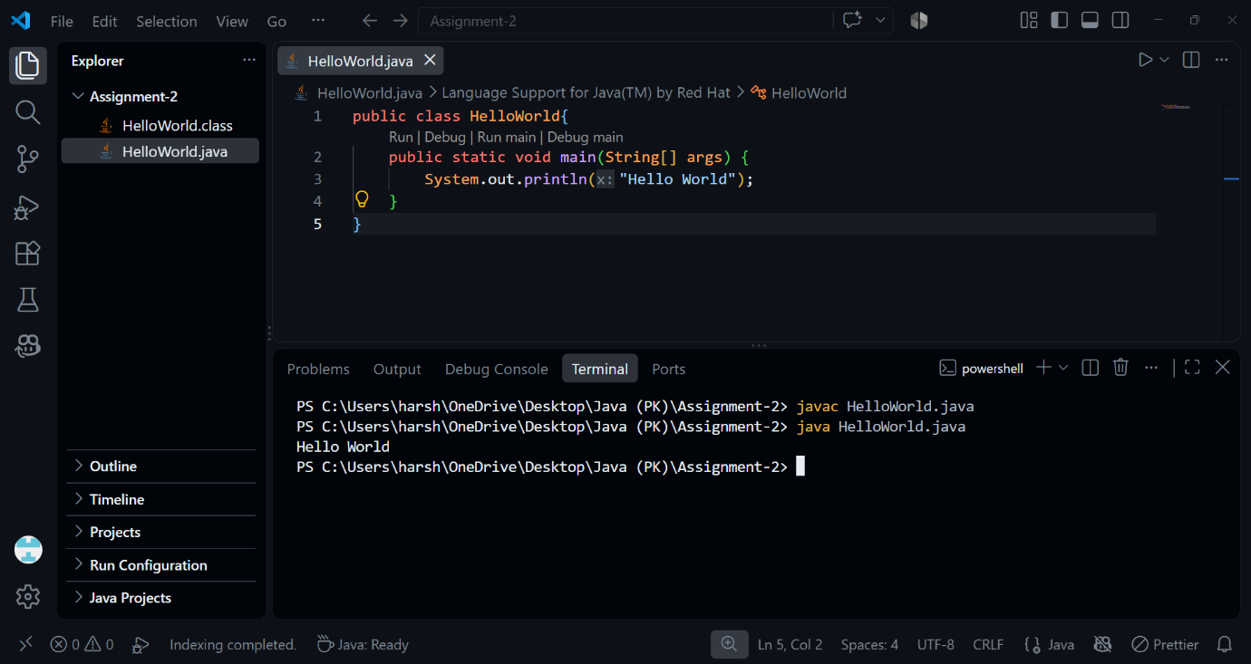

Screenshot of the output for all practical tasks.

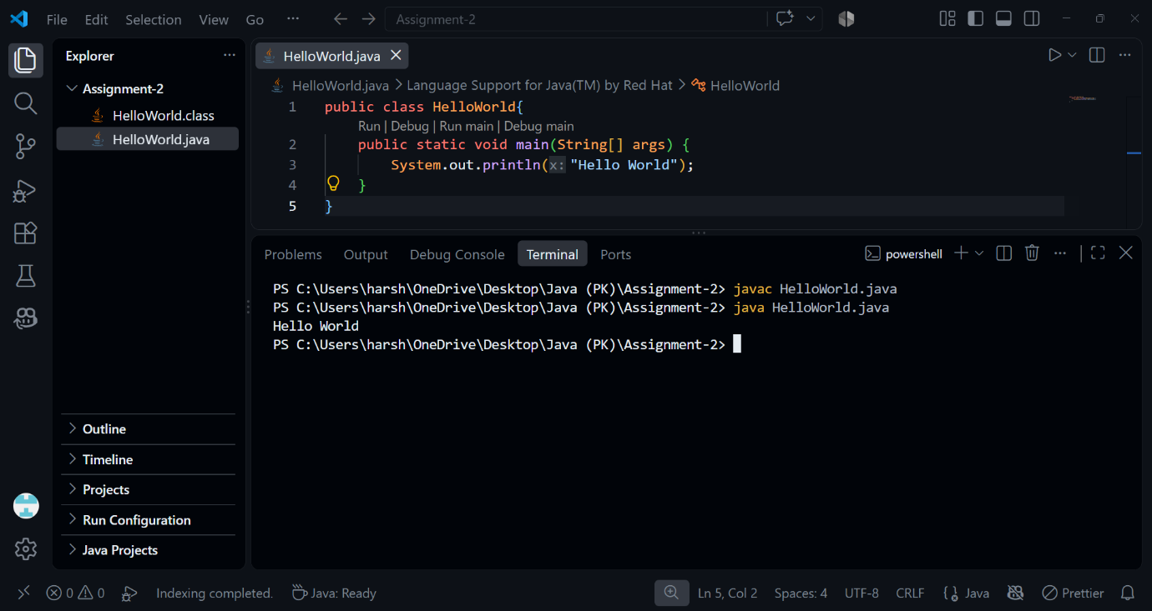

1. What is a Java program?
A Java program is a set of instructions written in the Java programming language to perform specific tasks. It is written in source code, compiled into bytecode, and executed by the JVM. Java programs are platform-independent, object-oriented, secure, and widely used.

2. What is the purpose of the main() method?
The main() method is the starting point of a Java program. When a Java application runs, the JVM looks for the main() method and begins execution from there. It allows the program to perform tasks by executing statements written inside it.

3. What is the difference between javac and java?
javac is the Java compiler that converts Java source code (.java) into bytecode (.class).
java is the Java launcher that runs the compiled bytecode using the JVM.

4. Explain the Java Program Structure in details.
A Java program is organized into different parts such as comments, package declarations, import statements, classes, variables, constructors, and methods. The class is the main building block of a Java program. The main() method is the standard starting point of program execution. Statements inside methods perform specific tasks. Java source code is compiled into bytecode, which is then executed by the Java Virtual Machine (JVM). This structure makes Java programs organized, reusable, readable, and easier to maintain.

